Weekly OEE Insight Report - Fillpac 1 & 2 (Packer 1 + Packer 2)
Weekly executive summary with quantified insights, loss drivers and action priorities
Report Week: Week 36
Start Date: 31st August 2026 End Date: 7th September 2026

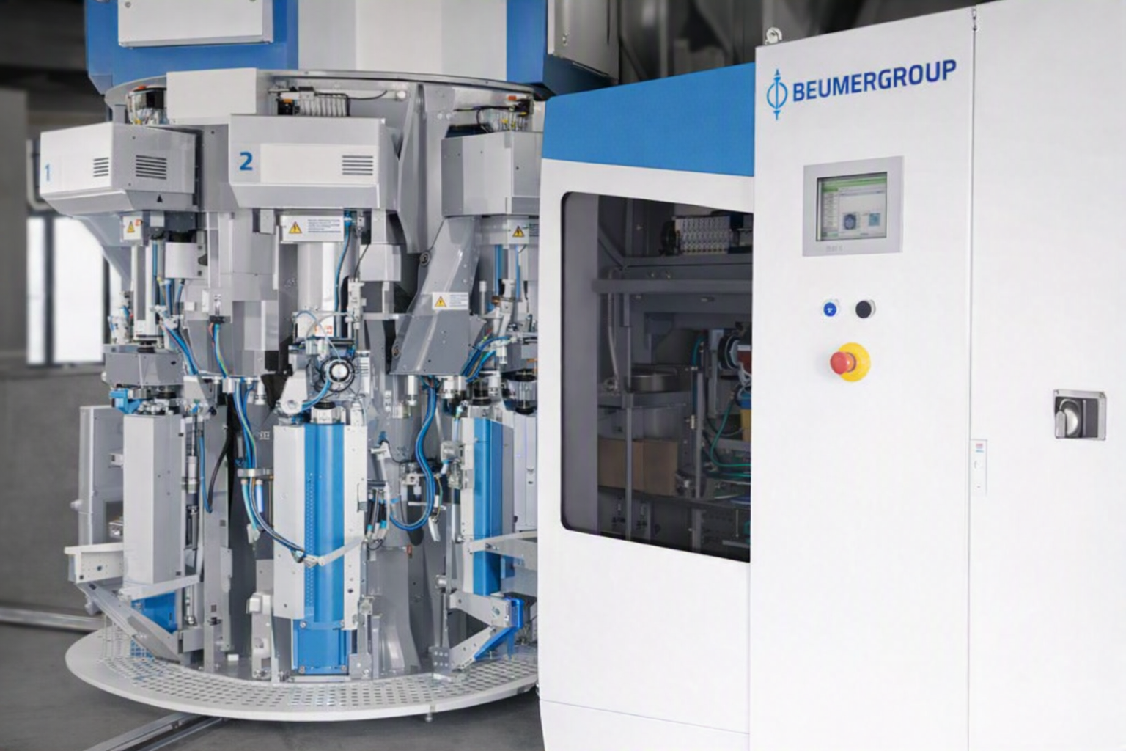

Contents

Section | Main heading | Page
1 | Executive Insight Dashboard | 3
2 | Why OEE Is Going Down | 4
3 | Quality, Fault Risk and Improvement Opportunity | 5
4 | Action Plan: What to Do Next Week | 6

1. Executive Insight Dashboard
This page explains the verified OEE results in plain language for operations, maintenance and management users.
Summary
The current OEE is 98.29%, which is on target at 85.00%. Availability is 98.33% and Performance is 100.00%. Quality is 99.96%. The weakest KPI is Availability at 98.33%. The strongest KPI is Performance at 100.00%.
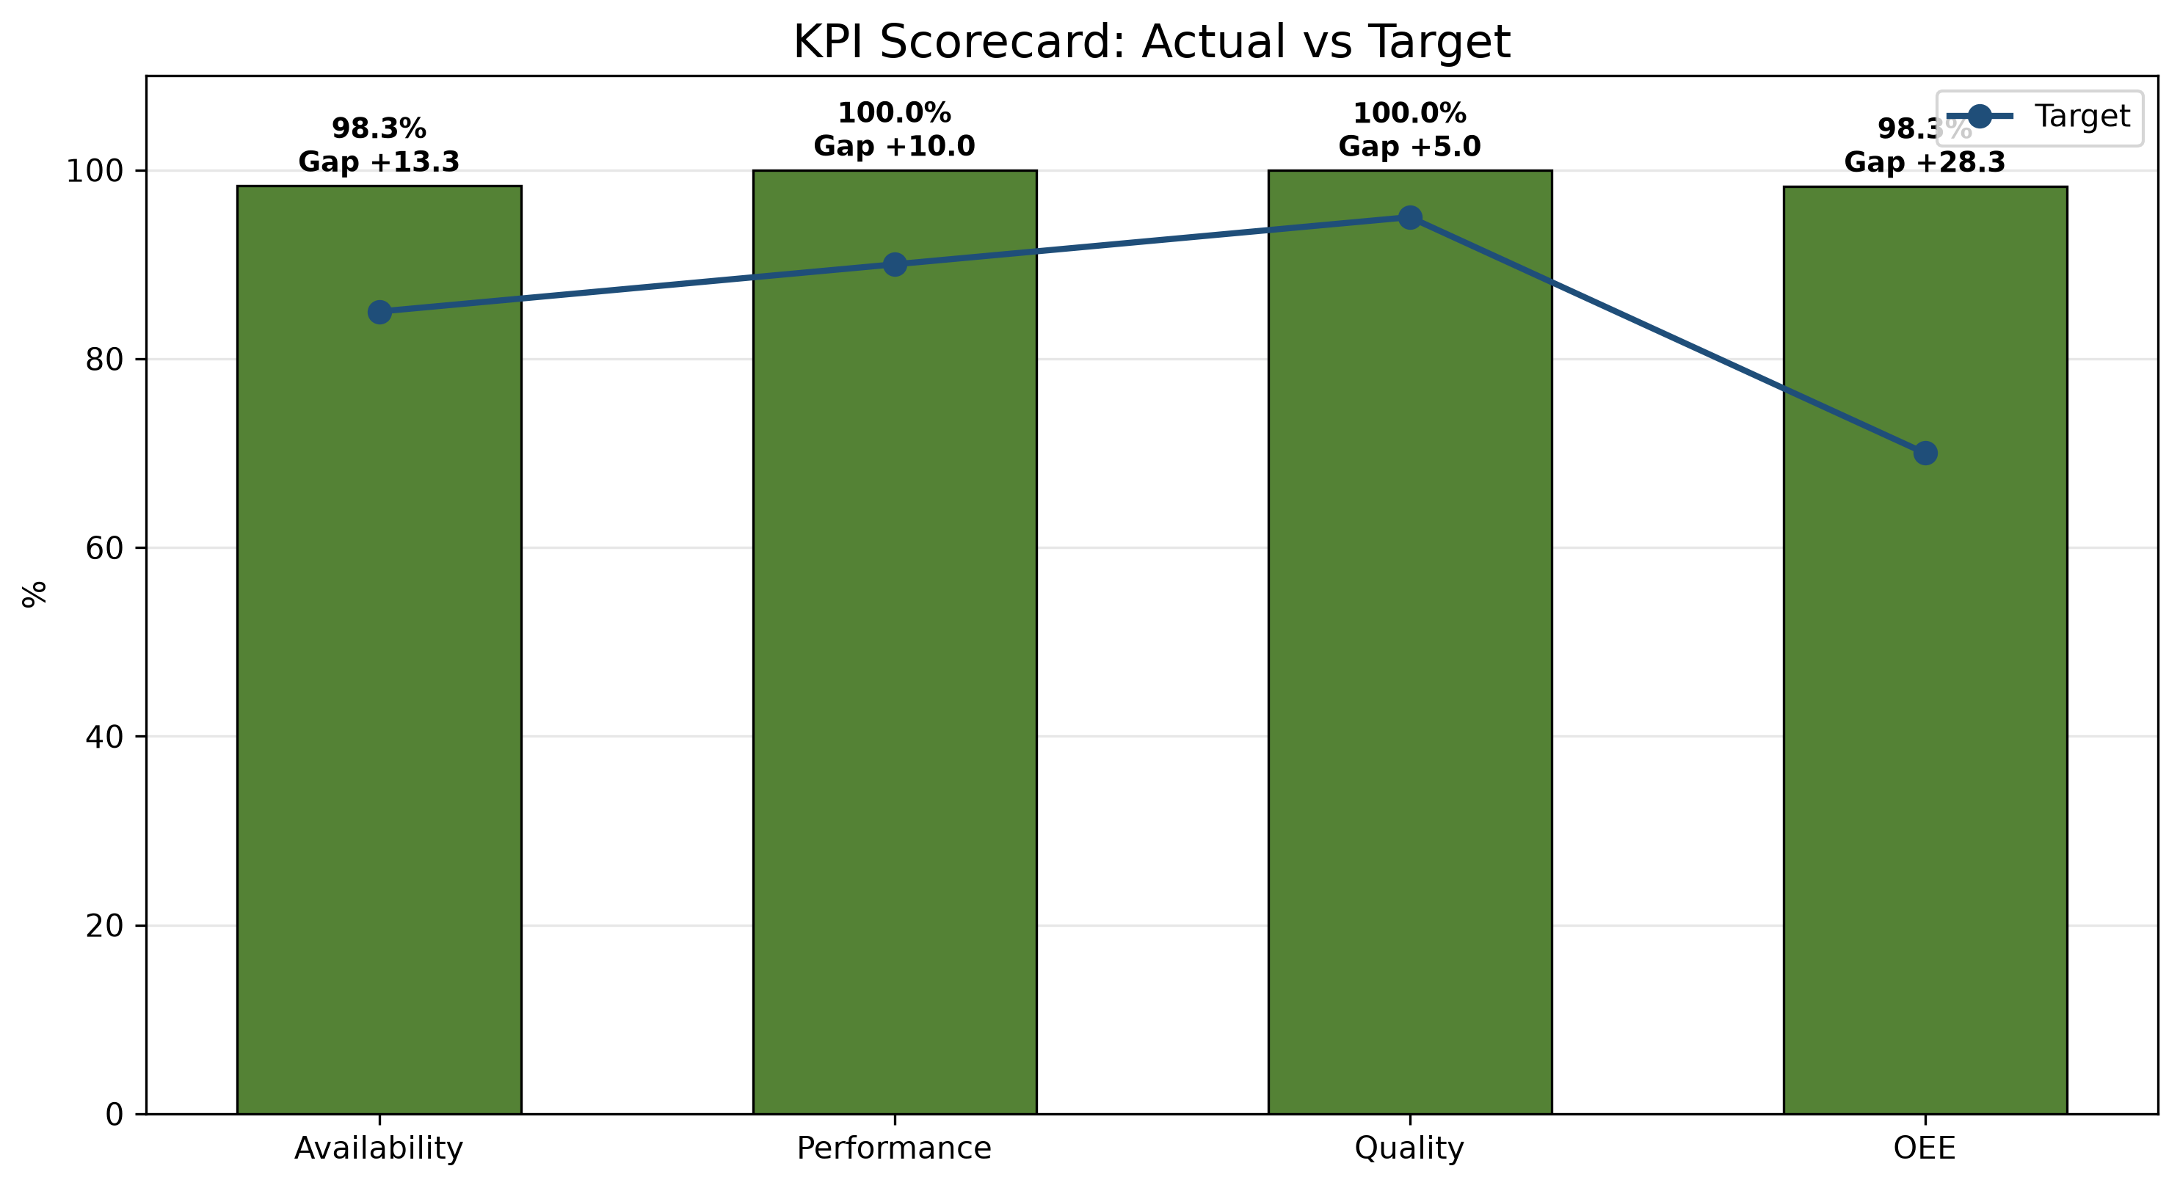
1. Main loss driver  The largest downtime contributor is Fillpac 2 Main Drive Stop with 2792.10 minutes of classified downtime. This represents 44.27% of the total classified downtime. | 2. Performance concern  Performance is currently at 100.00%, which is a significant increase from the previous week's performance of 39.14%. The production gap is 0. | 3. Strongest KPI  Performance is the strongest KPI at 100.00%
KPI Scorecard vs Industry Standard
KPI | Current | Industry standard | Status
OEE | 98.29% | 85% world-class | On Target
Availability | 98.33% | 90%+ | On Target
Performance | 100.00% | 95%+ | On Target
Quality | 99.96% | 99.9% | On Target
Week 37 vs Week 38 Comparison
KPI / Parameter | Week 37 | Week 38 | Change | Management insight
OEE | 38.34% | 98.29% | +59.95 pp | Availability decreased by 0.55 percentage points, Performance increased by 60.86 percentage points and Quality increased by 0.89 percentage points from the previous week. OEE changed by 59.95 percentage points.
Availability | 98.88% | 98.33% | -0.55 pp | Availability decreased by 0.55 pp week over week; currently 8.33 points above the 90.00% target.
Performance | 39.14% | 100.00% | +60.86 pp | Performance improved by 60.86 pp week over week; currently 5.00 points above the 95.00% target.
Quality | 99.07% | 99.96% | +0.89 pp | Quality improved by 0.89 pp week over week; currently 0.06 points above the 99.90% target.
pp = percentage points, the straight difference between two percentages (e.g. 45% to 50% is +5 pp), not a percent change.
pp = percentage points, the straight difference between two percentages (e.g. 45% to 50% is +5 pp), not a percent change.

2. Why OEE Is Going Down

Rank | Fault code / parameter | Loss | Insight from data | Immediate action
1 | Fillpac 2 Main Drive Stop | 2792.10 min | Fillpac 2 Main Drive Stop accounts for 2792.10 minutes of recorded downtime. | Prioritize investigation of Fillpac 2 Main Drive Stop using available production and equipment records.
2 | Fillpac 2 Belt Not Running | 1800.65 min | Fillpac 2 Belt Not Running accounts for 1800.65 minutes of recorded downtime. | Prioritize investigation of Fillpac 2 Belt Not Running using available production and equipment records.
3 | Fillpac 1 Main Drive Stop | 1714.11 min | Fillpac 1 Main Drive Stop accounts for 1714.11 minutes of recorded downtime. | Prioritize investigation of Fillpac 1 Main Drive Stop using available production and equipment records.
Decision point
The weakest KPI is Availability at 98.33%. Investigate Fillpac 2 Main Drive Stop and its impact on downtime.

The largest downtime contributor is Fillpac 2 Main Drive Stop with 2792.10 minutes of classified downtime. This represents 44.27% of the total classified downtime.
Shift changeover delay is a controllable availability loss. Week 38 data show delay time during handover and start-up stabilization.
Shift changeover | Delay time
Shift A Changeover Delay | 837.93 min
Shift B Changeover Delay | 47.31 min
Shift C Changeover Delay | 21.27 min
Total Week 38 delay | 906.51 min

2.2 Spout Downtime by Machine - Week 38
Spout-level downtime highlights which individual spouts are driving each machine's Spout Fault minutes, so maintenance can target the specific spouts responsible rather than the machine as a whole.
Fillpac 1 (PLC_01)
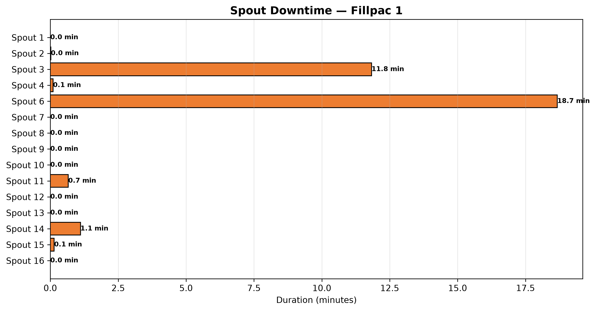
Fillpac 2 (PLC_02)
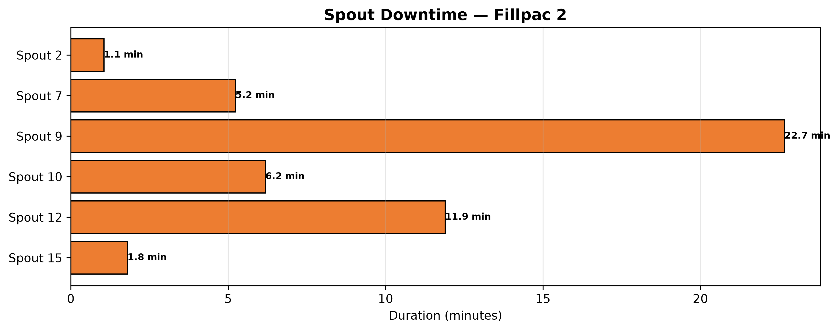

3. Quality, Fault Risk and Improvement Opportunity
The current quality loss is 0.04%. The largest contributor to this loss is Out of Limit Bags with 2,974 bags (67.85% of recorded quality loss).
Quality Loss Mix
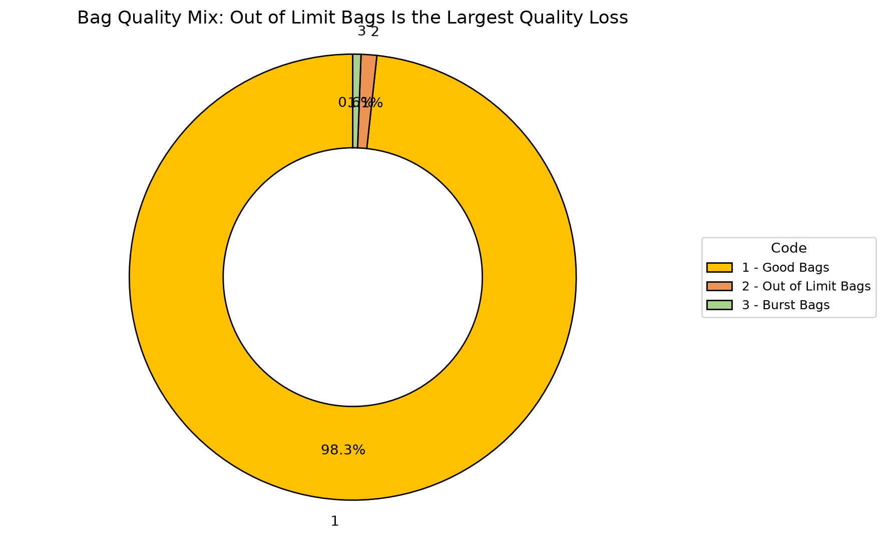
Code | Parameter | Quantity |  | What it means | Control action
1 | Good Bags | 11575417 bags |  | Good Bags represents 99.96% of total bags produced this week. | Baseline reference — no corrective action required.
2 | Out of Limit Bags | 2974 bags |  | Out of Limit Bags represents 0.03% of total bags produced this week. | Review process records associated with Out of Limit Bags and prioritize corrective action.
3 | Burst Bags | 1409 bags |  | Burst Bags represents 0.01% of total bags produced this week. | Review process records associated with Burst Bags and prioritize corrective action.
Quality insight
Out of Limit Bags account for 2,974 bags of recorded quality loss. This represents 67.85% of the total recorded quality loss.

4. Action Plan: What to Do Next Week
Actions are prioritized from the verified OEE losses and AI-generated recommendations.
Priority | Owner |  | Fault code | Action | Success measure |  | Review frequency
P1 | Maintenance + Production |  | Maintenance + Production | Fillpac 2 Main Drive Stop | Reduce Fillpac 2 Main Drive Stop downtime (currently 2792.10 minutes this week) to recover Availability. |  | Cut Fillpac 2 Main Drive Stop downtime versus this week's 2792.10 minutes.
P1 | Maintenance + Production |  | Maintenance + Production | Fillpac 2 Belt Not Running | Reduce Fillpac 2 Belt Not Running downtime (currently 1800.65 minutes this week) to recover Availability. |  | Cut Fillpac 2 Belt Not Running downtime versus this week's 1800.65 minutes.
P1 | Maintenance + Production |  | Maintenance + Production | Fillpac 1 Main Drive Stop | Reduce Fillpac 1 Main Drive Stop downtime (currently 1714.11 minutes this week) to recover Availability. |  | Cut Fillpac 1 Main Drive Stop downtime versus this week's 1714.11 minutes.
P2 | Production |  | Production | Out of Limit Bags | Reduce Out of Limit Bags (currently 2974 bags this week) to recover Quality yield. |  | Cut Out of Limit Bags bags versus this week's 2974 bags.
If action is completed |  | Expected change |  | Approx. OEE result |  | Management decision
Fillpac 2 Main Drive Stop reduced |  | Availability improves first |  | ~98.29% |  | Continue the countermeasure until stable
Fillpac 2 Main Drive Stop plus Fillpac 2 Belt Not Running addressed |  | Near-target recovery |  | ~98.29% |  | Shift focus to Out of Limit Bags, the next-largest quality contributor
Availability stable + Out of Limit Bags reduced |  | Target recovery |  | ~98.29% |  | Standardize the new checks into SOP

