Weekly OEE Report
Weekly executive summary with quantified insights, loss drivers and action priorities
Report Week: Week 10
Start Date: 2nd March 2026 End Date: 9th March 2026



Contents

Section | Main heading | Page
1 | Executive Insight Dashboard | 3
2 | Why OEE Is Going Down | 4
3 | Quality, Fault Risk and Improvement Opportunity | 5
4 | Action Plan: What to Do Next Week | 6

1. Executive Insight Dashboard
This page explains the verified OEE results in plain language for operations, maintenance and management users.
Summary
The current OEE is 53.57%, below the target of 85.00%. Performance is the weakest KPI at 54.87%, while Quality is the strongest at 99.85%.
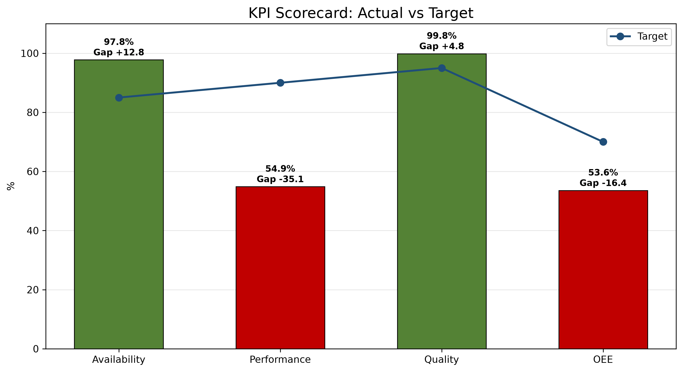
1. Main loss driver  Fillpac 4 Belt Not Running accounts for 178.81 minutes of classified downtime, representing 37.91% of total classified downtime. | 2. Performance concern  The actual good bags produced are 35,913 while the expected good bags were 65,450. This represents a production gap of 29,537 bags. | 3. Strongest KPI  Quality is the strongest KPI at 99.85%.
KPI Scorecard vs Industry Standard
KPI | Current | Industry standard | Status
OEE | 53.57% | 85% world-class | Critical
Availability | 97.77% | 90%+ | On Target
Performance | 54.87% | 95%+ | Critical
Quality | 99.85% | 99.9% | Below Target
Week 9 vs Week 10 Comparison
KPI / Parameter | Week 9 | Week 10 | Change | Management insight
OEE | 0.00% | 53.57% | +53.57 pp | Availability increased by 97.77 percentage points from the previous week, Performance increased by 54.87 percentage points from the previous week, and Quality increased by 99.85 percentage points from the previous week.
Availability | 0.00% | 97.77% | +97.77 pp | Availability improved by 97.77 pp week over week; currently 7.77 points above the 90.00% target.
Performance | 0.00% | 54.87% | +54.87 pp | Performance improved by 54.87 pp week over week; currently 40.13 points below the 95.00% target.
Quality | 0.00% | 99.85% | +99.85 pp | Quality improved by 99.85 pp week over week; currently 0.05 points below the 99.90% target.
pp = percentage points, the straight difference between two percentages (e.g. 45% to 50% is +5 pp), not a percent change.
pp = percentage points, the straight difference between two percentages (e.g. 45% to 50% is +5 pp), not a percent change.

2. Why OEE Is Going Down

Rank | Fault code / parameter | Loss | Insight from data | Immediate action
1 | Fillpac 4 Belt Not Running | 178.81 min | Fillpac 4 Belt Not Running accounts for 178.81 minutes of recorded downtime. | Prioritize investigation of Fillpac 4 Belt Not Running using available production and equipment records.
2 | Fillpac 2 Belt Not Running | 147.98 min | Fillpac 2 Belt Not Running accounts for 147.98 minutes of recorded downtime. | Prioritize investigation of Fillpac 2 Belt Not Running using available production and equipment records.
3 | Fillpac 1 Belt Not Running | 102.21 min | Fillpac 1 Belt Not Running accounts for 102.21 minutes of recorded downtime. | Prioritize investigation of Fillpac 1 Belt Not Running using available production and equipment records.
4 | Fillpac 4 Main Drive Stop | 15.97 min | Fillpac 4 Main Drive Stop accounts for 15.97 minutes of recorded downtime. | Prioritize investigation of Fillpac 4 Main Drive Stop using available production and equipment records.
Decision point
Prioritize investigation of the largest supplied downtime driver, Fillpac 4 Belt Not Running.

Fillpac 4 Belt Not Running accounts for 178.81 minutes of classified downtime, representing 37.91% of total classified downtime.
Shift changeover delay is a controllable availability loss. Week 10 data show delay time during handover and start-up stabilization.
Shift changeover | Delay time
Shift A Changeover Delay | 0.00 min
Shift B Changeover Delay | 0.00 min
Shift C Changeover Delay | 207.03 min
Total Week 10 delay | 207.03 min

2.2 Spout Downtime by Machine - Week 10
Spout-level downtime highlights which individual spouts are driving each machine's Spout Fault minutes, so maintenance can target the specific spouts responsible rather than the machine as a whole.
Fillpac 1 (PLC_01)
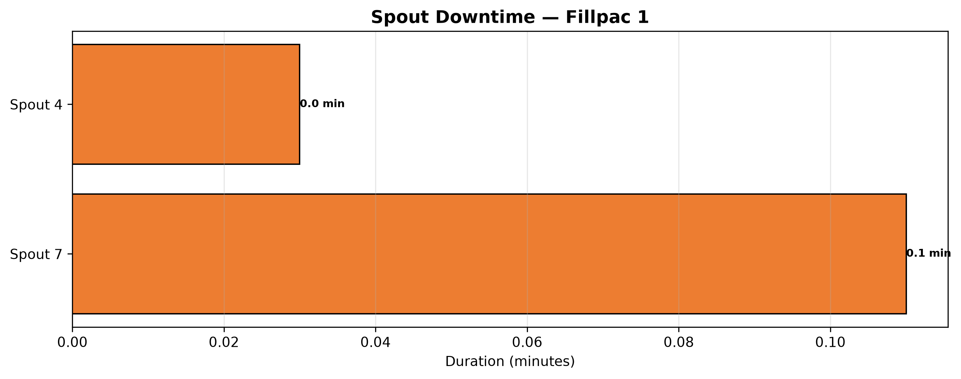
Fillpac 2 (PLC_02)
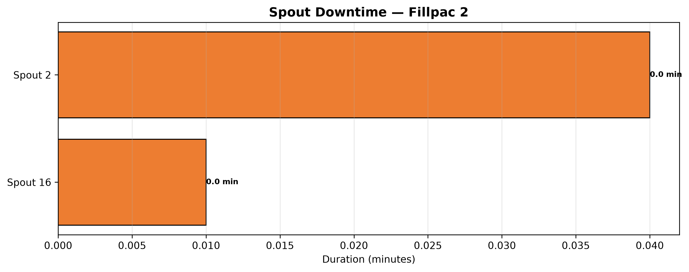
Fillpac 3 (PLC_03)
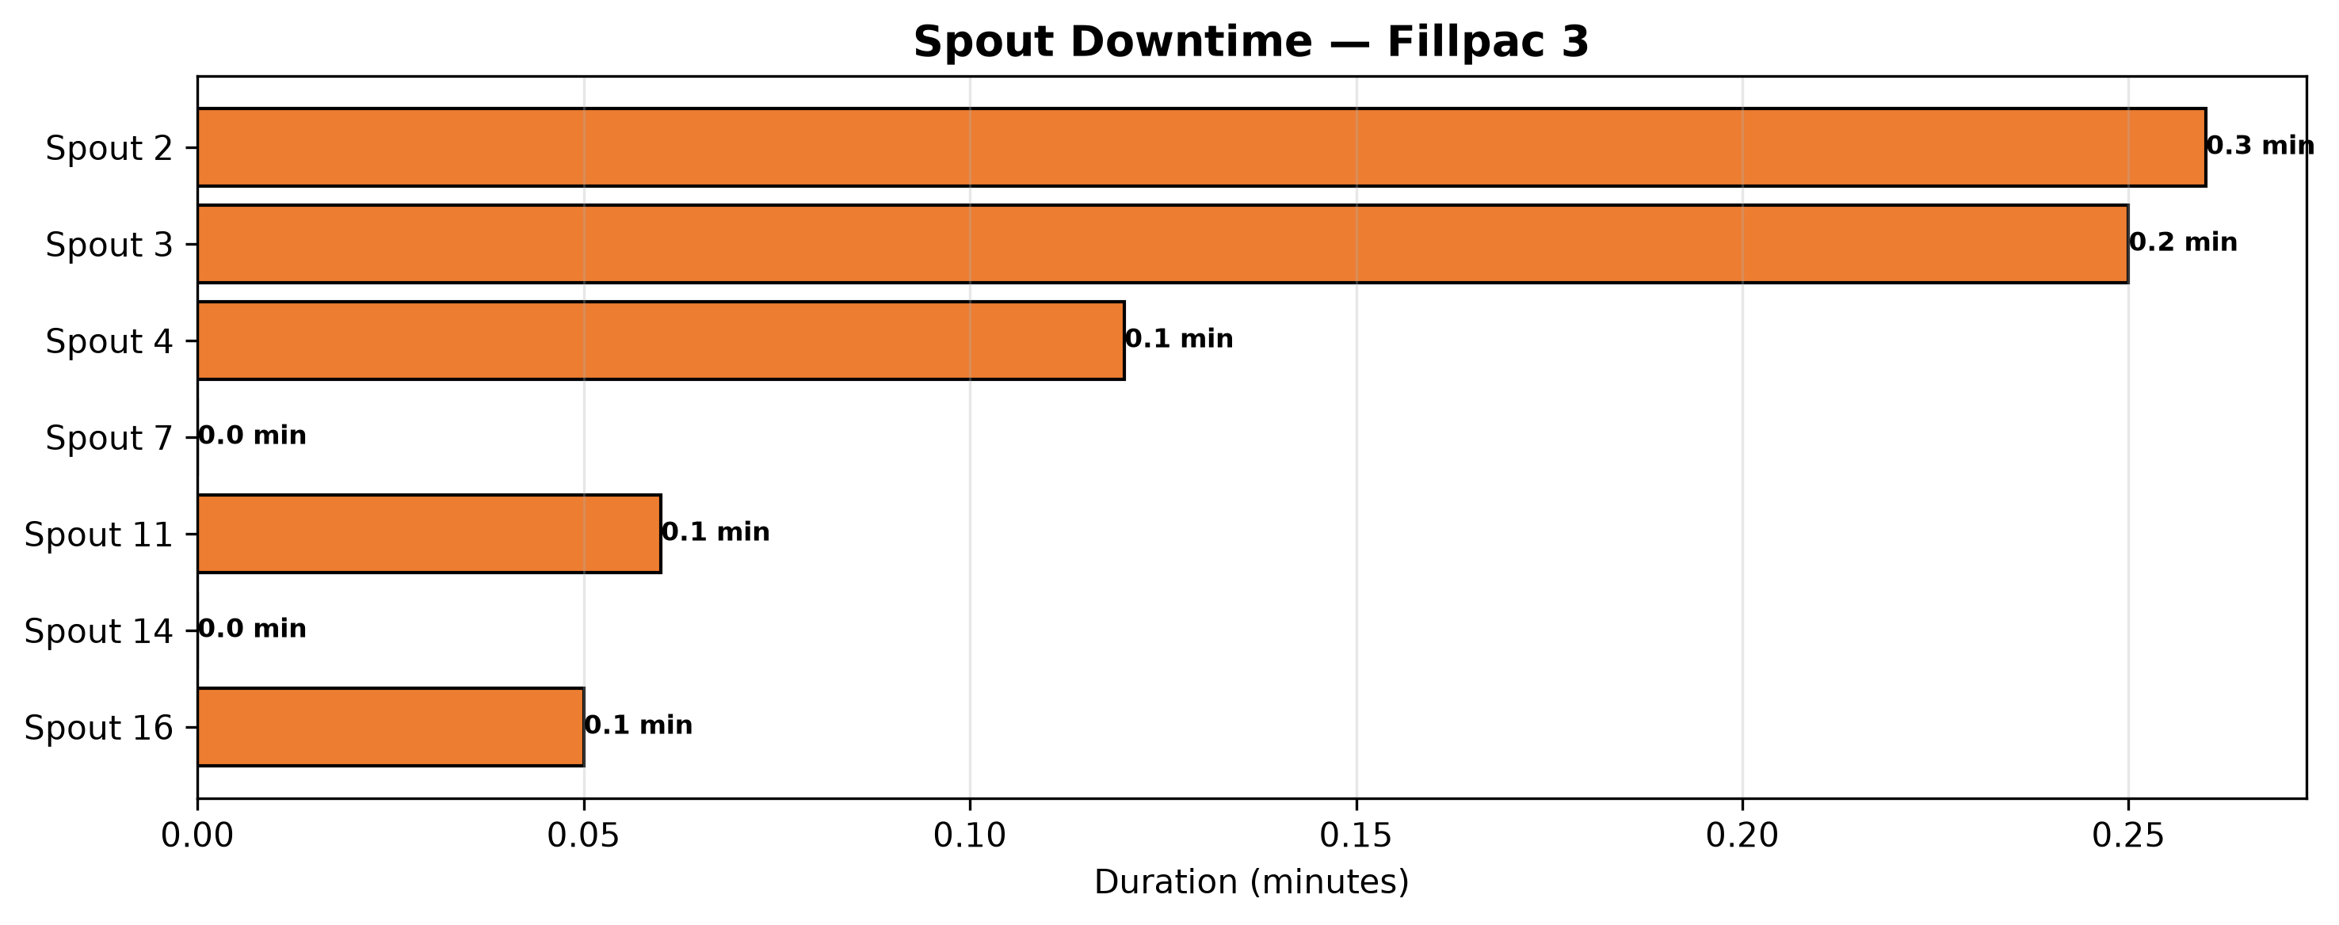
Fillpac 4 (PLC_04)
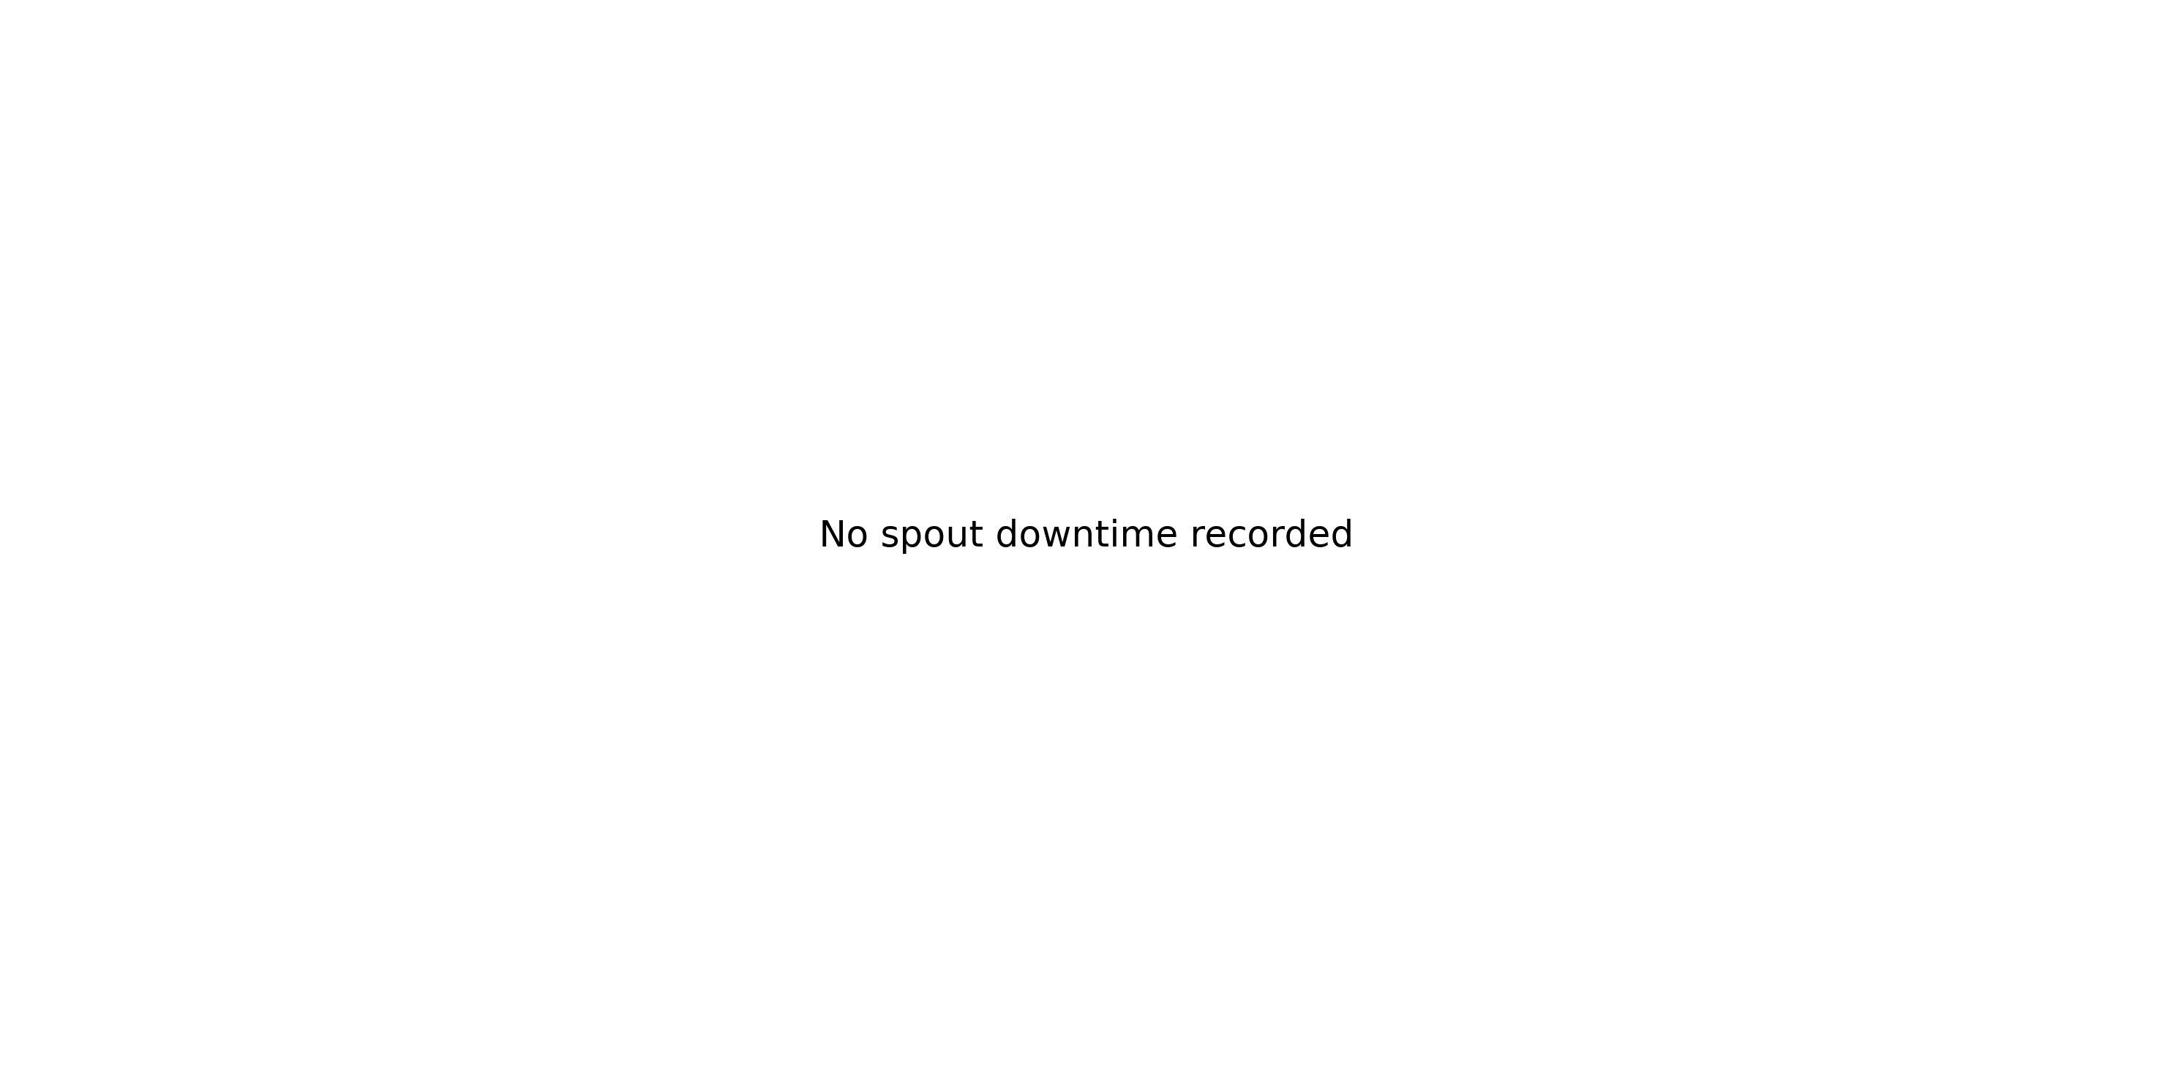

3. Quality, Fault Risk and Improvement Opportunity
The total bad bags are 53 bags, representing a quality loss of 0.15%. The largest contributor to this loss is Burst Bags at 53 bags (100.00% of recorded quality loss).
Quality Loss Mix
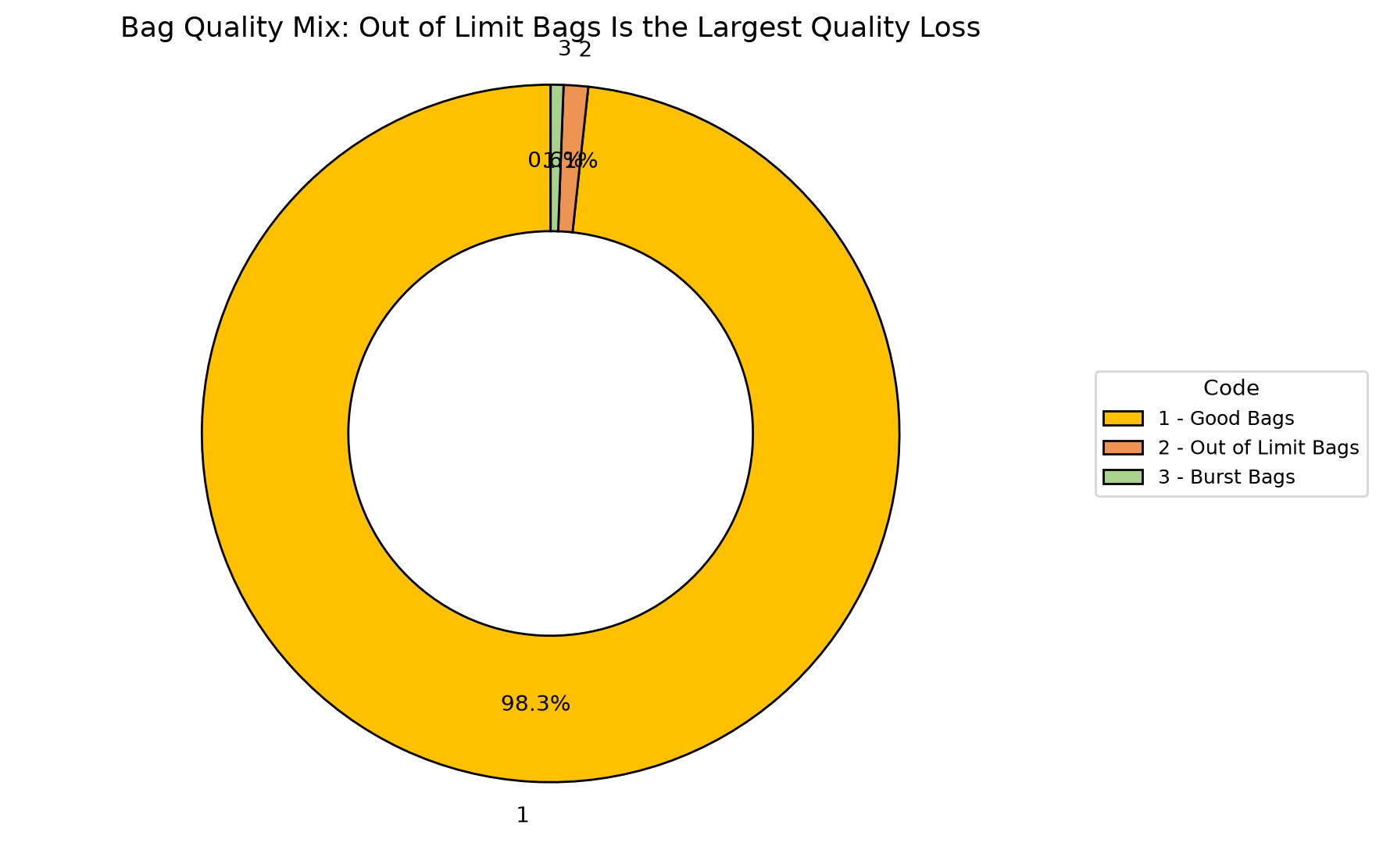
Code | Parameter | Quantity |  | What it means | Control action
1 | Good Bags | 35913 bags |  | Good Bags represents 99.85% of total bags produced this week. | Baseline reference — no corrective action required.
2 | Burst Bags | 53 bags |  | Burst Bags represents 0.15% of total bags produced this week. | Review process records associated with Burst Bags and prioritize corrective action.
Quality insight
Burst Bags account for 53 bags of recorded quality loss.

4. Action Plan: What to Do Next Week
Actions are prioritized from the verified OEE losses and AI-generated recommendations.
Priority | Owner |  | Fault code | Action | Success measure |  | Review frequency
P1 | Maintenance + Production |  | Maintenance + Production | Fillpac 4 Belt Not Running | Reduce Fillpac 4 Belt Not Running downtime (currently 178.81 minutes this week) to recover Availability. |  | Cut Fillpac 4 Belt Not Running downtime versus this week's 178.81 minutes.
P1 | Maintenance + Production |  | Maintenance + Production | Fillpac 2 Belt Not Running | Reduce Fillpac 2 Belt Not Running downtime (currently 147.98 minutes this week) to recover Availability. |  | Cut Fillpac 2 Belt Not Running downtime versus this week's 147.98 minutes.
P1 | Maintenance + Production |  | Maintenance + Production | Fillpac 1 Belt Not Running | Reduce Fillpac 1 Belt Not Running downtime (currently 102.21 minutes this week) to recover Availability. |  | Cut Fillpac 1 Belt Not Running downtime versus this week's 102.21 minutes.
P1 | Maintenance + Production |  | Maintenance + Production | Fillpac 4 Main Drive Stop | Reduce Fillpac 4 Main Drive Stop downtime (currently 15.97 minutes this week) to recover Availability. |  | Cut Fillpac 4 Main Drive Stop downtime versus this week's 15.97 minutes.
If action is completed |  | Expected change |  | Approx. OEE result |  | Management decision
Fillpac 4 Belt Not Running reduced |  | Availability improves first |  | ~67.71% |  | Continue the countermeasure until stable
Fillpac 4 Belt Not Running plus Fillpac 2 Belt Not Running addressed |  | Near-target recovery |  | ~77.14% |  | Shift focus to Burst Bags, the next-largest quality contributor
Availability stable + Burst Bags reduced |  | Target recovery |  | ~85.00% |  | Standardize the new checks into SOP

