Weekly OEE Insight Report - Shree Packer 1, Shree Packer 2, Shree Packer 3, Shree Packer 4Weekly OEE Insight Report - Fillpac 1 & 2 (Packer 1 + Packer 2)
Weekly executive summary with quantified insights, loss drivers and action prioritiesWeekly executive summary with quantified insights, loss drivers and action priorities
Report Week: Week 9
Start Date: 23rd February 2026 End Date: 2nd March 2026



Contents

Section | Main heading | Page
1 | Executive Insight Dashboard | 3
2 | Why OEE Is Going Down | 4
3 | Quality, Fault Risk and Improvement Opportunity | 5
4 | Action Plan: What to Do Next Week | 6

1. Executive Insight Dashboard
This page explains the verified OEE results in plain language for operations, maintenance and management users.
Summary
Fillpac 1 & 2 (Packer 1 + Packer 2) has an OEE of 28.77%, classified as Critical. Performance is the weakest KPI at 29.95%, while Quality remains strongest at 98.28%.
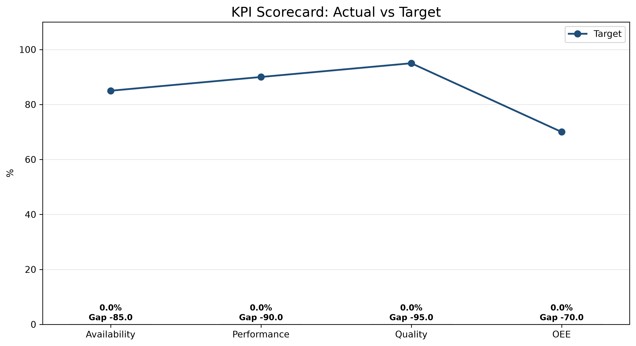
1. Main loss driver  Performance is the weakest KPI at 29.95%. Fillpac 1 Main Drive Stop accounts for 3423.12 minutes of the 0.00 minutes of recorded availability loss this week. | 2. Performance is a concern  Performance is 29.95%. Actual good-bag production was 474,589 bags against 1,584,829 bags expected. | 3. Quality is the strongest KPI  Quality is 98.28%. Biggest quality focus is Out of Limit Bags at 5475 bags (1.13% of total bags produced).
KPI Scorecard vs Industry Standard
KPI | Current | Industry standard | Status
OEE | 0.00% | 85% world-class | OEE for Shree Packer 1, Shree Packer 2, Shree Packer 3, Shree Packer 4 in week 9 is 0.00%, classified as Critical.
Availability | 0.00% | 90%+ | Availability is 0.00%, with 0.00 min of availability loss out of 0.00 min planned.
Performance | 0.00% | 95%+ | Performance is 0.00%.
Quality | 0.00% | 99.9% | Quality is 0.00%, with 0 good bags out of 0 produced.
Week 8 vs Week 9 Comparison
KPI / Parameter | Week 8 | Week 9 | Change | Management insight
OEE | - | 0.00% | - | No prior data
Availability | - | 0.00% | - | No prior data
Performance | - | 0.00% | - | No prior data
Quality | - | 0.00% | - | No prior data
pp = percentage points, the straight difference between two percentages (e.g. 45% to 50% is +5 pp), not a percent change.
pp = percentage points, the straight difference between two percentages (e.g. 45% to 50% is +5 pp), not a percent change.

2. Why OEE Is Going Down

Rank | Fault code / parameter | Loss | Insight from data | Immediate action
Decision point
No downtime contributors were recorded this week.

2.1 Shift Changeover Delay Time - Week 9
Shift changeover delay is a controllable availability loss. Week 9 data show delay time during handover and start-up stabilization.
Shift changeover | Delay time
Shift A Changeover Delay | 0.00 min
Shift B Changeover Delay | 0.00 min
Shift C Changeover Delay | 0.00 min
Total Week 9 delay | 0.00 min

2.2 Spout Downtime by Machine - Week 9
Spout-level downtime highlights which individual spouts are driving each machine's Spout Fault minutes, so maintenance can target the specific spouts responsible rather than the machine as a whole.
Shree Packer 1 (PLC_01)
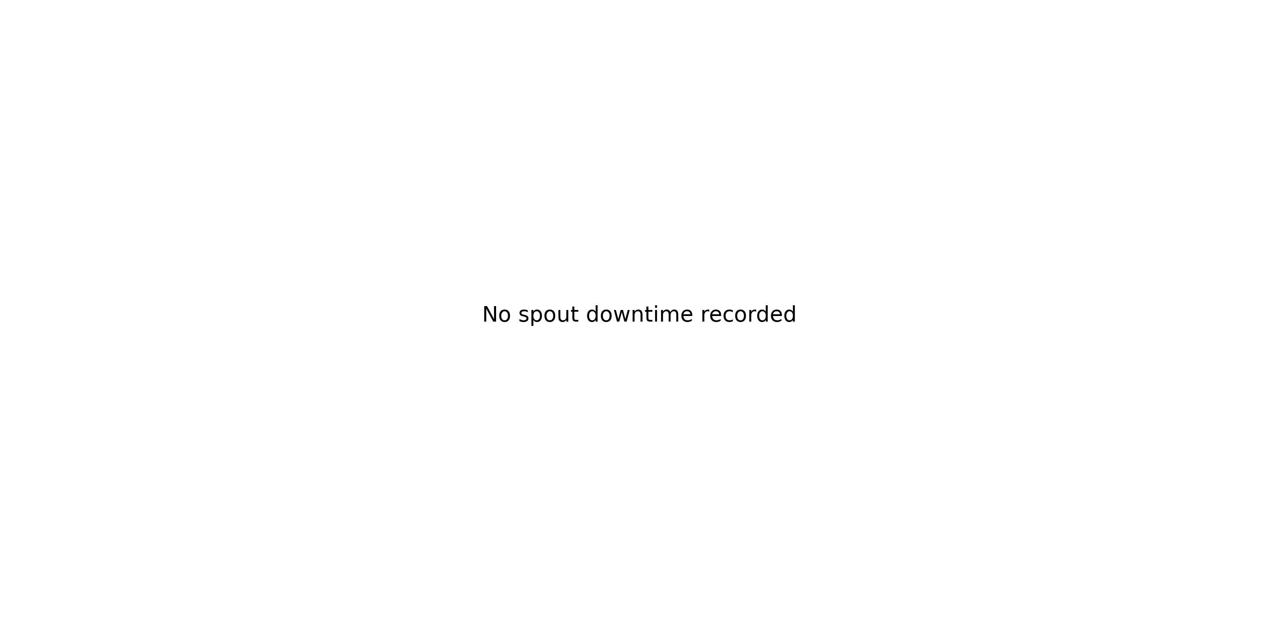
Shree Packer 2 (PLC_02)
Shree Packer 3 (PLC_03)
Shree Packer 4 (PLC_04)

3. Quality, Fault Risk and Improvement Opportunity
Out of Limit Bags is the largest quality-loss cause at 5475.00 bags, out of 8324.00 total quality-loss bags (1.72% of production).
Quality Loss Mix
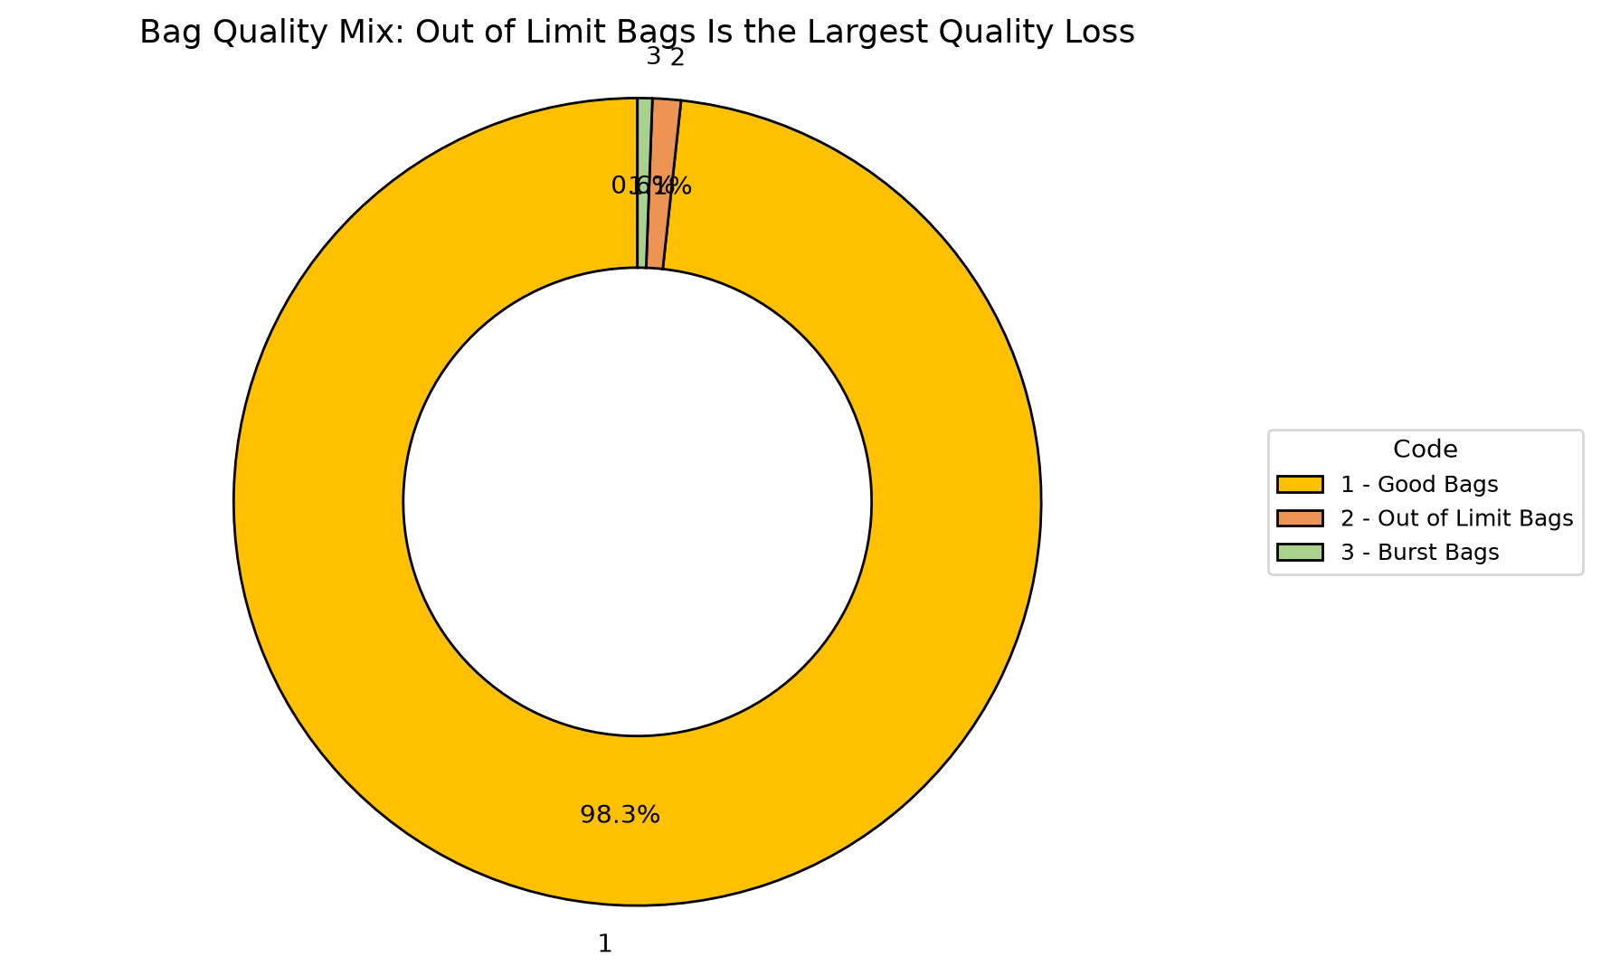
Code | Parameter | Quantity |  | What it means | Control action
Quality insight
No quality loss was recorded this week.

4. Action Plan: What to Do Next Week
Actions are prioritized from the verified OEE losses and AI-generated recommendations.
Priority | Owner |  | Fault code | Action | Success measure |  | Review frequency
If action is completed |  | Expected change |  | Approx. OEE result |  | Management decision
Top loss reduced |  | Availability improves first |  | ~38.25% |  | Continue the countermeasure until stable
Top losses addressed |  | Near-target recovery |  | ~63.75% |  | Shift focus to the next-largest quality contributor
Availability stable + quality improved |  | Target recovery |  | ~85.00% |  | Standardize the new checks into SOP

