Weekly OEE Insight Report - Fillpac 1 & 2 (Packer 1 + Packer 2)
Weekly executive summary with quantified insights, loss drivers and action priorities
Report Week: Week 36
Start Date: 31st August 2026 End Date: 7th September 2026

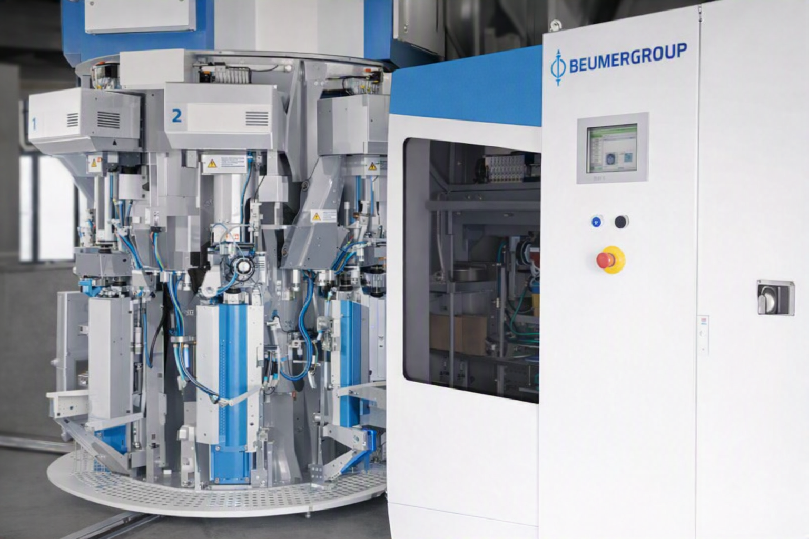

Contents

Section | Main heading | Page
1 | Executive Insight Dashboard | 3
2 | Why OEE Is Going Down | 4
3 | Quality, Fault Risk and Improvement Opportunity | 5
4 | Action Plan: What to Do Next Week | 6

1. Executive Insight Dashboard
This page explains the verified OEE results in plain language for operations, maintenance and management users.
Summary
Fillpac 1 & 2 (Packer 1 + Packer 2) has an OEE of 28.77%, classified as Critical. Performance is the weakest KPI at 29.95%, while Quality remains strongest at 98.28%.
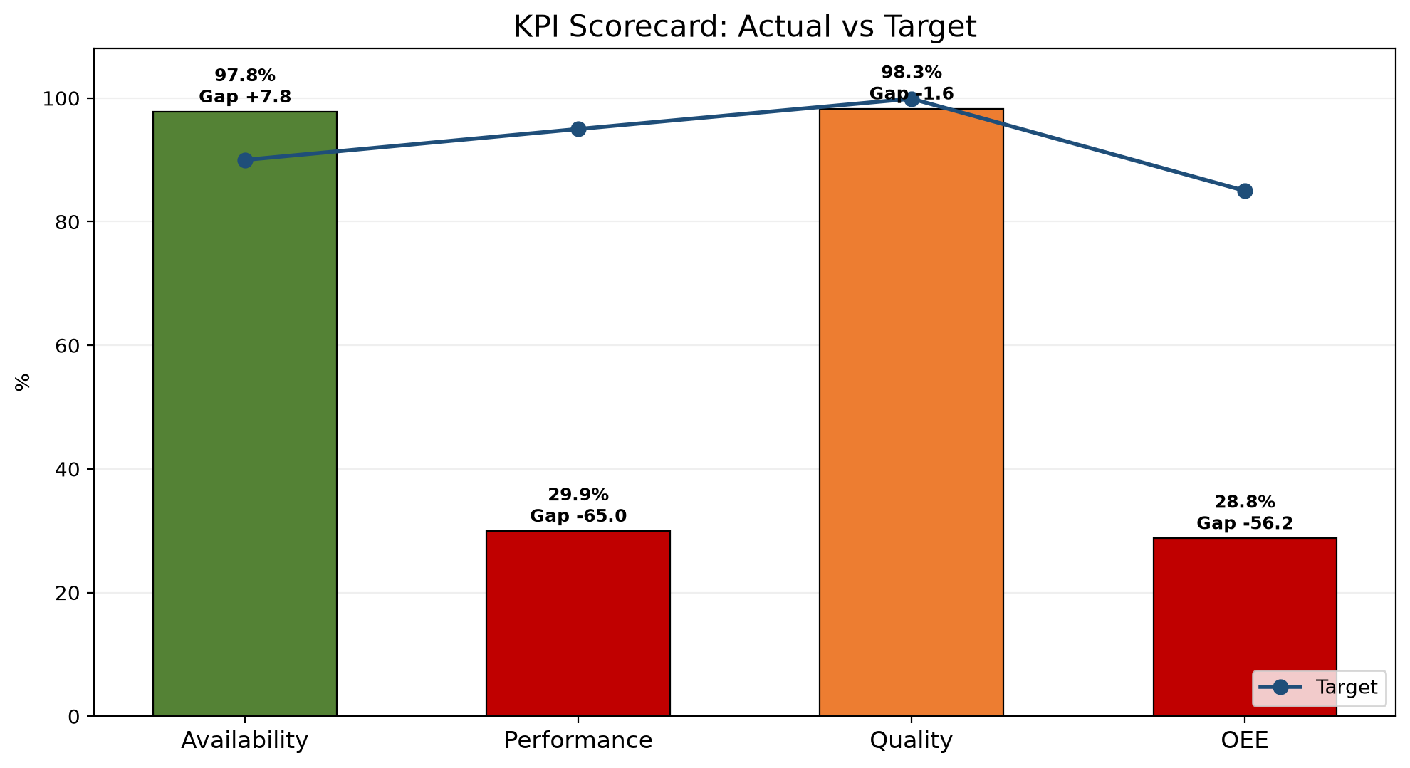
1. Main loss driver  Performance is the weakest KPI at 29.95%. Fillpac 1 Main Drive Stop accounts for 3423.12 minutes of the 0.00 minutes of recorded availability loss this week. | 2. Performance is a concern  Performance is 29.95%. Actual good-bag production was 474,589 bags against 1,584,829 bags expected. | 3. Quality is the strongest KPI  Quality is 98.28%. Biggest quality focus is Out of Limit Bags at 5475 bags (1.13% of total bags produced).
KPI Scorecard vs Industry Standard
KPI | Current | Industry standard | Status
OEE | 28.77% | 85% world-class | OEE for Fillpac 1 & 2 (Packer 1 + Packer 2) in week 36 is 28.77%, classified as Critical.
Availability | 97.78% | 90%+ | Availability is 97.78%, with 0.00 min of availability loss out of 0.00 min planned.
Performance | 29.95% | 95%+ | Performance is 29.95%.
Quality | 98.28% | 99.9% | Quality is 98.28%, with 474,589 good bags out of 482,913 produced.
Week 35 vs Week 36 Comparison
KPI / Parameter | Week 35 | Week 36 | Change | Management insight
OEE | 33.05% | 28.77% | -4.28 pp | Decreased -4.28 pp week over week, still 56.23 points below the 85.00% target.
Availability | 97.80% | 97.78% | -0.02 pp | No Change -0.02 pp week over week, still 0.00 points below the 90.00% target.
Performance | 34.16% | 29.95% | -4.21 pp | Decreased -4.21 pp week over week, still 65.05 points below the 95.00% target.
Quality | 98.92% | 98.28% | -0.64 pp | Decreased -0.64 pp week over week, still 1.62 points below the 99.90% target. Out of Limit Bags remains the main quality-loss driver.
pp = percentage points, the straight difference between two percentages (e.g. 45% to 50% is +5 pp), not a percent change.

2. Why OEE Is Going Down

Rank | Fault code / parameter | Loss | Insight from data | Immediate action
1 | Fillpac 1 Main Drive Stop | 3423.12 min | Fillpac 1 Main Drive Stop accounts for 3423.12 minutes of recorded downtime. | Prioritize investigation of Fillpac 1 Main Drive Stop using available production and equipment records.
2 | Fillpac 2 Main Drive Stop | 1939.82 min | Fillpac 2 Main Drive Stop accounts for 1939.82 minutes of recorded downtime. | Prioritize investigation of Fillpac 2 Main Drive Stop using available production and equipment records.
3 | Fillpac 2 Belt Not Running | 388.32 min | Fillpac 2 Belt Not Running accounts for 388.32 minutes of recorded downtime. | Prioritize investigation of Fillpac 2 Belt Not Running using available production and equipment records.
4 | Fillpac 1 Spout Fault | 115.70 min | Fillpac 1 Spout Fault accounts for 115.70 minutes of recorded downtime. | Prioritize investigation of Fillpac 1 Spout Fault using available production and equipment records.
5 | Fillpac 2 Spout Fault | 82.59 min | Fillpac 2 Spout Fault accounts for 82.59 minutes of recorded downtime. | Prioritize investigation of Fillpac 2 Spout Fault using available production and equipment records.
Decision point
Attack the top two recorded downtime losses first: Fillpac 1 Main Drive Stop and Fillpac 2 Main Drive Stop. Together they account for 5362.94 minutes of downtime. This provides the largest immediate opportunity to recover availability.

2.1 Shift Changeover Delay Time - Week 36
Shift changeover delay is a controllable availability loss. Week 36 data show delay time during handover and start-up stabilization.
Shift changeover | Delay time
Shift A Changeover Delay | 1977.90 min
Shift B Changeover Delay | 82.10 min
Shift C Changeover Delay | 160.40 min
Total Week 36 delay | 2220.40 min

2.2 Spout Downtime by Machine - Week 36
Spout-level downtime highlights which individual spouts are driving each machine's Spout Fault minutes, so maintenance can target the specific spouts responsible rather than the machine as a whole.
Fillpac 1 (PLC_01)
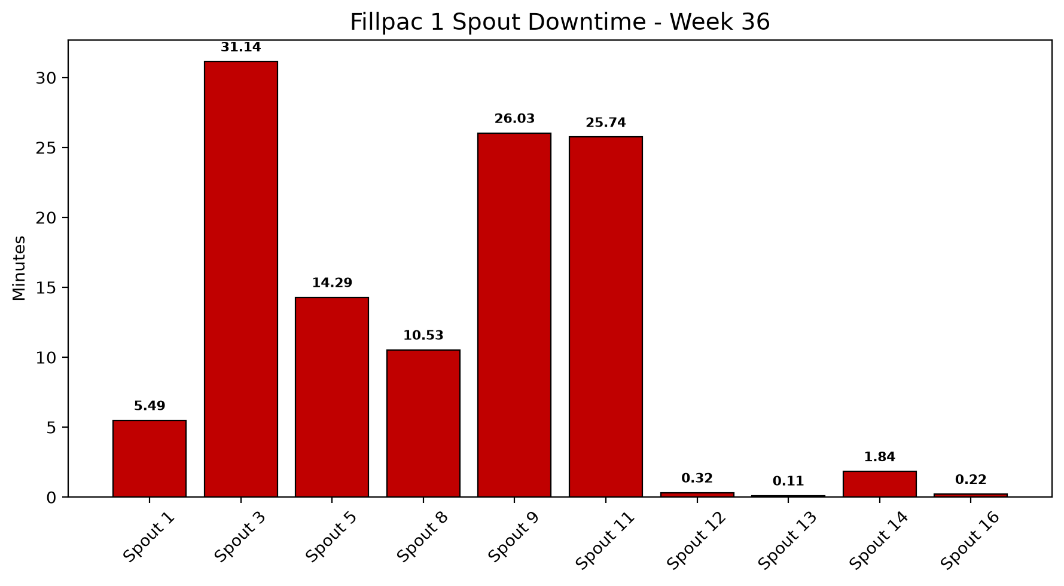
Fillpac 2 (PLC_02)
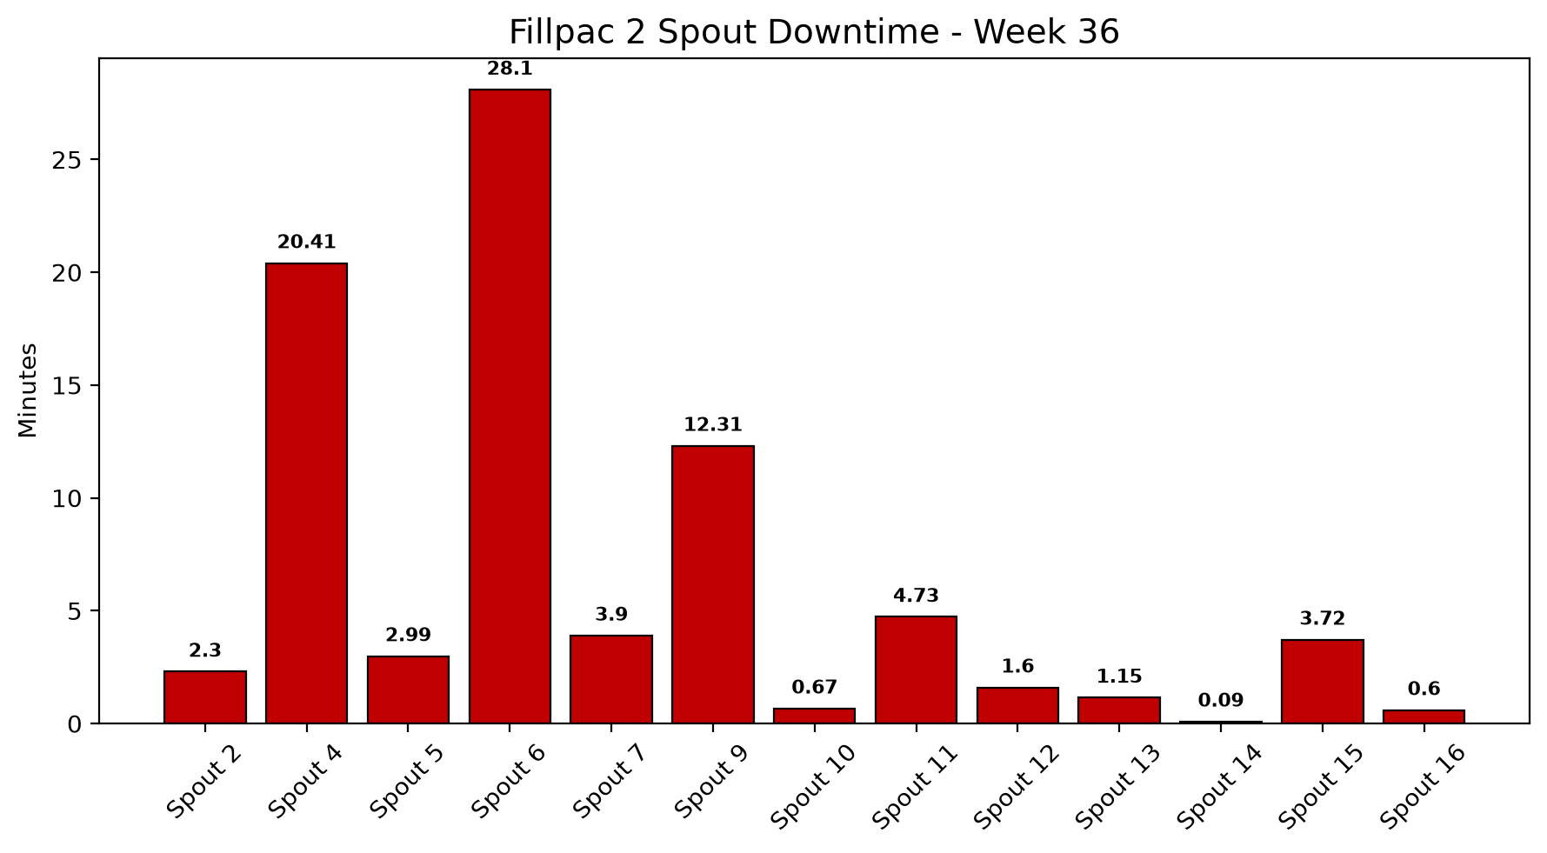

3. Quality, Fault Risk and Improvement Opportunity
Out of Limit Bags is the largest quality-loss cause at 5475.00 bags, out of 8324.00 total quality-loss bags (1.72% of production).
Quality Loss Mix
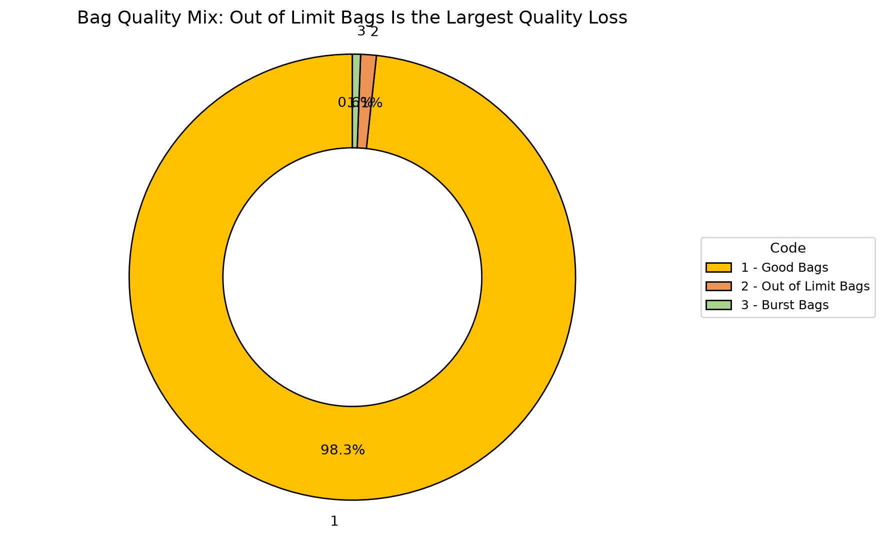
Code | Parameter | Quantity |  | What it means | Control action
1 | Good Bags | 474589 bags |  | Good Bags represents 98.28% of total bags produced this week. | Baseline reference — no corrective action required.
2 | Out of Limit Bags | 5475 bags |  | Out of Limit Bags represents 1.13% of total bags produced this week. | Review process records associated with Out of Limit Bags and prioritize corrective action.
3 | Burst Bags | 2849 bags |  | Burst Bags represents 0.59% of total bags produced this week. | Review process records associated with Burst Bags and prioritize corrective action.
Quality insight
Out of Limit Bags is the largest quality-loss category this week at 5475 bags (1.13% of total bags produced). Addressing it is the next-best lever after availability, since it directly improves dispatchable good bags and reduces customer risk.

4. Action Plan: What to Do Next Week
Actions are prioritized from the verified OEE losses and AI-generated recommendations.
Priority | Owner |  | Fault code | Action | Success measure |  | Review frequency
P1 | Maintenance + Production |  | Maintenance + Production | Fillpac 1 Main Drive Stop | Reduce Fillpac 1 Main Drive Stop downtime (currently 3423.12 minutes this week) to recover Availability. |  | Cut Fillpac 1 Main Drive Stop downtime versus this week's 3423.12 minutes.
P1 | Maintenance + Production |  | Maintenance + Production | Fillpac 2 Main Drive Stop | Reduce Fillpac 2 Main Drive Stop downtime (currently 1939.82 minutes this week) to recover Availability. |  | Cut Fillpac 2 Main Drive Stop downtime versus this week's 1939.82 minutes.
P1 | Maintenance + Production |  | Maintenance + Production | Fillpac 2 Belt Not Running | Reduce Fillpac 2 Belt Not Running downtime (currently 388.32 minutes this week) to recover Availability. |  | Cut Fillpac 2 Belt Not Running downtime versus this week's 388.32 minutes.
P1 | Maintenance + Production |  | Maintenance + Production | Fillpac 1 Spout Fault | Reduce Fillpac 1 Spout Fault downtime (currently 115.70 minutes this week) to recover Availability. |  | Cut Fillpac 1 Spout Fault downtime versus this week's 115.70 minutes.
If action is completed |  | Expected change |  | Approx. OEE result |  | Management decision
Fillpac 1 Main Drive Stop reduced |  | Availability improves first |  | ~54.07% |  | Continue the countermeasure until stable
Fillpac 1 Main Drive Stop plus Fillpac 2 Main Drive Stop addressed |  | Near-target recovery |  | ~70.94% |  | Shift focus to Out of Limit Bags, the next-largest quality contributor
Availability stable + Out of Limit Bags reduced |  | Target recovery |  | ~85.00% |  | Standardize the new checks into SOP

