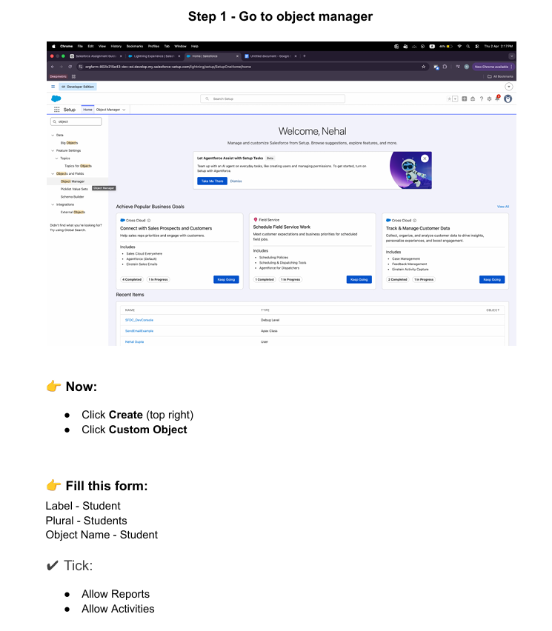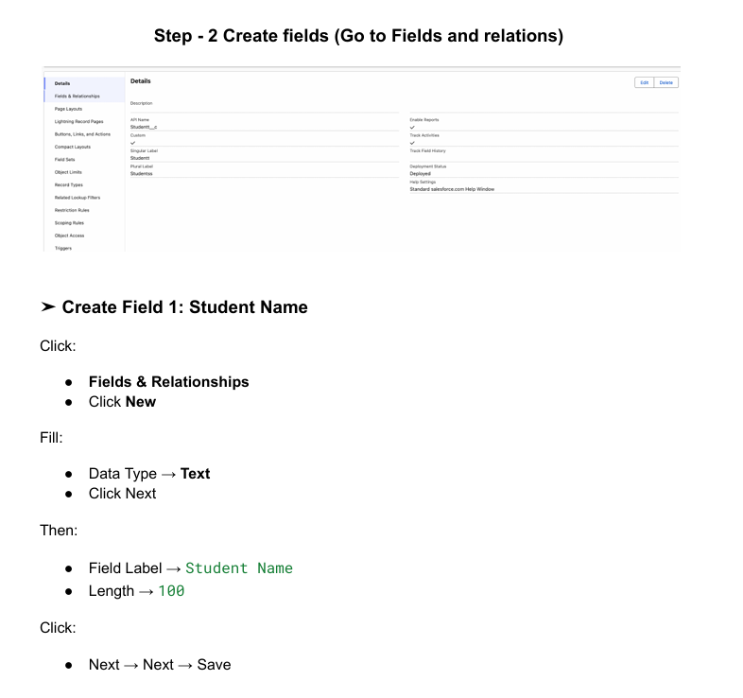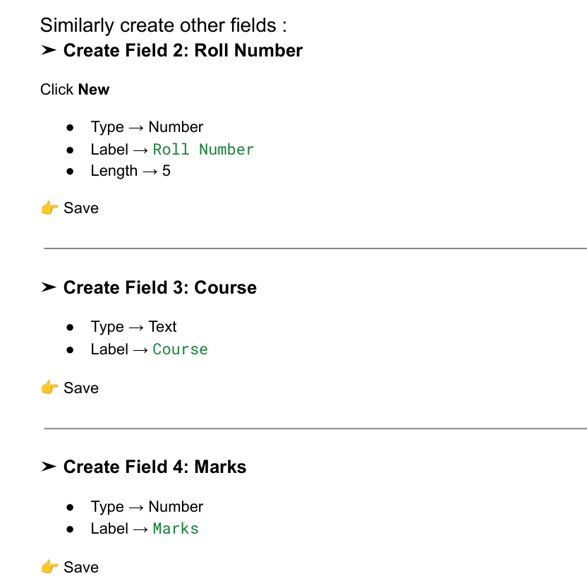

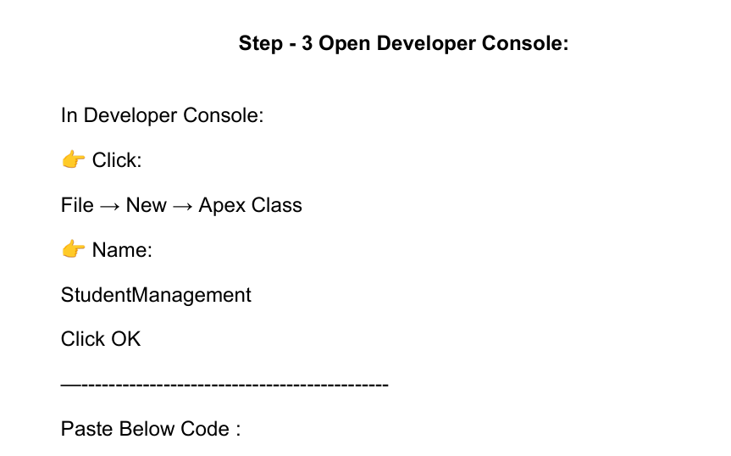

public class StudentManagement {

public Student__c studentRec {get; set;}
public Id editId {get; set;}

public StudentManagement() {

studentRec = new Student__c();
}

// Save or Update Student
public PageReference saveStudent() {

if(editId == null) {

insert studentRec;

ApexPages.addMessage(
new ApexPages.Message(
ApexPages.Severity.CONFIRM,
'Student Added Successfully'
)
);

} else {

update studentRec;

ApexPages.addMessage(
new ApexPages.Message(
ApexPages.Severity.CONFIRM,
'Student Updated Successfully'
)
);

editId = null;
}

studentRec = new Student__c();

return null;
}

// View Students
public List<Student__c> getStudents() {

return [
SELECT Id,
Student_Name__c,
Roll_Number__c,
Class__c,
Mobile_Number__c
FROM Student__c
];
}

// Edit Student
public PageReference editStudent() {

Id sid = ApexPages.currentPage()
.getParameters()
.get('sid');

studentRec = [
SELECT Id,
Student_Name__c,
Roll_Number__c,
Class__c,
Mobile_Number__c
FROM Student__c
WHERE Id = :sid
];

editId = sid;

return null;
}

// Delete Student
public PageReference deleteStudent() {

Id sid = ApexPages.currentPage()
.getParameters()
.get('sid');

Student__c s = [
SELECT Id
FROM Student__c
WHERE Id = :sid
];

delete s;

return null;
}
}

Setup -> home -> Visualforce Page ->new

<apex:page controller="StudentManagement">

<apex:form>

<apex:pageBlock title="Student Record Management">

<apex:pageMessages/>

<apex:pageBlockSection columns="1">

<apex:inputText
value="{!studentRec.Student_Name__c}"
label="Student Name"/>

<apex:inputText
value="{!studentRec.Roll_Number__c}"
label="Roll Number"/>

<apex:inputText
value="{!studentRec.Class__c}"
label="Class"/>

<apex:inputText
value="{!studentRec.Mobile_Number__c}"
label="Mobile Number"/>

</apex:pageBlockSection>

<apex:commandButton
value="Save"
action="{!saveStudent}"/>

</apex:pageBlock>

<br/>

<apex:pageBlock title="Student List">

<apex:pageBlockTable
value="{!students}"
var="s">

<apex:column
value="{!s.Student_Name__c}"
headerValue="Name"/>

<apex:column
value="{!s.Roll_Number__c}"
headerValue="Roll No"/>

<apex:column
value="{!s.Class__c}"
headerValue="Class"/>

<apex:column
value="{!s.Mobile_Number__c}"
headerValue="Mobile"/>

<!-- Edit Button -->
<apex:column headerValue="Edit">

<apex:commandLink
value="Edit"
action="{!editStudent}">

<apex:param
name="sid"
value="{!s.Id}"/>

</apex:commandLink>

</apex:column>

<!-- Delete Button -->
<apex:column headerValue="Delete">

<apex:commandLink
value="Delete"
action="{!deleteStudent}">

<apex:param
name="sid"
value="{!s.Id}"/>

</apex:commandLink>

</apex:column>

</apex:pageBlockTable>

</apex:pageBlock>

</apex:form>

</apex:page>

