INTRODUCTION

The project entitled “Financial Management System " which keep the day by day tally record as a complete banking or financial system. It can keep the information of Saver, Loaner, and Share Holder and also managed it. The exciting part of this project is; it displays the day book, Profit and Loss Acc, Statistical Summary and Interest Information.

SYNOPSIS

The project entitled “Financial Management System " which keep the day by day tally record as a complete banking or financial system. It can keep the information of Saver, Loaner, and Share Holder and also managed it. The exciting part of this project is; it displays the day book, Profit and Loss Acc, Statistical Summary and Interest Information.

AIM

In the existing system the transactions are done only manually but in proposed system we have to computerize all the banking transaction using the software Financial management system.
They are:
Adminestrative Module

ADMINISTRATIVE MODULE

This module is the main module which performs all the main operations in the system. The major operations in the system are:

- Admin login
- Add/Delete/Update/View/Save Employee
- Add/Delete/Update/View/Save Member
- Transaction module
- Expenditure module
- Income module
- Contra module
- Daybook module
- Profit and Loss
- Summary module

SYSTEM STUDY AND ANALISYS

SYSTEM ANALYSIS

System analysis is a process of gathering and interpreting facts, diagnosing problems and the information to recommend improvements on the system. It is a problem solving activity that requires intensive communication between the system users and system developers. System analysis or study is an important phase of any system development process. The system is studied to the minutest detail and analyzed. The system analyst plays the role of the interrogator and dwells deep into the working of the present system. The system is viewed as a whole and the input to the system are identified. The outputs from the organizations are traced to the various processes. System analysis is concerned with becoming aware of the problem, identifying the relevant and decisional variables, analyzing and synthesizing the various factors and determining an optimal or at least a satisfactory solution or program of action.
A detailed study of the process must be made by various techniques like interviews, questionnaires etc. The data collected by these sources must be scrutinized to arrive to a conclusion. The conclusion is an understanding of how the system functions. This system is called the existing system. Now the existing system is subjected to close study and problem areas are identified. The designer now functions as a problem solver and tries to sort out the difficulties that the enterprise faces. The solutions are given as proposals. The proposal is then weighed with the existing system analytically and the best one is selected. The proposal is presented to the user for an endorsement by the user. The proposal is reviewed on user request and suitable changes are made. This is loop that ends as soon as the user is satisfied with proposal.
Preliminary study is the process of gathering and interpreting facts, using the information for further studies on the system. Preliminary study is problem solving activity that requires intensive communication between the system users and system developers. It does various feasibility studies. In these studies a rough figure of the system activities can be obtained, from which the decision about the strategies to be followed for effective system study and analysis can be taken.

EXISTING SYSTEM
In the existing system the transactions are done only manually but in proposed system we have to computerize all the banking transaction using the software financial management system.

2. 1.1 Problems With Existing System

- Lack of security of data.
- More man power.
- Time consuming.
- Consumes large volume of pare work.
- Needs manual calculations.
- No direct role for the higher officials.
- Damage of machines due to lack of attention.

To avoid all these limitations and make the working more accurately the system needs to be computerized.

Proposed System

The aim of proposed system is to develop a system of improved facilities. The proposed system can overcome all the limitations of the existing system. The system provides proper security and reduces the manual work.

2. 2. 1 AdVantages of the Proposed System

The system is very simple in design and to implement. The system requires very low system resources and the system will work in almost all configurations. It has got following features

- Security of data.
- Ensure data accuracy’s.
- Proper control of the higher officials.
- Reduce the damages of the machines.
- Minimize manual data entry.
- Minimum time needed for the various processing.
- Greater efficiency.
- Better service.
- User friendliness and interactive.
- Minimum time required.

2.3. FEASIBILITY STUDY

Feasibility study is made to see if the project on completion will serve the purpose of the organization for the amount of work, effort and the time that spend on it. Feasibility study lets the developer foresee the future of the project and the usefulness. A feasibility study of a system proposal is according to its workability, which is the impact on the organization, ability to meet their user needs and effective use of resources. Thus when a new application is proposed it normally goes through a feasibility study before it is approved for development.

The document provide the feasibility of the project that is being designed and lists various areas that were considered very carefully during the feasibility study of this project such as Technical, Economic and Operational feasibilities. The following are its features:

2.3.1. TECHNICAL FEASIBILITY

The system must be evaluated from the technical point of view first. The assessment of this feasibility must be based on an outline design of the system requirement in the terms of input, output, programs and procedures. Having identified an outline system, the investigation must go on to suggest the type of equipment, required method developing the system, of running the system once it has been designed.

Technical issues raised during the investigation are:

Does the existing technology sufficient for the suggested one?
Can the system expand if developed?

The project should be developed such that the necessary functions and performance are achieved within the constraints. The project is developed within latest technology. Through the technology may become obsolete after some period of time, due to the fact that never version of same software supports older versions, the system may still be used. So there are minimal constraints involved with this project. The system has been developed using Java the project is technically feasible for development.

2.3.2. ECONOMIC FEASIBILITY

The developing system must be justified by cost and benefit. Criteria to ensure that effort is concentrated on project, which will give best, return at the earliest. One of the factors, which affect the development of a new system, is the cost it would require.

The following are some of the important financial questions asked during preliminary investigation:

- The costs conduct a full system investigation.
- The cost of the hardware and software.
- The benefits in the form of reduced costs or fewer costly errors.

Since the system is developed as part of project work, there is no manual cost to spend for the proposed system. Also all the resources are already available, it give an indication of the system is economically possible for development.

2.3.3. BEHAVIORAL FEASIBILITY

This includes the following questions:

- Is there sufficient support for the users?
- Will the proposed system cause harm?

The project would be beneficial because it satisfies the objectives when developed and installed. All behavioral aspects are considered carefully and conclude that the project is behaviorally feasible.

SYSTEM DESIGN

3.1 INTRODUCTION

Design is the first step into the development phase for any engineered product or system. Design is a creative process. A good design is the key to effective system. The term “design” is defined as “the process of applying various techniques and principles for the purpose of defining a process or a system in sufficient detail to permit its physical realization”. It may be defined as a process of applying various techniques and principles for the purpose of defining a device, a process or a system in sufficient detail to permit its physical realization. Software design sits at the technical kernel of the software engineering process and is applied regardless of the development paradigm that is used. The system design develops the architectural detail required to build a system or product. As in the case of any systematic approach, this software too has undergone the best possible design phase fine tuning all efficiency, performance and accuracy levels. The design phase is a transition from a user oriented document to a document to the programmers or database personnel. System design goes through two phases of development: Logical and Physical Design.

LOGICAL DESIGN:
The logical flow of a system and define the boundaries of a system. It includes the following steps:
- Reviews the current physical system – its data flows, file content, volumes , frequencies etc.
- Prepares output specifications – that is, determines the format, content and frequency of reports.
- Prepares input specifications – format, content and most of the input functions.
- Prepares edit, security and control specifications.
- Specifies the implementation plan.
- Prepares a logical design walk through of the information flow, output, input, controls and implementation plan.
- Reviews benefits, costs, target dates and system constraints.

PHYSICAL DESIGN:
Physical system produces the working systems by define the design specifications that tell the programmers exactly what the candidate system must do. It includes the following steps.
- Design the physical system.
- Specify input and output media.
- Design the database and specify backup procedures.
- Design physical information flow through the system and a physical design Walk through.
- Plan system implementation.
- Prepare a conversion schedule and target date.
- Determine training procedures, courses and timetable.
- Devise a test and implementation plan and specify any new hardware/software.
- Update benefits , costs , conversion date and system constraints

Design/Specification activities:

- Concept formulation.
- Problem understanding.
- High level requirements proposals.
- Feasibility study.
- Requirements engineering.
- Architectural design.

MODULE DESIGN

Admin

The Administrator logs in using the admin login. In this module two operations are done. During login the Login and Password is verified with that in the database

INPUT DESIGN

The design of input focuses on controlling the amount of input required, controlling the errors, avoiding delay, avoiding extra steps and keeping the process simple. The input is designed in such a way so that it provides security and ease of use with retaining the privacy. Input Design considered the following things:

  - What data should be given as input?
  - How the data should be arranged or coded?
  - The dialog to guide the operating personnel in providing input.
  - Methods for preparing input validations and steps to follow when error occur.

OBJECTIVES

Input Design is the process of converting a user-oriented description of the input into a computer-based system. This design is important to avoid errors in the data input process and show the correct direction to the management for getting correct information from the computerized system.
It is achieved by creating user-friendly screens for the data entry to handle large volume of data. The goal of designing input is to make data entry easier and to be free from errors. The data entry screen is designed in such a way that all the data manipulates can be performed. It also provides record viewing facilities.
When the data is entered it will check for its validity. Data can be entered with the help of screens. Appropriate messages are provided as when needed so that the user will not be in a maize of instant. Thus the objective of input design is to create an input layout that is easy to follow

OUTPUT DESIGN

A quality output is one, which meets the requirements of the end user and presents the information clearly. In output design it is determined how the information is to be displaced for immediate need and also the hard copy output. It is the most important and direct source information to the user. Efficient and intelligent output design improves the system’s relationship to help user decision-making.

Designing computer output should proceed in an organized, well thought out manner; the right output must be developed while ensuring that each output element is designed so that people will find the system can use easily and effectively. When analysis design computer output, they should :
- Identify the specific output that is needed to meet the requirements.
- Select methods for presenting information.
- Create document, report, or other formats that contain information produced by the system.

3.3 DATABASE DESIGN

A database is an organized mechanism that has the capability of storing information through which a user can retrieve stored information in an effective and efficient manner. The data is the purpose of any database and must be protected.

The database design is a two level process. In the first step, user requirements are gathered together and a database is designed which will meet these requirements as clearly as possible. This step is called Information Level Design and it is taken independent of any individual DBMS.

In the second step, this Information level design is transferred into a design for the specific DBMS that will be used to implement the system in question. This step is called Physical Level Design, concerned with the characteristics of the specific DBMS that will be used. A database design runs parallel with the system design. The organization of the data in the database is aimed to achieve the following two major objectives.
- Data Integrity
- Data independence

Normalization is the process of decomposing the attributes in an application, which results in a set of tables with very simple structure. The purpose of normalization is to make tables as simple as possible. Normalization is carried out in this system for the following reasons.

- To structure the data so that there is no repetition of data , this helps in saving.
- To permit simple retrieval of data in response to query and report request.
- To simplify the maintenance of the data through updates, insertions, deletions.
- To reduce the need to restructure or reorganize data which new application requirements arise.

RELATIONAL DATABASE MANAGEMENT SYSTEM (RDBMS):

A relational model represents the database as a collection of relations. Each relation resembles a table of values or file of records. In formal relational model terminology, a row is called a tuple, a column header is called an attribute and the table is called a relation. A relational database consists of a collection of tables, each of which is assigned a unique name. A row in a tale represents a set of related values.

RELATIONS, DOMAINS & ATTRIBUTES:

A table is a relation. The rows in a table are called tuples. A tuple is an ordered set of n elements. Columns are referred to as attributes. Relationships have been set between every table in the database. This ensures both Referential and Entity Relationship Integrity. A domain D is a set of atomic values. A common method of specifying a domain is to specify a data type from which the data values forming the domain are drawn. It is also useful to specify a name for the domain to help in interpreting its values. Every value in a relation is atomic, that is not decomposable.

RELATIONSHIPS:

Table relationships are established using Key. The two main keys of prime importance are Primary Key & Foreign Key. Entity Integrity and Referential Integrity Relationships can be established with these keys.Entity Integrity enforces that no Primary Key can have null values.Referential Integrity enforces that no Primary Key can have null values.
Referential Integrity for each distinct Foreign Key value, there must exist a matching Primary Key value in the same domain. Other key are Super Key and Candidate Keys.
Relationships have been set between every table in the database. This ensures both Referential and Entity Relationship Integrity.

NORMALIZATION:

As the name implies, it denoted putting things in the normal form. The application developer via normalization tries to achieve a sensible organization of data into proper tables and columns and where names can be easily correlated to the data by the user. Normalization eliminates repeating groups at data and thereby avoids data redundancy which proves to be a great burden on the computer resources. These includes:

- Normalize the data.
- Choose proper names for the tables and columns.
- Choose the proper name for the data.

First Normal Form:

The First Normal Form states that the domain of an attribute must include only atomic values and that the value of any attribute in a tuple must be a single value from the domain of that attribute. In other words 1NF disallows “relations within relations” or “relations as attribute values within tuples”. The only attribute values permitted by 1NF are single atomic or indivisible values.

The first step is to put the data into First Normal Form. This can be donor by moving data into separate tables where the data is of similar type in each table. Each table is given a Primary Key or Foreign Key as per requirement of the project. In this we form new relations for each nonatomic attribute or nested relation. This eliminated repeating groups of data.

A relation is said to be in first normal form if only if it satisfies the constraints that contain the primary key only.

Second Normal Form:

According to Second Normal Form, For relations where primary key contains multiple attributes, no nonkey attribute should be functionally dependent on a part of the primary key.

In this we decompose and setup a new relation for each partial key with its dependent attributes. Make sure to keep a relation with the original primary key and any attributes that are fully functionally dependent on it. This step helps in taking out data that is only dependant on apart of the key.

A relation is said to be in second normal form if and only if it satisfies all the first normal form conditions for the primary key and every non-primary key attributes of the relation is fully dependent on its primary key alone.
Third Normal Form:

According to Third Normal Form, Relation should not have a nonkey attribute functionally determined by another nonkey attribute or by a set of nonkey attributes. That is, there should be no transitive dependency on the primary key.

In this we decompose and set up relation that includes the nonkey attributes that functionally determines other nonkey attributes. This step is taken to get rid of anything that does not depend entirely on the Primary Key.

A relation is said to be in third normal form if only if it is in second normal form and more over the non key attributes of the relation should not be depend on other non key attribute.

tables structure

Table: usertable
Primary Key: username

Field | Data Type | Constraints | Description
username | Char(15) | Primary key | User name
password | Number(9) |  | password

Table: employee_table
Primary Key: emp id

Field | Data Type | Constraints | Description
Emp id | Number(9) | Primary key
name | char(30)
gender | char(30)
DOB | date
Address | char(30)
phone | number
cell | number
joindate | date
department | char(30)

Table: member_table
Primary Key: member id

Field | Data Type | Constraints | Description
member id | Number(9) | Primary key
name | char(30)
gender | char(30)
DOB | date
Address | char(30)
phone | number
cell | number
joindate | date
type | Char(20)
Acc_no | number
fee | Char(20)

Table: bank_table
Primary bank id

Field | Data Type | Constraints | Description
bank id | Number(9) | Primary key
name | char(30)
type | char(30)
date | date
Address | char(30)
total | number
Acc_no | number

Table: expensetrans
Primary Key: emp id

Field | Data Type | Constraints | Description
emp id | Number(9) | Primary key
particular | char(30)
underby | char(30)
date | date
cheque | date
cash | number
bid | number

Table: bankwithdraw
Primary Key: b id

Field | Data Type | Constraints | Description
emp id | Number(9) | Primary key
name | char(30)
Acc_no | Number
date | date
amount | Number

Table: bankdeposit
Primary Key: b id

Field | Data Type | Constraints | Description
emp id | Number(9) | Primary key
name | char(30)
Acc_no | Number
date | date
amount | Number

Table: loan
Primary Key: loan id

Field | Data Type | Constraints | Description
loan id | Number(9) | Primary key
Member id | Number
date | date
amount | Number

Table: incometransaction
Primary Key: emp id

Field | Data Type | Constraints | Description
emp id | Number(9) | Primary key
particulars | Char(30)
date | date

Table: saver
Primary Key: mem id

Field | Data Type | Constraints | Description
mem id | Number(9) | Primary key
total | Number
underby | char(30)
date | date
cheque | date
cash | number
B id | number

Table: capital
Primary Key: amount

Field | Data Type | Constraints | Description
particulars | Char(30)
amount | number

Table: cash
Primary Key: amount

Field | Data Type | Constraints | Description
amount | number

Table: loaninterest
Primary Key: mem id

Field | Data Type | Constraints | Description
mem id | Number(9) | Primary key
amount | Number
date | date

Table: saverinterest
Primary Key: mem id

Field | Data Type | Constraints | Description
mem id | Number(9) | Primary key
amount | Number
date | date

Table: share
Primary Key: mem id

Field | Data Type | Constraints | Description
mem id | Number(9) | Primary key
amount | Number
date | date

Table: loaninterest
Primary Key: mem id

Field | Data Type | Constraints | Description
mem id | Number(9) | Primary key
amount | Number
date | date

SYSTEM DEVELOPEMENT

4.1 SYSTEM SPECIFICATION

HARDWARE REQUIREMENTS

Processor : X86 Compatible processor with 1.7 GHz Clock speed

RAM : 512 MB or more

Hard disk : 20 GB or more

Monitor : VGA/SVGA

Keyboard : 104 Keys

Mouse : 2 buttons/ 3 buttons

SOFTWARE REQUIREMENTS

Operating System : Windows 2000/XP
Front end : Visual Basic 6.0
Back end : MS Access

4.2 SOFTWARE ENVIRONMENT

The Control Properties
Before writing an event procedure for the control to response to a user's input, you have to set certain properties for the control to determine its appearance and how it will work with the event procedure. You can set the properties of the controls in the properties window or at runtime.
Handling some of the common controls

3.2.1 The Text Box
The text box is the standard control for accepting input from the user as well as to display the output. It can handle string (text) and numeric data but not images or pictures. String in a text box can be converted to a numeric data by using the function Val(text). The following example illustrates a simple program that processes the input from the user.
Example 3.1
In this program, two text boxes are inserted into the form together with a few labels. The two text boxes are used to accept inputs from the user and one of the labels will be used to display the sum of two numbers that are entered into the two text boxes. Besides, a command button is also programmed to calculate the sum of the two numbers using the plus operator. The program use creates a variable sum to accept the summation of values from text box 1 and text box 2.The procedure to calculate and to display the output on the label is shown below. The output is shown in Figure 3.2
Private Sub Command1_Click()
‘To add the values in text box 1 and text box 2
Sum = Val(Text1.Text) + Val(Text2.Text)
‘To display the answer on label 1
Label1.Caption = Sum
End Sub

Figure 3.2
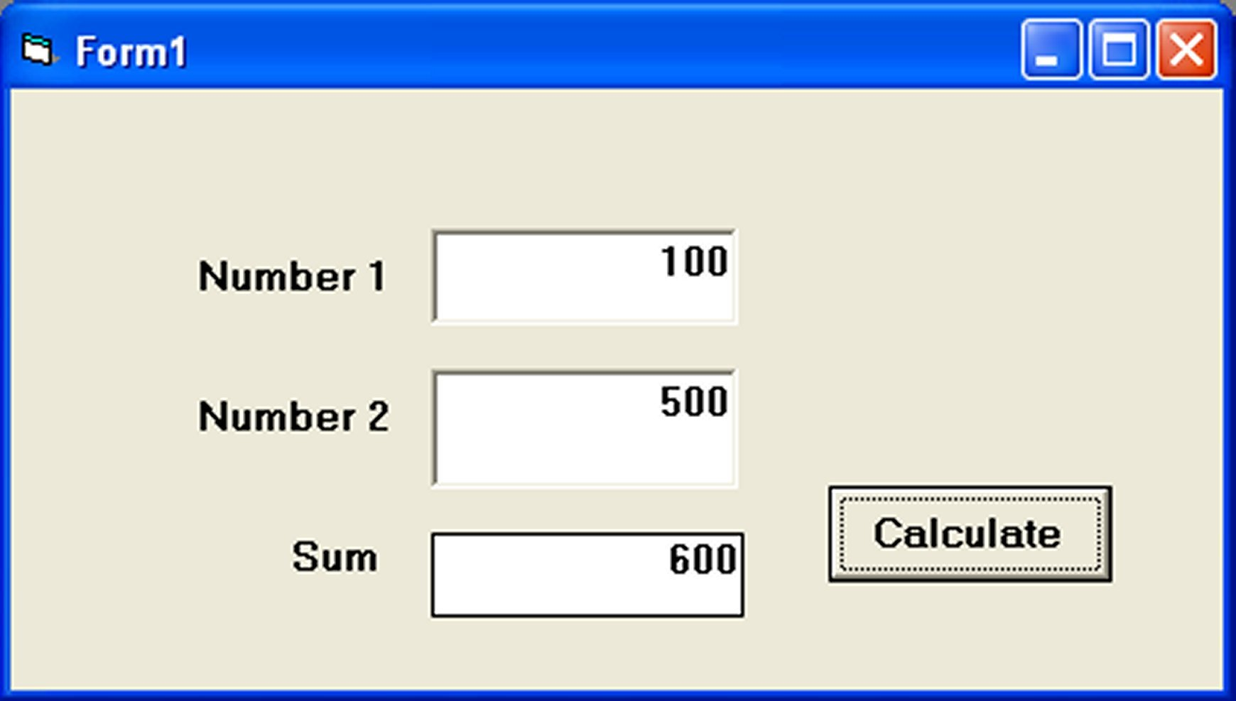

3.2.2 The Label
The label is a very useful control for Visual Basic, as it is not only used to provide instructions and guides to the users, it can also be used to display outputs. One of its most important properties is Caption. Using the syntax label.Caption, it can display text and numeric data . You can change its caption in the properties window and also at runtime. Please refer to Example 3.1 and Figure 3.1 for the usage of label.

3.2.3 The Command Button
The command button is one of the most important controls as it is used to execute commands. It displays an illusion that the button is pressed when the user click on it. The most common event associated with the command button is the Click event, and the syntax for the procedure is
Private Sub Command1_Click ()
Statements
End Sub

3.2.4 The Picture Box
The Picture Box is one of the controls that is used to handle graphics. You can load a picture at design phase by clicking on the picture item in the properties window and select the picture from the selected folder. You can also load the picture at runtime using the LoadPicture method. For example, the statement will load the picture grape.gif into the picture box.
Picture1.Picture=LoadPicture ("C:\VB program\Images\grape.gif")
You will learn more about the picture box in future lessons. The image in the picture box is not resizable.

3.2.5 The Image Box
The Image Box is another control that handles images and pictures. It functions almost identically to the picture box. However, there is one major difference, the image in an Image Box is stretchable, which means it can be resized. This feature is not available in the Picture Box. Similar to the Picture Box, it can also use the LoadPicture method to load the picture. For example, the statement loads the picture grape.gif into the image box.
Image1.Picture=LoadPicture ("C:\VB program\Images\grape.gif")

3.2.6 The List Box
The function of the List Box is to present a list of items where the user can click and select the items from the list. In order to add items to the list, we can use the AddItem method. For example, if you wish to add a number of items to list box 1, you can key in the following statements
Example 3.2

Private Sub Form_Load ( )

List1.AddItem “Lesson1”
List1.AddItem “Lesson2”
List1.AddItem “Lesson3”
List1.AddItem “Lesson4”

End Sub
The items in the list box can be identified by the ListIndex property, the value of the ListIndex for the first item is 0, the second item has a ListIndex 1, and the second item has a ListIndex 2 and so on

3.2.7 The Combo Box
The function of the Combo Box is also to present a list of items where the user can click and select the items from the list. However, the user needs to click on the small arrowhead on the right of the combo box to see the items which are presented in a drop-down list. In order to add items to the list, you can also use the AddItem method. For example, if you wish to add a number of items to Combo box 1, you can key in the following statements
Example 3.3
Private Sub Form_Load ( )
Combo1.AddItem “Item1”
Combo1.AddItem “Item2”
Combo1.AddItem “Item3”
Combo1.AddItem “Item4”
End Sub

3.2.8 The Check Box

The Check Box control lets the user selects or unselects an option. When the Check Box is checked, its value is set to 1 and when it is unchecked, the value is set to 0. You can include the statements Check1.Value=1 to mark the Check Box and Check1.Value=0 to unmark the Check Box, as well as use them to initiate certain actions. For example, the program will change the background color of the form to red when the check box is unchecked and it will change to blue when the check box is checked. You will learn about the conditional statement If….Then….Elesif in later lesson. VbRed and vbBlue are color constants and BackColor is the background color property of the form.

3.2.9 The Option Box

The Option Box control also lets the user selects one of the choices. However, two or more Option Boxes must work together because as one of the Option Boxes is selected, the other Option Boxes will be unselected. In fact, only one Option Box can be selected at one time. When an option box is selected, its value is set to “True” and when it is unselected; its value is set to “False”. In the following example, the shape control is placed in the form together with six Option Boxes. When the user clicks on different option boxes, different shapes will appear. The values of the shape control are 0, 1, and 2,3,4,5 which will make it appear as a rectangle, a square, an oval shape, a rounded rectangle and a rounded square respectively.
Example 3.4
Private Sub Option1_Click ( )
Shape1.Shape = 0
End Sub
Private Sub Option2_Click()
Shape1.Shape = 1
End Sub
Private Sub Option3_Click()
Shape1.Shape = 2
End Sub
Private Sub Option4_Click()
Shape1.Shape = 3
End Sub
Private Sub Option5_Click()
Shape1.Shape = 4
End Sub
Private Sub Option6_Click()
Shape1.Shape = 5
End Sub

3.2.10 The Drive List Box

The Drive ListBox is for displaying a list of drives available in your computer. When you place this control into the form and run the program, you will be able to select different drives from your computer as shown in Figure 3.3

3.2.11 The Directory List Box
The Directory List Box is for displaying the list of directories or folders in a selected drive. When you place this control into the form and run the program, you will be able to select different directories from a selected drive in your computer as shown in Figure 3.4

3.2.12 The File List Box
The File List Box is for displaying the list of files in a selected directory or folder. When you place this control into the form and run the program, you will be able to shown the list of files in a selected directory as shown in Figure 3.5
You can coordinate the Drive List Box, the Directory List Box and the File List Box to search for the files you want. The procedure will be discussed in later lessons.

SYSTEM IMPLEMENTATION AND TESTING

5.1 CODING

Main Form Coding

Option Explicit
Public str As String
Dim cflag As Boolean
Dim mflag As Boolean
Dim flag As Boolean
Dim lstmain1 As ListItem
Dim st As String
Public vbmsgbox As VbMsgBoxResult
Private Sub Check3_Click()
End Sub

Private Sub cal_Click()
Shell ("calc.exe"), vbNormalFocus
End Sub

Private Sub CheckTIncheque_Click()
If CheckTIncheque.value = 1 Then
lblTInBid.Visible = True
combTInBid.Visible = True
txtTIncheque.Visible = True
Else
lblTInBid.Visible = False
combTInBid.Visible = False
txtTIncheque.Visible = False
txtTIncheque.Text = ""
End If
End Sub

Private Sub chkTExCash_Click()
If chkTExCash.value = 1 Then
txtTExCash.Visible = True
Else
txtTExCash.Text = ""
txtTExCash.Visible = False
End If
End Sub

Private Sub chkTExCheque_Click()
If chkTExCheque.value = 1 Then
lblBankid.Visible = True
txtTExCheque.Visible = True
combTExBid.Visible = True
Else
lblBankid.Visible = False
txtTExCheque.Visible = False
combTExBid.Visible = False
txtTExCheque.Text = "
End If
End Sub

Private Sub cmdAbout_Click()
SSTab1.Tab = 9
End Sub

Private Sub cmdAdd_Click()
Form2.Show
Frame1.Visible = False
End Sub

Private Sub cmdBankAdd_Click()
Frame1.Visible = False
Form5.Show
End Sub

Private Sub cmdBankDelete_Click()
Dim a As Integer
st = ListBank.Text
str = "select * from tblBank where b_id=" & st
CustomRecordSetOpen str
With res
While Not .EOF
a = MsgBox("Do you want delete?", vbOKCancel)
If (a = vbOK) Then
.Delete
.MoveNext
.UpdateBatch
MsgBox "Deleted Successfully..."
Else
Exit Sub
End If
Wend
End With
CloseRecordSet
End Sub

Private Sub cmdBankEdit_Click()
cmdBankAdd.Enabled = False
cmdBankDelete.Enabled = False
cmdBankEdit.Enabled = False
cmdBankSave.Visible = True
End Sub

Private Sub cmdBankSave_Click()
st = ListBank.Text
str = "select * from tblBank where b_id=" & st
CustomRecordSetOpen str
With res
!Name = txtBankName.Text
!address = txtBankAddress.Text
!acc_no = txtBankAccNo.Text
!Type = combBankType.Text
!total = txtBankTotal.Text
.UpdateBatch
MsgBox "Successfullt Edited...", vbInformation
End With
CloseRecordSet
cmdBankAdd.Enabled = True
cmdBankDelete.Enabled = True
cmdBankEdit.Enabled = True
cmdBankSave.Visible = False
End Sub

Private Sub cmdBankView_Click()
If flag = False Then
flag = True
st = "tblBank"
CustomRecordSetOpen st
With res
While Not .EOF
ListBank.AddItem !b_id
.MoveNext
Wend
End With
CloseRecordSet
cmdBankDelete.Enabled = True
cmdBankEdit.Enabled = True

Else
flag = False
txtBankAccNo.Text = ""
txtBankAddress.Text = ""
txtBankName.Text = ""
'combBankType.Text = ""
txtBankTotal.Text = ""
ListBank.Clear
cmdBankDelete.Enabled = False
cmdBankEdit.Enabled = False
End If
End Sub

Private Sub cmdCAdd_Click()
Form3.Show
Frame1.Visible = False
End Sub

Private Sub cmdCDelete_Click()
st = ListM.Text
str = "Select name,address,gender,phone,cell,join_date,type,acc_no from member where mmbr_id=" & st
CustomRecordSetOpen str
With res
While Not .EOF
.Delete
.MoveNext
.UpdateBatch
Wend
End With
MsgBox "Member Deleted Successfully..."
CloseRecordSet
txtCName.Text = ""
txtCAddress.Text = ""
txtCAccno.Text = ""
optCFemale.value = False
optCMale.value = False
txtCPhone.Text = ""
txtCCell.Text = ""
'combCType.Text = ""
End Sub

Private Sub cmdCExit_Click()
End Sub

Private Sub cmdCEdit_Click()
cmdCSave.Visible = True
cmdCAdd.Enabled = False
cmdCDelete.Enabled = False
cmdCEdit.Enabled = False
combCType.Enabled = False
txtCAccno.Enabled = False
txtCName.SetFocus
End Sub

Private Sub cmdCSave_Click()
st = ListM.Text
'str = "Select name,address,gender,phone,cell,join_date,type,acc_no from member where mmbr_id=" & st
str = "Select * from member where mmbr_id=" & st
CustomRecordSetOpen str
With res
While Not .EOF
!Name = txtCName.Text
!address = txtCAddress.Text
If optCMale.value = True Then !gender = "Male"
If optCFemale.value = True Then !gender = "Female"
!phone = txtCPhone.Text
!cell = txtCCell.Text
!join_date = dateCDoj.value
!Type = combCType.Text
!acc_no = txtCAccno.Text
.MoveNext
.UpdateBatch
Wend
End With
CloseRecordSet
MsgBox "Info Edit Successfully..."
cmdCSave.Visible = False
cmdCDelete.Enabled = True
cmdCEdit.Enabled = True
cmdCAdd.Enabled = True
combCType.Enabled = True
txtCAccno.Enabled = True
End Sub

Private Sub cmdCView_Click()
cmdCDelete.Enabled = True
cmdCEdit.Enabled = True
If mflag = False Then
mflag = True
st = "Select * from member"
CustomRecordSetOpen st
With res
While Not .EOF
ListM.AddItem !mmbr_id
.MoveNext
Wend
End With
CloseRecordSet
Else
mflag = False
txtCName.Text = ""
txtCAddress.Text = ""
txtCAccno.Text = ""
txtCPhone.Text = ""
txtCCell.Text = ""
optCFemale.value = False
optCMale.value = False
'combCType.Text = ""
ListM.Clear
End If
End Sub

Private Sub cmdDelete_Click()
st = List.Text
CloseRecordSet
str = "Select emp_id,name,gender,dob,address,phone,cell,join_date,department from employee where emp_id=" & st
CustomRecordSetOpen str
With res
While Not .EOF
.Delete
.MoveNext
.UpdateBatch
Wend
End With
vbmsgbox = MsgBox("Successfully Deleted", vbInformation)
txtName.Text = ""
txtAddress.Text = ""
Option1.value = False
Option2.value = False
txtPhone.Text = ""
txtCell.Text = ""
'Combo1.Text = ""
CloseRecordSet
End Sub

Private Sub cmdDepReset_Click()
cmdDepSave.Enabled = True
txtDepName.Text = ""
txtDepAccNo.Text = ""
txtDepAmount.Text = ""
End Sub

Private Sub cmdDepSave_Click()
Dim a As Integer
a = MsgBox("Are You Sure...", vbOKCancel)
If (a = vbOK) Then
st = "Select * from tblbankdeposit"
CustomRecordSetOpen st
With res
.AddNew
!b_id = combDepId.Text
!Name = txtDepName.Text
!Date = dateDep.value
!acc_no = txtDepAccNo.Text
!amount = txtDepAmount.Text
.UpdateBatch
End With
CloseRecordSet
str = combDepId.Text
st = "Select total from tblBank where b_id=" & str
CustomRecordSetOpen st
With res
!total = !total + Val(txtDepAmount.Text)
.UpdateBatch
End With
MsgBox "Successfully Deposited..."
CloseRecordSet
cmdDepSave.Enabled = False
Else
txtDepAmount.SetFocus
Exit Sub
End If
st = "select amount from tblcash "
CustomRecordSetOpen st
If (res.EOF = True And res.BOF = True) Then
With res
.AddNew
!amount = txtDepAmount.Text
.UpdateBatch
End With
CloseRecordSet
Exit Sub
End If
st = "select amount from tblcash "
CustomRecordSetOpen st
With res
!amount = res!amount - Val(txtDepAmount.Text)
.UpdateBatch
End With
CloseRecordSet
End Sub

Private Sub cmdEdit_Click()
cmdSave.Visible = True
cmdDelete.Enabled = False
cmdAdd.Enabled = False
cmdEdit.Enabled = False
txtName.SetFocus
End Sub

Private Sub cmdexit_Click()
Unload Me
End Sub

Private Sub cmdLoan_Click()
txtLoanAmount.Enabled = True
'txtLoanId.Enabled = True
dateloan.Enabled = True
'cmdLoanReset.Enabled = True
cmdLoanSave.Enabled = True
End Sub

Private Sub cmdLoanReset_Click()
'txtLoanId.Text = ""
txtLoanAmount.Text = ""
End Sub

Private Sub cmdLoanSave_Click()
Dim a As Integer
Dim b As String
Dim temp As String
a = MsgBox("Are you sure...", vbOKCancel)
If (a = vbOK) Then
st = "loan"
CustomRecordSetOpen st
With res
.AddNew
!mmbr_id = comboloan.Text
!Date = dateloan
!amount = txtLoanAmount.Text
.UpdateBatch
End With
CloseRecordSet
txtLoanAmount.Text = ""
txtLoanAmount.SetFocus
End If
b = comboloan.Text
st = "select mmbr_id,amount,date from tblLoanInterestReceipt where mmbr_id=" & b
CustomRecordSetOpen st
If (res.EOF = True And res.BOF = True) Then
With res
.AddNew
!mmbr_id = comboloan.Text
' !amount = txtLoanAmount.Text
!Date = dateloan
.UpdateBatch
End With
CloseRecordSet
Exit Sub
End If
st = "select amount from loan where mmbr_id like '" & b & "'"
CustomRecordSetOpen st
txttemp.Text = res!amount
CloseRecordSet
st = "select mmbr_id,amount,date from tblLoanInterestReceipt where mmbr_id=" & b
CustomRecordSetOpen st
With res
!mmbr_id = comboloan.Text
!Date = dateloan
!amount = Val(txtLoanAmount.Text) + Val(txttemp.Text)
.UpdateBatch
MsgBox ("Record saved")
End With
CloseRecordSet
st = "select amount from tblcash "
CustomRecordSetOpen st
If (res.EOF = True And res.BOF = True) Then
With res
.AddNew
!amount = txtLoanAmount.Text
.UpdateBatch
End With
CloseRecordSet
Exit Sub
End If
st = "select amount from tblcash "
CustomRecordSetOpen st
With res
!amount = res!amount - Val(txtLoanAmount.Text)
.UpdateBatch
End With
CloseRecordSet
End Sub

Private Sub cmdPayInterest_Click()
Form4.Show
Form1.Frame1.Visible = False
End Sub

Private Sub cmdSave_Click()
st = List.Text
str = "Select * from employee where emp_id=" & st
CustomRecordSetOpen str
With res
While Not .EOF
!Name = txtName.Text
If Option1.value = True Then !gender = "Male"
If Option2.value = True Then !gender = "Female"
!dob = DTPickeremp.value
!address = txtAddress.Text
!phone = txtPhone.Text
!cell = txtCell.Text
!join_date = DTPicker2.value
!department = Combo1.Text
.MoveNext
.UpdateBatch
Wend
End With
vbmsgbox = MsgBox("Record Edit Successfully...", vbInformation)
cmdSave.Visible = False
cmdAdd.Enabled = True
cmdDelete.Enabled = True
cmdEdit.Enabled = True
CloseRecordSet
End Sub

Private Sub cmdSaving_Click()
Form6.Show
Form1.Frame1.Visible = False
End Sub

Private Sub cmdSavingSave_Click()
Dim a As String
Dim b As String
dbconnection
str = "tblsaver"
CustomRecordSetOpen str
a = MsgBox("Are You Sure!!!", vbOKCancel)
If (a = vbOK) Then
With res
.AddNew
!mmbr_id = cmbsaving.Text
!Date = DTPickerSaving.value
!amount = txtSavingAmount.Text
.UpdateBatch

End With
txtSavingAmount.Text = ""
cmbsaving.SetFocus
st = "select amount from tblcash "
CustomRecordSetOpen st
If (res.EOF = True And res.BOF = True) Then
With res
.AddNew
!amount = txtSavingAmount.Text
.UpdateBatch
End With
CloseRecordSet
Exit Sub
End If
st = "select amount from tblcash "
CustomRecordSetOpen st
With res
!amount = res!amount + Val(txtSavingAmount.Text)
.UpdateBatch
End With
CloseRecordSet
MsgBox "Entry Successfully Recorded..."
Else
Exit Sub
End If
CloseRecordSet
b = cmbsaving.Text
st = "select mmbr_id,amount,date from tblSaverInterest where mmbr_id=" & b
CustomRecordSetOpen st
If (res.EOF = True And res.BOF = True) Then
With res
.AddNew
!mmbr_id = cmbsaving.Text
'!amount = txtSavingAmount.Text
!Date = DTPickerSaving.value
.UpdateBatch
End With
CloseRecordSet
Exit Sub
End If
st = "select amount from tblsaverInterest where mmbr_id like '" & b & "'"
CustomRecordSetOpen st
txttempsaver.Text = res!amount
CloseRecordSet
st = "select mmbr_id,amount,date from tblSaverInterest where mmbr_id=" & b
CustomRecordSetOpen st
With res
!mmbr_id = cmbsaving.Text
!Date = DTPickerSaving.value
!amount = Val(txtSavingAmount.Text) + Val(txttempsaver.Text)
.UpdateBatch
End With
CloseRecordSet
End Sub

Private Sub cmdShare_Click()
txtShareAmount.Enabled = True
'txtShareId.Enabled = True
DTPickerShare.Enabled = True
'cmdShareReset.Enabled = True
cmdShareSave.Enabled = True
End Sub

Private Sub cmdSearchDaybook_Click()
Dim sum As Integer
Dim a As Integer
Dim data As Date
data = DTPicker1.value
MSFlexGrid2.Clear
MSFlexGrid2.Cols = 5
MSFlexGrid2.TextMatrix(0, 1) = "Date"
MSFlexGrid2.TextMatrix(0, 2) = "Particular"
MSFlexGrid2.TextMatrix(0, 3) = "Debit"
MSFlexGrid2.TextMatrix(0, 4) = "Credit"
st = "select date,particular,total from tblExpenseTrans where date like '" & data & "'"
CustomRecordSetOpen st
a = 1
With res
While (Not (.EOF))
MSFlexGrid2.Rows = a + 1
MSFlexGrid2.TextMatrix(a, 1) = !Date
MSFlexGrid2.TextMatrix(a, 2) = !particular
MSFlexGrid2.TextMatrix(a, 3) = !total
MSFlexGrid2.TextMatrix(a, 4) = ""
.MoveNext
a = a + 1
sum = a
Wend
End With
CloseRecordSet
st = "select date,name,amount from tblbankdeposit where date like '" & data & "'"
CustomRecordSetOpen st
a = sum
With res
While (Not (.EOF))
MSFlexGrid2.Rows = a + 1
MSFlexGrid2.TextMatrix(a, 1) = !Date
MSFlexGrid2.TextMatrix(a, 2) = !Name
MSFlexGrid2.TextMatrix(a, 3) = !amount
MSFlexGrid2.TextMatrix(a, 4) = ""
.MoveNext
a = a + 1
sum = a
Wend
End With
CloseRecordSet
st = "select date,name,amount from tblbankwithdraw where date like '" & data & "'"
CustomRecordSetOpen st
a = sum
With res
While (Not (.EOF))
MSFlexGrid2.Rows = a + 1
MSFlexGrid2.TextMatrix(a, 1) = !Date
MSFlexGrid2.TextMatrix(a, 2) = !Name
MSFlexGrid2.TextMatrix(a, 3) = ""
MSFlexGrid2.TextMatrix(a, 4) = !amount
.MoveNext
a = a + 1
sum = a
Wend
End With
CloseRecordSet
st = "select date,mmbr_id,amount from loan where date like '" & data & "'"
CustomRecordSetOpen st
a = sum
With res
While (Not (.EOF))
MSFlexGrid2.Rows = a + 1
MSFlexGrid2.TextMatrix(a, 1) = !Date
MSFlexGrid2.TextMatrix(a, 2) = "Loan Paid To MId " & "(" & !mmbr_id & ")"
MSFlexGrid2.TextMatrix(a, 3) = !amount
MSFlexGrid2.TextMatrix(a, 4) = ""
.MoveNext
a = a + 1
sum = a
Wend
End With
CloseRecordSet
st = "select Date,Particulars,Total from tblIncomeTrans where Date like '" & data & "'"
CustomRecordSetOpen st
a = sum
With res
While (Not (.EOF))
MSFlexGrid2.Rows = a + 1
MSFlexGrid2.TextMatrix(a, 1) = !Date
MSFlexGrid2.TextMatrix(a, 2) = !Particulars
MSFlexGrid2.TextMatrix(a, 3) = ""
MSFlexGrid2.TextMatrix(a, 4) = !total
.MoveNext
a = a + 1
sum = a
Wend
End With
CloseRecordSet
st = "select date,mmbr_id,amount from tblsaver where date like '" & data & "'"
CustomRecordSetOpen st
a = sum
With res
While (Not (.EOF))
MSFlexGrid2.Rows = a + 1
MSFlexGrid2.TextMatrix(a, 1) = !Date
MSFlexGrid2.TextMatrix(a, 2) = "Save Amount Receipt MId by " & "(" & !mmbr_id & ")"
MSFlexGrid2.TextMatrix(a, 3) = ""
MSFlexGrid2.TextMatrix(a, 4) = !amount
.MoveNext
a = a + 1
sum = a
Wend
End With
CloseRecordSet
st = "select date,mmbr_id,amount from tblShare where date like '" & data & "'"
CustomRecordSetOpen st
a = sum
With res
While (Not (.EOF))
MSFlexGrid2.Rows = a + 1
MSFlexGrid2.TextMatrix(a, 1) = !Date
MSFlexGrid2.TextMatrix(a, 2) = "Share Receipt MId by " & "(" & !mmbr_id & ")"
MSFlexGrid2.TextMatrix(a, 3) = ""
MSFlexGrid2.TextMatrix(a, 4) = !amount
.MoveNext
a = a + 1
sum = a
Wend
End With
CloseRecordSet
End Sub

Private Sub cmdShareSave_Click()
Dim a As String
Dim b As String
str = "tblShare"
CustomRecordSetOpen str
a = MsgBox("Are You Sure!!!", vbOKCancel)
If (a = vbOK) Then
With res
.AddNew
!mmbr_id = cmbShare.Text
!Date = DTPickerShare.value
!amount = txtShareAmount.Text
.UpdateBatch
End With
txtShareAmount.Text = ""
txtShareAmount.SetFocus
CloseRecordSet
str = "tblcapital"
CustomRecordSetOpen str
With res
.AddNew
!particular = "mid" & "(" & cmbShare.Text & ")"
'!amount = txtShareAmount.Text
.UpdateBatch
End With
st = "select amount from tblcash "
CustomRecordSetOpen st
If (res.EOF = True And res.BOF = True) Then
With res
.AddNew
!amount = txtShareAmount.Text
.UpdateBatch
End With
CloseRecordSet
Exit Sub
End If
st = "select amount from tblcash "
CustomRecordSetOpen st
With res
!amount = res!amount + Val(txtShareAmount.Text)
.UpdateBatch
End With
CloseRecordSet

MsgBox "Entry Successfully Recorded..."
Else
Exit Sub
End If
End Sub

Private Sub cmdTCapitalSave_Click()
Dim a As String
st = "tblcapital"
CustomRecordSetOpen st
a = MsgBox("Are you sure!!!", vbOKCancel)
If (a = vbOK) Then
With res
.AddNew
!particular = "Cash"
!amount = txtTCapitalAmount.Text
.UpdateBatch
End With
CloseRecordSet
MsgBox "Entry Successfully Recorded..."
txtTCapitalAmount.Text = ""
txtTCapitalAmount.SetFocus
Else
txtTCapitalAmount.Text = ""
txtTCapitalAmount.SetFocus
Exit Sub
End If
st = "select amount from tblcash "
CustomRecordSetOpen st
If (res.EOF = True And res.BOF = True) Then
With res
.AddNew
!amount = txtTCapitalAmount.Text
.UpdateBatch
End With
CloseRecordSet
Exit Sub
End If
st = "select amount from tblcash "
CustomRecordSetOpen st
With res
!amount = res!amount + Val(txtTCapitalAmount.Text)
.UpdateBatch
End With
CloseRecordSet
End Sub

Private Sub cmdTExReset_Click()
txtTExId.Text = ""
txtTExParticular.Text = ""
chkTExCash.value = 0
chkTExCheque.value = 0
txtTExTotal.Text = ""
'combTExUnderBy.Text = ""
txtTExId.SetFocus
End Sub

Private Sub cmdTExSave_Click()
Dim a As Integer
str = "tblExpenseTrans"
CustomRecordSetOpen str
a = MsgBox("Are you Sure!!!", vbOKCancel)
If (a = vbOK) Then
With res
.AddNew
!emp_id = txtTExId.Text
!Date = dateTEx.value
!particular = txtTExParticular.Text
!UnderBy = combTExUnderBy.Text
!Cash = Val(txtTExCash.Text)
!Cheque = Val(txtTExCheque.Text)
!b_id = combTExBid.Text
!total = txtTExTotal.Text
.UpdateBatch
End With
st = "select amount from tblcash "
CustomRecordSetOpen st
If (res.EOF = True And res.BOF = True) Then
With res
.AddNew
!amount = txtTExCash.Text
.UpdateBatch
End With
CloseRecordSet
Exit Sub
End If
st = "select amount from tblcash "
CustomRecordSetOpen st
With res
!amount = res!amount - Val(txtTExCash.Text)
.UpdateBatch
End With
CloseRecordSet
MsgBox "Entry Successfully Recorded..."
Else
Exit Sub
End If
CloseRecordSet
If chkTExCheque.value = 1 Then
str = combTExBid.Text
st = "Select total from tblBank where b_id=" & str
CustomRecordSetOpen st
With res
While Not .EOF
!total = !total - Val(txtTExCheque.Text)
.UpdateBatch
.MoveNext
Wend
End With
CloseRecordSet
Else
Exit Sub
End If
End Sub

Private Sub cmdTInReset_Click()
'txtTExId.Text = ""
txtTExParticular.Text = ""
chkTExCash.value = 0
chkTExCheque.value = 0
txtTExTotal.Text = ""
'combTExUnderBy.Text = ""
txtTExId.SetFocus
txtTIn.Text = ""
txtTInParticular.Text = ""
checkTincash.value = 0
CheckTIncheque.value = 0
txtTInTotal.Text = ""
End Sub

Private Sub cmdTInSave_Click()
Dim a As Integer
str = "tblIncomeTrans"
CustomRecordSetOpen str
a = MsgBox("Are you Sure!!!", vbOKCancel)
If (a = vbOK) Then
With res
.AddNew
!emp_id = combTInEid.Text
!Date = dateTIn.value
!Particulars = txtTInParticular.Text
!UnderBy = combTInUnderBy.Text
!Cash = Val(txtTIncash.Text)
If CheckTIncheque.value = 1 Then
!Cheque = Val(txtTIncheque.Text)
!b_id = combTInBid.Text
End If
'!total = txtTInTotal.Text
.UpdateBatch
End With
st = "select amount from tblcash "
CustomRecordSetOpen st
If (res.EOF = True And res.BOF = True) Then
With res
.AddNew
!amount = txtTIncash.Text
.UpdateBatch
End With
CloseRecordSet
Exit Sub
End If
st = "select amount from tblcash "
CustomRecordSetOpen st
With res
!amount = res!amount + Val(txtTIncash.Text)
.UpdateBatch
End With
CloseRecordSet
MsgBox "Entry Successfully Recorded..."
Else
Exit Sub
End If
CloseRecordSet
If CheckTIncheque.value = 1 Then
str = combTInBid.Text
st = "Select total from tblBank where b_id=" & str
CustomRecordSetOpen st
With res
While Not .EOF
!total = !total + Val(txtTIncheque.Text)
.UpdateBatch
.MoveNext
Wend
End With
CloseRecordSet
Else
Exit Sub
End If
End Sub

Private Sub cmdView_Click()
cmdDelete.Enabled = True
cmdEdit.Enabled = True
Dim row As Integer
If cflag = False Then
cflag = True
CloseRecordSet
CustomRecordSetOpen "select * from employee"
With res
.MoveFirst
While Not .EOF
List.AddItem !emp_id
.MoveNext
Wend
End With
CloseRecordSet
Else
cflag = False
txtName.Text = ""
txtAddress.Text = ""
Option1.value = False
Option2.value = False
txtPhone.Text = ""
txtCell.Text = ""
'Combo1.Text = ""
List.Clear
End If
End Sub

Private Sub cmdWithReset_Click()
txtWithAmount.Text = ""
txtWithName.Text = ""
txtWithAccNo.Text = ""
txtWithAmount.SetFocus
cmdWithSave.Enabled = True
End Sub

Private Sub cmdWithSave_Click()
Dim a As Integer
a = MsgBox("Are You Sure...", vbOKCancel)
If (a = vbOK) Then
st = "Select * from tblbankwithdraw"
CustomRecordSetOpen st
With res
.AddNew
!b_id = combWithId.Text
!Name = txtWithName.Text
!Date = dateWith.value
!acc_no = txtWithAccNo.Text
!amount = txtWithAmount.Text
.UpdateBatch
End With
CloseRecordSet
str = combWithId.Text
st = "Select total from tblBank where b_id=" & str
CustomRecordSetOpen st
With res
!total = !total - Val(txtWithAmount.Text)
.UpdateBatch
End With
MsgBox "Successfully Withdrawn..."
CloseRecordSet
cmdWithSave.Enabled = False
Else
txtWithAmount.SetFocus
Exit Sub
End If
st = "select amount from tblcash "
CustomRecordSetOpen st
If (res.EOF = True And res.BOF = True) Then
With res
.AddNew
!amount = txtWithAmount.Text
.UpdateBatch
End With
CloseRecordSet
Exit Sub
End If
st = "select amount from tblcash "
CustomRecordSetOpen st
With res
!amount = res!amount + Val(txtWithAmount.Text)
.UpdateBatch
End With
CloseRecordSet
End Sub

Private Sub combDepId_Click()
str = combDepId.Text
st = "Select b_id,name,date,acc_no from tblBank where b_id=" & str
CustomRecordSetOpen st
With res
txtDepName = !Name
txtDepAccNo = !acc_no
dateDep.value = !Date
End With
CloseRecordSet
txtDepAmount.SetFocus
End Sub

Private Sub combEx_Click()
flexcaption.Visible = True
Dim intRow As Integer
Dim totalparticular As Integer
Dim a As Integer
str = combEx.Text
flexcaption.Caption = str
st = "select sum(cash)as tot from tblExpenseTrans where underBy like '" & str & "'"
CustomRecordSetOpen st
txtExCashAmount.Text = res!tot
CloseRecordSet
st = "select sum(cheque)as tot from tblExpenseTrans where underBy like '" & str & "'"
CustomRecordSetOpen st
txtExChequeAmount.Text = res!tot
CloseRecordSet
txtExTotal.Text = Val(txtExCashAmount.Text) + Val(txtExChequeAmount.Text)
MSFlexGrid1.Cols = 5
MSFlexGrid1.TextMatrix(0, 1) = "Date"
MSFlexGrid1.TextMatrix(0, 2) = "Particular"
MSFlexGrid1.TextMatrix(0, 3) = "Cash"
MSFlexGrid1.TextMatrix(0, 4) = "Cheque"
st = "select date, particular, cash, cheque from tblExpenseTrans where underBy = '" & str & "'"
' st = "tblExpenseTrans"
CustomRecordSetOpen st
a = 1
With res
' .MoveFirst
While (Not (.EOF))
MSFlexGrid1.Rows = a + 1
MSFlexGrid1.TextMatrix(a, 1) = !Date
MSFlexGrid1.TextMatrix(a, 2) = !particular
MSFlexGrid1.TextMatrix(a, 3) = !Cash
MSFlexGrid1.TextMatrix(a, 4) = !Cheque
.MoveNext
a = a + 1
Wend
'totalparticular = .RecordCount
End With
CloseRecordSet
End Sub

Private Sub combIncome_Click()
lblIncomeflex.Visible = True
Dim intRow As Integer
Dim totalparticular As Integer
Dim a As Integer
str = combIncome.Text
lblIncomeflex.Caption = str
st = "select sum(cash)as tot from tblIncomeTrans where underBy like '" & str & "'"
CustomRecordSetOpen st
txtIncomeCash.Text = res!tot
CloseRecordSet
st = "select sum(cheque)as tot from tblIncomeTrans where underBy like '" & str & "'"
CustomRecordSetOpen st
txtIncomecheque.Text = res!tot
CloseRecordSet
txtIncomeTotal.Text = Val(txtIncomeCash.Text) + Val(txtIncomecheque.Text)
flexIncome.Cols = 5
flexIncome.TextMatrix(0, 1) = "Date"
flexIncome.TextMatrix(0, 2) = "Particular"
flexIncome.TextMatrix(0, 3) = "Cash"
flexIncome.TextMatrix(0, 4) = "Cheque"
st = "select date, particulars, cash, cheque from tblIncomeTrans where underBy = '" & str & "'"
CustomRecordSetOpen st
a = 1
With res

While (Not (.EOF))
flexIncome.Rows = a + 1
flexIncome.TextMatrix(a, 1) = !Date
flexIncome.TextMatrix(a, 2) = !Particulars
flexIncome.TextMatrix(a, 3) = !Cash
flexIncome.TextMatrix(a, 4) = !Cheque
.MoveNext
a = a + 1
Wend
'totalparticular = .RecordCount
End With
CloseRecordSet
End Sub

Private Sub combWithId_Click()
str = combWithId.Text
st = "Select b_id,name,date,acc_no from tblBank where b_id=" & str
CustomRecordSetOpen st
With res
txtWithName = !Name
txtWithAccNo = !acc_no
dateWith.value = !Date
End With
CloseRecordSet
txtWithAmount.SetFocus
End Sub

Private Sub Command3_Click()
Form4.Show
Form1.Frame1.Visible = False
End Sub

Private Sub Command1_Click()
Frame1.Visible = False
Form7.Show
End Sub

Private Sub cu_Click()
Form1.Frame1.Visible = False
Form9.Show
End Sub

Private Sub flexIncome_Click()
flexIncome.Sort = 1
End Sub

Private Sub Form_Load()
dbconnection
SSTab1.Tab = 9
End Sub

Private Sub Form_unLoad(cancel As Integer)
Frame1.Visible = False
End Sub

Private Sub Label82_Click()
Form7.Show
End Sub

Private Sub list_Click()
Dim str As String
str = List.Text
CustomRecordSetOpen "select name,gender,dob,address,phone,cell,join_date,department from employee where emp_id=" & str
With res
txtName.Text = !Name
If !gender = "Male" Then
Option1.value = True
Else
Option2.value = True
End If
DTPickeremp.value = !dob
txtAddress.Text = !address
txtPhone.Text = !phone
txtCell.Text = !cell
DTPicker2.value = !join_date
Combo1.Text = !department
End With
CloseRecordSet
End Sub

Private Sub ListBank_Click()

st = ListBank.Text
str = "Select name,address,date,acc_no,type,total from tblBank where b_id=" & st
CustomRecordSetOpen str
With res
txtBankName.Text = !Name
txtBankAccNo.Text = !acc_no
txtBankAddress.Text = !address
combBankType.Text = !Type
txtBankTotal.Text = !total
End With
CloseRecordSet
End Sub

Private Sub ListM_Click()
st = ListM.Text
str = "Select name,address,gender,phone,cell,join_date,type,acc_no from member where mmbr_id=" & st
CustomRecordSetOpen str
With res
txtCName.Text = !Name
txtCAddress.Text = !address
txtCAccno.Text = !acc_no
If !gender = "Female" Then optCFemale.value = True
If !gender = "Male" Then optCMale.value = True
txtCPhone.Text = !phone
txtCCell.Text = !cell
dateCDoj.value = !join_date
combCType.Text = !Type
End With
CloseRecordSet
End Sub

Private Sub MSFlexGrid1_Click()
MSFlexGrid1.Sort = 1
End Sub

Private Sub note_Click()
Shell ("notepad.exe"), vbNormalFocus
End Sub

Private Sub SSTab1_Click(PreviousTab As Integer)
Dim a As Integer
Dim temp1 As Double
Dim temp2 As Double
st = "select sum(amount) as tot from tblPlLoanInterest"
CustomRecordSetOpen st
txtPlInInterest.Text = res!tot
CloseRecordSet
st = "select sum(interest) as tot from tblPlSaverInterest"
CustomRecordSetOpen st
txtPlExInterest.Text = res!tot
CloseRecordSet
st = "select sum(total) as tot from tblExpenseTrans where underBy like '" & "Indirect Expenses" & "'"
CustomRecordSetOpen st
txtplex.Text = res!tot
CloseRecordSet
st = "select sum(total) as tot from tblExpenseTrans where underBy like '" & "Direct Expenses" & "'"
CustomRecordSetOpen st
txtpldx.Text = res!tot
CloseRecordSet
st = "select sum(total) as tot from tblExpenseTrans where underBy like '" & "Purchase" & "'"
CustomRecordSetOpen st
txtplpam.Text = res!tot
CloseRecordSet
Dim myTotal As Double
Dim flag As Boolean
Dim ttotal As Double
myTotal = 0
flag = False
CustomRecordSetOpen "tblIncomeTrans"
With res
If res.RecordCount <> 0 Then
.MoveFirst
While Not .EOF
If !UnderBy = "Direct Income" Then
myTotal = myTotal + !total
flag = True
End If
.MoveNext
Wend
Else
MsgBox "the table is empty"
CloseRecordSet
Exit Sub
End If
If flag = False Then
txtPlDIn.Text = "0"
Else
txtPlDIn.Text = myTotal
End If
CloseRecordSet
End With
Dim myTotal1 As Double

myTotal1 = 0
flag = False
CustomRecordSetOpen "tblIncomeTrans" With res
If res.RecordCount <> 0 Then
.MoveFirst
While Not .EOF
If !UnderBy = "Indirect Income" Then
myTotal1 = myTotal1 + !total
flag = True
End If
.MoveNext
Wend
Else
MsgBox "the table is empty"
CloseRecordSet
Exit Sub
End If
If flag = False Then
txtPlII.Text = "0"
Else
txtPlII.Text = myTotal1
End If
CloseRecordSet
End With
Dim myTotal2 As Double
'Dim ttotal1 As Double
myTotal2 = 0
flag = False
CustomRecordSetOpen "tblIncomeTrans"
With res
If res.RecordCount <> 0 Then
.MoveFirst
While Not .EOF
If !UnderBy = "Other Income" Then
myTotal2 = myTotal2 + !total
flag = True
End If
.MoveNext
Wend
Else
MsgBox "the table is empty"
CloseRecordSet
Exit Sub
End If
If flag = False Then
txtPlOI.Text = "0"
Else
txtPlOI.Text = myTotal
End If
CloseRecordSet
'Exit Sub
End With
Dim myTotal3 As Double
'Dim ttotal1 As Double
myTotal3 = 0
flag = False
CustomRecordSetOpen "tblIncomeTrans"
With res
If res.RecordCount <> 0 Then
.MoveFirst
While Not .EOF
If !UnderBy = "Sales Income" Then
myTotal3 = myTotal3 + !total
flag = True
End If
.MoveNext
Wend
Else
MsgBox "the table is empty"
CloseRecordSet
Exit Sub
End If
If flag = False Then
txtPlSI.Text = "0"
Else
txtPlSI.Text = myTotal3
End If
CloseRecordSet
'Exit Sub
End With
temp1 = Val(txtplex.Text) + Val(txtpldx.Text) + Val(txtplpam.Text) + Val(txtPlExInterest.Text)
temp2 = Val(txtPlDIn.Text) + Val(txtPlII.Text) + Val(txtPlInInterest.Text) + Val(txtPlOI.Text) + Val(txtPlSI.Text)
txttemppl.Text = temp2 - temp1
If (txttemppl.Text > 0) Then
lblpl.Caption = "Net Profit"
txtpl.Text = txttemppl.Text
Else
lblpl.Caption = "Net Loss"
txtpl.Text = txttemppl.Text
End If
st = "select sum(cash) as cashtot,sum(cheque) as chequetot from tblExpenseTrans"
CustomRecordSetOpen st
txtTtotal.Text = res!cashtot + res!chequetot
CloseRecordSet
st = "select sum(cash) as cashtot,sum(cheque) as chequetot from tblIncomeTrans"
CustomRecordSetOpen st
txtTIn.Text = res!cashtot + res!chequetot
CloseRecordSet
st = "select b_id from tblBank where type='Assets'"
CustomRecordSetOpen st
combTExBid.Clear 'Expenditure Bank Id
combDepId.Clear 'Deposit Bank Id
combWithId.Clear 'Withdraw Bank Id
res.MoveFirst
While Not res.EOF
combTExBid.AddItem res!b_id
combDepId.AddItem res!b_id
combWithId.AddItem res!b_id
res.MoveNext
Wend
CloseRecordSet
st = "Select emp_id from employee"
CustomRecordSetOpen st
combTInEid.Clear
res.MoveFirst
While Not res.EOF
combTInEid.AddItem res!emp_id 'For Income Employee Id
res.MoveNext
Wend
CloseRecordSet
st = "Select emp_id from employee"
CustomRecordSetOpen st
txtTExId.Clear
res.MoveFirst
While Not res.EOF
txtTExId.AddItem res!emp_id 'For Expense Employee Id
res.MoveNext
Wend
CloseRecordSet
'For Expenditure Tab
st = "Select Distinct underBy from tblExpenseTrans"
CustomRecordSetOpen st
combEx.Clear
While Not res.EOF
combEx.AddItem res!UnderBy
res.MoveNext
Wend
CloseRecordSet
'For Income combo groub
st = "Select Distinct UnderBy from tblIncomeTrans"
CustomRecordSetOpen st
combIncome.Clear
While Not res.EOF
combIncome.AddItem res!UnderBy
res.MoveNext
Wend
CloseRecordSet
'for Income Bank Id
st = "select b_id from tblBank where type='Assets'"
CustomRecordSetOpen st
combTInBid.Clear
res.MoveFirst
While Not res.EOF
combTInBid.AddItem res!b_id
res.MoveNext
Wend
CloseRecordSet
st = "select distinct mmbr_id from tblsaver"
CustomRecordSetOpen st
comboloan.Clear
res.MoveFirst
While Not res.EOF
comboloan.AddItem res!mmbr_id
res.MoveNext
Wend
CloseRecordSet
st = "Select mmbr_id from member"
CustomRecordSetOpen st
cmbsaving.Clear
cmbShare.Clear
res.MoveFirst
While Not res.EOF
cmbsaving.AddItem res!mmbr_id
cmbShare.AddItem res!mmbr_id
res.MoveNext
Wend
CloseRecordSet
flex_display
st = "select * from tblPL"
CustomRecordSetOpen st

res!particular = lblpl.Caption
res!amount = txtpl.Text
res.UpdateBatch
CloseRecordSet
End Sub

Private Sub flex_display()
Dim sum As Integer
Dim a As Integer
Dim data As Date
data = DTPicker2.value
MSFlexGrid2.Cols = 5
MSFlexGrid2.TextMatrix(0, 1) = "Date"
MSFlexGrid2.TextMatrix(0, 2) = "Particular"
MSFlexGrid2.TextMatrix(0, 3) = "Debit"
MSFlexGrid2.TextMatrix(0, 4) = "Credit"
st = "select date,particular,total from tblExpenseTrans where date like '" & data & "'"
CustomRecordSetOpen st
a = 1
With res
While (Not (.EOF))
MSFlexGrid2.Rows = a + 1
MSFlexGrid2.TextMatrix(a, 1) = !Date
MSFlexGrid2.TextMatrix(a, 2) = !particular
MSFlexGrid2.TextMatrix(a, 3) = !total
MSFlexGrid2.TextMatrix(a, 4) = ""
.MoveNext
a = a + 1
sum = a
Wend
End With
CloseRecordSet
st = "select date,name,amount from tblbankdeposit where date like '" & data & "'"
CustomRecordSetOpen st
a = sum
With res
While (Not (.EOF))
MSFlexGrid2.Rows = a + 1
MSFlexGrid2.TextMatrix(a, 1) = !Date
MSFlexGrid2.TextMatrix(a, 2) = !Name
MSFlexGrid2.TextMatrix(a, 3) = !amount
MSFlexGrid2.TextMatrix(a, 4) = ""
.MoveNext
a = a + 1
sum = a
Wend
End With
CloseRecordSet
st = "select date,name,amount from tblbankwithdraw where date like '" & data & "'"
CustomRecordSetOpen st
a = sum
With res
While (Not (.EOF))
MSFlexGrid2.Rows = a + 1
MSFlexGrid2.TextMatrix(a, 1) = !Date
MSFlexGrid2.TextMatrix(a, 2) = !Name
MSFlexGrid2.TextMatrix(a, 3) = ""
MSFlexGrid2.TextMatrix(a, 4) = !amount
.MoveNext
a = a + 1
sum = a
Wend
End With
CloseRecordSet
st = "select date,mmbr_id,amount from loan where date like '" & data & "'"
CustomRecordSetOpen st
a = sum
With res
While (Not (.EOF))
MSFlexGrid2.Rows = a + 1
MSFlexGrid2.TextMatrix(a, 1) = !Date
MSFlexGrid2.TextMatrix(a, 2) = "Loan Paid To MId " & "(" & !mmbr_id & ")"
MSFlexGrid2.TextMatrix(a, 3) = !amount
MSFlexGrid2.TextMatrix(a, 4) = ""
.MoveNext
a = a + 1
sum = a
Wend
End With
CloseRecordSet
st = "select Date,Particulars,Total from tblIncomeTrans where Date like '" & data & "'"
CustomRecordSetOpen st
a = sum
With res
While (Not (.EOF))
MSFlexGrid2.Rows = a + 1
MSFlexGrid2.TextMatrix(a, 1) = !Date
MSFlexGrid2.TextMatrix(a, 2) = !Particulars
MSFlexGrid2.TextMatrix(a, 3) = ""
MSFlexGrid2.TextMatrix(a, 4) = !total
.MoveNext
a = a + 1
sum = a
Wend
End With
CloseRecordSet
st = "select date,mmbr_id,amount from tblsaver where date like '" & data & "'"
CustomRecordSetOpen st
a = sum
With res
While (Not (.EOF))
MSFlexGrid2.Rows = a + 1
MSFlexGrid2.TextMatrix(a, 1) = !Date
MSFlexGrid2.TextMatrix(a, 2) = "Save Amount Receipt MId by " & "(" & !mmbr_id & ")"
MSFlexGrid2.TextMatrix(a, 3) = ""
MSFlexGrid2.TextMatrix(a, 4) = !amount
.MoveNext
a = a + 1
sum = a
Wend
End With
CloseRecordSet
st = "select date,mmbr_id,amount from tblShare where date like '" & data & "'"
CustomRecordSetOpen st
a = sum
With res
While (Not (.EOF))
MSFlexGrid2.Rows = a + 1
MSFlexGrid2.TextMatrix(a, 1) = !Date
MSFlexGrid2.TextMatrix(a, 2) = "Share Receipt MId by " & "(" & !mmbr_id & ")"
MSFlexGrid2.TextMatrix(a, 3) = ""
MSFlexGrid2.TextMatrix(a, 4) = !amount
.MoveNext
a = a + 1
sum = a
Wend
End With
CloseRecordSet
End Sub

Private Sub Timer1_Timer()
dateTEx = Date
End Sub

Private Sub Timer2_Timer()
dateTIn = Date
End Sub

Private Sub Timer3_Timer()
DTPicker2 = Date
End Sub

Private Sub Timer4_Timer()
DTPickerdaybook = Date
End Sub

Private Sub Timer5_Timer()
DTPickerSaving = Date
End Sub

Private Sub Timer6_Timer()
DTPickerShare = Date
End Sub

Private Sub Timer7_Timer()
dateloan = Date
End Sub

Private Sub Timer8_Timer()
dateWith = Date
End Sub

Private Sub Timer9_Timer()
dateDep = Date
End Sub

Private Sub txtLoanAmount_LostFocus()
'Dim a As String
'a = comboloan.Text
st = "select sum(amount) as total from tblsaver where mmbr_id like '" & comboloan.Text & "'"
CustomRecordSetOpen st
'MsgBox "Hello"
Text1.Text = res!total
If (Val(Text1.Text) < 20000) Then
MsgBox "Sorry You haven't Access", vbInformation
txtLoanAmount.Text = ""
comboloan.SetFocus
CloseRecordSet
Exit Sub
Else
cmdLoanSave.SetFocus
End If
CloseRecordSet
End Sub

Private Sub txtShareAmount_LostFocus()
'Dim a As Double
'a = txtShareAmount.Text
If (Val(txtShareAmount.Text) < 300) Or (Val(txtShareAmount.Text) > 5000) Then
MsgBox "Enter amount between 300 and 5000", vbInformation
txtShareAmount.Text = ""
'txtShareAmount.SetFocus
Exit Sub
End If
End Sub

Private Sub txtTExCheque_LostFocus()

st = combTExBid.Text
str = "Select total from tblBank where b_id= " & st
CustomRecordSetOpen str
If Val(txtTExCheque.Text) <= res!total Then
MsgBox "Amount is Available...", vbInformation
txtTExTotal = Val(txtTExCash.Text) + Val(txtTExCheque.Text)
Else
MsgBox "Amount is not availble"
txtTExCheque = ""
txtTExCheque.SetFocus
End If
CloseRecordSet
End Sub

Private Sub txtTIncheque_LostFocus()
txtTExTotal = Val(txtTExCash.Text) + Val(txtTExCheque.Text)
txtTInTotal.Text = Val(txtTIncash.Text) + Val(txtTIncheque.Text)
End Sub

5.2 SYSTEM IMPLEMENTATION AND TESTING

Implementation is the stage of the project where the theoretical design is turned into a working system. It can be considered to be the most crucial stage in achieving a successful new system gaining the users confidence that the new system will work and will be effective and accurate. It is primarily concerned with user training and documentation. Conversion usually takes place about the same time the user is being trained or later. Implementation simply means convening a new system design into operation, which is the process of converting a new revised system design into an operational one.

5.2.1. System Testing

Software Testing is the process of executing software in a controlled manner, in order to answer the question - Does the software behave as specified?. Software testing is often used in association with the terms verification and validation. Validation is the checking or testing of items, includes software, for conformance and consistency with an associated specification. Software testing is just one kind of verification, which also uses techniques such as reviews, analysis, inspections, and walkthroughs. Validation is the process of checking that what has been specified is what the user actually wanted.

Validation : Are we doing the right job?
Verification : Are we doing the job right?

Software testing should not be confused with debugging. Debugging is the process of analyzing and localizing bugs when software does not behave as expected. Although the identification of some bugs will be obvious from playing with the software, a methodical approach to software testing is a much more thorough means for identifying bugs. Debugging is therefore an activity which supports testing, but cannot replace testing.
Other activities which are often associated with software testing are static analysis and dynamic analysis. Static analysis investigates the source code of software, looking for problems and gathering metrics without actually executing the code. Dynamic analysis

looks at the behavior of software while it is executing, to provide information such as execution traces, timing profiles, and test coverage information.

Testing is a set of activity that can be planned in advanced and conducted systematically. Testing begins at the module level and work towards the integration of entire computers based system. Nothing is complete without testing, as it vital success of the system testing objectives, there are several rules that can serve as testing objectives. They are

Testing is a process of executing a program with the intend of finding an error.A good test case is one that has high possibility of finding an undiscovered error.A successful test is one that uncovers an undiscovered error.

If a testing is conducted successfully according to the objectives as stated above, it would uncovered errors in the software also testing demonstrate that the software function appear to be working according to the specification, that performance requirement appear to have been met.

There are three ways to test program.
- For correctness
- For implementation efficiency
- For computational complexity

Test for correctness are supposed to verify that a program does exactly what it was designed to do. This is much more difficult than it may at first appear, especially for large programs.

TEST PLAN

A test plan implies a series of desired course of action to be followed in accomplishing various testing methods. The Test Plan acts as a blue print for the action that is to be followed. The software engineers create a computer program, its documentation and related data structures. The software developers is always responsible for testing the individual units of the programs, ensuring that each performs the function for which it was designed. There is an independent test group (ITG) which is to remove the inherent problems associated with letting the builder to test the thing that has been built. The specific objectives of testing should be stated in measurable terms. So that the mean time to failure, the cost to find and fix the defects, remaining defect density or frequency of occurrence and test work-hours per regression test all should be stated within the test plan.

The levels of testing include:

- Unit testing
- Integration Testing
- Data validation Testing
- Output Testing

UNIT TESTING

Unit testing focuses verification effort on the smallest unit of software design – the software component or module. Using the component level design description as a guide, important control paths are tested to uncover errors within the boundary of the module. The relative complexity of tests and uncovered scope established for unit testing. The unit testing is white-box oriented, and step can be conducted in parallel for multiple components. The modular interface is tested to ensure that information properly flows into and out of the program unit under test. The local data structure is examined to ensure that data stored temporarily maintains its integrity during all steps in an algorithm’s execution. Boundary conditions are tested to ensure that all statements in a module have been executed at least once. Finally, all error handling paths are tested.

Tests of data flow across a module interface are required before any other test is initiated. If data do not enter and exit properly, all other tests are moot. Selective testing of execution paths is an essential task during the unit test. Good design dictates that error conditions be anticipated and error handling paths set up to reroute or cleanly terminate processing when an error does occur. Boundary testing is the last task of unit testing step. Software often fails at its boundaries.

Unit testing was done in Sell-Soft System by treating each module as separate entity and testing each one of them with a wide spectrum of test inputs. Some flaws in the internal logic of the modules were found and were rectified.

INTEGRATION TESTING

Integration testing is systematic technique for constructing the program structure while at the same time conducting tests to uncover errors associated with interfacing. The objective is to take unit tested components and build a program structure that has been dictated by design. The entire program is tested as whole. Correction is difficult because isolation of causes is complicated by vast expanse of entire program. Once these errors are corrected, new ones appear and the process continues in a seemingly endless loop.

After unit testing in Sell-Soft System all the modules were integrated to test for any inconsistencies in the interfaces. Moreover differences in program structures were removed and a unique program structure was evolved.

VALIDATION TESTING OR SYSTEM TESTING

This is the final step in testing. In this the entire system was tested as a whole with all forms, code, modules and class modules. This form of testing is popularly known as Black Box testing or System testing.

Black Box testing method focuses on the functional requirements of the software. That is, Black Box testing enables the software engineer to derive sets of input conditions that will fully exercise all functional requirements for a program.

Black Box testing attempts to find errors in the following categories; incorrect or missing functions, interface errors, errors in data structures or external data access, performance errors and initialization errors and termination errors.

OUTPUT TESTING OR USER ACCEPTANCE TESTING

The system considered is tested for user acceptance; here it should satisfy the firm’s need. The software should keep in touch with perspective system; user at the time of developing and making changes whenever required. This done with respect to the following points

- Input Screen Designs,
- Output Screen Designs,
- Online message to guide the user and the like.

The above testing is done taking various kinds of test data. Preparation of test data plays a vital role in the system testing. After preparing the test data, the system under study is tested using that test data. While testing the system by which test data errors are again uncovered and corrected by using above testing steps and corrections are also noted for future use.

5.3. Training

Once the system is successfully developed the next important step is to ensure that the administrators are well trained to handle the system. This is because the success of a system invariably depends on how they are operated and used. The implementation depends upon the right people being at the right place at the right time. Education involves creating the right atmosphere and motivating the user. The administrators are familiarized with the run procedures of the system, working through the sequence of activities on an ongoing basis.

Implementation is the state in the project where the theoretical design is turned into a working system. By this, the users get the confidence that the system will work effectively. The system can be implemented only after through testing.

The systems personnel check the feasibility of the system. The actual data were inputted to the system and the working of the system was closely monitored. The master option was selected from the main menu and the actual data were input through the corresponding input screens. The data movement was studied and found to be correct queries option was then selected and this contains various reports. Utilities provide various data needed for inventory was input and the module was test run. Satisfactory results were obtained. Reports related to these processes were also successfully generated. Various input screen formats are listed in the appendix.

Implementation walkthroughs ensure that the completed system actually solves the original problem. This walkthrough occurs just before the system goes into use, and it should include careful review of all manuals, training materials and system documentation. Again, users, the analyst and the members of the computer services staff may attend this meeting.

APPENDIX

SCREEN SHOTS

Login

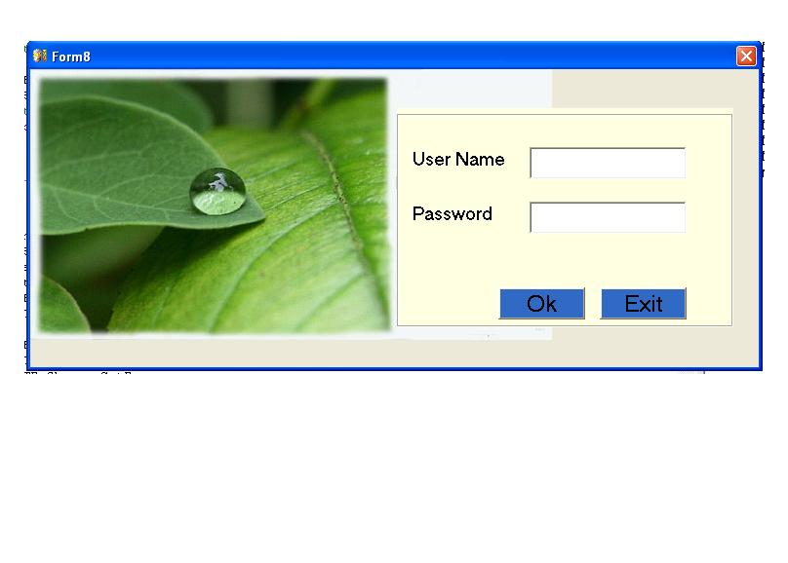

Home
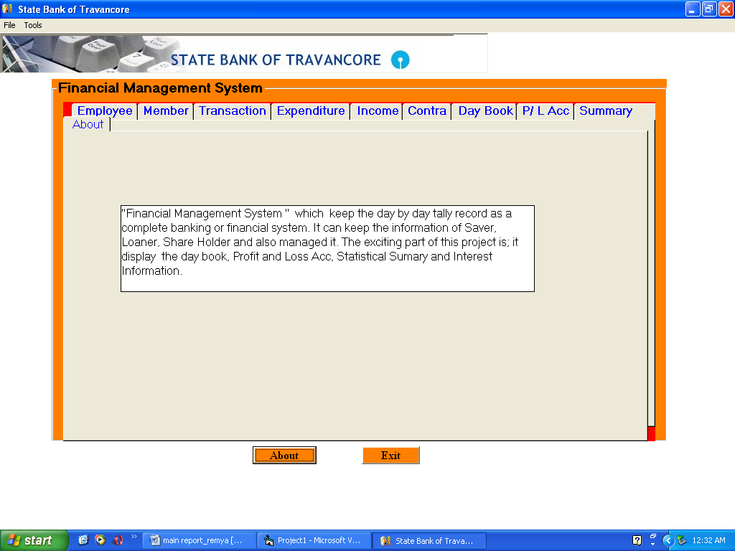

Employee

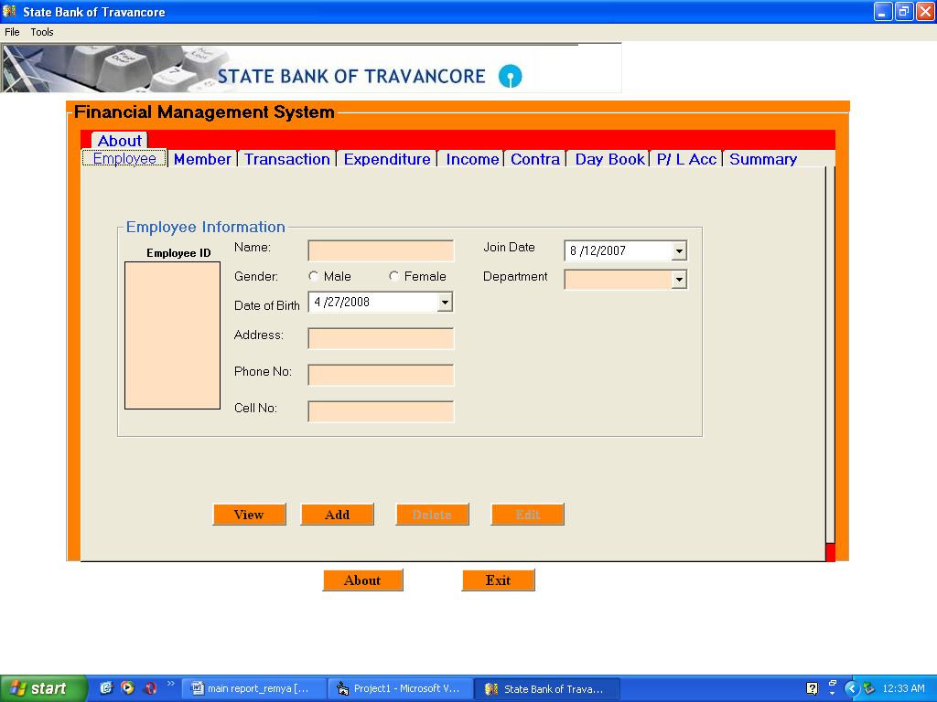

Member

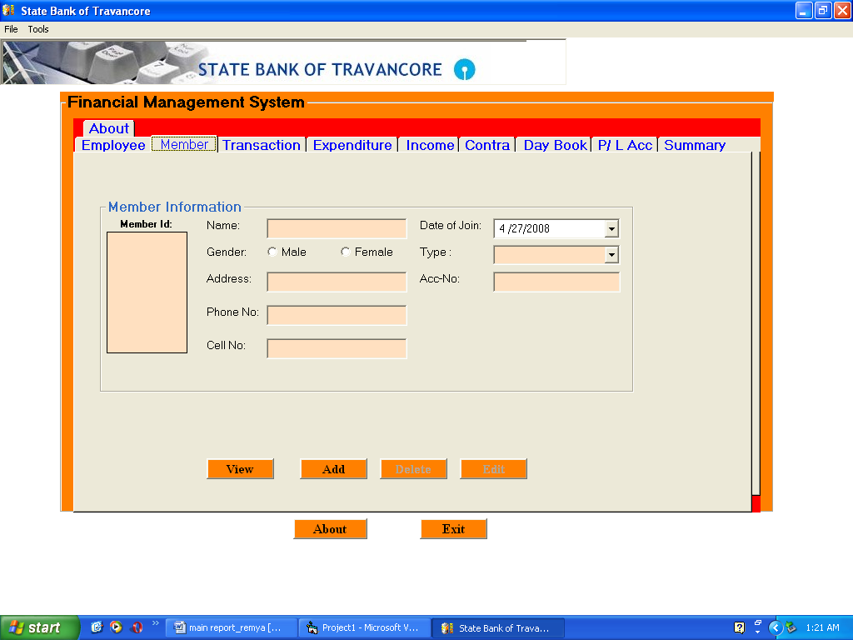

Transaction

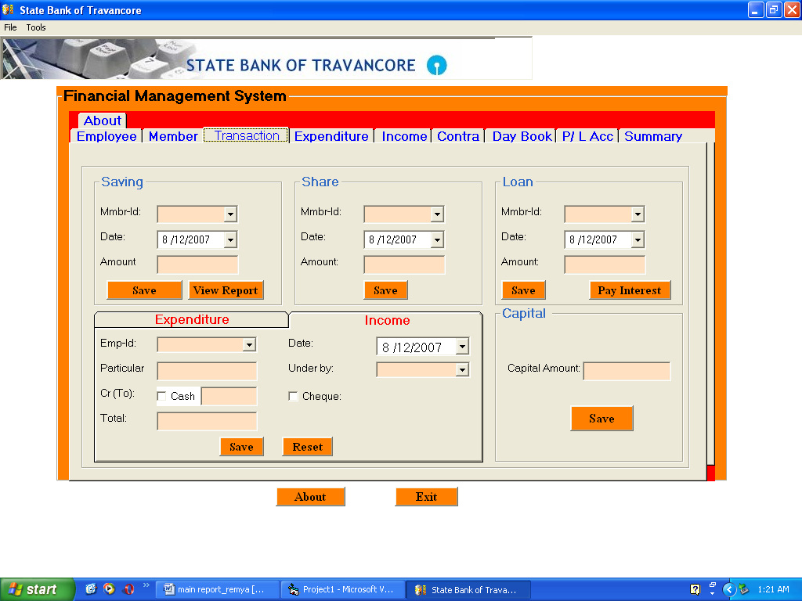

Expenditure

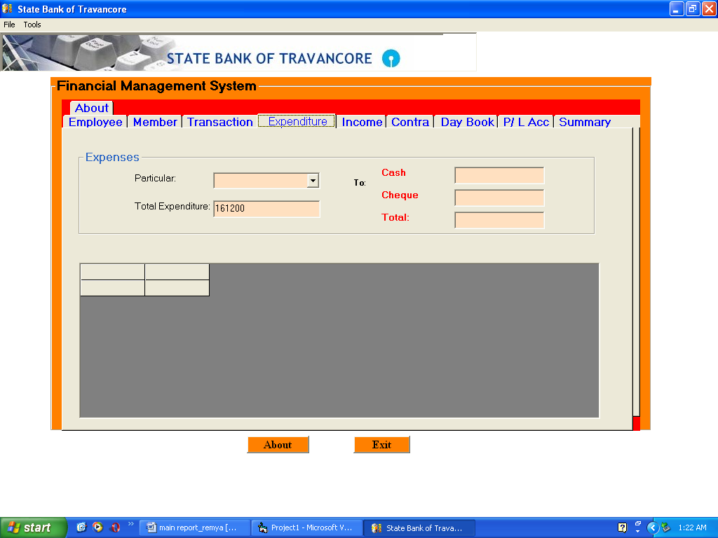
Income

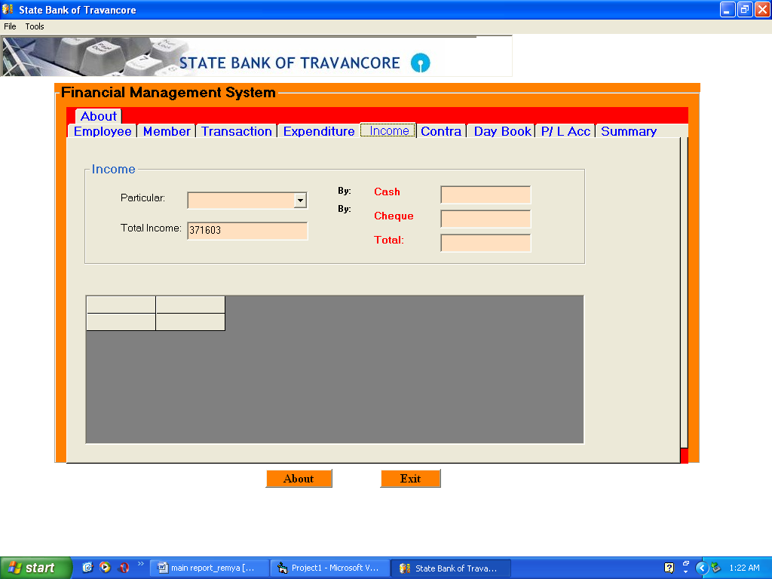

Contra

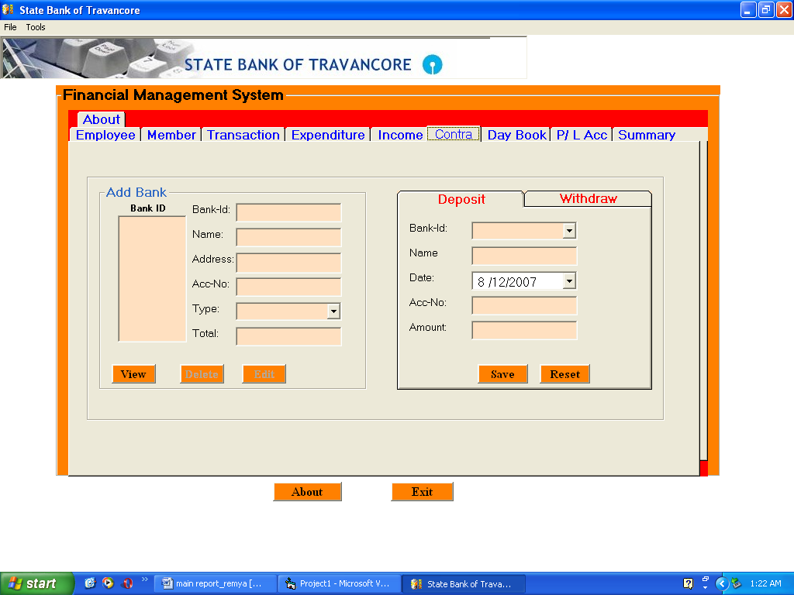

Day Book

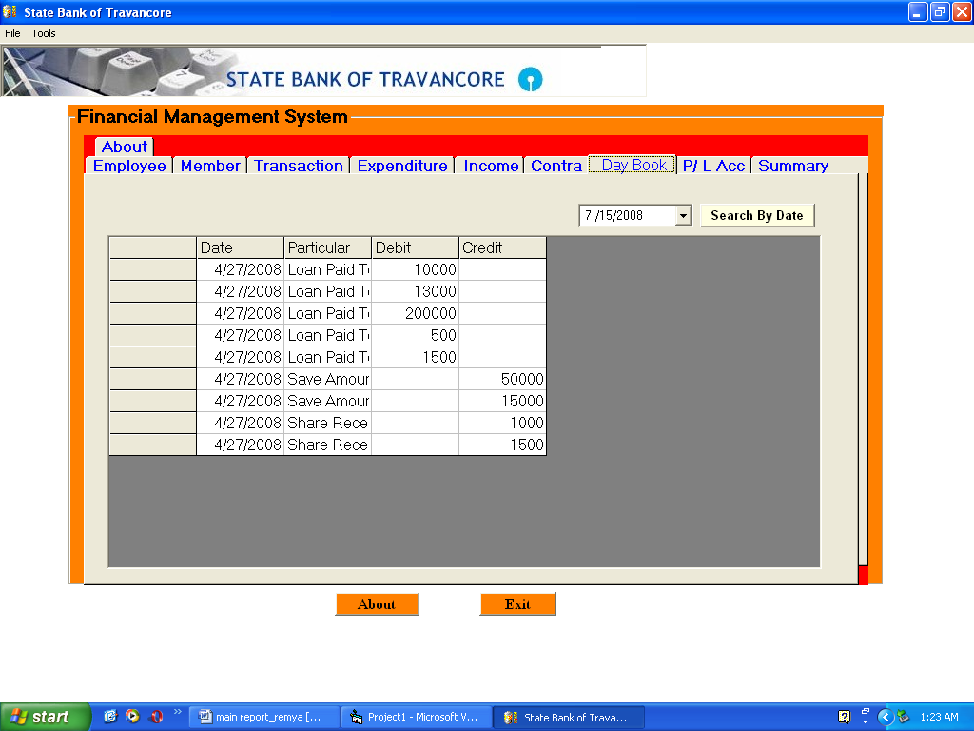

Profit/Loss Account
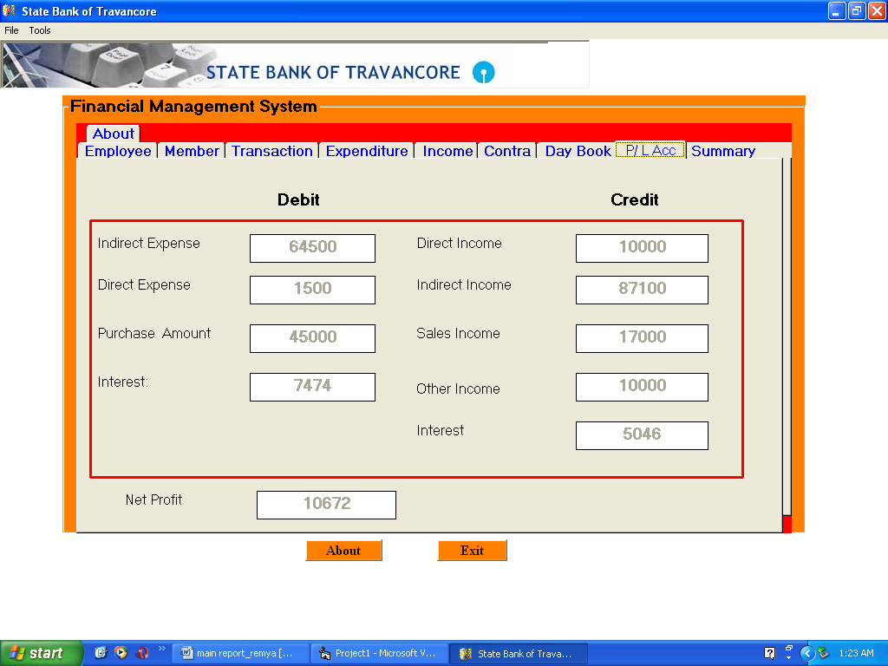
Summary Report

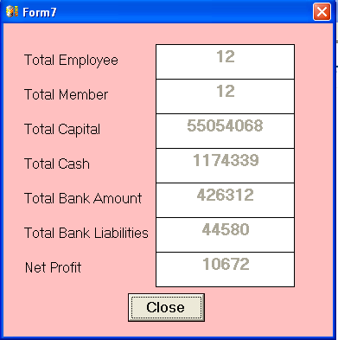

CONCLUSION

The project entitled “Financial Management System " which keep the day by day tally record as a complete banking or financial system. It can keep the information of Saver, Loaner, and Share Holder and also managed it. The exciting part of this project is; it displays the day book, Profit and Loss Acc, Statistical Summary and Interest Information.

BIBLIOGRAPHY

BOOKS:

- Charles Hampfed (2000) ‘Visual Basic’ University of
Toronto
- Herbert Schildt (2000) ‘Visual Basic 6.0’ Tata McGraw Hill
- John Zukowski (2000) ‘Visual Basic 6.0’ ‘BPB Publications
- Jamie Jaworsky ‘Visual Basic 6.0’Techmedia
- Stefen Denninger ‘Visual Basic 6.0’Author’s Press
- Ian Somerville ‘Software engineering’
- Rajeev mall ‘Software engineering’
- Elmasri Navathe ‘Fundamentals of database systems’

ONLINE REFERENCE:

www.w3schools.com
www.theserverside.com
www.visual.com

