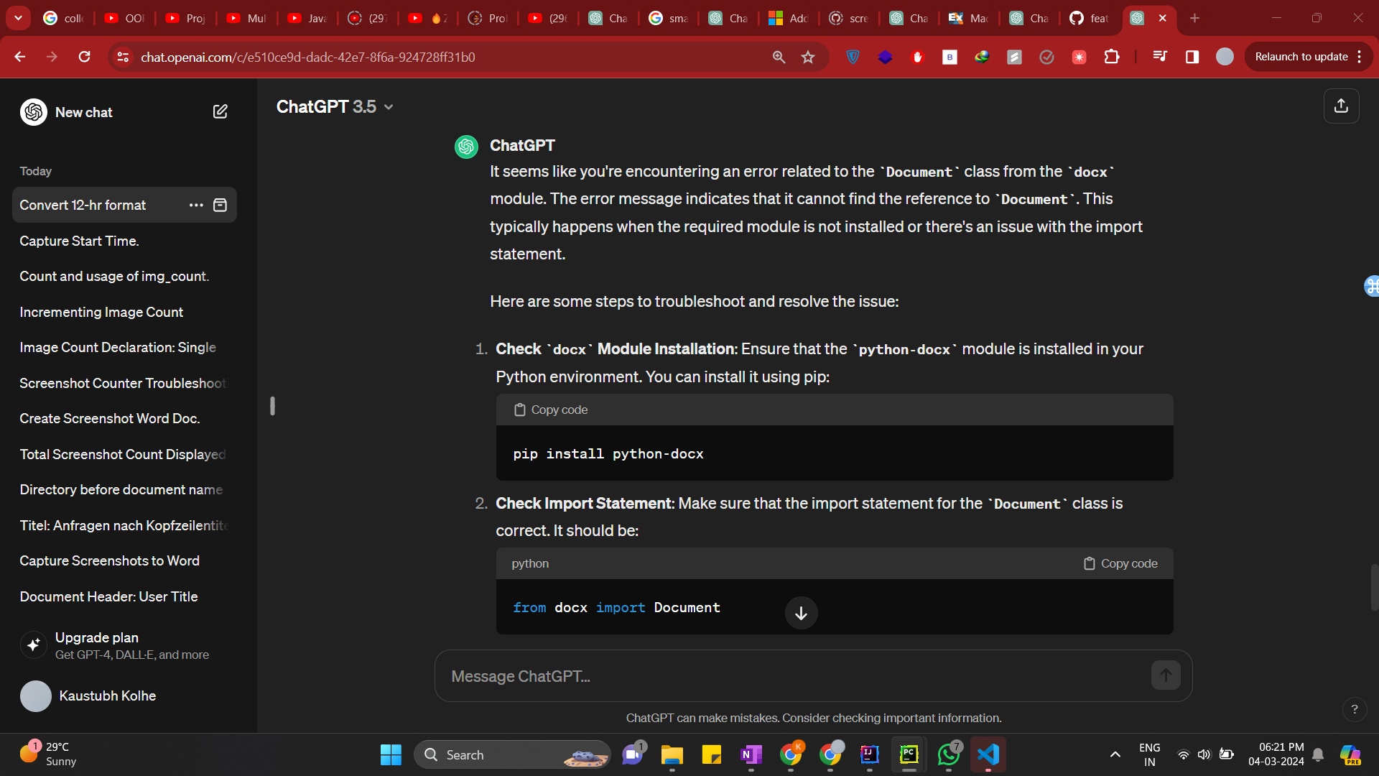

Screenshot 1



Screenshot 2



Screenshot 3

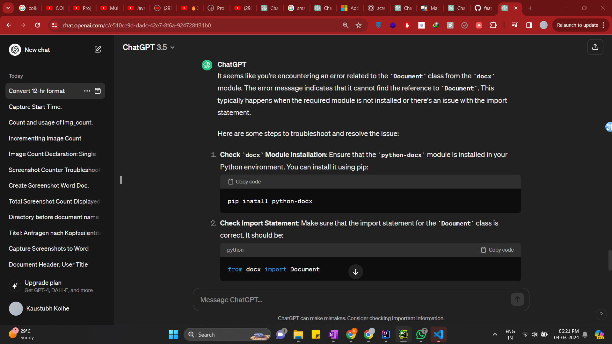

Screenshot 4



Screenshot 5



Screenshot 6