**Yelp**

**Introduction**

Yelp is people sourced social networking and business review site. Site has various categories like restaurant , food , coffee and tea. The users in yelp can give reviews and ratings about particular product or service. Yelp allows to Sing In and Sign Up options which allows user to create account and use the account. Administrator can add , remove and update category where as normal user can add , remove and update his/ her reviews and ratings. The yelp also shows reviews of other people and gives chance for user to edit his/ her reviews. User can always able to see the last login time while navigating through yelp. Yelp provides validations for user and the administrator.

**System Design**

The yelp site has home page which gives option to admin / user to login or sign in to the account. The admin can login to the system using admin privileges. If admin does not gives appropriate user name / password / email id / last name / first name the system at server side will do the checks and display appropriate message to the admin. The system checks the admin’s credentials and displays a page that allows admin to add / delete / update category.

Yelp checks users credentials at login and sign up time. If the user does not enters appropriate credentials then system throws the message of required values of fields at server side. Once the user is authenticated he can add / delete / update particular reviews and comments. User can see his comments when he logs in along with the last login date and time. User can see all the comments of other users at home screen.

For building Yelp application **JMS along with Servlets and JSP** is used. The server consists of **JBoss**. The server has **deployment descriptor** which has all the information about the application including services exposed. The server has **service class which is exposed to the client** with the required dependencies. Server side communicates with **MYSQL database.** Server creates a connection for MYSQL database and serves request of databases for client.

**Code Snapshots**

**SignIn DAO at server side**

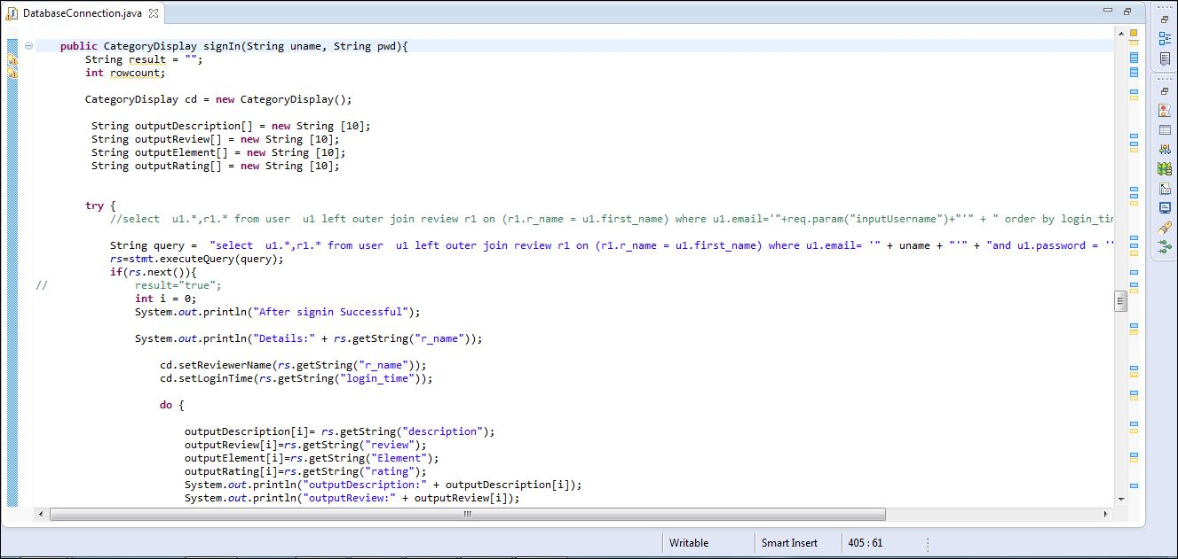

**SignIn Consumer at server side**

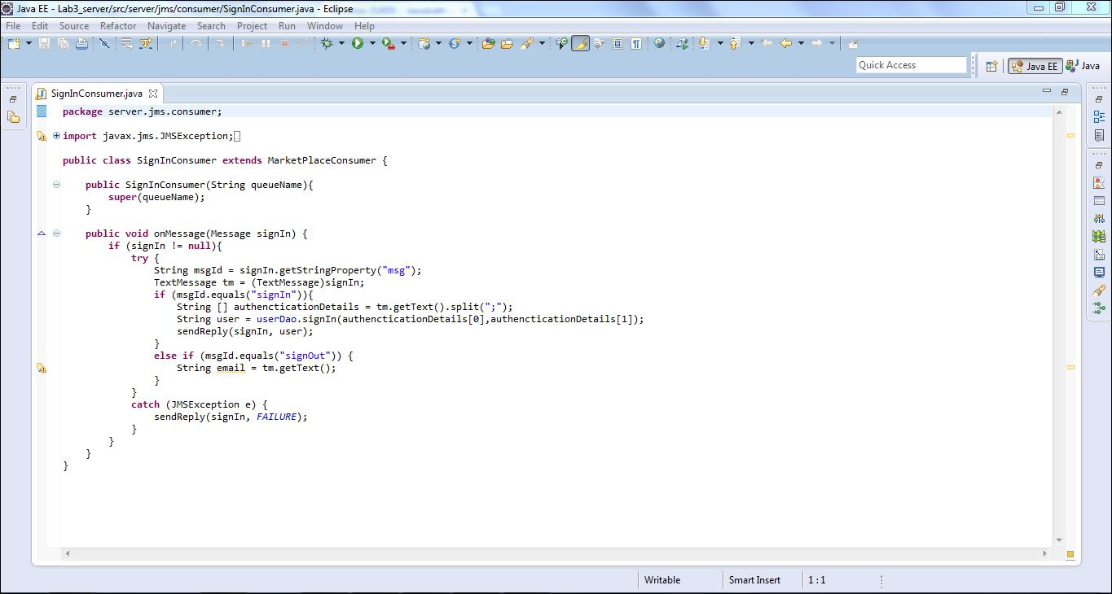

**SignIn Servlet at client side**

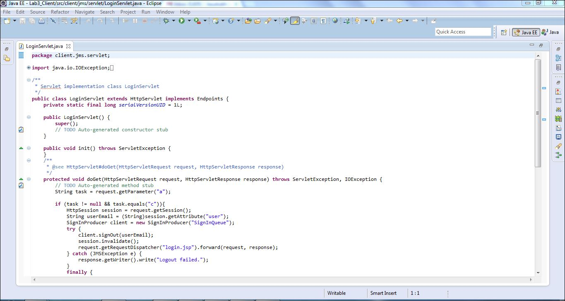

**SignIn producer at client side**

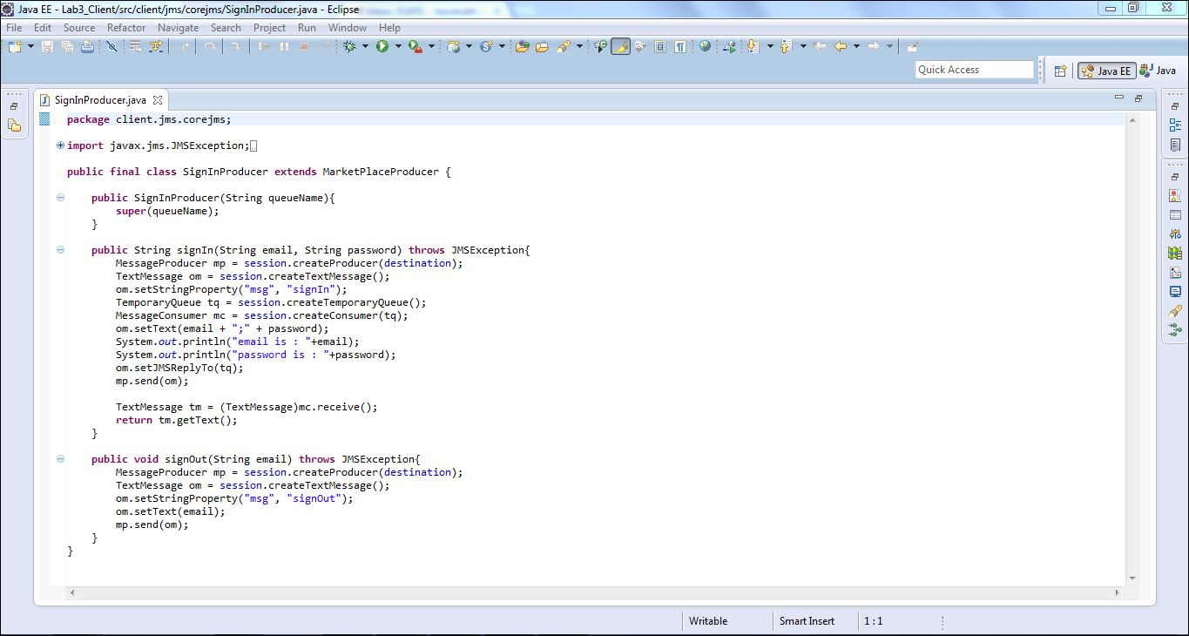

**Creating queue in localhost web-console.**

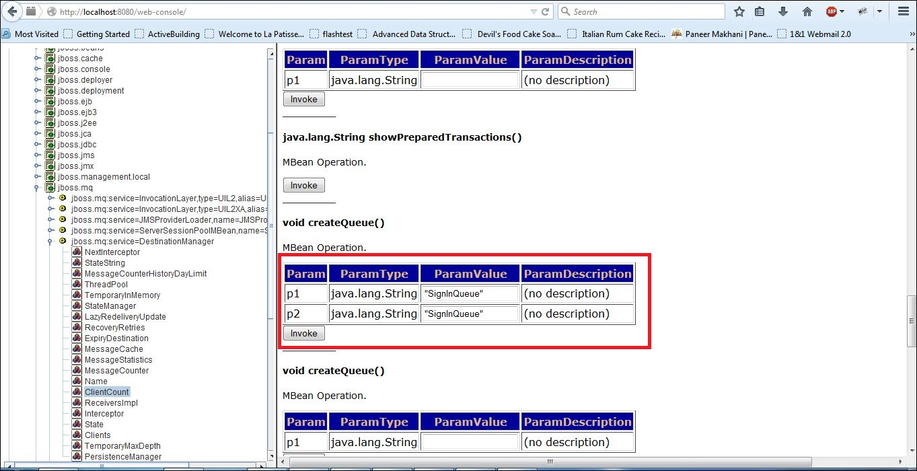

**JNDI Bind to Sign In queue for exchanging messages.**

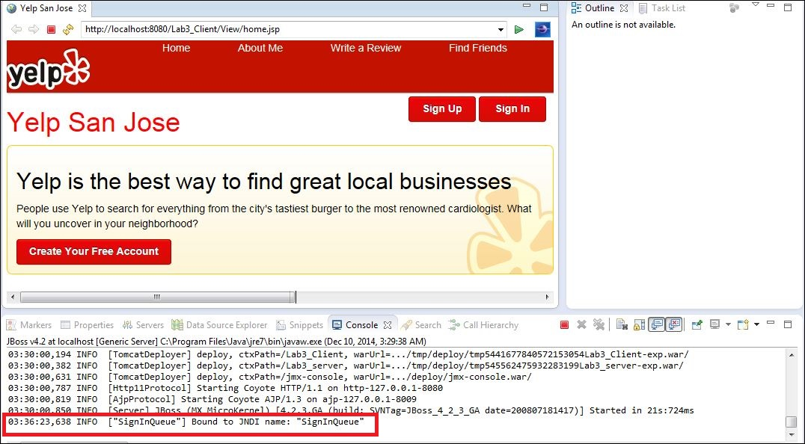

**Creating topic in localhost web-console.**

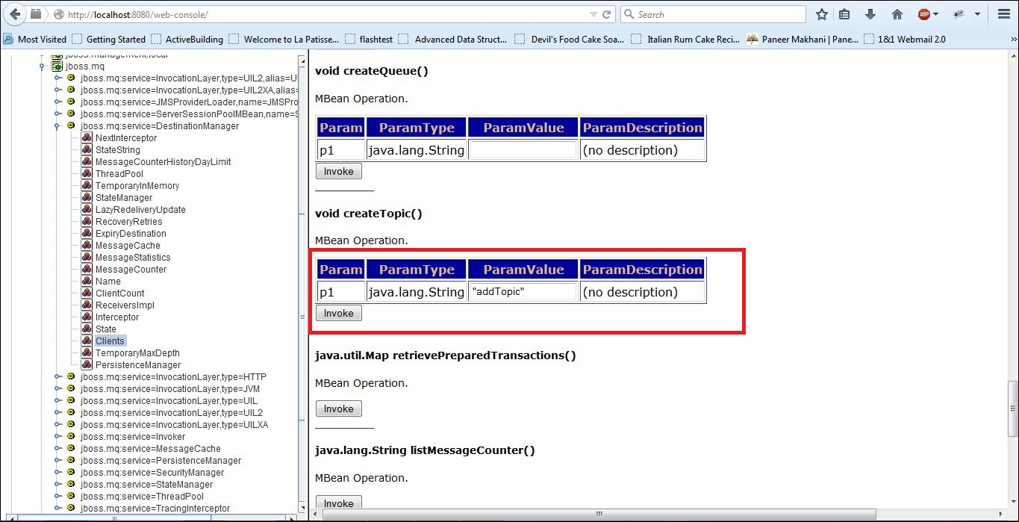

**JNDI Bind to add category topic for exchanging messages.**

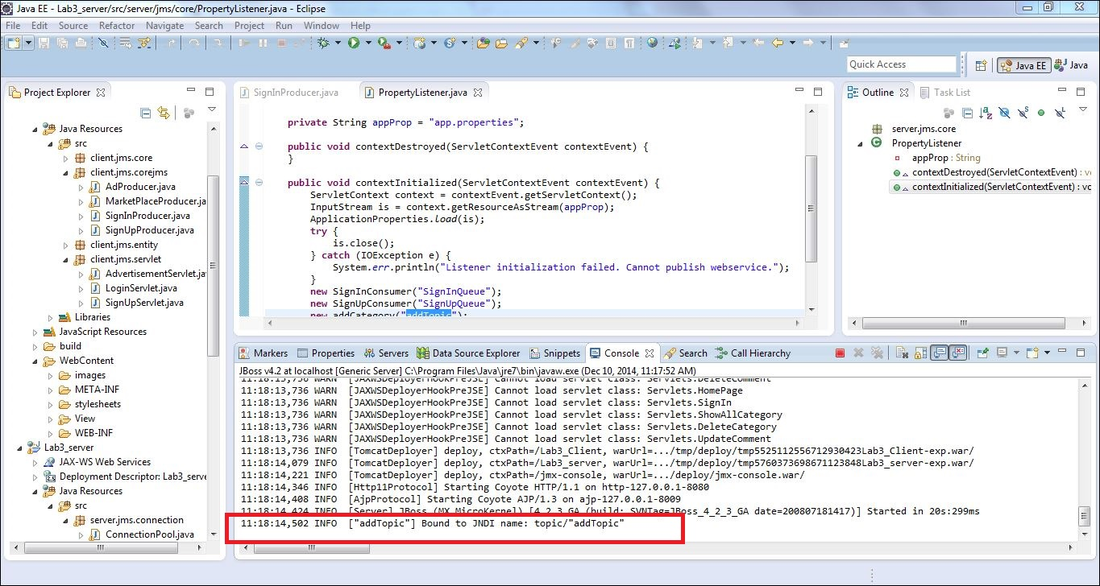

**Code snippet for sign In, signup , add Category , delete Category and update Category.**

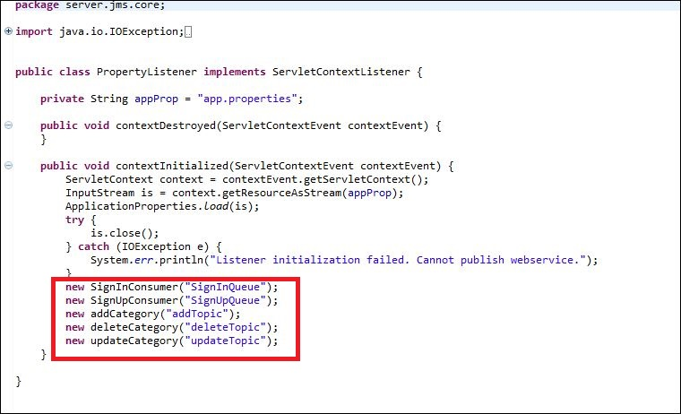

**Results**

**Home page**

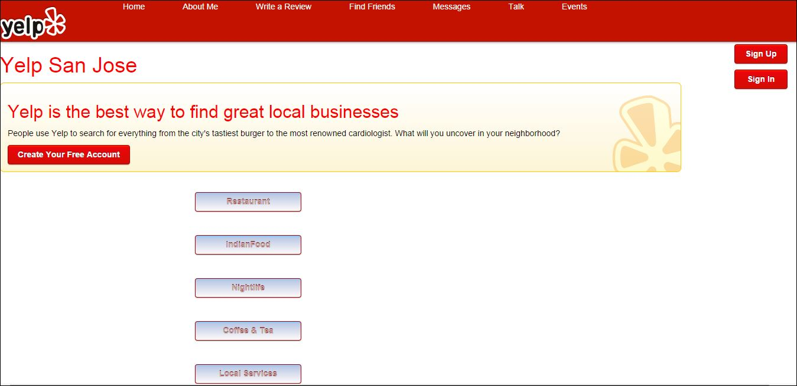

**Sign Up**

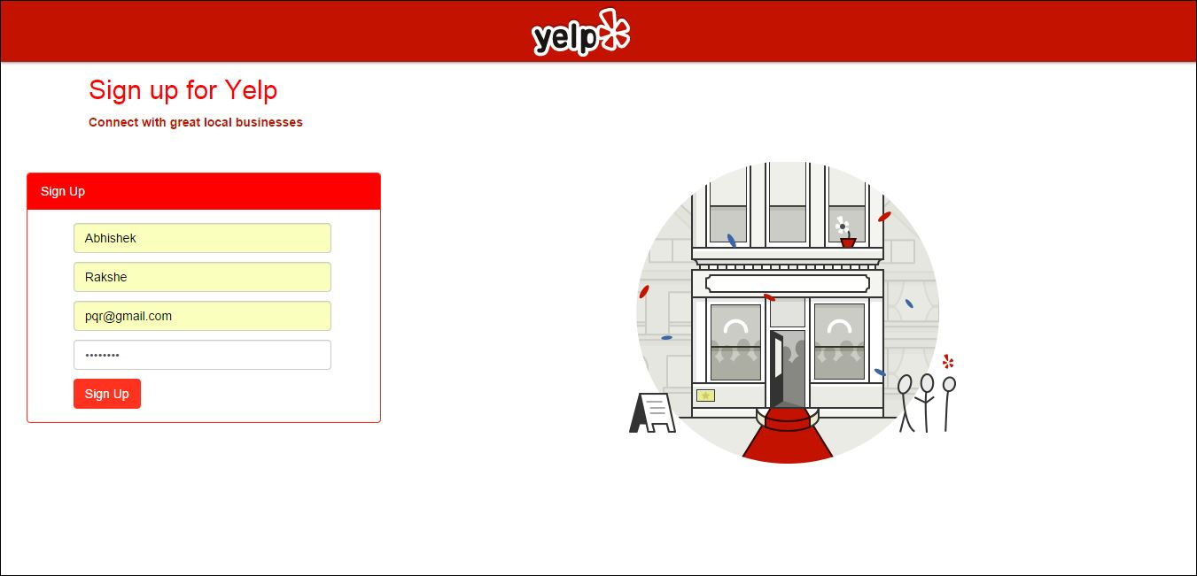

**Sign Up – If credentials are not correct**

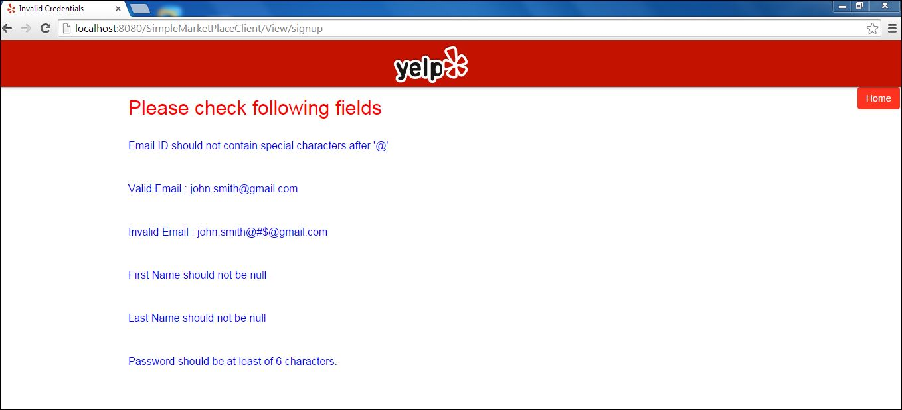

**Sign Up – If credentials are correct the message will be displayed with login creation time**

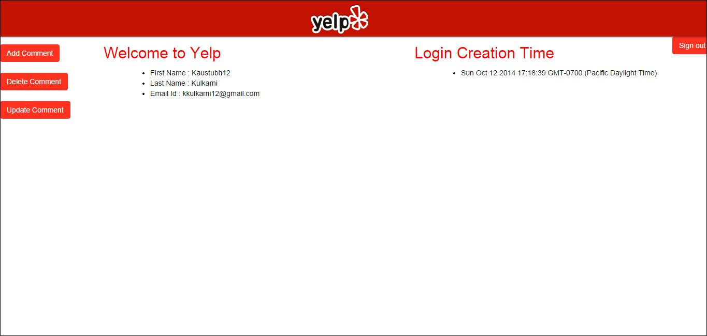

**Sign In**

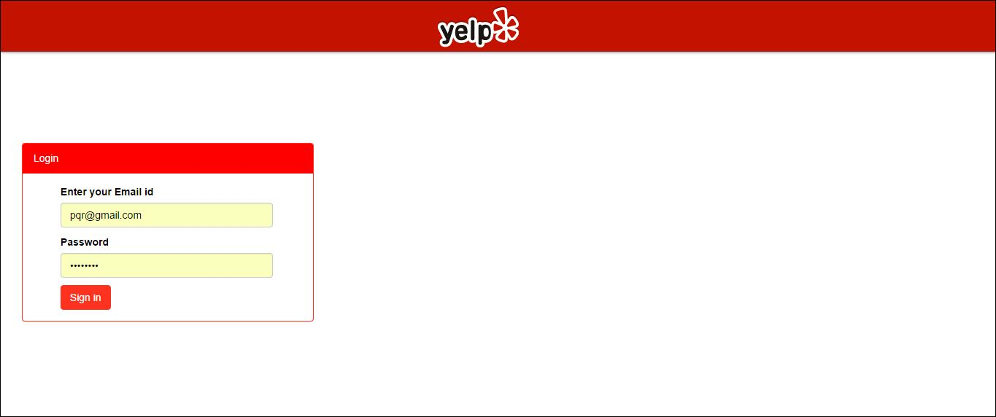

**Sign In – If credentials are not correct**

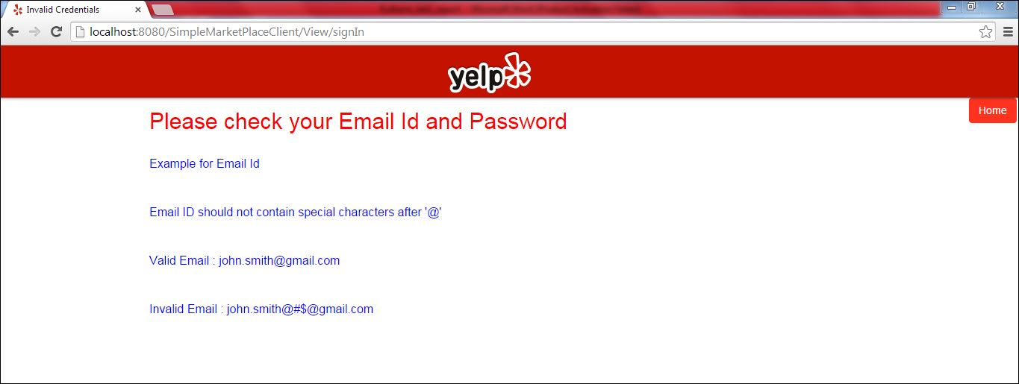

**Sign In – If credentials are correct, the user will see his/ her comments with last login time.**

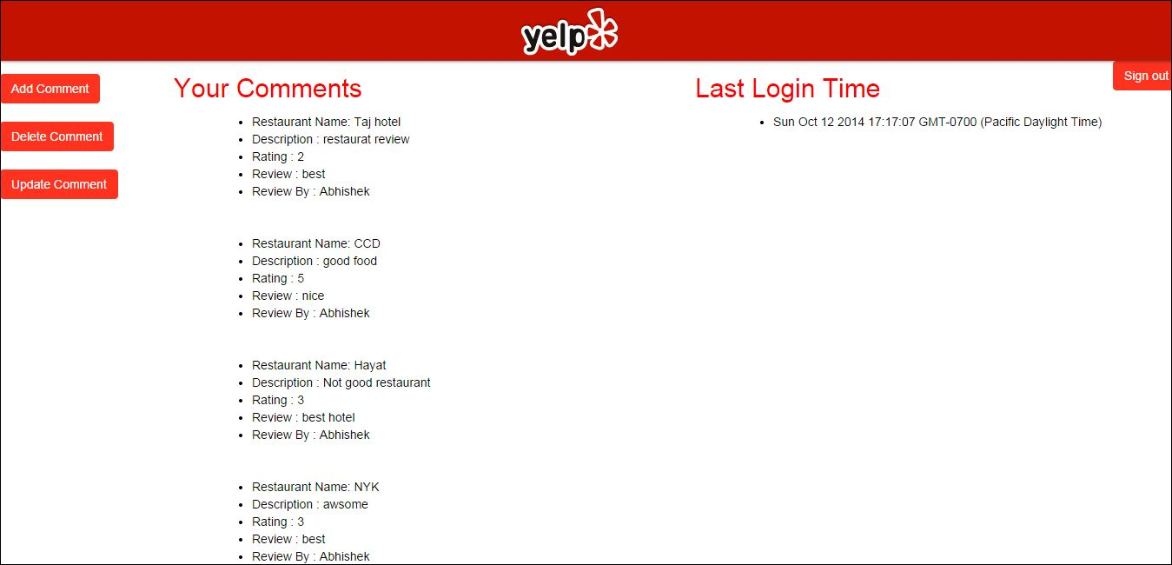

**Add comment form**

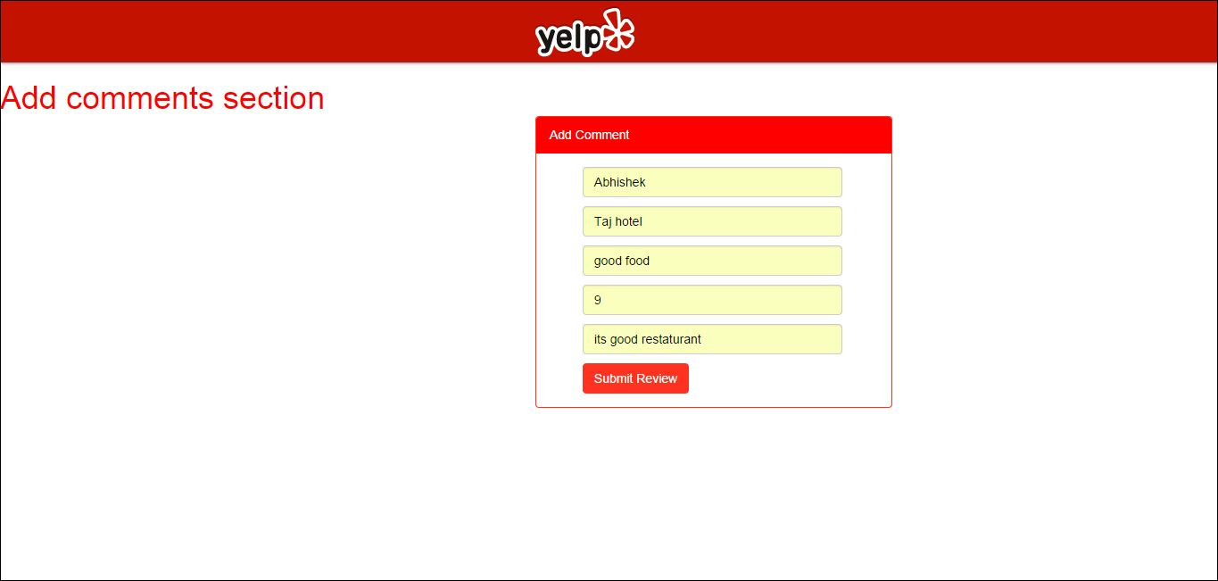

**Add comment - If comments rating is not number and reviewer does not give his name.**

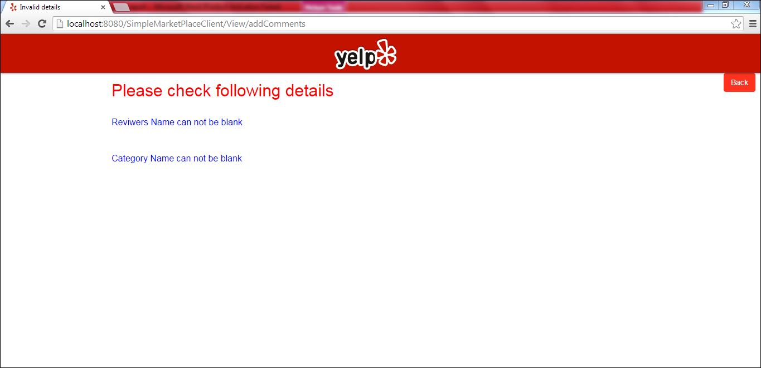

**Add comment - If correct comments are added.**

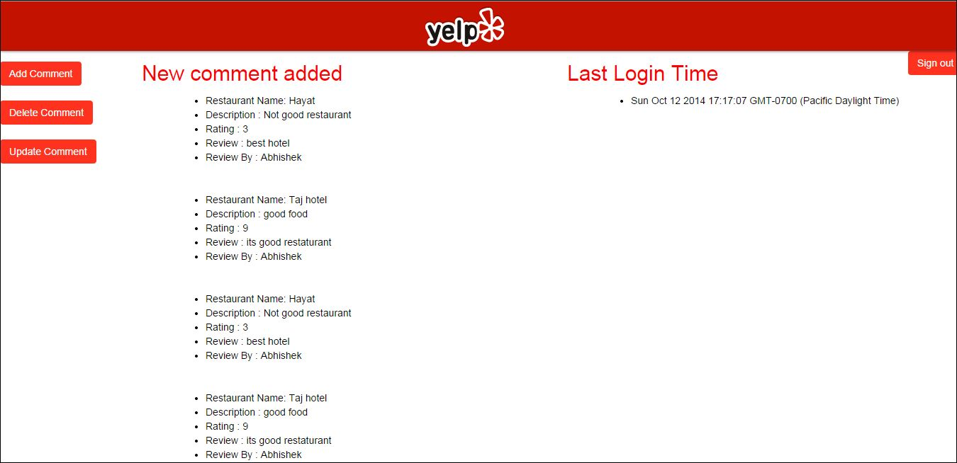

**Delete comment form**

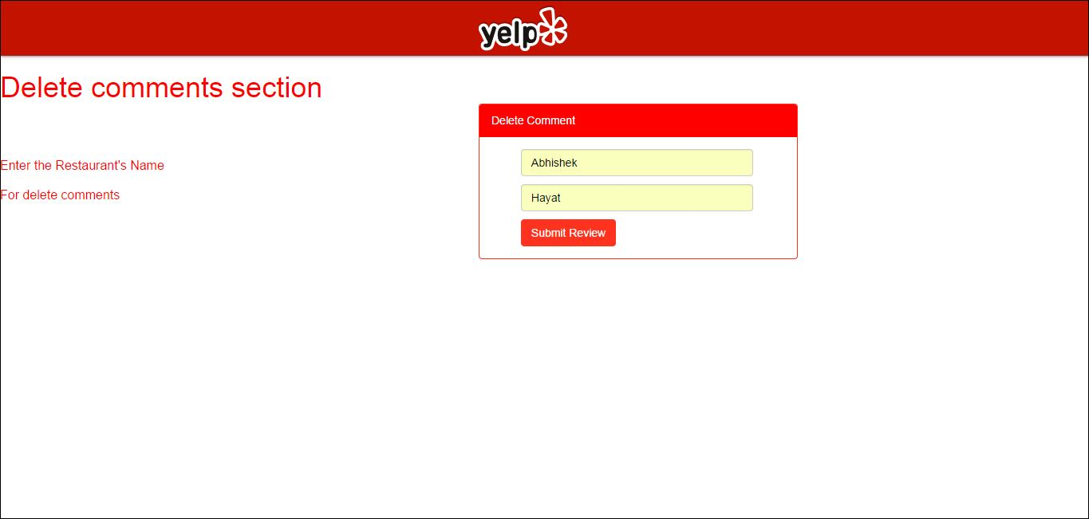

**Delete comment - If incorrect comment user tries to delete.**

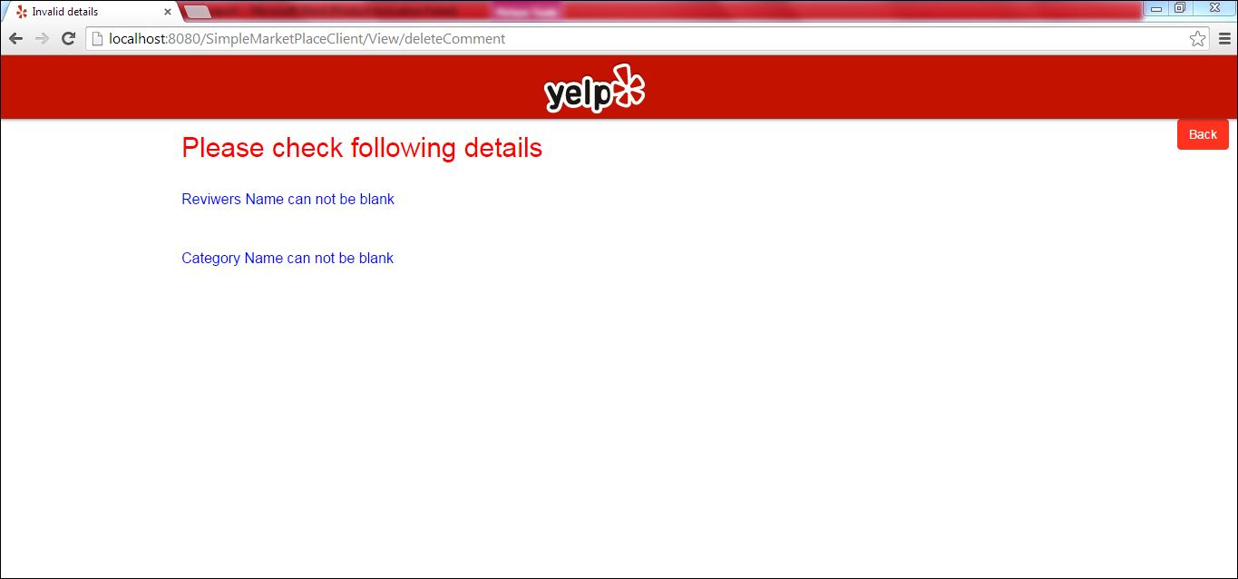

**Delete comment - If correct comments are given.**

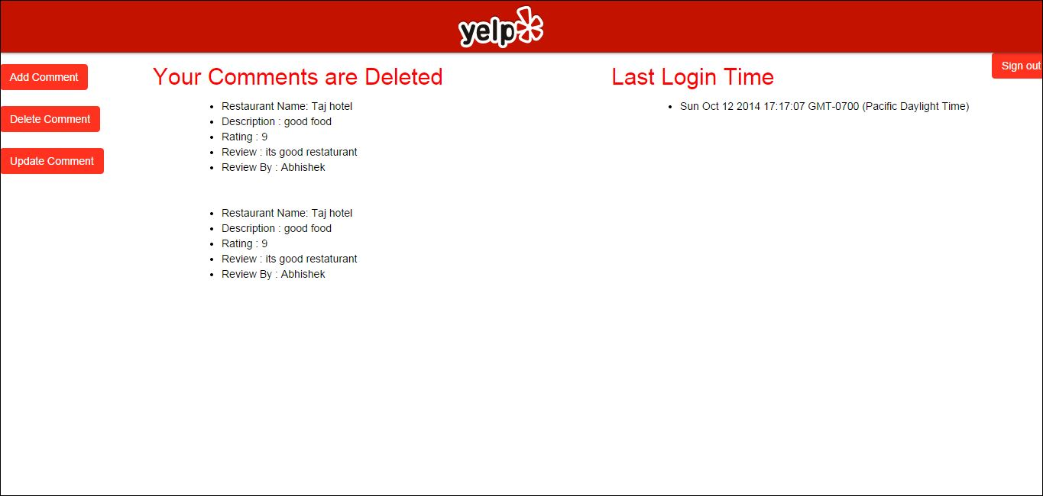

**Update comment form**

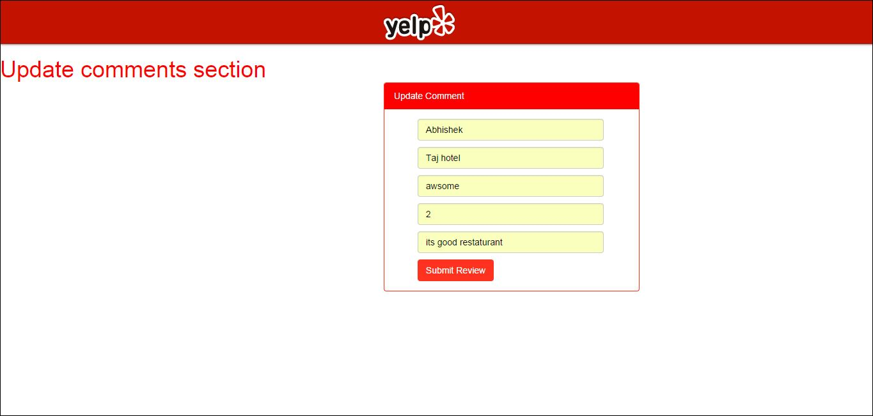

**Update comment - If incorrect comment are given by user.**

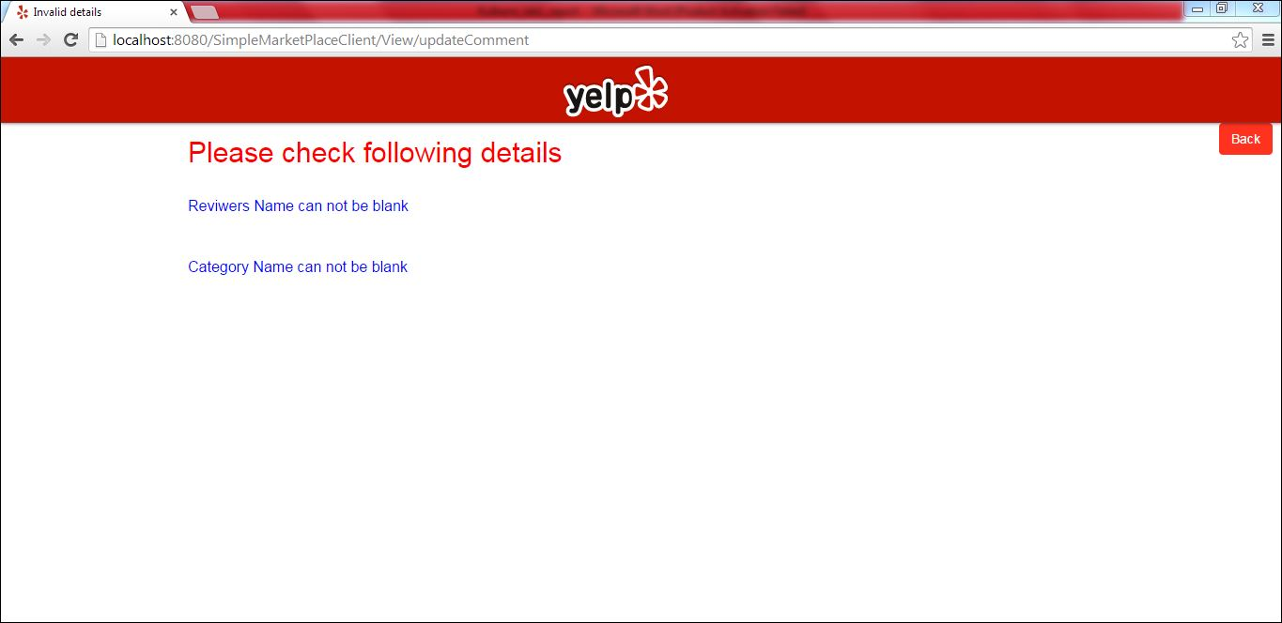

**Update comment - If correct comments are given.**

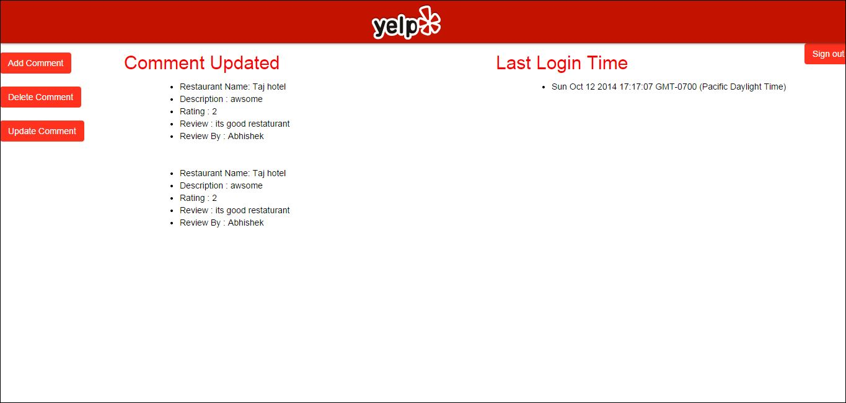

**Sign In – Admin**

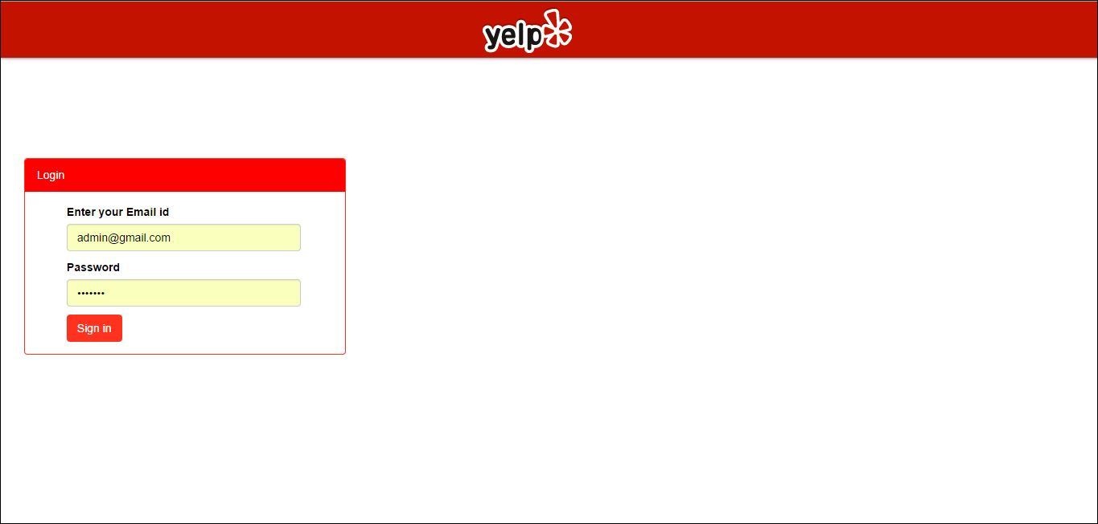

**Sign In – Admin - If credentials are not correct**



**Sign In – Admin - If credentials are correct**

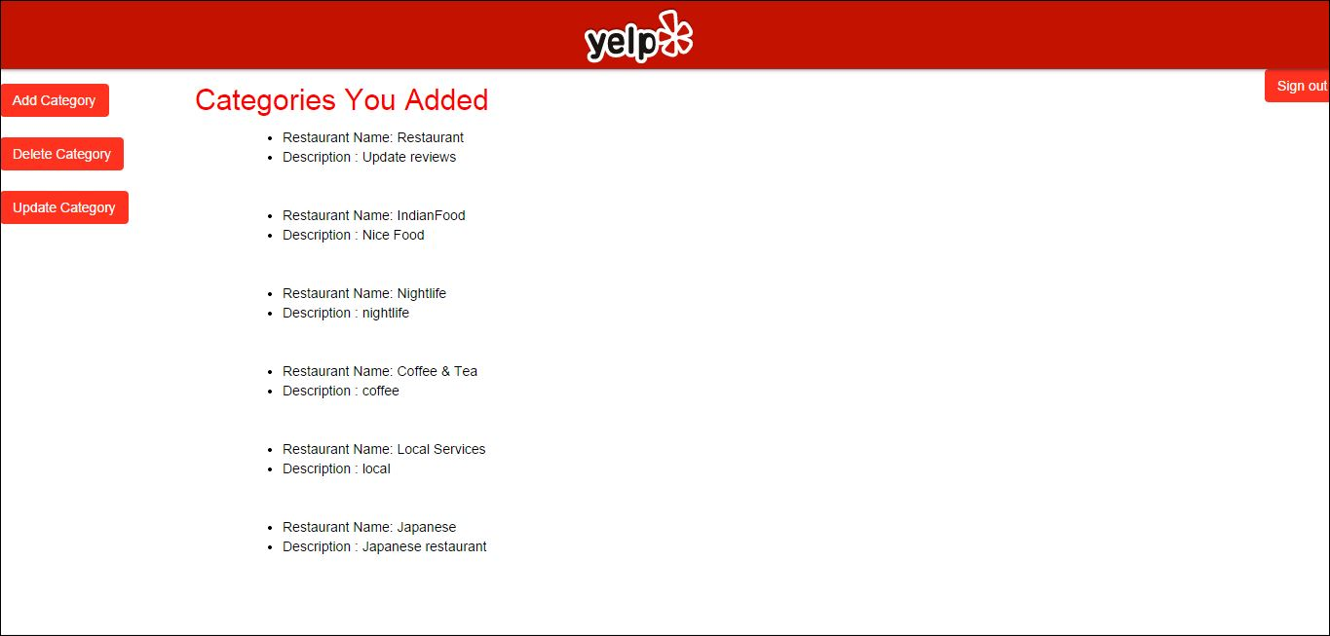

**Add category form**

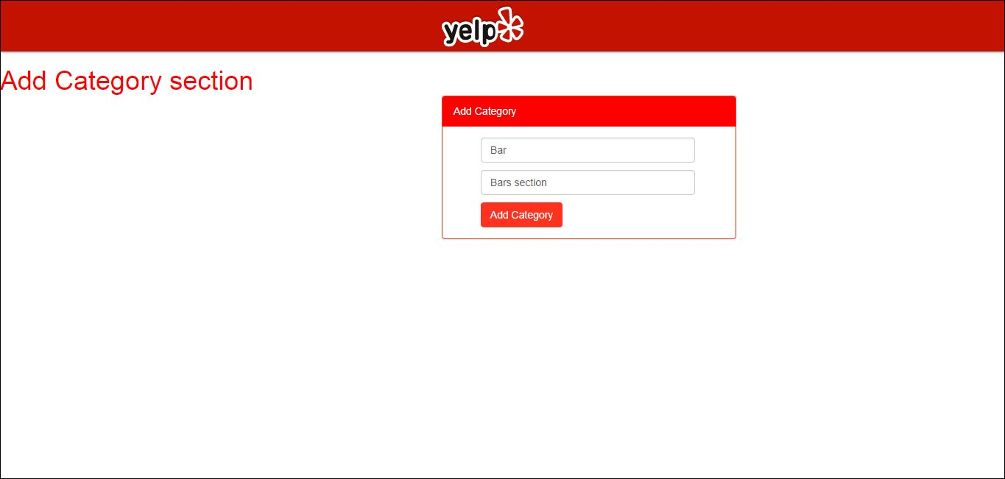

**Add category form : If category name is given as null.**

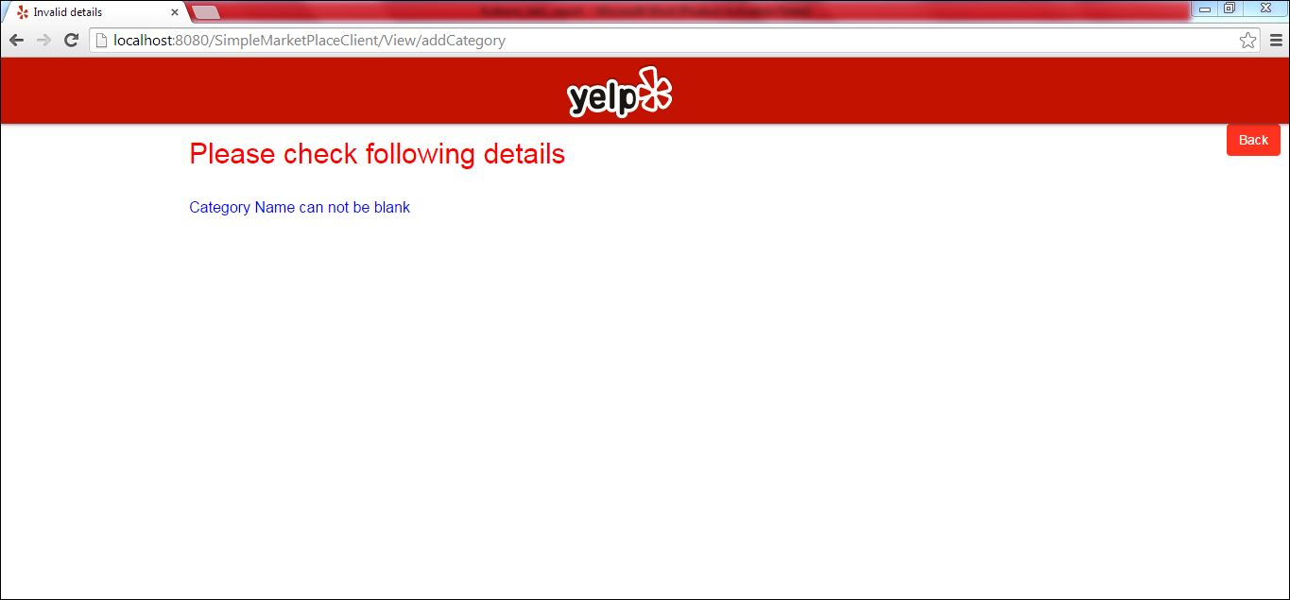

**Add category form : If category name is given correctly.**

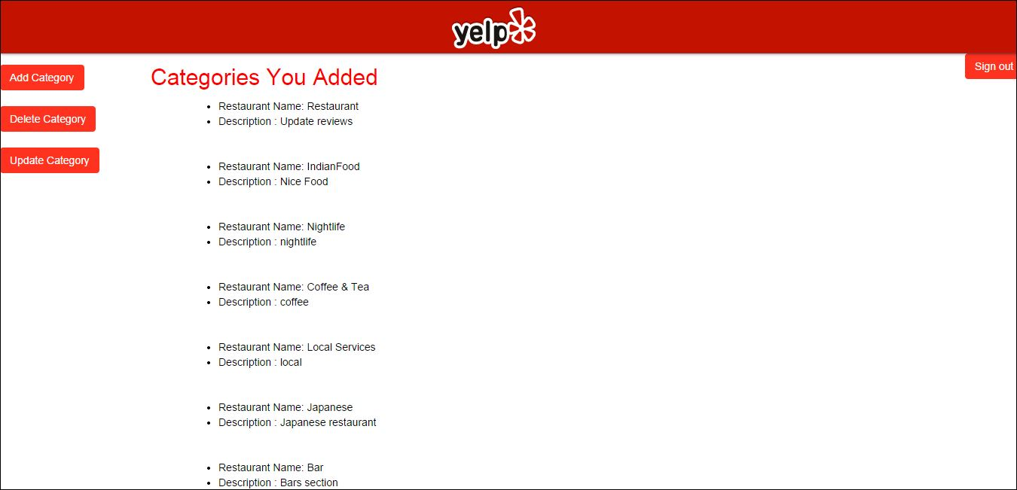

**Delete category form**

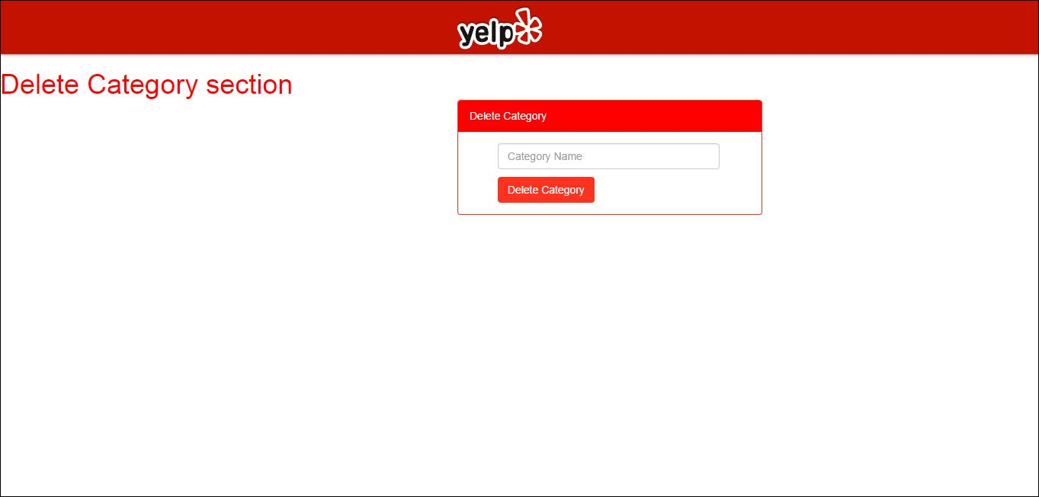

**Delete category form : If category name is given as null.**

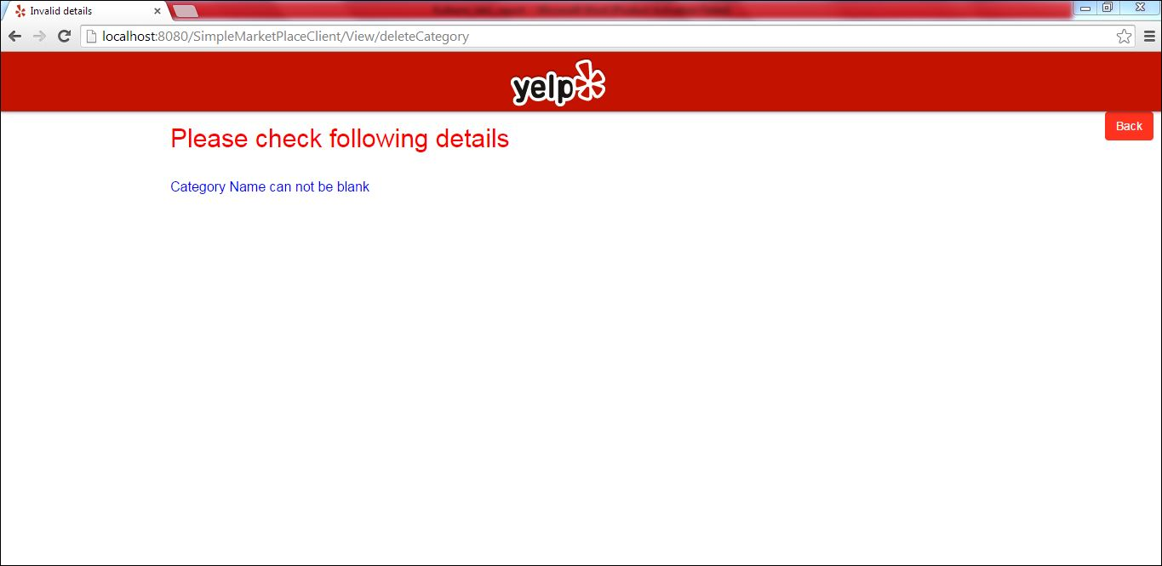

**Delete category form : If category name is given correctly.**

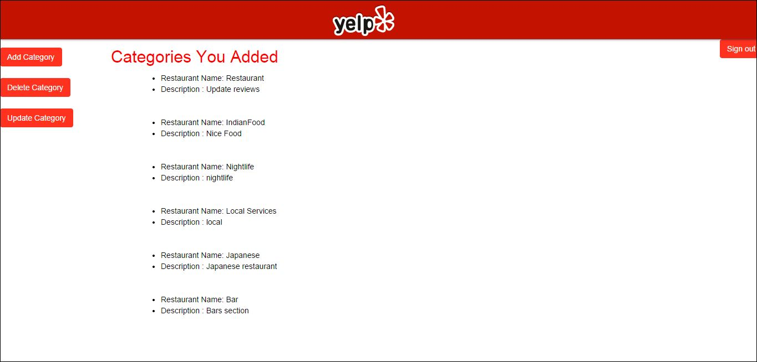

**Update category form**

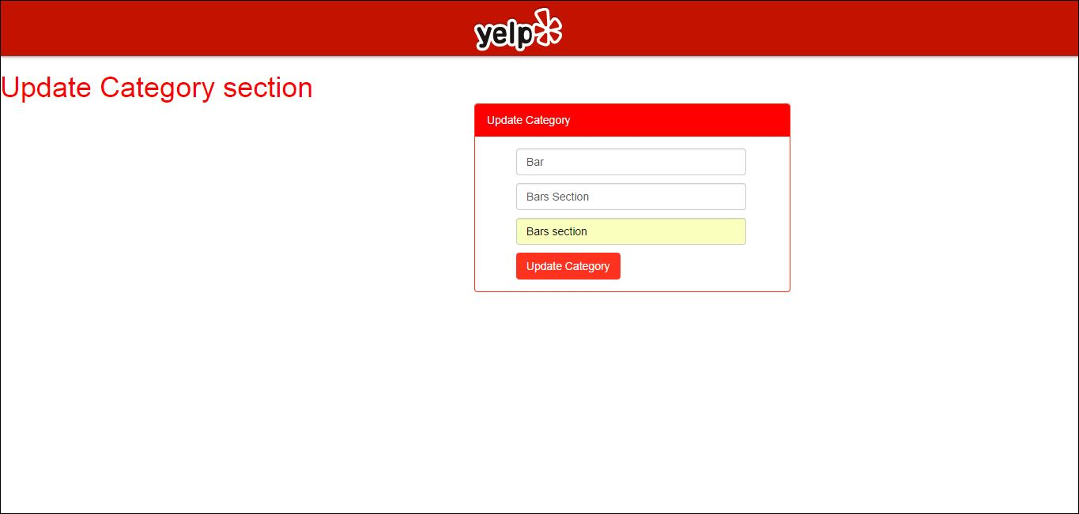

**Update category form : If category name is given as null.**

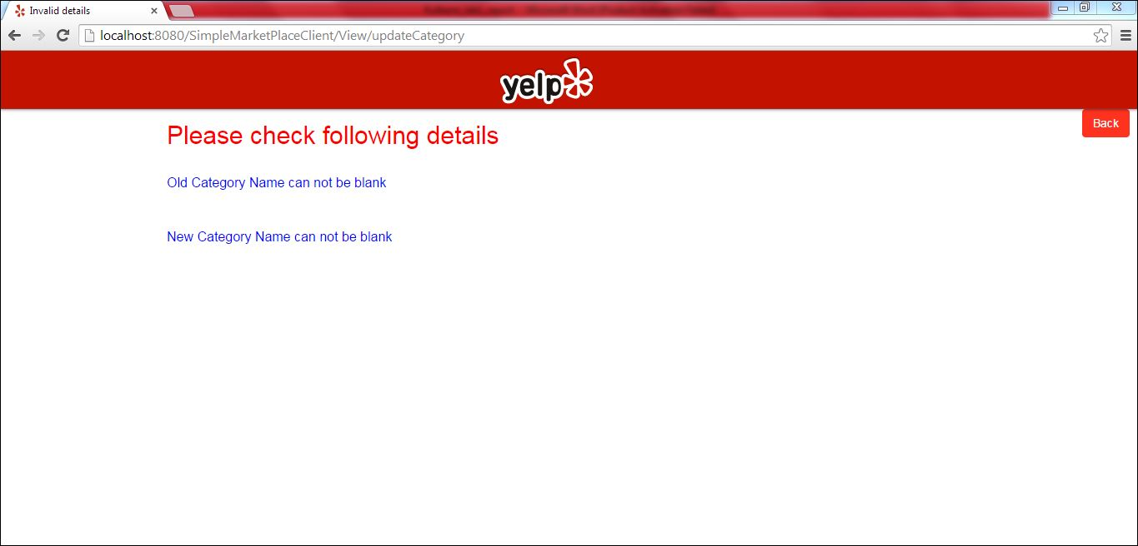

**Update category form : If category name is correctly given.**

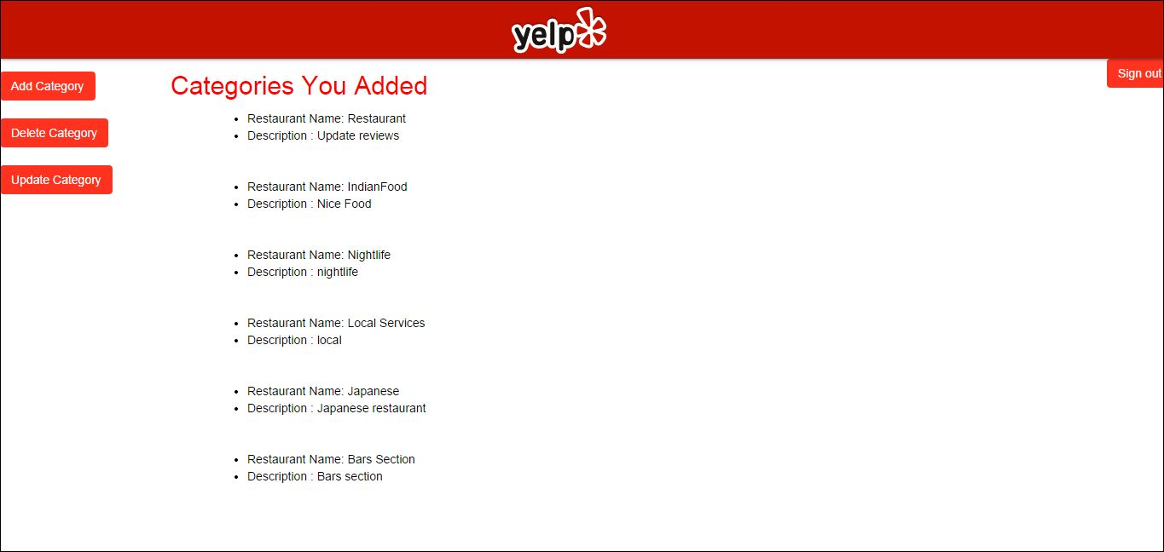

**Sign out : Sign out will redirect user to home page.**

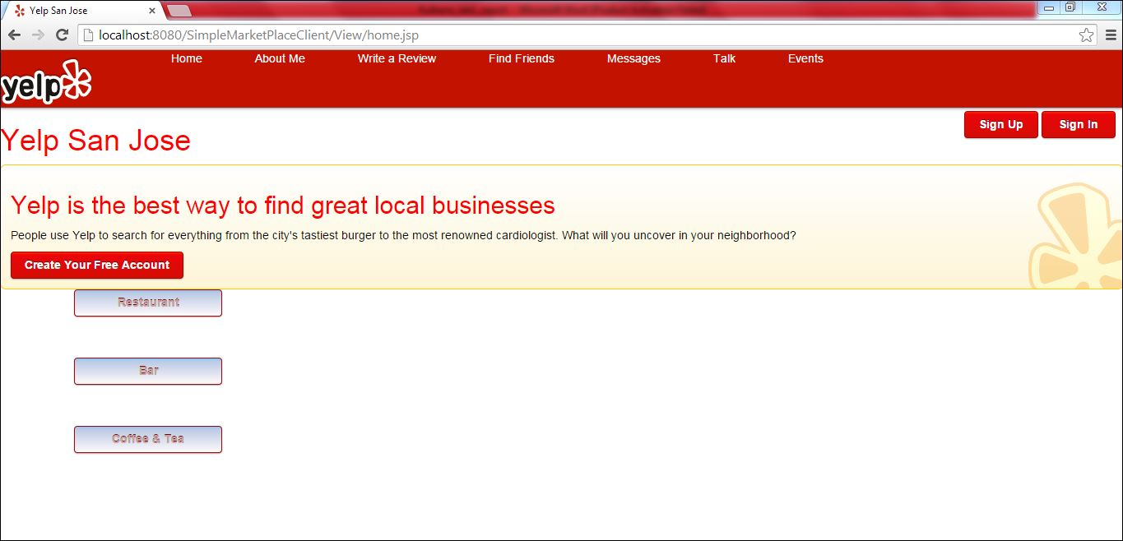

**Restaurant on home page : If user clicks on restaurants on home page he will see all the restaurants and its review wrote by other people**

