**Process Documents**

# Cloning GitHub Repo

Go to git bash and execute the command   
“git clone https://github.com/kaustubhlambe11/vm_pricing”  
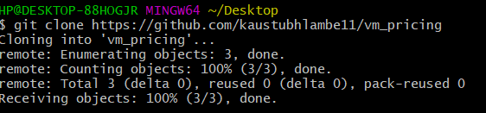

# Folder Structure

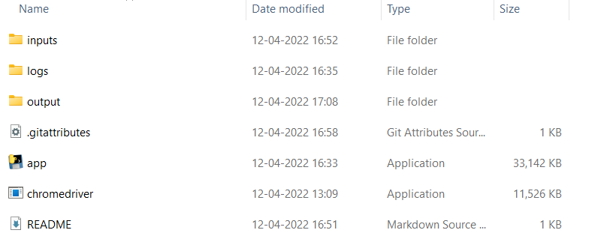

# Check Chrome Version

Open Chrome -> Settings-> Select About Chrome  
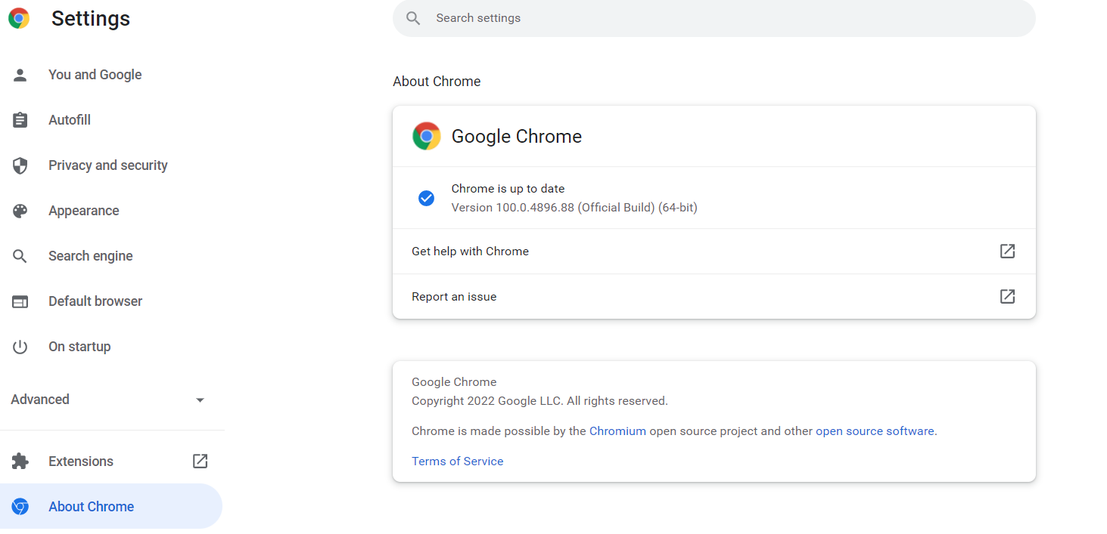

# Download Chrome Driver for python interface

* Go to following link  
  <https://chromedriver.chromium.org/downloads>
* In Screenshot out chrome version is 100 so we will have to download chrome driver with same version  
   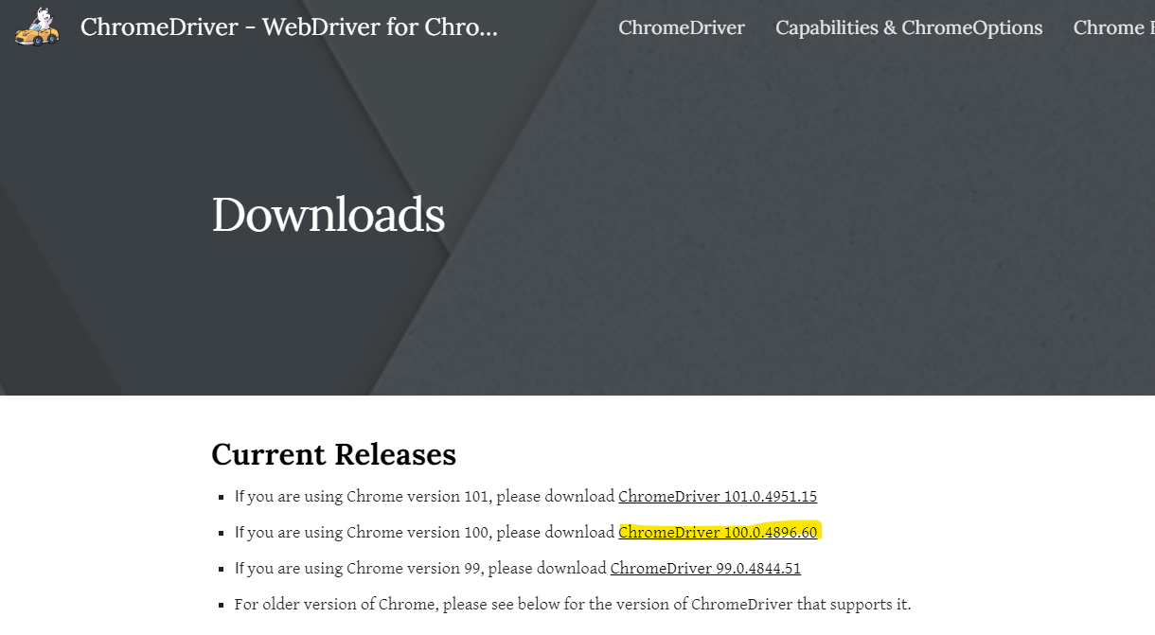
* Click on the hyperlink marked with yellow marker in above image  
  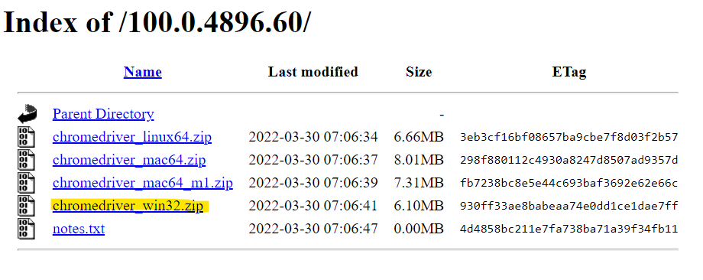
* Click on yellow marked zip file and it will automatically get downloaded
* Unzip the file and replace chromedriver.exe in our root folder of project  
  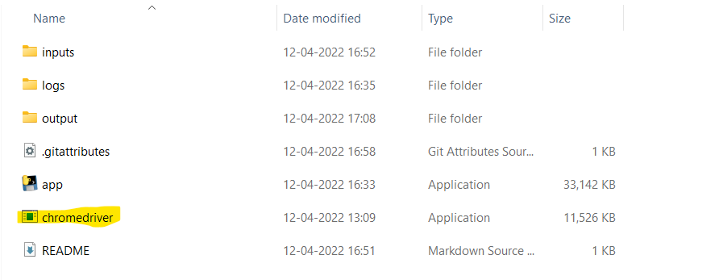

# Input File

* Go inputs folder and update **azure_vm_pricing.csv** with required inputs  
  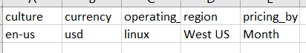

# Tool Execution

* Open CMD and navigate to project folder
* Execute following command  
  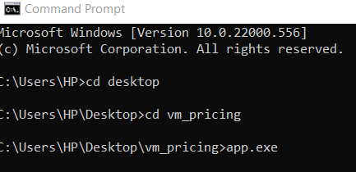
* The tool will get executed in case of any error occurs please check in the logs folder
* Logs will be created only when error occurs
* Output csv will be generated in output folder after successful execution