Puppet-Assignment-1

1. On all Three Machines (Master, Slave_1, Slave_2)
2. Update packages:

sudo apt update && sudo apt upgrade -y

1. Download Puppet-packages and install it:

wget https://apt.puppet.com/puppet6-release-focal.deb

sudo dpkg -i puppet7-release-focal.deb

sudo apt update

1. Changes Puppet-Server/Master Public IP in hosts file

sudo nano /etc/hosts

1. Configuration On Master Node
2. Add fire-wall rule:

sudo ufw allow 8140

1. Install Puppet Server

sudo apt install puppetserver

1. Start and enable(starts on reboot) puppetserver.service

sudo systemctl enable puppetserver.service

sudo systemctl start puppetserver.service

sudo systemctl status puppetserver.service

1. Configuration On Agent/Slave Node
2. Install Puppet Agent

sudo apt install puppet-agent

1. Start and enable(starts on reboot) puppetserver.service

sudo systemctl enable puppet.service

sudo systemctl start puppet.service

sudo systemctl status puppet.service

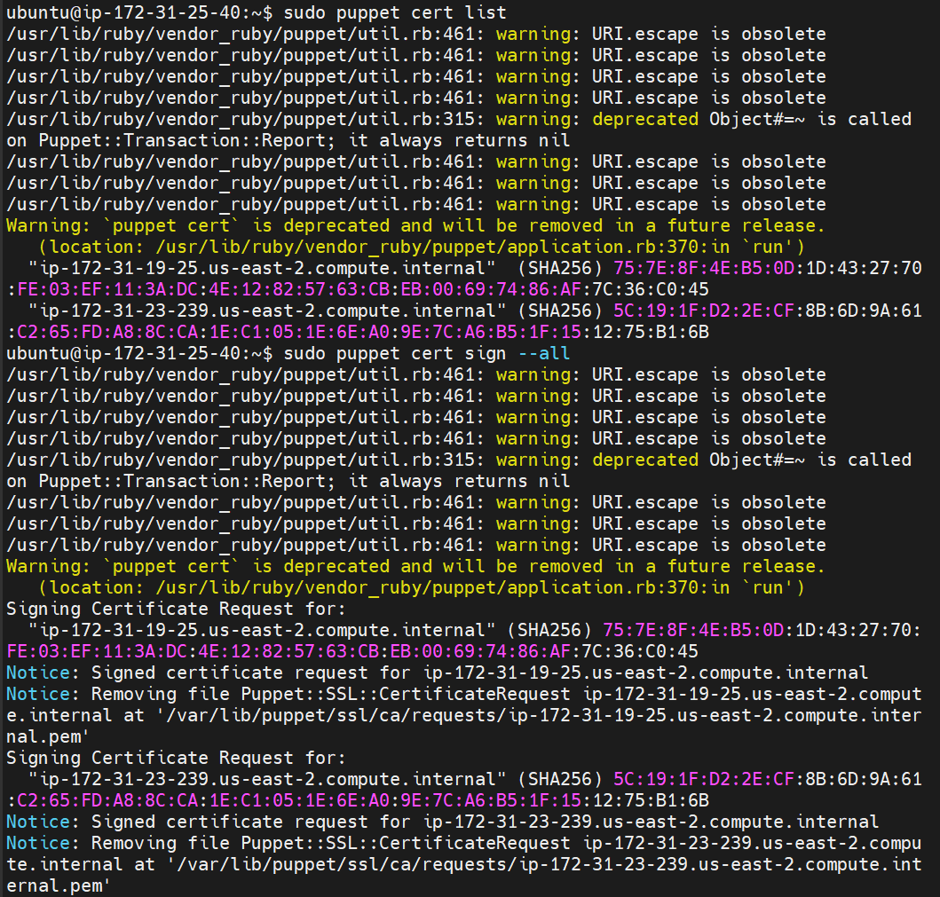

1. Installing apache2 using manifest

