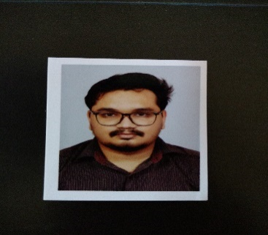

**Kaustubh Hemant Mishal**

**Phone: 09552863654**

**E-Mail: kaustubhm339@gmail.com**

**Ambitious professional targeting assignments in Quality Control/ Production Support/Web Development with an organization of high repute in Manufacturing/ IT industry**

**Location Preference: Mumbai/Pune/PAN India**

**ǁ Profile Summary ǁǁǁǁǁǁ**

* Focused & resourceful professional with skills in Manufacturing, Front-end Web Development, Bootstrap and Sales & Marketing to provide insights to management for organisational effectiveness
* Flair of utilizing modern tools, techniques & methods in the domain of Mechanical Engineering & Web Development
* Gained understanding in various concepts like Maintenance Engineering, Quality Control, Front-end Web Development, & Service Engineering, CAD Designing concepts during college
* Capability to work high in pressure environment with strict deadlines & multiple deliverables and providing effective service
* Exposure in Manufacturing Technology, Design & Optimization, Fabrication of Laser Plastic Welding & Bearing Washing Machine & Optimization of Car Muffler for Noise Reduction under academic projects
* Possess excellent communication, technical, analytical & relationship management skills by utilizing process-oriented approach towards the accomplishment of organizational goals

**ǁ Academic Project ǁǁǁǁǁǁ**

**Mini Project**

Title : Laser Plastic Welding

Area : Manufacturing Technology

Duration : Jan’15-May’15

Description :

* + - * It was the process of bonding plastic by using focused laser radiation
      * Laser plastic welding, which was referred as through-transmission welding

**Main Project**

Title : Bearing Washing Machine

Area : Maintenance (Manufacturing Industries)

Duration : Jun’10- Jun’11

Description : Fabrication of Bearing Washing Machine

Title : Optimization of Car Muffler for Noise Reduction

Area : Design and Optimization

Duration : Jul’15-Jun’16

Description : Research and Fabrication

Title : Front-end Development

Area : Web Designer

Duration : Nov’16 – till date

Description : Developed the Business Website for Aakruti Studios

**ǁ Certification ǁǁǁǁǁǁ**

* Pursuing certification course in Web Development/ Bootstrap/ Angular JS from Udemy

**ǁ Training/ Workshop ǁǁǁǁǁǁ**

* Attended workshop on Basics of CFD and FEM in September 2015, Pune

**ǁ Extracurricular Activities ǁǁǁǁǁǁ**

* Received prizes in several singing competitions in school
* Participated in L&T and Thakur Polytechnic at National Level Project Competition
* Engaged in Team Games Competition & an active Counterstrike player and won prizes
* Played cricket at university level

**ǁ Education ǁǁǁǁǁǁ**

* BE in Mechanical Engineering from Marathwada Mitramandal’s Institute of Technology, Pune University, Pune with 62.93% in 2016
* Diploma in Mechanical Engineering, Vidhyavardhini Bhausaheb Vartak Polytechnic, MSBTE, Vasai with 66.79% in 2011
* 10th Class from Dr. M.G. Pareulaekar Mitramandal’s, Maharashtra State Board, Vasai with 78.76% in 2008

**ǁ IT Skills ǁǁǁǁǁǁ**

* MS Office (Word, Excel and PowerPoint) & Internet Applications
* Front-end Web Development Language: HTML5, CSS3, JavaScript, jQuery Twitter Bootstrap
* CMS: WordPress
* Modelling Software: CATIA V5, Inventor, Ansys
* *Currently Learning: Node.js, Express, Angular 4

**ǁ Personal Details ǁǁǁǁǁǁ**

Date of Birth: 3rd March 1993

Languages Known: English, Marathi & Hindi

Permanent Address: F-102, New Venkatesh Apartment, Parnaka, Vasai (W)-401201

Date Signature