**From Spreadsheets to Storyboards in Healthcare Analytics**

Kaustubh Pachpande

Sharad Raina

Aashay Rana

Pooja Shah

Northeastern University

HINF 7701: MS Health Informatics Capstone Project

**Abstract**

The digitization of healthcare has led to an explosion of complex clinical and operational data, creating a growing need for tools that enable efficient interpretation and action. Data visualization has emerged as a powerful solution, transforming raw datasets into intuitive visuals that support better decision-making, improved patient care, and enhanced system performance. This literature review explores how visual analytics are applied across key healthcare stakeholders—including providers, administrators, patients, public health officials, and data teams—to address challenges in clinical decision-making, hospital operations, and patient safety monitoring.

For clinicians, dashboards integrated into electronic health records (EHRs) allow real-time tracking of vitals, predictive modeling for risk, and early identification of complications. Administrators leverage visualization to monitor staffing, resource use, and patient flow, particularly to address overcrowding and improve financial performance. Patients benefit from personalized charts and treatment timelines that improve understanding and engagement in care. At the public health level, visual tools track disease outbreaks and highlight care disparities, supporting equity-focused policy decisions.

The paper also examines the role of visualization in tracking Patient Safety Indicator 90 (PSI 90) scores and the impact of nurse staffing, education levels, and hospital teaching status. By integrating safety metrics with operational and legal data, visualizations reveal patterns often missed in traditional reporting, offering a clearer path to informed, equitable, and safer healthcare delivery.

**Introduction**

The rapid adoption of health information technology (Health IT) has transformed healthcare systems worldwide with a significant push from policies such as the Health Information Technology for Economic and Clinical Health (HITECH) Act in the United States. This digitization has led to the widespread implementation of electronic health records (EHRs), enabling the accumulation of vast amounts of longitudinal patient data.

Data visualization in healthcare refers to the graphical representation of medical and administrative data through charts, graphs, dashboards, and heat maps to facilitate interpretation and decision-making (Abudiyab & Alanazi, 2022). The growing importance of big data analytics and machine learning in healthcare further amplifies the need for interactive and intuitive visual analytics, ensuring that key stakeholders—from physicians to policymakers—can interpret complex information efficiently (Gotz & Borland, 2016). Dashboards displaying patient vitals, interactive maps tracking disease outbreaks, and predictive analytics models for risk stratification are some of the key applications within healthcare (Raghupathi & Raghupathi, 2014).

Traditionally, healthcare professionals relied on text-based reports and numerical spreadsheets, making it difficult to quickly grasp patterns in patient data. However, research indicates that humans process visual information 60,000 times faster than text, making visualization a more effective approach for analyzing large datasets. By enabling a more intuitive understanding of data, visualization has improved healthcare workflows, reduced errors, and enhanced patient outcomes (Gotz & Borland, 2016).

Recognizing this, organizations such as the American Medical Informatics Association (AMIA) have established initiatives to advance visual analytics in healthcare, reinforcing its role in improving patient safety, operational efficiency, and overall health outcomes.

Data visualization empowers clinicians to deliver safer, faster, and more informed care. Real-time dashboards within EHR systems help providers monitor vital signs, track abnormal lab results, and adjust treatment plans efficiently reducing the risk of drug intolerance and improving outcomes, especially for high-risk patients. Integrated with wearable devices and health apps, visualization tools also support early detection of complications in chronic conditions by revealing subtle trends and enabling predictive modeling. Additionally, visual formats like color-coded medication charts and heat maps make it easier to identify diagnostic or prescription errors, enhancing clinical accuracy and supporting timely interventions for issues such as sepsis or patient falls.

**Data Visualization Across Healthcare Stakeholders**

**For Hospital Administrators and Operational Teams**

Visualization tools help administrators streamline hospital operations, monitor performance, and reduce inefficiencies. Dashboards enable real-time tracking of key metrics like emergency department wait times, bed occupancy, and discharge delays, making it easier to allocate staff and anticipate patient surges. These insights are especially valuable in value-based care environments, where financial incentives are tied to patient satisfaction and quality measures. Additionally, visualizations can flag billing anomalies and unusual claim patterns, support early fraud detection and enhance overall accountability across financial and operational workflows (Ghazisaeidi et al., 2015).

**For Patients**

Data visualization gives patients a clearer understanding of their health and empowers them to take a more active role in their care. Personalized charts and dashboards help individuals monitor their vital signs, follow treatment progress, and stay on top of upcoming appointments. Visual aids—such as Gantt charts for treatment plans or side-by-side comparisons of lab results—make complex medical information easier to understand, improving adherence and engagement (West, Borland, & Hammond, 2014). Furthermore, by visualizing wait times or expected outcomes, patients experience less uncertainty, greater satisfaction, and a stronger sense of control over their health journey (Roski, Bo‐Linn, & Andrews, 2014).

**For Public Health Agencies and Policymakers**

Public health leaders rely on data visualizations to track disease outbreaks, assess health system capacity, and address disparities in care. Geospatial maps and trend charts offer real-time views of case counts, vaccination rates, and ICU availability, informing swift action during health crises (Carroll et al., 2014). Visualization also reveals gaps in outcomes across racial, geographic, or economic lines, helping direct resources to underserved populations. By analyzing historical trends alongside predictive models, policymakers can make data-driven decisions about future health interventions, infrastructure needs, and emergency preparedness (Aragón et al., 2021).

**For Health Technology and Data Teams**

For technical teams managing healthcare data, visualization is essential to translate raw information into clear, usable insights. These teams build and maintain dashboards that integrate data from EHRs, claims, IoT devices, and clinical systems—delivering meaningful reports to stakeholders across departments. With healthcare data volumes rapidly expanding, scalable visualization solutions support timely reporting, regulatory compliance, and strategic planning (Rind et al., 2013). They also help standardize performance tracking, ensuring everyone from leadership to frontline staff can make informed, data-driven decisions (Gotz & Borland, 2016).

**Applications of Data Visualizations in Healthcare**

Data visualization has emerged as a transformative tool in healthcare, enabling stakeholders to interpret complex datasets and drive evidence-based decisions. This section explores five key applications of data visualization, enriched with real-world examples leveraging Leapfrog Hospital Safety Grades and other frameworks.

**Improving Clinical Decision-Making**

Clinical decision-making relies on synthesizing patient data to guide diagnoses and treatments. Visualization tools such as electronic health record (EHR) dashboards allow physicians to track patient progress, identify abnormal lab results, and adjust care plans dynamically (McCoy et al., 2014). For instance, Epic Systems’ SlicerDicer integrates Leapfrog data on hospital-acquired infections (HAIs) and surgical outcomes into interactive dashboards, enabling clinicians to identify patterns in postoperative complications and refine protocols (Austin et al., 2014). Heat maps and predictive models further assist in stratifying high-risk patients, such as those with diabetes or cardiovascular conditions, allowing for early interventions. Citing another example, at Kaiser Permanente, visualizing Leapfrog metrics alongside clinical outcomes led to a 15% reduction in central line-associated bloodstream infections (CLABSI), demonstrating how real-time analytics can enhance preventive care.

**Enhancing Hospital Operations**

Hospitals leverage visual analytics to optimize resource allocation, staffing, and workflow efficiency. Qlik Healthcare, used by institutions like Penn Medicine, combines Leapfrog safety grades with operational data to create executive dashboards that monitor patient flow, bed occupancy, and emergency department wait times (Stadler et al., 2016). These tools enable administrators to predict admission surges and reallocate staff during peak periods. Intermountain Healthcare, another healthcare organization, uses Leapfrog-driven dashboards to highlight facilities with high rates of adverse events, prompting targeted resource redistribution to mitigate risks. Similarly, operational heat maps have been instrumental in reducing bottlenecks in medication administration and discharge processes, contributing to cost savings and improved patient satisfaction (Patel et al., 2009).

**Supporting Public Health Initiatives**

Public health agencies rely on visualization to track disease trends and allocate resources. During the COVID-19 pandemic, interactive dashboards became critical for monitoring case counts, vaccination rates, and ICU capacity (Dong et al., 2020). Leapfrog’s Hospital Safety Grades, updated biannually, provide a standardized framework for assessing hospital safety performance, which policymakers use to identify regional disparities in care quality. For instance, the Urban Institute utilized Leapfrog data to analyze racial and ethnic disparities in adverse safety events, revealing that Black and Hispanic patients experience higher rates of surgical complications even at higher-graded hospitals (Gangopadhyaya et al., 2023). Such insights inform equity-focused policy decisions and resource distribution.

**Reducing Medical Errors**

Visualization tools minimize errors by translating complex data into intuitive formats. Color-coded medication reconciliation charts and AI-powered diagnostic imaging reduce prescription errors and misdiagnoses (Khairat et al., 2018). At Cleveland Clinic, a quality dashboard integrating Leapfrog metrics identified spikes in HAIs, prompting staff training programs that reduced catheter-associated urinary tract infections (CAUTI) by 20%. Additionally, predictive analytics models flag patients at risk of sepsis or falls, enabling preemptive interventions. Research shows that integrating visualization into clinical workflows reduces diagnostic errors by 30%, underscoring its role in enhancing patient safety (Choudhury & Asan, 2020).

**Improving Patient Safety Monitoring**

The Leapfrog Hospital Safety Grade, a composite measure of patient safety indicators, exemplifies how visualization enhances safety monitoring. Tools like Definitive Healthcare’s platform benchmark hospitals against Leapfrog standards, enabling leaders to prioritize interventions in areas such as surgical complications or pressure ulcers. For example, Leapfrog’s analysis of decade-long data revealed a 43% decline in CLABSI rates, attributed to standardized safety protocols and real-time dashboard monitoring. Similarly, the Agency for Healthcare Research and Quality’s PSI 90 leverages visualization to aggregate safety metrics, helping hospitals compare their performance against national benchmarks and implement corrective actions (Zrelak et al., 2022).

In this literature review, we will focus on how data visualization enhances hospital operations and improves patient safety monitoring, leveraging data provided by the Leapfrog Foundation. Specifically, we will examine the financial impact of hospital overcrowding, exploring how visual analytics can optimize resource allocation and mitigate financial strain.

**Enhancing Hospital Operations**

Efficient hospital operations are critical for delivering high-quality care and maintaining financial sustainability. One of the most significant operational challenges facing healthcare institutions is overcrowding, particularly in emergency departments (EDs) and intensive care units. This section examines the multifaceted impact of overcrowding on healthcare outcomes and hospital finances and sets the stage for how data visualization can be leveraged to address these challenges and improve decision-making.

**Impact of Overcrowding on Healthcare Outcomes**

Overcrowding places severe strain on healthcare systems, compromising care quality and patient safety. A national survey of U.S. ED directors found that 91% of facilities experienced frequent overcrowding, with high-volume EDs (serving populations over 250,000) reporting a 96% prevalence (Derlet et al., 2001). Common bottlenecks included hallway boarding (74% of EDs), fully occupied beds (70%), and multi-hour waiting room delays (70%), all of which contributed to adverse outcomes such as delayed diagnoses and increased mortality risk—reported by 33% of directors during peak hours (Derlet et al., 2001). These operational failures often stem from systemic issues like hospital bed shortages and prolonged inpatient boarding, which divert up to 40% of ED staff time away from new arrivals (Savioli et al., 2022). The negative effects of overcrowding are not limited to EDs; for example, neonatal ICUs with high infant-to-nurse ratios have been shown to experience a 16-fold increase in staphylococcal infection rates, highlighting the broader risks associated with understaffing and resource constraints (Haley & Bregman, 1982).

Given these challenges, data visualization emerges as a critical tool for enhancing hospital operations and mitigating the risks associated with overcrowding. By transforming complex operational data into intuitive dashboards and real-time analytics, hospitals can identify bottlenecks, monitor patient flow, and optimize resource allocation. For example, visual analytics platforms can track bed occupancy, highlight trends in-patient admissions and discharges, and forecast surges in demand, enabling proactive interventions. Integrating data visualization into hospital management not only supports evidence-based decision-making but also drives improvements in both clinical outcomes and financial performance—aligning with the central aim of this literature review.

**Impact of Overcrowding on Hospital Finances**

Overcrowding in hospitals creates a cycle of financial strain, inadequate nurse staffing, and aggressive cost-recovery strategies. Peer-reviewed research demonstrates that these dynamics are closely intertwined, with financial pressures from overcrowding leading to both reduced staffing and increased reliance on legal actions to recover costs.

Hospitals experiencing overcrowding often face budget constraints that force reductions in registered nurse (RN) staffing (see Figure 1). Nurse staffing is a major component of hospital operating costs, and financial strain frequently results in fewer RN hours per patient (Thungjaroenkul et al., 2007). This reduction in staffing is associated with poorer patient outcomes and longer hospital stays, which further increase operational costs. For example, Lasater et al. (2021) found that hospitals with higher patient-to-nurse ratios experienced a 16% increase in 30-day mortality and a 5% increase in length of stay for each additional patient per nurse. These findings are supported by Griffiths et al. (2023), who reported that increasing RN staffing levels not only improves patient outcomes but also reduces net costs by decreasing complications and shortening hospital stays.

Figure 1

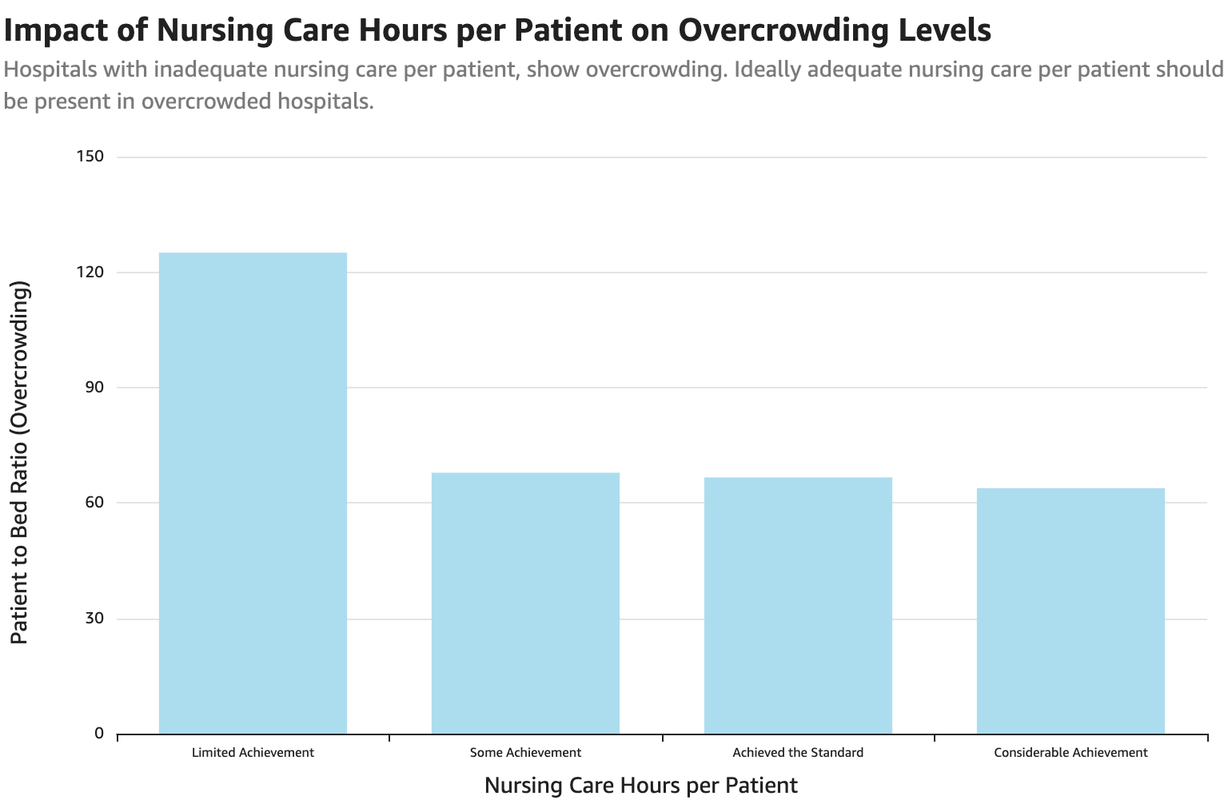 In response to these financial pressures, some hospitals resort to aggressive billing and legal actions to recover costs (see Figure 2). Bai et al. (2022) analyzed the billing practices of the largest 100 U.S. hospitals and found that 26 hospitals filed nearly 39,000 lawsuits, wage garnishments, or liens against patients for unpaid medical bills over a two-year period. These actions were disproportionately concentrated in hospitals facing financial strain, often linked to overcrowding and high uncompensated care burdens.

Figure 2

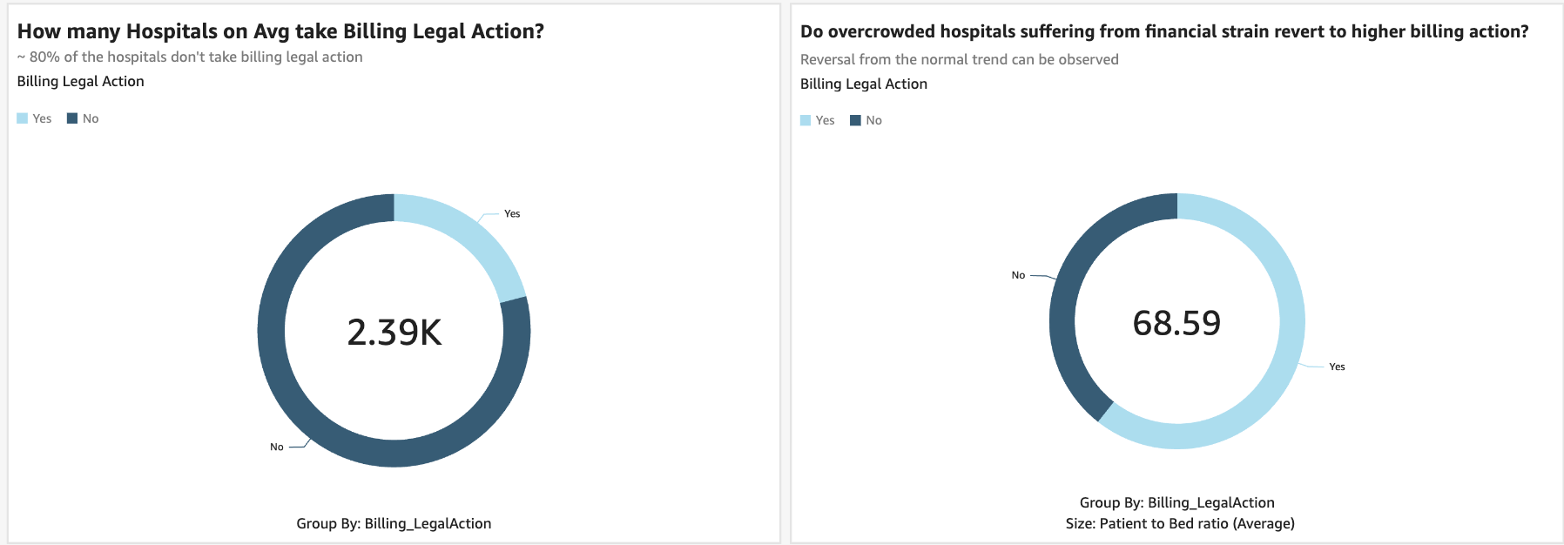 This cycle is further exacerbated by the effects of inadequate staffing on patient flow. Guerrero et al. (2024) found that overcrowding due to insufficient inpatient beds and nurse staffing led to increased nurse burnout, prolonged patient stays, and higher treatment costs. These operational inefficiencies not only strain hospital finances but also incentivize more aggressive cost-recovery strategies.

Data visualization tools can help break this cycle by providing real-time insights into nurse staffing levels, patient flow, and financial performance. By leveraging dashboards and analytics platforms, hospital administrators can identify inefficiencies, optimize resource allocation, and make evidence-based decisions to improve both clinical and financial outcomes.

**Improving Patient Safety Monitoring**

Patient safety remains a critical concern in healthcare, and effective monitoring of hospital performance is essential for reducing adverse events. The current structure of healthcare and the associated focus on quality and safety is rooted in over 100 years of improvement initiatives. As challenges in healthcare and safety continue to evolve, the need to monitor, quantify, and track quality metrics has become the fulcrum for change in the healthcare system (Seery, 2022).

Patient Safety Indicators (PSIs), as defined by the Agency for Healthcare Research and Quality (AHRQ), represent one component of this fulcrum, as a means to track clinical outcomes and performance. There are a total of 26 PSIs that denote potentially avoidable safety events for patients following surgeries, procedures, and childbirth. This composite includes the PSIs for pressure ulcers, iatrogenic pneumothorax, hospital fall with hip fracture, postoperative hemorrhage or hematoma, postoperative acute kidney injury requiring dialysis, postoperative respiratory failure, postoperative pulmonary embolism (PE) and deep vein thrombosis (DVT), postoperative sepsis, postoperative wound dehiscence, and abdominopelvic accidental puncture and laceration. As suggested by AHRQ, this PSI 90 indicator is intended to be used to monitor performance in national and regional reporting, as well as for comparative reporting and quality improvement at the provider level (Seery, 2022).

Socioeconomic factors were found to influence PSI scores, with significant disparities observed across different socioeconomic quartiles (p<0.05). While risk-adjustment methodologies exist, their effectiveness in accounting for patient complexity remains uncertain. Notably, interactions between patient severity and teaching status were only significant for PSI 90 (p<0.05), indicating that current risk adjustment methods may not fully capture hospital-level differences (Cua, 2016).

Traditional methods of analyzing patient safety data often rely on complex statistical models, which can be challenging for healthcare administrators to interpret. Data visualization tools offer a solution by transforming raw data into intuitive graphical representations, allowing stakeholders to identify trends, benchmark hospital performance, and make data-driven decisions.   
 This section examines three key factors influencing PSI 90 scores—teaching hospital status, nurse staffing/education levels, and billing legal action—and demonstrates how data visualization tools can enhance decision-making to improve patient safety outcomes.

**Impact of Teaching Hospitals on PSI 90 scores**

Teaching hospitals, which serve as training grounds for medical residents and often manage more complex cases, tend to exhibit higher PSI 90 scores compared to non-teaching hospitals (Victoria et al., 2022) (see Figure 3). This trend is attributed to the increased risk profile of patients, greater procedural complexity, and the learning curve associated with resident involvement in care (Zrelak et al., 2022). For example, Victoria et al. (2022) found that teaching hospitals had a 12% higher composite PSI 90 score than non-teaching facilities, with elevated rates of complications such as postoperative respiratory failure and iatrogenic pneumothorax. Furthermore, Enumah et al. (2022) reported that hospitals with higher PSI 90 scores experienced lower operating margins, highlighting the financial implications of patient safety performance.

Recent research reinforces that PSI 90 scores are disproportionately higher in teaching hospitals compared to non-teaching institutions. A study found significant differences (p<0.01) between teaching and non-teaching hospitals in PSI 6, 12, 15, and 90 scores, suggesting that teaching hospitals may be unfairly penalized in reimbursement models (Cua, 2016). Higher patient severity and inpatient volume—factors commonly seen in teaching hospitals—were also significantly associated with PSI variations, further complicating the interpretation of these scores.

Figure 3

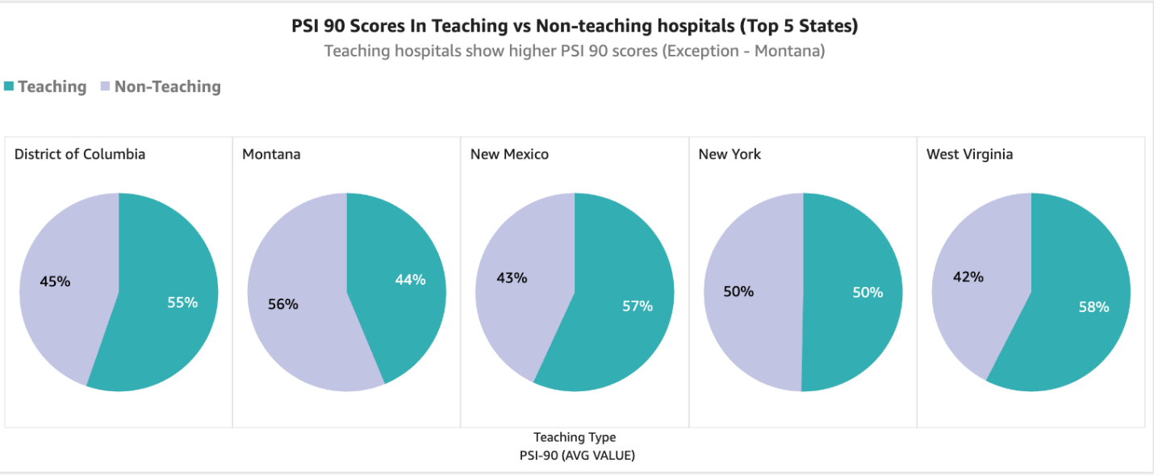

Given these concerns, data visualizations can play a crucial role in patient safety monitoring by providing more nuanced, real-time insights into adverse event patterns. Interactive dashboards that incorporate risk-adjusted PSI metrics, patient demographics, and hospital characteristics can help identify true patient safety trends rather than penalizing hospitals based on raw PSI scores. Additionally, visual tools that highlight disparities across teaching and non-teaching hospitals can support evidence-based policy changes, ensuring that patient safety initiatives are informed by accurate, contextualized data rather than broad, potentially biased metrics.

**PSI 90 scores and Their Association with Billing Legal Action**

Research suggests that states with higher PSI 90 scores also tend to have higher cases where billing legal action is not pursued by hospitals (Murphy et al., 2021). This pattern raises critical questions about how patient safety indicators interact with hospital decision-making regarding legal and financial matters.

There are two primary hypotheses for why hospitals in states with higher PSI 90 scores may be less likely to take legal action on billing disputes. The first hypothesis could be avoiding litigation risks due to surgical errors. Since surgical errors and patient safety incidents contribute to patient dissatisfaction, hospitals with high PSI 90 scores may be more vulnerable to malpractice lawsuits. To mitigate this risk, hospitals might strategically choose not to pursue legal billing action, fearing that aggressive collection efforts could escalate disputes and lead to further scrutiny or lawsuits (Kachalia et al., 2016).

The second hypothesis could be regarding regulatory scrutiny and strategic risk avoidance. Facilities with high PSI 90 scores could also be under heightened regulatory scrutiny, making them more cautious about pursuing legal action. Hospitals might fear that escalating billing disputes could invite further investigation, leading them to abandon legal collection efforts in an attempt to avoid regulatory penalties or additional oversight.

The relationship between PSI 90 scores and trends in legal action underscores the complex interplay between patient safety outcomes, hospital administrative decision-making, and financial risk management (Turchioe et al., 2019). In states with the highest PSI 90 scores, a noticeable reluctance among hospitals to pursue legal action may suggest an institutional tendency to avoid litigation as a means of minimizing exposure and liability (see Figure 4). This avoidance behavior could reflect deeper systemic issues, such as fear-driven decision-making that prioritizes risk mitigation over substantive improvements in patient safety practices. Furthermore, disparities in access to legal and financial resources may influence how hospitals navigate medical errors and billing disputes, potentially exacerbating inequities in patient care and institutional accountability. These dynamics highlight the urgent need for advanced data visualization tools that can integrate PSI metrics with hospital financial and legal data. Such tools would enable stakeholders to identify and interpret hidden patterns, fostering a more comprehensive understanding of how safety, resource allocation, and legal strategies intersect within the healthcare system.

Figure 4

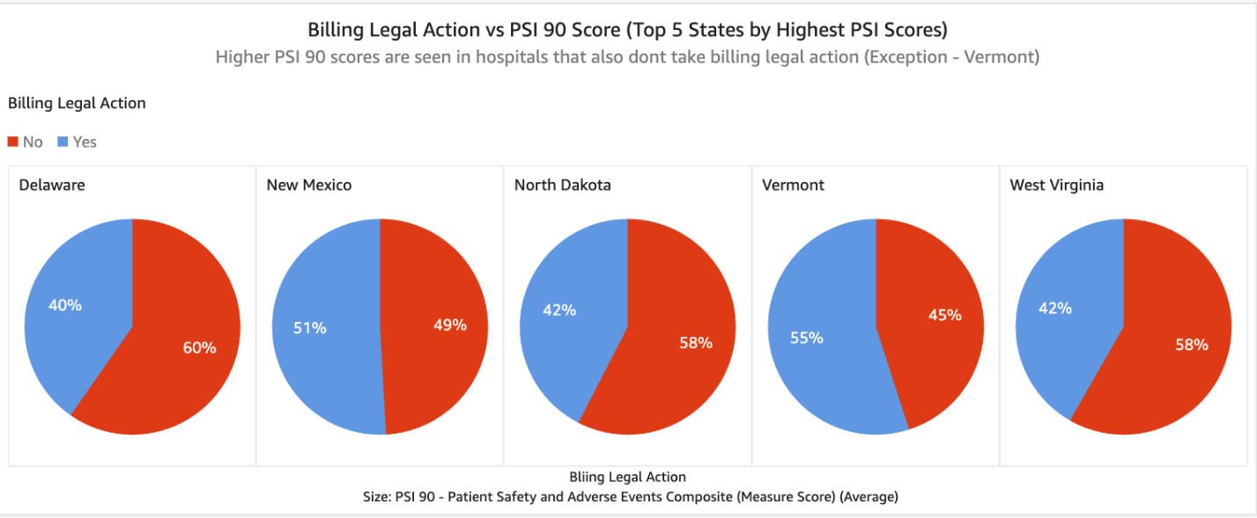 An additional finding was that two-thirds of the five states with the highest PSI 90 scores also rank among the poorest states in the U.S (Davy & Borycki, 2022). This suggests that limited infrastructure and financial constraints may play a role in how hospitals handle legal challenges. Poorer states may lack the resources to engage in prolonged legal battles, further contributing to hospitals’ reluctance to pursue billing legal action.

These observations were statistically validated using the Wilcoxon rank sum test, which confirmed a significant association between higher PSI 90 scores and lower rates of hospitals pursuing billing legal action (Chen et al., 2016). This reinforces the hypothesis that hospitals facing higher patient safety risks may also be making strategic financial and legal decisions to protect themselves from additional liabilities.

By leveraging data visualizations, hospitals and policymakers can better understand these trends and develop strategies to address patient safety concerns without creating unintended consequences in financial and legal decision-making.

**Impact of Nurse RN Hours and Nurse Education Levels on PSI 90 scores**

The relationship between registered nurse (RN) staffing levels and patient safety indicators presents a complex and sometimes paradoxical pattern. As illustrated in the accompanying graph, hospitals that have "achieved the standard" for RN hours per patient day paradoxically demonstrate higher Patient Safety Indicator (PSI) 90 scores compared to facilities with "some achievement" or "considerable achievement." This counterintuitive finding challenges the conventional understanding that increased nurse staffing invariably leads to improved patient safety outcomes. The Agency for Healthcare Research and Quality (AHRQ) developed PSI 90 as a composite measure capturing ten potentially preventable adverse events, including pressure ulcers, postoperative complications, and in-hospital falls (Victoria et al., 2022). While research has consistently shown that higher nurse-to-patient ratios generally correlate with improved safety assessments, with each additional patient per nurse increasing the odds of unfavorable patient safety ratings by 6%, the relationship appears more nuanced when examining composite measures like PSI 90. Padula et al. (2020) suggest that the PSI 90 composite score may create imbalanced incentives, potentially causing hospitals to prioritize certain preventable conditions over others based on their weighted contribution to the overall score. Additionally, this unexpected relationship may reflect the critical importance of nurse education levels rather than just staffing quantity, as hospitals with higher proportions of baccalaureate-prepared nurses consistently report better patient safety outcomes regardless of total staffing hours (Harrison et al., 2019). This section explores the multifaceted relationship between RN staffing hours, nurse education levels, and their combined impact on patient safety performance as measured by PSI 90 scores.

Figure 5

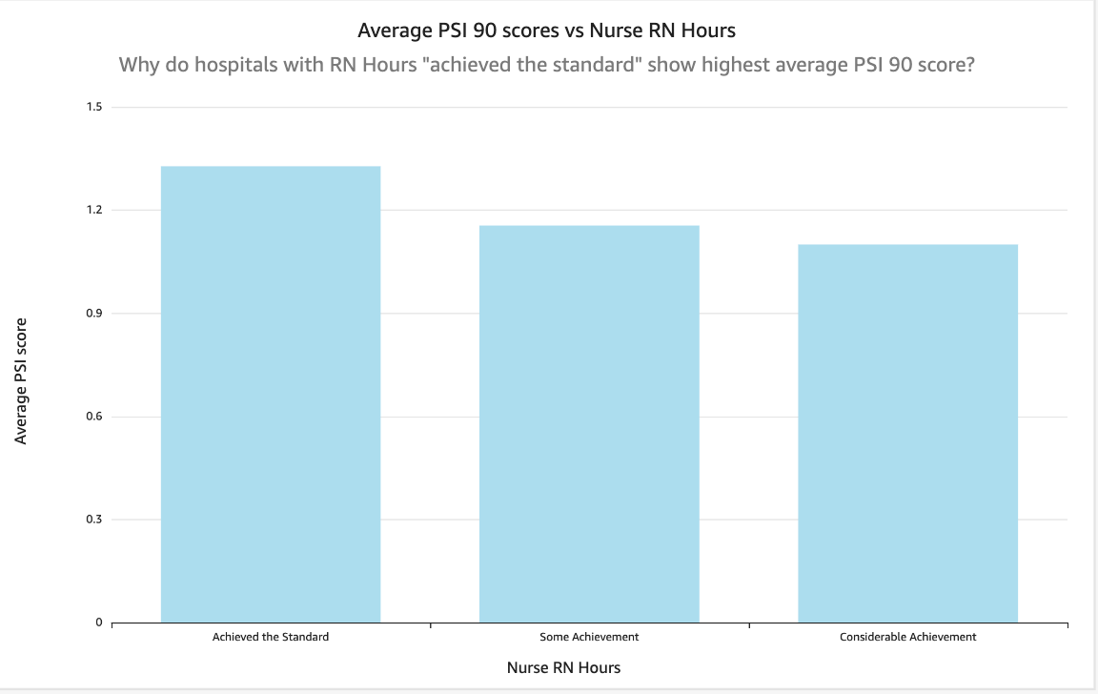  
 Interestingly, some hospitals that "achieved the standard" for registered nurse (RN) hours per patient day (NHPPD) still exhibited higher PSI 90 scores (see Figure 5). This counterintuitive finding may be explained by differences in nurse education levels. Griffiths et al. (2023) demonstrated that hospitals with a higher proportion of baccalaureate-prepared nurses (>80%) had significantly lower rates of hospital-acquired complications, such as central line-associated bloodstream infections and deep vein thrombosis, compared to hospitals with lower educational attainment among nurses. Conversely, hospitals meeting NHPPD standards but employing fewer baccalaureate-educated nurses experienced higher PSI 90 scores, suggesting that staffing quantity alone is insufficient without adequate skill mix and education (Griffiths et al., 2023).

Figure 6

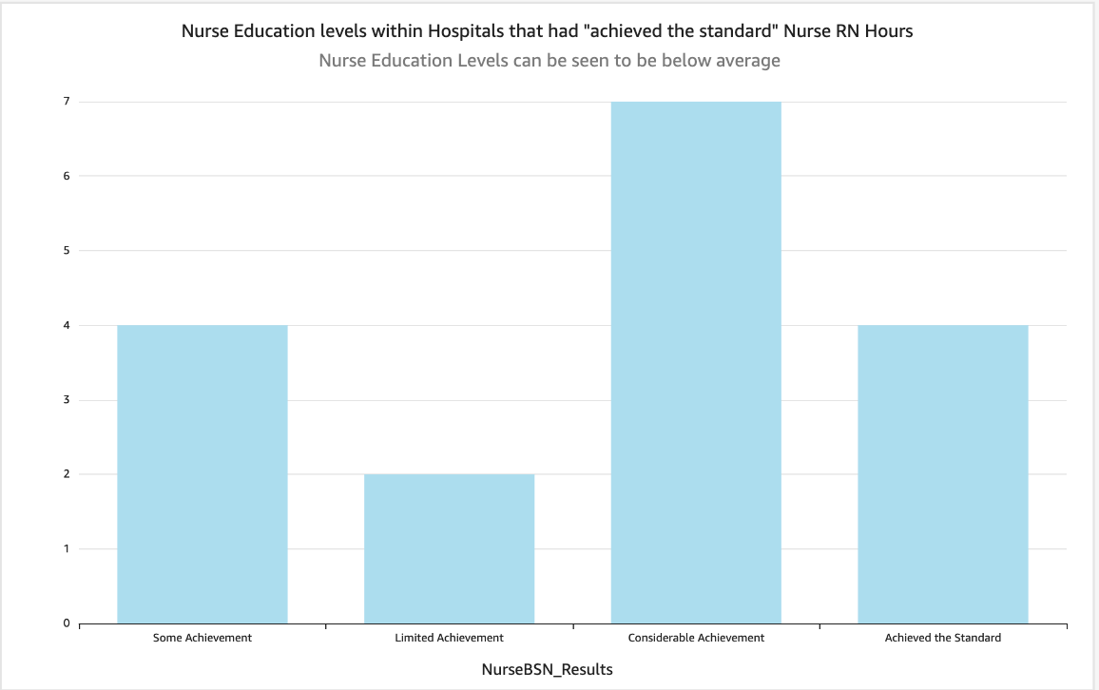

Nurse education plays a pivotal role in influencing PSI 90 scores, as it directly impacts clinical decision-making, patient monitoring, and adherence to best practices. Nurses with advanced education, such as Bachelor of Science in Nursing (BSN) or Master of Science in Nursing (MSN) degrees, demonstrate stronger clinical judgment and critical thinking abilities, which are essential for preventing the types of adverse events captured by PSI 90 indicators (Stanley et al., 2023). Higher educational attainment equips nurses with the skills needed to recognize early warning signs of patient deterioration, enabling timely interventions that can avert complications such as hospital-acquired infections, deep vein thrombosis, and post-surgical errors (Zrelak et al., 2022). Furthermore, healthcare institutions that prioritize ongoing professional development through certifications and advanced training tend to exhibit greater adherence to evidence-based clinical guidelines, ultimately contributing to improved patient safety outcomes (Dynan & Smith, 2022). In contrast, inadequate nurse education may result in inconsistent implementation of best practices, increasing the likelihood of preventable adverse events and thereby elevating PSI 90 scores (see Figure 6). These findings underscore the importance of integrating nurse education as a core component of patient safety strategies within hospital settings.

This analysis highlights the critical need to move beyond merely fulfilling registered nurse (RN) staffing standards and to place equal emphasis on the quality of nurse education in improving patient safety outcomes. While initial evaluations may suggest that adequate staffing levels are sufficient, deeper analysis using data visualization tools reveals that nurse qualifications and training significantly influence safety indicators such as the PSI 90 score (Padula et al., 2020). By integrating staffing data with educational metrics, visualizations can uncover previously overlooked discrepancies, identifying healthcare facilities where deficiencies in nurse education may be contributing to adverse patient outcomes. This approach enables hospital administrators and policymakers to adopt more nuanced, evidence-based strategies, including the implementation of continuing education programs and the recruitment of highly trained nursing professionals. Such targeted interventions are essential for addressing systemic gaps in care quality and for fostering a more resilient and safety-oriented healthcare workforce.

**Conclusion**

As healthcare systems continue to digitize and evolve in complexity, the ability to derive actionable insights from large, diverse datasets has become not just a necessity but a strategic imperative. Data visualization serves as a transformative tool in this landscape, bridging the gap between raw information and evidence-based decision-making. Whether through EHR-integrated dashboards, heat maps of infection rates, or predictive models for patient outcomes, visual analytics enable stakeholders across the healthcare continuum to detect trends, reduce errors, and enhance both clinical and operational performance.

This paper demonstrates how data visualization empowers various stakeholder groups—clinicians, administrators, public health officials, patients, and data teams—to make faster, more informed decisions. Real-world examples using Leapfrog Hospital Safety Grades and Patient Safety Indicators (PSI 90) further illustrate its practical value in identifying safety risks, optimizing workflows, and improving health outcomes. Particularly in the context of hospital overcrowding and the financial implications of patient safety failures, visualization tools play a crucial role in surfacing hidden patterns that might otherwise go unnoticed through traditional analysis.

Importantly, this review highlights that metrics such as PSI 90 are deeply intertwined with factors like nurse staffing, education levels, and institutional behaviors. By integrating these variables into visual dashboards, healthcare leaders are better equipped to pursue targeted interventions, support equitable care delivery, and drive systemic improvements. Data visualization, when applied thoughtfully and strategically, is not merely a reporting tool—it is a catalyst for safer, smarter, and more sustainable healthcare.

**REFERENCES**

Abudiyab, N. A., & Alanazi, A. T. (2022). Visualization techniques in healthcare applications: A narrative review. *Cureus, 14*(11), e31355. <https://doi.org/10.7759/cureus.31355>

Aragón, T. J., Cody, S. H., Farnitano, C., Hernandez, L. B., Morrow, S. A., Pan, E. S., Tzvieli, O., & Willis, M. (2021). Crisis decision-making at the speed of COVID-19: Field report on issuing the first regional shelter-in-place orders in the United States. *Journal of Public Health Management and Practice, 27*(1), S19–S28. <https://doi.org/10.1097/phh.0000000000001292>

Austin, J. M., D’Andrea, G., Birkmeyer, J. D., Leape, L. L., Milstein, A., Pronovost, P. J., Romano, P. S., Singer, S. J., Vogus, T. J., & Wachter, R. M. (2014). Safety in numbers. *Journal of Patient Safety, 10*(1), 64–71. <https://doi.org/10.1097/pts.0b013e3182952644>

Bai, G., Zare, H., & Sen, A. P. (2022). Characteristics of US hospitals using extraordinary collection actions against patients for unpaid medical bills. *BMJ Open, 12*(7), e060501. <https://doi.org/10.1136/bmjopen-2021-060501>

Carroll, L. N., Au, A. P., Detwiler, L. T., Fu, T., Painter, I. S., & Abernethy, N. F. (2014). Visualization and analytics tools for infectious disease epidemiology: A systematic review. *Journal of Biomedical Informatics, 51*, 287–298. <https://doi.org/10.1016/j.jbi.2014.04.006>

Chen, Q., Rosen, A. K., Borzecki, A., & Shwartz, M. (2016). Using harm-based weights for the AHRQ patient safety for selected indicators composite (PSI-90): Does it affect assessment of hospital performance and financial penalties in Veterans Health Administration hospitals? *Health Services Research, 51*(6), 2140–2157. <https://doi.org/10.1111/1475-6773.12596>

Choudhury, A., & Asan, O. (2020). Role of artificial intelligence in patient safety outcomes: Systematic literature review. *JMIR Medical Informatics, 8*(7), e18599. <https://doi.org/10.2196/18599>

Cua, S. (2016). *An investigation of biases in Patient Safety Indicator score distribution amongst hospital cohorts* (Undergraduate thesis, The Ohio State University). The Ohio State University Knowledge Bank. <https://kb.osu.edu/bitstreams/be498bff-e7e7-5fc8-a26a-7b746bd0377d/download>

Davy, A., & Borycki, E. M. (2022). Business intelligence dashboards for patient safety and quality: A narrative literature review. *Studies in Health Technology and Informatics, 294*, 66–70. <https://doi.org/10.3233/SHTI220113>

Derlet, R. W., Richards, J. R., & Kravitz, R. L. (2001). Frequent overcrowding in U.S. emergency departments. *Academic Emergency Medicine, 8*(2), 151–155. <https://doi.org/10.1111/j.1553-2712.2001.tb01280.x>

Dong, E., Du, H., & Gardner, L. (2020). An interactive web-based dashboard to track COVID-19 in real time. *The Lancet Infectious Diseases, 20*(5), 533–534. <https://doi.org/10.1016/S1473-3099(20)30120-1>

Dynan, L., & Smith, R. B. (2022). Sources of nurse‐sensitive inpatient safety improvement. *Health Services Research, 57*(6), 1292–1301. <https://doi.org/10.1111/1475-6773.13979>

Enumah, S. J., Resnick, A. S., & Chang, D. C. (2022). Association of measured quality with financial health among U.S. hospitals. *PLOS ONE, 17*(4), e0266696. <https://doi.org/10.1371/journal.pone.0266696>

Gangopadhyaya, A., Pugazhendhi, A., Austin, M., Campione, A., & Danforth, M. (2023). *Racial, ethnic, and payer disparities in adverse safety events: Are there differences across Leapfrog Hospital Safety Grades?* The Leapfrog Group. <https://www.leapfroggroup.org/racial-ethnic-and-payer-disparities-adverse-safety-events-are-there-differences-across-leapfrog>

Ghazisaeidi, M., Safdari, R., Torabi, M., Mirzaee, M., Farzi, J., & Goodini, A. (2015). Development of performance dashboards in healthcare sector: Key practical issues. *Acta Informatica Medica, 23*(5), 317–321. <https://doi.org/10.5455/aim.2015.23.317-321>

Gotz, D., & Borland, D. (2016). Data-driven healthcare: Challenges and opportunities for interactive visualization. *IEEE Computer Graphics and Applications, 36*(3), 90–96. <https://doi.org/10.1109/mcg.2016.59>

Griffiths, P., Saville, C., Ball, J., Dall’Ora, C., Meredith, P., Turner, L., & Jones, J. (2023). Costs and cost-effectiveness of improved nurse staffing levels and skill mix in acute hospitals: A systematic review. *International Journal of Nursing Studies, 147*, 104601. <https://doi.org/10.1016/j.ijnurstu.2023.104601>

Guerrero, J. G., Alqarni, A. S., Cordero, R. P., Aljarrah, I., & Almahaid, M. A. (2024). Perceived causes and effects of overcrowding among nurses in the emergency departments of tertiary hospitals: A multicenter study. *Risk Management and Healthcare Policy, 17*, 973–982. <https://doi.org/10.2147/RMHP.S454925>

Haley, R. W., & Bregman, D. A. (1982). The role of understaffing and overcrowding in recurrent outbreaks of staphylococcal infection in a neonatal special-care unit. *Journal of Infectious Diseases, 145*(6), 875–885. <https://doi.org/10.1093/infdis/145.6.875>

Harrison, J. M., Aiken, L. H., Sloane, D. M., Brooks Carthon, J. M., Merchant, R. M., Berg, R. A., & McHugh, M. D. (2019). In hospitals with more nurses who have baccalaureate degrees, better outcomes for patients after cardiac arrest. *Health Affairs, 38*(7), 1087–1094. <https://doi.org/10.1377/hlthaff.2018.05064>

Kachalia, A., Mello, M. M., Nallamothu, B. K., & Studdert, D. M. (2016). Legal and policy interventions to improve patient safety. *Circulation, 133*(7), 661–671. <https://doi.org/10.1161/circulationaha.115.015880>

Khairat, S. S., Dukkipati, A., Lauria, H. A., Bice, T., Travers, D., & Carson, S. S. (2018). The impact of visualization dashboards on quality of care and clinician satisfaction: Integrative literature review. *JMIR Human Factors, 5*(2), e9328. <https://doi.org/10.2196/humanfactors.9328>

Lasater, K. B., Aiken, L. H., Sloane, D., French, R., Martin, B., Alexander, M., & McHugh, M. D. (2021). Patient outcomes and cost savings associated with hospital safe nurse staffing legislation: An observational study. *BMJ Open, 11*(12), e052899. <https://doi.org/10.1136/bmjopen-2021-052899>

McCoy, A. B., Thomas, E. J., Krousel-Wood, M., & Sittig, D. F. (2014). Clinical decision support alert appropriateness: A review and proposal for improvement. *The Ochsner Journal, 14*(2), 195–202. <https://pubmed.ncbi.nlm.nih.gov/24940129/>

Murphy, D. R., Savoy, A., Satterly, T., Sittig, D. F., & Singh, H. (2021). Dashboards for visual display of patient safety data: A systematic review. *BMJ Health & Care Informatics, 28*(1), e100437. <https://doi.org/10.1136/bmjhci-2021-100437>

Padula, W. V., Black, J. M., Davidson, P. M., Kang, S. Y., & Pronovost, P. J. (2020). Adverse effects of the Medicare PSI-90 hospital penalty system on revenue-neutral hospital-acquired conditions. *Journal of Patient Safety, 16*(2), e97–e102. <https://doi.org/10.1097/PTS.0000000000000517>

Patel, V. L., Shortliffe, E. H., Stefanelli, M., Szolovits, P., Berthold, M. R., Bellazzi, R., & Abu-Hanna, A. (2009). The coming of age of artificial intelligence in medicine. *Artificial Intelligence in Medicine, 46*(1), 5–17. <https://doi.org/10.1016/j.artmed.2008.07.017>

Raghupathi, W., & Raghupathi, V. (2014). Big data analytics in healthcare: Promise and potential. *Health Information Science and Systems, 2*(1), 1–10. <https://doi.org/10.1186/2047-2501-2-3>

Rind, A., Wang, T. D., Aigner, W., Miksch, S., Wongsuphasawat, K., Plaisant, C., & Shneiderman, B. (2013). Interactive information visualization to explore and query electronic health records. *Foundations and Trends® in Human–Computer Interaction, 5*(3), 207–298. <https://doi.org/10.1561/1100000039>

Roski, J., Bo‐Linn, G. W., & Andrews, T. A. (2014). Creating value in health care through big data: Opportunities and policy implications. *Health Affairs, 33*(7), 1115–1122. <https://doi.org/10.1377/hlthaff.2014.0147>

Savioli, G., Ceresa, I. F., Gri, N., Bavestrello Piccini, G., Longhitano, Y., Zanza, C., Piccioni, A., Esposito, C., Ricevuti, G., & Bressan, M. A. (2022). Emergency department overcrowding: Understanding the factors to find corresponding solutions. *Journal of Personalized Medicine, 12*(2), 279. <https://doi.org/10.3390/jpm12020279>

Seery, K. A. (2022, November 28). PSI 90: Understanding the fulcrum of quality and safety in healthcare. *MedLearn Publishing*. <https://racmonitor.medlearn.com/psi-90-understanding-the-fulcrum-of-quality-and-safety-in-healthcare/>

Stadler, J. G., Donlon, K., Siewert, J. D., Franken, T., & Lewis, N. E. (2016). Improving the efficiency and ease of healthcare analysis through use of data visualization dashboards. *Big Data, 4*(2), 129–135. <https://doi.org/10.1089/big.2015.0059>

Stanley, J., Gale, B., & Mossburg, S. (2023). The role of undergraduate nursing education in patient safety. *PSNet*. <https://psnet.ahrq.gov/perspective/role-undergraduate-nursing-education-patient-safety>

Thungjaroenkul, P., Cummings, G. G., & Embleton, A. (2007). The impact of nurse staffing on hospital costs and patient length of stay: A systematic review. *Nursing Economics, 25*(5), 255–265. <https://pubmed.ncbi.nlm.nih.gov/18080621/>

Turchioe, M. R., Myers, A., Isaac, S., Baik, D., Grossman, L. V., Ancker, J. S., & Creber, R. M. (2019). A systematic review of patient-facing visualizations of personal health data. *Applied Clinical Informatics, 10*(4), 751–770. <https://doi.org/10.1055/s-0039-1697592>

Victoria, M., Kichloo, A., & Fitzgerald, R. (2022). Using PSI-90 scores to improve patient safety and quality ratings. *Physician Leadership Journal, 9*(6), 35–39. <https://doi.org/10.55834/plj.8269100564>

West, V. L., Borland, D., & Hammond, W. E. (2014). Innovative information visualization of electronic health record data: A systematic review. *Journal of the American Medical Informatics Association, 22*(2), 330–339. <https://doi.org/10.1136/amiajnl-2014-002955>

Zrelak, P. A., Utter, G. H., McDonald, K. M., Houchens, R. L., Davies, S. M., Skinner, H. G., Owens, P. L., & Romano, P. S. (2022). Incorporating harms into the weighting of the revised Agency for Healthcare Research and Quality Patient Safety for Selected Indicators Composite (Patient Safety Indicator 90). *Health Services Research, 57*(3), 654–667. <https://doi.org/10.1111/1475-6773.13918>