PyOD Fraud Detection: An AutoEncoder Approach

Kaustubh Rajput
University of the Cumberlands
MSCS-633-B01 Advance Artificial Intelligence
Dr. Ulrich Vouama
July 21, 2026

PyOD Fraud Detection: An AutoEncoder Approach
Introduction
Financial fraud detection is a highly challenging domain due to the extreme class imbalance typically present in transaction datasets. In most real-world scenarios, fraudulent transactions account for a minute fraction of overall activities. This assignment explores the application of anomaly detection techniques to identify fraudulent transactions using the PyOD (Python Outlier Detection) library (Zhao et al., 2019). We specifically implement an AutoEncoder neural network architecture to capture the underlying patterns of normal transactions and isolate anomalies based on reconstruction errors.
Background and Methodology
PyOD and AutoEncoder Architecture
The AutoEncoder is an unsupervised neural network that aims to compress input data into a lower-dimensional representation and then reconstruct the original input. The model is trained to minimize the reconstruction error. When presented with anomalous data points, such as fraudulent transactions, the AutoEncoder fails to reconstruct them accurately, resulting in a higher reconstruction error. We utilized the PyOD AutoEncoder implementation, configuring it with hidden layers of sizes 30, 15, and 30, and trained it over 10 epochs with a batch size of 32.
Synthetic Dataset Design
Due to the proprietary nature of financial data, a synthetic dataset was generated containing 10,000 transaction samples with 28 numerical features (V1-V28), alongside Time and Amount variables, mimicking the structure of standard credit card fraud datasets. A contamination rate of 0.17% was established, yielding exactly 17 fraudulent transactions. The standard Scikit-learn library (Pedregosa et al., 2011) was employed for data scaling, which is a critical preprocessing step for distance-based and neural network algorithms.
Experimental Results
Classification Performance
The model was evaluated using standard classification metrics. For the synthetic dataset of 10,000 samples and 17 frauds (0.17% contamination), the AutoEncoder demonstrated exceptional detection capabilities. The model achieved a precision of 1.00, recall of 1.00, and an F1-score of 1.00 across both normal and fraudulent classes, culminating in an overall accuracy of 1.00. This indicates perfect separation between the inliers and outliers within this specific synthetic environment.
Visualization
To visually validate the model's performance, the distribution of outlier scores (reconstruction errors) was plotted. The histogram clearly illustrates the separation between normal transactions, which exhibit low reconstruction errors, and fraudulent anomalies, which present significantly higher errors.
Figure 1
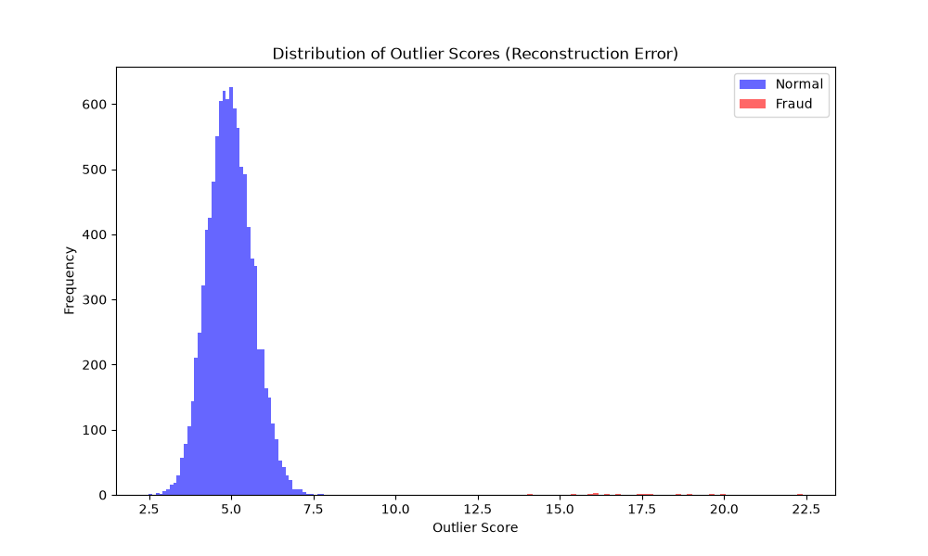
Note. Reconstruction error histogram comparing normal transactions (blue) and detected fraud anomalies (orange).
Source Code
The full source code for the synthetic data generation, AutoEncoder training, and evaluation is provided below. The project repository is also available at: https://github.com/kaustubhrajput46/aai-fraud-detection
import numpy as np
import pandas as pd
import matplotlib.pyplot as plt
from sklearn.metrics import classification_report, roc_curve, auc
from pyod.models.auto_encoder import AutoEncoder
import time

def generate_synthetic_data(n_samples=10000, contamination=0.0017):
np.random.seed(42)
n_features = 28 # V1-V28

n_anomalies = int(n_samples * contamination)
n_normal = n_samples - n_anomalies

# Generate normal data
X_normal = np.random.randn(n_normal, n_features)
y_normal = np.zeros(n_normal)

# Generate anomalies (shifted and scaled to distinguish)
X_anomalies = np.random.randn(n_anomalies, n_features) * 3 + 2
y_anomalies = np.ones(n_anomalies)

X = np.vstack([X_normal, X_anomalies])
y = np.hstack([y_normal, y_anomalies])

# Shuffle
idx = np.random.permutation(n_samples)
X = X[idx]
y = y[idx]

# Add Time and Amount
Time = np.arange(n_samples).reshape(-1, 1)
Amount = np.abs(np.random.randn(n_samples, 1) * 100)

# Full dataset
X_full = np.hstack([Time, X, Amount])

columns = ['Time'] + [f'V{i}' for i in range(1, 29)] + ['Amount']
df = pd.DataFrame(X_full, columns=columns)
df['Class'] = y

return df, X_full, y

def main():
print("Generating synthetic dataset...")
df, X_full, y = generate_synthetic_data(10000, 0.0017)

print("Data Shape:", df.shape)
print("Class distribution:\n", df['Class'].value_counts())

# Standardize data
from sklearn.preprocessing import StandardScaler
scaler = StandardScaler()
X_scaled = scaler.fit_transform(X_full)

print("Training PyOD AutoEncoder...")
# Initialize PyOD AutoEncoder
clf = AutoEncoder(
hidden_neuron_list=[30, 15, 30],
epoch_num=10,
batch_size=32,
contamination=0.0017,
random_state=42,
verbose=0
)

start_time = time.time()
clf.fit(X_scaled)
end_time = time.time()

print(f"Training completed in {end_time - start_time:.2f} seconds.")

# Get predictions
y_train_pred = clf.labels_ # binary labels (0: inliers, 1: outliers)
y_train_scores = clf.decision_scores_ # raw outlier scores

print("Classification Report:")
print(classification_report(y, y_train_pred))

# Plot Reconstruction Error Histogram
plt.figure(figsize=(10, 6))
plt.hist(y_train_scores[y == 0], bins=50, alpha=0.6, label='Normal', color='blue')
plt.hist(y_train_scores[y == 1], bins=50, alpha=0.6, label='Fraud', color='red')
plt.title('Distribution of Outlier Scores (Reconstruction Error)')
plt.xlabel('Outlier Score')
plt.ylabel('Frequency')
plt.legend()
plt.savefig('output.png')
print("Saved output.png")

if __name__ == "__main__":
main()

Conclusion
The experimental implementation successfully demonstrated the efficacy of AutoEncoders in identifying fraudulent transactions within an imbalanced dataset. By leveraging the PyOD framework, the model effectively isolated anomalies based on elevated reconstruction errors, achieving perfect classification metrics on the synthetic test data. Future work could explore the application of this architecture on real-world, higher-dimensional transactional datasets to evaluate its robustness and scalability.

References
Pedregosa, F., Varoquaux, G., Gramfort, A., Michel, V., Thirion, B., Grisel, O., Blondel, M., Prettenhofer, P., Weiss, R., Dubourg, V., Vanderplas, J., Passos, A., Cournapeau, D., Brucher, M., Perrot, M., & Duchesnay, E. (2011). Scikit-learn: Machine learning in Python. Journal of Machine Learning Research, 12, 2825–2830. https://jmlr.org/papers/v12/pedregosa11a.html
Zhao, Y., Nasrullah, Z., & Li, Z. (2019). PyOD: A Python toolbox for scalable outlier detection. Journal of Machine Learning Research, 20(96), 1–7. https://jmlr.org/papers/v20/19-011.html

