Financial Modelling & Conservative Forecasts of Angel One (NSE: ANGLEONE)
Assessing Earnings Power Under India’s Financialization Shift
India’s household savings are rapidly migrating toward financial assets.
What does this structural change imply for the long‑term earnings capacity of a leading digital broker?
Author: Kaustubh Sardesai
Date: February 2026
Context: Self‑Initiated Analytical Case Study
Tools Used: SQL, Excel, Tableau

Executive Summary
This report evaluates Angel One’s historical financial performance and develops conservative financial forecasts through FY2030 to assess earnings durability under India’s financialization trend. Using SQL‑based financial modelling and margin‑anchored projections, the analysis finds that revenue scale has expanded materially while profitability has become increasingly cash‑generative. A capped 15% growth framework suggests Angel One can potentially exceed ₹10,000 Cr in revenue by FY2030 while sustaining positive operating cash flows. The results position Angel One as a structural beneficiary of India’s shift toward financial assets rather than a purely cyclical brokerage story.
Context & Business Question
India is undergoing a structural reallocation of household savings away from physical assets such as gold and real estate toward financial instruments, including equities, mutual funds, and ETFs. This “Financialization” theme has driven a multi‑year expansion in retail investor participation and trading activity.
Angel One, as a digital‑first brokerage platform, operates at the center of this shift.
Business Question:
How durable is Angel One’s earnings model, and what level of revenue and operating cash flow can be reasonably expected over the next five years under conservative growth assumptions?

Data & Methodology
Data Sources:
- Angel One historical financials (FY2016–FY2025)
- Income Statement and Cash Flow line items
Methodology:
- SQL used to calculate historical growth, margins, and cash conversion
- Revenue CAGR computed from FY2022–FY2025
- Growth rate capped at 15% to maintain conservative framing
- Five‑year average operating cash flow margin (FY2021–FY2025) used for projections
- Recursive SQL model used to project FY2026–FY2030

Key Insights
1. Revenue scaled more than 2.3x between FY2022 and FY2025
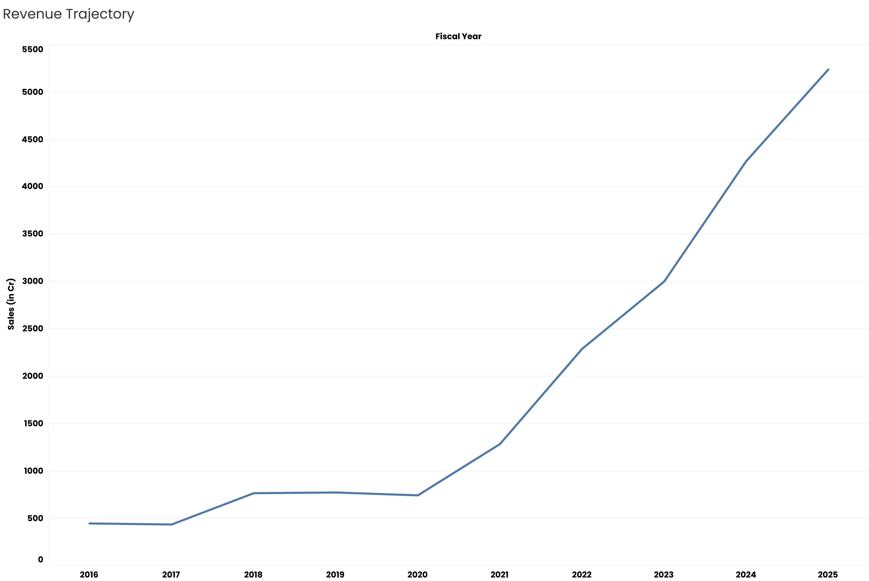
Revenue increased from ₹2,292 Cr in FY2022 to ₹5,239 Cr in FY2025. This implies an implied CAGR of ~31%, reflecting the rapid onboarding of retail clients and higher platform activity. Growth has persisted despite market cycles, indicating structural demand rather than one‑off surges. The scale expansion provides operating leverage potential as fixed costs are spread across higher volumes.

2. Net profit margins improved materially alongside scale
Net profit rose from ₹625 Cr in FY2022 to ₹1,172 Cr in FY2025. Net margin expanded from ~27% to ~22%, remaining elevated relative to traditional brokerages. This level of profitability suggests strong unit economics even in competitive pricing environments. Margin stability supports long‑term reinvestment capacity.
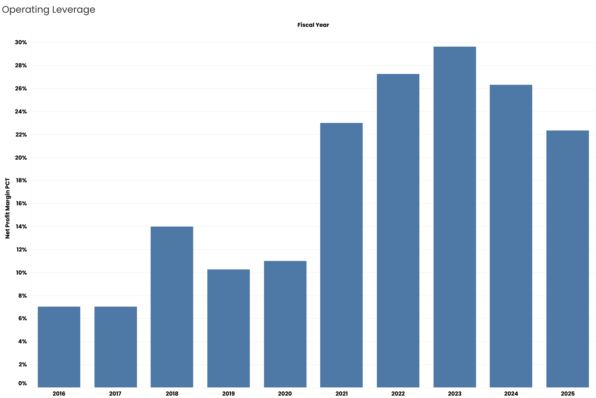

3. Quality of earnings strengthened through positive cash conversion
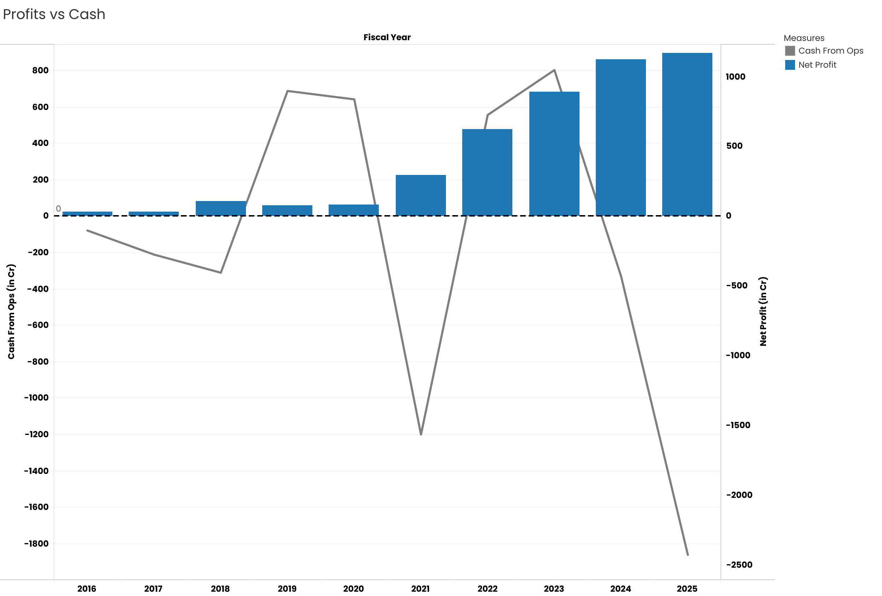
Several recent years show operating cash flows exceeding reported net profit, producing cash conversion ratios above 1.0. This indicates profits are increasingly backed by cash rather than accounting accruals. Higher cash realization improves balance‑sheet flexibility and reduces funding dependence.

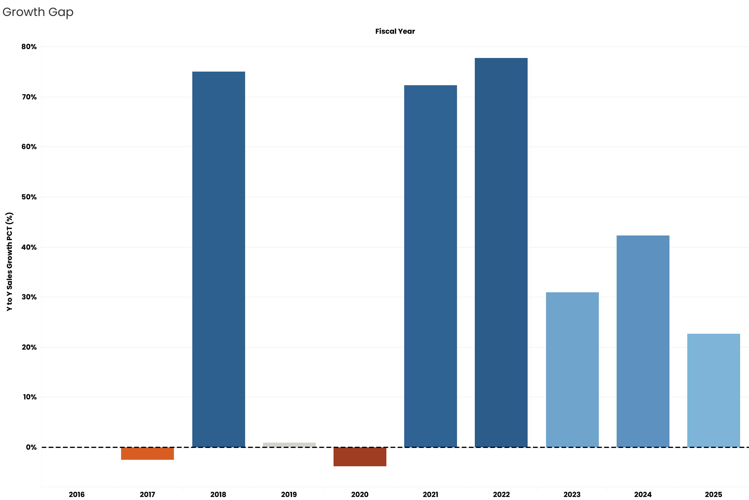

4. Operating cash flow margin averages ~11% over FY21–FY25
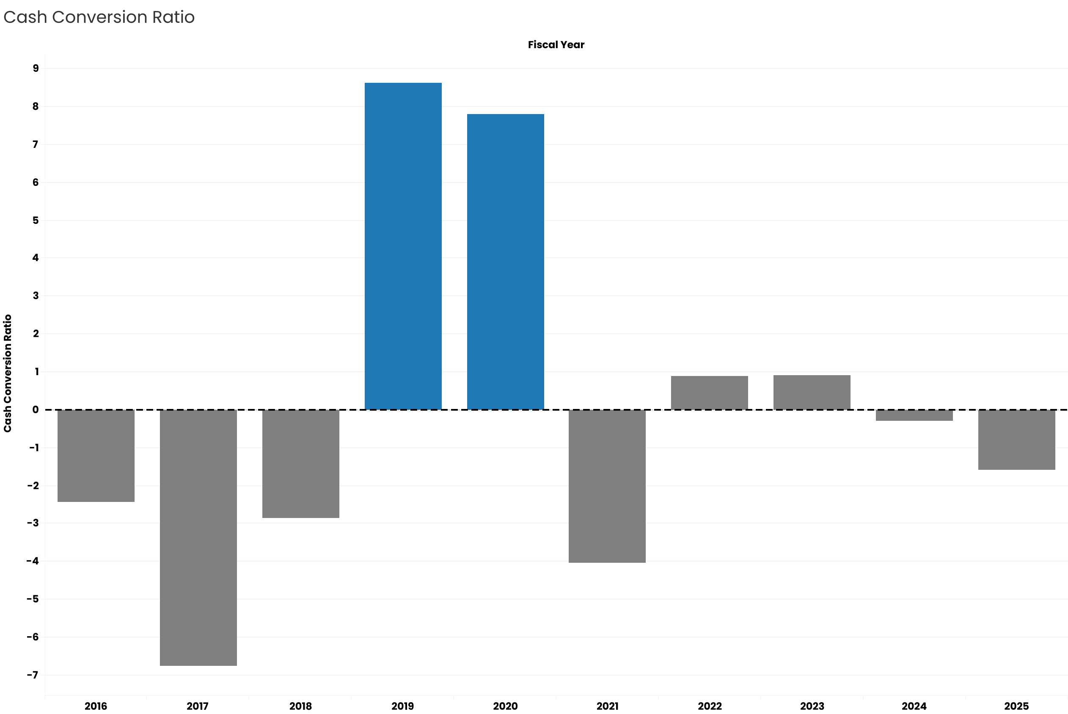
Across FY2021–FY2025, cumulative operating cash flow divided by cumulative revenue implies an average margin of approximately 11%. This margin forms the anchor for forward projections. Using a multi‑year average dampens the effect of unusually strong or weak single years.

5. Conservative model projects revenue exceeding ₹10,500 Cr by FY2030
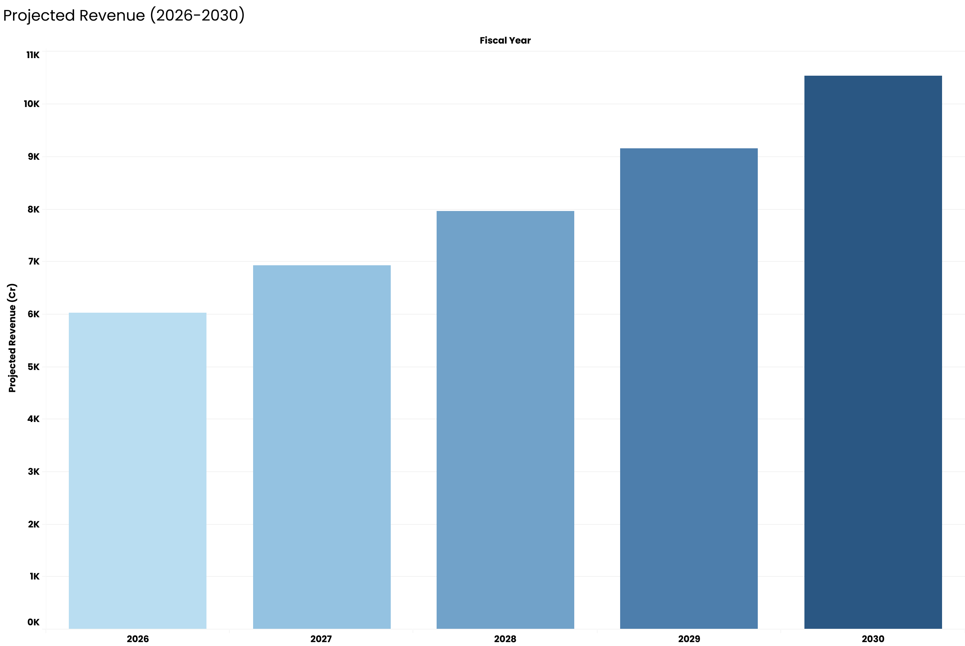
Applying a capped 15% annual growth rate from FY2025 produces projected revenue of ~₹6,025 Cr in FY2026, rising to ~₹10,500 Cr by FY2030. These projections assume no acceleration from new product lines or pricing expansion. Growth is driven purely by continued participation growth.

6. Projected operating cash flows approach ₹1,150 Cr by FY2030
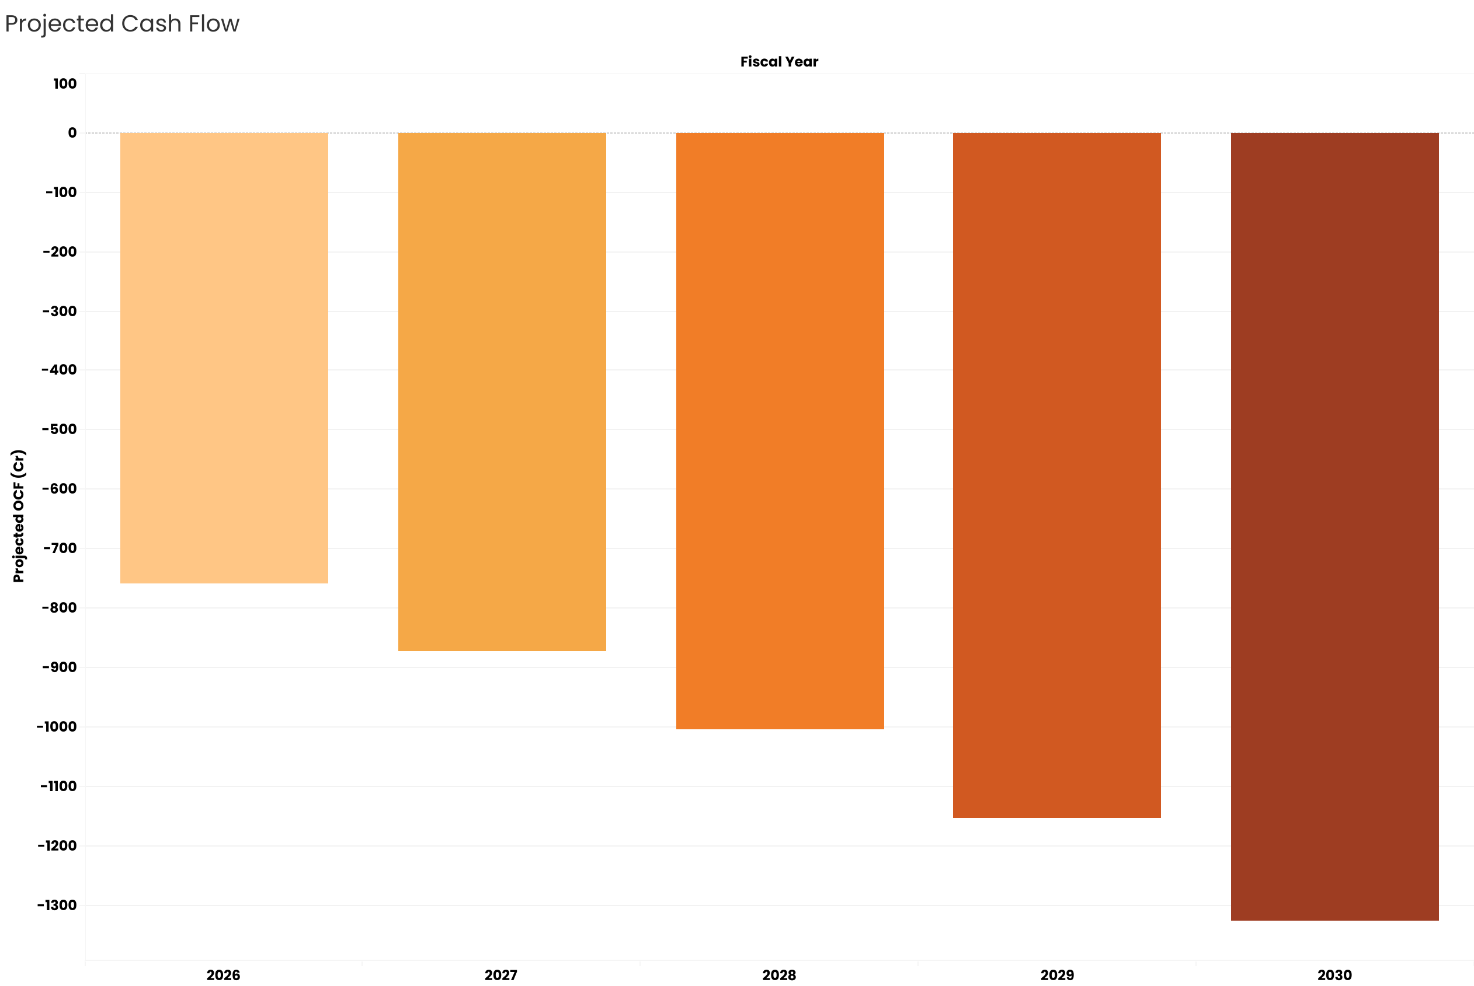
Applying the 11% average margin to projected revenues yields operating cash flow of ~₹660 Cr in FY2026 and ~₹1,150 Cr in FY2030. This implies internal cash generation alone could fund technology, marketing, and expansion initiatives without heavy external financi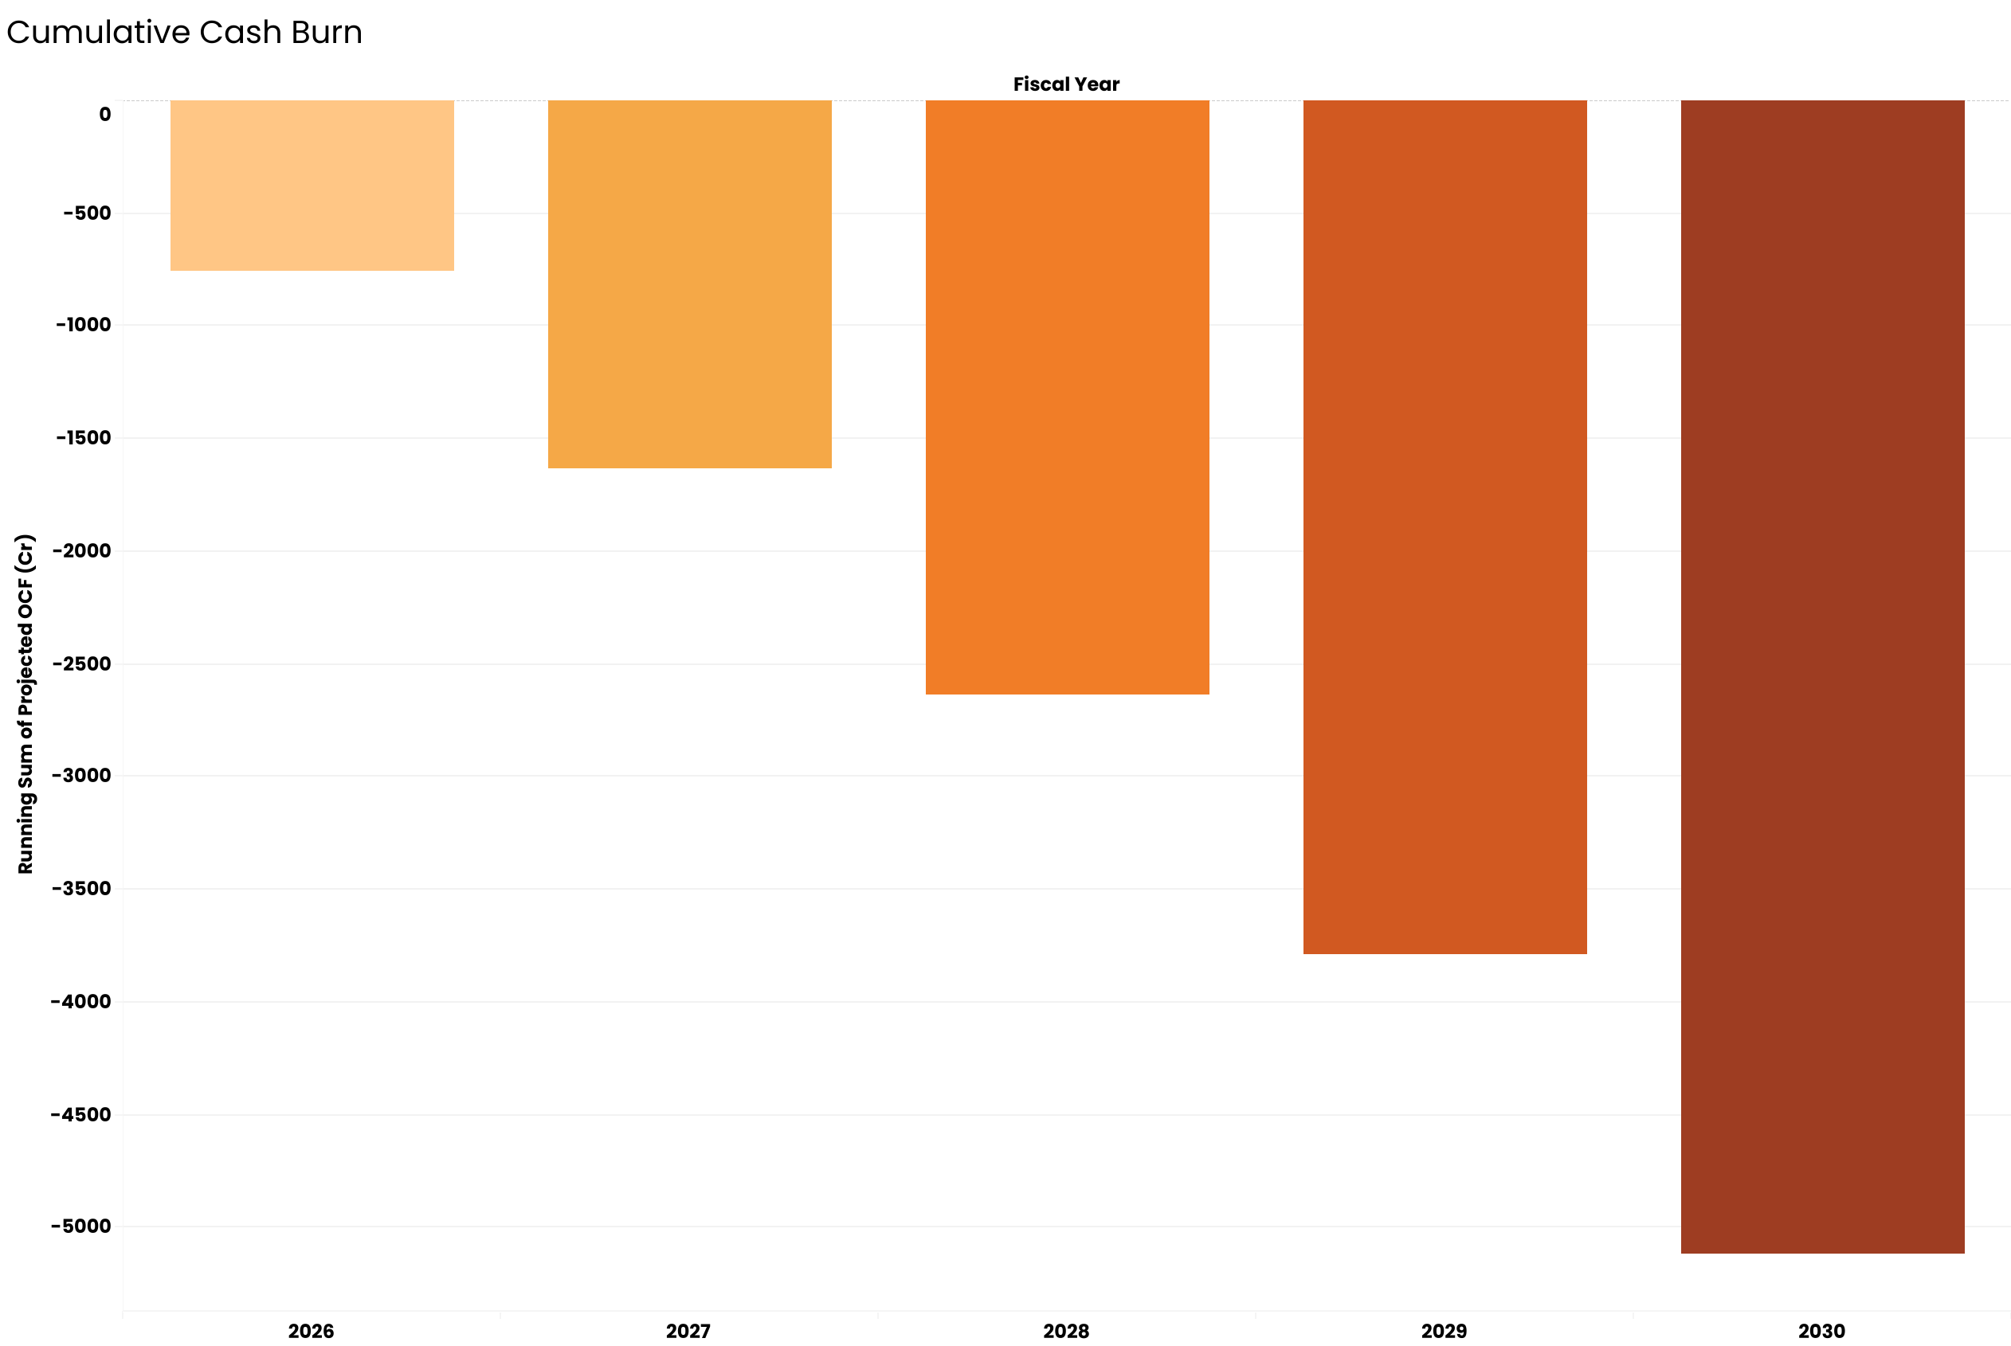

Analysis & Deep Dives
Angel One’s financial trajectory exhibits characteristics of a platform business rather than a transactional brokerage. Revenue growth has remained strong even as industry pricing compresses, implying volume and engagement effects are offsetting lower per‑trade economics. The combination of scale, margin stability, and improving cash conversion supports the interpretation that Angel One’s economics are structurally tied to India’s expanding investor base.
Relative to peers such as Zerodha, Groww, and Upstox, Angel One’s public financials allow clearer visibility into profitability dynamics. The conservative projections do not assume market share gains, only continuation of financialization‑driven participation.

Recommendations / Implications
- Evaluate Angel One using long‑term cash generation rather than short‑term trading volume cycles.
- Monitor operating cash flow margin as the primary health indicator of the business model.
- Use conservative growth assumptions when valuing platform‑driven financial services firms.
- Track client additions and assets under custody as leading indicators of revenue durability.
Limitations & Assumptions
- Financial data accuracy depends on source filings.
- Projections assume constant margins and no major regulatory shocks.
- Growth capped at 15% may understate upside in bull market conditions.
- No explicit modeling of pricing changes or new product monetization.
Appendix
Supporting SQL scripts, data preparation logic, and Tableau dashboards available upon request.

Financial Modelling & Conservative Forecasts of Angel One

SQL CODE
Kaustubh Sardesai
2026-02-10

-- 1. Create a simple table to hold the financial data
CREATE TABLE angel_one_financials (
fiscal_year DATE,
sales DECIMAL(10,2),
operating_profit DECIMAL(10,2),
net_profit DECIMAL(10,2),
cash_from_ops DECIMAL(10,2),
cash_from_investing DECIMAL(10,2),
cash_from_financing DECIMAL(10,2)
)
;

-- 2. Insert the actual data from your Excel file
INSERT INTO angel_one_financials VALUES ('2016-03-31', 451.2, 443.34, 31.72, -77.44, -13.21, 39.59);
INSERT INTO angel_one_financials VALUES ('2017-03-31', 440.05, 397.94, 31.01, -209.97, -49.52, 350.33);
INSERT INTO angel_one_financials VALUES ('2018-03-31', 770.25, 529.86, 107.93, -309.49, 47.41, 238.89);
INSERT INTO angel_one_financials VALUES ('2019-03-31', 777.69, 470.41, 79.83, 689.44, -5.71, -360.9);
INSERT INTO angel_one_financials VALUES ('2020-03-31', 747.6, 671.83, 82.35, 643.3, -28.13, -448.89);
INSERT INTO angel_one_financials VALUES ('2021-03-31', 1288.69, 495.92, 296.86, -1198.67, 24.8, 894.12);
INSERT INTO angel_one_financials VALUES ('2022-03-31', 2291.9, 342.72, 624.81, 557.55, -52.35, -165.13);
INSERT INTO angel_one_financials VALUES ('2023-03-31', 3002.3, 274.67, 889.95, 804.2, -185.11, -908.13);
INSERT INTO angel_one_financials VALUES ('2024-03-31', 4272.34, 415.41, 1125.53, -329.9, -91.05, 1330.88);
INSERT INTO angel_one_financials VALUES ('2025-03-31', 5239.22, 529.24, 1172.08, -1859.84, -340.82, 1916.91);

WITH historical_trends AS (
SELECT
fiscal_year,
sales,
net_profit,
cash_from_ops,

-- Calculate Previous Year's Sales for Growth Formula
LAG(sales) OVER (ORDER BY fiscal_year) as prev_year_sales,

-- Calculate Previous Year's Cash for Trend
LAG(cash_from_ops) OVER (ORDER BY fiscal_year) as prev_year_cash,

-- Calculate Margins
(net_profit / NULLIF(sales,0)) * 100 as net_profit_margin_pct,
(cash_from_ops / NULLIF(sales,0)) * 100 as cash_flow_margin_pct
FROM angel_one_financials
),
growth_stats AS (
SELECT
*,
-- YoY Growth Calculation
((sales - prev_year_sales) / NULLIF(prev_year_sales,0)) * 100 as yoy_sales_growth_pct
FROM historical_trends
)
SELECT
fiscal_year,
sales,
yoy_sales_growth_pct,
net_profit,
net_profit_margin_pct,
cash_from_ops,

-- Question 6: Cash Conversion (Quality of Earnings)
-- If > 1, company converts profit to cash well. If < 1, profit is "on paper".
(cash_from_ops / NULLIF(net_profit,0)) as cash_conversion_ratio,

-- Question 9: Simple Forecast for Next Year (Sales * 1.15)
-- We assume a conservative 15% growth here. You can change 1.15 to your own assumption.
sales * 1.15 as forecast_next_year_sales

FROM growth_stats
ORDER BY fiscal_year DESC
;

-- Question: What are the projected Sales and Cash Flows for the next 5 years (2026-2030) assuming revenue growth is capped at 15%?

WITH RECURSIVE
-- 1. Get the Baseline Data (The latest year, 2025)
baseline AS (
SELECT
fiscal_year,
sales,
cash_from_ops
FROM angel_one_financials
WHERE fiscal_year = '2025-03-31'
),

-- 2. Calculate Assumptions (Growth Rate & Margin)
assumptions AS (
SELECT
-- Calculate the raw CAGR first
(POWER(
(SELECT sales FROM angel_one_financials WHERE fiscal_year = '2025-03-31') /
NULLIF((SELECT sales FROM angel_one_financials WHERE fiscal_year = '2022-03-31'), 0),
1.0/3
) - 1) AS actual_cagr,

-- Cap the Growth Rate at 15% using LEAST() function
LEAST(
0.15,
(POWER(
(SELECT sales FROM angel_one_financials WHERE fiscal_year = '2025-03-31') /
NULLIF((SELECT sales FROM angel_one_financials WHERE fiscal_year = '2022-03-31'), 0),
1.0/3
) - 1)
) AS capped_growth_rate,

-- Calculate 5-Year Average Cash Flow Margin
(SELECT SUM(cash_from_ops) FROM angel_one_financials WHERE fiscal_year >= '2021-03-31') /
(SELECT SUM(sales) FROM angel_one_financials WHERE fiscal_year >= '2021-03-31') AS avg_cf_margin
),

-- 3. Recursive Projection (The Forecasting Engine)
projections AS (
-- Base Case: Start with 2025 Actuals to project 2026
SELECT
1 AS projection_year_index,
DATE_ADD(fiscal_year, INTERVAL 1 YEAR) as forecast_date,
sales * (1 + (SELECT capped_growth_rate FROM assumptions)) as projected_sales,
(sales * (1 + (SELECT capped_growth_rate FROM assumptions))) * (SELECT avg_cf_margin FROM assumptions) as projected_cash_flow
FROM baseline

UNION ALL

-- Recursive Step: Project subsequent years
SELECT
projection_year_index + 1,
DATE_ADD(forecast_date, INTERVAL 1 YEAR),
projected_sales * (1 + (SELECT capped_growth_rate FROM assumptions)),
(projected_sales * (1 + (SELECT capped_growth_rate FROM assumptions))) * (SELECT avg_cf_margin FROM assumptions)
FROM projections
WHERE projection_year_index < 5
)

-- 4. Final Report Output
SELECT
forecast_date as "Fiscal Year",
ROUND(projected_sales, 2) as "Projected Revenue (Cr)",
ROUND(projected_cash_flow, 2) as "Projected OCF (Cr)",
CONCAT(ROUND((SELECT capped_growth_rate FROM assumptions) * 100, 1), '%') as "Growth Assumption",
CONCAT(ROUND((SELECT avg_cf_margin FROM assumptions) * 100, 1), '%') as "Margin Assumption"
FROM projections;

