Global Layoff Trends Analysis (2023–2025)
Author: Kaustubh Sardesai
Date: January 2026
Tools Used: Excel, SQL, Tableau
Context: Self-Initiated Portfolio Project

Executive Summary
This report analyzes global workforce reduction trends between 2023 and 2025 using publicly available layoff data. The objective is to identify patterns across industries, geographies, company stages, and time periods. Key findings highlight concentrated layoffs in specific industries, uneven geographic impacts, and distinct temporal waves of workforce reductions. The insights from this analysis support strategic workforce planning, investment risk assessment, and policy evaluation.

Business Task
The primary business objective is to understand how workforce reductions are distributed across industries, regions, and company characteristics over time. This analysis aims to inform stakeholders about structural labour market shifts and identify risk signals associated with company stage, funding levels, and industry concentration.

Key Stakeholders
- Business leaders and strategy teams
- Investors and financial analysts
- Policy and labour market analysts
- Talent and workforce planning teams

Data Sources
The analysis uses a global layoffs dataset compiled from publicly reported workforce reduction announcements. The dataset spans from 2023 to 2025 and includes company-level information such as industry, country, total employees laid off, company stage, funding raised, and announcement dates. The data may be subject to reporting bias, delayed disclosures, and inconsistencies across regions.

Tools and Methodology
Data preparation and analysis were conducted using SQL for data cleaning and transformation, Excel for validation and exploratory checks, and Tableau for visualisation. The methodology included duplicate removal, standardisation of categorical fields, date normalisation, and aggregation across multiple dimensions such as time, geography, industry, and company attributes.

Data Preparation and Cleaning
Key data preparation steps included removing duplicate records, standardizing company names and categorical variables, converting date fields into a consistent format, and validating numerical fields such as layoff counts and funding amounts. Records with unverifiable or incomplete critical information were excluded to improve analytical reliability.

Analysis and Key Findings

Finding 1
Layoffs are highly concentrated in a small number of industries, indicating structural employment pressures rather than evenly distributed workforce adjustments.
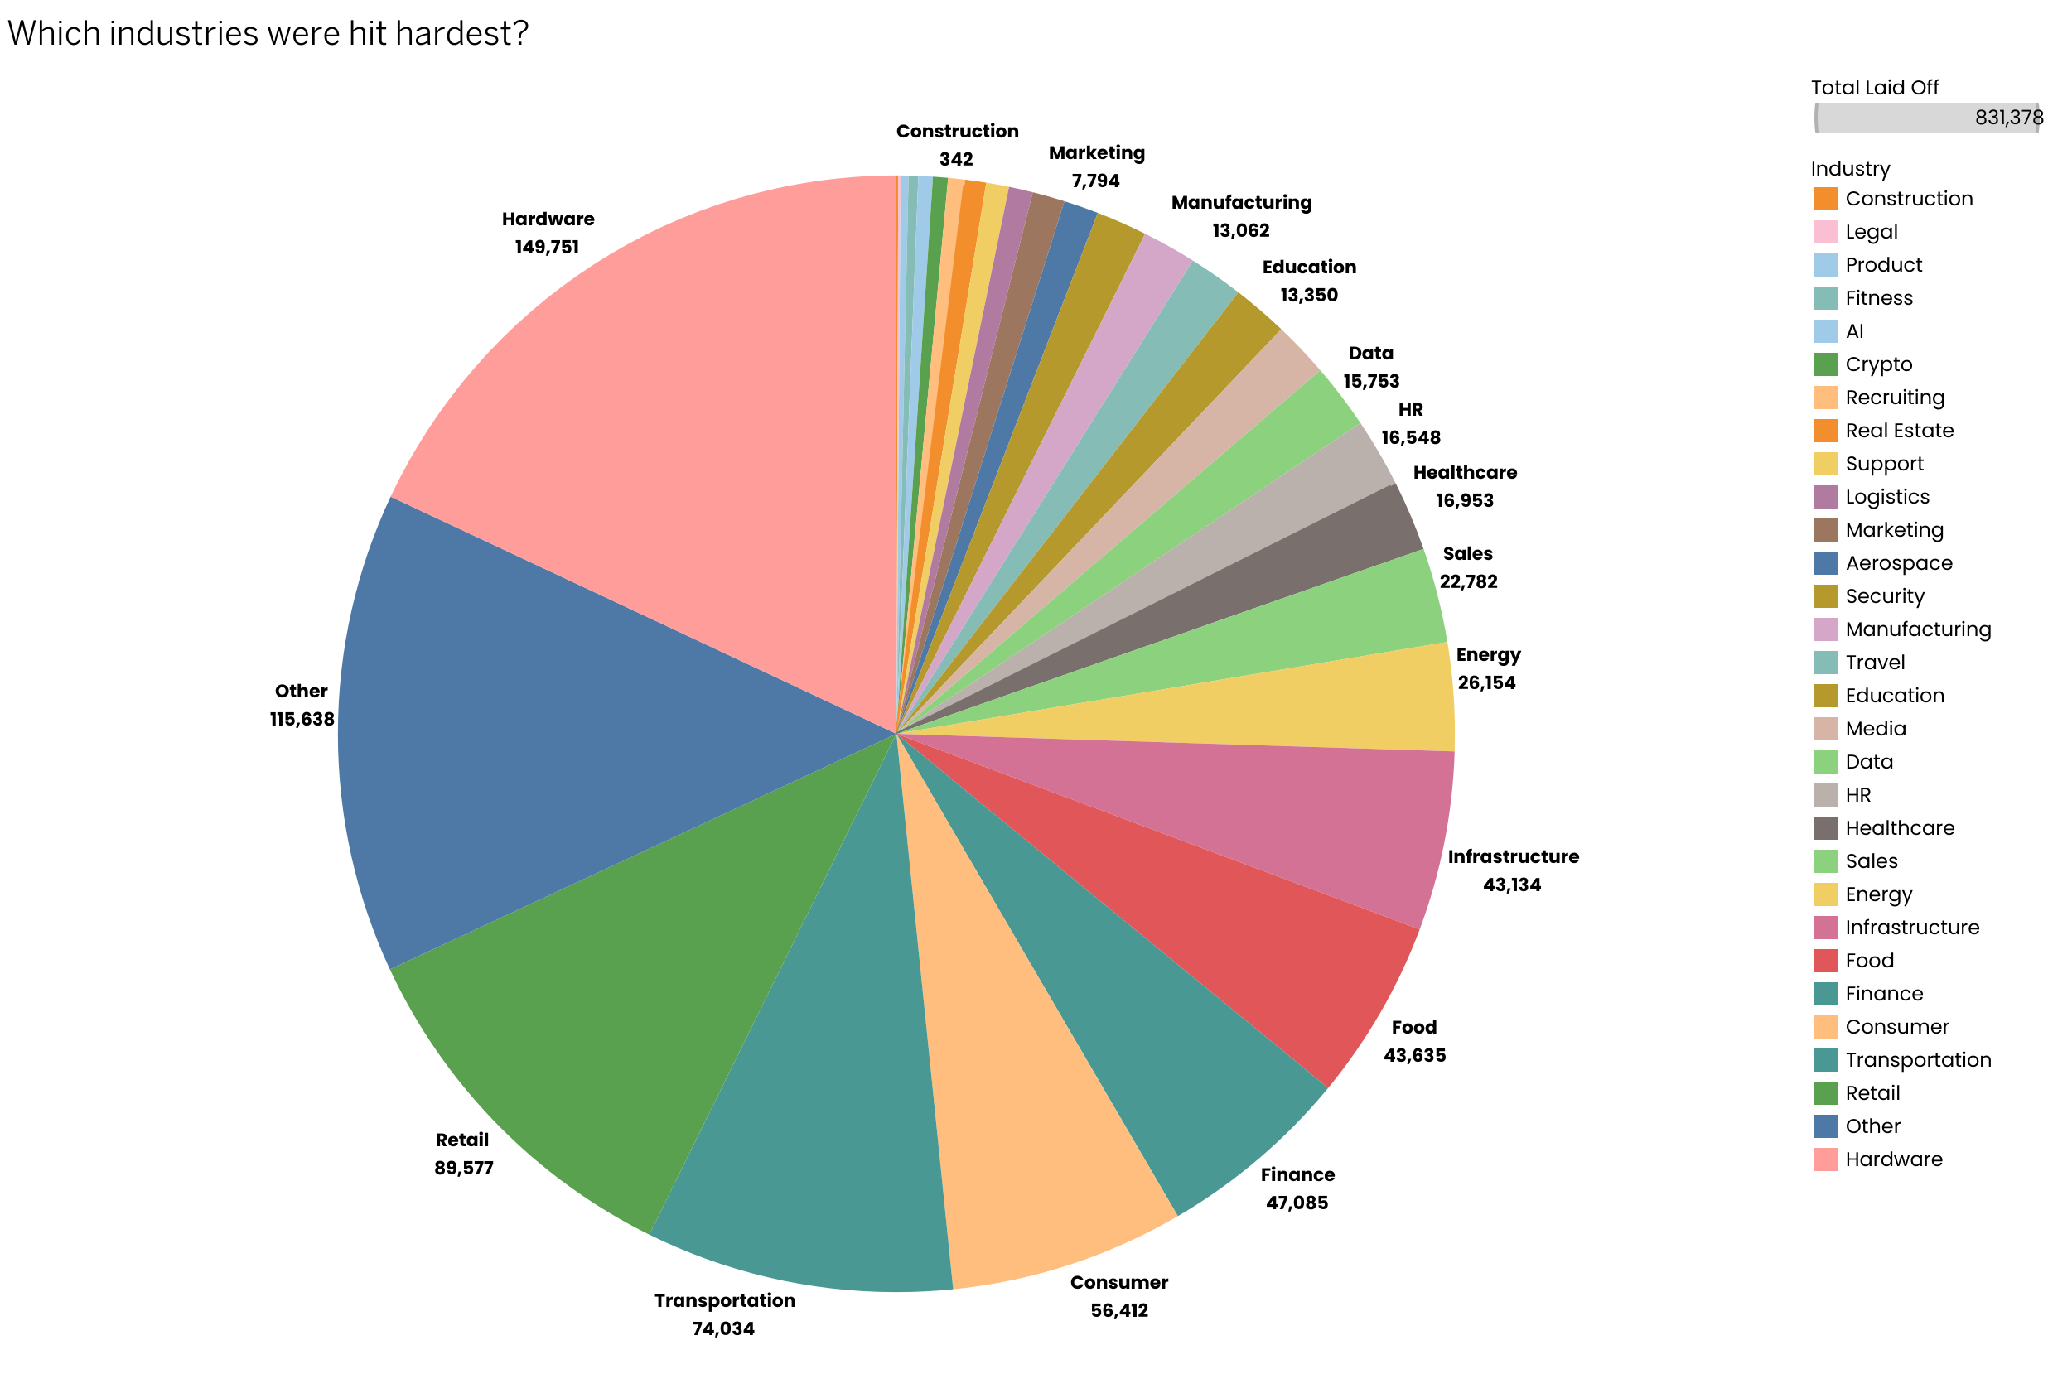

Finding 2
Workforce reductions exhibit clear time-based patterns, with certain periods experiencing sharp spikes in layoffs, followed by stabilization.
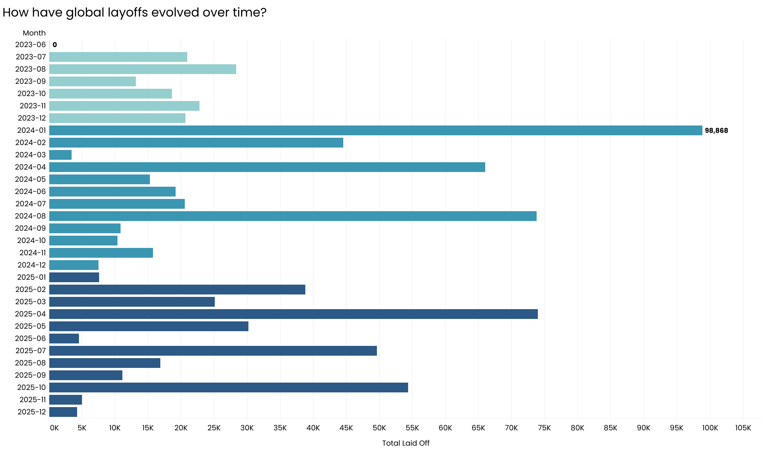
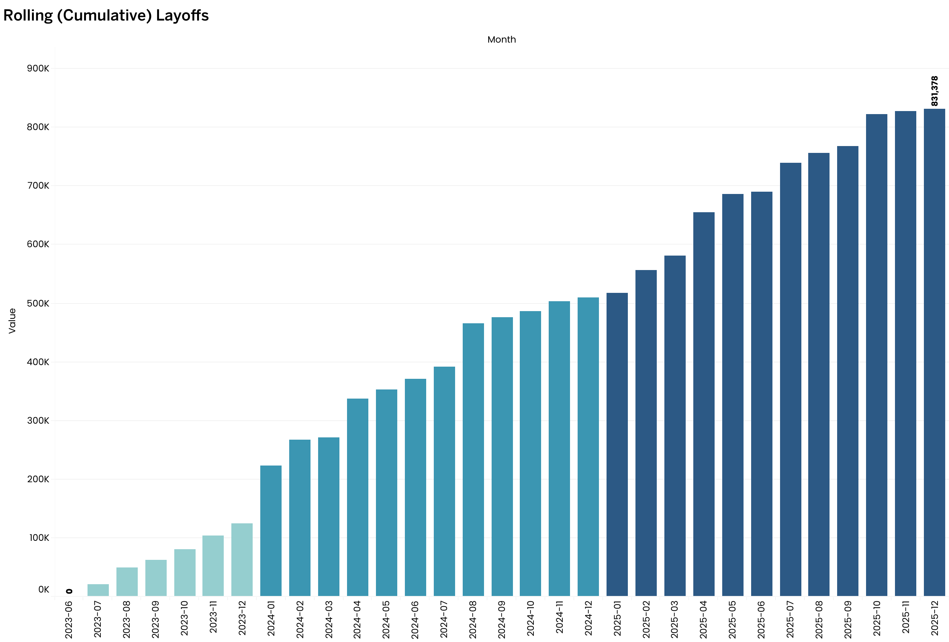

Finding 3
A limited number of companies account for a disproportionate share of total layoffs, highlighting concentration risk.
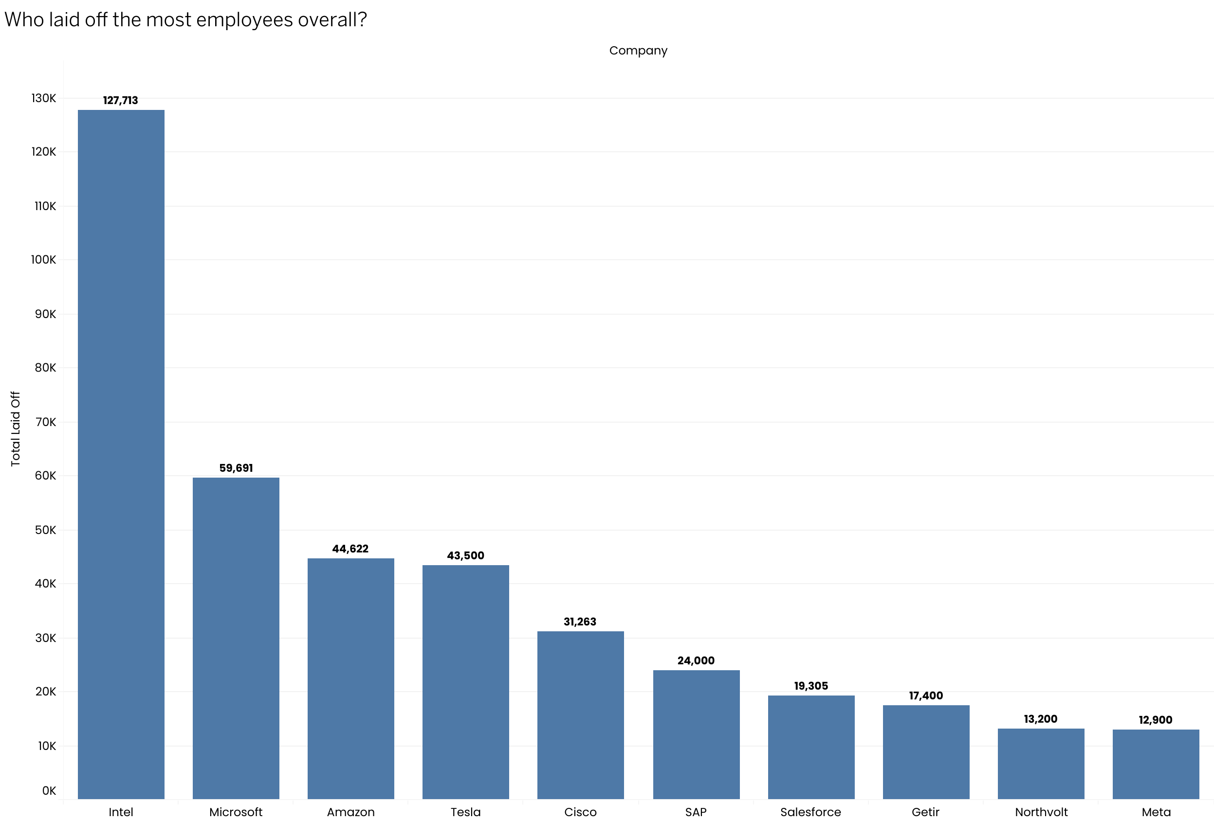

Finding 4
Later-stage and well-funded companies contribute significantly to total layoff volumes, suggesting that scale effects, rather than early-stage instability alone, are at play.
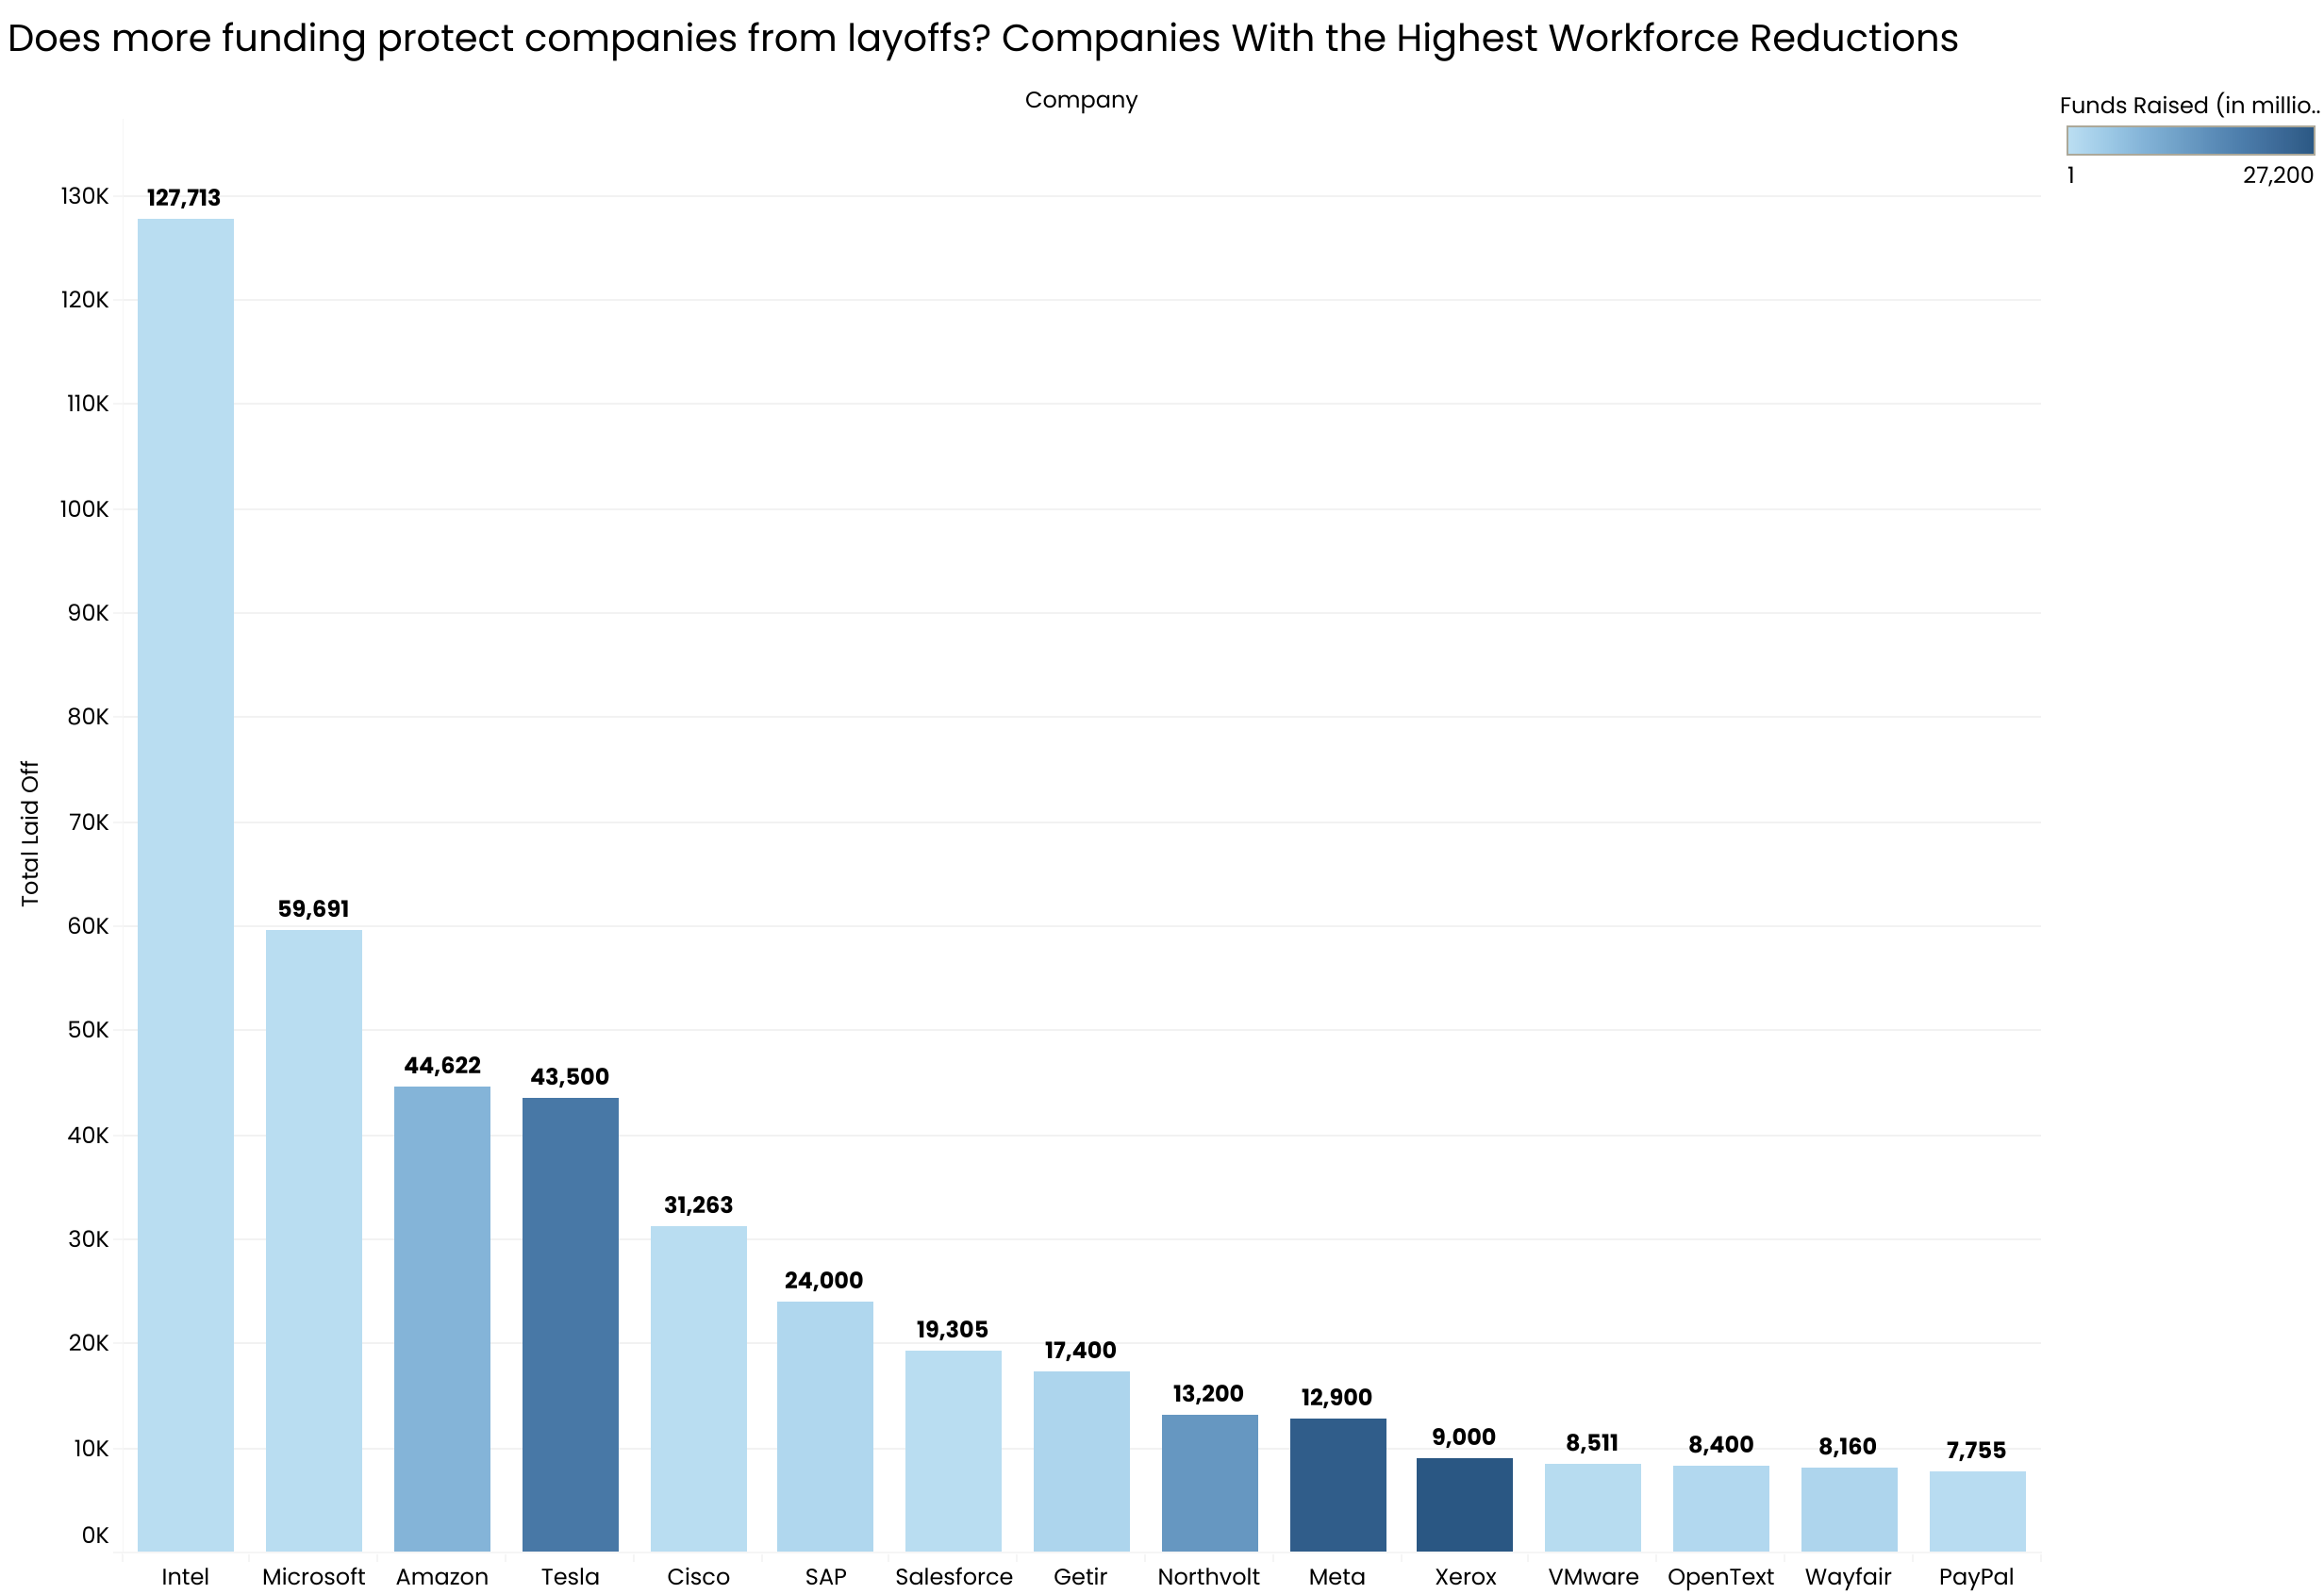
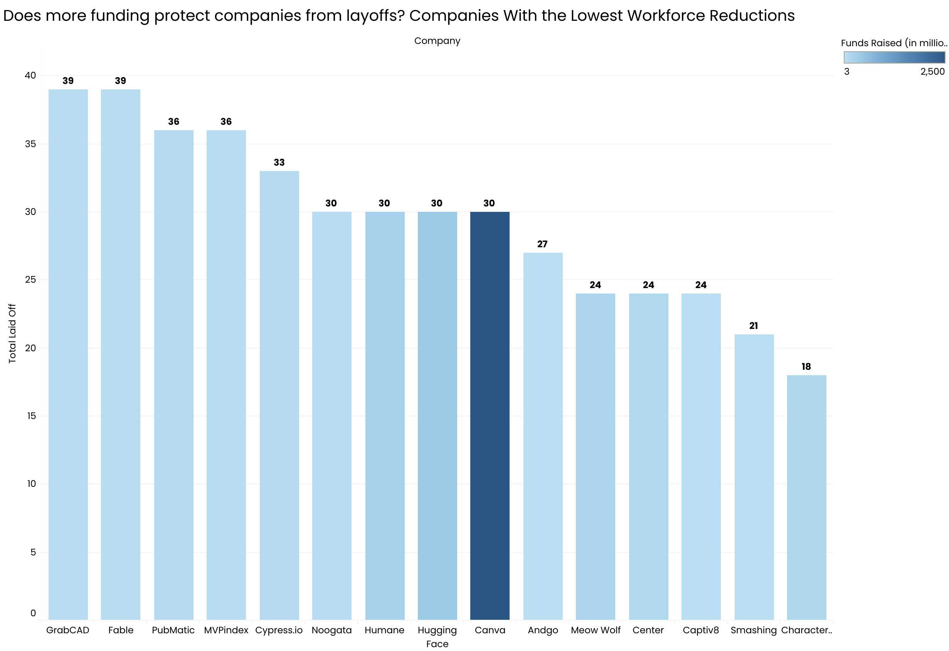

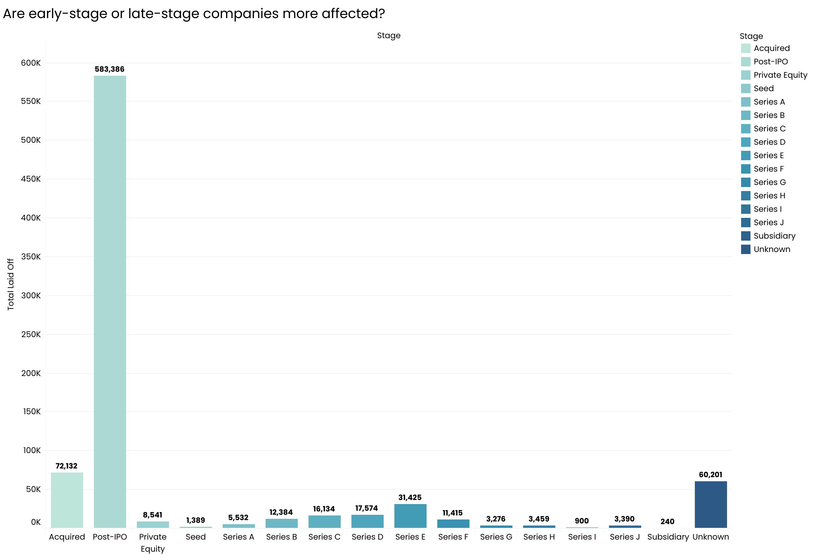

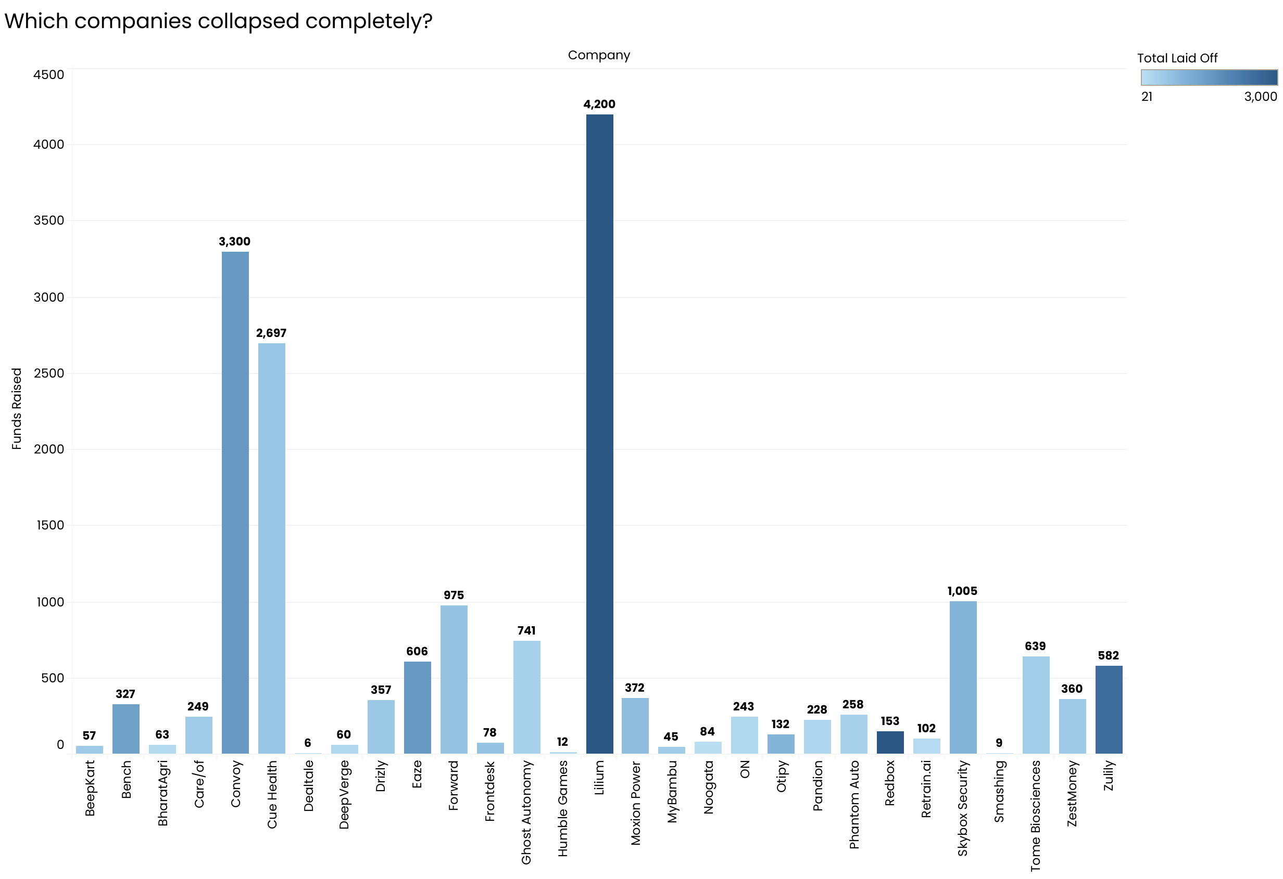

Finding 5
Geographic distribution of layoffs is uneven, with a small number of countries representing the majority of reported workforce reductions.
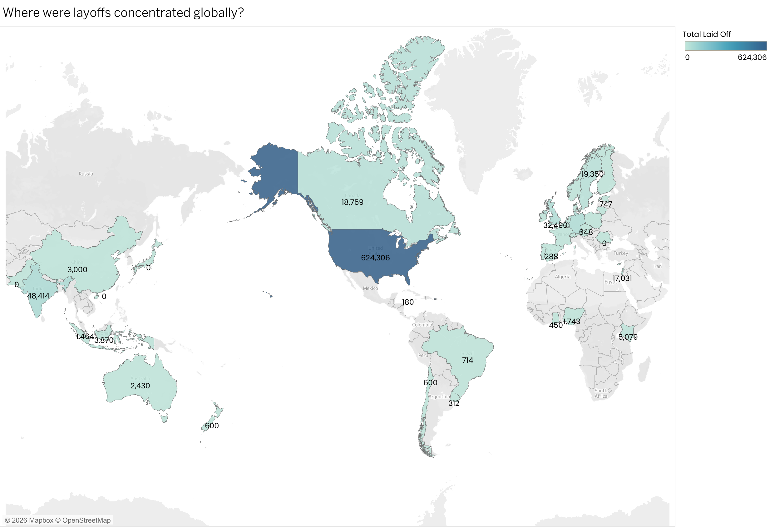

Recommendations
- Monitor industry-level workforce trends to anticipate downstream impacts on talent availability.
- Incorporate layoff concentration metrics into investment and risk assessment frameworks.
- Use time-based layoff patterns as early indicators for organizational restructuring cycles.
- Apply geographic insights to inform regional workforce and policy planning.

Limitations and Assumptions
The analysis relies on publicly reported data, which may underrepresent smaller companies or regions with limited disclosure practices. Funding data is incomplete for some organizations, and layoffs may be announced after internal decisions are made, introducing timing lags.

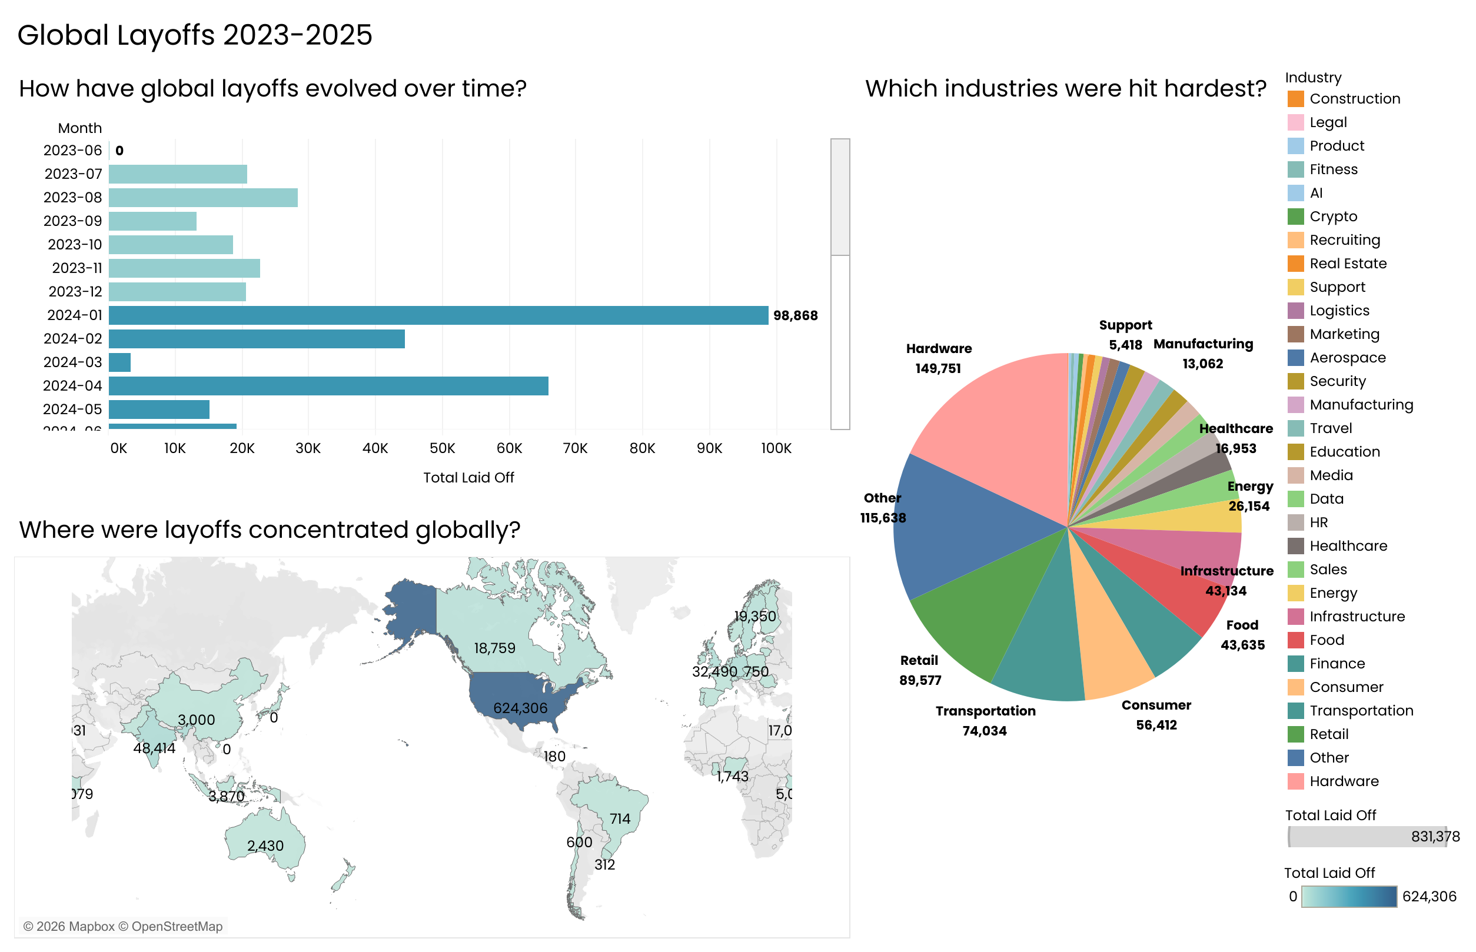

Future Work
Future analysis could integrate financial performance indicators, hiring data, or macroeconomic variables to better understand causal relationships. Expanding the dataset to include additional years and private disclosures would further strengthen trend analysis.

Conclusion
This analysis provides a structured overview of global layoff dynamics and highlights key concentration and timing patterns. By translating raw layoff data into actionable insights, the report demonstrates how data analytics can support informed decision-making across business, investment, and workforce planning contexts.

Appendix
Supporting SQL queries, data preparation scripts, and detailed exploratory analysis are provided in the accompanying R Markdown document.

World Layoffs 2023-25
Kaustubh Sardesai
2026-01-12
## Data Cleaning and Exploratory Data Analysis Project
## World Layoffs
SELECT*
FROM World_layoffs.layoffs;

##1. Remove Duplicates
##2. Standardise the Data
##3. Null Values or Blank Values
##4. Remove Any Columns
## Creating a staging table to avoid any manipulations of raw data
DROP TABLE IF EXISTS layoffs_staging;
CREATE TABLE layoffs_staging
LIKE layoffs;
INSERT layoffs_staging
SELECT*
FROM layoffs
;
## 1. Remove Duplicates
SELECT *,
ROW_NUMBER() OVER
(PARTITION BY company,location,total_laid_off,`date`,percentage_laid_off,industry,`source`,stage,funds_raised,country,date_added)
AS ROW_NUM
FROM World_layoffs.layoffs_staging
;
##If ROW_NUM is 2 its a duplicate

WITH duplicate_cte AS
(
SELECT *,
ROW_NUMBER() OVER
(PARTITION BY company,location,total_laid_off,`date`,percentage_laid_off,industry,`source`,stage,funds_raised,country,date_added)
AS ROW_NUM
FROM World_layoffs.layoffs_staging
)
SELECT*
FROM duplicate_cte
WHERE ROW_NUM > 1
;
## Filtering for the duplicates using CTE

SELECT*
FROM layoffs_staging
WHERE company = 'Cars24'
;
## Confirming the results of the above qury

DROP TABLE IF EXISTS layoffs_staging;
CREATE TABLE `layoffs_staging`(
`company` text,
`location` text,
`total_laid_off` INT,
`date` text,
`percentage_laid_off` DECIMAL(5,2),
`industry` text,
`source` text,
`stage` text,
`funds_raised` int DEFAULT NULL,
`country` text,
`date_added` text,
`ROW_NUM` INT
) ENGINE=InnoDB DEFAULT CHARSET=utf8mb4 COLLATE=utf8mb4_0900_ai_ci
;
## Created a layoffs _staging2 table to manupulate dupliate data
SELECT*
FROM World_layoffs.layoffs_staging2
;

INSERT INTO layoffs_staging2 (
company,
location,
total_laid_off,
`date`,
percentage_laid_off,
industry,
source,
stage,
funds_raised,
country,
date_added,
ROW_NUM
)
SELECT
company,
location,
total_laid_off,
`date`,
percentage_laid_off,
industry,
source,
stage,
funds_raised,
country,
date_added,
ROW_NUMBER() OVER (
PARTITION BY
company,
location,
total_laid_off,
`date`,
percentage_laid_off,
industry,
source,
stage,
funds_raised,
country,
date_added
) AS ROW_NUM
FROM layoffs_staging;
## Added all the data from layoffs_staging table plus the ROW_NUM coloumn which is to be filtered next
SELECT*
FROM World_layoffs.layoffs_staging2
WHERE ROW_NUM > 1
;
## Filtered Duplicates in layoffs_staging2 table

DELETE
FROM World_layoffs.layoffs_staging2
WHERE ROW_NUM > 1
;
##Deleted duplicates from layoffs_staging2 table
SELECT*
FROM World_layoffs.layoffs_staging2;
## Stage 1 - removing duplicates complete

## 2. Standardise the Data
SELECT company, (TRIM(company))
FROM World_layoffs.layoffs_staging2
;

UPDATE World_layoffs.layoffs_staging2
SET company = TRIM(company)
;
SELECT DISTINCT industry
FROM World_layoffs.layoffs_staging2
ORDER BY 1
;
## Just to check

SELECT DISTINCT location
FROM World_layoffs.layoffs_staging2
ORDER BY 1
;
## Just to check

SELECT DISTINCT country
FROM World_layoffs.layoffs_staging2
ORDER BY 1
;
## Just to check

UPDATE World_layoffs.layoffs_staging2
SET `date` = STR_TO_DATE(`date`, '%m/%d/%Y')
WHERE `date` LIKE '%/%/%'
;
## Converting date coloumn from text to int
ALTER TABLE World_layoffs.layoffs_staging2
MODIFY COLUMN `date` DATE
;
## Modifying the coloumn and table
SELECT*
FROM World_layoffs.layoffs_staging2
WHERE industry IS NULL
OR industry = ''
;
## Found another duplicate company named appsmith - it wasnt filtered earlier as industry coloumn had no data on these rows

## Addition to stage 1 - removing the duplicates
SELECT*
FROM World_layoffs.layoffs_staging2
WHERE company = 'appsmith'
;
## making sure if there is more data on Company 'Appsmith' - only 2 lines both same

DELETE
FROM World_layoffs.layoffs_staging2
WHERE company = 'appsmith'
;
##Deleted all layoff data from company 'Applesmith' as data couldnt be varified as accurate
## 3. Null Values or Blank Values
## No NULLS in relevent coloumns
## 4. Remove Any Columns
## No Coloumns to be removed at this stage
## Exploratory Data Analysis
SELECT*
FROM World_layoffs.layoffs_staging2

SELECT MAX(total_laid_off), MAX(percentage_laid_off)
FROM World_layoffs.layoffs_staging2
;
## finding MAX

SELECT*
FROM World_layoffs.layoffs_staging2
WHERE percentage_laid_off = 1
ORDER BY total_laid_off DESC
;
## companies which went bust

SELECT*
FROM World_layoffs.layoffs_staging2
WHERE percentage_laid_off = 1
ORDER BY funds_raised DESC
;
## layoffs based on funds raised by companies

SELECT MIN(`date`), MAX(`date`)
FROM World_layoffs.layoffs_staging2
;
## finding start and end date of the records in the dataset

SELECT company, SUM(total_laid_off)
FROM World_layoffs.layoffs_staging2
GROUP BY company
ORDER BY 2 DESC
;
## Layoffs based on company

SELECT industry, SUM(total_laid_off)
FROM World_layoffs.layoffs_staging2
GROUP BY industry
ORDER BY 2 DESC
;
## layoffs based on industry

SELECT country, SUM(total_laid_off)
FROM World_layoffs.layoffs_staging2
GROUP BY country
ORDER BY 2 DESC
;
## layoffs based on country

SELECT YEAR (`date`), SUM(total_laid_off)
FROM World_layoffs.layoffs_staging2
GROUP BY YEAR (`date`)
ORDER BY 1 DESC
;
## layoffs based on year

SELECT stage, SUM(total_laid_off)
FROM World_layoffs.layoffs_staging2
GROUP BY stage
ORDER BY 2 DESC
;
## layoffs based on fundraising stage of the company

SELECT substring(`date`,1,7) as `MONTH`, SUM(total_laid_off)
FROM World_layoffs.layoffs_staging2
WHERE substring(`date`,1,7) IS NOT NULL
GROUP BY `MONTH`
ORDER BY 1 ASC
;
## layoffs based on month of the year

WITH rolling_total AS
(
SELECT substring(`date`,1,7) as `MONTH`, SUM(total_laid_off) as total_fired
FROM World_layoffs.layoffs_staging2
WHERE substring(`date`,1,7) IS NOT NULL
GROUP BY `MONTH`
ORDER BY 1 ASC
)
SELECT `MONTH`, total_fired, SUM(total_fired) OVER (ORDER BY `MONTH`) AS rolling_total
FROM rolling_total
;
##rolling total of layoffs

SELECT company, YEAR (`date`), SUM(total_laid_off)
FROM World_layoffs.layoffs_staging2
GROUP BY company, YEAR (`date`)
ORDER BY company ASC
;
## layoffs per company per year

WITH company_year (company, years, total_laid_off) AS
(
SELECT company, YEAR (`date`), SUM(total_laid_off)
FROM World_layoffs.layoffs_staging2
GROUP BY company, YEAR (`date`)
),
Company_Year_Rank AS
(
SELECT*, DENSE_RANK () OVER(PARTITION BY years ORDER BY total_laid_off DESC) AS ranking
FROM company_year
WHERE years IS NOT NULL
ORDER BY ranking ASC
)
SELECT *
FROM Company_Year_Rank
WHERE ranking <= 5
;
## 2 CTEs used to find out top 5 companies (in terms of employee lay offs) every year.

SELECT
DATE_FORMAT(`date`, '%Y-%m') AS month,
SUM(total_laid_off) AS total_laid_off
FROM layoffs_staging2
GROUP BY month
ORDER BY month
;
## Time based Trends



WITH monthly AS (
SELECT
DATE_FORMAT(`date`, '%Y-%m') AS month,
SUM(total_laid_off) AS total_laid_off
FROM layoffs_staging2
GROUP BY month
)
SELECT
month,
total_laid_off,
SUM(total_laid_off) OVER (ORDER BY month) AS cumulative_layoffs
FROM monthly
;
## Rolling (Cumulative) Layoffs


WITH monthly AS (
SELECT
DATE_FORMAT(`date`, '%Y-%m') AS month,
SUM(total_laid_off) AS total_laid_off
FROM layoffs_staging2
GROUP BY month
)
SELECT
month,
total_laid_off,
SUM(total_laid_off) OVER (ORDER BY month) AS cumulative_layoffs
FROM monthly
;
## Rolling (Cumulative) Layoffs

SELECT
company,
SUM(total_laid_off) AS total_laid_off
FROM layoffs_staging2
GROUP BY company
ORDER BY total_laid_off DESC
LIMIT 10
;
## Top 10 Companies by Total Layoffs


SELECT
industry,
SUM(total_laid_off) AS total_laid_off
FROM layoffs_staging2
GROUP BY industry
ORDER BY total_laid_off DESC
;
## Layoffs by Industry

SELECT
country,
SUM(total_laid_off) AS total_laid_off
FROM layoffs_staging2
GROUP BY country
;
##layoffs by Country (Map)


SELECT
stage,
SUM(total_laid_off) AS total_laid_off
FROM layoffs_staging2
GROUP BY stage
ORDER BY total_laid_off DESC
;
## Layoffs by Company Stage

SELECT
company,
SUM(total_laid_off) AS total_laid_off,
MAX(funds_raised) AS funds_raised
FROM layoffs_staging2
WHERE funds_raised IS NOT NULL
GROUP BY company
;
## Funds Raised vs Layoffs


SELECT
company,
industry,
country,
total_laid_off,
funds_raised
FROM layoffs_staging2
WHERE percentage_laid_off = 1
ORDER BY total_laid_off DESC
;
## Companies That Shut Down (100% Layoffs)

WITH company_year AS (
SELECT
company,
YEAR(`date`) AS year,
SUM(total_laid_off) AS total_laid_off
FROM layoffs_staging2
GROUP BY company, year
),
ranked AS (
SELECT *,
DENSE_RANK() OVER (PARTITION BY year ORDER BY total_laid_off DESC) AS rank_
FROM company_year
)
SELECT *
FROM ranked
WHERE rank_ <= 5
;
## Top 5 Companies by Layoffs Each Year



