World Layoffs 2023-25
Kaustubh Sardesai
2026-01-12
## Data Cleaning and Exploratory Data Analysis Project
## World Layoffs
SELECT*
FROM World_layoffs.layoffs;

##1. Remove Duplicates
##2. Standardise the Data
##3. Null Values or Blank Values
##4. Remove Any Columns
## Creating a staging table to avoid any manipulations of raw data
DROP TABLE IF EXISTS layoffs_staging;
CREATE TABLE layoffs_staging
LIKE layoffs;
INSERT layoffs_staging
SELECT*
FROM layoffs
;
## 1. Remove Duplicates
SELECT *,
ROW_NUMBER() OVER
(PARTITION BY company,location,total_laid_off,`date`,percentage_laid_off,industry,`source`,stage,funds_raised,country,date_added)
AS ROW_NUM
FROM World_layoffs.layoffs_staging
;
##If ROW_NUM is 2 its a duplicate

WITH duplicate_cte AS
(
SELECT *,
ROW_NUMBER() OVER
(PARTITION BY company,location,total_laid_off,`date`,percentage_laid_off,industry,`source`,stage,funds_raised,country,date_added)
AS ROW_NUM
FROM World_layoffs.layoffs_staging
)
SELECT*
FROM duplicate_cte
WHERE ROW_NUM > 1
;
## Filtering for the duplicates using CTE

SELECT*
FROM layoffs_staging
WHERE company = 'Cars24'
;
## Confirming the results of the above qury

DROP TABLE IF EXISTS layoffs_staging;
CREATE TABLE `layoffs_staging`(
`company` text,
`location` text,
`total_laid_off` INT,
`date` text,
`percentage_laid_off` DECIMAL(5,2),
`industry` text,
`source` text,
`stage` text,
`funds_raised` int DEFAULT NULL,
`country` text,
`date_added` text,
`ROW_NUM` INT
) ENGINE=InnoDB DEFAULT CHARSET=utf8mb4 COLLATE=utf8mb4_0900_ai_ci
;
## Created a layoffs _staging2 table to manupulate dupliate data
SELECT*
FROM World_layoffs.layoffs_staging2
;

INSERT INTO layoffs_staging2 (
company,
location,
total_laid_off,
`date`,
percentage_laid_off,
industry,
source,
stage,
funds_raised,
country,
date_added,
ROW_NUM
)
SELECT
company,
location,
total_laid_off,
`date`,
percentage_laid_off,
industry,
source,
stage,
funds_raised,
country,
date_added,
ROW_NUMBER() OVER (
PARTITION BY
company,
location,
total_laid_off,
`date`,
percentage_laid_off,
industry,
source,
stage,
funds_raised,
country,
date_added
) AS ROW_NUM
FROM layoffs_staging;
## Added all the data from layoffs_staging table plus the ROW_NUM coloumn which is to be filtered next
SELECT*
FROM World_layoffs.layoffs_staging2
WHERE ROW_NUM > 1
;
## Filtered Duplicates in layoffs_staging2 table

DELETE
FROM World_layoffs.layoffs_staging2
WHERE ROW_NUM > 1
;
##Deleted duplicates from layoffs_staging2 table
SELECT*
FROM World_layoffs.layoffs_staging2;
## Stage 1 - removing duplicates complete

## 2. Standardise the Data
SELECT company, (TRIM(company))
FROM World_layoffs.layoffs_staging2
;

UPDATE World_layoffs.layoffs_staging2
SET company = TRIM(company)
;
SELECT DISTINCT industry
FROM World_layoffs.layoffs_staging2
ORDER BY 1
;
## Just to check

SELECT DISTINCT location
FROM World_layoffs.layoffs_staging2
ORDER BY 1
;
## Just to check

SELECT DISTINCT country
FROM World_layoffs.layoffs_staging2
ORDER BY 1
;
## Just to check

UPDATE World_layoffs.layoffs_staging2
SET `date` = STR_TO_DATE(`date`, '%m/%d/%Y')
WHERE `date` LIKE '%/%/%'
;
## Converting date coloumn from text to int
ALTER TABLE World_layoffs.layoffs_staging2
MODIFY COLUMN `date` DATE
;
## Modifying the coloumn and table
SELECT*
FROM World_layoffs.layoffs_staging2
WHERE industry IS NULL
OR industry = ''
;
## Found another duplicate company named appsmith - it wasnt filtered earlier as industry coloumn had no data on these rows

## Addition to stage 1 - removing the duplicates
SELECT*
FROM World_layoffs.layoffs_staging2
WHERE company = 'appsmith'
;
## making sure if there is more data on Company 'Appsmith' - only 2 lines both same

DELETE
FROM World_layoffs.layoffs_staging2
WHERE company = 'appsmith'
;
##Deleted all layoff data from company 'Applesmith' as data couldnt be varified as accurate
## 3. Null Values or Blank Values
## No NULLS in relevent coloumns
## 4. Remove Any Columns
## No Coloumns to be removed at this stage
## Exploratory Data Analysis
SELECT*
FROM World_layoffs.layoffs_staging2

SELECT MAX(total_laid_off), MAX(percentage_laid_off)
FROM World_layoffs.layoffs_staging2
;
## finding MAX

SELECT*
FROM World_layoffs.layoffs_staging2
WHERE percentage_laid_off = 1
ORDER BY total_laid_off DESC
;
## companies which went bust

SELECT*
FROM World_layoffs.layoffs_staging2
WHERE percentage_laid_off = 1
ORDER BY funds_raised DESC
;
## layoffs based on funds raised by companies

SELECT MIN(`date`), MAX(`date`)
FROM World_layoffs.layoffs_staging2
;
## finding start and end date of the records in the dataset

SELECT company, SUM(total_laid_off)
FROM World_layoffs.layoffs_staging2
GROUP BY company
ORDER BY 2 DESC
;
## Layoffs based on company

SELECT industry, SUM(total_laid_off)
FROM World_layoffs.layoffs_staging2
GROUP BY industry
ORDER BY 2 DESC
;
## layoffs based on industry

SELECT country, SUM(total_laid_off)
FROM World_layoffs.layoffs_staging2
GROUP BY country
ORDER BY 2 DESC
;
## layoffs based on country

SELECT YEAR (`date`), SUM(total_laid_off)
FROM World_layoffs.layoffs_staging2
GROUP BY YEAR (`date`)
ORDER BY 1 DESC
;
## layoffs based on year

SELECT stage, SUM(total_laid_off)
FROM World_layoffs.layoffs_staging2
GROUP BY stage
ORDER BY 2 DESC
;
## layoffs based on fundraising stage of the company

SELECT substring(`date`,1,7) as `MONTH`, SUM(total_laid_off)
FROM World_layoffs.layoffs_staging2
WHERE substring(`date`,1,7) IS NOT NULL
GROUP BY `MONTH`
ORDER BY 1 ASC
;
## layoffs based on month of the year

WITH rolling_total AS
(
SELECT substring(`date`,1,7) as `MONTH`, SUM(total_laid_off) as total_fired
FROM World_layoffs.layoffs_staging2
WHERE substring(`date`,1,7) IS NOT NULL
GROUP BY `MONTH`
ORDER BY 1 ASC
)
SELECT `MONTH`, total_fired, SUM(total_fired) OVER (ORDER BY `MONTH`) AS rolling_total
FROM rolling_total
;
##rolling total of layoffs

SELECT company, YEAR (`date`), SUM(total_laid_off)
FROM World_layoffs.layoffs_staging2
GROUP BY company, YEAR (`date`)
ORDER BY company ASC
;
## layoffs per company per year

WITH company_year (company, years, total_laid_off) AS
(
SELECT company, YEAR (`date`), SUM(total_laid_off)
FROM World_layoffs.layoffs_staging2
GROUP BY company, YEAR (`date`)
),
Company_Year_Rank AS
(
SELECT*, DENSE_RANK () OVER(PARTITION BY years ORDER BY total_laid_off DESC) AS ranking
FROM company_year
WHERE years IS NOT NULL
ORDER BY ranking ASC
)
SELECT *
FROM Company_Year_Rank
WHERE ranking <= 5
;
## 2 CTEs used to find out top 5 companies (in terms of employee lay offs) every year.

SELECT
DATE_FORMAT(`date`, '%Y-%m') AS month,
SUM(total_laid_off) AS total_laid_off
FROM layoffs_staging2
GROUP BY month
ORDER BY month
;
## Time based Trends

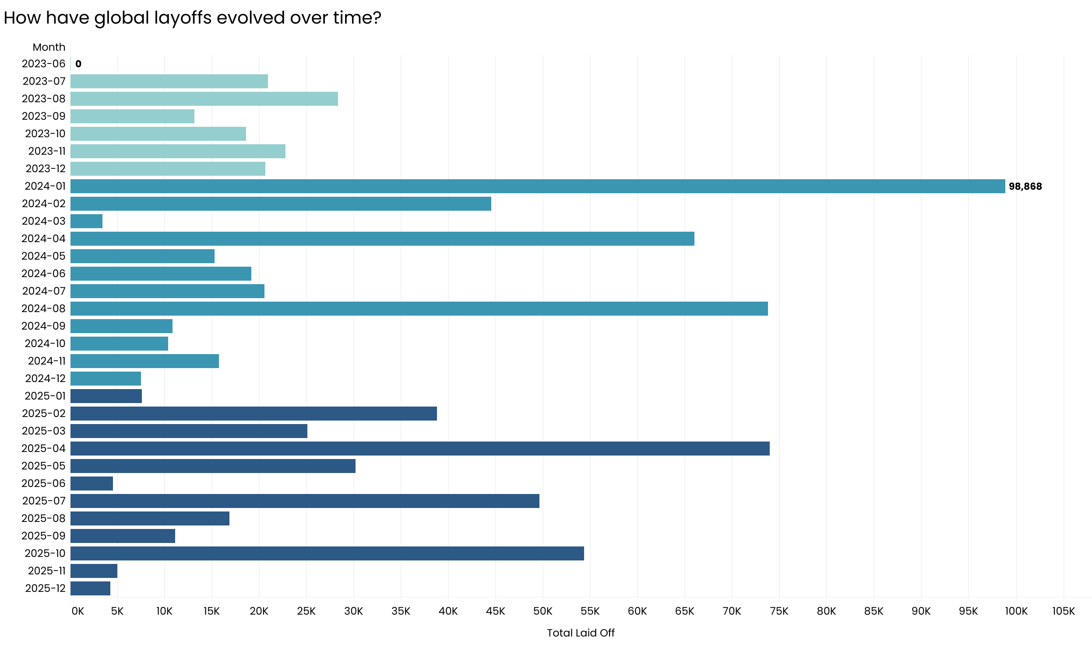

WITH monthly AS (
SELECT
DATE_FORMAT(`date`, '%Y-%m') AS month,
SUM(total_laid_off) AS total_laid_off
FROM layoffs_staging2
GROUP BY month
)
SELECT
month,
total_laid_off,
SUM(total_laid_off) OVER (ORDER BY month) AS cumulative_layoffs
FROM monthly
;
## Rolling (Cumulative) Layoffs

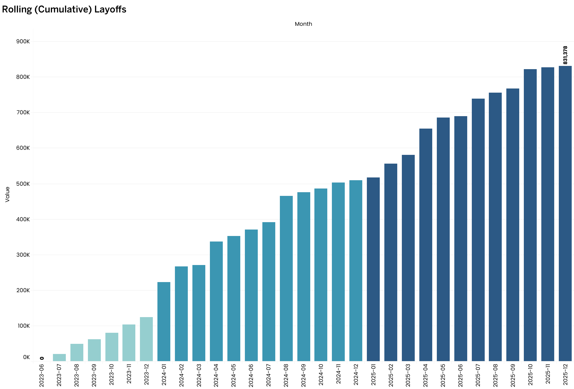
WITH monthly AS (
SELECT
DATE_FORMAT(`date`, '%Y-%m') AS month,
SUM(total_laid_off) AS total_laid_off
FROM layoffs_staging2
GROUP BY month
)
SELECT
month,
total_laid_off,
SUM(total_laid_off) OVER (ORDER BY month) AS cumulative_layoffs
FROM monthly
;
## Rolling (Cumulative) Layoffs

SELECT
company,
SUM(total_laid_off) AS total_laid_off
FROM layoffs_staging2
GROUP BY company
ORDER BY total_laid_off DESC
LIMIT 10
;
## Top 10 Companies by Total Layoffs

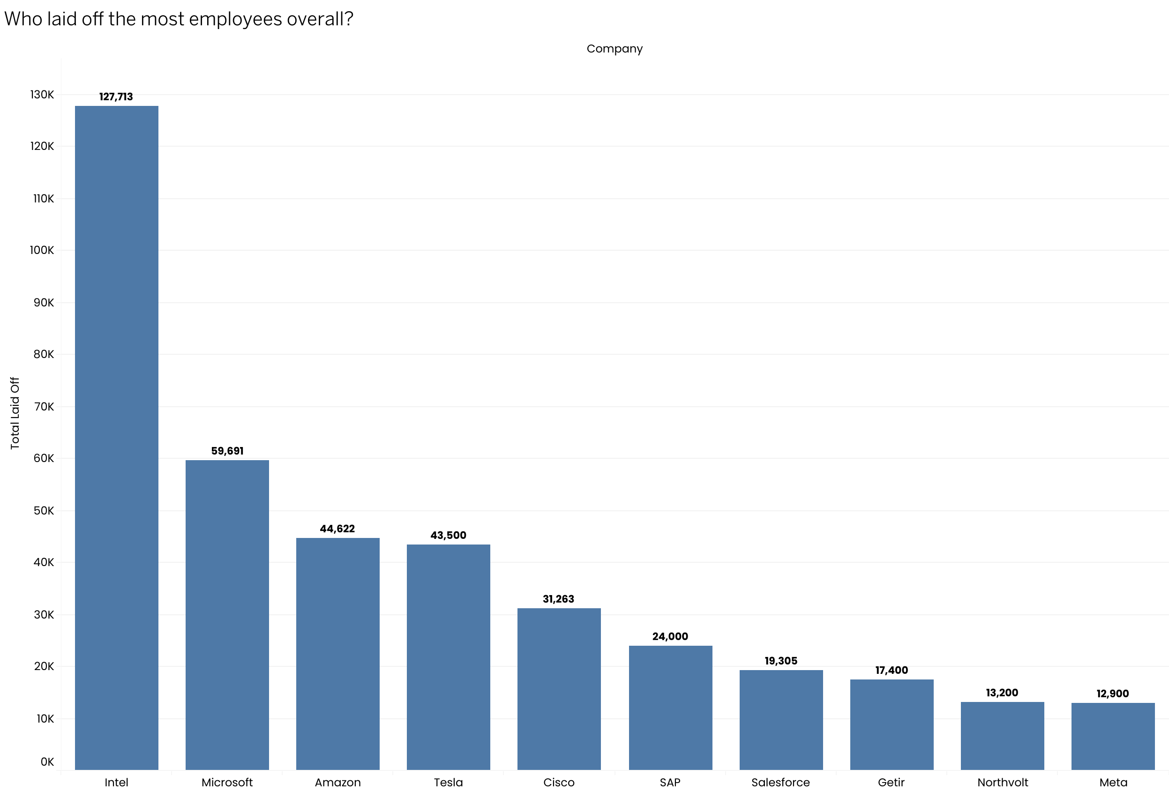
SELECT
industry,
SUM(total_laid_off) AS total_laid_off
FROM layoffs_staging2
GROUP BY industry
ORDER BY total_laid_off DESC
;
## Layoffs by Industry
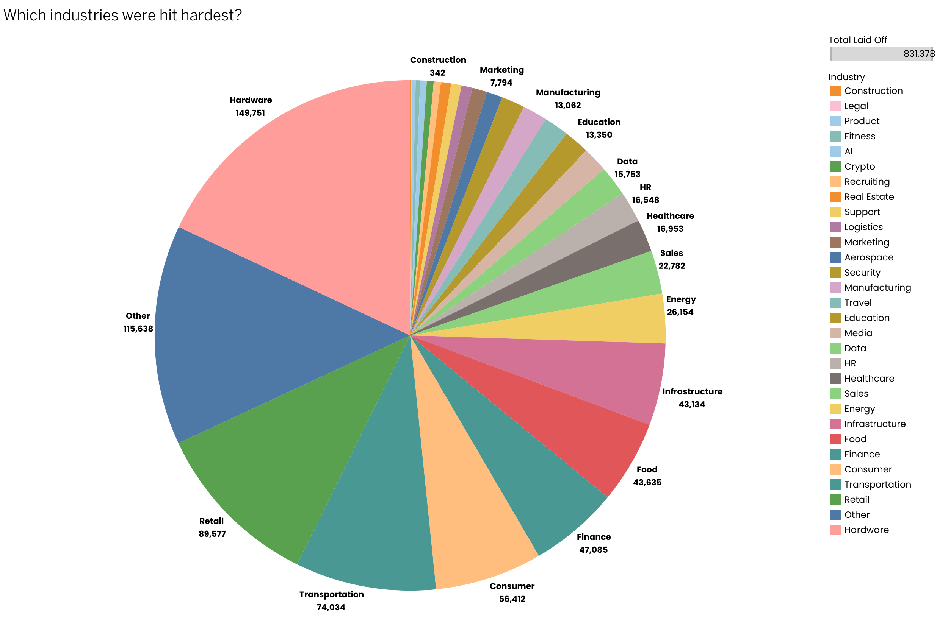
SELECT
country,
SUM(total_laid_off) AS total_laid_off
FROM layoffs_staging2
GROUP BY country
;
##layoffs by Country (Map)

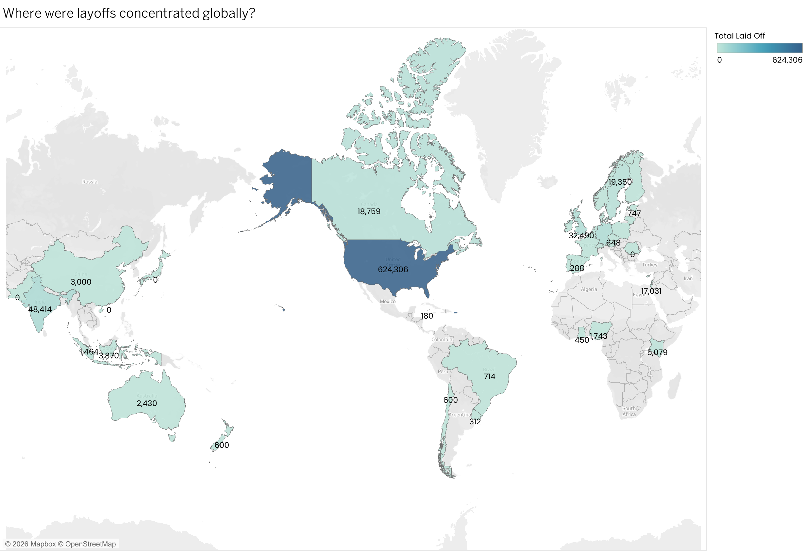
SELECT
stage,
SUM(total_laid_off) AS total_laid_off
FROM layoffs_staging2
GROUP BY stage
ORDER BY total_laid_off DESC
;
## Layoffs by Company Stage
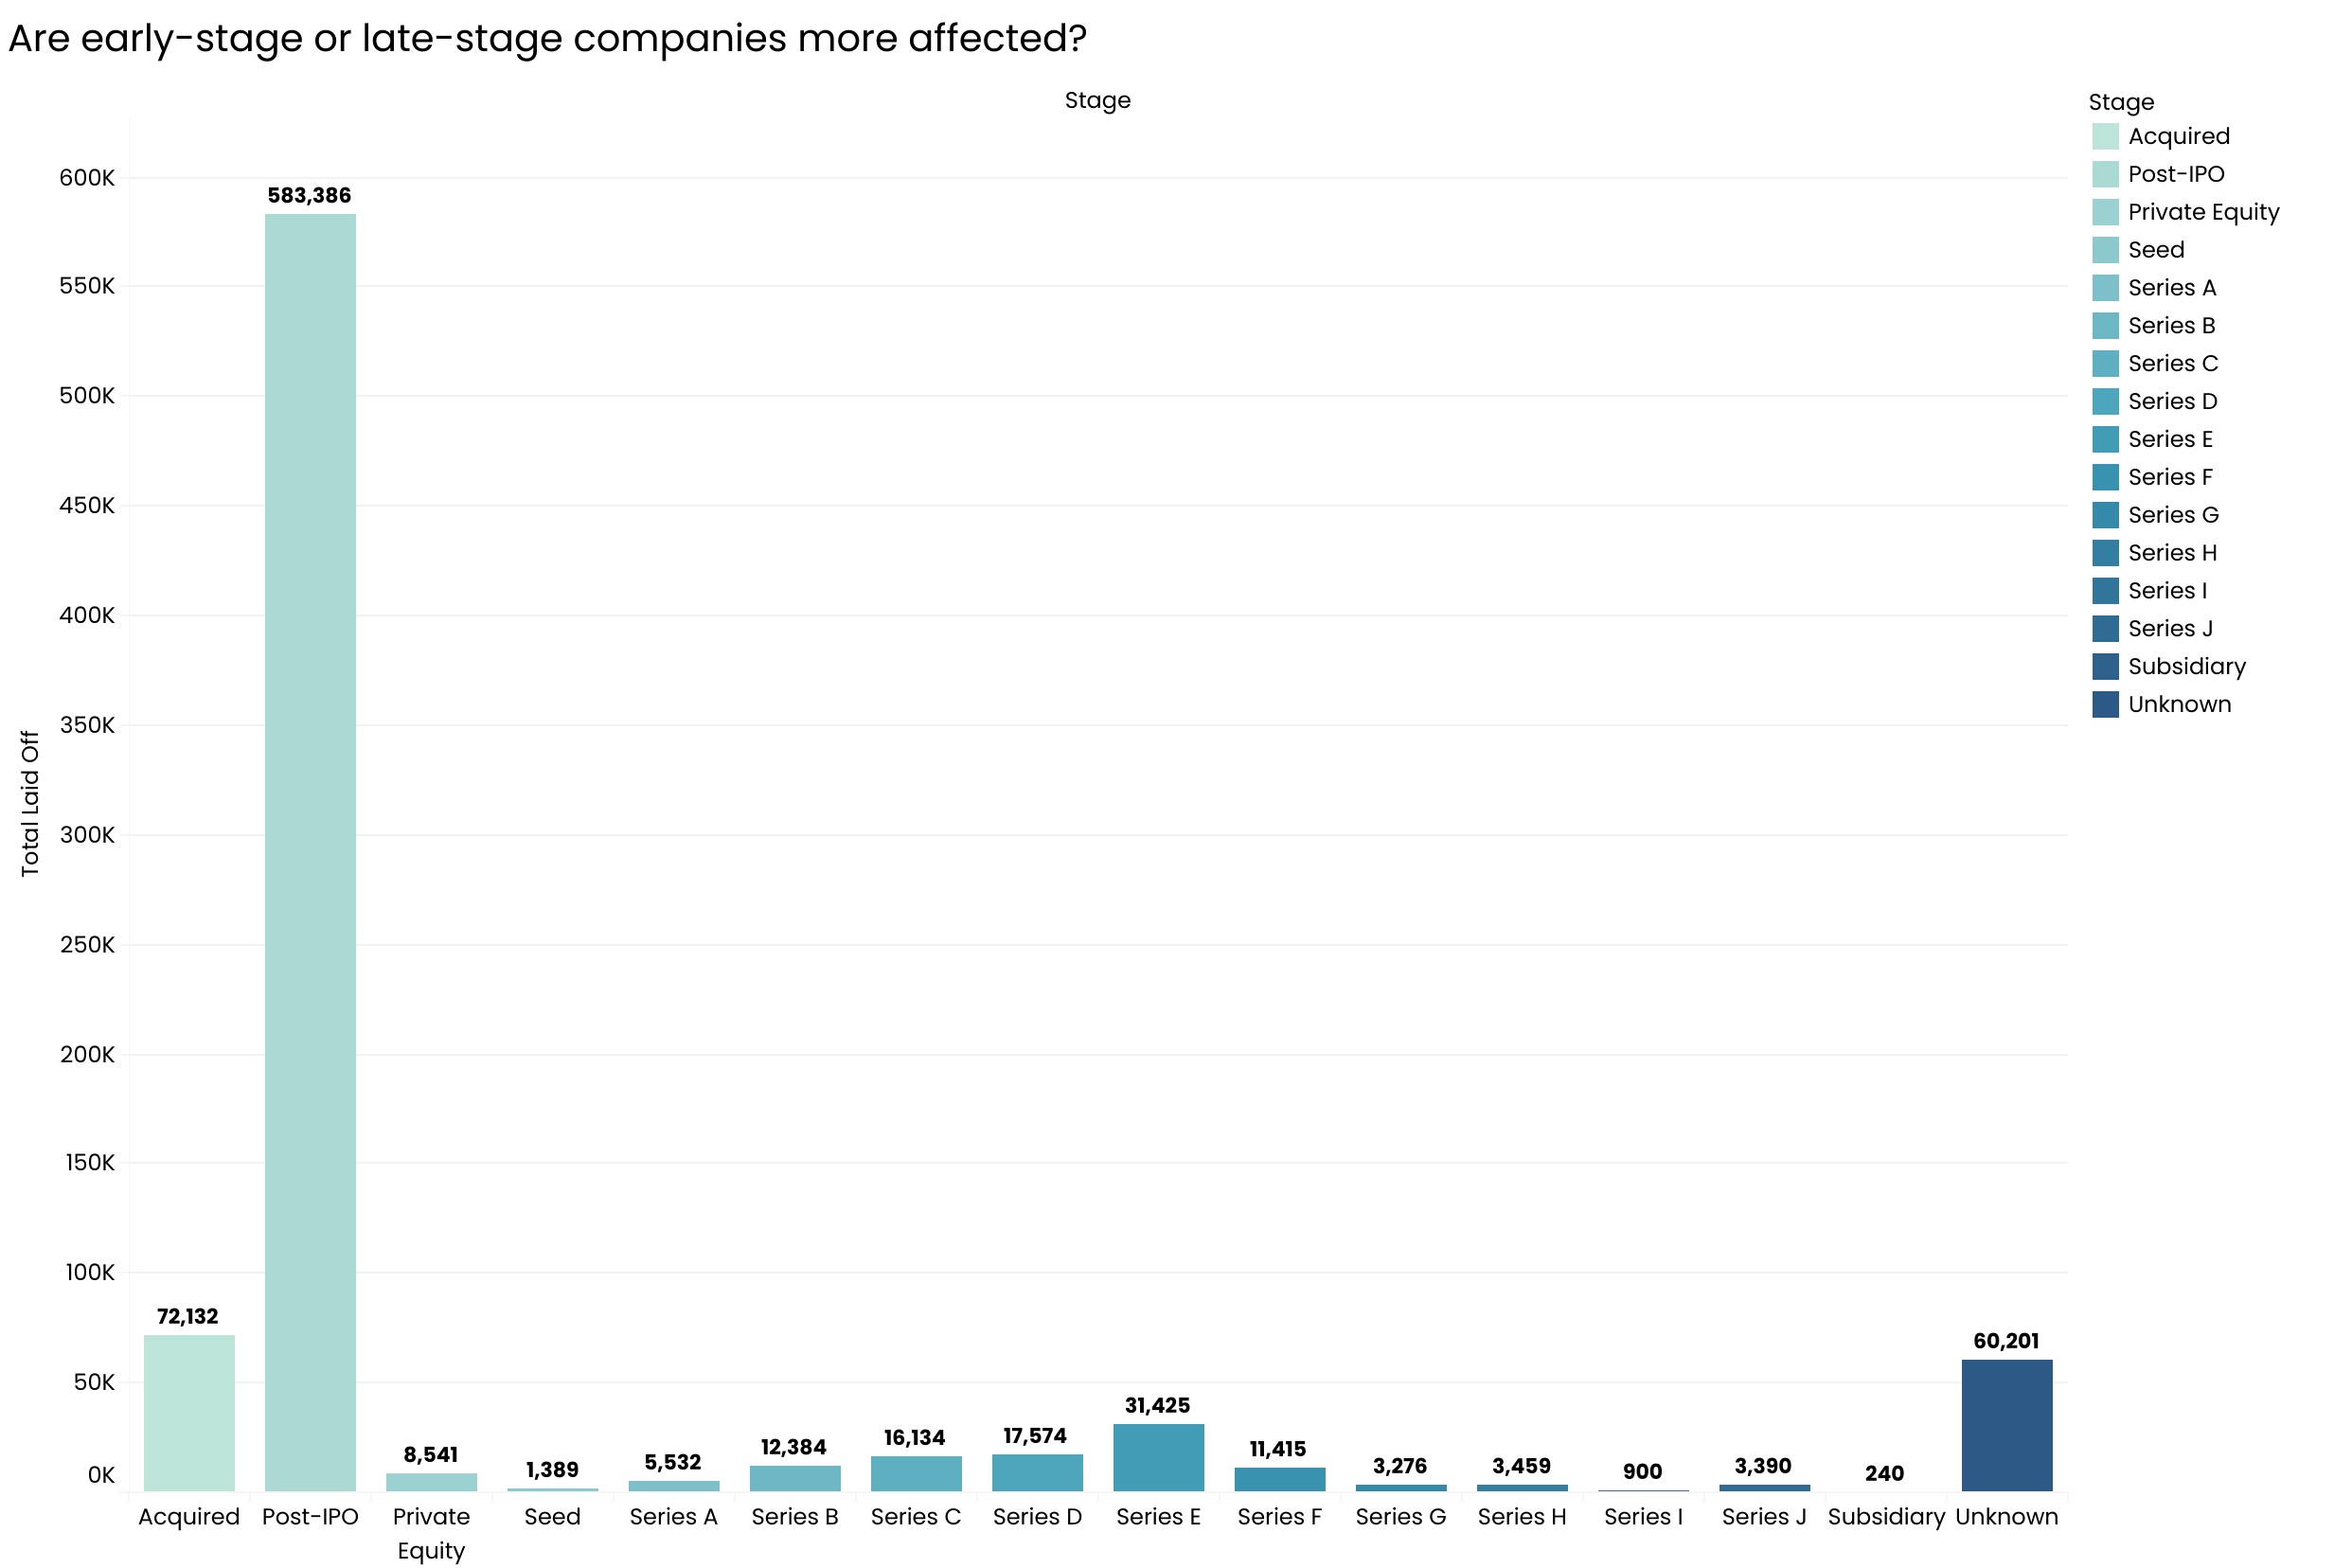
SELECT
company,
SUM(total_laid_off) AS total_laid_off,
MAX(funds_raised) AS funds_raised
FROM layoffs_staging2
WHERE funds_raised IS NOT NULL
GROUP BY company
;
## Funds Raised vs Layoffs
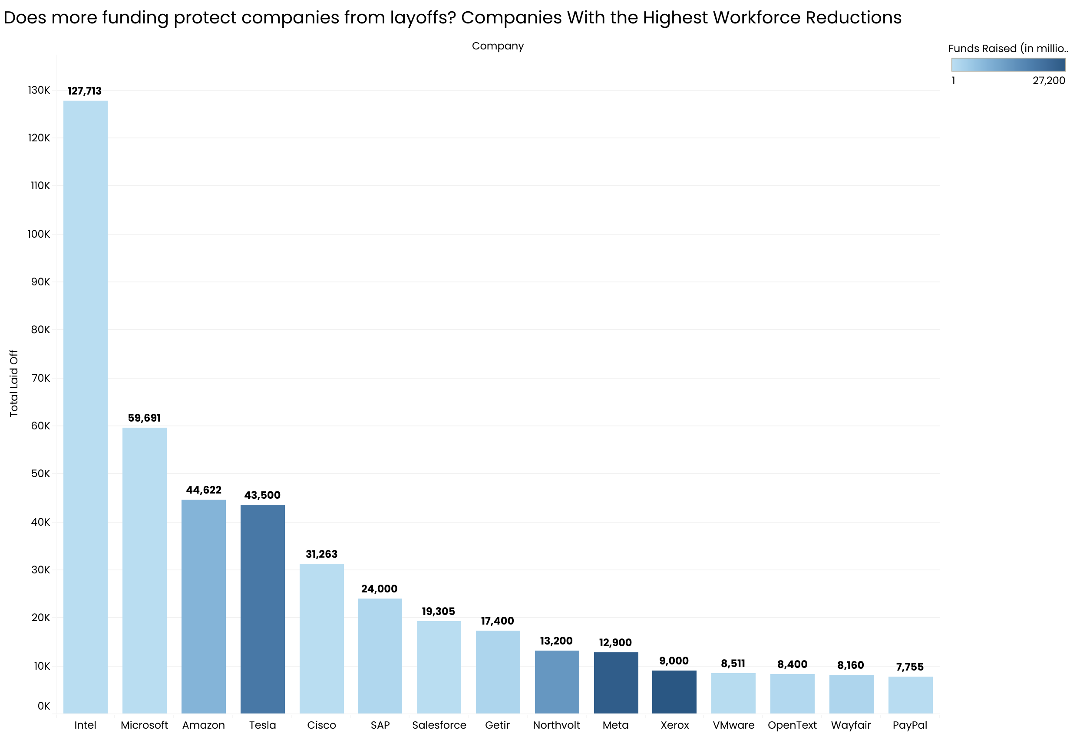
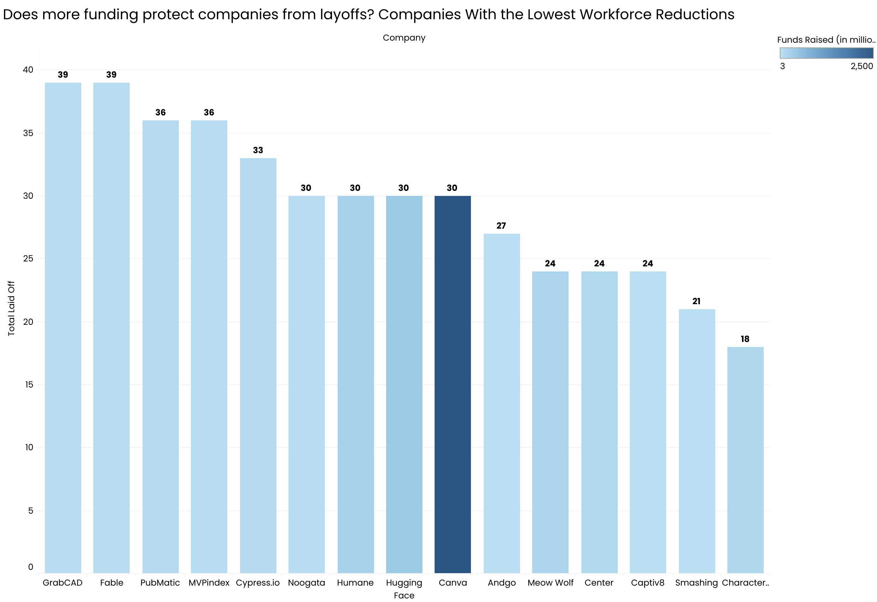
SELECT
company,
industry,
country,
total_laid_off,
funds_raised
FROM layoffs_staging2
WHERE percentage_laid_off = 1
ORDER BY total_laid_off DESC
;
## Companies That Shut Down (100% Layoffs)
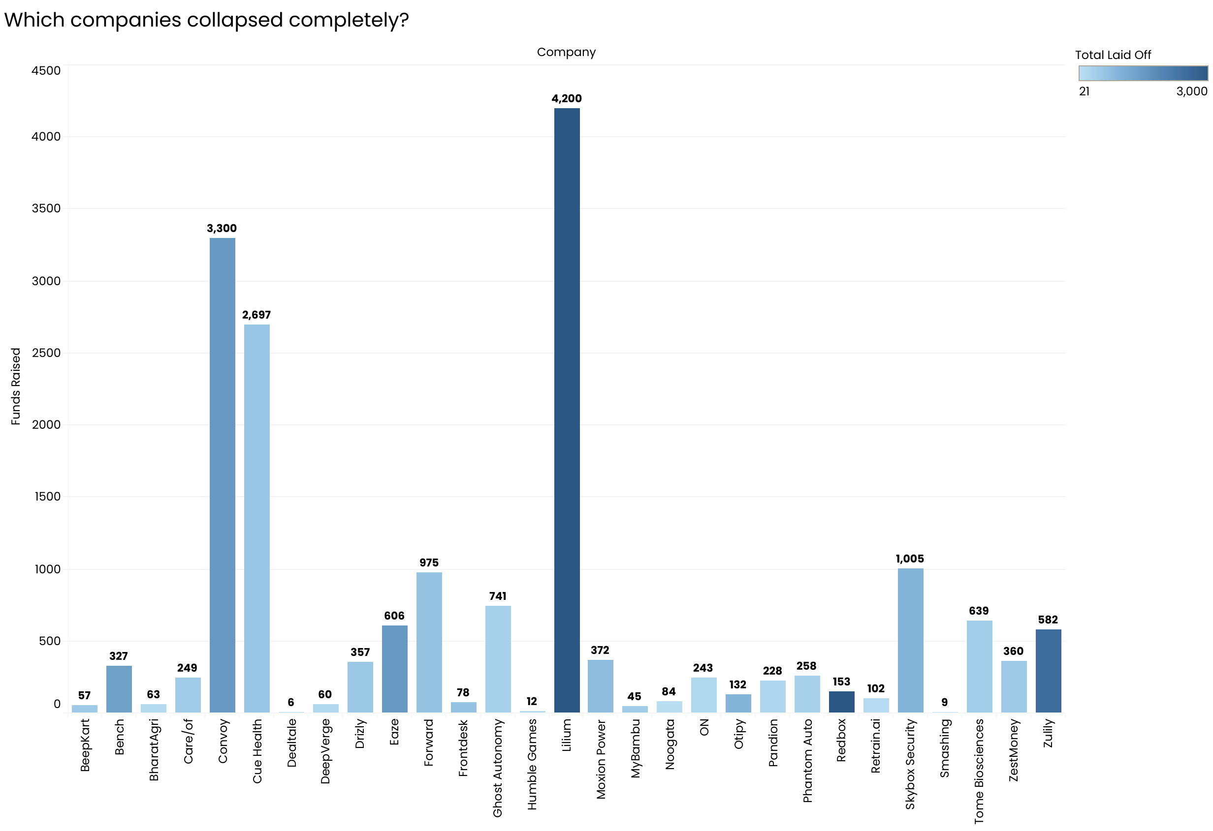
WITH company_year AS (
SELECT
company,
YEAR(`date`) AS year,
SUM(total_laid_off) AS total_laid_off
FROM layoffs_staging2
GROUP BY company, year
),
ranked AS (
SELECT *,
DENSE_RANK() OVER (PARTITION BY year ORDER BY total_laid_off DESC) AS rank_
FROM company_year
)
SELECT *
FROM ranked
WHERE rank_ <= 5
;
## Top 5 Companies by Layoffs Each Year

