TraceGraph DARPA GNN
Comparative Report
  - GCN GraphSAGE and GAT
Verified experimental results | 2 November 2026

Abstract
Three graph neural networks were trained to reconstruct masked activity features from DARPA Transparent Computing Engagement 5 FiveDirections telemetry. Preparation covered all 37 locally downloaded archives, yielding 1,312 graphs and 24,106,424 node-window rows. All models completed five epochs; development data selected their checkpoints before common final testing on 2,664,540 node-window rows.
GraphSAGE achieved the lowest development MSE and the lowest observed test MSE and MAE. Its test MSE of 0.354878308 was 36.53% below the training-mean reference. GCN and GAT achieved test MSE values of 0.373378216 and 0.368743389 respectively. These scores establish performance on feature reconstruction; security classification has not been evaluated. [R1, R2]

Aim
Compare the representation-learning behavior of GCN, GraphSAGE and GAT under a shared graph preparation and masked-feature reconstruction protocol, and provide traceable results and reproduction instructions for the TraceGraph team.

Objectives
Prepare auditable native graph features; fit preprocessing only on training data; compare three graph encoders against a constant reference; select checkpoints using development error; evaluate the frozen selections; and inspect residual distributions without assigning attack labels.
Model | Selected epoch | Test MSE | MSE reduction versus mean
GCN | 5 | 0.373378 | 33.22%
GraphSAGE | 5 | 0.354878 | 36.53%
GAT | 3 | 0.368743 | 34.05%

Project relevance and scope
TraceGraph uses operating-system activity and native relationships for provenance investigation. These experiments test whether graph encoders can recover numeric activity patterns from surrounding context. All three models are standalone research models. Production integration, an attack threshold and validated attack or benign classification remain separate work.

1 Dataset and graph representation
Source: DARPA Transparent Computing Engagement 5, FiveDirections Windows telemetry, distributed as gzip-compressed Avro Common Data Model records. The public dataset catalogue is https://github.com/darpa-i2o/Transparent-Computing. The experiment covers the complete local download, not the complete DARPA release. [R2, R4]
Inventory measure | Verified value
Local archives | 37
Decoded raw records | 345,099,571
Eligible unique Events | 330,788,968
Prepared graphs | 1,312
Node-window rows | 24,106,424
Features per row | 115
Window duration | 5 minutes

Native graph construction
Nodes are identified by publishing-host UUID and native entity UUID. Event subject-to-predicate references provide graph connections. Native subjects can represent threads; process-root identity is not assumed. For message passing, the graph uses an undirected adjacency projection. Repeated endpoint pairs collapse for adjacency, while native event-action occurrence counts remain numeric features. Self-references are excluded from stored adjacency and convolution operators handle their own self or root contributions.

Feature design
Feature group | Count | Meaning
Outgoing references | 57 | 56 fixed action categories plus UNKNOWN
Incoming references | 57 | The same action categories at destination entities
Subject Events without a predicate | 1 | Events with neither predicate reference

Examples of native actions include READ, WRITE, EXECUTE, CONNECT, CREATE_THREAD and LOADLIBRARY. The feature vector excludes UUID values, paths, command lines, absolute timestamps and annotations. Identifiers remain available for grouping and traceability. The action vocabulary is fixed by the protocol rather than fitted from the test set.

Integrity and event accounting
Exact native Event-key deduplication used full raw-record fingerprints. The completed preparation found no identical repeats to remove and no conflicting keys to quarantine. Every prepared node feature vector was independently checked against SQL aggregates. Two temporal purge gaps account for 2,058,940 Events; the remaining 328,730,028 Events contribute to the selected graphs. [R4, R5]

2 Data partitions and preprocessing
Partition | Graphs | Node-window rows | Native Events
Training | 758 | 15,819,608 | 211,686,253
Development | 284 | 5,622,276 | 77,198,703
Test | 270 | 2,664,540 | 39,845,072

A node-window row is an entity in a five-minute graph, not a globally unique entity. The same native entity may appear in multiple windows and chronological partitions.

Chronological boundaries
Partition | UTC boundary
Training | Before 9 May 2019 at 00:00
First purge gap | 9 May 2019 from 00:00 to 00:05
Development | 9 May 00:05 to before 10 May 00:00
Second purge gap | 10 May 2019 from 00:00 to 00:05
Test | 10 May 2019 from 00:05 onward

Preprocessing
Each nonnegative raw count receives a log1p transformation. Population means and standard deviations are fitted using training node-windows only. Development and test reuse the frozen statistics. Constant training columns use scale one. The scaler is saved, fingerprinted and bound to every selected checkpoint.
normalized_feature = (log1p(raw_count) - training_mean) / training_std

Overlap and independence
Partition pair | Recurring native entities
Training and development | 115,807
Training and test | 90,656
Development and test | 104,835

These are counts of intersecting native identities, not percentages of node-window rows. Temporal separation does not establish independent incidents or identity isolation. Known graph structure and neighboring activity can expose context relevant to the masked target; the measured task is within-window imputation rather than future-event prediction. [R2, R4]

3 Model architectures
Each model uses two graph-message-passing layers, ReLU between those layers, and a linear decoder from a 32-value latent representation to 115 normalized output features. The implementation has no graph-level pooling or classification head. [R3]
Property | GCN | GraphSAGE | GAT
Hidden width | 64 | 64 | 4 heads of 16
Latent width | 32 | 32 | 1 head of 32
Decoder output | 115 | 115 | 115
Parameters | 13,299 | 22,707 | 13,491
Aggregation | Degree normalized | Mean with root transform | Learned attention

Graph Convolutional Network
115 -> GCNConv 64 -> ReLU -> GCNConv 32 -> Linear 115
GCN combines connected-node features using degree-normalized aggregation. It supplies a compact graph baseline for recovering a node’s activity from local context. Because the experiment uses neighbor sampling, normalization is calculated on the sampled computation graph and approximates full-graph GCN normalization. Its selected checkpoint is epoch 5.

Graph Sample and Aggregate
115 -> SAGEConv 64 -> ReLU -> SAGEConv 32 -> Linear 115
GraphSAGE uses mean neighborhood aggregation with a separate transformation of the root node. Bounded sampling limits the surrounding computation per seed batch. GraphSAGE has the largest parameter count in this comparison, so its lower observed error cannot be attributed solely to aggregation under an equal-parameter budget. Its selected checkpoint is epoch 5.

Graph Attention Network
115 -> GATConv 4 x 16 heads -> ReLU
-> GATConv 1 x 32 head -> Linear 115
GAT learns attention coefficients over the connected nodes in its sampled context. The four first-layer heads are concatenated to width 64; the second layer outputs width 32. Attention adds flexibility but does not guarantee better reconstruction or explain whether an event is malicious. All five epochs completed; epoch 3 had the lowest development MSE and supplied the final test weights.

4 Training and evaluation protocol
Setting | Shared value
Optimizer | Adam
Learning rate | 0.001
Weight decay | 0.0001
Seed-node batch size | 256
Neighbor fanouts | 10 then 5 over two hops
Training mask probability | 0.20 for whole node vectors
Loss | Mean Squared Error
Precision and seed | Float32 and seed 42
Epoch budget | 5 per family
Selection rule | Lowest development masked MSE including epoch zero

Training objective
For each sampled batch, clean normalized node features are retained as targets. Whole input vectors are masked to normalized zero with probability 0.20. Loss is computed only on masked seed nodes. If a small training batch masks no seeds, one seed is chosen uniformly to ensure that an optimization target exists. Every eligible seed node is visited once per epoch.

Evaluation and checkpoint selection
During development and test evaluation, all seed-node input vectors are masked; context vectors retain the seeded 20% masking rule. Neighbor sampling is deterministic for a fixed graph and seed. Development MSE selects each checkpoint, including initialization as epoch zero. All three checkpoints are frozen before any final test comparison. Training and evaluation losses therefore use different masking conditions.

Metrics and reference
MSE is the average squared reconstruction difference across target rows and all 115 features. MAE is the corresponding average absolute difference. Both are reported in normalized feature space. Lower values indicate closer reconstruction. The constant reference predicts the normalized training mean for each target.
MSE = sum((prediction - target)^2) / (target_rows x 115)
MAE = sum(abs(prediction - target)) / (target_rows x 115)
MSE reduction percent = 100 x (1 - model_MSE / reference_MSE)
The reference development MSE is 0.491797238 and test MSE is 0.559116830. Reference MAE was not recorded in the original test report. A relative reconstruction improvement is not detection accuracy. [R1, R2]

5 Final measured comparison
Metric | GCN | GraphSAGE | GAT
Selected epoch | 5 | 5 | 3
Development MSE | 0.331072538 | 0.298864339 | 0.332544491
Development MAE | 0.080219557 | 0.059072563 | 0.067783435
Final test MSE | 0.373378216 | 0.354878308 | 0.368743389
Final test MAE | 0.086357332 | 0.066772435 | 0.071878950
Test MSE reduction | 33.22% | 36.53% | 34.05%

Table 1 Frozen selected checkpoints evaluated on the same 2,664,540 target rows in 270 test graphs [R1]
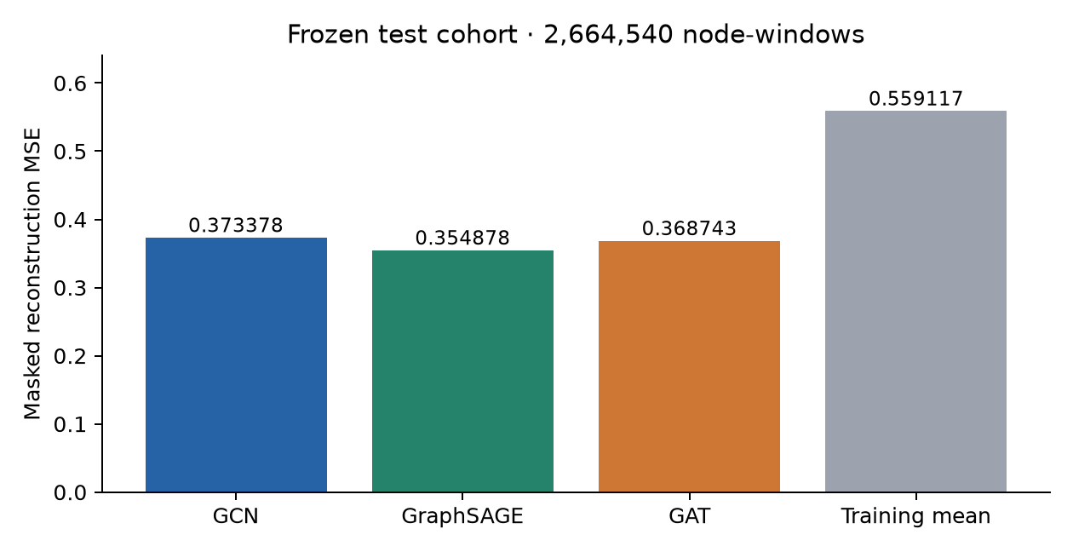
Figure 1 Final normalized masked reconstruction MSE Lower values are better

Interpretation
GraphSAGE leads this run on development MSE, test MSE and test MAE. Its test MSE is 36.53% below the training-mean reference. GAT has lower test MSE and MAE than GCN, although GCN has slightly lower selected development MSE than GAT. This is an observed comparison under the fixed protocol, not evidence of universal architecture superiority.
The earlier ordinary and denoising autoencoders use 62 features and a different, much smaller cohort. Their loss values do not form a matched comparison with these graph models. AE–1D-CNN–BiLSTM has not been implemented or trained in this experiment.

6 Development learning curves
Epoch | GCN MSE | GraphSAGE MSE | GAT MSE
0 | 0.886148 | 1.802108 | 4.339407
1 | 0.352171 | 0.313554 | 0.346766
2 | 0.335843 | 0.305887 | 0.333090
3 | 0.338244 | 0.309423 | 0.332544
4 | 0.343721 | 0.301983 | 0.344633
5 | 0.331073 | 0.298864 | 0.338264

Table 2 Development MSE after each epoch Epoch zero evaluates initialization before training [R6]
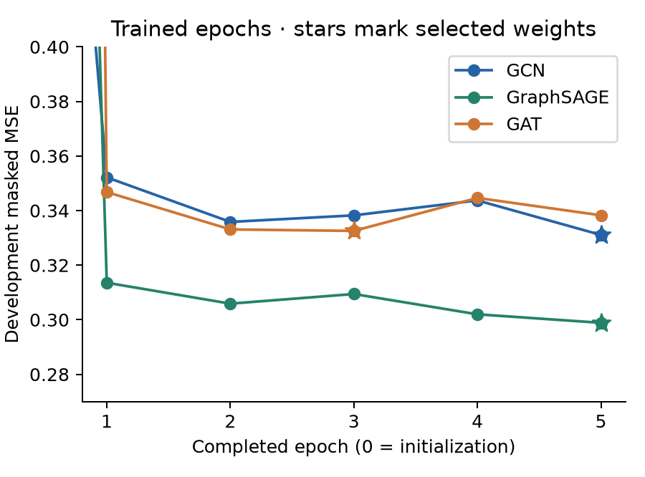
Figure 2 Trained epoch detail Stars indicate the checkpoints selected using development MSE
GCN and GraphSAGE selected epoch 5. GAT selected epoch 3 because epochs 4 and 5 had higher development MSE. The recorded curves are not monotonic: a five-epoch budget does not demonstrate convergence or a globally optimal configuration. No test scores were used to choose an epoch.

7 Training execution and observed timing
Runtime component | Recorded setting
GPU | NVIDIA GeForce RTX 4050 Laptop GPU with 6 GB memory
Python | 3.11.9
PyTorch | 2.15.0+cu132
PyTorch Geometric | 2.8.1
CPU role | Graph loading and bounded neighbor sampling
GPU role | Model forward pass gradients and parameter updates

Training losses collected during parameter updates
Epoch | GCN training MSE | GraphSAGE training MSE | GAT training MSE
1 | 0.336154 | 0.315023 | 0.349749
2 | 0.316310 | 0.287254 | 0.320870
3 | 0.309774 | 0.282280 | 0.312087
4 | 0.313307 | 0.281767 | 0.320790
5 | 0.305142 | 0.277607 | 0.316464

These losses aggregate batches while the model is being updated; they are not fresh evaluations of the final frozen checkpoint. Different masking conditions also prevent a conventional clean-input interpretation of their gap from development loss.
Model | Training function minutes | Final test seconds
GCN | 159.05 | 124.33
GraphSAGE | 320.18 | 108.14
GAT | 186.99 | 153.80

CPU and GPU coordination
GCN and GraphSAGE trained with serial CPU batch preparation followed by CUDA processing. The remaining GAT run used one CPU producer thread and a two-batch queue, pinned host tensors and nonblocking CUDA transfers. This overlaps preparation with GPU work while preserving sampling order, masks and learning settings. All original final tests used the prefetch implementation.
A separate three-repeat GAT benchmark on 30,654 real training rows measured median durations of 6.9605 seconds for serial preparation and 5.9572 seconds for prefetching: 1.1684 times throughput. This small measurement does not guarantee a full-epoch speedup. The successful training-function times above include development evaluation and checkpoint work, exclude abandoned runs and data preparation, and reflect differing resource conditions. They are not a controlled architecture-speed comparison. [R1, R7]

8 Residual error analysis
Frozen-model replay covered all 270 test graphs without optimization or checkpoint reselection. It reproduced the saved test MSE, MAE and mean-reference MSE exactly on this runtime. The following values describe the distribution of per-row MSE across all 115 normalized features. [R8]
Statistic | GCN | GraphSAGE | GAT
Median row MSE | 0.016183 | 0.010364 | 0.012120
95th percentile | 0.870415 | 0.990546 | 0.763579
99th percentile | 5.149458 | 5.171817 | 4.745698
Maximum row MSE | 1726.447876 | 1682.260010 | 2705.290039
Top 1 percent error share | 65.16% | 61.36% | 69.94%

Distribution findings
GraphSAGE has the lowest average and median row error. GAT has the lowest 95th-percentile error but also the largest maximum row error. The highest-error 1% of rows contributes 65.16% of squared residual for GCN, 61.36% for GraphSAGE and 69.94% for GAT. Average and tail rankings therefore differ; an aggregate mean does not describe every part of the cohort.

Largest feature residual contributors
Model | Feature | Share of squared residual
GCN | Incoming LOGOUT | 3.36%
 | Incoming EXECUTE | 3.07%
 | Outgoing FORK | 2.79%
GraphSAGE | Incoming LOGOUT | 3.51%
 | Incoming CHECK_FILE_ATTRIBUTES | 3.27%
 | Incoming EXECUTE | 3.24%
GAT | Incoming LOGOUT | 3.35%
 | Incoming EXECUTE | 3.13%
 | Outgoing LOGOUT | 2.89%

Incoming LOGOUT reference counts are the largest single residual contributor for all three models. A residual contribution measures numeric reconstruction difficulty rather than causality or security intent. Ten high-error native rows per model were retained locally with graph and entity references and unknown labels for descriptive review. They were not accepted as attack annotations.

9 Verification limitations and conclusion

Completed verification
All 1,312 graph files matched their recorded hashes. Source sizes and modification times were rechecked for the 37 archives. Source, Event and partition totals reconciled; histories supported the development selection rules; final test reports matched their aggregate and target-row coverage. All three checkpoints loaded strictly on CPU with matching parameter counts and tensor-state fingerprints. Both the original pipeline contract and supplementary execution profile were validated. [R5]
The frozen error-analysis replay reproduced every model’s saved test MSE, MAE and reference MSE, and confirmed unchanged model states and checkpoint files. Six new reporting checks passed for metric validity, coverage, history and selection consistency, checkpoint and aggregate binding, security-claim rejection, residual calculations and changed reporting inputs. Earlier 14 focused GNN and prefetch checks also passed. These checks validate software and artifact consistency, not security effectiveness.

Validity limits
One seed and five epochs were used per model. There are no multi-seed confidence intervals or hyperparameter-search results. CUDA scatter operations can be nondeterministic, so exact equality on another runtime is not promised. Strict local reload and replay are complete; independent clean-machine reproduction and a new raw-byte rehash were not performed.
Native entities recur across partitions and graph neighbors expose same-window activity. The evaluation does not establish independent incident generalization or forecasting. The parameter budgets differ, and elapsed training times reflect different execution and resource conditions. The tested cohort has now been inspected for metrics and diagnostics; future tuning requires fresh evaluation evidence.
Security intent remains unknown in this workflow. Accuracy, precision, recall, F1, ROC AUC, false-positive rates and detection thresholds are unavailable without trustworthy labels and a suitable detection protocol. The original supervised task and production integration retain their prerequisite gaps.

Conclusion and project decision
GraphSAGE is the strongest candidate among these three models for average masked-feature reconstruction under the measured protocol. It achieved test MSE 0.354878308 and MAE 0.066772435, with 36.53% lower MSE than the mean reference. GAT offers a different tail-error profile, while GCN provides the smaller baseline. Preserve the frozen results as the completed three-model experiment. Any new model, detector threshold, tuning study or production integration requires a separately specified next task.

10 Saved artifacts and reproduction
Repository branch: deeplearning/shlok. Published experiment and reporting commit: 916e8c1. Run the commands from C:\codes\PBL sem 7\tracegraph using the recorded isolated environments. [R9]

Selected checkpoints
D:\Deep Learning\tracegraph-gnn-workspace\runs\gcn\best.pt
D:\Deep Learning\tracegraph-gnn-workspace\runs\graphsage\best.pt
D:\Deep Learning\tracegraph-gnn-workspace\runs\gat\best.pt
Each model directory contains its history, training report, final test report and execution receipt. The workspace complete.json records final completion. Standalone run.json test flags are historical pre-test receipts; test.json and complete.json provide the subsequent final evaluation.

Artifact verification without training
.cache/ml-envs/darpa-gpu-py311/Scripts/python.exe `
-m research.ml.gnn_results.verify `
--work "D:/Deep Learning/tracegraph-gnn-workspace" `
--source "D:/Deep Learning/fivedirections-20261010T174625Z-1-049/fivedirections" `
--output ".cache/gnn-results-20261102/verification.json"

Frozen residual replay on the GPU
.cache/ml-envs/darpa-gpu-py311/Scripts/python.exe `
-m research.ml.gnn_results.analyze `
--work "D:/Deep Learning/tracegraph-gnn-workspace" `
--verification ".cache/gnn-results-20261102/verification.json" `
--output ".cache/gnn-results-20261102"

Rebuild the report tables and figures
research/ml/.venv/Scripts/python.exe `
-m research.ml.gnn_results.report `
--work "D:/Deep Learning/tracegraph-gnn-workspace" `
--verification ".cache/gnn-results-20261102/verification.json" `
--analysis ".cache/gnn-results-20261102/error_analysis.json" `
--output "data/ml/datasets/darpa/gnn_full"
The plotting environment uses Matplotlib; the model verification and residual commands use the pinned Python 3.11 CUDA environment. Teammates can regenerate figures from the committed aggregate files using report --plots-only without raw archives or checkpoints. Do not launch training over the completed workspace. Fresh raw-data or training reproduction requires a separate work directory, the same inputs and an integrity review. Large raw data, weights and individual review rows remain local.

11 Evidence references and checkpoint fingerprints
The following project artifacts are the primary experimental evidence. The public repository is https://github.com/kaustubhvanshiv/tracegraph/tree/deeplearning/shlok. Paths below are relative to that repository unless identified as local workspace artifacts.
[R1] data/ml/datasets/darpa/gnn_full/results_20261102.json
Final selected metrics, parameter counts, runtime and partition summaries.
[R2] research/ml/gnn_results/README.md
Methods, measured findings, limitations and teammate commands.
[R3] research/ml/gnn_full/model.py and config.json
Actual model architectures and frozen training settings.
[R4] research/ml/gnn_full/TASK_SPEC.md
Predeclared representation, target, temporal split and completion rules.
[R5] data/ml/datasets/darpa/gnn_full/verification_20261102.json
Completed graph, checkpoint, history, provenance and coverage verification.
[R6] data/ml/datasets/darpa/gnn_full/histories_20261102.json
Recorded initialization and epochs 1 through 5 for every model.
[R7] data/ml/datasets/darpa/gnn_full/prefetch_benchmark_20261101.json
Training-only throughput benchmark and timing limits.
[R8] data/ml/datasets/darpa/gnn_full/error_analysis_20261102.json
Frozen replay, row distributions and per-feature residual summaries.
[R9] data/ml/datasets/darpa/gnn_full/RESULTS_20261102.md
Human-readable results, charts and CSV comparison.

Selected checkpoint SHA256 values
GCN
1574b91e12a9382c7aebbd6924f5129f3528748fa11a21b40e260c7e1f95573c
GraphSAGE
cd4eec384931a2fe3bad5c1ee4ca23ad71511b5594dc2dcde204ab99a3fffd5e
GAT
9c6a420804a6bfa77a6255af00acc7467edd2f89f4dfc5f81b7a5aace0ff4444
These fingerprints identify the verified local selected files Model weights are not included in the public report

