TraceGraph GNN Results
  - GCN GraphSAGE and GAT | 2 November 2026
GraphSAGE achieved the lowest average reconstruction error in the completed three-model experiment. Its test MSE was 36.53% below the training-mean reference. All models completed five epochs and final evaluation.

Dataset and task
DARPA TC Engagement 5 FiveDirections: all 37 local archives, 330.8 million eligible Events, 1,312 five-minute graphs and 24.1 million node-window rows. The input has 115 features: outgoing and incoming action counts plus no-predicate Events. Training used 15,819,608 rows; development 5,622,276; test 2,664,540.
Task: reconstruct masked node features from graph context. Counts receive log1p and training-only normalization. Chronological partitions have five-minute gaps; native entities can recur across partitions.
Model | Neighbor processing | Parameters | Best epoch
GCN | Degree-normalized aggregation | 13,299 | 5
GraphSAGE | Mean aggregation with root transform | 22,707 | 5
GAT | Attention with 4 then 1 heads | 13,491 | 3

Shared setup: 115 input features, 64 hidden values, 32 latent values and a 115-feature decoder. Adam learning rate 0.001, weight decay 0.0001, batch 256, fanouts 10/5, 20% training masking and seed 42. Training used the NVIDIA RTX 4050 Laptop GPU.

Measured comparison
Model | Dev MSE | Test MSE | Test MAE | MSE reduction
GCN | 0.331073 | 0.373378 | 0.086357 | 33.22%
GraphSAGE | 0.298864 | 0.354878 | 0.066772 | 36.53%
GAT | 0.332544 | 0.368743 | 0.071879 | 34.05%

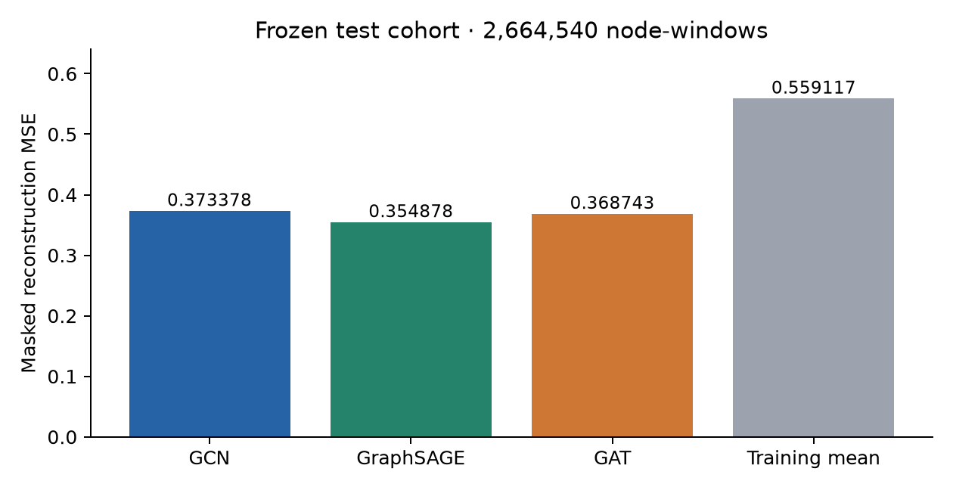
Figure 1 Frozen test reconstruction MSE Lower is better Mean reference MSE is 0.559117

Learning curves and important findings
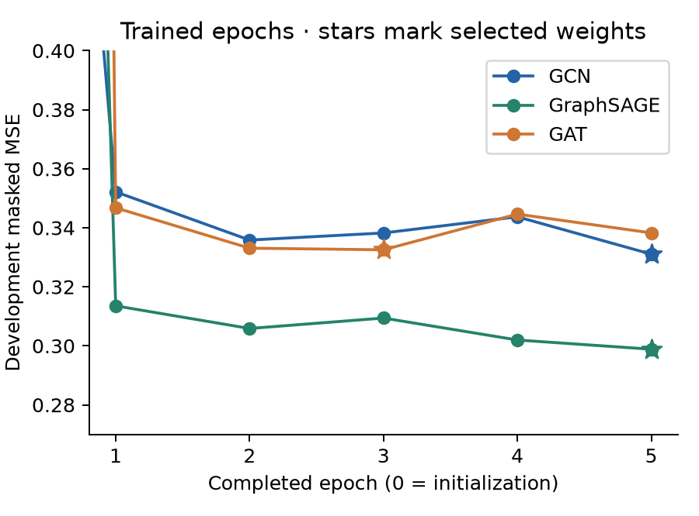
Figure 2 Development loss after training Stars mark the selected checkpoints
GCN and GraphSAGE selected epoch 5. GAT selected epoch 3 because its later development MSE was worse. All selections were frozen before final testing. Training masks 20% of vectors; evaluation masks every seed node, so the two loss levels use different conditions.

Error analysis
Model | Median row MSE | 95th percentile | Top 1% error share
GCN | 0.016183 | 0.870415 | 65.16%
GraphSAGE | 0.010364 | 0.990546 | 61.36%
GAT | 0.012120 | 0.763579 | 69.94%

GraphSAGE has the lowest average and median error. GAT has a lower 95th-percentile error but the largest maximum error. The highest-error 1% of rows contributes 61–70% of squared residual. High reconstruction error does not establish malicious activity.

Verification and limits
All 1,312 graph files and all three checkpoint states passed verification. Frozen replay reproduced the saved test scores. Six new reporting checks passed. One seed and five epochs per model do not establish universal superiority; GraphSAGE also has more parameters. The test cohort is now inspected and should not guide further tuning.
These are self-supervised reconstruction results. Attack accuracy, precision, recall, F1 and detection thresholds remain unevaluated. The complete local download is covered; the entire DARPA release is not claimed. AE–1D-CNN–BiLSTM was not trained.
Evidence and full tables: github.com/kaustubhvanshiv/tracegraph/blob/deeplearning/shlok/data/ml/datasets/darpa/gnn_full/RESULTS_20261102.md

