Video for step by Step

https://www.youtube.com/watch?v=pHIgRv4r6Tk

RDS Info

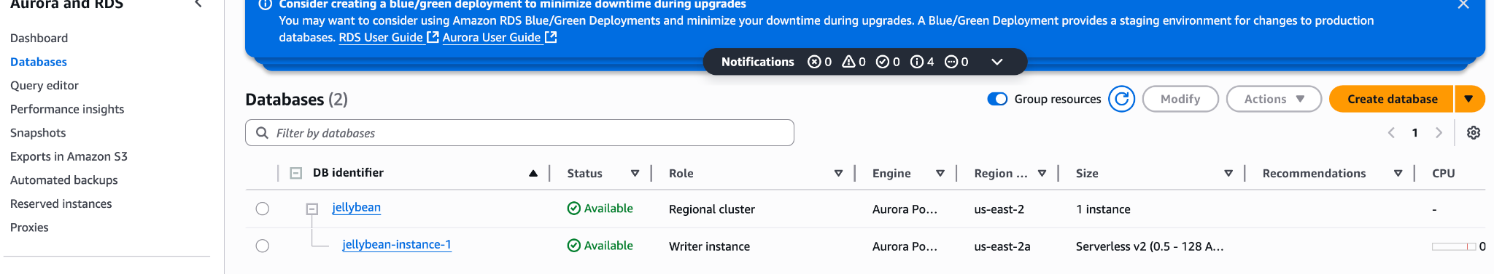

To connect an AWS Lambda function to an Amazon RDS PostgreSQL database, you need:
- RDS endpoint, port, username, and password
- VPC configuration (Lambda must be in same VPC/subnet and security group must allow access)
- Database client library, such as psycopg2 for Python

✅ Python Lambda Example: Connect to Amazon RDS PostgreSQL

1. Python code (using psycopg2)
python
CopyEdit
import os
import psycopg2

# Load from environment variables
DB_HOST = os.environ['DB_HOST']
DB_NAME = os.environ['DB_NAME']
DB_USER = os.environ['DB_USER']
DB_PASSWORD = os.environ['DB_PASSWORD']
DB_PORT = os.environ.get('DB_PORT', 5432)

def lambda_handler(event, context):
try:
connection = psycopg2.connect(
host=DB_HOST,
dbname=DB_NAME,
user=DB_USER,
password=DB_PASSWORD,
port=DB_PORT
)
cursor = connection.cursor()
cursor.execute("SELECT version();")
version = cursor.fetchone()

return {
'statusCode': 200,
'body': f'Connected to PostgreSQL version: {version}'
}

except Exception as e:
return {
'statusCode': 500,
'body': f'Error connecting to PostgreSQL: {str(e)}'
}

finally:
if 'cursor' in locals():
cursor.close()
if 'connection' in locals():
connection.close()

2. Environment variables (set in Lambda configuration)
Set these in your Lambda console or Terraform/CDK:
- DB_HOST: your RDS endpoint (e.g., mydb.cluster-xxxx.us-west-2.rds.amazonaws.com)
- DB_NAME: the PostgreSQL database name
- DB_USER: your master or app-specific username
- DB_PASSWORD: the password (consider using AWS Secrets Manager instead)
- DB_PORT: typically 5432

3. Include psycopg2
- Lambda does not come with psycopg2 by default.
- Use psycopg2-binary locally to test, but deploy with compiled psycopg2 for Lambda.
You can use a Lambda Layer or a deployment package. The easiest way:

Using psycopg2 via Lambda Layer (recommended):
- Download a compatible layer from:
  - https://github.com/jkehler/awslambda-psycopg2
- Add it as a Lambda Layer.

4. Network Access
- Your Lambda must be in the same VPC and subnet group as the RDS instance.
- The RDS security group must allow inbound traffic from the Lambda's subnet/group on port 5432.

Optional: Use Secrets Manager (for DB credentials)
Instead of hardcoding credentials:
python
CopyEdit
import boto3
import json

def get_db_credentials(secret_name):
client = boto3.client('secretsmanager')
secret = client.get_secret_value(SecretId=secret_name)
return json.loads(secret['SecretString'])

Then use this to replace DB_USER, DB_PASSWORD, etc.

Let me know if you want a ZIP template or SAM/CDK deployment config!

You said:
DESCRIBE STEPS FOR "Add it as a Lambda Layer" to add psycopg2-binary

ChatGPT said:
Here are the step-by-step instructions to create and add a Lambda Layer containing psycopg2-binary (for PostgreSQL access) to your AWS Lambda function.

✅ Steps to Add psycopg2-binary as a Lambda Layer

⚙️ Option 1: Use Prebuilt Layer (Fastest)
If you want to skip the manual packaging, use a prebuilt psycopg2 Lambda Layer:
Popular source: https://github.com/jkehler/awslambda-psycopg2
Steps:
- Download the prebuilt ZIP file for your Python version (e.g., psycopg2-3.9.zip)
- Go to AWS Lambda Console → Layers
- Click Create layer
- Name it psycopg2-layer
- Upload the ZIP file
- Choose compatible runtimes (e.g., Python 3.9)
- Click Create
- Go to your Lambda function
  - In the Layers section, click Add a layer
  - Choose Custom layer
  - Select the layer you just created
✅ Done! You can now import psycopg2 in your Lambda function.

🔨 Option 2: Build Your Own psycopg2 Lambda Layer (More Control)
If you want to package it yourself (or need a different version):

Step 1: Prepare local build environment
Use a Linux environment (Amazon Linux 2) to match Lambda. You can use Docker for that:
bash
CopyEdit
docker run -it --rm -v "$PWD":/var/task amazonlinux:2 bash

Inside Docker:
bash
CopyEdit
yum install -y gcc python3-devel postgresql-devel zip
pip3 install psycopg2-binary -t python
zip -r psycopg2-layer.zip python

This creates a valid layer ZIP in your current folder: psycopg2-layer.zip

Step 2: Upload the layer to AWS
- Go to the AWS Lambda console → Layers
- Click Create Layer
- Name: psycopg2-layer
- Upload the psycopg2-layer.zip
- Runtime: Choose your Lambda Python runtime (e.g., Python 3.9)
- Click Create

Step 3: Attach the layer to your Lambda
- Go to your Lambda function
- Scroll down to Layers
- Click Add a layer
- Choose Custom layer
- Select psycopg2-layer and version
- Click Add

✅ Done
Now your Lambda function can import and use psycopg2 like this:
python
CopyEdit
import psycopg2

