Documentation of VBExercises project

Kaustuv Prajapati, MBA IT 6th batch.

Table of Contents

Documentation of VBExercises project 2

Disclaimer 2

# Documentation of VBExercises project

## Disclaimer

This doc explains how the code structure is implemented in the Application. Explains about the components used.

Also contains the note for various techniques and tools, example, syntax, good practices, shortcuts, custom methods and code flow.

# General Application

Figure App UI

General MenuStrip is added for general functions.

TabControl is added for multi tabl selection

Exercises tab:

* ListView for exercise selection
* Panel for exercise Form display.

# Exercise 1

Write a program to calculate discount on the basis of following assumption: a) If purchased amount is greater than or equal to 1000, discount is 5%

## Core Code

Figure Exercise 1 in action. Calculating discount

Below is the core CODE component

Private Sub Update_Discount_Settings(newPurchaseAmt)

If newPurchaseAmt >= 1000 Then

discountable = True

DisStatLvlVal.Text = "YES"

DisStatLvlVal.ForeColor = Color.Green

DisPerLblVal.Text = "5%"

Else

discountable = False

DisStatLvlVal.Text = "NO"

DisStatLvlVal.ForeColor = Color.Red

DisPerLblVal.Text = "Na"

End If

End Sub

## Click Handler Code

Private Sub CalculateBtn_Click(sender As Object, e As EventArgs) Handles CalculateBtn.Click

' CALCULATING 5% DISCOUNT ON Purchase Amt

Dim discountAmt, disPercent As Double

If discountable Then

disPercent = 0.05 ' in percentage

discountAmt = Math.Round(newPurchaseAmt * disPercent, 2)

newPurchaseAmt = Math.Round(newPurchaseAmt - discountAmt, 2)

Else

discountAmt = 0

End If

DisAmtValLbl.Text = discountAmt & " Rs /-"

FinalAmtLblVal.Text = newPurchaseAmt & " Rs /-"

End Sub

# Exercise 2

Write a program to calculate discount on the basis of following assumption: a) If purchased amount is greater than or equal to 1000, discount is 5% b) If purchased amount is less than 1000, discount is 3%

## Core Code

Private Sub Update_Discount_Settings(newPurchaseAmt)

If newPurchaseAmt >= 1000 Then

discountable = True

DisStatLvlVal.Text = "YES"

DisStatLvlVal.ForeColor = Color.Green

DisPerLblVal.Text = "5%"

disPercent = 0.05 ' in percentage

ElseIf newPurchaseAmt < 1000 Then

discountable = True

DisStatLvlVal.Text = "YES"

DisStatLvlVal.ForeColor = Color.Green

DisPerLblVal.Text = "3%"

disPercent = 0.03 ' in percentage

End If

End Sub

Figure Exercise 2 in action

## Button Click Handler

Private Sub CalculateBtn_Click(sender As Object, e As EventArgs) Handles CalculateBtn.Click

Dim discountAmt As Double

If discountable Then

discountAmt = Math.Round(newPurchaseAmt * disPercent, 2)

newPurchaseAmt = Math.Round(newPurchaseAmt - discountAmt, 2)

Else

discountAmt = 0

End If

DisAmtValLbl.Text = discountAmt & " Rs /-"

FinalAmtLblVal.Text = newPurchaseAmt & " Rs /-"

End Sub

# Exercise 3

Write a program to calculate discount on the basis of following assumption: a)

If purchased amount is greater than or equal to 5000, discount is 10% b)

If purchased amount is greater than or equal to 4000 and less than 5000, discount is 7% c)

If purchased amount is greater than or equal to 3000 and less than 4000, discount is 5% d)

If purchased amount is greater than or equal to 2000 and less than 3000, discount is 3% e)

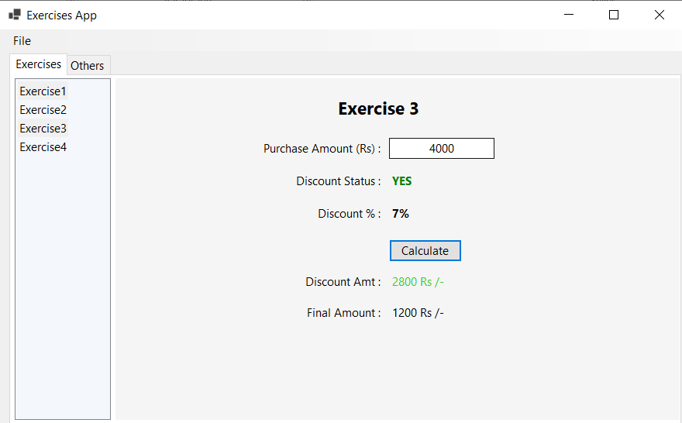 If purchased amount is less than 2000, discount is 2%

Figure Exercise 3 in action

## Core Code

Private Sub Update_Discount_Settings(newPurchaseAmt)

If newPurchaseAmt >= 5000 Then

Calculate_Discount(True, "YES", Color.Green, "10%", 0.1)

ElseIf newPurchaseAmt >= 4000 And newPurchaseAmt < 5000 Then

Calculate_Discount(True, "YES", Color.Green, "7%", 0.07)

disPercent = 0.7 ' in percentage

ElseIf newPurchaseAmt >= 3000 And newPurchaseAmt < 4000 Then

Calculate_Discount(True, "YES", Color.Green, "5%", 0.05)

ElseIf newPurchaseAmt >= 2000 And newPurchaseAmt < 3000 Then

Calculate_Discount(True, "YES", Color.Green, "3%", 0.03)

ElseIf newPurchaseAmt < 2000 Then

Calculate_Discount(True, "YES", Color.Green, "2%", 0.02)

End If

End Sub

Private Sub Calculate_Discount(discountableBool, disStatLblVal, disStatLblColor, disPerLblValNew, disPercentVal)

discountable = discountableBool

Me.DisStatLblVal.Text = disStatLblVal

Me.DisStatLblVal.ForeColor = disStatLblColor

DisPerLblVal.Text = disPerLblValNew

disPercent = disPercentVal ' in percentage

End Sub

## Button Click Handler

Private Sub CalculateBtn_Click(sender As Object, e As EventArgs) Handles CalculateBtn.Click

Dim discountAmt As Double

If discountable Then

discountAmt = Math.Round(newPurchaseAmt * disPercent, 2)

newPurchaseAmt = Math.Round(newPurchaseAmt - discountAmt, 2)

Else

discountAmt = 0

End If

DisAmtValLbl.Text = discountAmt & " Rs /-"

FinalAmtLblVal.Text = newPurchaseAmt & " Rs /-"

End Sub

# Exercise 4

Write a program to calculate the simple interest on the basis of following assumption:

a) If balance is greater than 99999, interest is 7 %

b) If balance is greater than or equal to 50000 and less than 100000 interest is 5 %

c) If balance is less than 50000, interest is 3%

Functionality Coding remains