Summary

This report is about the personal website that I have created. It is a portfolio website which includes my relevant personal information. The website is completely based on HTML-5 and CSS-3 codes, apart html and css no languages are used. This web site is created by observing several other professional websites, but the Non of the code that is used to create this website is copied or derived from elsewhere. Atom text Editor is used for coding.

1. Introduction

Rather than jumping into the sketching of website design, I visited other’s professional personal websites to built up an idea for including all the requirements in an appropriate manner. After over viewing few portfolio web pages, I roughly sketched a design on paper sheet, which I then improved in a computer sketching software “Wire Frame Sketcher”. In corresponding with the desktop view of my website I drew design for each web page(home page, bio page, cv page, contact page) that would be appropriate for the Tablet and Mobile devices.

Some of the websites that I witness in developing my own portfolio are:

* <https://joel.sh/about>
* <http://www.garysheng.com/>
* <http://www.fiftycoffees.com/>
* <http://www.kristagray.com/>
* <http://www.rachaelgking.com/>

2. Developing This Website

2.1 Designing Sketch

Home Page Sketch

This is the 1st rough sketch design of home page(index.html page). As in the figure 2.1.1 the page covers 100% width of the screen, thus the website is full length website. The below sketch is for desktop view( for pc and laptop). It has the header which is determined to be fixed in position. The header is divided in to 2 part the DIV and NAV each takes 50% width of the header total length.

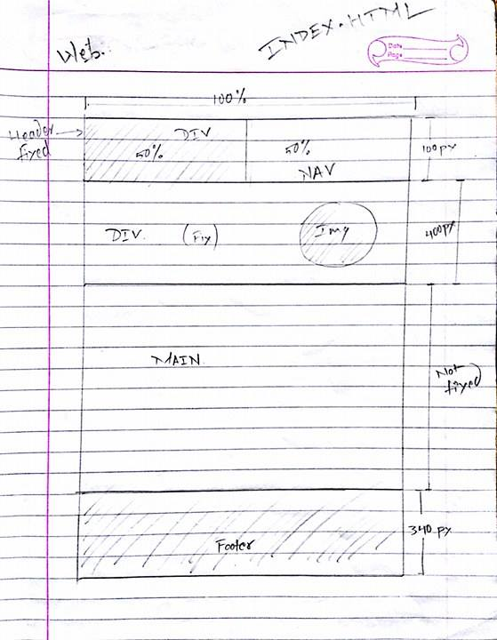The DIV part is used for Logo, and NAV is used for navigation panel. Below header there is a single row DIV that is fixed too and consist an circular image. Then below that there is MAIN part home page that would contain the main component of home pages. And at the bottom there is FOOTER that would contain footer items.

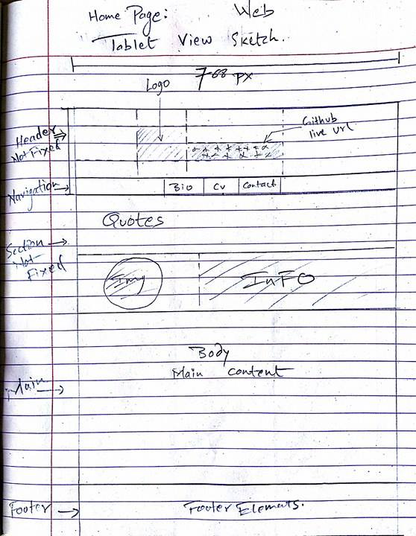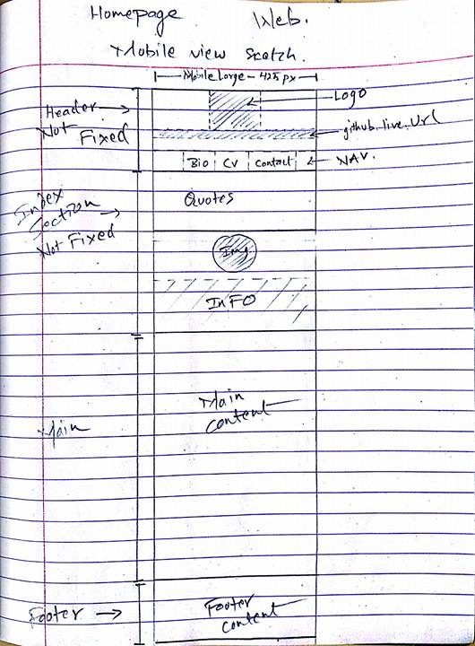Home page sketch tablet and mobile

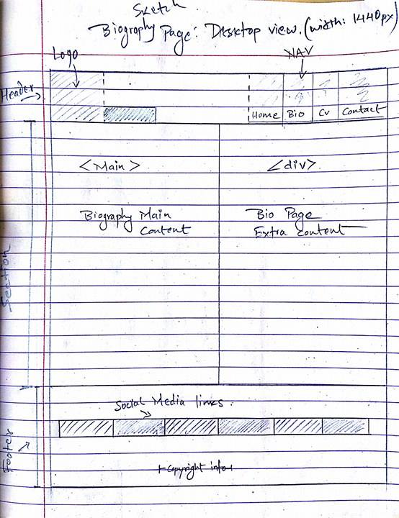Biography Page desktop view Sketch.

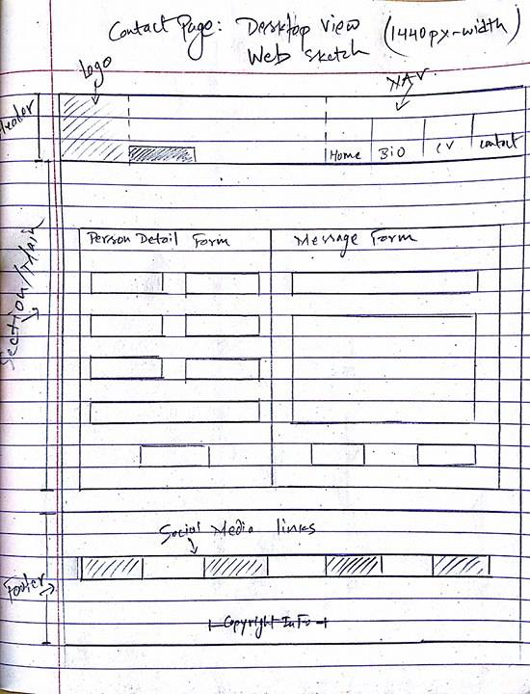Contact Page Sketch

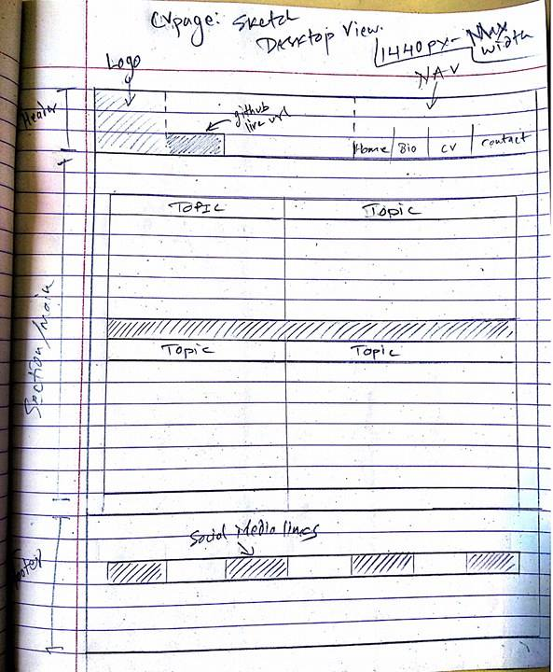CV Page Sketch

2.2 Designing Wire Frames

Home Page Wire Frame

Desktop view

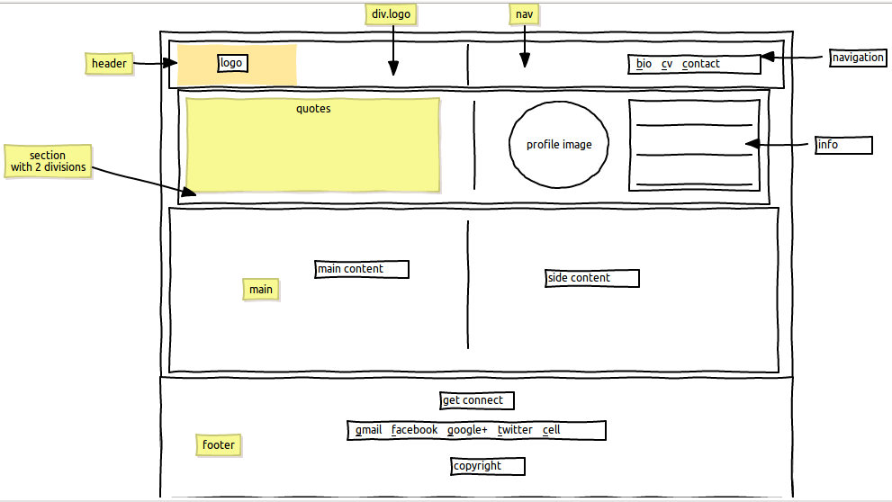Below figure 2.2.1 is a wire frame of Home page desktop view, consisting header, section, main and footer. The header part is same as of the sketch above. The SECTION part, which was DIV in the sketch contains 2 sub divisions(columns), one is for quote and another is for brief profile detail. Below there is a main part, in the wire frame it says main content and side content; it’s because while I create this wire frame I was not sure what to include in this main section. The prototype design is different but the concept of this wire frame is used in prototype. At the bottom there is Footer part and its elements.

Tablet view

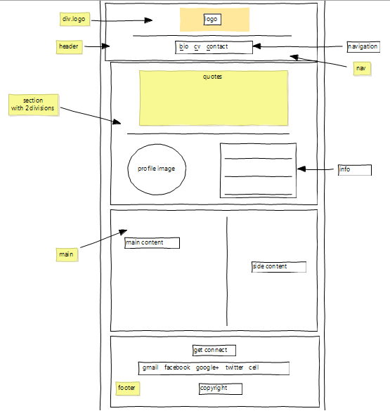Below is the wire frame of Homepage for Tablet View. It’s elements/items are same of the desktop view but their orientation is different and more compatible to the tablet devices. In this design the header items and section items are arranged in column covering 100% width of the screen by each of them.

Mobile view

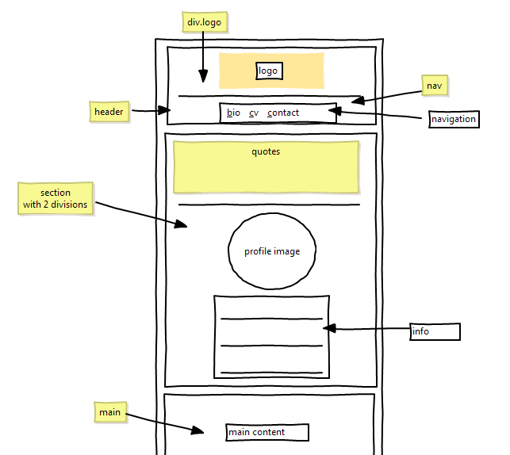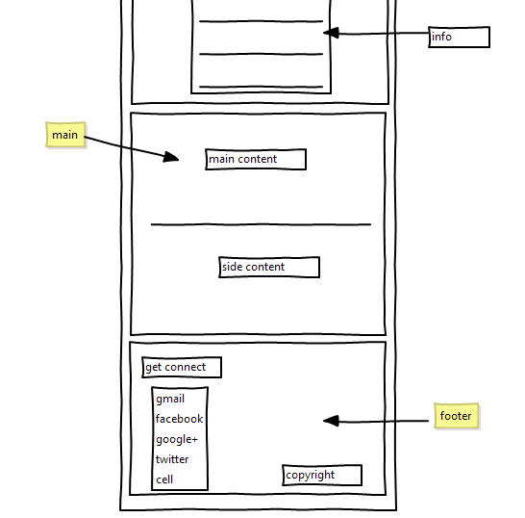Below Figure 2.2.3 is the wire frame for the home page mobile view. All the elements are same as of desktop view, but the layout interface is upgraded to make more compatible with mobile screen device. In this design section, main part and footer are optimised for mobile view.

Wire Frame for Bio and Contact pages.(desktop view)

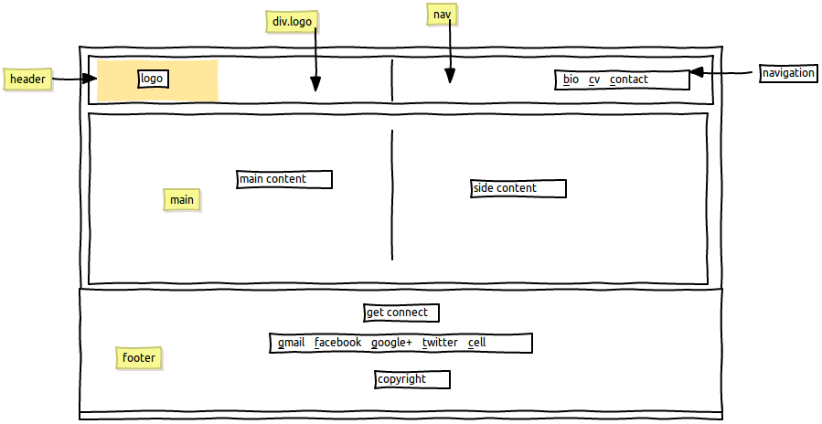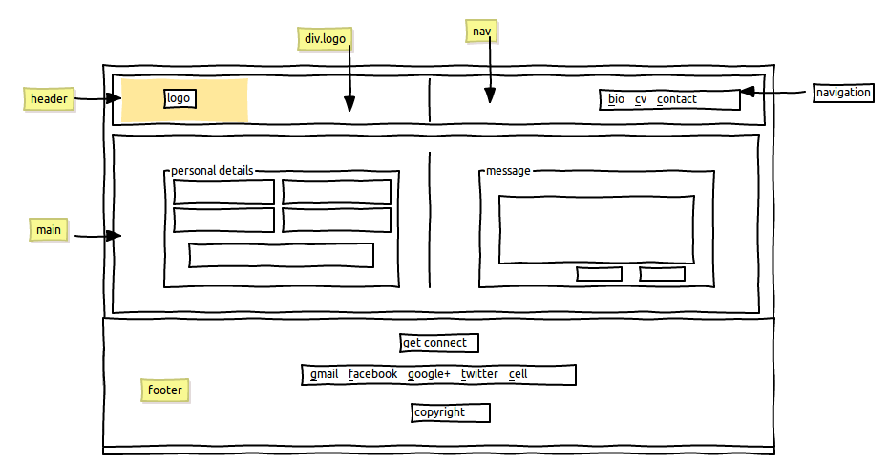Both wire frame of bio (figure 2.2.4) and contact (figure 2.2.5) are similar in context of designing layout, the only difference is their content. The Bio page contains text and image and a contact page contains contact form.

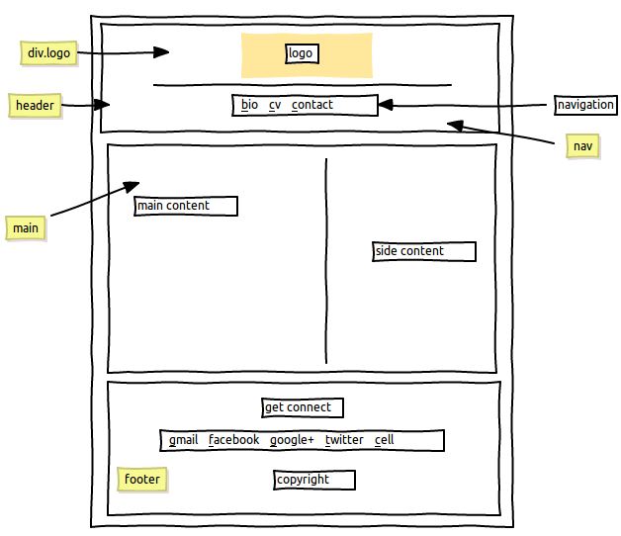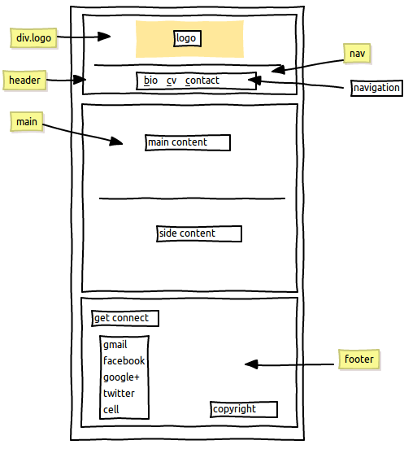Bio and Contact Tablet and mobile view

Wire frame for CV page

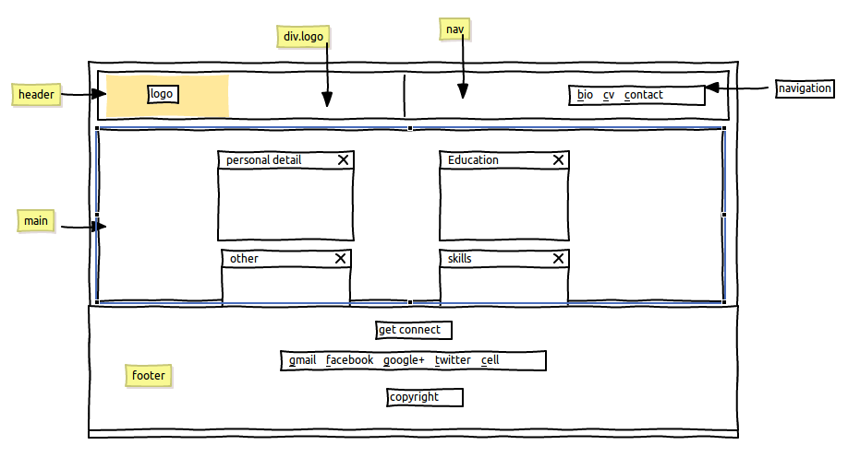CV wire frame consist of boxes for each sub element of CV.

2.3 Prototype Development

The web site layout is created based on the sketch and wire frames. Some contents/elements in the prototype could be differ from the wire frame design, but the overall architectural design is based upon the wire frames.

1st week of project development.

Figure 2.3.1 is a screen shot image of prototype of the home page(in 1st week). Segment are not clearly distinguished. The above dark row is header with some text on right side which is navigation panel. Below that the purple color larger part is section part. As we can see the screen is scrolled up so the complete content are not seen, most bottom part is a small part of segment, and even below that there is footer which is not seen on the figure.

- Things that are done in first week of project development.

* Folder management is done as required.
* Design layout of the website if formed.
* Links between the pages are established.
* 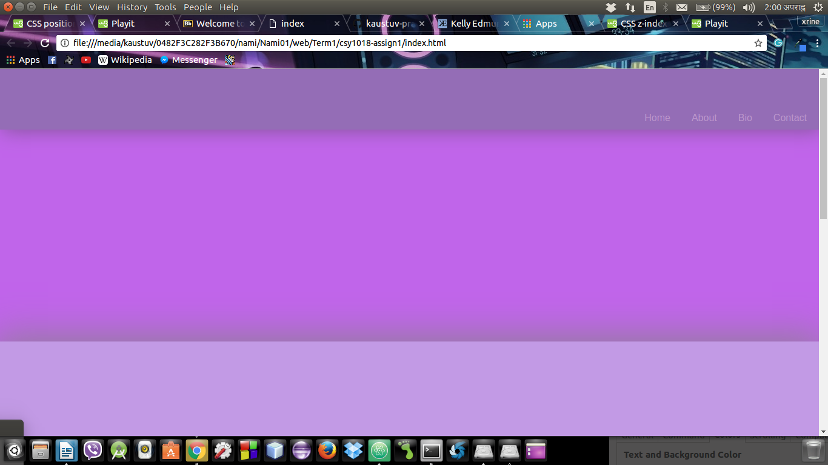Social media links and there logo are manged.

2nd week of project development.

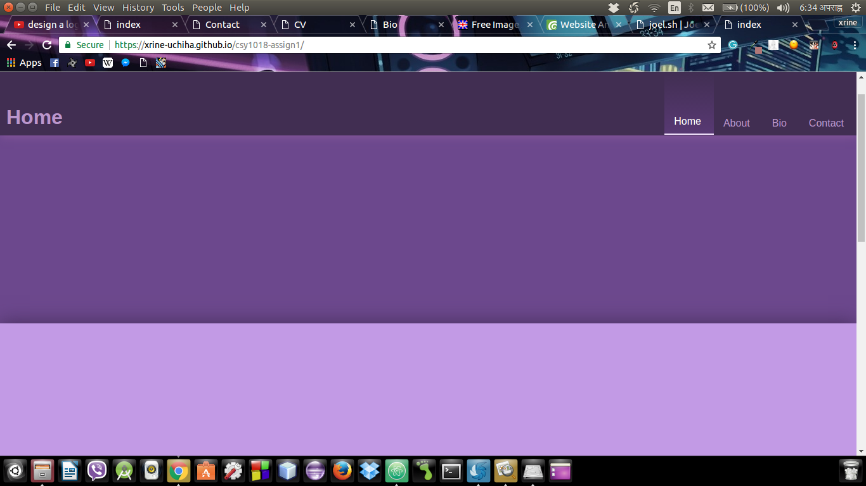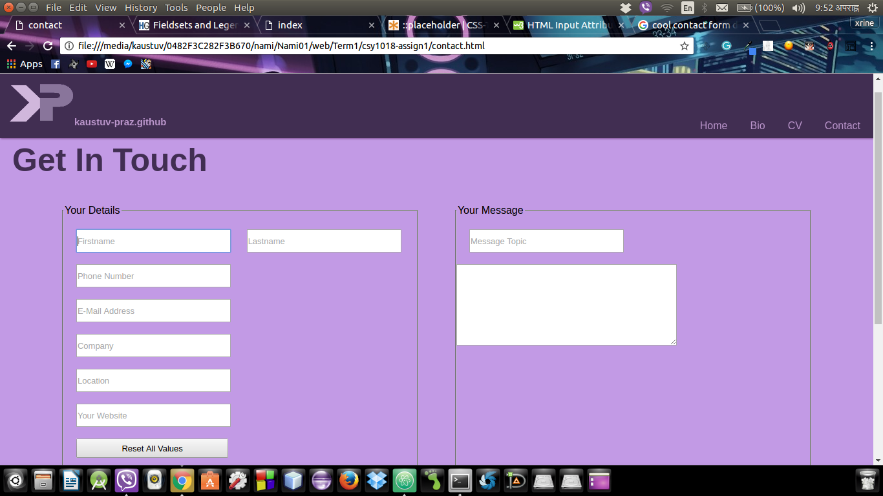In this week the major focus was on design and graphic management. Figure shows the website after 2nd week.

3rd week of project development.

On the 3rd week I worked on adding the content to the web site and after that I focus on making the websites responsive. This website is responsive to 4 different type of screens.

* Laptop or Pc screen, with the high resolution of width 1025px to 1440px.
* 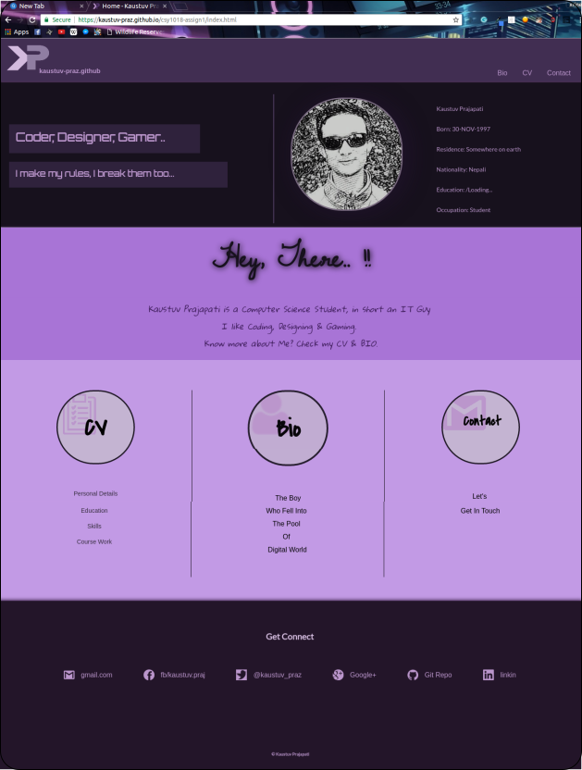Laptop or Pc screen, with the low resolution of max width 1024px.
* 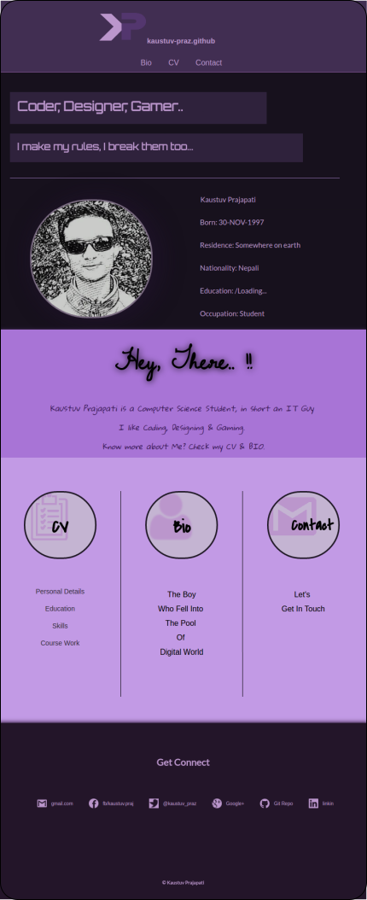Tablet view, with the screen resolution of max width 768px.
* 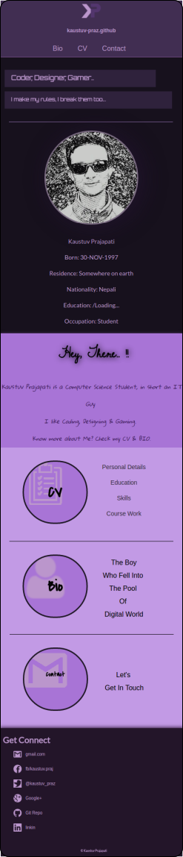All mobile view, screen resolution of width range from (320px to 425px).

4th week of project development.

On 4th week I realize that the css codes are getting heavy and difficult to debug, so css code specifications is done (file handling is done), all total of 21 css files are created, for each media queries and html pages, the main.css connects all the major css files. The style.css contains design layout of all pages, laptop.css, mobile.css and tablet.css carries design responsiveness. The css file for html content management is in the file with name “html-file-name_device-responsive.css.” for example. If I need to manage the content of home (index) page for tablet view then I have to make change in css file named “index_tablet.css”.

5th week of project development.

This week the css was improved, code redundancy is minimized, Google API fonts are added to make website more attractive and readable, paragraph and line spacing are managed. Also error handling was done & validation improvement wass done.

3. Prototypes

3.1 Home page (index page) prototypes.

3.1.1 Home page Desktop/Laptop view (width 1024px to 1440px)

3.1.2 Home page tablet view (Max-width: 768px)

3.1.3 Home page Mobile view (width 320px to 425px)

3.2 Biography page prototype.

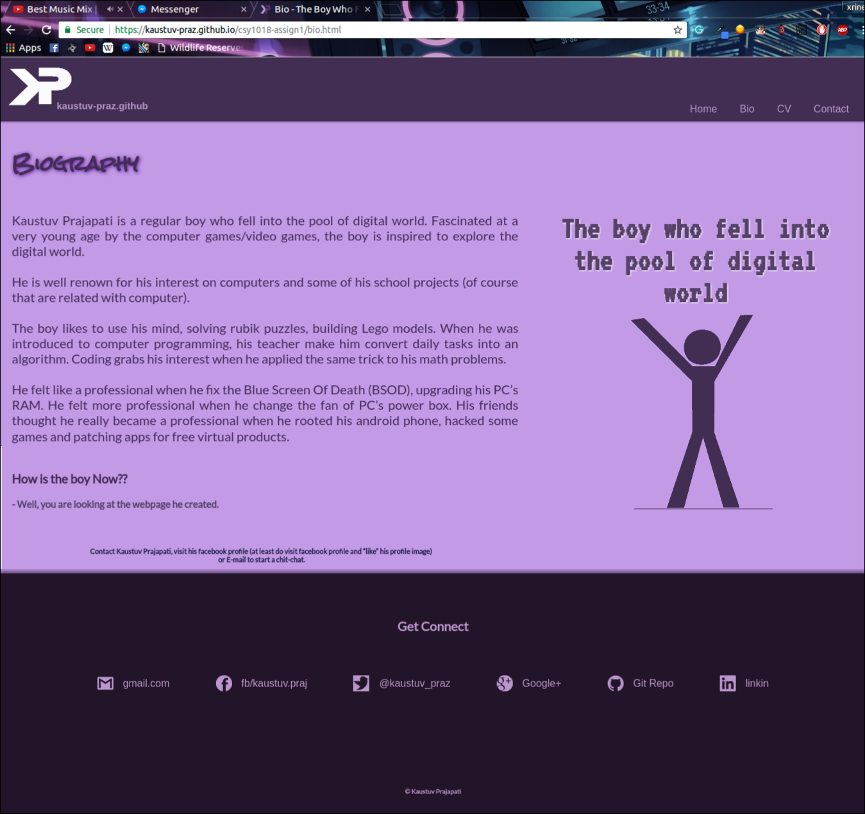3.2.1Biography page Desktop/Laptop view (width 1024px to 1440px)

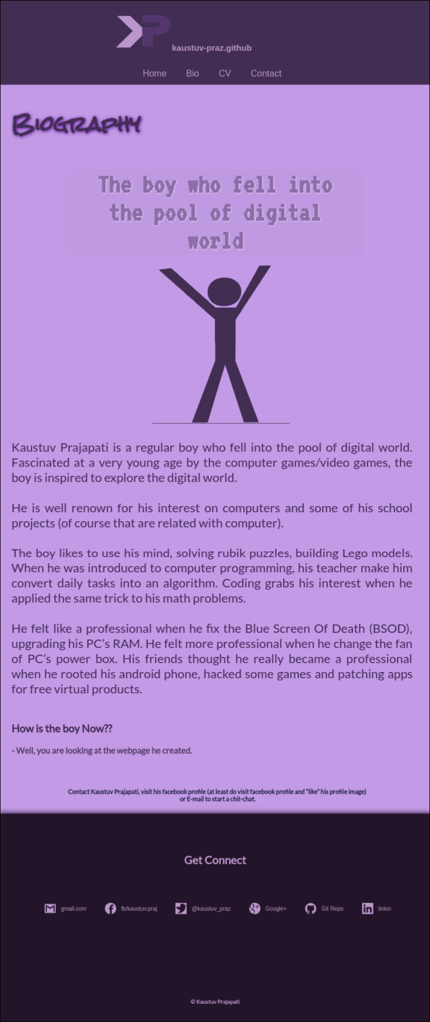3.2.2 Home page tablet view (Max-width: 768px)

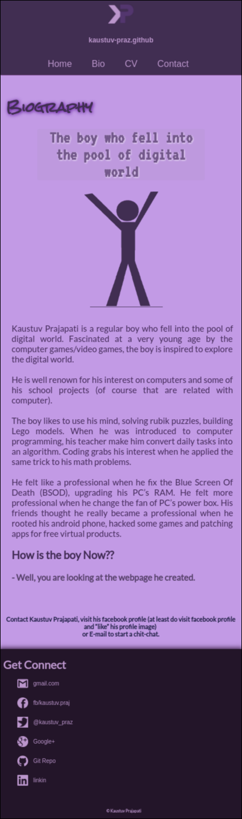3.2.3 Biography page Mobile view (width 320px to 425px)

3.3 Contact page prototypes.

3.4 Contact page prototypes.

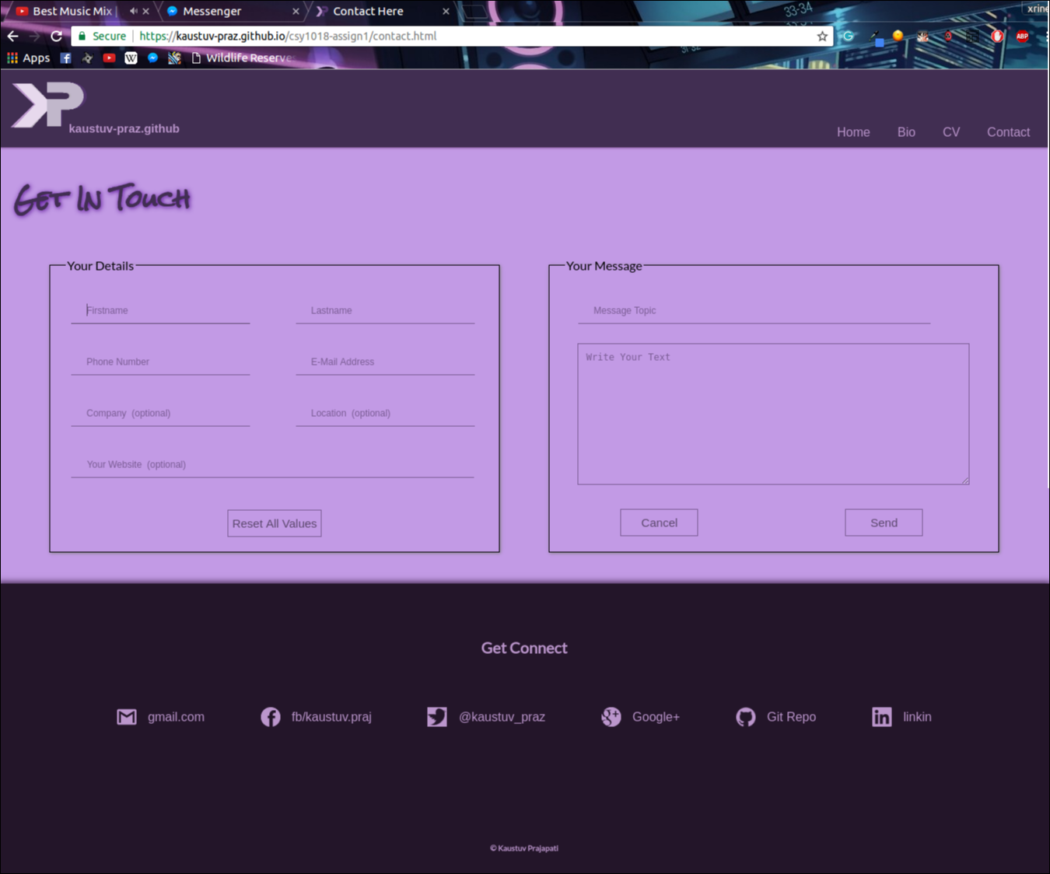3.4.1 Contact page Desktop/Laptop view (width 1024px to 1440px)

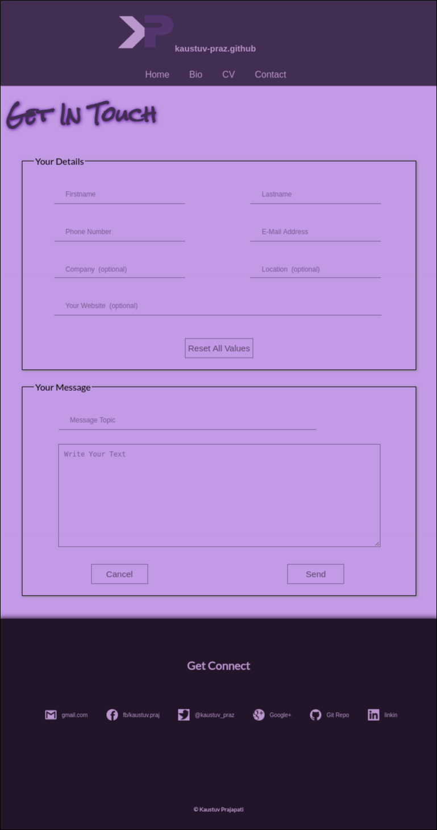3.4.2 Contact page tablet view (Max-width: 768px)

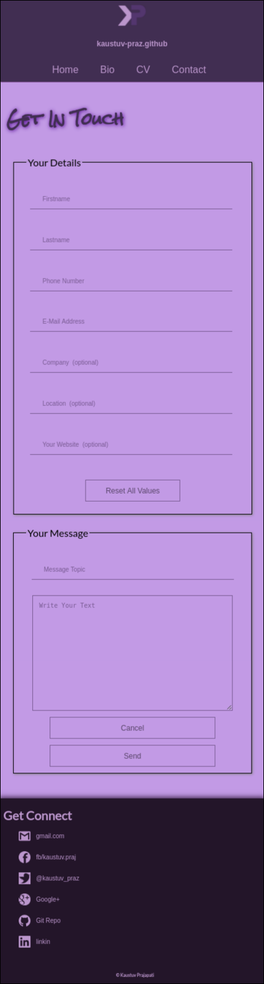3.4.3 Contact page Mobile view (width 320px to 425px)

Error Handling

Header And Footer

* The header part consist of logo, git hub live URL and navigation panel.
* The footer consist of contact links, social media links and copyright info.

Problems in header and footer.

I got the header design idea form <https://joel.sh/about>, but the codes are my own. After I create the header and footer as I designed in wire frame, the website was working as I expected, but when I check the validation in HTML 5 validator.([https://validator.w3.org](https://validator.w3.org/)) it gives the error that Element <a> not allowed as child of element <ul> in this context.

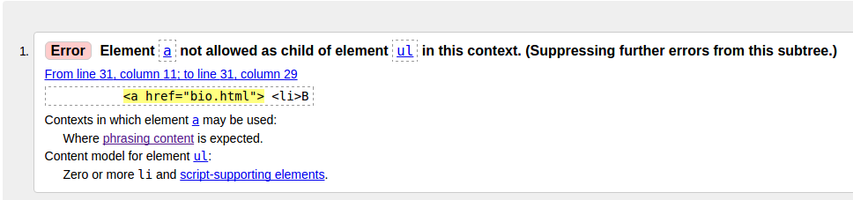 To overcome this error I create a <div> inside <li> element and use <a> on that <div>.

Similar problem appear on the footer <ul> as well.

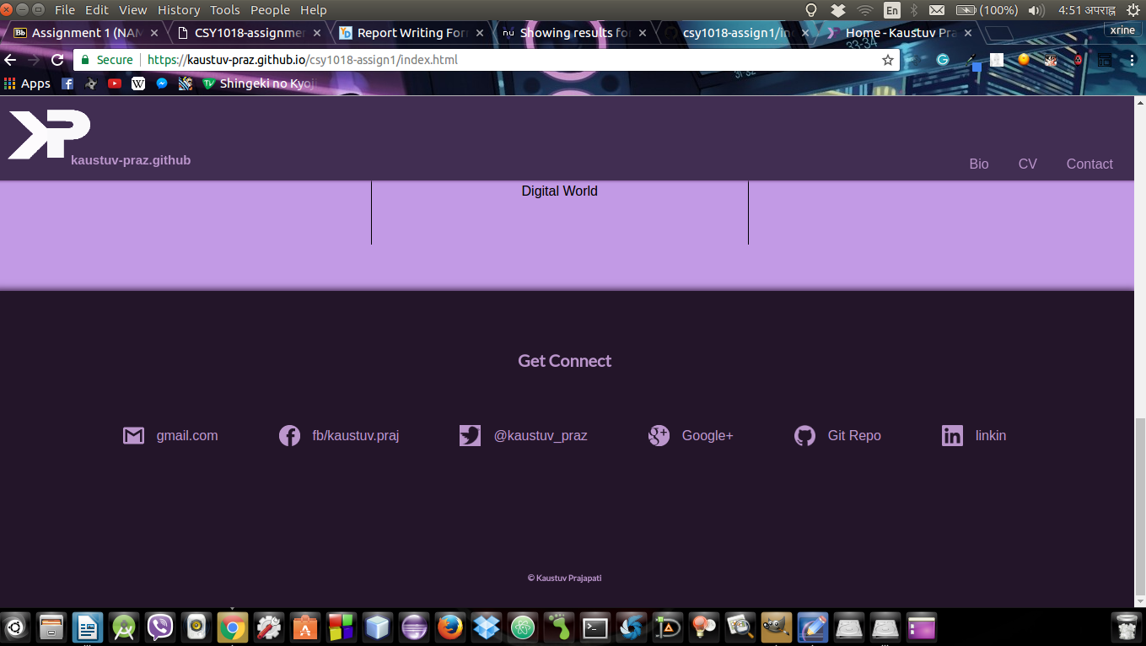In order to improve the graphic of logo the 3D-Rotation and transparency is used. There are 2 logo image on left top corner overlapping one on another for better graphic and less memory consumption. After debugging the errors and improving the color/graphics header and footer looked as in the figure xx