



Kaustuv Prajapati

**Date: 30-APR-2017**

**UN ID: 17421493**

Assignment-1

Problem Solving & Programming

A Greenfoot Project

Ball Defenders

# 1 Introduction

This report is about the ball game based on Java Codes that is created by using Greenfoot application. We were given a scenario.

# 2 Analysis of Solution

## 2.1 Ball Defenders-Game Intro

“Ball Defenders” is the name of the game. It is a single player game that has 3 different modes, basic mode, intermediate mode and the advance mode. The game main objective is to defend the ball (not letting pass through) to prevent it from touching the wall. As the scenario was instructed, the basic mode and intermediate mode fulfills all the requirements. The opponent team is computer controlled/automatic.

### 2.2 Game Mechanism

Game starts with the cover page as in the figure 2.1, The players are suppose to read the instruction given in the cover page. A player has to enter in one of the game modes to play the game. The game is run in only one mode at a time. A player can change the mode while playing the game, but a he/she needs to pause the game in order to change the mode. New game can be started after the game ends.

### 2.3 Inputs & Controls

This is a single player game.

Babies can be move only vertically up and down.

Controls:

|  |  |
| --- | --- |
| Task | Keys and controls |
| To move the baby up | Up Arrow |
| To move the baby down | Down Arrow |
| To select Top Baby | Alphabet key -> a |
| To select Middle Baby | Alphabet key -> s |
| To select Bottom Baby | Alphabet key -> d |

\*Note: central baby is selected at beginning.

\*output and testing is done in video.

### 2.4 Game rules

* Get 1 point when ball touches right side of wall.
* Loose 1 point when ball touches left side of the wall.
* Make 5 points to win the game.

### 2.5 Algorithm

#### 2.5.1 System Algorithm

/\* algorithm of game \*/

step 1: Start.

step 2: Show the Game cover page.

step 3: Declare a special key to pause the game and if pressed, pause the game then allow the user to change game mode or resume the game.

step 4: Enter the game mode on the basis of user input.

step 5: Stop.

/\* game algorithm ends \*/

#### 2.5.2 Basic Mode Algorithm

/\* basic mode algorithm \*/

step 1: Start.

step 2: Set the below statement in loop until the game is paused.

step 3: Move the ball with certain speed.

step 4: If ball touches the barrier, do nothing.

step 5: If ball touches either babies, reflect the ball in 180 degree.

step 6: Show the pause instruction when game is paused.

/\* loop statements ends \*/

step 6: Stop.

/\* basic mode algorithm ends \*/

#### 2.5.3 Intermediate Mode Algorithm

/\* intermediate mode algorithm \*/

step 1: Start.

step 2: Declare variables baby1\_score, baby2\_Score.

step 3: Add 2 babies on each team/side making all total of 6 babies.

step 4: Set the below statement in loop until the game is paused.

step 5: If ball touches the barrier, do nothing.

step 6: If ball touches either babies, reflect the ball random direction.

step 7: If ball touches wall, reflect the ball in random direction.

step 8: Make the right side babies move vertically up and down automatically.

step 9: If the ball touches right side wall, then increase the value of baby1\_Score by 1.

baby1\_Score = baby1\_Score + 1 OR baby1\_Score++

step 10: If the ball touches left side wall, then increase the value of baby2\_Score by 1.

baby2\_Score = baby2\_Score + 1 OR baby2\_Score++

step 11: Control the baby on left side with keys individually.

step 12: If baby1\_Score is greater than or equals to 5. Declare baby on left side is winner.

Goto step 15.

step 13: If baby2\_Score is greater than or equals to 5. Declare baby on right side is winner.

Goto step 15.

step 14: If the game is paused, show the pause instruction.

/\* Loop statement ends here \*/

step 15: End

/\* End of intermediate mode Algorithm \*/

#### 2.5.4 Advance Mode Algorithm

/\* advance mode algorithm \*/

step 1: Start.

step 2: Declare Variable baby1\_Score, baby2\_Score, ball\_speed.

step 3: Add 2 babies on each team/side making all total of 6 babies.

step 4: Add border on the game screen.

step 5: Set the below statement in loop until the game is paused.

step 6: If ball touches the barrier, do nothing.

step 7: If ball touches either babies, reflect the ball random direction.

step 8: If ball touches wall, reflect the ball in specific direction. /\* to make it look more natural \*/

step 9: If the ball is reflected after touching right side wall, then the ball should not touch right side babies.

step 10: If the ball is reflected after touching left side wall, then the ball should not touch left side babies.

step 11: When ball touches babies

produce sound.

step 12: When ball touches walls

produce sound.

step 13: Make the right side babies move vertically up and down automatically.

step 14: If the ball touches right side wall, then increase the value of baby1\_Score by 1.

baby1\_Score = baby1\_Score + 1 OR baby1\_Score++

step 15: If the ball touches left side wall, then increase the value of baby2\_Score by 1.

baby2\_Score = baby2\_Score + 1 OR baby2\_Score++

step 16: Control the baby on left side with keys individually.

step 17: If baby1\_Score is greater than or equals to 5. Declare baby on left side is winner.

Goto step 20.

step 18: If baby2\_Score is greater than or equals to 5. Declare baby on right side is winner.

Goto step 20.

step 19: If the game is paused, show the pause instruction.

/\* loop statements ends \*/

step 20: Stop.

# 3 Gaming Design (Flowchart)

## game_flowchart.png3.1 Flowchart of Game Architecture

## 3.2 Flowchart of function/method basicMode();

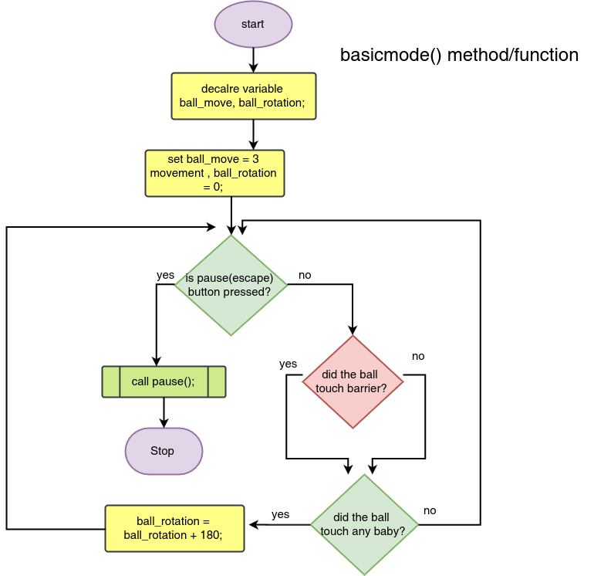

## intermediate_mode().png3.3 Flowchart of function/method intermediateMode();

## 3.4 Flowchart of function/method advanceMode();

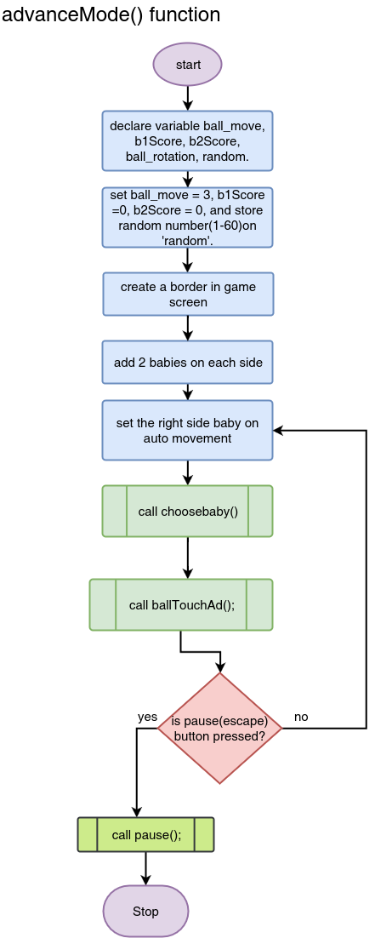

## pause().png3.5 Flowchart of function/method pause()

## 3.6 Flowchart of function/method ballTouch(random);ballTouch(random).png

## 3.7 Flowchart of function/method ballTouchAd();

This flowchart is for advance mode

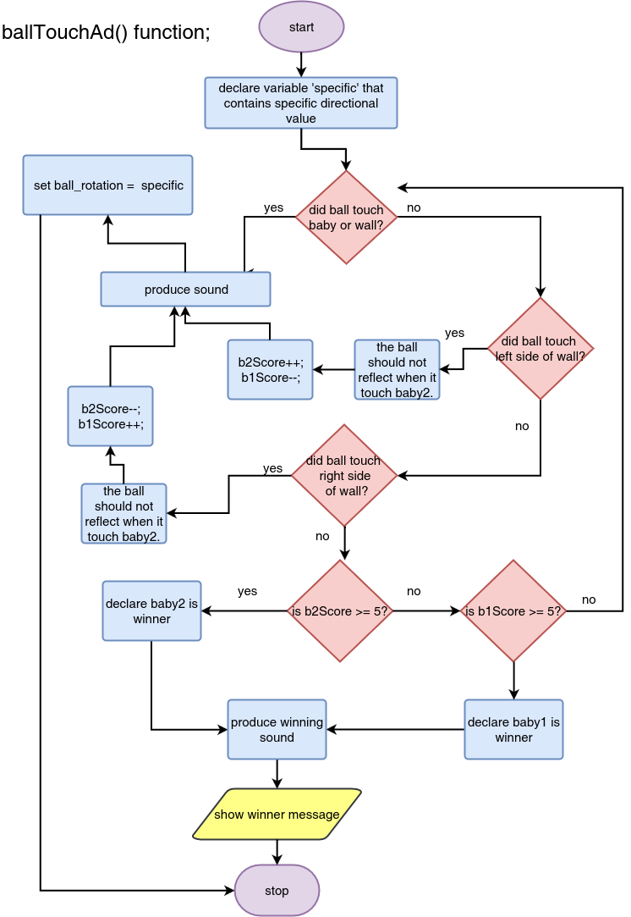

## chooseBaby().png3.8 Flowchart of function/method ballTouchAd()

# 4 Source Code

## 4.1 Source Code

# 5 Conclusion

# 6 References