Video Analytics Pipeline Performance Report

**Performance Metrics**

- FPS Achieved: 9 FPS (real-time performance)

- Resolution: 540x900 pixels

**Hardware Configuration**

- CPU: Intel i5 12th Generation

- GPU: None (CPU-only implementation)

- RAM: 8GB

**Implementation Details**

1. Object Detection

- Model: YOLOv8n (nano variant)

- Confidence Threshold: 0.5

- Classes: All classes enabled

2. Object Tracking

- Max Age: 40 frames (maximum frames a track can be lost before deletion)

- Min Hits: 3 frames (minimum hits to initialize a track)

- IOU Threshold: 0.3 (for track assignment)

3. Scene Monitoring

- Missing Object Frames: 15 frames (before an object is considered missing)

- Stability Frames: 5 frames (before a new object is considered stable)

**Visualization Settings**

- FPS Display: Enabled

- Bounding Boxes: Enabled

- Labels: Enabled

- Box Thickness: 2 pixels

- Text Size: 0.5

- Text Thickness: 2 pixels

- Color Scheme:

- Missing Objects: Red (BGR: [0, 0, 255])

- New Objects: Green (BGR: [0, 255, 0])

- Normal Objects: Blue (BGR: [255, 0, 0])

**Optimization Notes**

1. The system is running on CPU-only hardware, which explains the moderate FPS performance.

2. Using YOLOv8n (nano variant) for better performance on CPU.

3. Implemented object tracking to maintain object identities across frames.

4. Scene monitoring to handle object stability and missing object detection.

**Future Improvements**

1. GPU acceleration could significantly improve FPS performance.

2. Model quantization could be explored for better CPU performance.

3. Multi-threading could be implemented for better resource utilization.

4. Resolution optimization could be considered for better performance.

**Screenshots**

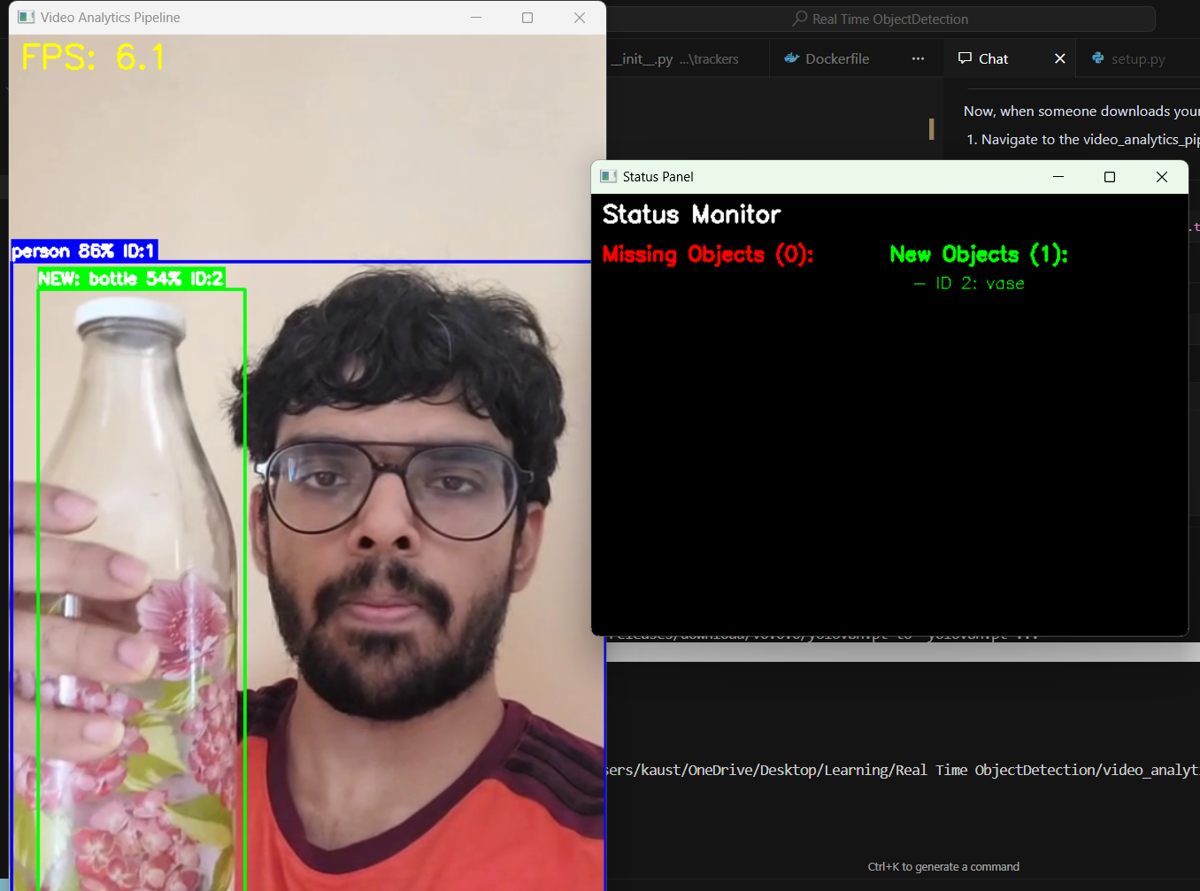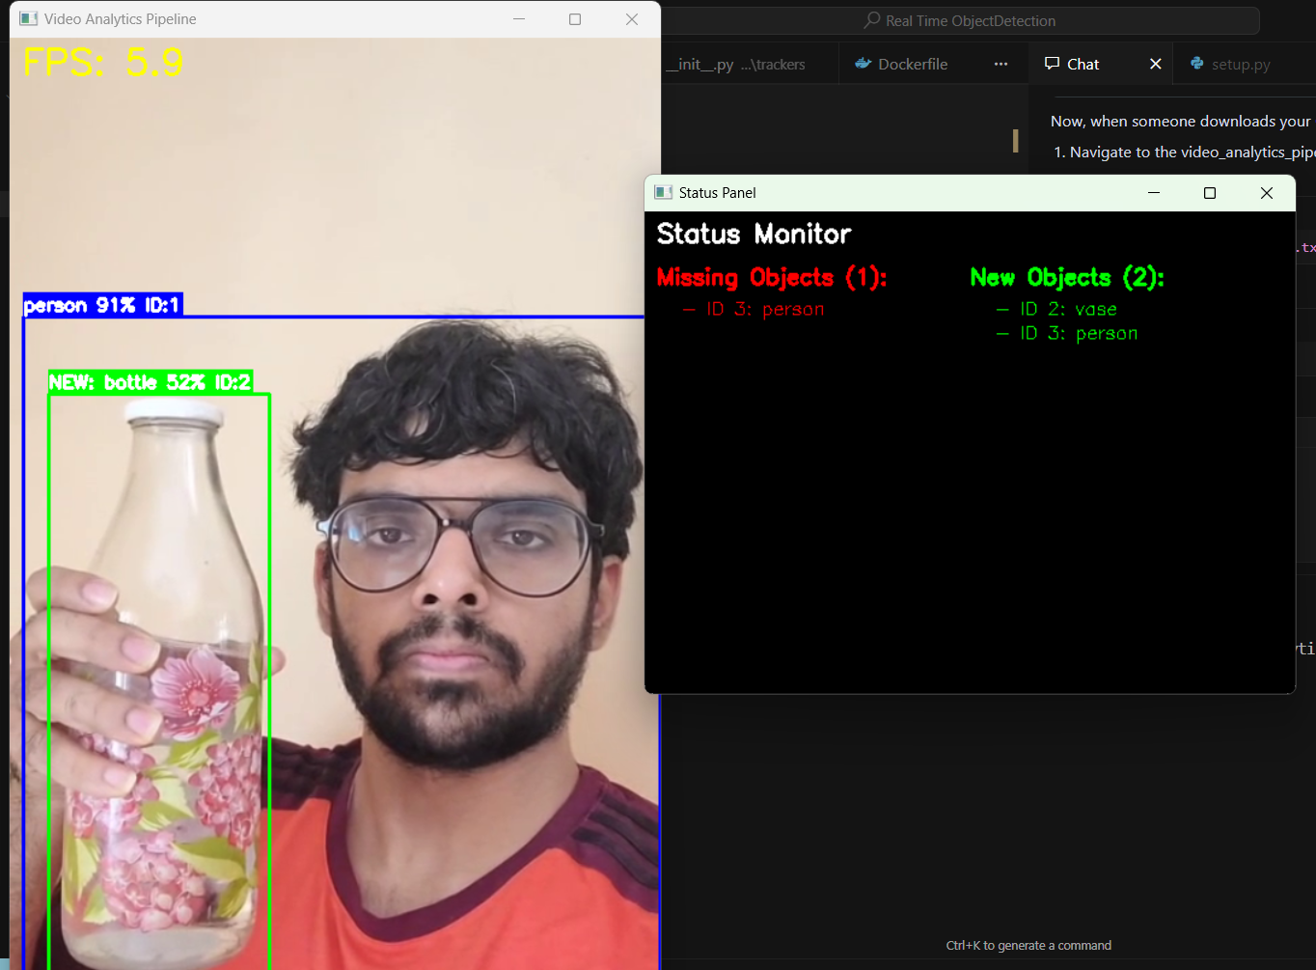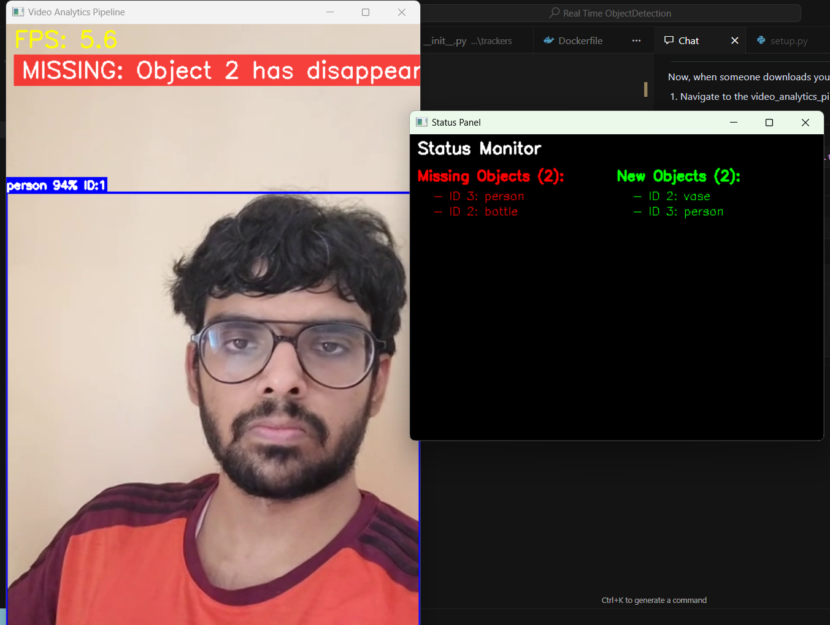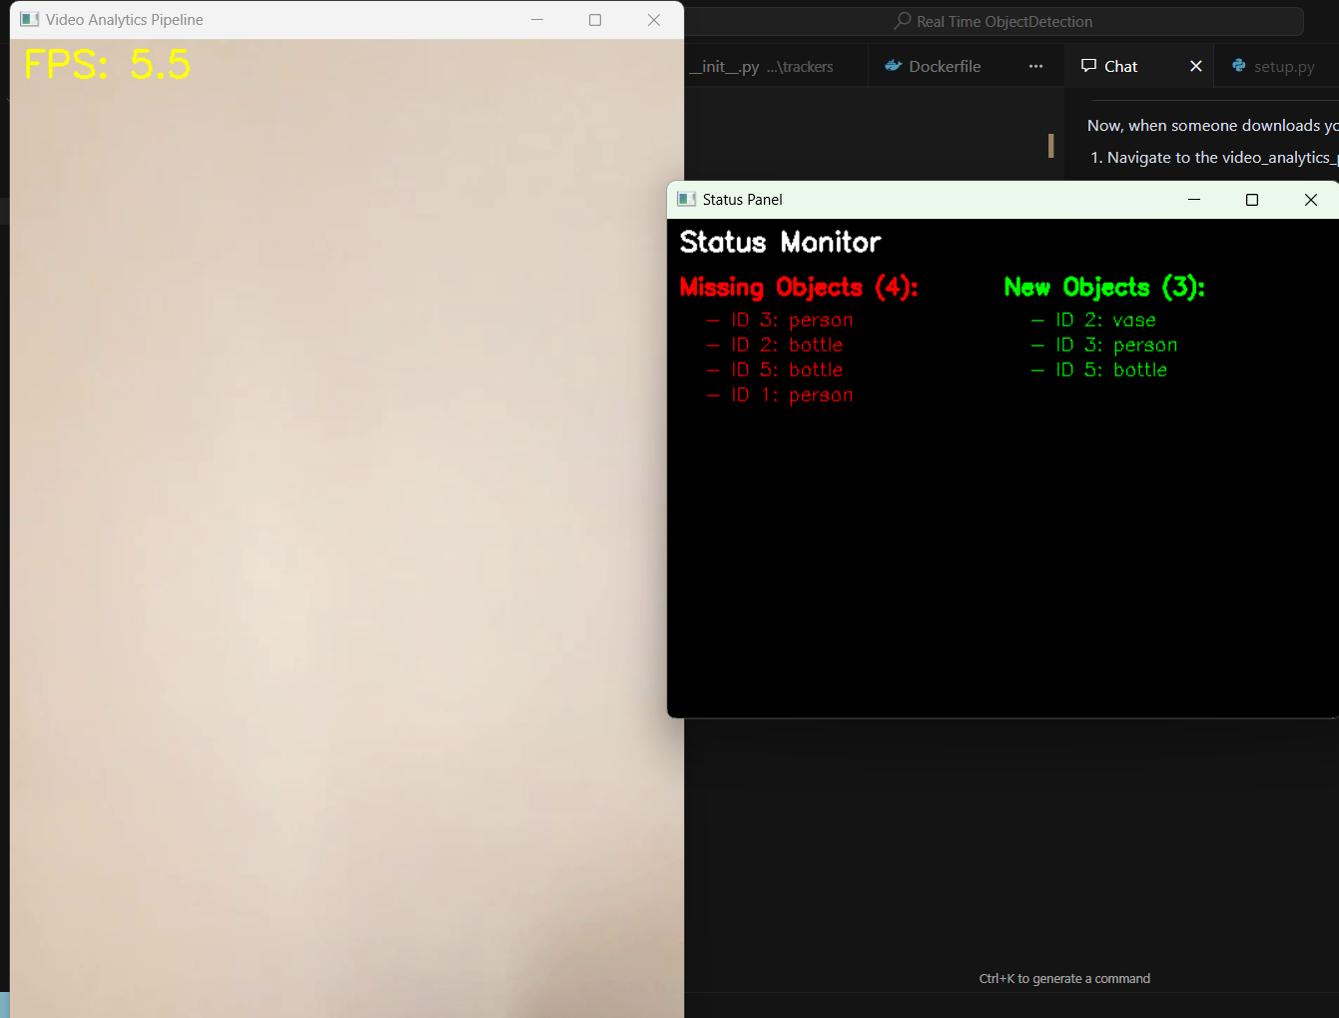

**Video**

[**20250427_110532.mp4**](https://drive.google.com/file/d/1NCBPdjFPTnILA1MFek3wE9bxbuHwmJ9s/view?usp=sharing)