Software

Engineering

Software Requirement Specifications, Project Plan, Draft Architecture and Design

E-commerce Website: Aesthetic Front-End and Functional Back-end

Software Requirements Specification (SRS)

1. Goal
The primary goal is to build a fully deploy-able, high-performance E-commerce platform that provides a seamless shopping experience for customers and robust management tools for administrators.

2. Key Deliverables
- Fully functional Client/Retail-facing web application.
- Comprehensive Biz Side (Admin) dashboard for operations.
- Secure Back end API and integrated database.

3. Functional Requirements (FR)

FR: 3.1 Client/Retail Side:

FR: 3.1.1: Product Catalog: Search and filter functionality for items.
FR: 3.1.2: Shopping Cart: Add, remove, and update item quantities.
FR: 3.1.3: Checkout & Payment: Integration with electronic payment systems.

FR: 3.2 Biz Side (Admin)

FR:3.2.1: Inventory Management: CRUD operations for products and categories.
FR:3.2.2: Order Fulfillment: View and update status of customer orders.
FR:3.2.3: Transaction Acknowledgment System: Generating Invoice, Receipt for clients and Logs for Admins. In-app notifications and mails notifications.
FR:3.2.4: User Analytics: Basic reporting on sales and site traffic.

4. Non-Functional Requirements (NFR)
NFR: 4.1 : Usability & Design: Clean, aesthetic,semantic UI with minimalist design
NFR: 4.2 : Performance: Fast page load times and optimized back-end processing.
NFR: 4.3 : Security: Ensure security of data and payment processings.
NFR: 4.4 : Scalability: N-tier architecture to support increasing user traffic.

Project Plan

5. Team and Responsibilities:

- Design Team:
  - Gargee Kakaty (Lead)
  - Kaustuva Kashyap
- Front-End Development Team:
  - Abhishek Das (Lead)
  - Gargee Kakaty
- Back-end Development Team
  - Ronit Choudhury (Co- Dev)
  - Abhishek Das (Co-Dev)
- Documentation Team:
  - Ronit Choudhury
  - Kaustuva Kashyap

6. Development Methodology: RAD Evolutionary Model
The combined use of the Rapid Application Development (RAD) and Evolutionary Model is ideal for the E-commerce project due to the need for speed, adaptability, and high user focus.

Why RAD and Evolutionary Model are a good fit:

Rapid Delivery and Early Feedback (RAD)

Handling Evolving Requirements (Evolutionary Model)

Risk Mitigation through Iteration

Focus on Usability (RAD)

How the approach will be implemented:

Time-boxing: The project will be broken down into short, fixed-length phases . Each phase will focus on delivering a functional subset of the requirements, such as a "Minimum Viable Shopping Experience" followed by an "Admin Management Module."

Prototyping and Tool-Based Construction: The Development teams will leverage integrated development environments (IDEs) and potentially low-code tools for rapid construction of the Biz Side (Admin) dashboard and the secure Backend API, maximizing code reuse and speed.

Concurrent Component Development: The Front-end and Back-end teams will work in parallel. While the Back end team (Ronit Choudhury and Abhishek Das) develops the core API for Inventory Management, the Front-end team (Abhishek Das and Gargee Kakaty) can simultaneously build the client-side UI based on mock data, integrating the components in the later stages of each evolutionary cycle.

Iterative Refinement: Each iteration will result in a tested, working deliverable. For example, the first iteration might focus only on the Product Catalog and basic searching, while subsequent iterations add the Shopping Cart, Checkout, and then the Admin-facing modules.

7. Architecture Design Drafts:
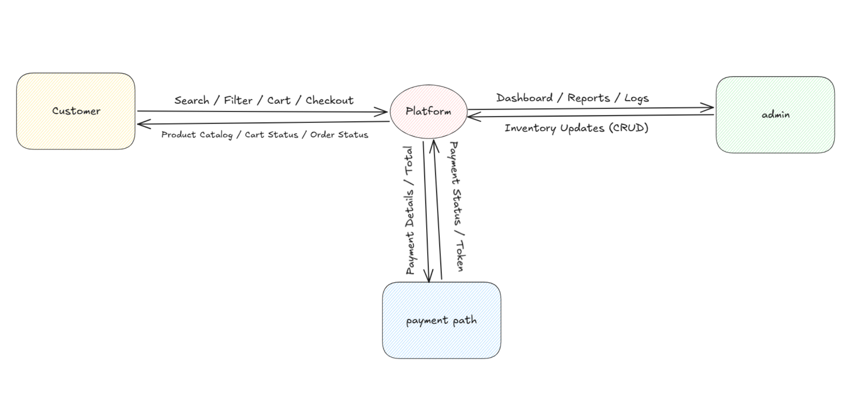
Figure A

High Level Architecture Design of the platform. The Main Components are:
- Customer/Client which supports the following high level functions:
  - Service Offered by the Interface:
    - Search: Searching product catalogue
    - Filter: Filtering product catalogue by tags
    - Cart: Storing products for ordering for saving for future.
    - Checkout (includes orders and payment)
  - Servives Offered to the Interface:
    - Product Catalogue Data
    - Cart Status
    - Order Status
- A Main Platform Server: Includes the Database and Main Logic
- A Business/ Admin Client : for Inventory Management/Operations, Reports, logs and Dashboard
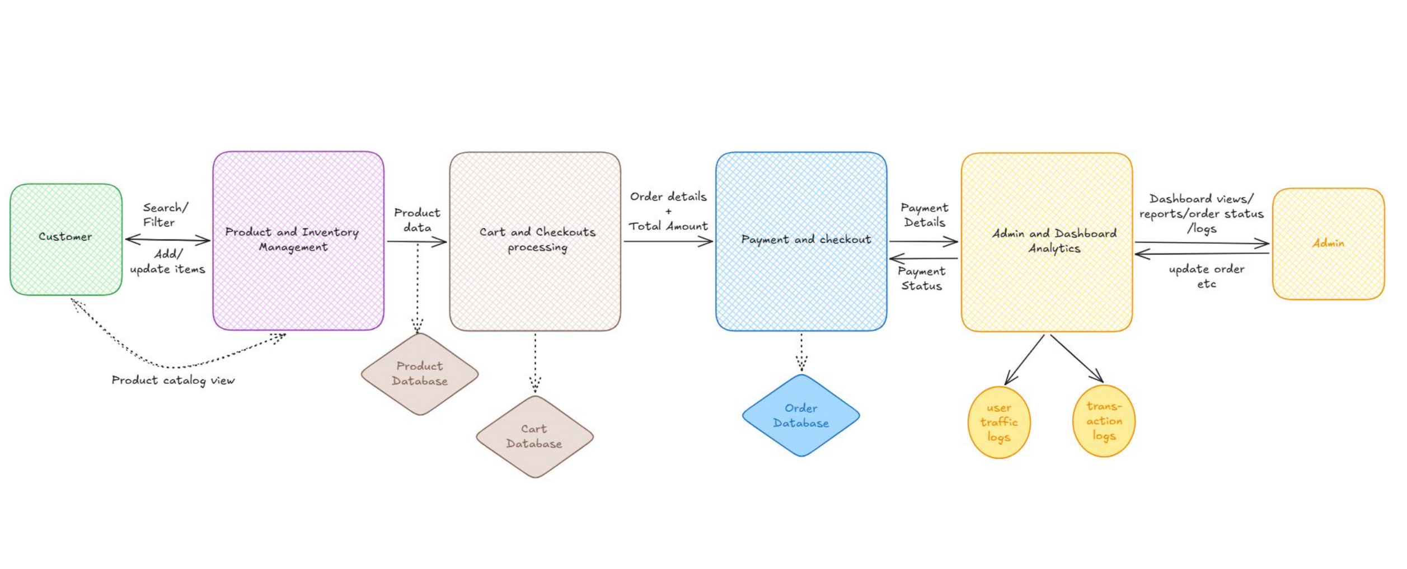
Figure B

—EOF—

