Problem 1:

LDA Accuracy = 97%

QDA Accuracy = 96%

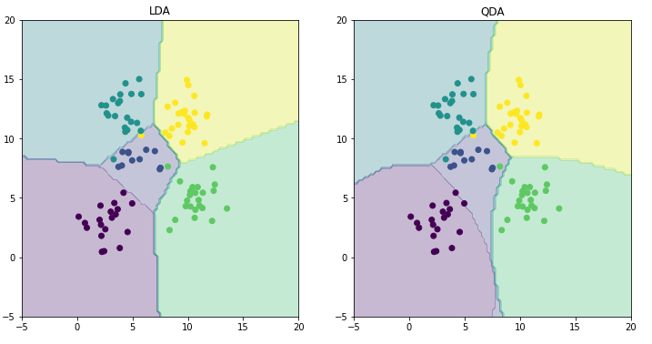

TODO – Explain the difference in the boundaries

Problem 2

MSE without intercept mean of magnitude of weights: 0.20690517560805177

MSE with intercept mean of magnitude of weights: 0.28581612984613397

MSE without intercept 0.3846563402704013

MSE with intercept 0.3732876481125678

TODO – Explain which one is better

Problem 3

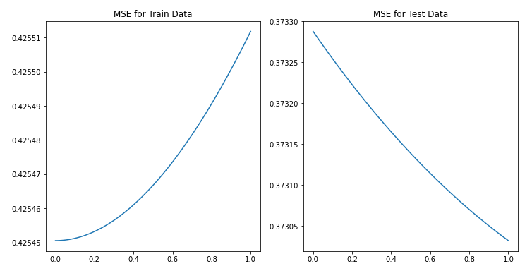

TODO - Compare the two approaches in terms of errors on train and test data. What is the optimal value

for lambda and why?

Problem 4

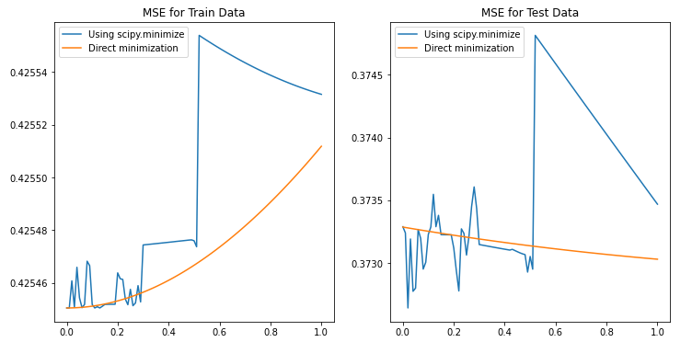

TODO - Compare with the results obtained in Problem 3.

Problem 5