Antimicrobial Stewardship Platform

# Problem statement

# Antimicrobial opposition is expanding; in any case, antimicrobial medication advancement is easing back. Presently like never before previously, antimicrobial stewardship is absolutely critical as an approach to advance the utilization of antimicrobials to forestall the advancement of obstruction and improve understanding results. This audit depicts the why, what, who, how, when, and where of antimicrobial stewardship. Procedures of stewardship are summed up, and an arrangement for usage of a stewardship program is illustrated.

Presented somewhere in the range of 1935 and 2003. Be that as it may, fast antimicrobial improvement accompanied a cost—antimicrobial obstruction. In the medical clinic, protection from anti-infection agents and antifungals represents the best concern. In 2003, US escalated care units (ICUs) answered to the Centers for Disease Control and Prevention that about 60% of Staphylococcus aureus disengages were impervious to methicillin.1 Although the pace of obtrusive methicillin-safe S aureus contaminations in medicinal services settings was demonstrated to be diminishing in a 2010 Centers for Disease Control and Prevention study,2 detaches transitionally or unmistakably impervious to vancomycin are turning out to be less rare.3 Perhaps significantly progressively hard to oversee has been the expansion in gram-negative resistance.4 Programs, for example, the universal SMART (Study for Monitoring Antimicrobial Resistance Trend)5 and the SENTRY Antimicrobial Surveillance Program have indicated generous in wrinkles in the pace of Klebsiella protection from third-age cephalosporins, broadened range β-lactamase–creating Klebsiella pneumoniae and Escherichia coli, and Pseudomonas impervious to fluoroquinolones.1,6,7 During the previous 30 years, anti-microbial advancement has eased back impressively, and our alternatives for rewarding progressively safe diseases are turning out to be increasingly constrained. This audit means to portray the why, what, who, how, when, and where of antimicrobial stewardship.

# Implementation Details

## Architecture/Framework Used

Flask + jinja - Web Server Backend

Bootstrap - Web page frontend

MongoDB - Database

AWS EC2 - VM for deployment

OpenCV + tesseract - For OCR

NLTK - for information extraction from extracted OCR

Pandas - for storing and accessing drug database

## Modules

### Main OCR engine

The main OCR engine that is used to extract text from image that will be used in various other modules.

### Extract Report Information

When the patient uploads his culture sensitivity report, OCR is performed on that image and then the data is extracted as text. Then using NLP techniques, the data is extracted in a structured format which can be stored for training as well as can be used to display useful information to the patient.

### Detect Drug from Image

When the patient uploads an image of the purchased antibiotic, this module will detect which product he has purchased and can also find antibiompounds present in ttic drug cohat product by using both the image and database stored. This will help the patient to know more about what he is taking.

### Search Drug / Product

Patients can manually type and search about the product or by drug compounds and find that drug as well as other similar drugs available at our database.

### Display report information

The extracted information from the patient’s report will be displayed and he can see for which antibiotic compounds his infection is resistant to he can avoid using those compounds. Also a list of compounds for which his infection is sensitive will be displayed so he can search (by just clicking on them) about them and gain knowledge as well as can verify that the drug prescribed is safe and what are the side effects.

### Display Drug Information

It will display various useful information about the drug like side effects, components, safety advice as well as similar drugs.

### Database Client

Used to bridge this web app to MongoDB database to store information extracted from the uploaded report.

### Flask app

Main module to connect all other modules to their respective web pages via which the user can access those functionalities.

### Drug database

Used to access the information that is scraped and manually corrected about various drugs, products and their side effects.

## 

## Design Diagram

### Block Diagram

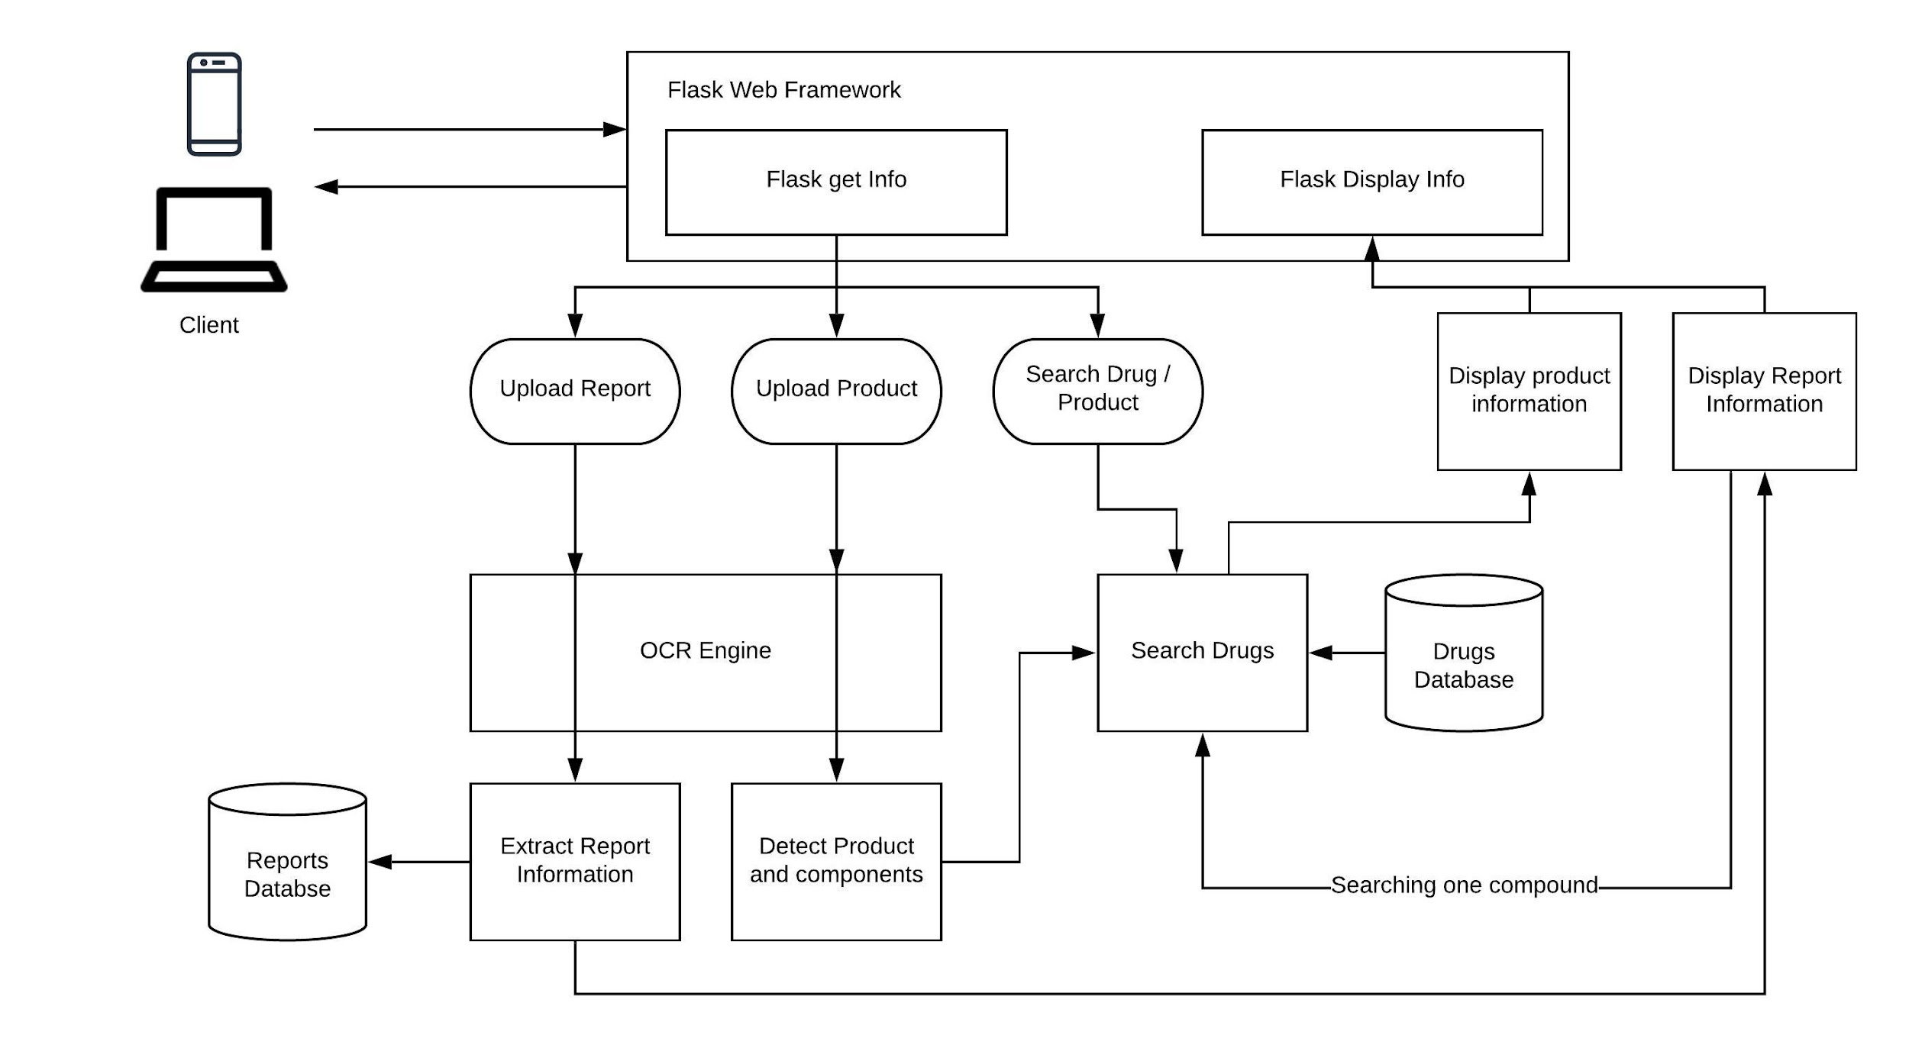

### 

### Use Case Diagram

* Web Stack
  + Flask + jinja (Python) [backend]
  + Bootstrap + JS + CSS [frontend]
  + MongoDB [Da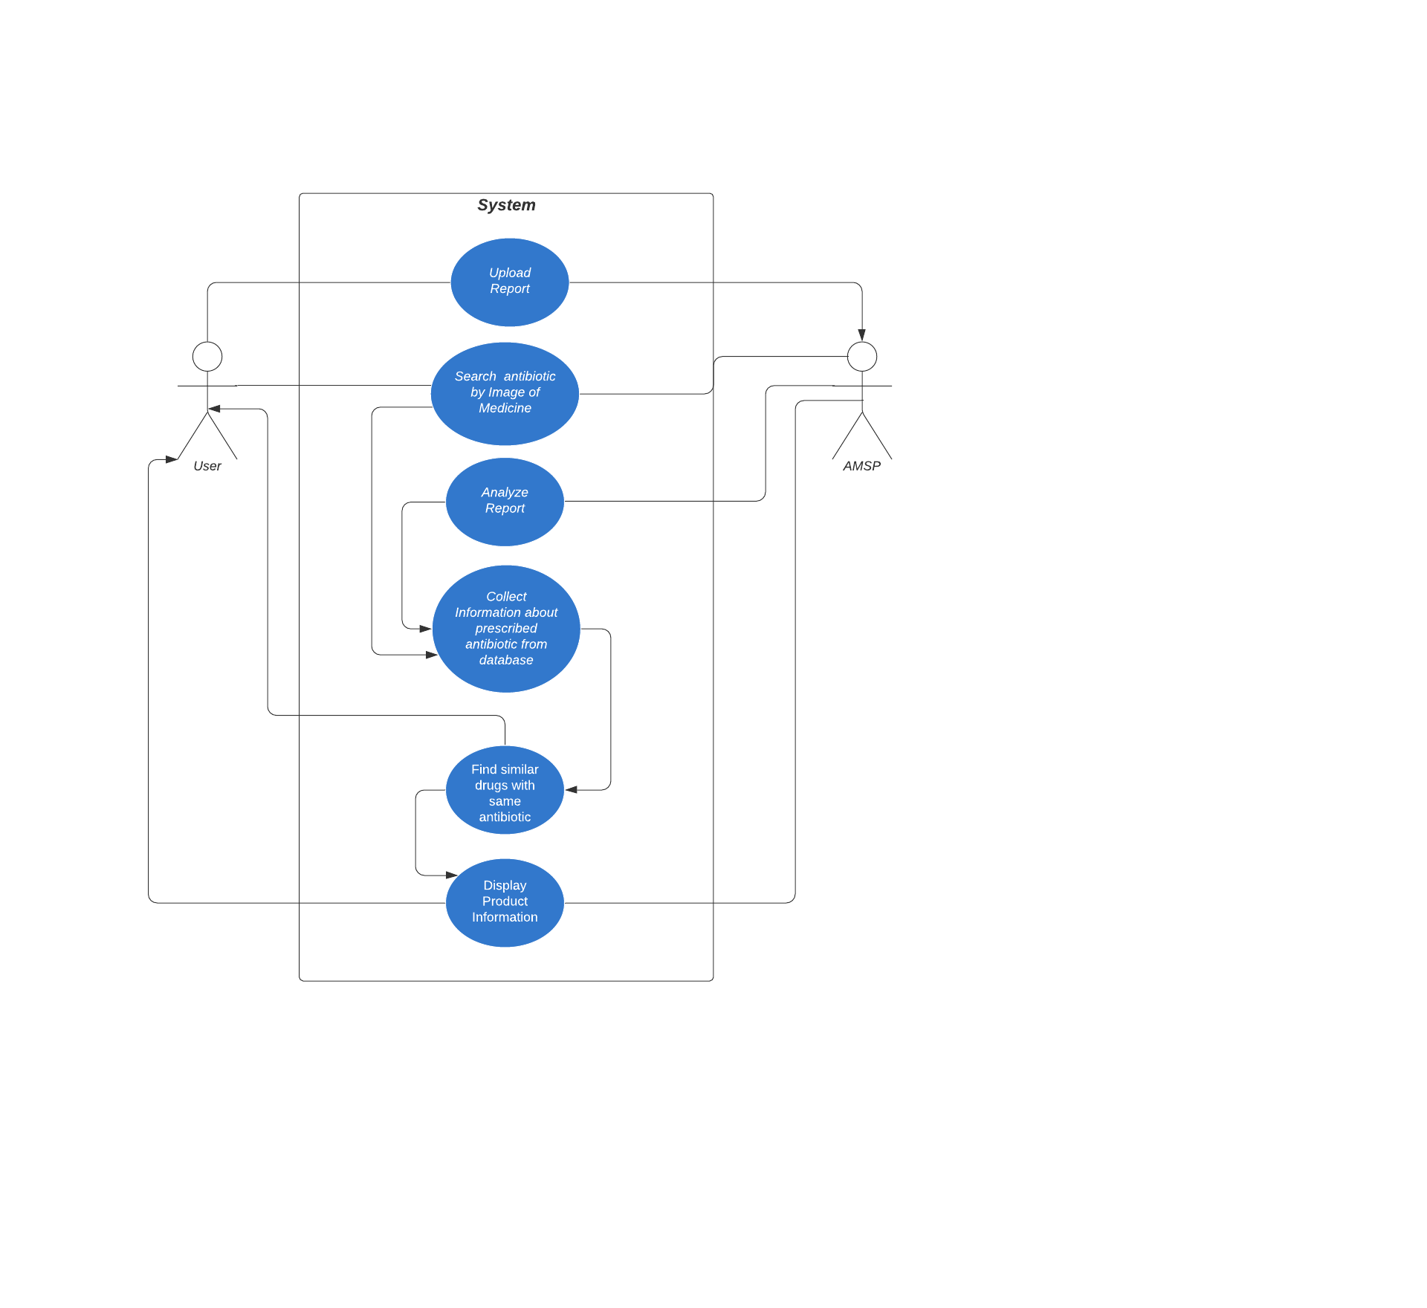

# Experimental results & Discussion

Using this tool, it is very easy to get information about your report or antibiotic product you are using. By using this the patient is also contributing towards research on a model that will predict at which time a drug will become resistant to most of the bacterias, and using that data the usage of antibiotics drug will be controlled.

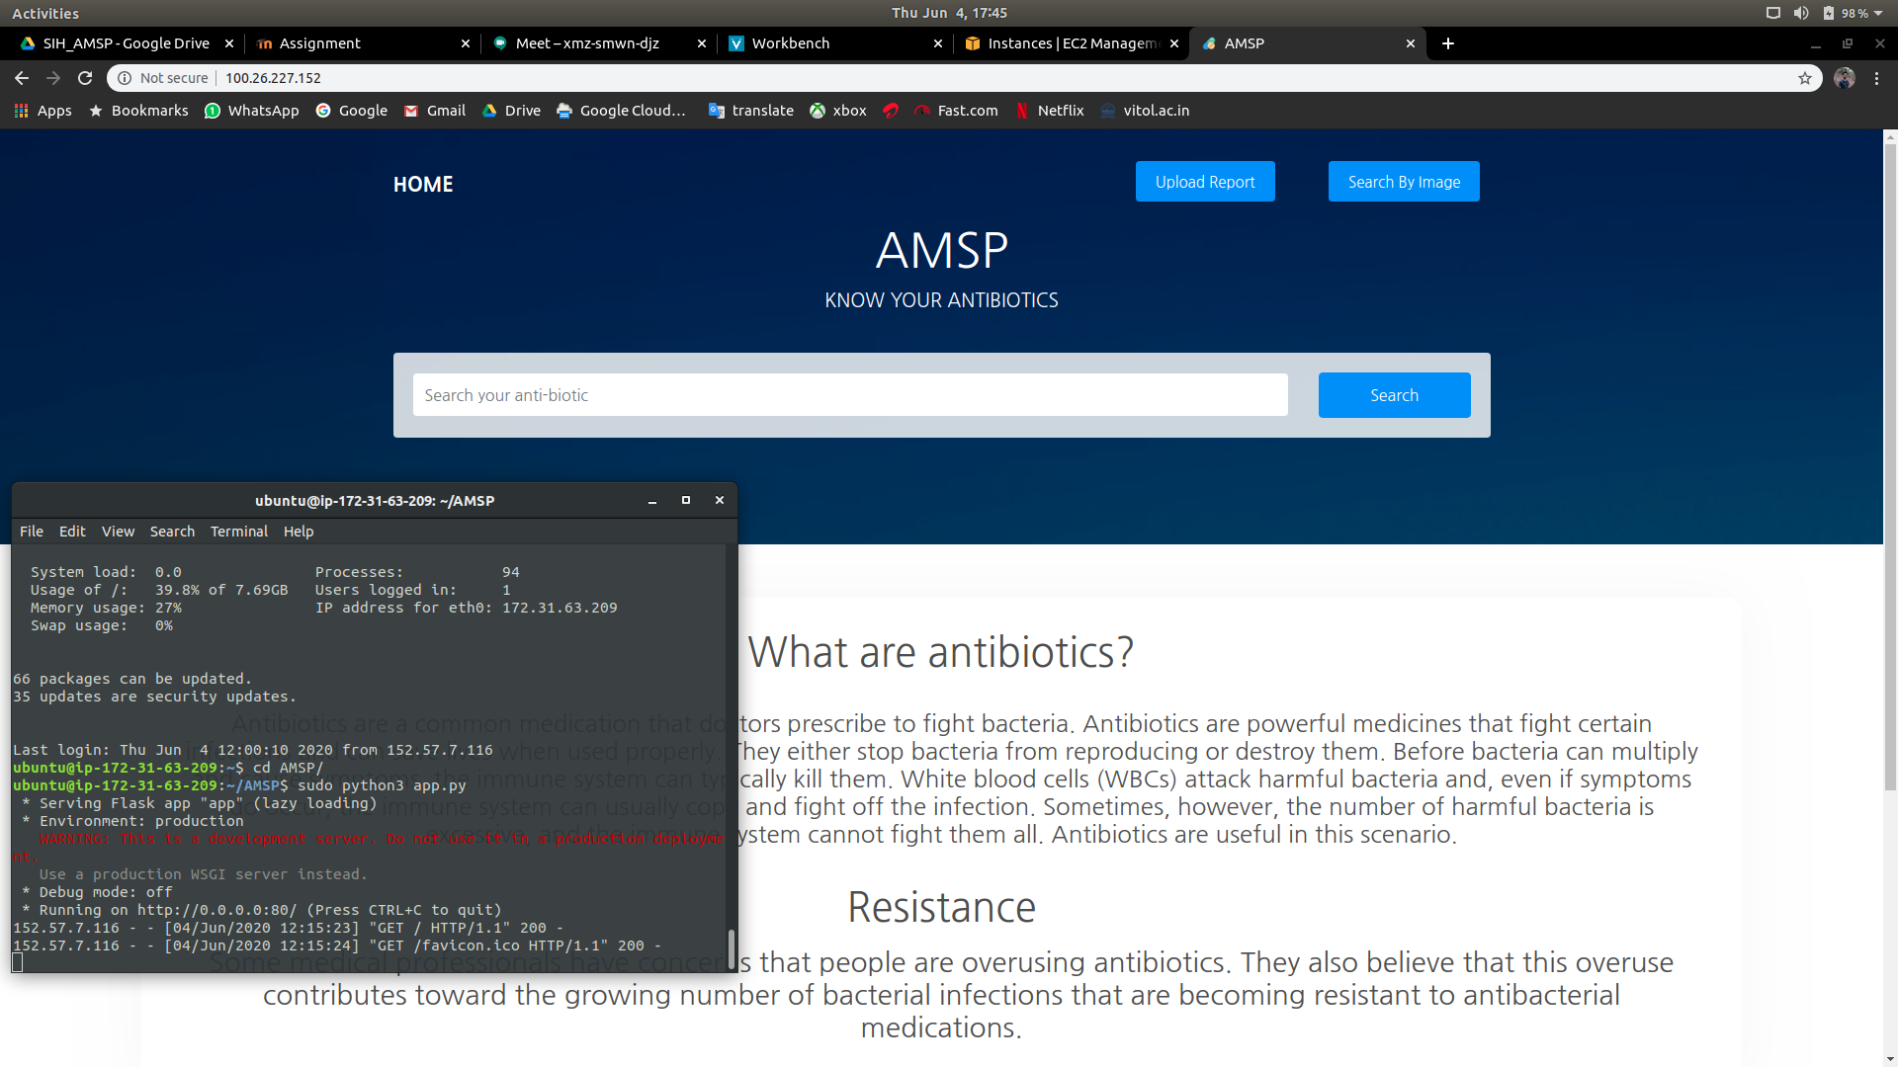

**Home page - AMSP (hosted on AWS)**

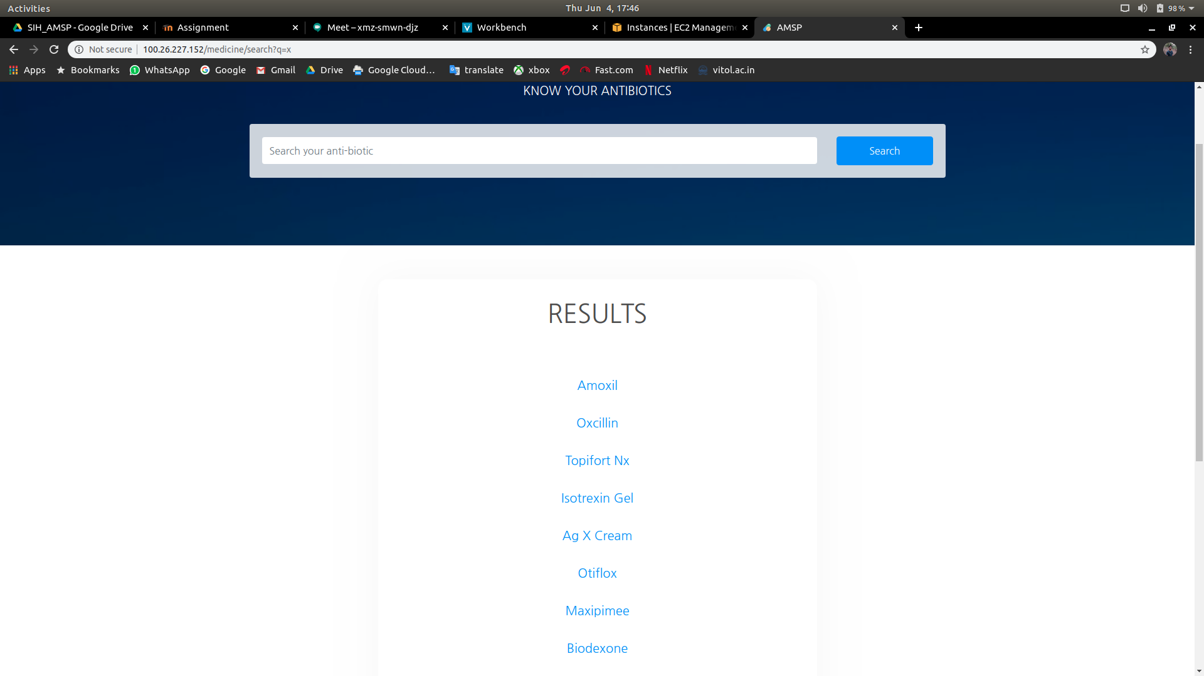

**Search results**

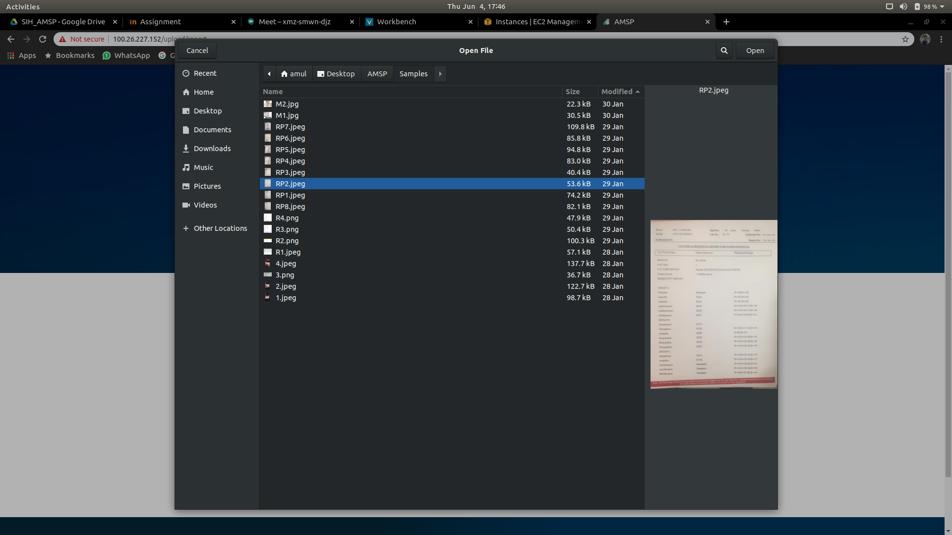

**Uploading Culture and Sensitivity Report**

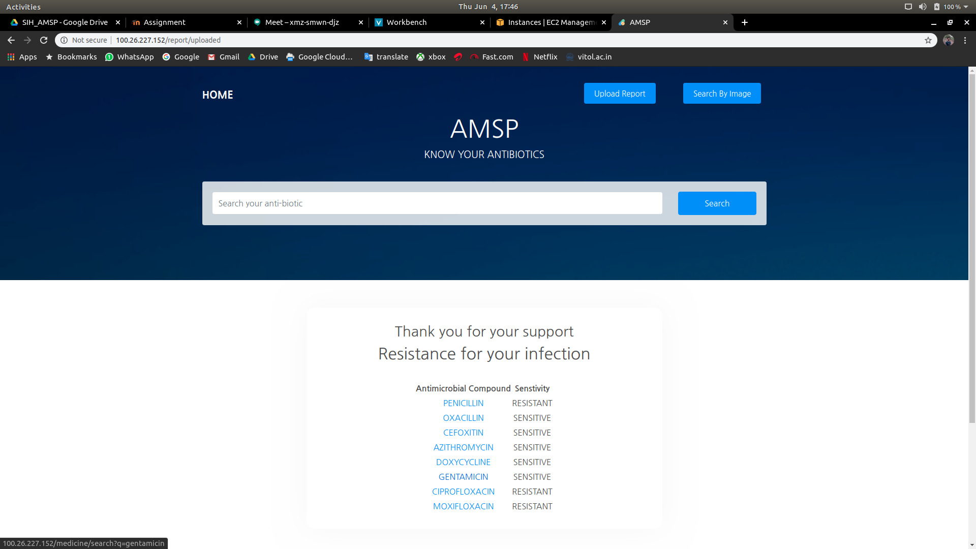

**Extracted information based on the report (sensitivity levels)**

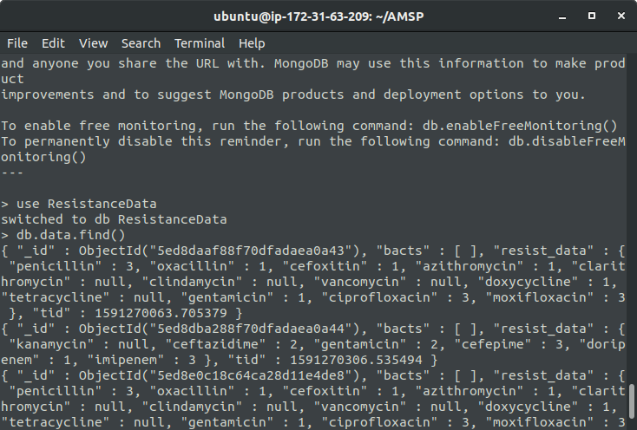

**Extracted data from report stored in MongoDB (on AWS)**

# Conclusion

As hospitalized patients become progressively mind boggling to treat, the expanding pervasiveness of antimicrobial opposition in both human services and network settings speaks to an overwhelming test. With the expanding unpredictability of contaminations and a scarcity of new antimicrobials being developed, the eventual fate of fruitful antimicrobial treatment looks somber. Antimicrobial stewardship can give all experts instruments to forestall the abuse of significant assets and help control the expansion in antimicrobial obstruction. Albeit frequently undervalued, the expansion of antimicrobial obstruction has at last grabbed the eye of compelling worldwide human services associations. The Institute of Medicine has recognized anti-microbial opposition as one of the key microbial dangers to wellbeing in the United States and has recorded diminishing the wrong utilization of antimicrobials as an essential answer to address this danger. The Get Smart battle, started by the Centers for Disease Control and Prevention in 1995, concentrated on lessening the utilization of improper antimicrobials in the outpatient setting. In 2010, the Centers for Disease Control and Prevention propelled Get Smart for Healthcare, a battle concentrated on improving antimicrobial use in inpatient medicinal services offices to forestall abuse of antimicrobials and advance the utilization of antimicrobial stewardship. The 2011 World Health Organization World Health Day concentrated on universal antimicrobial obstruction. This World Health Organization crusade has drawn together offices from everywhere throughout the world to center assets and battle the expansion in antimicrobial opposition.

# Reference

1. NNIS System; Division of Healthcare Quality Promotion, National Center for Infectious Diseases, Centers for Disease Control and Prevention, Public Health Service, US Department of Health and Human Services National Nosocomial Infections Surveillance (NNIS) System Report, data summary from January 1992 through June 2003, issued August 2003. *Am J Infect Control*. 2003;31(8):481-498 [[PubMed](https://www.ncbi.nlm.nih.gov/pubmed/14647111)] [[Google Scholar](https://scholar.google.com/scholar_lookup?journal=Am+J+Infect+Control&title=National+Nosocomial+Infections+Surveillance+(NNIS)+System+Report,+data+summary+from+January+1992+through+June+2003,+issued+August+2003&volume=31&issue=8&publication_year=2003&pages=481-498&pmid=14647111&)]
2. Kallen AJ, Mu Y, Bulens S, et al. Health care-associated invasive MRSA infections, 2005-2008. *JAMA*. 2010;304(6):641-648 [[PubMed](https://www.ncbi.nlm.nih.gov/pubmed/20699455)] [[Google Scholar](https://scholar.google.com/scholar_lookup?journal=JAMA&title=Health+care-associated+invasive+MRSA+infections,+2005-2008&author=AJ+Kallen&author=Y+Mu&author=S+Bulens&volume=304&issue=6&publication_year=2010&pages=641-648&pmid=20699455&)]
3. Kallen AJ, Srinivasan A. Current epidemiology of multidrug-resistant gram-negative *bacilli* in the United States. *Infect Control Hosp Epidemiol*. 2010;31(i):S51-S54 [[PubMed](https://www.ncbi.nlm.nih.gov/pubmed/20929371)] [[Google Scholar](https://scholar.google.com/scholar_lookup?journal=Infect+Control+Hosp+Epidemiol&title=Current+epidemiology+of+multidrug-resistant+gram-negative+bacilli+in+the+United+States&author=AJ+Kallen&author=A+Srinivasan&volume=31&issue=i&publication_year=2010&pages=S51-S54&pmid=20929371&)]
4. Paterson DL. The role of antimicrobial management programs in optimizing antibiotic prescribing within hospitals. *Clin Infect Dis* 2006; *42* (Suppl 2) : S90-5. Back to cited text no. 11
5. <https://flask.palletsprojects.com/en/1.1.x/>
6. <https://www.pyimagesearch.com/2017/07/10/using-tesseract-ocr-python/>
7. <https://aws.amazon.com/ec2/getting-started/>