Project Report

Stitching pairs of images

Usage: >> stitch_pair

For Harris detector, the radius was chosen to be 2 so that the size of mask is 5. This was done based on the knowledge from previous project.

Different neighbor sizes were selected and tested, they are displayed below

Neighbor size = 3

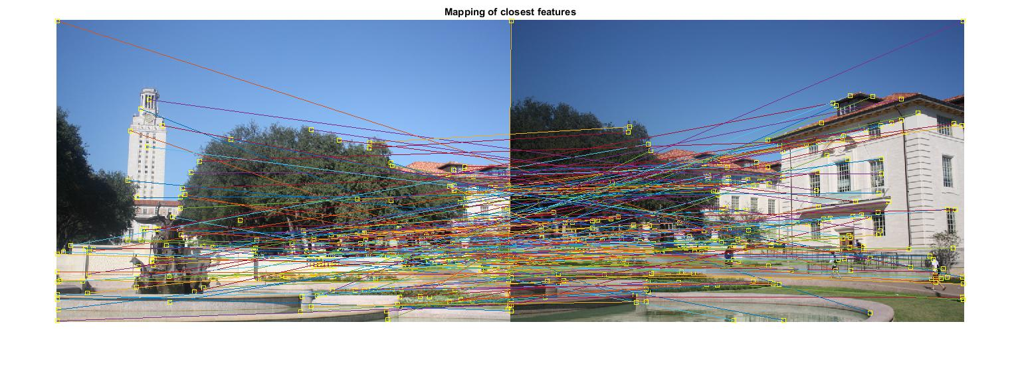

Neighbor size = 5

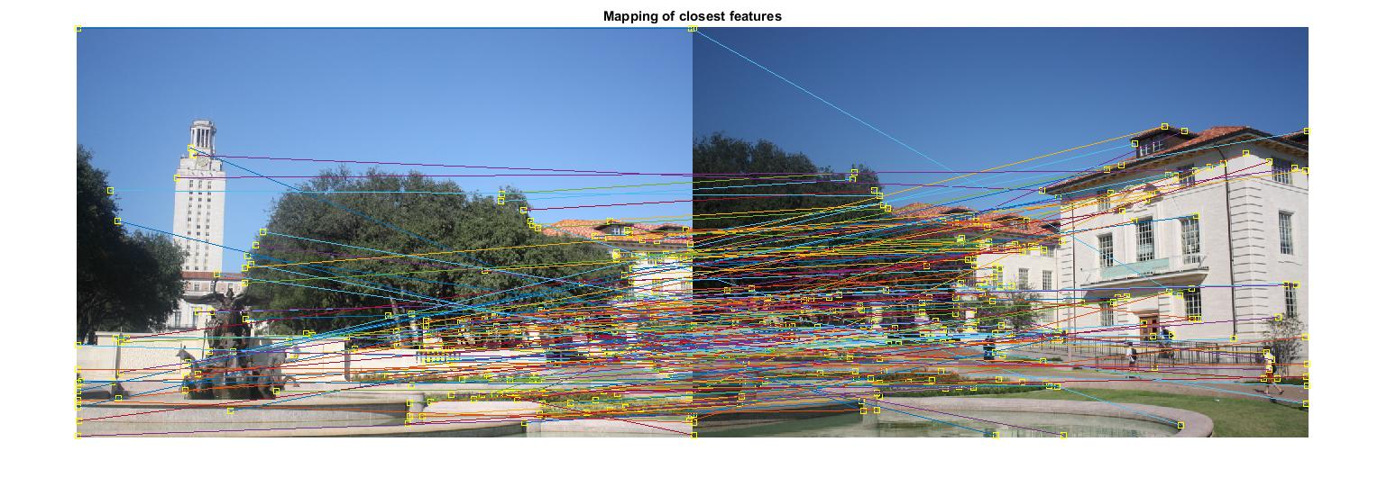

Neighbor size = 7

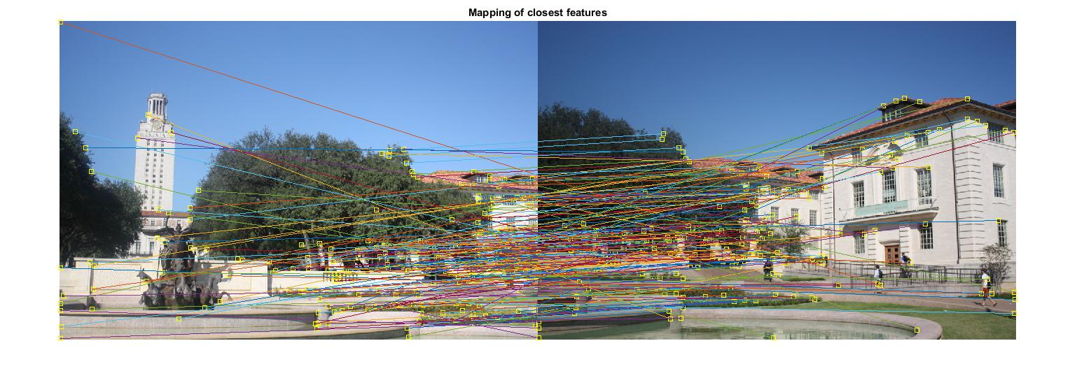

Neighbor size = 9

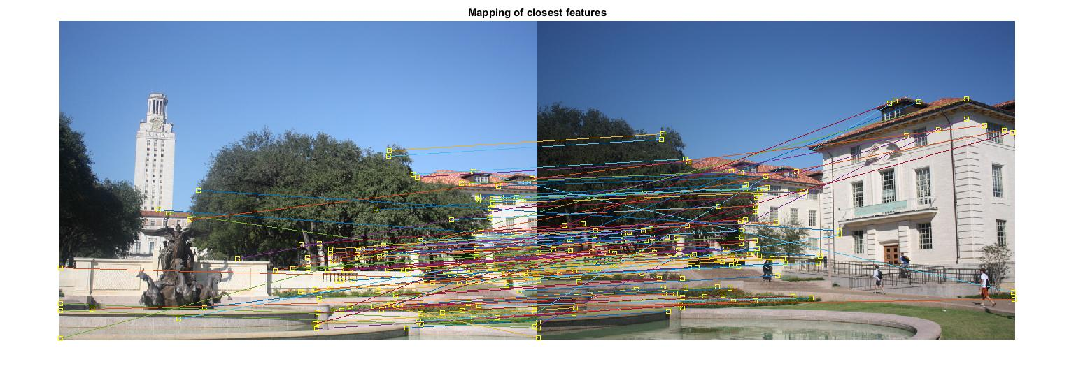

Neighbor size = 10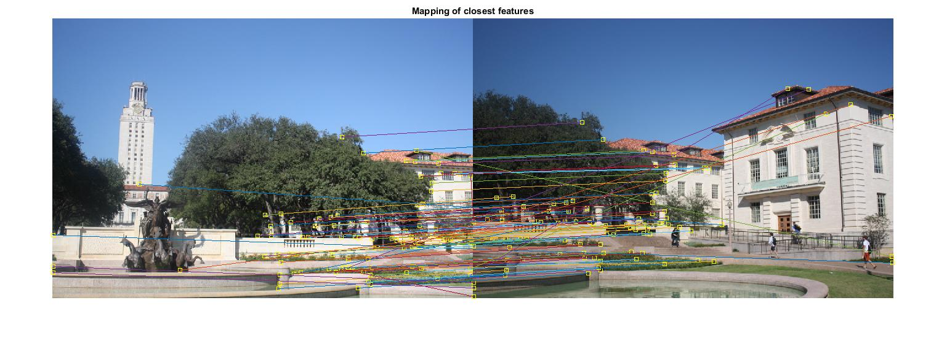

To get descriptors, top 200 points with minimum distance were selected.

RANSAC was applied on these feature points to get the inliers and residual error

Number of Iterations = 200

Number of Inliers: 42

Mean Residual Error: 0.7743

With these inliers found the optimal features, see below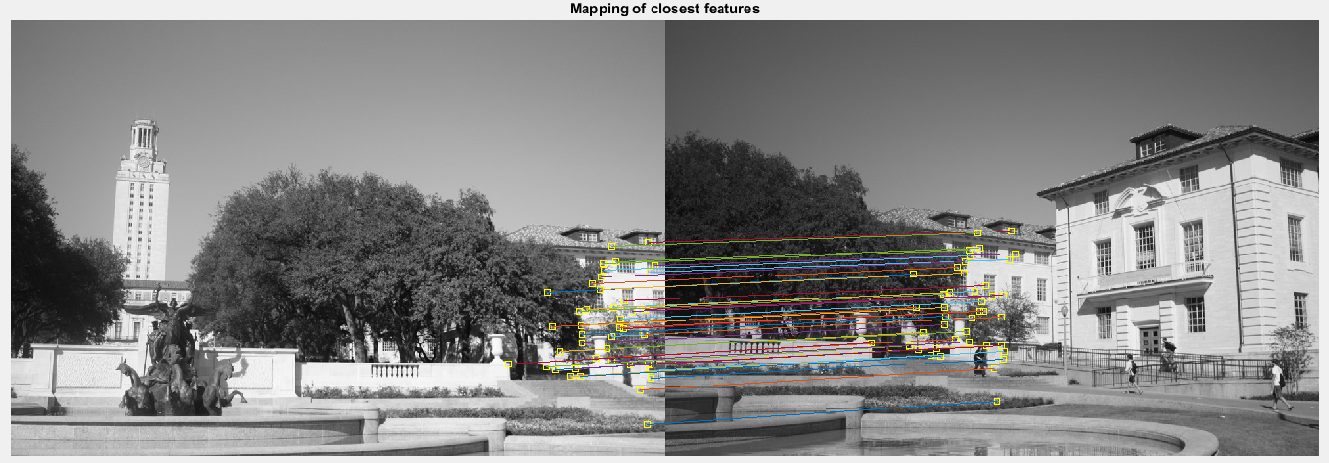

Homography transformed image was created. Instead of using maketform and imtransform, I used **projective2d** and **imwarp**.

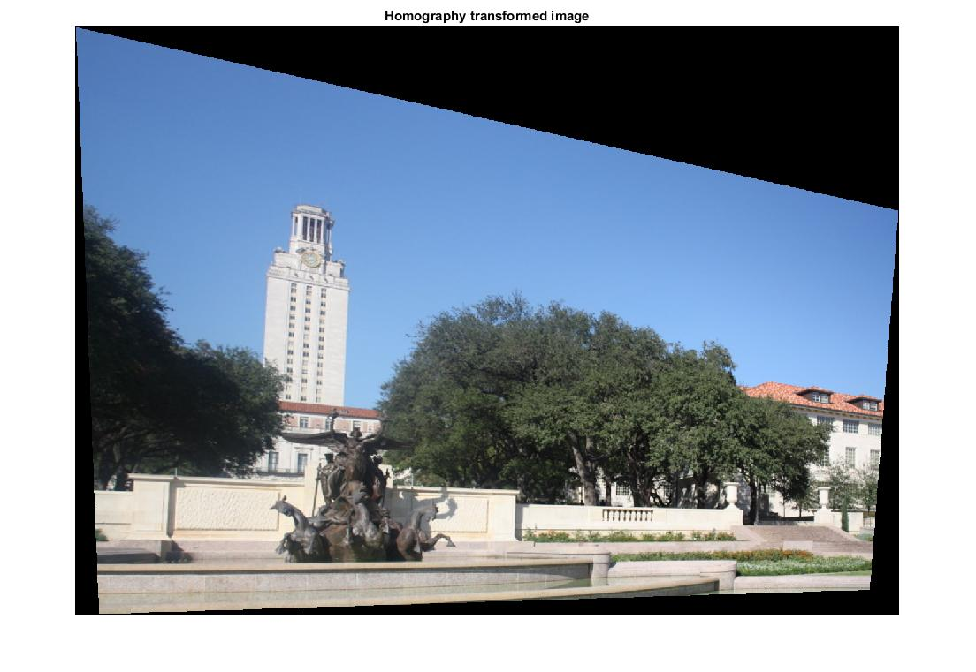

Finally the image was stitched. The following two approaches were taken to stitch the image

1. stitched_img = left_img/2 + right_img/2

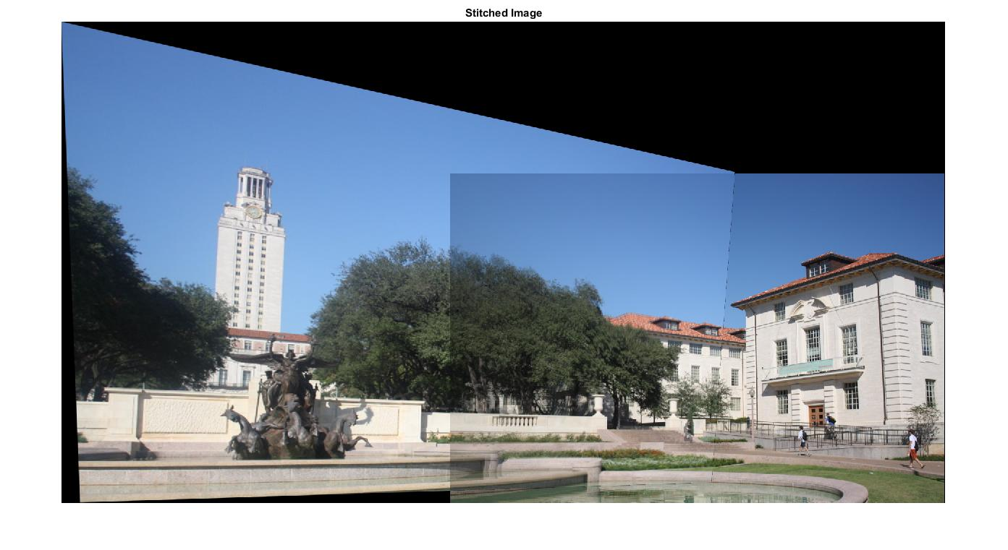

1. stitched_img = max(left_img, right_img)

The idea for trying this method was adopted from a reference link.

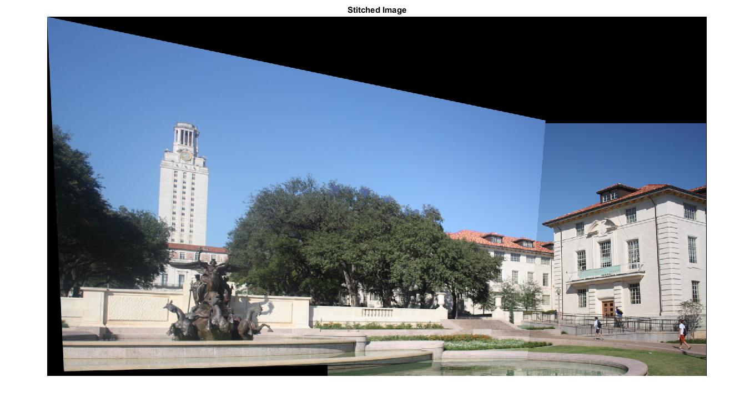

Fundamental Matrix Estimation and Triangulation

Usage: >>

The residual errors, mean squared distance between points in the 2 images and their corresponding epipolar lines, for normalized and un-normalized 8 point algorithm are given below

|  |  |  |
| --- | --- | --- |
| Image \ Algorithm | Normalized | Un-normalized |
| House | 15.4492 | 26.7532 |
| Library | 20.8026 | 11.8459 |

Normalized Algorithm:

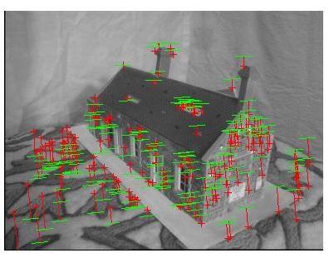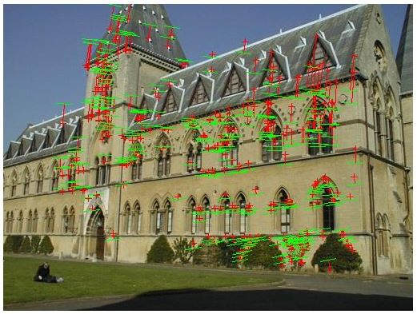

Un-normalized Algorithm:

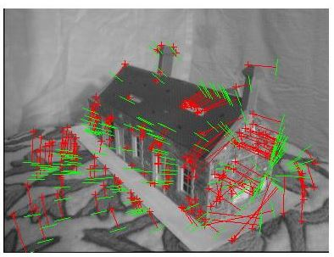

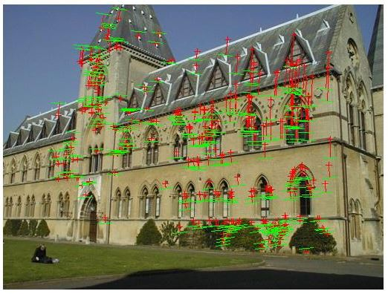

For Fundamental matrix using RANSAC and normalized algorithm, the following results were obtained based on different threshold values

|  |  |  |  |  |  |
| --- | --- | --- | --- | --- | --- |
| Image | Num of Iterations | Threshold | RANSAC num of points | Num of Inliers | Mean Residual Error |
| House | 200 | 10 | 4 | 67 | 15.0827 |
|  |  | 7 |  | 36 | 17.3419 |
|  |  | 15 |  | 114 | 12.713 |
|  |  |  |  |  |  |
|  |  |  |  |  |  |
| Library | 200 | 15 | 4 | 182 | 13.9331 |
|  |  | 12 |  | 114 | 16.253 |
|  |  | 10 |  | 112 | 13.8316 |

Mean residual error between 2D and 3D points for both images are given below,

|  |  |  |  |  |
| --- | --- | --- | --- | --- |
| Image | House 1 image | House 2 image | Library 1 image | Library 2 image |
| Mean between 2D and 3D points | 0.0025 | 0.1566 | 0.0731 | 0.2677 |

References:

1. Lecture slides
2. http://citeseerx.ist.psu.edu/viewdoc/download?doi=10.1.1.186.5926&rep=rep1&type=pdf
3. http://home.deib.polimi.it/boracchi/teaching/IAS/Stitching/stitch.html
4. https://en.wikipedia.org/wiki/Eight-point_algorithm
5. https://en.wikipedia.org/wiki/Triangulation_(computer_vision)
6. https://mliu.physics.ucsd.edu/estimation-fundamental-matrix.pdf
7. https://www.coursera.org/learn/robotics-perception/lecture/Bwk0d/epipolar-geometry-i