Phase Test Plan – Join Flow

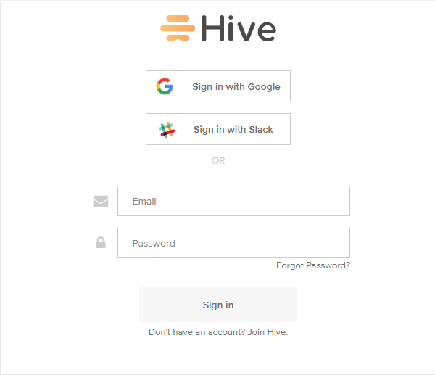

Version: 1.0

Created: 4/17/2018

Status: DRAFT

Tester: Kautuk R Desai

# Introduction

This document offers test plan on joining hive as new user. The goal of the test plan is to able to efficiently test the join hive flow. The approach of the testing is manual

# Test Strategy

* **Cross-browser** **Testing**

|  |  |
| --- | --- |
| Browser Name | Version |
| Google Chrome | v60+ |
| Edge | v40+ |
| Firefox | v58+ |
| Internet Explorer | v11+ |

# Features to be tested

|  |  |  |
| --- | --- | --- |
| Feature | Pass criteria | Failure reason |
| Join hive button | Clicking the button opens hive introduction video page | Button click link broken |
| Video play button | Clicking the button starts the introduction of hive video | Button click link broken |
| Continue button | Clicking the button loads user information form | Button click link broken |
| First Name input field | Field name should not be empty | Field left empty |
| Last Name input field | Last name should not be empty | Field left empty |
| Email input field | Email should be unique | Email already registered |
| Password input filed | Password length should be greater than or equal 6 | Password field left empty / password length less than 6 |
| Form submit (continue) button | Upon click workspace info page loads | Above user info criteria not met. |
| Organization name field | Should not be empty | Field left empty |
| Organization size button | Can be left empty / upon clicking the appropriate button should highlight |  |
| Submit Workspace button | Upon click option to add task to action list appears | Organization field left empty |
|  |  |  |
| Submit action list button | Upon click option to add coworkers appears | Button click link broken |
| Coworkers input fields | Organization name already appears in the input field | Error in page load |
| Continue Button | Upon inserting coworkers email id button is enabled |  |
| Submit coworker (continue button)  Skip (invite later) button | Upon click file storage option page loads | Button click link broken |
| File Storage options | Upon click a specific file storage options and new window loads to authenticate and when done the option highlights | File storage linking broken / password incorrect |
| Finish button  Skip (configure later) | Upon click the hive workspace opens up with a welcome message. | Button click link broken |

# Approvals

|  |  |  |
| --- | --- | --- |
| Name | Date | Signature |
| Eric Typaldos |  |  |
|  |  |  |