

Experiment 7

Student Name: Kaushik Bhadra
Branch: BE-AIT-CSE
Semester: 5th
Subject Name: ADBMS
UID: 23BAI70483
Section/Group: 23AML_KRG-1
Date of Performance: 22 Nov 2025 Subject Code: 23CSP-333

MEDIUM - LEVEL
- Problem Title: Triggers Medium
- Problem Description: WHENEVER THERE IS A INSERTION ON STUDENT TABLE THEN, THE CURRENTLY INSERTED OR DELETED ROW SHOULD BE PRINTED AS IT AS ON THE OUTPUT CONSOLE WINDOW.
- SQL Commands:

CREATE TABLE student (
id SERIAL PRIMARY KEY,
name VARCHAR(50),
age INT,
class VARCHAR(10)
);

CREATE OR REPLACE FUNCTION fn_student_audit()
RETURNS TRIGGER
LANGUAGE plpgsql
AS
$$
BEGIN
IF TG_OP = 'INSERT' THEN
RAISE NOTICE 'Inserted Row -> ID: %, Name: %, Age: %, Class: %',
NEW.id, NEW.name, NEW.age, NEW.class;
RETURN NEW;

ELSIF TG_OP = 'DELETE' THEN
RAISE NOTICE 'Deleted Row -> ID: %, Name: %, Age: %, Class: %',
OLD.id, OLD.name, OLD.age, OLD.class;
RETURN OLD;
END IF;

RETURN NULL;
END;
$$;

CREATE TRIGGER trg_student_audit
AFTER INSERT OR DELETE
ON student
FOR EACH ROW
EXECUTE FUNCTION fn_student_audit();

INSERT INTO student (name, age, class)
VALUES ('Ravi', 20, 'CS101');

DELETE FROM student WHERE id = 1;

Output:
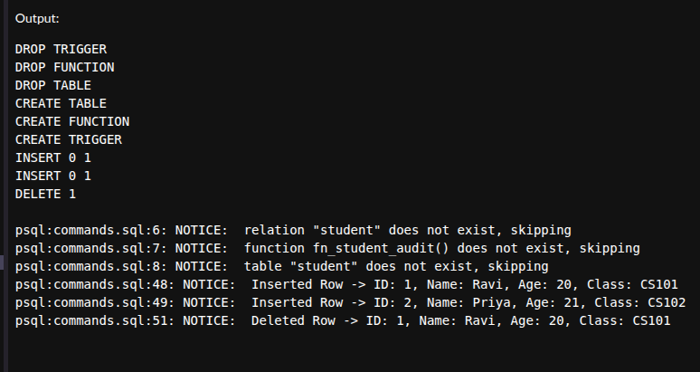
Fig1: View OUTPUT

Learning Outcomes:
  - I learned how to create new triggers.
  - I learned how to perform different types of triggers.
  - I learned how to create triggers with specific types.

HARD - LEVEL
- Problem Title: Triggers Hard level
- Problem Description: Whenever a new employee is inserted in tbl_employee, a record should be added to tbl_employee_audit like: "Employee name <emp_name> has been added at <current_time>" Whenever an employee is deleted from tbl_employee, a record should be added to tbl_employee_audit like:
"Employee name <emp_name> has been deleted at <current_time>"

The solution must use PostgreSQL triggers.

- SQL Commands:

CREATE TABLE tbl_employee (
emp_id SERIAL PRIMARY KEY,
emp_name VARCHAR(100) NOT NULL,
emp_salary NUMERIC
);

CREATE TABLE tbl_employee_audit (
sno SERIAL PRIMARY KEY,
message TEXT
);

CREATE OR REPLACE FUNCTION audit_employee_changes()
RETURNS TRIGGER
LANGUAGE plpgsql
AS
$$
BEGIN
IF TG_OP = 'INSERT' THEN
INSERT INTO tbl_employee_audit(message)
VALUES ('Employee name ' || NEW.emp_name || ' has been added at ' || NOW());
RETURN NEW;

ELSIF TG_OP = 'DELETE' THEN
INSERT INTO tbl_employee_audit(message)
VALUES ('Employee name ' || OLD.emp_name || ' has been deleted at ' || NOW());
RETURN OLD;
END IF;

RETURN NULL;
END;
$$

CREATE TRIGGER trg_employee_audit
AFTER INSERT OR DELETE
ON
tbl_employee
FOR EACH ROW
EXECUTE FUNCTION audit_employee_changes();

INSERT INTO tbl_employee(emp_name, emp_salary) VALUES ('Aman', 50000);

DELETE FROM tbl_employee WHERE emp_name = 'Aman';

SELECT * FROM tbl_employee_audit;

Output:

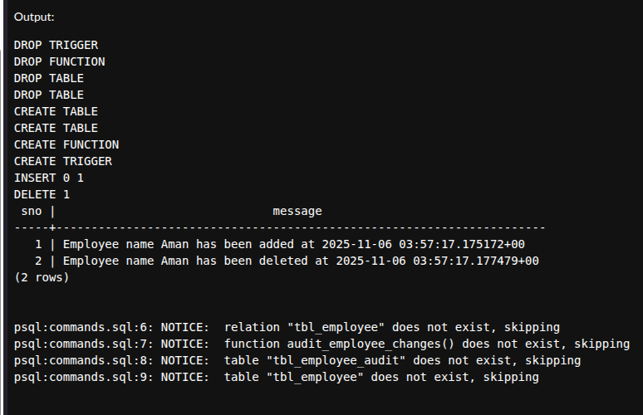
Fig1: View OUTPUT

9. Learning Outcomes:
  - I learned how to create triggers.
  - I learned how to perform types of triggers.

