PROJECT OVERVIEW
Vigil
Real-time payment risk and money-mule intelligence
Vigil stops a risky payment at the last safe moment, before any money moves, and finds the money-mule networks that scammers use to launder it. Every payment is decided in milliseconds by a transparent, auditable policy; graph learning, money tracing and an AI operations agent work around it.
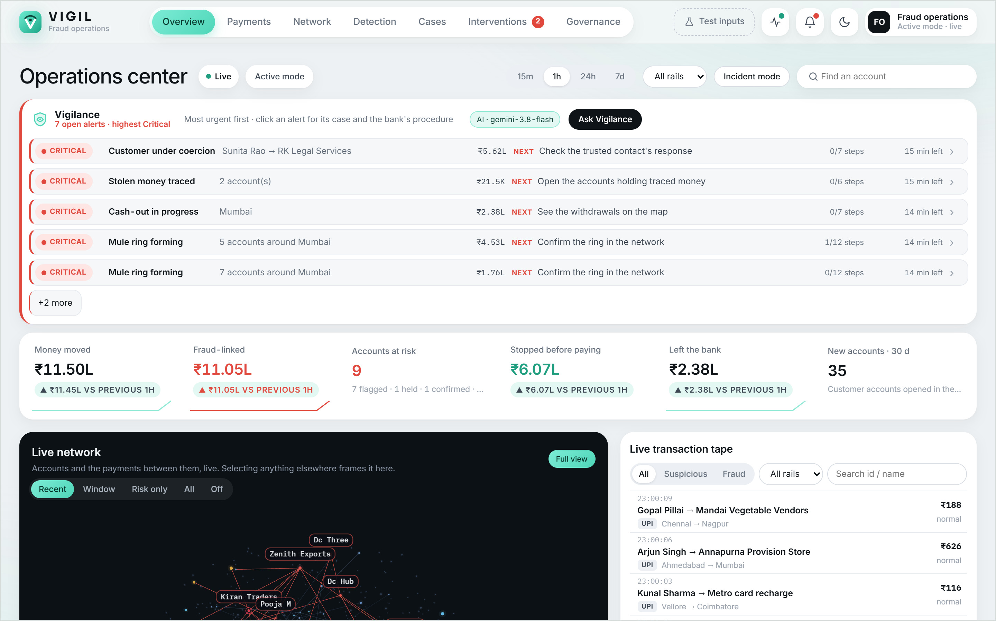
TEAM
Kausik G H  24BCE1328 | P Rithik Raju  24BCE5395 | Abhishek Kandavel  24BCE5424 | Advaith Anand  24BMV1025
October 2026

Vigil at a glance
The problem. Authorised-push-payment scams (fake police "digital arrest" calls, investment and job scams) trick people into sending money themselves. The money lands in mule accounts, rented or opened only to receive it and pass it on within minutes, usually as a ring. Once it leaves the bank it is almost impossible to recover, and most fraud tools only look after the payment has happened.
The idea. Vigil sits at the moment a customer presses Pay. Every payment is scored from five independent kinds of evidence and receives a proportionate response, from silent approval to holding just that one payment and alerting a trusted family member. No account is ever frozen. In parallel, eight detector families watch the whole payment network for mule rings, and whatever the network learns changes the very next payment decision.
01 Decides before money moves  Five evidence dimensions are fused by a versioned policy into one of five tiers, in about 4 ms. The customer sees facts; the bank sees every rule and its points. |  | 02 Finds mule rings  Network rules, a Random Forest, a graph attention network, drift, early warning and pattern memory re-score accounts on every payment. Agreement, not one score, sets an account's status.
03 Follows stolen money  When a scam is confirmed, TaintTrace follows the money through the ledger with the Lowest Intermediate Balance Rule. The next payment to any account holding it is held. |  | 04 Runs the fraud desk  Vigilance, an AI operations agent, raises and classifies alerts, scores their severity, writes the case and walks the bank's procedure. It is read-only: people act.

≈ 4 ms  median time to decide a payment (p95 under 9 ms) |  | 11 / 11  injected attack patterns caught live, with zero false positives |  | 0.953  PR-AUC of the graph neural network on bank worlds it never saw
8  independent detector families; one alone never flags an account |  | 150  synthetic bank worlds and 3.2 million payments for training and testing |  | 404  automated tests, including property-based money-conservation checks

Scope: a working prototype on synthetic data. No real customers or money are involved; the payment rail, the external fraud registry and call context are simulated and labelled as such on every screen.

How it works
One payment travels left to right across the top: evidence is gathered and fused, and a tier is chosen before any money moves. Once money moves, the ledger, the live graph and the detectors learn from it, and that learning flows back into the next decision.
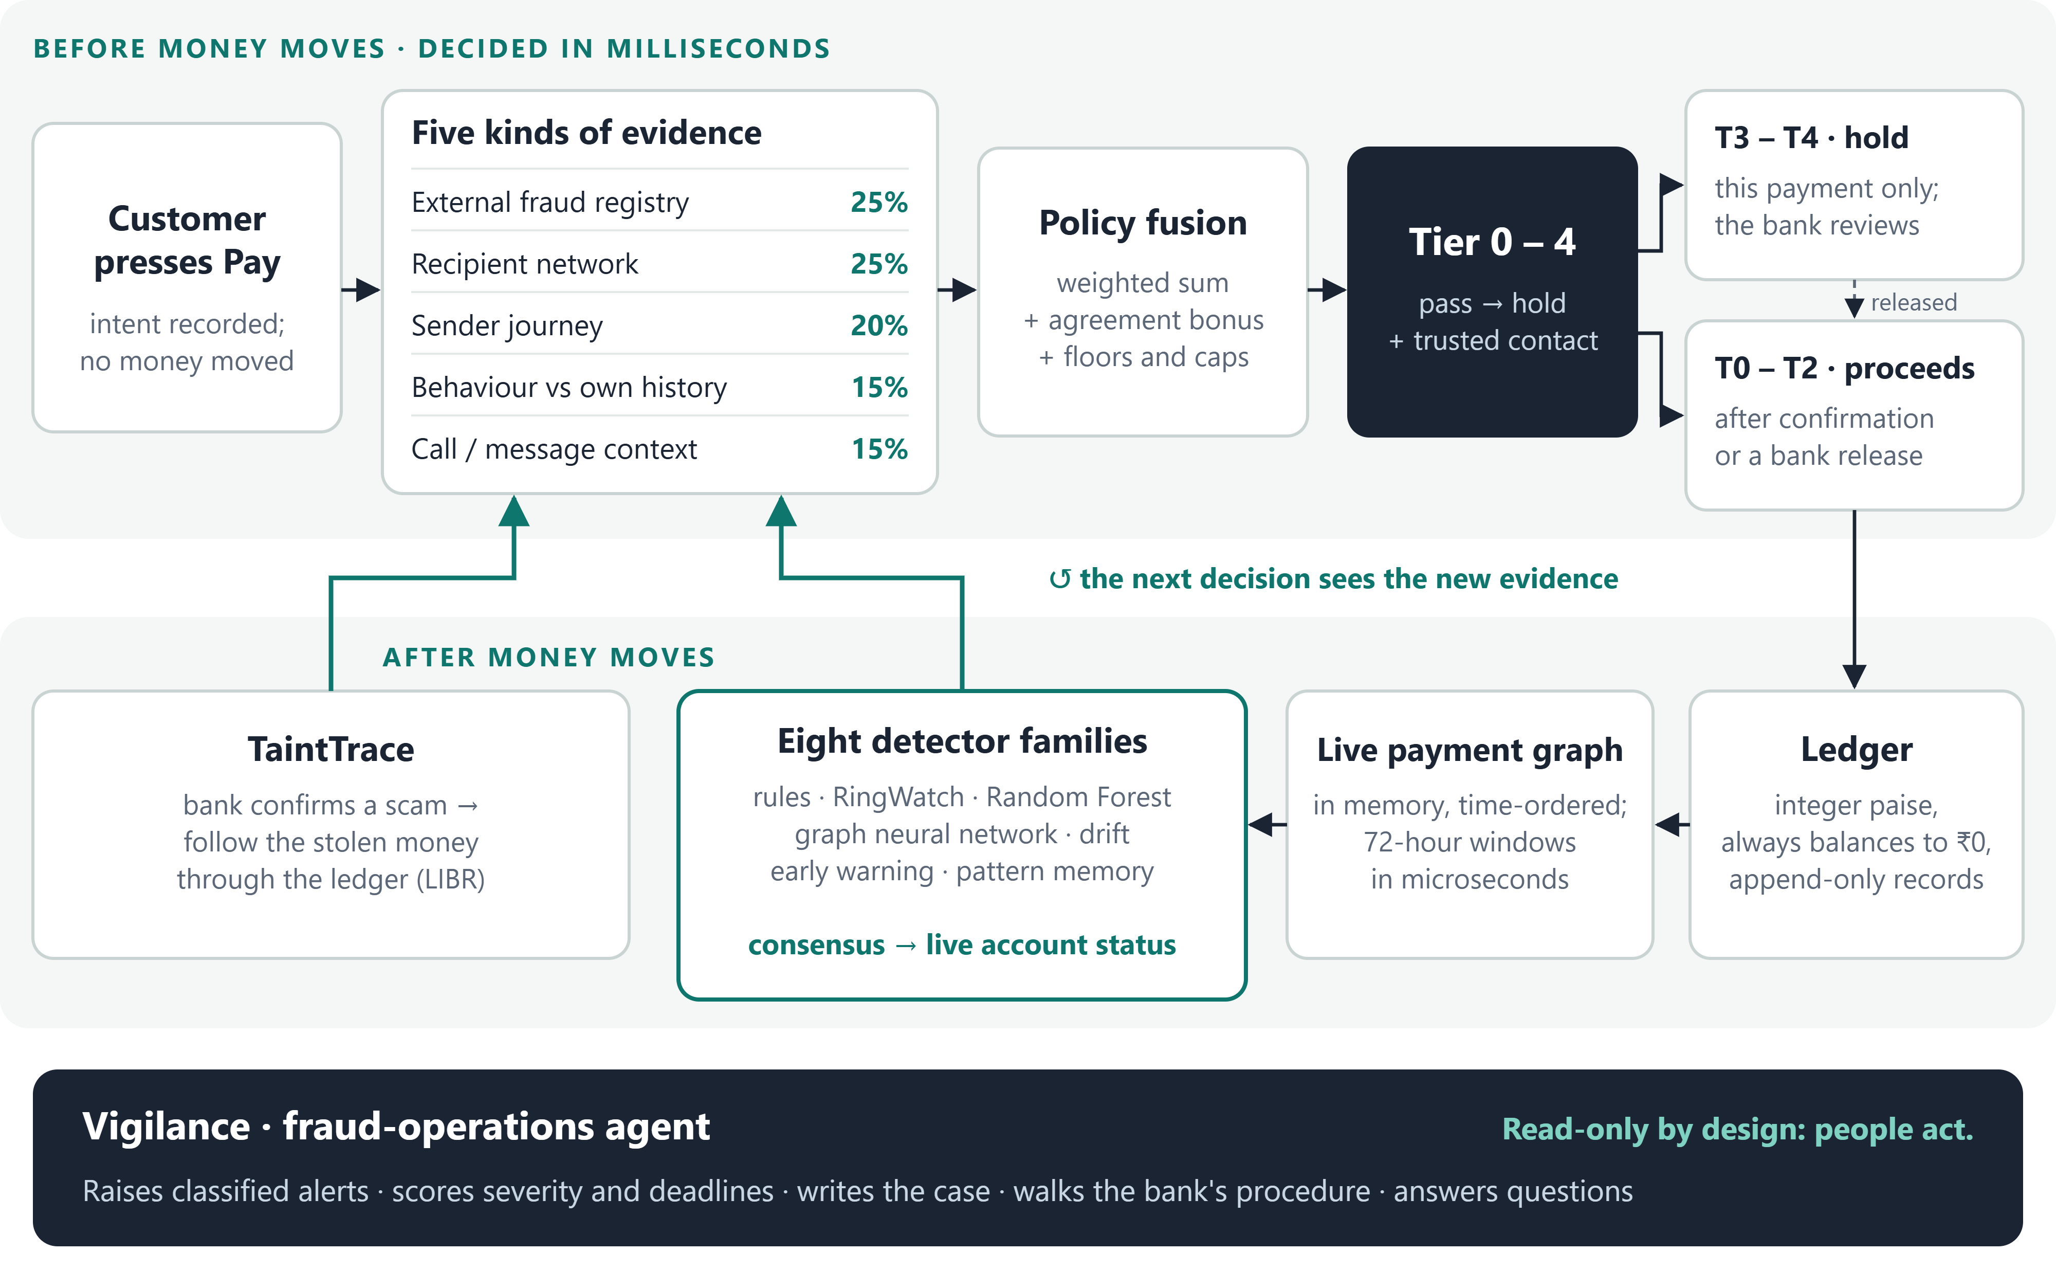

Three principles behind every design decision
- Rules decide, models corroborate. The payment tier comes only from a transparent, versioned policy. Machine-learning scores are shown beside it as evidence; a test proves the tier is identical with or without them.
- Proportionate, never punitive. A hold applies to one payment's amount, incoming money is never held, and the customer sees plain facts, never accusations. A trusted contact is alerted only when there is evidence the sender is being coerced.
- Deterministic and auditable. Money is stored as integer paise and the ledger always balances to ₹0. Every decision is an append-only record with a SHA-256 hash and its policy version, and a reset rebuilds the identical world, so every result can be reproduced.
Every screen updates live over WebSockets with no polling: the 3D network, the India money map, the transaction tape and the alerts all move the moment a payment posts.

1 Deciding before the money moves
Each payment is assessed on five dimensions. Every rule that fires adds a fixed, published contribution, and a dimension's score is the capped sum of its rules:
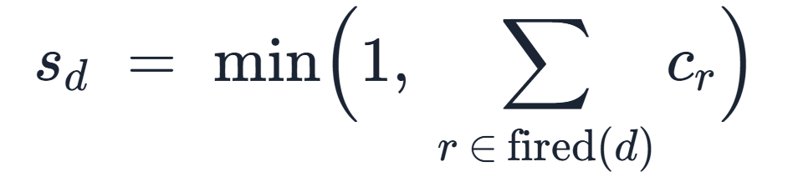
Dimension | Weight | What it looks at | Example signals (contribution)
External intelligence | 25% | What a fraud registry says about the recipient | reported 0.65 · confirmed mule 1.00
Network (RingWatch) | 25% | The recipient's money flows over the last 72 hours | many first-time senders 0.25 · rapid pass-through 0.30 · circular flow 0.25 · holds traced scam money 0.40
Journey (TrailScore) | 20% | What the sender did in the last 30 minutes | new device 0.20 · payee added 0.15 · limit raised 0.20 · all three in order +0.25
Behaviour | 15% | This payment against the sender's own 180 days | unusually large 0.30 · first payment to payee 0.15 · 80%+ of balance 0.30
Context (ContextFlag) | 15% | Pressure cues in a call or message | urgency 0.25 · secrecy 0.30 · fear of authority 0.35 · "bypass your bank" 0.30

The dimensions are fused with fixed weights. Independent evidence that agrees counts for more than one loud signal, so every additional dimension at 0.5 or above adds 0.10:
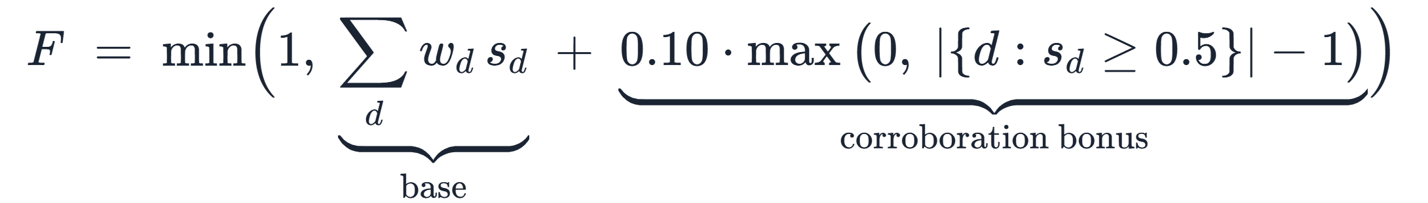
The final score picks a proportionate response. The examples above the bar are real decisions from the demo:
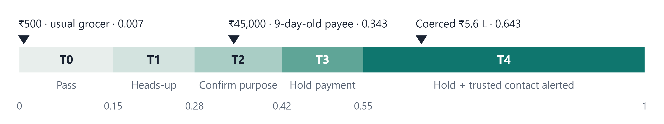
Four named adjustments are applied last and recorded by name on the decision: two floors that force at least Tier 3 when the recipient is a confirmed mule or holds ₹10,000 or more of traced scam money; a friction guard that caps clean, established relationships at Tier 1; and a cap that reserves Tier 4 for cases with evidence the sender is compromised or coerced. These numbers are hand-set, explainable values in one versioned file, which a risk officer can review in a diff.

Measuring "unusual" robustly
Behaviour uses a robust z-score built on the median and the median absolute deviation, so one old large payment cannot hide the next one. Floors stop a customer who always pays the same amount from producing an infinite score; 3.5 or above is an outlier.
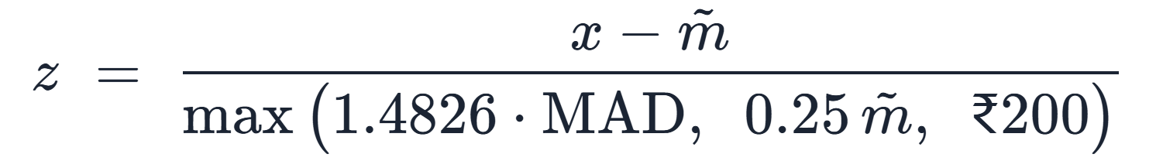
Worked example: a "digital arrest" scam. In eight minutes, Sunita (67) signs in on a new device, adds a payee, raises her transfer limit and takes a call from someone posing as police, who tells her to move ₹5,61,600, 95% of her savings, to a "verification account".
Vigil holds only that payment and sends the facts to her trusted contact, Arjun. Each step alone was ordinary; the sequence was not. The decision replay shows the score climbing 0.04 → 0.07 → 0.11 → 0.36 → 0.64, and removing the call context alone would have made it a Tier 2 "confirm the purpose" instead.
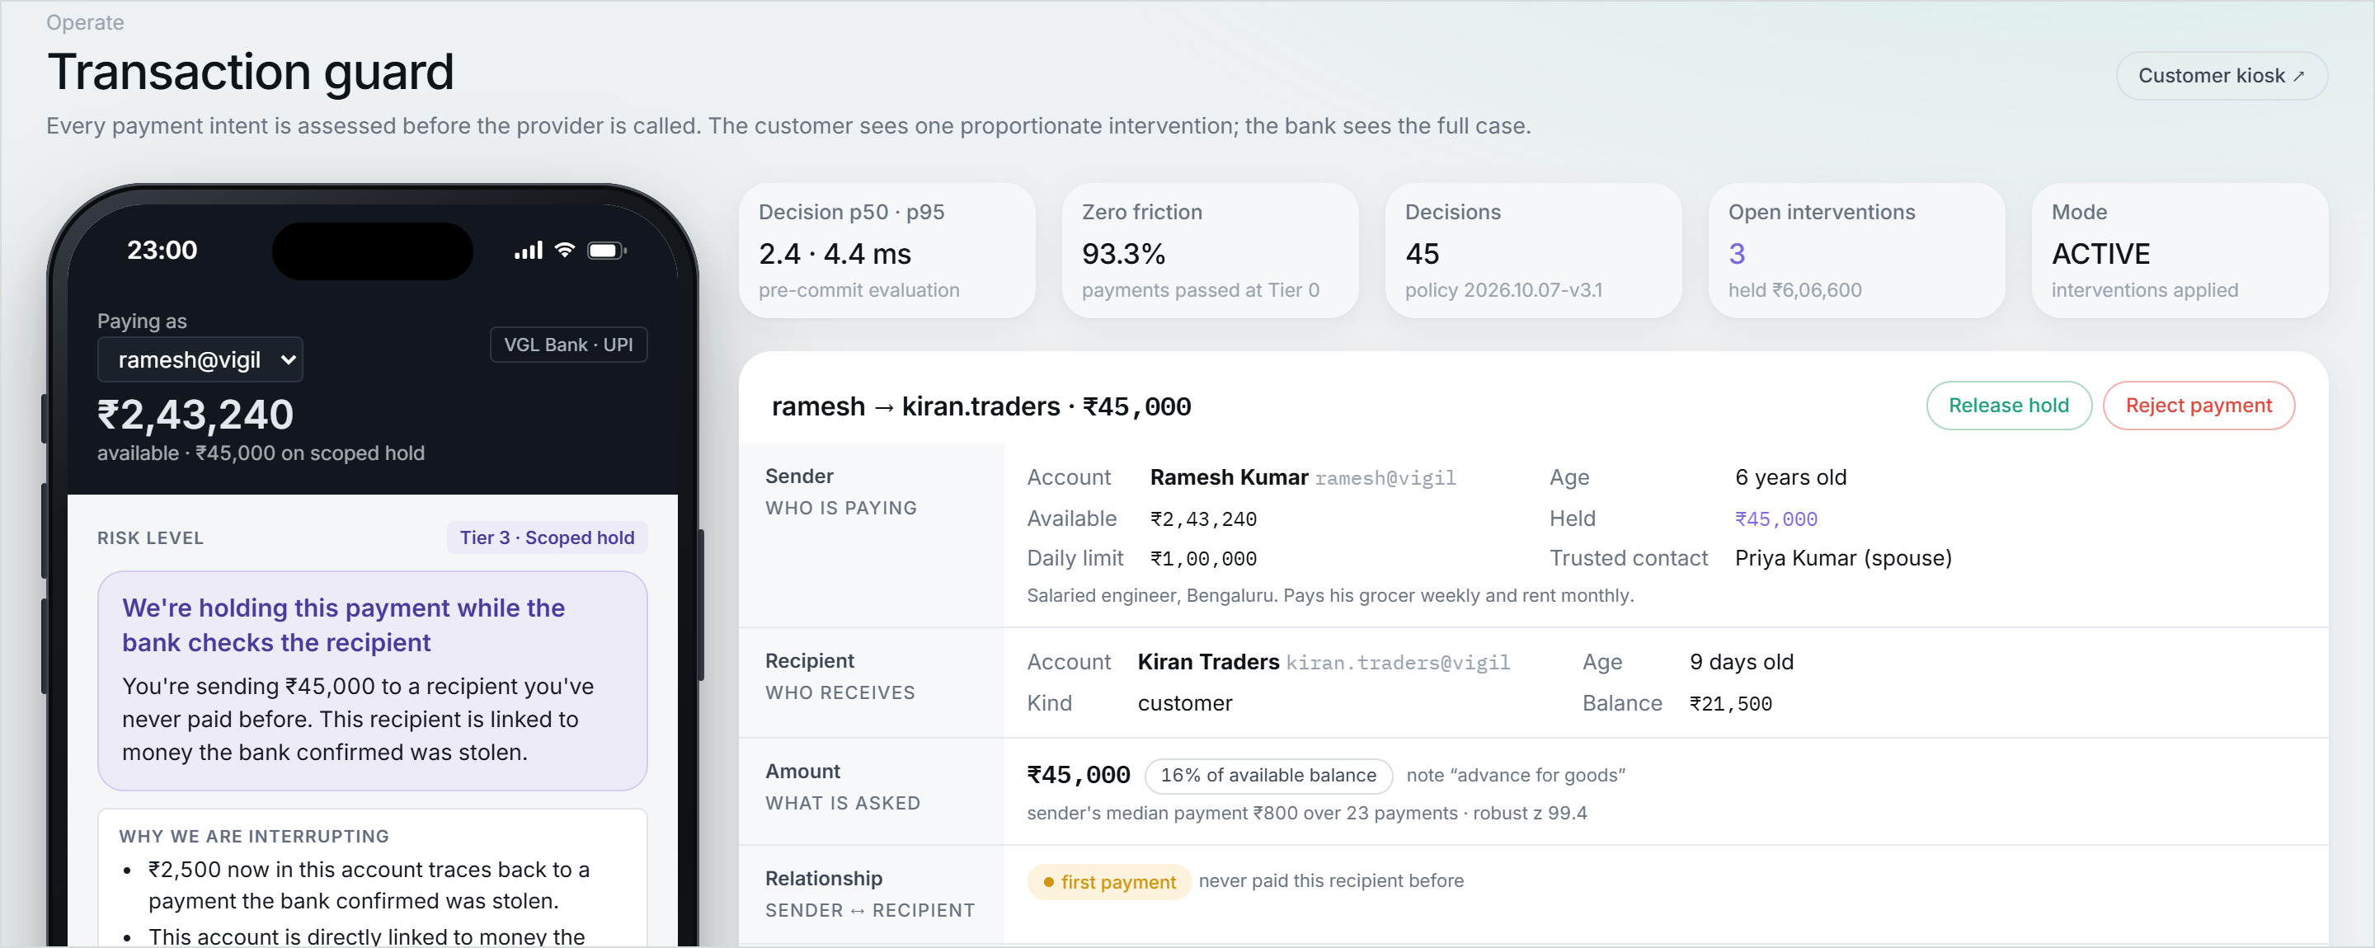
Transaction guard. The customer's phone (left) shows one calm, factual message; the bank (right) sees every rule, its evidence, its source and its points.

2 Finding mule rings
Beside the payment decision, every account is re-scored each time a payment lands. One function turns an account's last 72 hours into 15 behavioural features: counterparties in and out, value in and out, retention, the share forwarded within 60 minutes, the share of brand-new counterparties, transfers just under ₹10,000, device sharing, dormancy, channel mix, posting rate and account age. The same function feeds training and live scoring, so a model never sees features computed differently from those it learned on.
Detector family | How it works | Flags when
Rule engine | Six windowed checks: fan-in, fan-out, low retention, shared device, channel diversity, velocity | 4 or more of 12 points
RingWatch | Transparent money-flow rules on the recipient (also feed the payment decision) | network score ≥ 0.40
Random Forest | 100 trees, depth 10, class-balanced; isotonic-calibrated probability | ≥ 0.536 (max F1 on validation)
Graph attention network | Relational GAT over the 72-hour payment graph; sees two hops of neighbours | ≥ 0.583 (max F1 on validation)
Behavioural drift | Last 72 hours against the account's own previous 45 days | HIGH, with 2+ features changed
Early warning | Unusual relative to the whole population on two or more signals | top 8% of the population
Pattern memory | Similarity to ten mule-pattern prototypes built from training worlds only | similarity ≥ 0.731
External registry | Simulated fraud-registry listing | reported or confirmed mule

The graph neural network
Mules are defined by who they trade with, so the strongest model looks at the network itself. Two relational graph-attention layers (16 → 32 → 32, four heads of eight) keep separate weights for money coming in and money going out, because collecting is not distributing. Attention learns which neighbours matter:
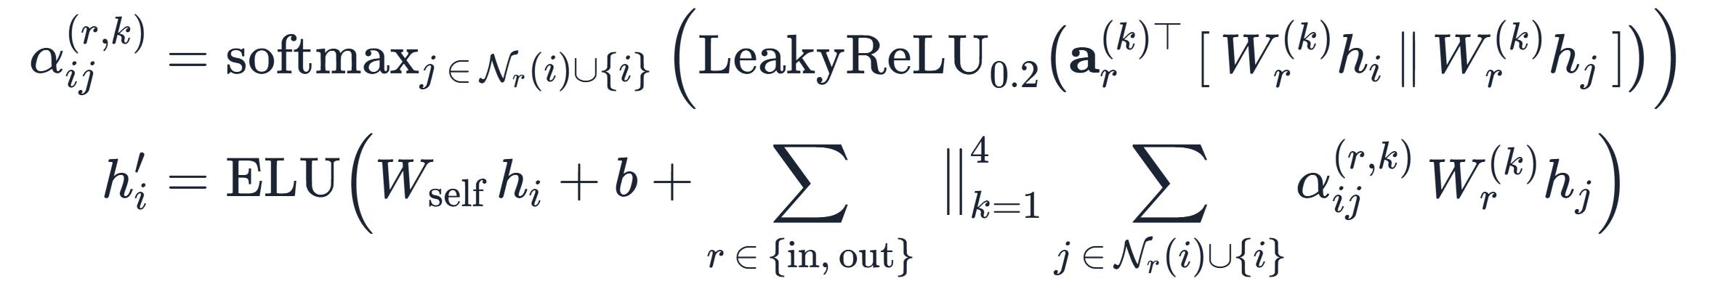
It is trained on 90 synthetic worlds with a class-weighted loss (a missed mule costs up to 20 times a false alarm), early-stopped on validation PR-AUC, then calibrated with isotonic regression so that a score of 0.8 means roughly 80%. The server runs a 4,961-parameter NumPy re-implementation that matches the trained PyTorch model to 3 × 10⁻⁷, so no deep-learning runtime sits on the request path.
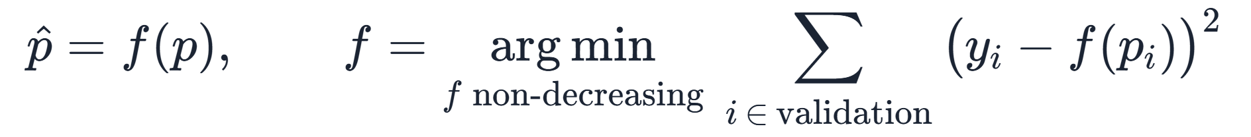

Change and similarity
Drift compares the last 72 hours with the account's own 45-day baseline, feature by feature. The scale κ is fitted on ordinary accounts, so a jump from 2 to 3 payments never looks like 2 to 200. Pattern memory compares a 13-dimension money-flow signature with the median signature c and robust scale k of each known pattern:
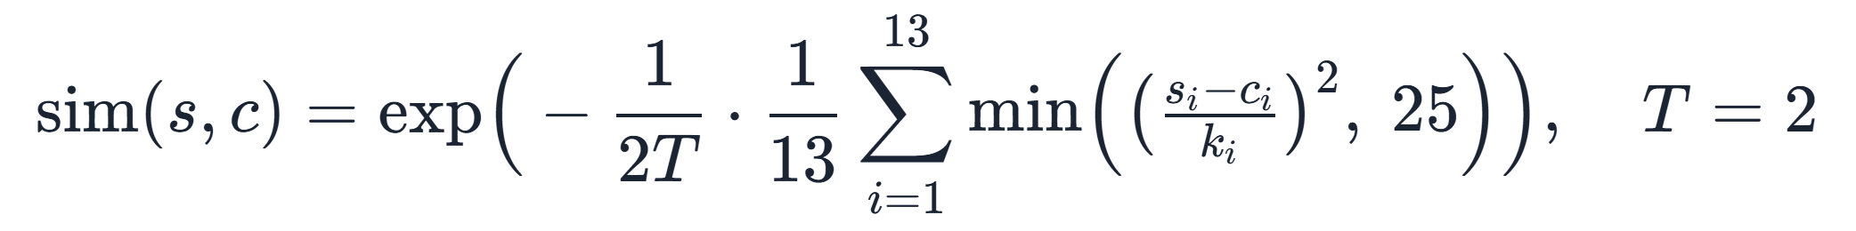

Agreement, not a single score
One family alone never paints an account red: a busy shop trips the rules, a salaried customer shows drift on payday, a scam victim shows sudden change. An account is flagged only when independent families agree and money is moving onward:
The model threshold T adapts after each graded attack (up one step if an innocent account was flagged, down if a corroborated mule was narrowly missed) and never touches a payment tier. Requiring mule evidence for agreement raised precision at "moderate agreement" from 0.55 to 0.86 at the same recall.
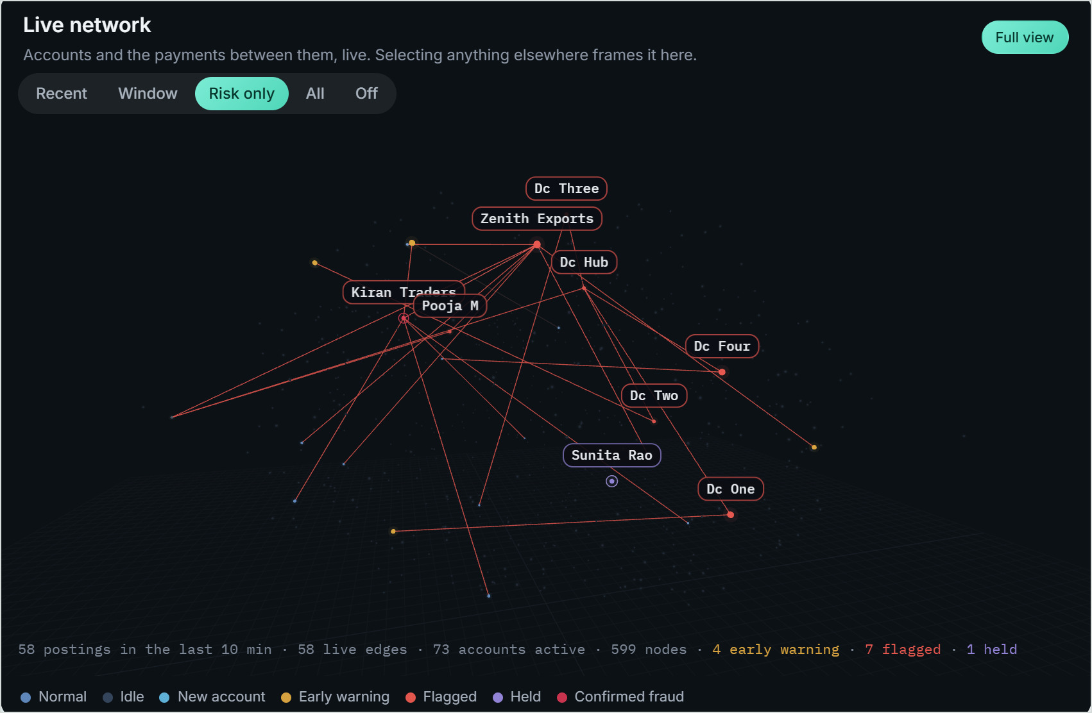  Live network, risk view: the mule ring and a five-account device farm light up as they form. |  | 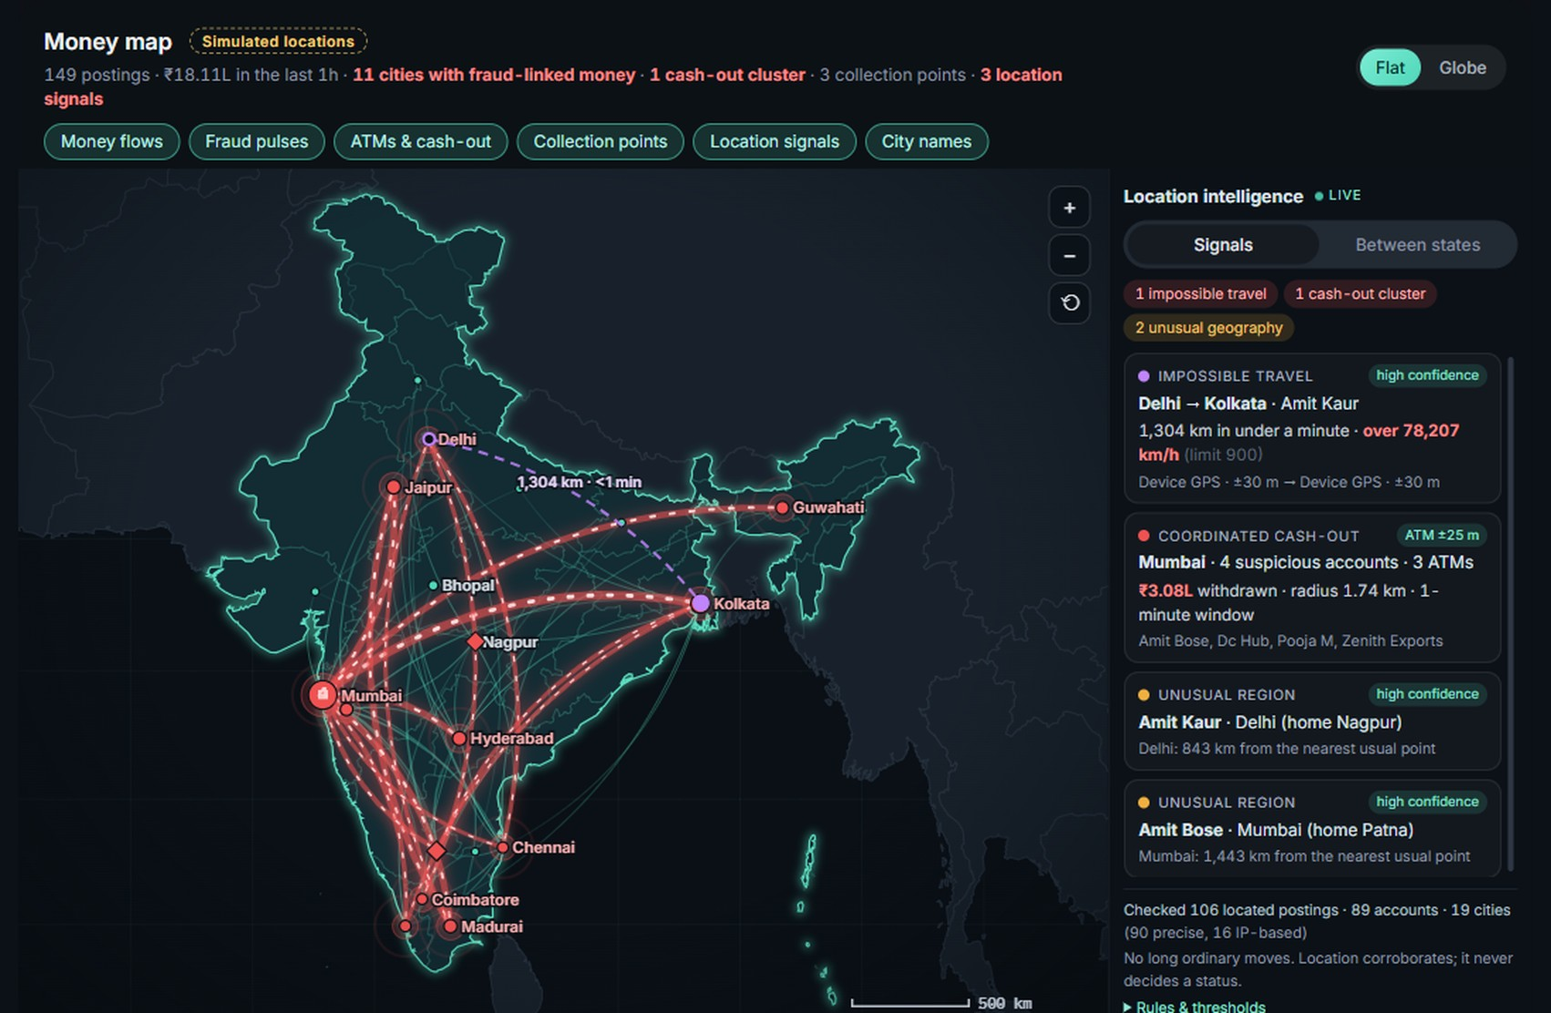  Money map: victims' money converging on Mumbai, with a cash-out cluster at its ATMs (simulated locations). The location intelligence rail beside it flags impossible travel, coordinated cash-out and unusual geography from precise location points; location only corroborates the detectors, it never decides.

3 Following the stolen money
Once stolen money mixes with an account holder's own money, there is no fact about which rupees left later. Courts settle this with tracing rules, and TaintTrace applies the Lowest Intermediate Balance Rule: the holder is presumed to spend their own money first, and the victim's claim can only shrink to the lowest balance since, never be refilled by later deposits.
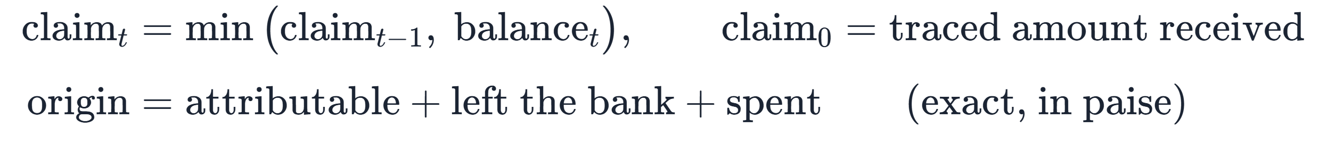
All incidents are traced in one pass, so two scams can never claim the same rupees, and conservation is exact to the paisa (property-tested on random flows). A pro-rata trace runs alongside for comparison, and limiting the trace to accounts the money could have reached cut a run from 2 s to 13 ms.
Example. When the bank confirmed one victim's ₹48,000 payment, LIBR placed ₹21,500 of it with the collector and ₹26,500 with the next account in the chain: exactly ₹48,000, nothing lost or invented. The next ₹45,000 payment to that collector moved from "confirm the purpose" to a scoped hold, and the customer was told why: "₹21,500 now in this account traces back to a payment the bank confirmed was stolen".

4 Vigilance: the fraud-operations agent
Vigilance turns live signals into work a fraud team can act on. A deterministic incident engine checks nine conditions whenever anything changes, and names each alert the way an analyst would:
Alert | Raised when
Customer under coercion | a Tier 4 hold is open and the trusted contact has been alerted
Stolen money traced | value from a bank-confirmed scam sits in one or more accounts
Mule ring forming | three or more risky accounts are linked by payments, at least one flagged
Cash-out in progress | three or more risky ATM withdrawals within 8 km and 45 minutes
Device farm | three or more accounts share one device, at least one flagged
Payment held for review | a Tier 3 hold is waiting for the bank
New account passing money through | an account up to 30 days old forwards 70% or more of at least ₹20,000 within 48 hours
Possible account takeover | the same account is in two places (phone GPS or ATM, after subtracting their accuracy) faster than 900 km/h allows
Suspected mule account | a flagged account that is not already part of a ring alert
Severity is an explainable score out of 100: 80 or more is Critical (respond within 15 minutes), 60–79 High (1 hour), 40–59 Medium (4 hours), below 40 Low (24 hours).
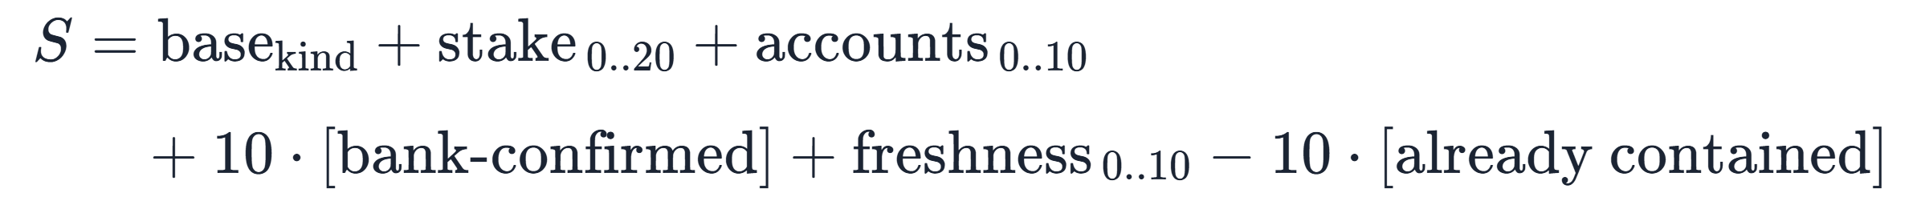
Each case carries the bank's procedure in four phases (contain, investigate, report, recover) with owners and deadlines modelled on Indian requirements: a Suspicious Transaction Report to FIU-IND within 7 working days, fraud reporting to RBI within 14 days, and coordination on the 1930 cyber-fraud helpline. Steps inside Vigil tick themselves when Vigil sees them done, and Vigilance can draft the STR grounds for the Principal Officer to review.
AI with guard-rails. An optional Google Gemini model writes the assessments and chat answers from live facts, using 19 read-only look-ups. Severity, classification and procedures never come from the model. A reply naming an account outside the alert is rejected; names and payment notes written by other people reach the model as labelled untrusted data, so instructions hidden in a payment note are ignored; and the interface accepts only seven whitelisted navigation actions. Without an API key, every alert, case and answer still works from live data.
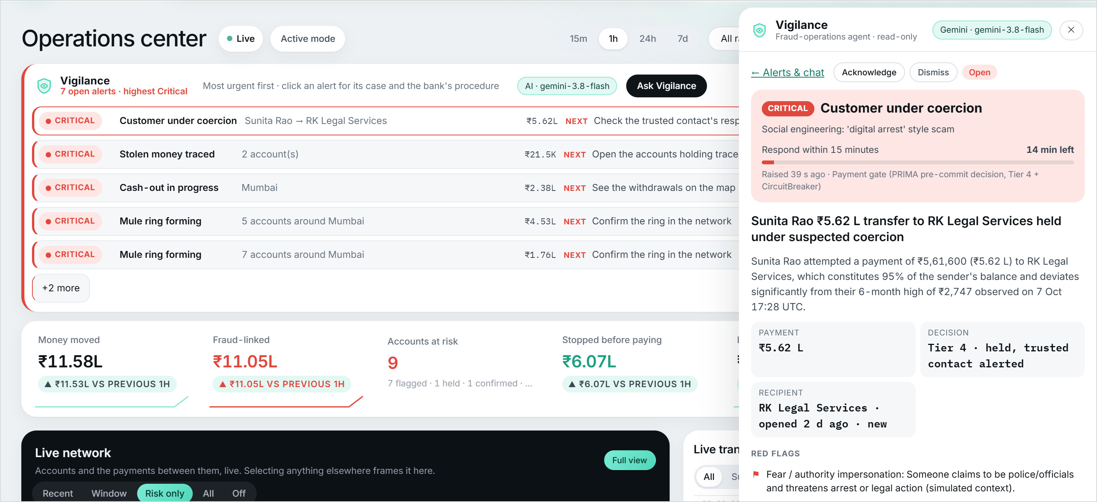
Vigilance ranks the open alerts on the Overview and opens the case beside any page: classification, time left, an AI-written assessment and the red flags in rupees.

5 Explainable and auditable by design
- One decision, three renderings: plain words for the customer (a banned-word list keeps accusations out), every rule, value and point for the analyst, and the hashed raw inputs for the auditor.
- Decision replay re-scores the evidence known at each moment. Counterfactuals re-run the same versioned policy without a piece of evidence, to show exactly what would have made the payment safe. No language model is involved in either.
- Provenance records the source, time, freshness and version of every signal. The policy file carries a content hash, so even an unversioned edit to a weight is detected on replay.
- Shadow mode lets a bank run Vigil beside its existing rules, record both recommendations and measure agreement before switching on a single intervention.
- SHAP explains the model; the reason line explains the decision. The two are deliberately kept in separate panels, so a model's opinion is never mistaken for the reason a payment was held.
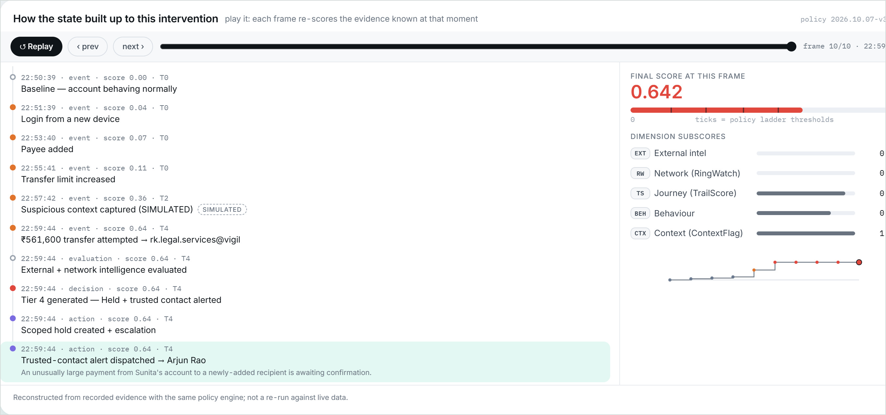
Decision replay for the coerced payment: new device, payee, limit, then the call. Every frame re-scores only the evidence known at that moment.

6 Results
All model figures are measured on 30 synthetic bank worlds the models never saw (9,171 accounts, 310 mules). Worlds are split 90 / 30 / 30 for training, calibration and testing, so no attack is ever partly seen in training, and every threshold is chosen on validation worlds only.
Detector | Precision | Recall | F1 | ROC-AUC | PR-AUC | False alarms / 1,000
Graph attention network | 0.963 | 0.926 | 0.944 | 0.983 | 0.953 | 1.2
Random Forest | 0.929 | 0.842 | 0.883 | 0.982 | 0.914 | 2.3
3 or more of 6 families agree | 0.844 | 0.784 | 0.813 | 0.965 | 0.833 | 5.1
Behavioural drift | 0.591 | 0.758 | 0.664 | 0.946 | 0.608 | 18.4
Pattern memory | 0.731 | 0.439 | 0.548 | 0.906 | 0.611 | 5.6
Early warning | 0.422 | 0.661 | 0.515 | 0.905 | 0.415 | 31.7
Rules alone | 0.202 | 0.394 | 0.267 | 0.740 | 0.123 | 54.4
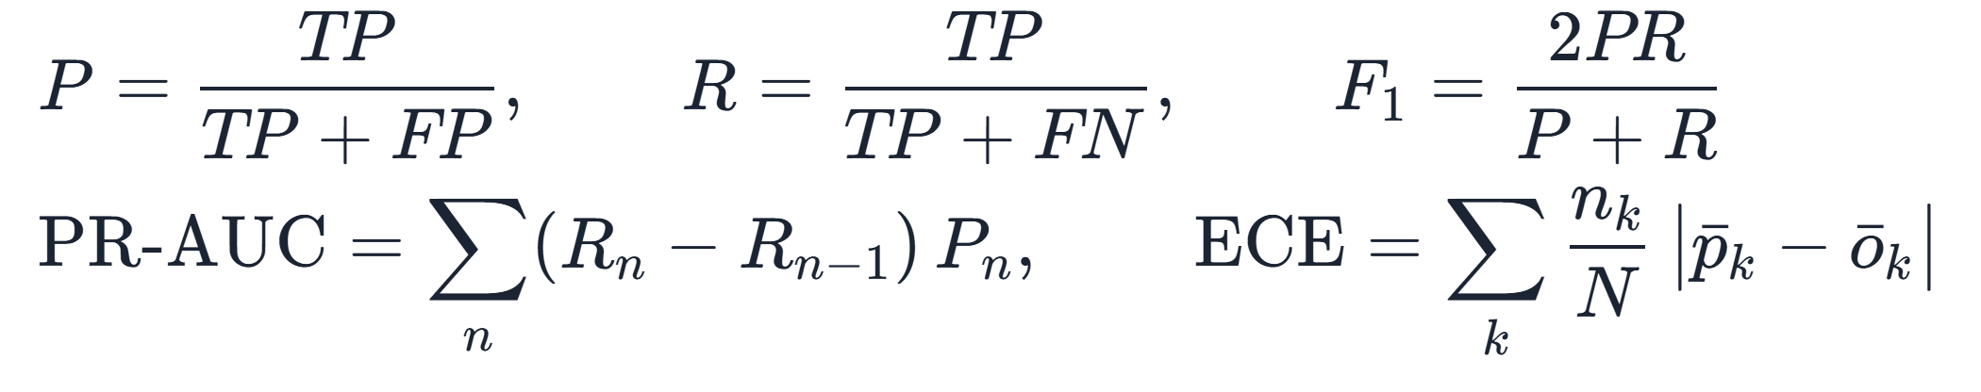
Isotonic calibration cut the Random Forest's expected calibration error from 0.029 to 0.003 (Brier score 0.0117 → 0.0063), so its scores can be read as probabilities on these worlds.
Live detection. Each of the eleven injectable attack patterns was run on a freshly reset world. Every pattern was caught, with zero false positives, and the first account was flagged within 0.02–3.7 seconds of the first injected payment. In the two patterns marked *, the remaining accounts were deliberately held at early warning: their only signal, a fast pass-through chain, also matches scam victims and customers paying bills on payday.
Pattern | Mules flagged | First flag | Pattern | Mules flagged | First flag
Money-mule network | 3 of 4* | 0.02 s | Shared-device cluster | 5 of 5 | 0.03 s
Fan-in | 1 of 1 | 3.5 s | Behavioural drift | 1 of 1 | 3.5 s
Fan-out | 1 of 1 | 1.8 s | Early volume spike | 1 of 1 | 1.2 s
Circular ring | 4 of 4 | 3.7 s | Smurfing | 1 of 1 | 2.4 s
Velocity chain | 3 of 5* | 1.2 s | Dormant activation | 1 of 1 | 3.5 s
Cross-channel burst | 1 of 1 | 3.5 s

An honest evaluation. Rebuilding the original prototype's protocol on the same worlds (features taken only from the attack window, random row split) produces an impressive-looking precision of 0.90. The same model on realistic traffic flags 74.6% of ordinary accounts, a precision of 0.04: it had learned "was touched by the injector". Vigil's windowed features, world-level split and validation-only tuning remove that leak, and leave-one-family-out tests are reported openly: the learned models are strongest on attack families they have seen, while the transparent rules still catch some unseen ones. That is exactly why rules decide and models corroborate.
Speed. A payment decision takes 4.1 ms at the median and 8.8 ms at p95 (200-decision benchmark); re-scoring every account touched by a new payment stays under 20 ms at the median; a full rebuild of the detection snapshot takes under a second.

7 Engineering
Layer | Technology
Backend | Python 3.11, FastAPI, Pydantic and SQLite (WAL mode, append-only decision records). One process on one port, on a single laptop.
Real time | WebSocket push to every screen with no polling; detection runs as post-commit hooks within a 30 ms budget.
Machine learning | scikit-learn (Random Forest, isotonic calibration), PyTorch for GNN training only, NumPy inference ports, TreeSHAP explanations.
Interface | React 18 and TypeScript; three.js for the 3D network and globe; d3-geo for an offline India map; Chart.js and Cytoscape.
AI agent | Google Gemini (optional, free tier) behind 19 read-only tools, output validation and prompt-injection defences.
Quality | 404 automated tests (pytest and Hypothesis property tests), deterministic seeded worlds, a smoke test and a latency benchmark.

- An in-memory, time-ordered payment graph instead of a graph database: a 72-hour window query is a binary search, answered in microseconds inside the same process.
- Exact money: integer paise everywhere, with largest-remainder splitting so traced amounts always add up to the paisa.
- Models as plain arrays: trained models are exported to NumPy and checked against the originals at training time, so the server never imports a deep-learning framework.
- Policy as data: every weight and threshold lives in versioned files; the interface reads them from the API and never hard-codes a number.

8 Beyond payments: connected industrial systems
Vigil's core is not specific to money. It is a live graph of entities exchanging something of value, scored by transparent rules and graph learning, with proportionate, explainable responses and a complete audit trail. The same architecture maps directly onto large networks of connected industrial devices:
In Vigil | In a connected industrial network
Account | Device, sensor, gateway or controller
Payment between accounts | Message, command or data flow between devices
Mule ring (fan-in, fan-out, fast chains) | A compromised cluster or botnet converging on one controller, or relaying commands onward
Behavioural drift against its own baseline | A device departing from its own normal operating profile: a slowly failing sensor or a hijacked node
Early warning against the population | A device behaving unlike the rest of its fleet
Graph neural network over two hops | A device judged by who it talks to, not only by what it reports
Pre-payment tiers, pass to hold | Command gating: allow, flag, require confirmation, or quarantine a single command without stopping the whole process
TaintTrace | Tracing how a bad command or corrupted reading propagated downstream
Shadow mode | Running beside existing control and alarm rules, measuring, then enforcing
Vigilance | Classified alerts with severity, response deadlines and step-by-step procedures for the operations team

Because every decision comes from versioned, explainable rules and every action is recorded, the approach suits environments where a false shutdown is as costly as a missed attack: the system can explain each alert, prove what it knew at the time, and be trialled safely in shadow before it is trusted to act.

