Assignment 13

Device Query

* Try the below mentioned commands, explain their task in one line and paste the output for each of them.
* All commands run under the WSL (windows subsystem for linux).
* **lshw (List Hardware)**

*This command list all the hardware details of system. By default it give all of the information to get an specific information command can be filter as below :*

sudo lshw -C [option]

|  |  |
| --- | --- |
| **Option** | **usage** |
| network | Gets the details of the network hardware devices. |
| memory | Displays the details of RAM. |
| storage | Show the details of the storage. |
| system | show the details of the motherboard and other things. |
| multimedia | Details of the sound card of system. |
| display | Know more about what is powering the display output. |
| bridge | Displays info about the PCIe bridges. |
| bus | It will list down buses and their details. |
| CPU | List the processor details |

**Output :**

kavan@Kavan:~$ lshw

WARNING: you should run this program as super-user.

kavan

description: Computer

width: 64 bits

capabilities: smp vsyscall32

*-core

description: Motherboard

physical id: 0

*-memory

description: System memory

physical id: 0

size: 8064MiB

*-cpu

product: 13th Gen Intel(R) Core(TM) i7-13620H

vendor: Intel Corp.

physical id: 1

bus info: cpu@0

version: 6.186.2

width: 64 bits

capabilities: fpu fpu_exception wp vme de pse tsc msr pae mce cx8 apic sep mtrr pge mca cmov pat pse36 clflush mmx fxsr sse sse2 ss ht syscall nx pdpe1gb rdtscp x86-64 constant_tsc rep_good nopl xtopology tsc_reliable nonstop_tsc cpuid pni pclmulqdq vmx ssse3 fma cx16 sse4_1 sse4_2 x2apic movbe popcnt tsc_deadline_timer aes xsave avx f16c rdrand hypervisor lahf_lm abm 3dnowprefetch ssbd ibrs ibpb stibp ibrs_enhanced tpr_shadow vnmi ept vpid ept_ad fsgsbase tsc_adjust bmi1 avx2 smep bmi2 erms invpcid rdseed adx smap clflushopt clwb sha_ni xsaveopt xsavec xgetbv1 xsaves avx_vnni umip waitpkg gfni vaes vpclmulqdq rdpid movdiri movdir64b fsrm serialize flush_l1d arch_capabilities

configuration: microcode=4294967295

*-generic

description: System peripheral

product: Virtio file system

vendor: Red Hat, Inc.

physical id: 2

bus info: pci@4257:00:00.0

version: 01

width: 64 bits

clock: 33MHz

capabilities: bus_master cap_list

configuration: driver=virtio-pci latency=64

resources: iomemory:e0-df iomemory:e0-df iomemory:c0-bf irq:0 memory:e00000000-e00000fff memory:e00001000-e00001fff memory:c00000000-dffffffff

*-virtio1 UNCLAIMED

description: Virtual I/O device

physical id: 0

bus info: virtio@1

configuration: driver=virtiofs

*-display:0

description: 3D controller

product: Microsoft Corporation

vendor: Microsoft Corporation

physical id: 3

bus info: pci@8383:00:00.0

version: 00

width: 32 bits

clock: 33MHz

capabilities: bus_master cap_list

configuration: driver=dxgkrnl latency=0

resources: irq:0

*-scsi

description: SCSI storage controller

product: Virtio console

vendor: Red Hat, Inc.

physical id: 4

bus info: pci@8f33:00:00.0

version: 01

width: 64 bits

clock: 33MHz

capabilities: scsi bus_master cap_list

configuration: driver=virtio-pci latency=64

resources: iomemory:90-8f iomemory:90-8f iomemory:90-8f irq:0 memory:9ffe00000-9ffe00fff memory:9ffe01000-9ffe01fff memory:9ffe02000-9ffe02fff

*-virtio0 UNCLAIMED

description: Virtual I/O device

physical id: 0

bus info: virtio@0

configuration: driver=virtio_console

*-display:1

description: 3D controller

product: Microsoft Corporation

vendor: Microsoft Corporation

physical id: 5

bus info: pci@abca:00:00.0

version: 00

width: 32 bits

clock: 33MHz

capabilities: bus_master cap_list

configuration: driver=dxgkrnl latency=0

resources: irq:0

*-pnp00:00

product: PnP device PNP0b00

physical id: 6

capabilities: pnp

configuration: driver=rtc_cmos

*-network

description: Ethernet interface

physical id: 1

logical name: eth0

serial: 00:15:5d:ba:ac:bb

size: 10Gbit/s

capabilities: ethernet physical

configuration: autonegotiation=off broadcast=yes driver=hv_netvsc driverversion=5.15.146.1-microsoft-standard-W duplex=full firmware=N/A ip=172.19.231.200 link=yes multicast=yes speed=10Gbit/s

WARNING: output may be incomplete or inaccurate, you should run this program as super-user.

* **lsusb (List USB Devices)**

*The lsusb command is a utility in Linux that allows users to list the USB (Universal Serial Bus) devices connected to the system.*

**Output :**

kavan@Kavan:~$ lsusb

Bus 002 Device 001: ID 1d6b:0003 Linux Foundation 3.0 root hub

Bus 001 Device 001: ID 1d6b:0002 Linux Foundation 2.0 root hub

* **lspci (List PCI Devices)**

*The lspci (list PCI) command is a Linux utility that displays detailed information about all PCI buses and devices in the system. It is based on the libpci library, which provides access to the PCI configuration space on a variety of operating systems.*

**Output :**

kavan@Kavan:~$ lspci

4257:00:00.0 System peripheral: Red Hat, Inc. Virtio file system (rev 01)

8383:00:00.0 3D controller: Microsoft Corporation Device 008e

8f33:00:00.0 SCSI storage controller: Red Hat, Inc. Virtio console (rev 01)

abca:00:00.0 3D controller: Microsoft Corporation Device 008e

* **lsblk (List Block Devices)**

*The 'lsblk' stands for 'list block devices', The lsblk command is a Linux command-line utility that lists information about all block devices on the system. This includes hard disk drives (HDDs), solid-state drives (SSDs), optical drives, and other storage devices.*

**Output :**

kavan@Kavan:~$ lsblk

NAME MAJ:MIN RM SIZE RO TYPE MOUNTPOINTS

sda 8:0 0 388.5M 1 disk

sdb 8:16 0 2G 0 disk [SWAP]

sdc 8:32 0 1T 0 disk /snap

/mnt/wslg/distro

/

* **lscpu (List CPU)**

*The lscpu command displays a variety of information about the CPU architecture, including The number of CPUs, The number of threads, The number of cores, The number of sockets, The cache details, The CPU architecture, The CPU vendor, The CPU model, The CPU frequency, The CPU flags.*

**Output :**

kavan@Kavan:~$ lscpu

Architecture: x86_64

CPU op-mode(s): 32-bit, 64-bit

Address sizes: 39 bits physical, 48 bits virtual

Byte Order: Little Endian

CPU(s): 16

On-line CPU(s) list: 0-15

Vendor ID: GenuineIntel

Model name: 13th Gen Intel(R) Core(TM) i7-13620H

CPU family: 6

Model: 186

Thread(s) per core: 2

Core(s) per socket: 8

Socket(s): 1

Stepping: 2

BogoMIPS: 5836.79

Flags: fpu vme de pse tsc msr pae mce cx8 apic sep mtrr pge mca cmov pat pse36 clflush mmx fxsr sse sse2 ss ht syscall nx pdpe1gb rdtscp lm constant_tsc rep_good

nopl xtopology tsc_reliable nonstop_tsc cpuid pni pclmulqdq vmx ssse3 fma cx16 sse4_1 sse4_2 x2apic movbe popcnt tsc_deadline_timer aes xsave avx f16c rd

rand hypervisor lahf_lm abm 3dnowprefetch ssbd ibrs ibpb stibp ibrs_enhanced tpr_shadow vnmi ept vpid ept_ad fsgsbase tsc_adjust bmi1 avx2 smep bmi2 erms

invpcid rdseed adx smap clflushopt clwb sha_ni xsaveopt xsavec xgetbv1 xsaves avx_vnni umip waitpkg gfni vaes vpclmulqdq rdpid movdiri movdir64b fsrm seri

alize flush_l1d arch_capabilities

Virtualization features:

Virtualization: VT-x

Hypervisor vendor: Microsoft

Virtualization type: full

Caches (sum of all):

L1d: 384 KiB (8 instances)

L1i: 256 KiB (8 instances)

L2: 10 MiB (8 instances)

L3: 24 MiB (1 instance)

Vulnerabilities:

Gather data sampling: Not affected

Itlb multihit: Not affected

L1tf: Not affected

Mds: Not affected

Meltdown: Not affected

Mmio stale data: Not affected

Retbleed: Mitigation; Enhanced IBRS

Spec rstack overflow: Not affected

Spec store bypass: Mitigation; Speculative Store Bypass disabled via prctl and seccomp

Spectre v1: Mitigation; usercopy/swapgs barriers and __user pointer sanitization

Spectre v2: Mitigation; Enhanced IBRS, IBPB conditional, RSB filling, PBRSB-eIBRS SW sequence

Srbds: Not affected

Tsx async abort: Not affected

* **df (Disk Free)**

*The df command in Linux is used to display the amount of disk space available on the filesystem. The FileSystem parameter specifies the name of the device on which the file system resides, the directory on which the file system is mounted, or the relative path name of a file system.*

**Output :**

kavan@Kavan:~$ df

Filesystem 1K-blocks Used Available Use% Mounted on

none 3997904 4 3997900 1% /mnt/wsl

none 395990012 136101968 259888044 35% /usr/lib/wsl/drivers

none 3997904 0 3997904 0% /usr/lib/modules

none 3997904 0 3997904 0% /usr/lib/modules/5.15.146.1-microsoft-standard-WSL2

/dev/sdc 1055762868 1902524 1000156872 1% /

none 3997904 84 3997820 1% /mnt/wslg

none 3997904 0 3997904 0% /usr/lib/wsl/lib

rootfs 3994648 1884 3992764 1% /init

none 3997904 808 3997096 1% /run

none 3997904 0 3997904 0% /run/lock

none 3997904 0 3997904 0% /run/shm

tmpfs 4096 0 4096 0% /sys/fs/cgroup

none 3997904 76 3997828 1% /mnt/wslg/versions.txt

none 3997904 76 3997828 1% /mnt/wslg/doc

C:\ 395990012 136101968 259888044 35% /mnt/c

D:\ 601881596 406166716 195714880 68% /mnt/d

G:\ 15728640 12185968 3542672 78% /mnt/g

H:\ 15728640 458840 15269800 3% /mnt/h

I:\ 15728640 786924 14941716 6% /mnt/i

J:\ 395990012 149096372 246893640 38% /mnt/j

snapfuse 128 128 0 100% /snap/bare/5

snapfuse 75776 75776 0 100% /snap/core22/864

snapfuse 93952 93952 0 100% /snap/gtk-common-themes/1535

snapfuse 41856 41856 0 100% /snap/snapd/20290

snapfuse 134272 134272 0 100% /snap/ubuntu-desktop-installer/1276

snapfuse 134912 134912 0 100% /snap/ubuntu-desktop-installer/1286

* **ip a (IP Address)**

*The ip a command in Linux is used to display the network interface addresses and routing table of the system. This will display a list of all the network interfaces on the system, along with their IP addresses, subnet masks, and default gateways.*

**Output :**

kavan@Kavan:~$ ip a

1: lo: <LOOPBACK,UP,LOWER_UP> mtu 65536 qdisc noqueue state UNKNOWN group default qlen 1000

link/loopback 00:00:00:00:00:00 brd 00:00:00:00:00:00

inet 127.0.0.1/8 scope host lo

valid_lft forever preferred_lft forever

inet6 ::1/128 scope host

valid_lft forever preferred_lft forever

2: eth0: <BROADCAST,MULTICAST,UP,LOWER_UP> mtu 1500 qdisc mq state UP group default qlen 1000

link/ether 00:15:5d:ba:ac:bb brd ff:ff:ff:ff:ff:ff

inet 172.19.231.200/20 brd 172.19.239.255 scope global eth0

valid_lft forever preferred_lft forever

inet6 fe80::215:5dff:feba:acbb/64 scope link

valid_lft forever preferred_lft forever

* **top**

*The top command in Linux is a very useful tool for monitoring system performance. It provides a real-time view of running processes, CPU and memory usage, and other system information. the list shows the process ID (PID), username, CPU usage, memory usage, and command name.*

**Output :**

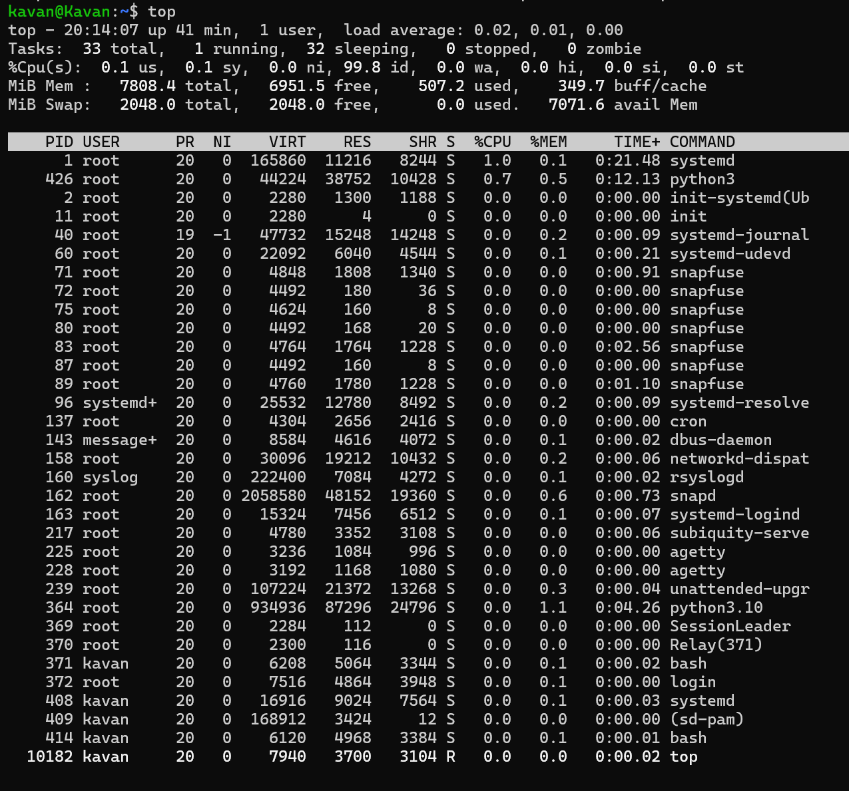

* **htop**

*The htop command is a Linux system monitor that provides real-time information about the system's CPU usage, memory, and running processes. It is similar to the top command, but it offers a number of advantages, including:*

*A more user-friendly interface, The ability to sort processes by different criteria, The ability to kill processes directly from the htop interface, The ability to view detailed information about individual processes*

**Output :**

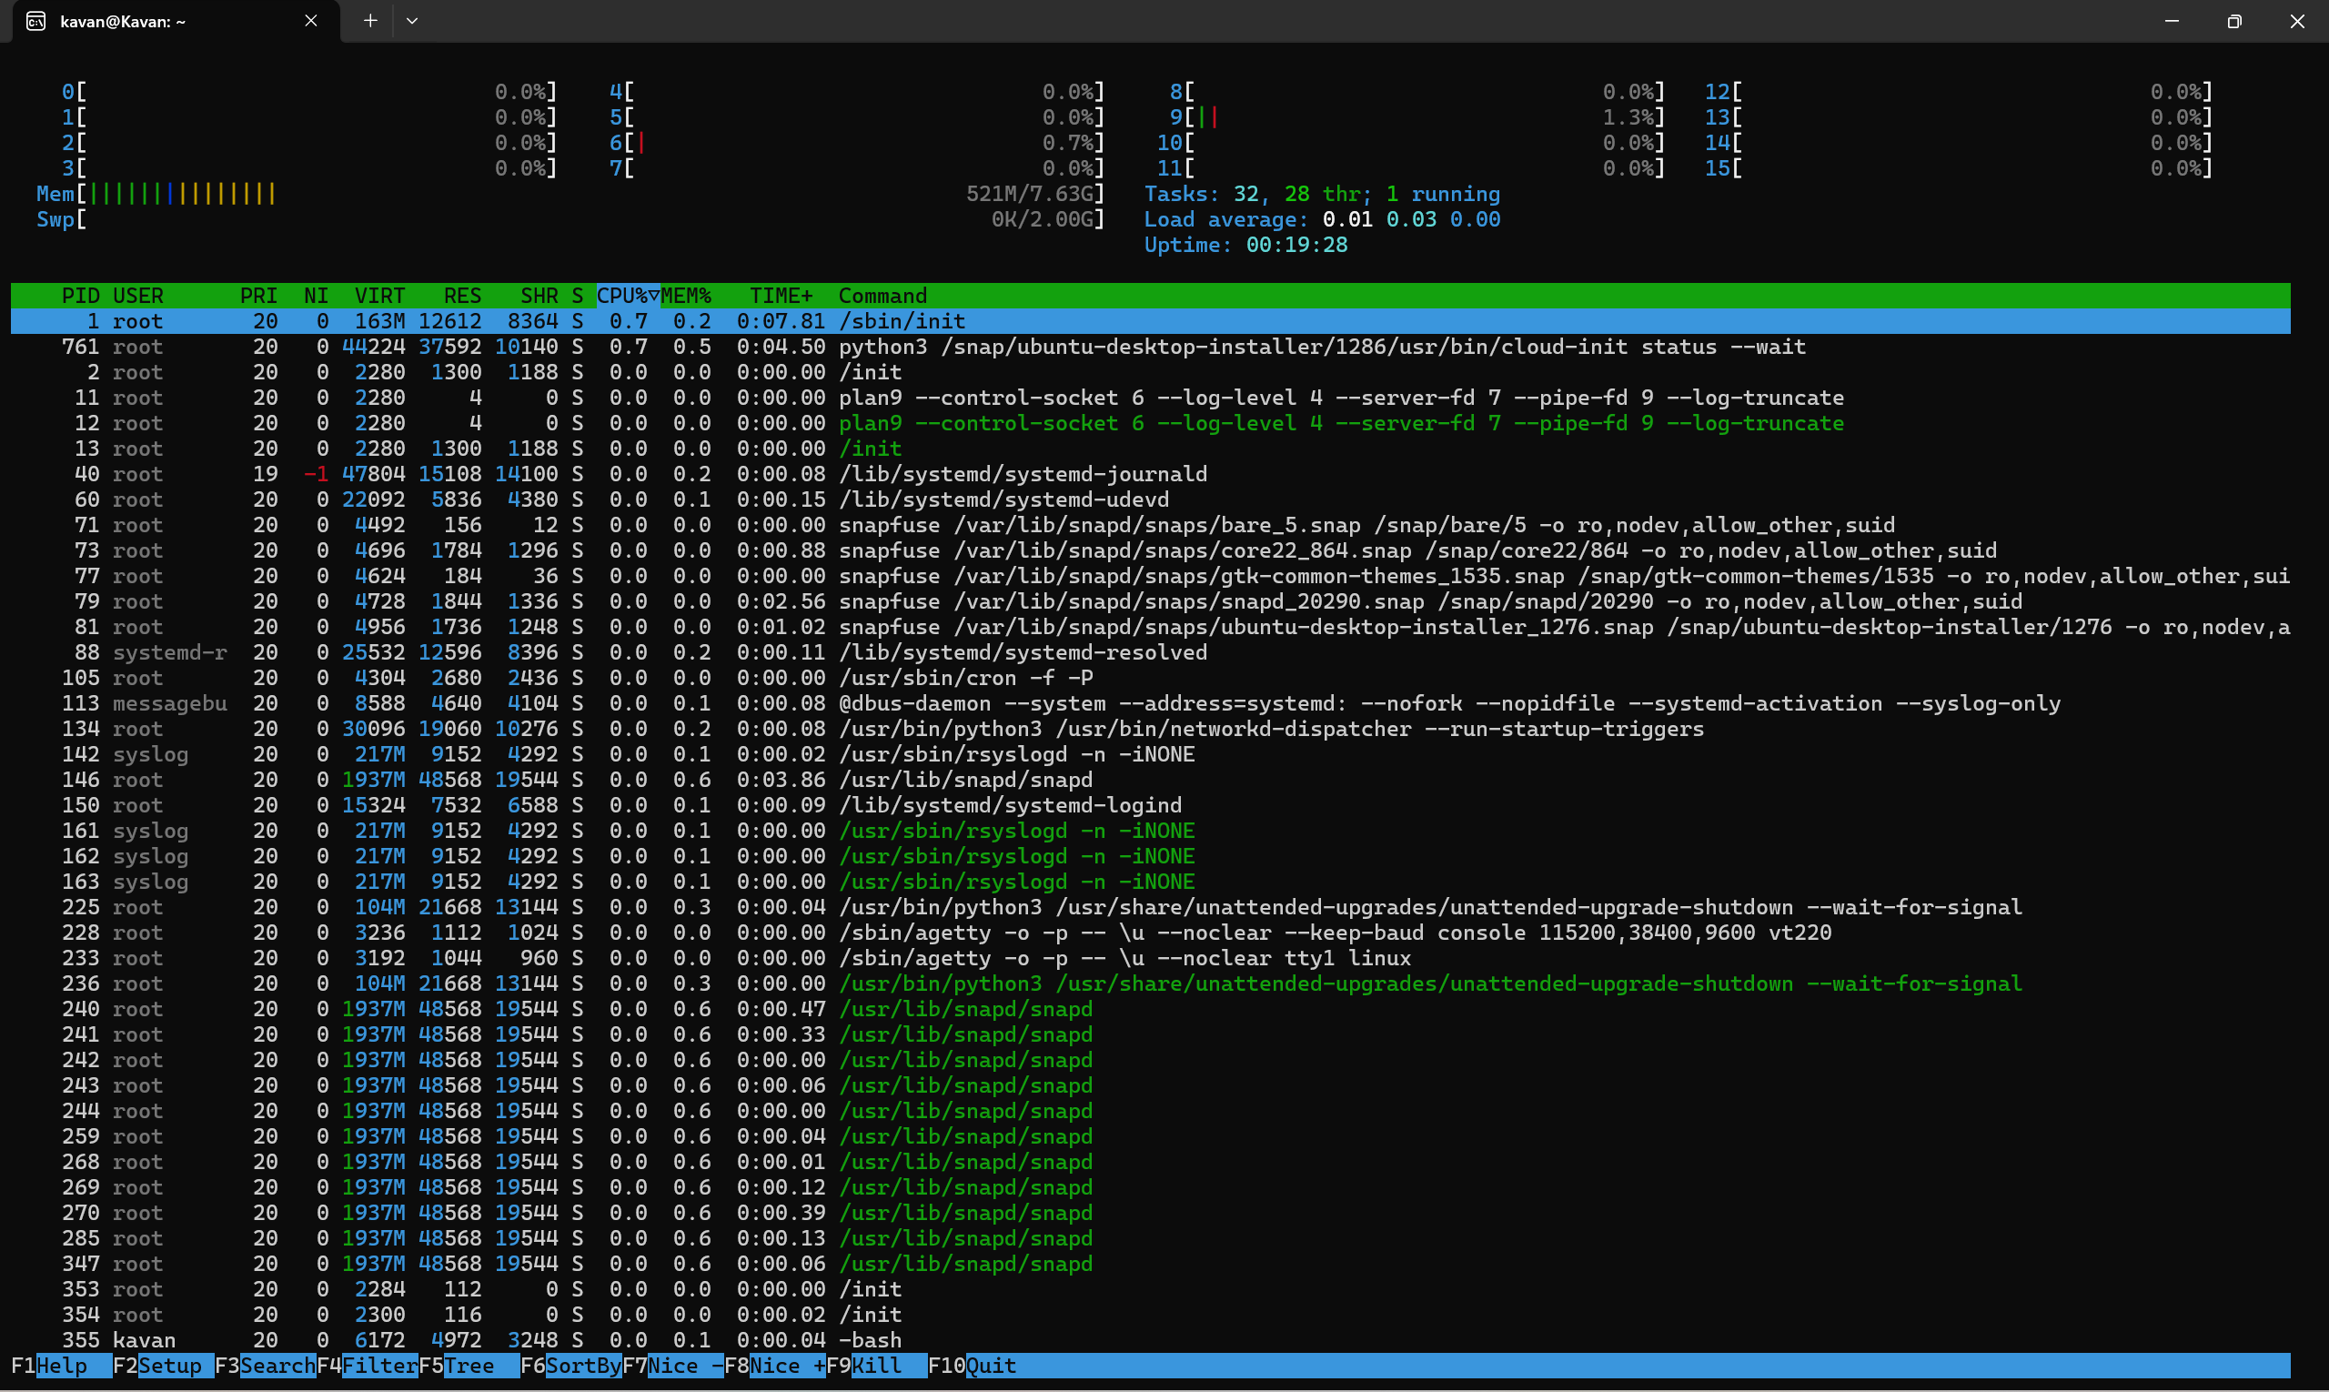

* **nvidia-smi**

*The nvidia-smi command is a Linux command-line utility that provides monitoring and management capabilities for NVIDIA GPUs. this displays an status of an NVIDIA GPU, such as its temperature, utilization, and memory usage.*

**Output :**

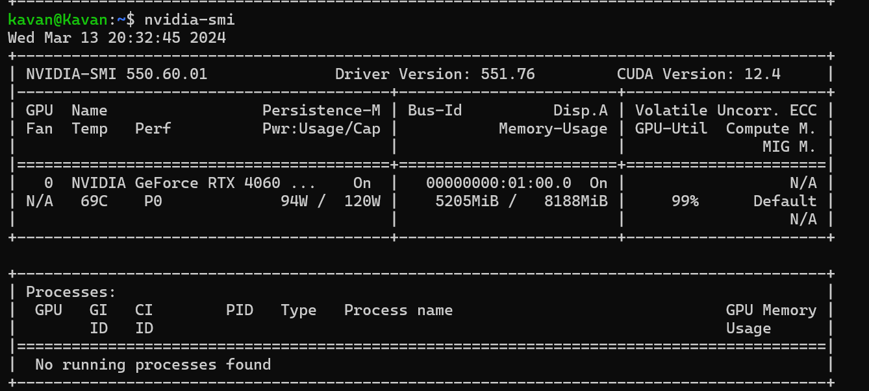

* **lstopo**

*The lstopo command is a Linux command that displays the topology of a system. This means that it shows how the different hardware components of the system are connected to each other.*

**Output :**

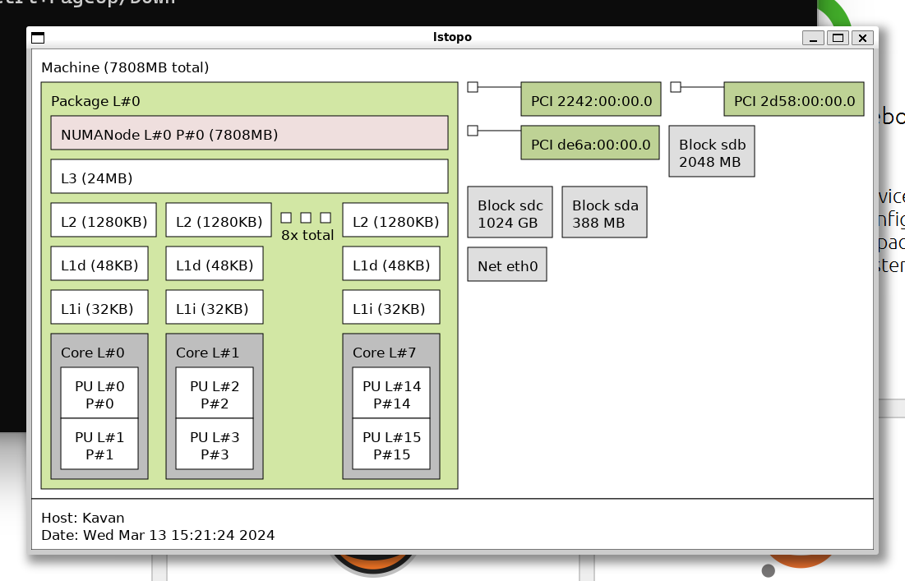

* **numactl**

*The numactl command is a utility that allows users to control the NUMA (Non-Uniform Memory Access) policy for processes or shared memory. It can be used to set the memory and processor affinity of a process, as well as to set a persistent policy for shared memory segments or files.*

**Output :**

kavan@Kavan:~$ numactl

usage: numactl [--all | -a] [--interleave= | -i <nodes>] [--preferred= | -p <node>]

[--physcpubind= | -C <cpus>] [--cpunodebind= | -N <nodes>]

[--membind= | -m <nodes>] [--localalloc | -l] command args ...

numactl [--show | -s]

numactl [--hardware | -H]

numactl [--length | -l <length>] [--offset | -o <offset>] [--shmmode | -M <shmmode>]

[--strict | -t]

[--shmid | -I <id>] --shm | -S <shmkeyfile>

[--shmid | -I <id>] --file | -f <tmpfsfile>

[--huge | -u] [--touch | -T]

memory policy | --dump | -d | --dump-nodes | -D

memory policy is --interleave | -i, --preferred | -p, --membind | -m, --localalloc | -l

<nodes> is a comma delimited list of node numbers or A-B ranges or all.

Instead of a number a node can also be:

netdev:DEV the node connected to network device DEV

file:PATH the node the block device of path is connected to

ip:HOST the node of the network device host routes through

block:PATH the node of block device path

pci:[seg:]bus:dev[:func] The node of a PCI device

<cpus> is a comma delimited list of cpu numbers or A-B ranges or all

all ranges can be inverted with !

all numbers and ranges can be made cpuset-relative with +

the old --cpubind argument is deprecated.

use --cpunodebind or --physcpubind instead

<length> can have g (GB), m (MB) or k (KB) suffixes

* **sar**

*The sar (System Activity Reporter) command is used for monitoring system performance in Linux. It can be used to collect, report, and save system activity information, such as CPU usage, memory usage, I/O activity, and network traffic.*

**Output :**

To generate a report of CPU usage every second for 5 seconds, used the following command:

**sar -u 1 5**

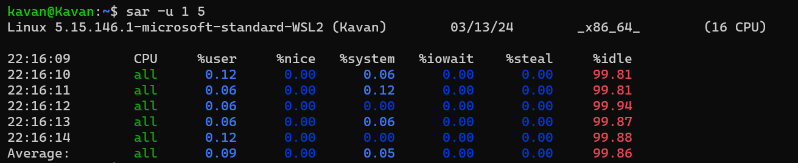

To generate a report of memory usage every minute for 5 minutes, used the following command:

**sar -r 60 5**

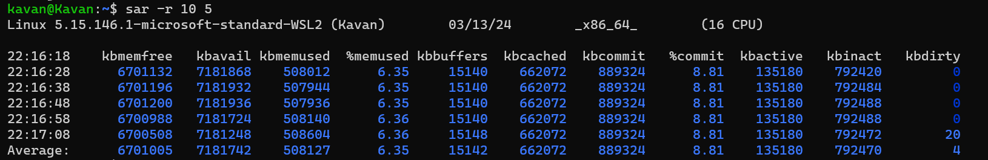

To generate a report of I/O activity every 1 seconds for 5 seconds, used the following command:

**sar -d 5 30**

