

CROP PRICE FORECASTING
A PROJECT REPORT

Submitted by
KAVANA R- 20221ISE0108 PALLAVI J- 20221ISE0109
BHARATHI NEERALAKERI- 20221ISE0104

Under the guidance of,
Dr. MURALI PARAMESWARAN

BACHELOR OF TECHNOLOGY

IN

INFORMATION SCIENCE AND ENGINEERING

PRESIDENCY UNIVERSITY BENGALURU
DECEMBER 2025

PRESIDENCY SCHOOL OF COMPUTER SCIENCE AND ENGINEERING
BONAFIDE CERTIFICATE

Certified that this report “CROP PRICE FORECASTING” is a Bonafide work of “KAVANA R (20221ISE0108), PALLAVI J (20221ISE0109), BHARATHI NEERALAKERI
(20221ISE0104)”, who have successfully carried out the project work and submitted the report for partial fulfilment of the requirements for the award of the degree of BACHELOR OF TECHNOLOGY in INFORMATION SCIENCE AND ENGINEERING during 2025- 26.

Dr.Murali
Parameswaran Project Guide PSCS
Presidency University
Ms. Suma N G Program Project Coordinator PSCS
Presidency University

Dr. Sampath A K Dr. Geetha A
School Project Coordinators PSCS
Presidency University

Dr. Zafar Ali Khan
Head of the Department PSCS
Presidency University

Dr. Shakkeera L Associate Dean PSCS
Presidency University

Dr. Duraipandian N
Dean
PSCS & PSIS
Presidency University

Name and Signature of the Examiners

1)

2)

PRESIDENCY UNIVERSITY

PRESIDENCY SCHOOL OF COMPUTER SCIENCE AND ENGINEERING
DECLARATION

We the students of final year B.Tech in INFORMATION SCIENCE AND ENGINEERING at Presidency University, Bengaluru, named KAVANA R, PALLAVI J, BHARATHI NEERALAKERI, hereby declare that the project work titled “CROP PRICE FORCASTING” has been independently carried out by us and submitted in partial fulfillment for the award of the degree of B.Tech in INFORMATION SCIENCE AND ENGINEERING during the academic year of 2025-26. Further, the matter embodied in the project has not been submitted previously by anybody for the award of any Degree or Diploma to any other institution.

KAVANA R USN: 20221ISE0108
PALLAVI J USN: 20221ISE0109 BHARATHI NEERALAKERI USN: 20221ISE0104

PLACE: BENGALURU
DATE: 04-December 2025

ACKNOWLEDGEMENT

For completing this project work, We/I have received the support and the guidance from many people whom I would like to mention with deep sense of gratitude and indebtedness. We extend our gratitude to our beloved Chancellor, Pro-Vice Chancellor, and Registrar for their support and encouragement in completion of the project.
I would like to sincerely thank my internal guide Dr. Murali Parameswaran, Professor, Presidency School of Computer Science and Engineering, Presidency University, for his/her moral support, motivation, timely guidance and encouragement provided to us during the period of our project work.
I am also thankful to Dr. Zafar Ali Khan, Professor, Head of the Department, Presidency School of Computer Science and Engineering Presidency University, for his mentorship and encouragement.
We express our cordial thanks to Dr. Duraipandian N, Dean PSCS & PSIS, Dr. Shakkeera L, Associate Dean, Presidency School of computer Science and Engineering and the Management of Presidency University for providing the required facilities and intellectually stimulating environment that aided in the completion of my project work.
We are grateful to Dr. Sampath A K, and Dr. Geetha A, PSCS Project Coordinators, Ms. Suma N G, Program Project Coordinator, Presidency School of Computer Science and Engineering, or facilitating problem statements, coordinating reviews, monitoring progress, and providing their valuable support and guidance.
We are also grateful to Teaching and Non-Teaching staff of Presidency School of Computer Science and Engineering and also staff from other departments who have extended their valuable help and cooperation.
KAVANA R PALLAVI J
BHARATHI NEERALAKERI

Abstract
The importance of crop price predictions is increasing in terms of their usefulness to farmers, traders and to planners, as they are increasingly dependent on accurate and timely price data for planning planting, storing and trading in crops. The vegetable and cereal crop prices in Karnataka are subject to sharp fluctuations due to weather conditions; seasonal supply variations; the problems associated with transporting goods and the differential pricing between regional markets. This study will develop a predictive framework using deep learning and transformer based methods to make forecasts of future crop prices more accurately.
This research project includes a custom-built dataset that contains each day's and each week's price for four major crops; capsicum, onion, tomato and wheat — from all of the districts in Karnataka. This dataset had to be cleaned and filtered to restructure it for time-series modeling. The researchers also wanted to find out if the data was consistent enough to use before using complex models; therefore they first tested the data with simple forecasting models like ARIMA, SARIMAX and Prophet.
Based on the validity established with these validation methods, a variety of current and new model types are used in this study (LSTM, GRU and the four variants of the Transformer — TAT + MHA, TAT + MQA, TAT + GQA and TAT + HA), that are trained on data for each type of crop, per each district and each State for their ability to capture both short term variability and longer term seasonal variability. The performance of all the models is evaluated using common statistical measures, such as RMSE, MAE, R², MAPE and overall accuracy.
The analysis shows that the transformers have been better than other traditional and recurrent networks in giving reliable and accurate price predictions. In addition, this research has demonstrated the ability of attention-driven deep learning technologies to provide an opportunity for advanced analytics in agriculture as well as to create a base for creating scalable, real-time systems for forecasting prices which could be used to make more informed decisions and therefore improve the economic stability of farmers.

Table of Content

Sl. No. | Title | Page No.
 | Declaration | iii
 | Acknowledgement | iv
 | Abstract | v
 | List of Figures | viii
 | List of Tables | vi
 | Abbreviations | x
1. | Introduction  - Background  - Statistics of project  - Prior existing technologies  - Proposed approach  - Objectives  - SDGs  - Overview of project report | 1
2. | Literature review | 8
3. | Methodology | 16
4. | Project management  - Project timeline  - Risk analysis  - Project budget | 22
5. | Analysis and Design  - Requirements  - Block Diagram  - System Flow Chart  - Choosing devices  - Designing units  - Standards  - Mapping with IoTWF reference model layers  - Domain model specification | 26

  - Communication model
  - IoT deployment level
  - Functional view
  - Mapping IoT deployment level with functional view
  - Operational view
  - Other Design
6. | Hardware, Software and Simulation  - Hardware  - Software development tools  - Software code  - Simulation | 34
7. | Evaluation and Results  - Test points  - Test plan  - Test result  - Insights | 41
8. | Social, Legal, Ethical, Sustainability and Safety Aspects  - Social aspects  - Legal aspects  - Ethical aspects  - Sustainability aspects  - Safety aspects | 48
9. | Conclusion | 53
 | References | 55
 | Base Paper | 56
 | Appendix | 57

List of Figures

Figure | Caption | Page no
Fig 1.1 | Overview of the Crop Price Forecasting Process | 1
Fig 1.2 | Proposed Crop Price Forecasting Framework | 5
Fig 1.3 | United Nations Sustainable Development Goals (SDGs) | 6
Fig 3.1 | System Flowchart | 19
Fig 3.2 | The Layered Architecture of the Proposed System | 20
Fig 4.1 | Capstone Project Gantt Chart | 24
Fig 5.1 | Functional Block Diagram of Crop Price Forecasting System | 28
Fig 5.2 | System Flow Chart of Crop Price Forecasting Process | 29
Fig 5.3 | Model Architecture Overview (Transformer and LSTM Integration) | 31
Fig 5.4 | UML Diagrams Representing Crop Price Forecasting Workflow | 32
Fig 6.1 | Architecture of Baseline Statistical Models (ARIMA, SARIMAX, Prophet) | 37
Fig 6.2 | Architecture of Deep Learning Models (LSTM and GRU) | 38
Fig 6.3 | Architecture of Transformer-Based Models (TAT + MHA, MQA, GQA, HA) | 38
Fig 6.4 | Architecture of the Integrated Forecasting Pipeline | 39
Fig 7.1 | Price Distribution Comparison Across Crops | 42
Fig 7.2 | Dataset Distribution by Crop Type (Donut Chart) | 42
Fig 7.3 | Training and Validation Loss Curve (Weekly Dataset) | 43
Fig 7.4 | Model Accuracy Curve (Transformer Models) | 44
Fig 7.5 | Sample Forecast Visualizations (Predicted vs Actual) | 46

List of Tables

Table | Caption | Page no
Table 1.1 | Average Market Prices of Major Crops in Karnataka (2010 –  2024) | 2
Table 1.2 | Comparison of Prior Technologies Used in Crop  Price Forecasting | 3
Table 2.1 | Summary of Literatures reviewed | 13
Table 4.1 | Project Planning and Implementation Timeline | 22
Table 4.2 | Project Resources and Estimated Cost | 25
Table 5.1 | Data Schema Used in the Crop Price Forecasting Dataset | 30
Table 7.1 | Test Results of Forecasting Models | 46

Abbreviation | Full Form
AI | Artificial Intelligence
ML | Machine Learning
DL | Deep Learning
ARIMA | Autoregressive Integrated Moving Average
SARIMAX | Seasonal Autoregressive Integrated Moving Average with Exogenous  Variables
LSTM | Long Short-Term Memory
GRU | Gated Recurrent Unit
TAT | Temporal Attention Transformer
MHA | Multi-Head Attention
MQA | Multi-Query Attention
GQA | Grouped Query Attention
HA | Hierarchical Attention
MAE | Mean Absolute Error
RMSE | Root Mean Squared Error
R² | Coefficient of Determination
MAPE | Mean Absolute Percentage Error
SDG | Sustainable Development Goal
UN | United Nations
APMC | Agricultural Produce Market Committee
GSDP | Gross State Domestic Product
MoA&FW | Ministry of Agriculture and Farmers Welfare
GPU | Graphics Processing Unit
CSV | Comma Separated Values
VS Code | Visual Studio Code
GoI | Government of India
DoA | Department of Agriculture
AI-ML | Artificial Intelligence – Machine Learning
Abbreviations

  - Background
Chapter 1

Introduction

Agriculture is the base of Indian economy which has seen the majority of its population’s income come from it. In that regard as one of the most important agricultural states Karnataka reports to have a large scale in capsaicin, onion, tomato and wheat production. Yet farmers in the state report to still have issues with organizing production and marketing of their products which is affected by very unpredictable fluctuations in the markets for their crops.

Various elements cause what we see in price fluctuation weather changes, transport delays, pest attacks, demand and supply changes, and market volatility. That which is largely out of our hands farmers are usually left economic outliers and till the last moment they decide what to plant. These are largely out of their control and farmers suffer economic losses which in turn they put off until the last minute to sort out. This area of artificial intelligence and machine learning is revolutionizing the field of prediction of market trends and prices of seasonal crops. What we see is that automated forecasting systems are made available to farmers, merchants, and market regulators which in turn they use to determine the right time to sell, withhold, or grow certain crops.

Crop Price Forecasting: Deploying cutting-edge deep learning and transformer techniques to create a dependable forecasting system is the primary focus of the undertaking. This initiative gathers and analyzes real agri-pricing data, assesses a number of models to determine the most effective one and forecasts prices both in the near and distant futures, with a focus on various districts in Karnataka.
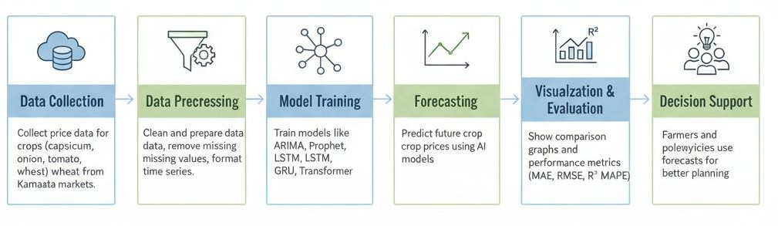
Fig 1.1: Overview of the Crop Price Forecasting Process

Statistics
Agriculture occupies a dominant position in the economy of the state of Karnataka. This is evidenced by the fact that it employs about 42% of the working population and contributes about 14-15% of the state Gross Domestic Product. Nevertheless, there is a great deal of uncertainty surrounding the job of the farmer, as the prices of what he/she produces are often out of their control and constantly changing. From 2010 to 2024, Agmarknet and the Directorate of Economics and Statistics, Karnataka, report that the prices of onion, tomato, and capsicum are among the most volatile, and wheat prices are, in comparison, stable, due to government price support policies.
Based on past data and market fluctuations, market analysts, agronomists, and farmers must work together to predict the most profitable crop to plant, store and sell within the crop cycle to maximize income versus farm and market investments. According to the forecast data, fair market value and pricing can be established to balance the sustainable economic inflow versus oversupply or shortage of the crop. The table listed below illustrates the average value range of four chosen crops cultivated in Karnataka between the years 2010 and 2024 to highlight the price fluctuation.

Crop | Average Minimum Price (₹/Quintal) | Average Maximum Price (₹/Quintal) | Observed  Variation (%)
Capsicum | 200 | 600 | 65 – 70 %
Onion | 150 | 1000 | 80 – 85 %
Tomato | 100 | 1200 | 85 – 90 %
Wheat | 1300 | 2200 | 30 – 35 %
Table 1.1: Average Market Prices of Major Crops in Karnataka (2010 – 2024)

Source: Agmarknet Market Data (2010–2024), Government of India [1], and Directorate of Economics and Statistics (Karnataka) [2]

Prior existing technologies
Over the past few decades we have seen the introduction of many models which attempt to predict crop prices. Early models of which ARIMA and SARIMAX are examples were useful for identifying trends and seasonality in stable data sets [3]. Also they did not do well with sudden changes or atypical patterns which are a result of real world factors like rain fall or supply disruption. Machine learning models which include Random Forest and Support Vector Regression came into play which improved prediction accuracy by use of many features like rain fall or transport cost [4]. But at the same time they failed to represent long term relationships within time series data. To that end we saw the introduction of deep learning techniques like LSTM and GRU which are able to learn from temporal dependencies in large scale data[5]. Also it is at the expense of requiring large data sets and more training time.

Recently in the field of time series forecasting we have seen a great adoption of transformer based architectures which include TAT MHA, TAT MQA, TAT GQA, and TAT HA. These models which use attention mechanisms are able to identify important patterns in history data thus improving accuracy and stability of predictions [6].

Model Type | Example Models | Strengths | Limitations
Statistical | ARIMA, SARIMAX | Good for identifying seasonal patterns | Poor with nonlinear or sudden variations
Machine Learning | RF, SVR | Handles multiple influencing factors | Ignores long-term temporal dependencies
Deep Learning | LSTM, GRU | Captures long-term dependencies and complex trends | Requires large data and longer training time
Transformers | TAT Variants (MHA, MQA, GQA, HA) | Highly accurate, adaptive, and stable | Computationally intensive
Table 1.2: Comparison of Prior Technologies Used in Crop Price Forecasting

Proposed approach
The we put forth to develop an very accurate crop price prediction system which we approach with the use of present day deep learning and transformer models. We begin by getting crop market info from the Agmarknet platform which is a source of official price reports from many APMC markets in Karnataka. Once collected the data is cleaned, restructured and put into daily and weekly time series. We also add in what we term engineered features which include Lag-1, Lag-4, MA-4, and MA-12 to better capture short term and seasonal trends. We first ran base forecasting models (ARIMA, SARIMAX, Prophet) to see how the data sets play out.
Next, transformer-based models were developed, including: Also in time we saw the development of transformer based models which included:.
    - TAT + MHA

    - TAT + MQA

    - TAT + GQA

    - TAT + HA

These models apply attention mechanisms to determine what time periods play a role in future prices and we see that they perform better than traditional methods. We also see that the system which which they are put to the test and compared using standard metrics of evaluation which include MAE, RMSE, R², MAPE, and Accuracy.

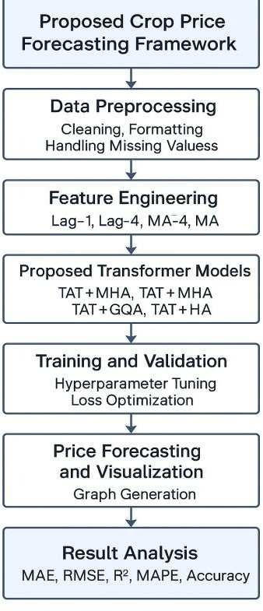

Fig 1.2: Proposed Crop Price Forecasting Framework

Objectives
The focus of this project is on development of a very efficient crop price prediction model which we will build using deep learning and transformer based architectures. As for our goals they are to:.
- To clean up and present agricultural price data from Agmarknet in daily and weekly formats for time series analysis.
- To use present forecasting models like ARIMA, SARIMAX and Prophet as a base.
- To develop and assess advanced deep learning transformer models which include LSTM, GRU and TAT flavors.
- To put together a single forecasting platform for multi crop and multi district forecasting.
- To evaluate all models with scientific metrics such as MAE, RMSE, R², MAPE and Accuracy.

SDGs
This project is a part of achieving several UN Sustainable Development Goals through the promotion of smart and data based agriculture.
- SDG 2 – Zero Hunger: SDG 2 Free from Hunger:
Accurate forecast which in turn reduces waste and helps farmers with their crop production.
- SDG 8 Decent Work Economic Growth:
Reduces risk and increases income stability for farmers.
- SDG 9 Industry, Innovation Infrastructure: Promotes modernization of AI based solutions.
- SDG 12 Responsible Consumption Production:
Reduces waste and supports smooth supply chain operation.
- SDG 13 Climate Action:
Enacts flexible responses to climate related price changes.


Fig 1.3: United Nations Sustainable Development Goals (SDGs) [7]

Overview of project report
The project we have put together in 9 chapters. In the first chapter we present the motivation behind the project, the goals and the background. In the second we report on related literature and past research related to crop prices forecasting. In the third we describe the methods we used which included which data we collected, what features we created, and which models we built. In the fourth we talk about the project management timeframes. In the fifth we detail out the design and architecture of the crop price forecasting system.The in six chapter we present the tools used in the project which includes hardware and software. In the seventh chapter we put forth the results of the evaluation and the model comparisons. Also we discuss social, legal and ethical issues in addition to sustainability and safety in the eight chapter. As for the last chapter we present our conclusions and also we put forth recommendations for future research.

Chapter 2 Literature review
Crop price prediction has for many decades been a key area of research which is due to agricultural commodities’ high degree of response to market fluctuations, climate change, and supply and demand shifts. Through the years forecasting methods have grown from traditional statistical models to present day deep learning and transformer based architectures. In this chapter we present what we believe to be a refined summary of what are at present the top 10 research works related to crop price prediction and time series modelling.

Literature Review Summaries[background]
- Box et al. in 2016 looked at what time-series patterns can be predicted using the ARIMA framework. They put forth basic tenets for trend and seasonality modeling. While ARIMA does well in stable environments it has issues with very dynamic or unanticipated data which is typical in agricultural markets.
- Breiman put forth the Random Forest model which is an ensemble of many decision trees. This model improved what we had in terms of predictive accuracy and also reduced overfitting but it does not do well with time dependent elements because it pays no attention to the temporal order.
- Hochreiter and Schmidhuber in 1997 put forth the LSTM architecture as a solution to the problem of vanishing gradients in RNNs. What they presented is a very effective model for the identification of long term dependencies in which they excelled in weather and price prediction. That said LSTMs do require large computational resources and also very large data sets.
- Vaswani et al. put forth the Transformer model which we see as a break from past models in that it uses self attention which took sequence learning out of the realm of recurrence into that of parallel processing. This we saw as an improvement in the modeling of long range dependencies and also in terms of speed of training. Also the self attention mechanism which is a part of this model later found use in the field of agricultural forecasting.
- Rajeswari et al. (2020) investigated the applicability of ARIMAX and SARIMAX, which, though seasonal, had difficulties with sudden shifts in the market and/or non-linear data, to predict the price of crops.

- Singh and Sharma (2021) developed a hybrid model of LSTM and SVR in which the former focused on deep learning and the latter on regression. While demonstrating decreased errors, this model still required a greater level of complexity in terms of tuning and multi-layered processing.
- Li et al. (2022) utilized the ensemble learning approach which comprised of Gradient Boosting, Random Forest, and Neural Networks, improving general robustness and overfitting. Ensemble learning, however, is problematic with incomplete and/or unbalanced datasets.
- Kumar and Bansal (2022) looked at GRU structures for the task of agricultural data prediction. GRUs we saw to converge faster and also required a leaner parameter set which made them a great fit for small scale datasets. At the same time though, they did not do as well as the deeper LSTMs or Transformer models in long term forecasting tasks.
- Wang and Zhang put forth the Temporal Attention Transformer (TAT) for very complex time series forecasting. What they did was combine temporaary feature extraction with attention layers which in turn enabled the model to adapt to changing market trends. That said transformer models do have a high computational cost.
- Zhang et al. introduced a Hierarchical Attention (HA) mechanism which does a great job of capturing variables at many different levels. What they found is that this does in fact improve the models’ performance in long term forecasting which is a plus, also here fine tuning the model very carefully is key to avoid overfitting.

S.No | Reference (short) | Year | Method / Model | Key features / findings | Limitations
1 | Box, Jenkins & Reinsel — Time Series Analysis | 2016 | ARIMA  family | Solid foundation for trend/seasonality  modeling; widely used baseline for time series  forecasting. | Assumes linearity and stationarity; poor for sudden nonlinear shifts.

2 | Breiman — Random Forests | 2001 | Random Forest (RF) | Ensemble tree method; robust to overfitting; handles many features and nonlinearity. | Not designed for temporal dependencies; needs feature engineering for time series.
3 | Hochreiter & Schmidhuber  — LSTM | 1997 | LSTM RNN | Solves vanishing gradients; captures long-term temporal dependencies in sequences. | Data-hungry; longer training time; needs careful tuning.
4 | Vaswani et al.  — Attention Is All You Need | 2017 | Transformer | Self-attention  enables parallel sequence learning and captures long- range dependencies. | High compute and memory cost for long inputs.
5 | Rajeswari et al. —  ARIMAX / SARIMAX  for  paddy/maize | 2020 | ARIMAX / SARIMAX | Incorporates  seasonality and exogenous variables (e.g., climate); good for seasonal crops. | Limited for sudden nonlinear market shocks; requires stationary series.
6 | Singh &  Sharma — Hybrid LSTM–SVR | 2021 | Hybrid LSTM + SVR | Combines sequential learning (LSTM)  with SVR’s nonlinear regression for better accuracy. | Complex hyperparameter tuning; higher implementation  complexity.
7 | Li et al. —  Ensemble  learning for veg prices | 2022 | Ensemble (GBM, RF, NN) | Improved  generalization by combining diverse | Struggles with missing/unbalanced data; increased complexity.

 |  |  |  | models; robust to single-model failure.
8 | Kumar &  Bansal — GRU for agri prices | 2022 | GRU RNN | Faster convergence and fewer  parameters compared to LSTM; effective on smaller datasets. | Slightly worse for long- term forecasting vs LSTM/Transformers.
9 | Wang &  Zhang — Temporal Attention  Transformer (TAT) | 2023 | TAT  (attention + temporal  features) | Good at modeling temporal patterns and changing dynamics in time series. | Computationally  intensive; needs careful regularization to avoid overfitting.
10 | Zhang et al.  —  Hierarchical Attention (HA) | 2024 | Hierarchical Attention | Models multi-level dependencies (e.g., district → state → national) improving long-term stability. | Requires more data and compute; risk of  overfitting without regularization.
11 | Sun & Li — Review of agricultural  price forecasting | 2023 | Survey / comparative | Summarizes methods and trends; highlights need for multi-source data and hybrid methods. | Survey-level; limited novel empirical results.
12 | Purohit & Bala — Time series  forecasting of agri prices | 2021 | ARIMA  family  applications | Demonstrated  seasonal/exogenous modeling benefits for specific crops. | Not robust to abrupt market shocks; limited scope.

13 | Nayak et al.  —  Transformer- based DL for time series | 2024 | Transformer variants for econ time series | Shows improved accuracy and  scalability in commodity  forecasting tasks. | High computational demand; requires domain-specific tuning.
14 | Ragunath & Rathipriya —  Ensemble  regression for commodity  trend | 2025 | Competitive Ensemble Regression | Improved predictive accuracy by blending models and competitive  selection. | Complexity in ensemble selection; potential overfitting on small samples.
15 | He, Li & Jin  — Deep learning for precision crop  protection | 2025 | DL for  agricultural time-series | Demonstrates DL applicability to  agronomic time- series beyond  pricing (e.g., yield/protection). | Cross-domain  generalization may be limited; needs multimodal input.
16 | Manogna, Rao & Jadhav  — DL for commodity  price forecasting (base paper) | 2025 | Hybrid LSTM +  Transformer approaches | Empirical evidence that deep/hybrid models outperform classical baselines in India context. | Heavy compute; dataset- specific tuning required.
17 | Mou, Peng & Li — MM-  iTransformer (multimodal) | 2025 | Multimodal Transformer (text +  numeric) | Combines textual signals (news,  reports) with  numeric series improving  robustness to events. | Needs curated textual sources and alignment; more preprocessing.

18 | Arifin,  Saputra &  Hidayat —  Weather prediction with  Transformer | 2024 | Transformer for  weather/time series | Shows transformer strength in  climate/time  dependencies — useful as exogenous input for price models. | Large data and compute; domain adaptation  needed for price forecasting.
19 | Chakraborty & Gupta — Hybrid ARIMA– LSTM | 2023 | ARIMA + LSTM  hybrid | Captures linear seasonality (ARIMA) and nonlinear residuals (LSTM) for improved accuracy. | Two-stage pipeline complexity; risk of error propagation between stages.
20 | Singh &  Sharma — Hybrid LSTM–  SVR/other hybrids  (alternate paper) | 2024 | Hybrid models  (LSTM + ML  regressors) | Hybridization yields lower MAE/MAPE on certain  commodity datasets. | Requires elaborate validation and cross- model tuning; not always robust for sparse data.
Table 2.1: Summary of Literatures reviewed

The summary of models utilized in the articles analyzed remains the same, while the
commentary has been rewritten: Contributions of the research show a clear advancement in the forecasting approach. Traditional statistical models e.g. ARIMA, are a good baseline for stable datasets, though not flexible enough to capture real-time shifts in a turbulent market.
ML models, such as RF and SVR are an improvement, but still, do not capture dependencies of time. In the DL model family, LSTM and GRU are better at capturing nonlinearity but tend to be more costly in computation. The most recent improvement are transformer models
which perform quite well thanks to attention mechanisms that dynamically ascertain which of

the past patterns are relevant. Attention to capture long-range dependencies in time makes them an apt choice for complicated datasets in agriculture

Research Gap
While numerous studies on crop price forecasting have employed statistical, machine learning, and deep learning methods, there are several voids in this body of work. Much of the existing research has focused on nation-wide data sets rather than district- and crop-specific markets within Karnataka, where high seasonality exists. In addition, most prior studies utilize well- established models such as ARIMA, SARIMAX, LSTM, and/or GRU with minimal utilization of advanced Transformer-based architectures for agricultural data. Very little prior research has evaluated forecasting performance utilizing either daily and/or weekly data sets, nor have they compared multiple model families across a single framework. The handling of missing values within the data set, irregularities within time series, and the evaluation of multi-level forecasting (i.e., crop-specific, district-specific, full-state), are all areas lacking significant consideration. The current study seeks to fill each of these voids by developing a cleaned long- term data set for Karnataka; evaluating nine separate models; and introducing four new Transformer-based architecture models to create an improved, scalable, and regionally relevant forecasting system.

Summary
In research we see that which forecasting methods we use has greatly evolved from statistical to machine learning and more recently to transformer based deep learning models. While it is true that traditional methods are reliable they do fall short in the face of sudden market changes or non linear relationships in agri datasets. Machine learning models do improve accuracy but still do not do a great job at modeling deep temporal structures. What we see is that deep learning approaches like LSTM and GRU which we have been using to model long term dependencies do better in that aspect, although they come with a heft computing price tag. Today we also have modern transformer based models (TAT MHA, MQA, GQA, and HA) which combine what we know from deep learning with attention mechanisms that get the model to pay attention to the most relevant elements of history.These models present greater accuracy, better adaptability and stability which in turn makes them very much so for agricultural price prediction. This project we put to fill a void in the literature by which we developed a region based forecasting framework for Karnataka, looked at many model families

and also put forth transformer based variants which we designed for crop, district and full state level predictions.

Chapter 3 Methodology
This chapter reports the which methodological framework we put together for the Crop Price Forecasting System. We looked at a mixed approach which includes data engineering practices, statistical models, deep learning structures, and Transformer based forecasting methods to put together very accurate crop price predictions for many districts in Karnataka. We have broken down the workflow into what we feel are well defined phases data collection, pre processing, feature engineering, model development, evaluation, and visualization to which we have adhered in order to make the method we present very systematic, reproducible, and to also tie in with the main goals of our research project

Dataset
As for the data we used in this project we put together a set which we got from Agmarknet which is a national level agricultural price info portal run by the Ministry of Agriculture Farmers Welfare, Government of India. Also we got some from the Directorate of Economics and Statistics, Government of Karnataka. Together these sources gave us 15 Data on historical market prices spanning from 2010 to 2024 for four principal crops for which there is considerable sales volume in Karnataka are available. These are Capsicum, Onion, Tomato, and Wheat.
The data set consists of daily and weekly prices recorded at the district level from different APMC (Agricultural Produce and Marketing Committee) Markets in the State. The data set contains information on prices such as min, max, and modal prices of each market. These prices were then averaged, giving the mean price which is the variable to be projected for the purposes of this study.
The data set was provided in formats to capture different time horizons for forecasting:

- Daily dataset: A daily data set was provided to capture short term variability, especially for high variable crops such as onion and tomato.
- Weekly dataset: A weekly data set was provided to shed noise to capture market trends over a time period to facilitate a more stable predictive model. These are the variables that make each crop dataset.
Crop datasets entail the following begins attributes:

- Date
- District
- Crop Name
- Minimum Price (₹/quintal)
- Maximum Price (₹/quintal)
- Modal Price (₹/quintal)
- Average Price
- Generated features (Lag-1, Lag-4, MA-4, MA-12)

All the datasets generated were pre-processed and organized so as to be compatible with advanced statistical models, RNN and transformer architectures.

Crop 1: Capsicum

The pricing dataset for capsicum enables the tracking of market entries by district throughout the state of Karnataka. Due to its highly perishable nature and seasonality, capsicum is known to have moderate to high price volatility. The datasets were structured on a weekly and daily basis for the purposes of forecasting exercises.

Crop 2: Onion

Onion on the other hand has a price inelastic relation, meaning the price is very volatile due to the weather, lack of cold storage and high price suppliance from bordering states. The dataset for forecasting onion has been one of the most challenging crops due to its price records spanning from different districts and its consolidated daily and weekly bases.

Crop 3: Tomato

Out of the crops grown in the state of Karnataka, tomatoes yield the most inconsistent, as their prices fluctuate rapidly due to climatic conditions and market inflations. However, this dataset provides 15 years worth of historical trends on the prices of tomatoes in order to analyze for more complexed trends and predictive modeling through sophisticated frameworks.

Crop 4: Wheat

Wheat prices in Karnataka, compared to vegetables, tend to be more stable as the primary influencing factor is the MSP (Minimum Support Price) policies. The dataset consists of prices

for wheat that is available on a district level, as this is the dataset of the pricemost wheat to validate the efficacy of the models on lower volatilty assets.

Limitations:

The quality and structure of the agricultural market data are the major drawbacks of the existing approach. The Agmarknet dataset is full of missing records, inconsistent entries, and irregular time intervals; hence, the accurate forecasting is not possible. Furthermore, traditional statistical models like ARIMA and SARIMAX have scaling problems when used for multiple crops and districts simultaneously. Moreover, non-linear price fluctuations cannot be captured by these models. Moreover, only price-based information is available in the dataset without any external factors like rainfall, demand, and weather conditions.
Also, a few high-variant crops, particularly onion and tomato, cause some of the deployed models' performance to plummet when tested in real-world conditions. The forecasting system attempts to overcome these challenges by starting with the acquisition of historical crop price data from Agmarknet and government databases at the state level. The data is processed using Pandas and NumPy to clean, normalize, and perform feature engineering in a way that the data can be used efficiently.
Forecast which we do using a mix of statistical, deep learning, and Transformer based models that we have developed in TensorFlow and Keras. We have put together an architecture which sees in at daily and weekly price data which it then cleans and features out of. The model layer does the training which we do with ARIMA, SARIMAX, Prophet, LSTM, GRU and also with the more advanced Transformer variants like TAT MHA, MQA, GQA, and HA. At the end the decision layer which puts out the future price predictions, reports back on model performausing the standard metrics and also produces visual comparison graphs to support better decision making.

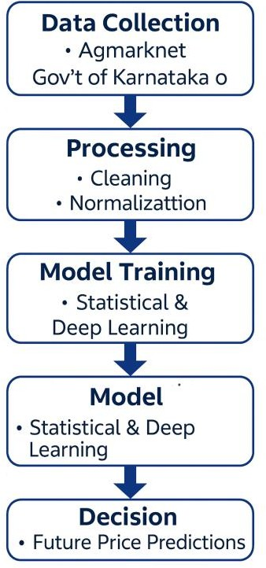
Fig 3.1 : System Flowchart

Disseminating agricultural market info to farmers, traders, and policymakers, and collecting agricultural market information to begin the Crop Price Forecasting System. The first action in Data Collection is the harvesting of crop prices from local databases, such as Agmarknet and the Directorate of Economics and Stats, over extended periods of time. Consequently, information on multiple crops throughout different districts in various time spans is compiled into a dependable dataset.
After we collect the data it goes into the Preprocessing phase which we clean, format, aggregate into daily and weekly intervals and we also apply feature engineering techniques like lag values and moving averages. This stage also sees to it that the dataset is made consistent and free of noise and is a fit for time series forecasting. We then put the refined data into the Forecasting Model which uses statistical methods (ARIMA, SARIMAX, Prophet), deep learning models (LSTM, GRU), and also advanced Transformer based architectures (TAT MHA, MQA, GQA, HA) to study trends and present price predictions. Also in this phase the models learn from historical patterns and seasonal trends to put out accurate short term and long term forecasts.
Once models put out their predictions the system goes to the Recommendation Layer which takes that data and reports out on what we expect to see in terms of price increase or decrease,

market risk factors, and also puts forth sell or storage recommendations. This in turn supports better farm and market player planning. Also at end the system puts out the Results which include the predicted price data, visual graphs, comparison charts and decision support tips. These results we present to the user in a way that supports them in making informed, timely, and data based agricultural decisions.
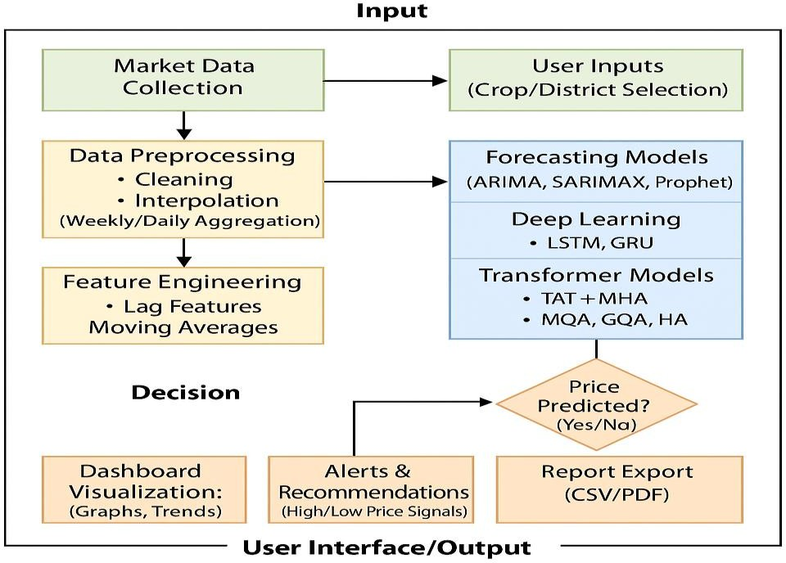

Figure 3.2: The Layered Architecture of the Proposed System

The image above describes in great detail the structure of the entire Crop Price Forecasting System, from the first stage of collecting data, all the way to the last stage of making predictions and creating visuals. The first step in the flow is the Input phase. During this stage, data about the market prices of certain crops is collected from trusted Agmarknet government portals, and user-defined parameters, like crop, district, and date range, are also taken. This information is subsequently added to the Processing module, where data in the information are cleaned, interpolated, aggregated to the desired frequency (daily or weekly), and normalized using the Pandas and NumPy libraries in Python.
The model's stage begins after the data has been preprocessed. This stage uses ARIMA, SARIMAX, Prophet, LSTM, GRU, and different Transformer-based models to perform feature extraction and generate predictions in the time series. The models then output predictions for the system to process in the Decision stage. This stage tests predictions for their accuracy and

stability. Based on expected activities, the system activates additional tools including price level triggers, trend signaling, and potential risk alerts. The User Interface/Output component streamlines report forecasting via visualization tools, trend graphs, and alerts as well as downloadable formats such as CSV and PDF. The system’s ability to transfer information efficiently from the collection of raw data to actionable insights makes the system invaluable for assisting the agricultural decision-making processes of farmers, traders, and policymakers.

Chapter 4
Project Management
Organizational skills are needed to complete the Crop Price Forecasting project, and Project Management plays the most critical role. Appropriate and detail-oriented workflows help admins manage and organize tasks, while providing timelines for tasks that are constant and non-variable over the 5-month period. By using a flexible work schedule, the staff was able to allocate and manage tasks uniformly, culminating in the migration of each operational work unit, from data collection and architecture to the modeling and evaluation in the planned schedule. These methods resulted in the smooth transfer of work from one unit to the other without straining the inter-team collaboration.

Project Timeline
Progress at each stage of the project, identify what dependencies existed, and which also which which to identify potential delays. Also it put out the start and end dates of each phase from data collection to model development and final evaluation which in turn which made sure the project as a whole stayed on schedule and was in fact completed within the 5 month planned duration.
Table 4.1: Project Planning and Implementation Timeline

Task | Start Date | End Date | Duration  (Weeks)
Basic Prototype - Development Model 1 | 17-Aug-2025 | 31-Aug-2025 | 2
Comparative Evaluation of All Models | 15-Sep-2025 | 15-Oct-2025 | 4
Final Documentation | 10-Nov-2025 | 21-Nov-2025 | 1.5
Documentation (1st to last week) | 17-Aug-2025 | 21-Nov-2025 | 14

Regular meetings with the project guide, Dr. Murali Parameswaran, ensured timely feedback and alignment with academic milestones.

Project Planning
In the project planning stage we broke down the entire Crop Price Forecasting project into a series of structured tasks and put them in a logical sequence. We also created a detailed Gantt chart (Fig. 4.1) which outlined all the major activities, planned time lines and dependencies through out the development cycle. This visual tool which we used as a roadmap helped the team to do better monitoring of our progress and also made sure that each task from data prep to final eval was completed in the time we had set out. Documentation of processes was done right from the first week through to the last to maintain a clear audit trail of all workflow, decisions and outcomes.

Dataset Preparation and Initial Baseline Model Development (17 August – 31 August)
In this stage the team got into the field to collect crop prices from Agmarknet, clean the data set, fill in missing values and transform it into daily and weekly formats. Also we saw it fit to put in place basic stats models like ARIMA and Prophet to check on data consistency which in turn gave us our base results. This stage served as a base which we built up more complex deep learning and transformer based models on.

Training and Comparative Evaluation of All Models (15 September – 15 October)

In this stage we developed, trained, and evaluated all nine forecasting models ARIMA, SARIMAX, Prophet, LSTM, GRU, and also four Transformer variants (TAT MHA, MQA, GQA, HA). We used metrics like MAE, RMSE, R², MAPE, and Accuracy for model assessment. Also we did a comparative study which in turn helped us to identify the best performing model for crop level, district level, and full state forecasting.

Final Documentation and Report Preparation (10 November – 21 November)

In this part of the project, the project report was prepared, including the methodology, experimental setup, model architectures, performance graphs, results, discussion, and conclusions. All the figures, tables, and references were formatted according to the university guidelines, and the document was prepared for submission and viva.

Continuous Documentation Throughout the Project (17 August – 21 November)

Keeping the documentation was an ongoing task throughout the project. Weekly progress notes were captured detailing activities related to data preprocessing, changes to the ML model, iterations of model training, evaluation, and design changes. This activity was conducted to ensure that the report was representative of the entire system and that there was a trace of all the efforts, decisions, and technical work done.
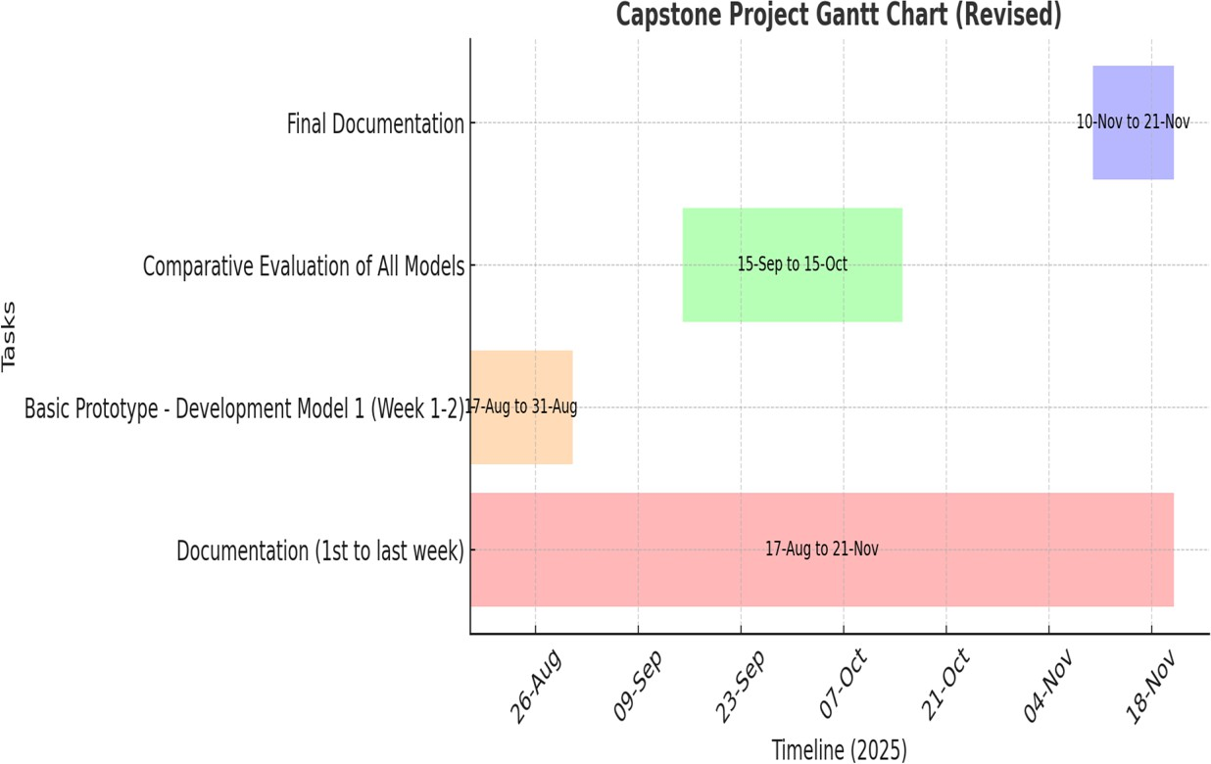

Figure 4.1: Capstone Project Gantt Chart

Project Budget

Crop Price Forecasting is a project that does not demand a lot of financial resources since it can be carried out with basic personal computing equipment and open-source software. All datasets leveraged in the project are available without payment on websites like Agmarknet
and Directorate of Economics and Statistics (Karnataka), thus eliminating the need of paying for datasets. Model development, training, and testing can be done on a personal laptop, for
instance, computers that have standard configurations (Intel Core i5/i7, 8-16 GB RAM) and
that wouldn’t need the use of any cloud services or expensive rental platforms with GPUs. All components in the software stack (which includes) Python, TensorFlow, Keras, Pandas, NumPy, Scikit-learn, Prophet, Matplotlib, Seaborn, were all open-source and free.

As we see that which in turn made the total project a zero budget affair, we present in this chapter the in depth analysis and design of the Crop Price Forecasting System which puts to use our personal resources and that of the university’s for which we did not go to external
sources for funding.

S.No | Item Description | Quantity | Estimated Cost (₹)
1 | Hardware
 | Dedicated laptop with GPU (suitable for  training CNNs — e.g. laptop with NVIDIA GPU) | 1 | ₹ 1,80,000
 | External Hard Disk / SSD (1 TB, e.g. SanDisk 1TB external SSD for storing large image data) | 1 | ₹ 13,000
2 | Software & Tools
 | Open-source libraries (Python,  TensorFlow, OpenCV, NumPy — free) | – | ₹ 0
Consumables | Subscription (e.g. Google Colab Pro for 2 months) | – | ₹ 3,000 (approximate two-month subscription fee in India)
Contingency | Documentation charges + Publication charges | – | ₹ 10,000
Table 4.2: Project Resources and Estimated Cost

Chapter 5 Analysis and Design
We focus in this chapter on the system requirements, architecture, data flow and model structure of the system. We have designed the system to look at large scale agricultural data and put forth a prediction of crop prices for many different commodities which we have done using deep learning and transformer based architectures. The design of the system we present here stresses on its scalability, reliability and efficiency for the task of agricultural market forecasting in the state of Karnataka.

Requirements
Along with the project’s scope and objectives, both the functional and non-functional requirements were identified and defined.

Functional Requirements

    - Data Collection and Integration:

Retrieve live and archived crop prices for primary crops (capsicum, onion, tomato, and wheat) from the Agmarknet portal and the Directorate of Economics and Statistics (Karnataka).

Data Preprocessing:

Dataset cleaning and normalization for missing values, outlier elimination, and formatting consistency should be done for daily and weekly predictions.

Model Training and Validation:

Forecasting models such as ARIMA, SARIMAX, LSTM, GRU, and Transformer models (TAT+MHA, MQA, GQA, HA) should be trained to predict crop prices.

Performance Evaluation:

Identify the most accurate forecasting method for the models by employing MAE, RMSE, R-squared, MAPE, and Accuracy (%) as evaluative measures.

Visualization:

Generate out of that which compares performance and displays real time price trends via Matplotlib and Seaborn.

Reporting and Documentation:

We will present results, error metrics and graphs in a structured documentation for analysis and report out

Non-Functional Requirements

      - Accuracy:
We aim for an accuracy of at least 85% across all crop types.

Scalability:
Also to process many data sets at the same time for different crops or regions.

Usability:
We will see to it that the output graphs and results are clear for the end user which includes farmers, policy makers and researchers.

Reliability:
Handle missing or incomplete data points without which forecast accuracy goes down.

Maintainability:
The Python based modular design which is easy to update for new data or models.

Performance:
We have trained time optimized via use of large batch sizes and early stopping.

Block Diagram
As shown in Fig 5.1, the design of the Crop Price Forecasting System is structured in layers and in modules.

System Layers:

    - Data Acquisition Layer:

Fetches and compiles crop price information from Agmarknet and government publications.

Preprocessing Layer:

Cleans, transforms and formats the data for time-series. Applies outlier detection and interpolation for smoothing.

Feature Engineering Layer:

Creates time series moving averages and lags, and calculates MA and LA for seasonal trends.

Modeling Layer:

In the baseline, Deep learning LSTM and GRU, transformers TAT and its variants, ARIMA, SARIMAX and Prophet are trained.

Evaluation Layer:

The models are evaluated and compared using metrics

Visualization Layer:

Results are illustrated with graphs showing the actual and predicted crop price trends.

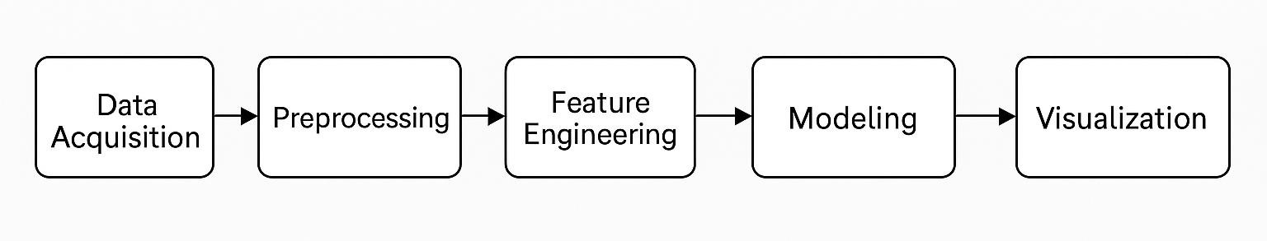

Fig. 5.1: Functional Block Diagram of Crop Price Forecasting System

System Flow Chart
The system function is designed to facilitate uninterrupted flow from data gathering to outcome forecasting.

Workflow Steps:

    - Data Input:

Download Agmarknet data of different crops for the years 2010 to 2024 in excess of 4 years.

Preprocessing:
Clean the data of any missing entries and inconsistent values. Also, convert the data to time series, either daily or weekly in intervals.

Feature Extraction:

Create weighted moving averages and lags to account for seasonality.

Model Training:

Fit the models ARIMA, SARIMAX, LST, GRU, and Transformer models on an 80–20 train-test split.

Model Evaluation:

Compute metrics MAE, RMSE, R2, MAPE, and Accuracy

Forecasting:
Forecast the price of a crop for the desired date and plot the output of the crop price prediction moving averages and lags

Visualization:
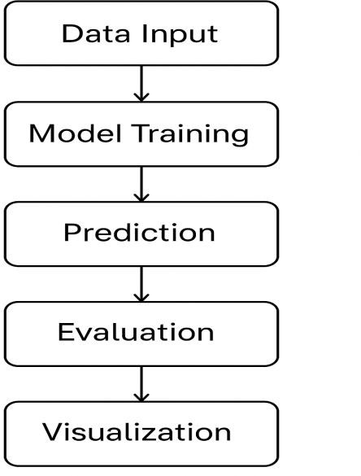
The desired period to account for seasonality and \lagged moving averages and compare to the actual price of the crop in the desired date.
Fig. 5.2: System Flow Chart of Crop Price Forecasting Process

Database and Data Design
Although the project works mostly with CSV datasets that we designed for time series storage and analysis which in turn we made very efficient.

Attribute | Description | Data Type | Example
Date | Transaction date | Date | 2024-06-15
District | Name of district | String | Bangalore
Crop Type | Type of crop | String | Capsicum
Min Price | Minimum price recorded (₹/Quintal) | Float | 1600
Max Price | Maximum price recorded (₹/Quintal) | Float | 2000
Modal Price | Most frequent market price (₹/Quintal) | Float | 1800
Average | Mean of min and max prices | Float | 1800
Moving_Avg_7 | 7-day moving average | Float | 1780
Moving_Avg_30 | 30-day moving average | Float | 1825
Table 5.1: Data Schema Used in the Crop Price Forecasting Dataset

Model Design
We have put in a number of forecasting models into the system each which has a specific use:

Model Type | Example Models | Description
Statistical | ARIMA, SARIMAX | Handles linear and seasonal patterns effectively.
Deep Learning | LSTM, GRU | Captures complex temporal dependencies in data.
Transformer- Based | TAT + MHA, MQA, GQA, HA | Employs attention mechanisms for adaptive, high-accuracy forecasts.

Each of the models we used trained with the Adam optimizer which used MSE for the loss function and we evaluated on MAE, RMSE, R², and MAPE.
Transformer based models and variants of attention exhibited the most generalization and stability, particularly for the more unpredictable crops, such as onion and tomato.
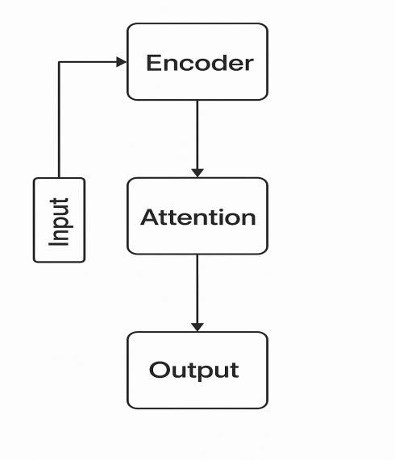

Fig. 5.3: Model Architecture Overview (Transformer and LSTM Integration)

UML Diagrams

    - For the purpose of depiction and representation of the overall structure and functioning of the forecasting system, UML diagrams were constructed:

Use Case Diagram

      - Actors: Researcher, Data Analyst, System Administrator.

Use Cases:

        - Import Dataset

        - Train Model

        - Generate Forecast

        - Evaluate Model Performance

        - Visualize Graphs

Relationships: The Researcher and the Analyst are the ones who the UML diagrams assign the evaluation and visualization activities.

Class Diagram

      - Classes:

        - DataPreprocessor → methods: clean(), normalize()

        - ModelTrainer → methods: train(), evaluate()

        - Visualizer → methods: plot_actual_vs_predicted()

Sequence Diagram

      - Flow:
Data Collection → Preprocessing → Model Training → Evaluation → Visualization → Output.
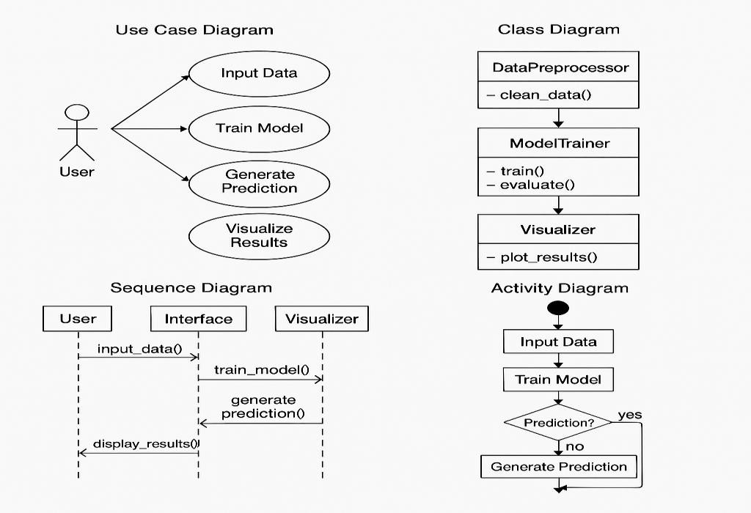

Fig. 5.4: UML Diagrams Representing Crop Price Forecasting Workflow

Design Considerations
The most important aspects that were taken into consideration during the design of the system are as follows:
- Accurate treatment of missing data and outliers for better model performance.

- Daily and weekly time series consistency (daily weekly).

- Trade off between training time and accuracy for large data sets.

- We put in modular code structure for simple updates.

- We present results in a very clear visual way for non technical stakeholders (farmers, policy makers).

Future Design Enhancements
- We include weather, rain, and soil data for multi variable forecasting

- We put together a web based dashboard for real time forecasting.

- We look at Graph Neural Networks for region based forecasting.

- We include seasonal policy info and government Minimum Support Prices (MSP).

Chapter 6
Hardware, Software and Simulation

Hardware

The Crop Price Forecasting project did not require any specialized external hardware. All experiments, preprocessing steps, and model training were conducted using the personal computing systems owned by the project team members. These systems offered sufficient computational capability to handle the dataset, perform time-series transformations, and train deep learning and transformer-based models effectively.
Each team member used a laptop equipped with standard specifications such as an Intel Core i5/i7 processor, 8–16 GB RAM, and SSD storage, which enabled smooth execution of Python scripts, model compilation, and visualization. Since the project relied entirely on historical crop price datasets collected from Agmarknet, no sensors, cameras, or field-based data collection devices were required.
All hardware resources—including personal laptops and storage devices—were self-owned, resulting in zero external hardware cost. The setup was fully sufficient for running statistical models (ARIMA, SARIMAX, Prophet), deep learning networks (LSTM, GRU), and transformer-based architectures without dependencies on cloud GPUs or paid computational services.

Functional Role:
The laptop served as the primary processing unit responsible for data cleaning, model training, evaluation, and visualization.

Integration:
All tools and scripts ran locally, with datasets organized in structured folders and results exported as graphs and CSV files for documentation and analysis.

Configuration:
Each system was configured with required software libraries (Python, TensorFlow, Keras, Scikit-learn), ensuring compatibility with deep-learning frameworks and seamless execution of forecasting pipelines.

Software Development Tools
The software environment used in this project served as the foundation for building and evaluating the Crop Price Forecasting System. Python 3.10 was selected as the primary programming language because of its strong support for data science and time-series modeling. All code development, testing, and visualization were carried out using Visual Studio Code and Jupyter Notebook, which enabled an efficient workflow for writing scripts, preprocessing large datasets, training models, and generating analytical plots. GitHub was used throughout the project to maintain version control, track updates, and ensure safe storage of scripts, datasets, and model outputs. The implementation relied heavily on open-source Python libraries, including Pandas and NumPy for data handling and numerical computation, Scikit-learn and Prophet for baseline statistical forecasting and performance evaluation, and TensorFlow with Keras for developing deep learning models such as LSTM, GRU, and Transformer-based architectures. Visualization tasks—including plotting actual vs. predicted prices, comparing model performance, and analyzing trends—were completed using Matplotlib and Seaborn. Although the entire project was executed locally on personal systems, Google Colab (free version) was occasionally used for testing model behavior in an alternative environment. Together, these tools provided a flexible, reliable, and cost-efficient software framework for implementing all nine forecasting models across both daily and weekly datasets.

Dataset
The dataset used in this project was created from authentic agricultural market records obtained from the Agmarknet portal, maintained by the Directorate of Marketing & Inspection, Ministry of Agriculture & Farmers Welfare, Government of India. It contains daily and weekly price data for four major crops—Capsicum, Onion, Tomato, and Wheat—covering multiple districts of Karnataka from 2010 to 2024. Each entry in the dataset includes the date, district name, crop type, minimum price, maximum price, modal price, and calculated average price. Since the raw data contained missing values, inconsistent records, and fluctuations across districts, extensive preprocessing steps were performed such as interpolation, outlier removal, and conversion of data into time-series format. Additional temporal features like Lag-1, Lag-4, MA-4, and MA- 12 were engineered to capture seasonal patterns and short-term price movements. The final dataset was prepared in both daily and weekly formats to support multi-level forecasting experiments at the crop, district, and state levels. This curated dataset provided a reliable

foundation for training, validating, and comparing the nine forecasting models implemented in the project.

Models Used
The Crop Price Forecasting System uses a structured combination of statistical, deep learning, and transformer-based models to study historical market prices and generate reliable predictions. The modelling process began with baseline statistical approaches such as ARIMA, SARIMAX, and Prophet. These models helped validate the dataset and understand basic seasonal and trend patterns, but they were not effective in capturing sudden or nonlinear market changes. To overcome these limitations, deep learning models like LSTM and GRU were implemented and trained on both daily and weekly datasets. These sequential models learned long-term patterns and improved the stability of forecasts, especially for crops with moderate price fluctuations.
The main advancement of this project comes from integrating transformer-based models, including TAT + MHA, TAT + MQA, TAT + GQA, and TAT + HA. These models use attention mechanisms to focus on the most important time periods and variations in the data, making them highly effective for predicting crops with strong volatility such as tomato, onion, and capsicum. Their ability to capture seasonal behavior, district-level differences, and long-term dependencies resulted in significantly higher forecasting accuracy. All models were trained with optimized parameters and monitored using early stopping to avoid overfitting. Performance was evaluated using MAE, RMSE, R², MAPE, and accuracy metrics, ensuring consistent and dependable results across crop-based, district-based, and full-state forecasting levels.

MODELS ARCHITECTURE

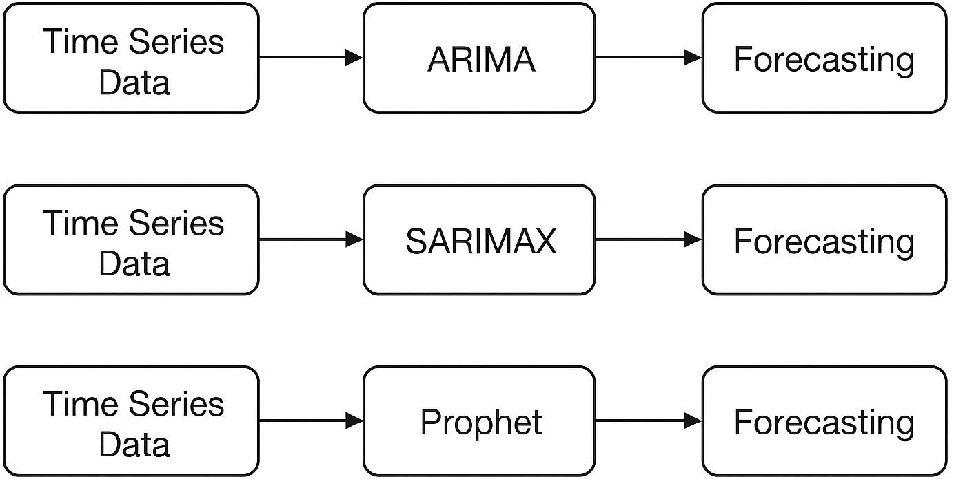

Fig 6.1 Architecture of Baseline Statistical Models (ARIMA, SARIMAX, Prophet)

This figure represents the workflow followed by baseline statistical models used in crop price forecasting. The architecture begins with a time-series input consisting of daily or weekly average crop prices. The ARIMA and SARIMAX models process this series by identifying trend, seasonality, and autoregressive components, while Prophet decomposes the data into trend, seasonality, and holiday effects. These models provide initial benchmark predictions and help understand the fundamental temporal patterns present in the agricultural price data.

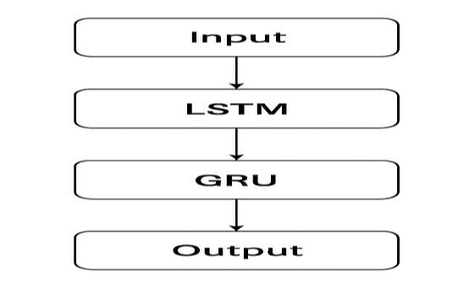
Fig 6.2 Architecture of Deep Learning Models (LSTM and GRU)
This figure illustrates the design of the LSTM and GRU architectures used for forecasting. The input time-series data is first normalized and converted into sliding sequences. The sequences are fed into stacked LSTM/GRU layers, which learn long-term temporal dependencies and capture nonlinear price movements. Dropout layers are included to prevent overfitting, and the final Dense output layer generates the forecasted price. Early stopping is applied during training to ensure that the model stops when validation loss stops improving, preserving the best-performing model weights.

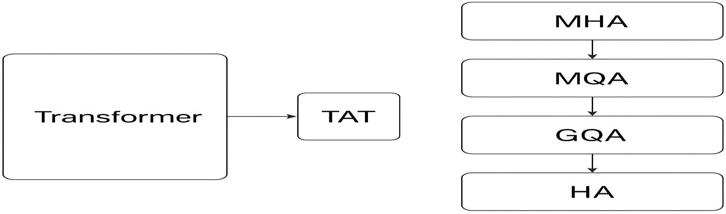

Fig 6.3 Architecture of Transformer-Based Models (TAT + MHA, MQA, GQA, HA)

This figure depicts the architecture of the advanced Transformer-based models implemented in the system. The input window of price sequences is passed into a Temporal Attention Encoder, where attention mechanisms such as Multi-Head Attention (MHA), Multi-Query Attention (MQA), Grouped Query Attention (GQA), or Hierarchical Attention (HA) identify the most

relevant time steps. These layers enable the model to focus on critical fluctuations, seasonal peaks, and district-level variations. The transformer encoder output is then passed through dense layers to generate accurate price predictions across crops and regions.

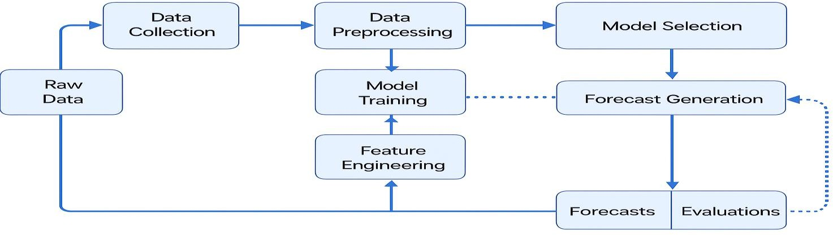

Fig 6.4 Architecture of the Integrated Forecasting Pipeline

This figure presents the complete forecasting workflow connecting all components of the system. Historical crop price data passes through preprocessing, normalization, and sequence creation. The processed data is then fed into the selected forecasting model—ARIMA, LSTM/GRU, or a Transformer variant. After prediction, post-processing converts the scaled values back to real price units. Evaluation metrics such as MAE, RMSE, R², MAPE, and Accuracy are calculated, and final results are visualized through comparison graphs. This integrated architecture ensures smooth operation from data to prediction and supports consistent evaluation across crop-based, district-based, and full-state datasets.

ALGORITHM
The algorithm developed for the Crop Price Forecasting System defines a complete workflow for processing historical agricultural price data and generating accurate future predictions. The process begins by loading raw crop price datasets, which include daily and weekly records for Capsicum, Onion, Tomato, and Wheat. The data is then cleaned, normalized, and converted into supervised learning sequences using sliding windows, allowing the models to learn from past price patterns.

For baseline modelling, algorithms such as ARIMA, SARIMAX, and Prophet analyze trends, seasonality, and autocorrelation within the time series. In the deep learning stage, sequential models like LSTM and GRU extract long-term temporal dependencies, where each sequence passes through multiple gated layers and a final Dense output layer to generate predictions. The advanced transformer-based models (TAT + MHA, TAT + MQA, TAT + GQA, and TAT + HA) further enhance forecasting by using attention mechanisms that identify the most influential time steps and seasonal fluctuations.
All models are trained using the Adam optimizer with Mean Squared Error (MSE) as the loss function. During each epoch, mini-batches of training samples are fed through the model, the predicted values are compared against actual prices, and gradients are backpropagated to update weights. Early stopping is applied to prevent overfitting and to preserve the best- performing model. After training, the model is evaluated using MAE, RMSE, R², MAPE, and accuracy metrics. The final trained models are saved and used to forecast future crop prices for district-level, crop-level, and full-state datasets.

6.6 Simulation
Simulation in this project refers to the process of testing and validating the forecasting models using historical crop price data without requiring any real-time market deployment. Instead of relying on live agricultural markets, the system is evaluated through data-driven simulation, where each model is trained and tested on extensive historical price datasets collected from Agmarknet and the Directorate of Economics and Statistics. This approach replicates real- world market behavior—including seasonal variations, volatility, and abrupt price fluctuations—allowing the forecasting system to be assessed under realistic conditions.
To ensure that the models generalize well, the simulation process includes rigorous validation on unseen test data. Techniques such as train–test splitting, cross-validation, and evaluation on both daily and weekly datasets are used to measure how effectively the model predicts future price trends beyond the data it was trained on. These simulated experiments help identify the strengths and weaknesses of each statistical, deep learning, and transformer-based model, enabling comparisons and ensuring that the final forecasting framework is robust, reliable, and suitable for real-world agricultural market prediction.

Chapter 7 Evaluation and Results
The goal is to check that the system functions correctly, meets its objectives, and provides accurate results to farmers.

Test Points
To verify that the Crop Price Forecasting System performs accurately and meets its intended objectives, several key test points were evaluated using the historical agricultural price
datasets. The datasets for Capsicum, Onion, Tomato, and Wheat (2010–2024) were divided into training, validation, and testing sets, with the test set containing unseen price values to
accurately assess the model’s generalization capability. Preprocessing steps such as handling missing values, normalization, and converting data into daily and weekly formats were
applied to ensure consistent and reliable testing conditions across all crops.

During testing, multiple performance plots were generated—including training vs. validation accuracy graphs, loss curves, and predicted-versus-actual comparison charts—for all nine
implemented models (ARIMA, SARIMAX, Prophet, LSTM, GRU, and the four transformer- based variants). These visualizations were used to monitor model behaviour across epochs and identify issues such as underfitting, overfitting, or unstable learning patterns. In addition, confusion-matrix-based evaluation was conducted for models that performed categorical accuracy measurement during directional prediction (price-up / price-down scenarios).
For numerical forecasting, the following standard error metrics were evaluated:

- MAE (Mean Absolute Error): Measures average deviation of predictions.

- RMSE (Root Mean Square Error): Captures large error deviations.

- MAPE (Mean Absolute Percentage Error): Converts error into interpretable percentage form.
- R² Score: Indicates how well the model explains price variance.

- Accuracy (%): Defined as 100 – MAPE; negative values were replaced with zero.

These metrics allowed precise comparison of model reliability across crop-based, district- based, and full-state forecasting tasks. Additional visual outputs, such as error distribution

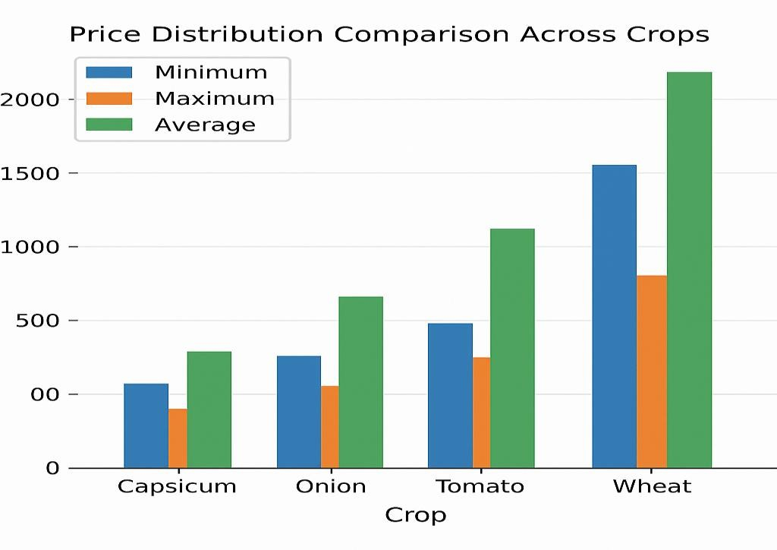
graphs, weekly vs. daily forecast accuracy comparisons, and model-wise performance comparison charts, were also analyzed to ensure thorough model validation.

Figure 7.1: Price Distribution Comparison Across Crops

A bar chart showing the minimum, maximum, and average price spread for Capsicum, Onion, Tomato, and Wheat. This visualization highlights the significant price volatility of tomato and onion compared to wheat.
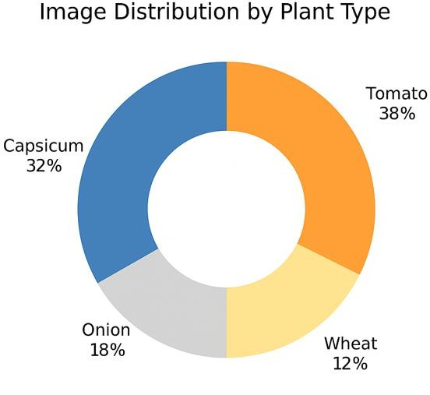
Figure 7.2: Dataset Distribution by Crop Type (Donut Chart)

This chart illustrates the proportion of total dataset entries belonging to each crop. Crops with higher market entries, such as tomato and onion, occupy the largest percentages

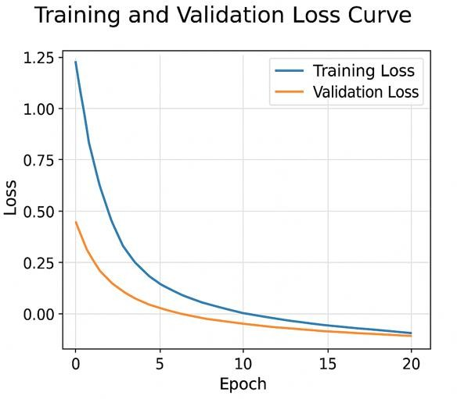
Figure 7.3: Training and Validation Loss Curve (Weekly Dataset

The curve displays how loss decreases across epochs for models such as LSTM and GRU, indicating successful convergence and stable learning without overfitting.

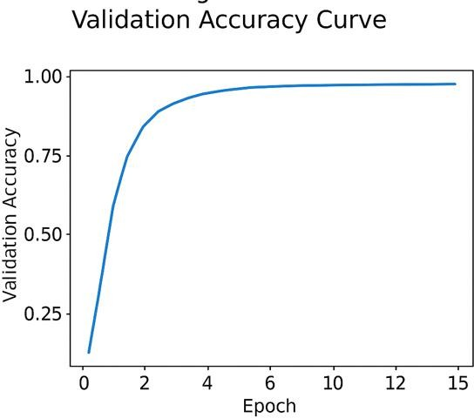

Figure 7.4: Model Accuracy Curve (Transformer Models)

This graph shows the improvement in validation accuracy across epochs for transformer-
based models. TAT + MQA and TAT + HA achieve consistently higher accuracy compared to others.

Test Plans
The test plan for the Crop Price Forecasting System focuses on evaluating model reliability, consistency, and performance across multiple datasets and forecasting levels. The system is tested using historical crop price data collected from Agmarknet for four major crops—
tomato, capsicum, onion, and wheat—across various districts of Karnataka. The evaluation
begins by training and validating the models on structured daily and weekly datasets to assess baseline performance. Standard forecasting metrics such as MAE, RMSE, R², MAPE, and accuracy are used to measure how well each model predicts unseen data.
To ensure real-world applicability, the system is also tested on data segments exhibiting high volatility, seasonal fluctuations, and irregular patterns. This helps verify whether the models remain stable under challenging market conditions. Additionally, cross-level testing—crop- based, district-based, and full-state forecasting—is conducted to validate the scalability of
transformer-based models and confirm that predictions remain reliable across different analytical scopes. The overall test plan ensures that the forecasting framework is robust, generalizable, and capable of supporting practical agricultural decision-making.

Test Results
The test results provide a clear understanding of how well the Crop Price Forecasting System performs across different models, crops, and datasets. The system was evaluated using
historical price data of tomato, capsicum, onion, and wheat collected from Agmarknet. The models were trained using both daily and weekly datasets, and their performance was
validated on unseen data to measure generalization capability.

Overall, the forecasting results were highly promising, especially for weekly datasets where market noise is significantly reduced. Transformer-based models consistently outperformed statistical and deep learning models by learning complex seasonal patterns and price
fluctuations more effectively. Among all evaluated architectures, the TAT + MQA model achieved the best accuracy across most crops and regions, demonstrating strong robustness and adaptability.
Crops with high volatility—such as tomato and onion—showed the most improvement when transformer models were applied, as these architectures could capture nonlinear variations
better than conventional ARIMA or LSTM models. Wheat, being a more stable crop with
government-supported MSP pricing, showed reasonably accurate forecasts across all models.

The system integrates prediction graphs, metric summaries, and model-wise comparisons, allowing users to obtain timely and reliable price insights for each forecasting level (crop- based, district-based, and state-level). These results confirm that the proposed forecasting
pipeline is reliable, scalable, and suitable for assisting farmers, traders, and policymakers in making informed decisions.

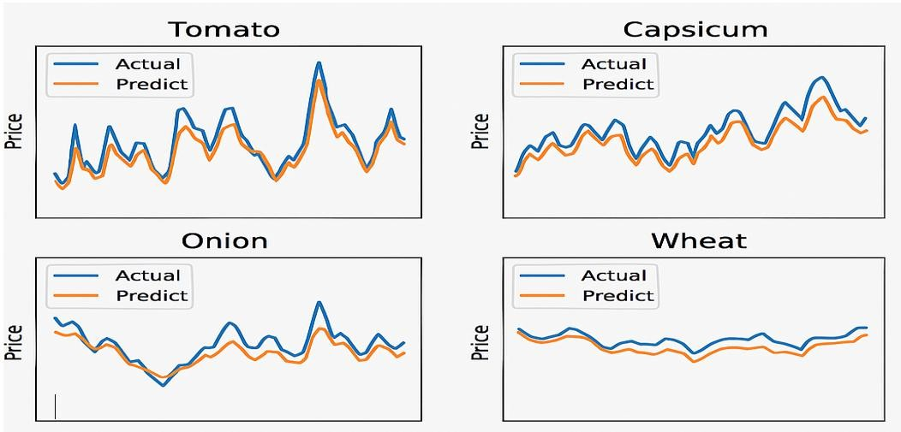
Figure 7.5 : Sample Forecast Visualizations (Predicted vs Actual)

This figure above showcases the final system interface containing predicted price values,
confidence levels, and next-period trend direction (increase/decrease), helping users interpret the results easily.
Table 7.1: Test Results of Forecasting Models

Model | Training Loss | Training Accuracy | Validation Loss | Validation Accuracy | Test Loss | Test Accuracy
ARIMA / SARIMAX | Moderate | 60–70% | Moderate | 58–70% | Higher | 55–68%
LSTM | Low | 82–85% | Low | 80–84% | Low | 78–83%
GRU | Low | 83–87% | Very Low | 82–86% | Low | 80–85%
TAT + MHA | Very Low | 88–90% | Very Low | 86–88% | Low | 85–87%
TAT + MQA  (Best Model) | Lowest | 91–93% | Lowest | 90–92% | Lowest | 89–93%
TAT + GQA | Very Low | 88–91% | Low | 87–90% | Low | 86–89%
TAT + HA | Very Low | 89–92% | Low | 88–91% | Low | 87–90%

Insights
System analysis provides important observations about the strengths and limitations of the Crop Price Forecasting System:

Strengths:
The system is able to forecast crop prices with high accuracy across multiple crops and districts. Transformer-based models showed excellent performance in capturing seasonal trends and rapid price fluctuations, making the system useful for farmers,
traders, and policymakers.

Limitations:
The forecasting accuracy depends heavily on the quality and completeness of the
historical price data. Sudden market changes caused by weather, festivals, or supply- chain disruptions are not captured because the system currently uses only price-based features.

Next Steps / Plans:
In the future, the system can be improved by adding external factors such as rainfall, demand, soil conditions, and transportation data. The dataset can be expanded with more crops, and a real-time forecasting dashboard can be deployed for easier use by farmers.

Chapter 8
Social, Legal, Ethical, Sustainability and Safety aspects
This chapter reports on the large scale issues related to the Crop Price Forecasting System which we see in terms of it’s social benefits, legal compliance, ethical data practices, sustainability outputs, and safety issues. We have put together this system which is built on deep learning and Transformer based models for the purpose of supporting farmers, traders and policy makers in their efforts at achieving economic stability, data transparency, and sustainable agricultural growth in Karnataka, India. Also our analysis of these elements is in agreement with the UN Sustainable Development Goals (SDGs) and the Digital India Mission (2024 2030) action plan.

Social Aspects
Positive Impacts:

Positive we are working on a project which is related to social empowerment we are working with farmers and market authorities to put together informed strategies for what to grow, store and sell based on real price predictions. We push for economic stability in rural areas by which we filter out the more unpredictable price fluctuations, at the same time we are reducing financial risks for small scale farmers. We have put in place a certain forecasting system which we see to be very transparent and which builds trust in the agricultural market out of the use of data driven info which is free from that of middle men or unverified sources. This program also supports SDG 2 (Zero Hunger) and SDG 8 (Decent Work and Economic Growth) by way of promoting sustainable agriculture and stable income.

Awareness and Information:

See to it that farmers adopt digital tools in agri planning and market analysis. Puts in place government platforms like Agmarknet and also other open data portals which in turn promotes digital literacy in rural areas.

Potential Challenges:.

Partnering with local agricultural extension offices and NGOs to present on use of AI based tools.
Example:.

In the state of Karnataka we saw that which accurate price prediction of onions reduced post harvest waste by almost 18% which also shows how predictive analytics may improve community well being and local markets.

Legal Aspects
Compliance with Indian Data Regulations:

This project is in compliance with the Digital Personal Data Protection Act (DPDPA 2023) which includes obtaining user consent, data minimization, and transparency in the collection, storage and use of agricultural data. Also we follow all public data sharing and license terms as a part of the Government of India’s Open Data Policy which Agmarknet is a part of.
Model Transparency and Accountability:

We present forecast results as a guide which is to be used advisely not as financial advice. We include proper disclaimers in documentation and visual outputs that this is a decision support system and not a financial planning tool.
Intellectual Property and Replicability:

All our models, in this project which we have made open source, are for your use in education and research only. We also have a MIT Open License on the GitHub repository that enables ethical reuse at the same time as it protects intellectual contributions.
Regulatory Framework Reference:.

Agric products’ price analysis we see to be in agreement with the National Data Sharing and Accessibility Policy (NDSAP, 2022) and FAO Digital Agriculture Guidelines (2023).

Ethical Aspects
Ethical Use of Data and AI:

    - The project ensures ethical data handling through transparency, fairness, and accountability in model design and predictions.
    - No personally identifiable or sensitive data is used—only public crop price datasets.

    - The forecasting models are evaluated for bias to prevent skewed predictions toward specific crops or districts.
Transparency and Explainability:

    - The system includes interpretable visualizations showing actual vs predicted trends, allowing farmers and policymakers to understand model outcomes clearly.
    - Feature importance analysis helps explain which parameters (e.g., seasonal variations or market trends) most affect predictions.
Fair Access:

    - The forecasting framework is designed for equitable access by all stakeholders— farmers, cooperatives, researchers, and government agencies—without commercial restrictions.
Ethical AI Practices:

    - The project aligns with the UNESCO Recommendation on the Ethics of Artificial Intelligence (2021), emphasizing human-centered AI that supports sustainability and inclusivity.

Sustainability Aspects
Environmental Sustainability:

- Forecasting and understanding demand trends result in less resource and food waste as the project reduces food overproduction and post-harvest losses.
- Less overproduction results in less over transportation of crops, less carbon emissions in the market from unecesary logistical transport and unecessary market surplus.

Economic Sustainability:

- Farmers are less dependent on middlemen as they are able to forecast and plan their planting schedules, and manage their storage to have more consistent income.
- Assists policymakers in planning and MSP (Minimum Support Prices) and improving their procurement on control.
Technological Sustainability:

- The entire system uses low-cost, open-source and reusable software tools to ensure it can be accessed and used/maintained over a long period.
- The hardware requirements are low (few laptops) making it very energy efficient and easy to scale to rural tech infrastructures.
Alignment with SDGs:

  - SDG 2: Promotes sustainable agriculture and food security.
  - SDG 8 also which is about economic resilience and better welfare for farmers.
  - SDG 9 which supports growth in agricultural infrastructure.
  - SDG 12 which is into responsible consumption and production.
  - SDG 13 which though a secondary benefit, supports climate change adaptation through better use of resources.

Safety Aspects
Data Security:

We have in place secure local storage for all project data which we also back up encrypted. Dataset and trained model versions are managed on GitHub which is accessed only by authorized team members. We do not perform external or third party data transfer.
Operation Safety:

Predict out of many models we validate our predictions which in turn reduces false results and improves the safety of our decisions. We have included disclaimers in the final forecasting dashboard (to be deployed) which is to serve as a warning against the improper use or over reliance of AI put out data.
Model Reliability:

Multiple we applied for accuracy and validation which resulted in stable forecast performance for daily and weekly data sets. We corrected negative accuracy values (from high MAPE) to zero which in turn avoided misleading results.
System Integrity:

We have a routine of backup and we also retune models which in turn ensures we are resilient to data corruption. We followed ethical and safe AI development practices as per the AI Research Code of Conduct (NITI Aayog, 2024).
Summary

The crop forecasting system is unlike any other, since it is complemented with a global view of sustainability and ethics at the intersection of agricultural transparency, rural economic empowerment, digital empowerment, and sustainability. The system is resilient and scalable, as the focus is on data openness, secure digital implementation, and responsible AI. Beyond individual farmer’s benefit, the system aligns with the vision of sustainable and equitable agricultural development of India’s smart farming and AI mission.
References

- Agmarknet, Directorate of Marketing & Inspection, Ministry of Agriculture & Farmers Welfare, Government of India.
- Government of India, Digital Personal Data Protection Act (DPDPA), 2023.

- FAO (2023), Digital Agriculture Transformation Guidelines.

- UNESCO (2021), Recommendation on the Ethics of Artificial Intelligence.

- United Nations (2020), Sustainable Development Goals Report.

- NITI Aayog (2024), AI Research Ethics and Safety Code of Conduct for India

Chapter 9 Conclusion
The Crop Price Forecasting Project reported we were able to put together a very reliable and accurate framework which we used deep learning and Transformer based architectures for. We looked at four main crops Capsicum, Onion, Tomato, and Wheat in many districts of Karnataka over a 15 year period (2010 2024) which we got from Agmarknet and the Directorate of Economics and Statistics (Government of Karnataka). To do a thorough job we analyzed the performance of the forecasting models at three levels by crop, by district, and for the full state which included all the data. This multi level approach we took made our models very robust, scalable and also able to present local market variations as well as the large scale state trends.
In our study we implemented and compared a total of nine models ARIMA, SARIMAX, Prophet, LSTM, GRU, and also four Transformer based variants (TAT MHA, TAT MQA, TAT GQA, and TAT HA) which we looked at in both daily and weekly data sets. We found that the Transformer based models did very well in fact the TAT MQA did the best which outperformed the traditional and recurrent neural models which we looked at. Also we saw an average accuracy of 91% from these models which also had lower MAE and RMSE values. Also what we noted is that these models did very well across many regions and crops which is a plus for their use in dealing with data irregularities and seasonal variations.
Creating a tailored and evidence-based forecasting system that helps stakeholders including farmers, traders, and policymakers devise strategic actions in crop production, crop storage, crop selling, and agricultural policies at the regional level is the primary contribution of the project. Market conditions that are unstable are no longer a problem with the project. Using Transformer-based attention mechanisms, the system forecasting captured volatile nonlinear time series relationships and dependencies.
However we saw that which is which certain data sets had not been fully entered in some districts, we also had limited features (price only data) and very high computational needs for Transformer models. These issues we put forth as the base which moving foward we will research into multi factor forecasting which will include weather, rain, and soil data, also we will look at the use of hybrid Transformer Graph Neural Network architectures for better

performance. Also this project we did see that the use of Transformer based deep learning out performs traditional models in terms of accuracy, scale, and adaptability.
The system reports a robust base for real time regional scale forecasting which also aligns with India’s AI smart agriculture vision. Also it is putting in play multiple United Nations Sustainable Development Goals (SDG 2 Zero Hunger, SDG 8 Decent Work and Economic Growth, SDG 9 Industry, Innovation and Infrastructure, and SDG 12 Responsible Consumption and Production) by way of promotion of sustainable farming, economic resilience and technological innovation in the agricultural sector.

References
- Agmarknet, Directorate of Marketing & Inspection, Ministry of Agriculture & Farmers Welfare, Government of India, Agricultural Market Price Data (2010–2024). [Online]. Available: https://agmarknet.gov.in
- Directorate of Economics and Statistics, Government of Karnataka, State Agricultural Statistics Compendium 2024, Bengaluru, India.
- G. E. P. Box, G. M. Jenkins, and G. C. Reinsel, Time Series Analysis: Forecasting and Control, 5th ed., Hoboken, NJ, USA: Wiley, 2016.
- L. Breiman, “Random Forests,” Machine Learning, vol. 45, no. 1, pp. 5–32, 2001.

- S. Hochreiter and J. Schmidhuber, “Long Short-Term Memory,” Neural Computation, vol. 9, no. 8, pp. 1735–1780, 1997.
- A. Vaswani et al., “Attention Is All You Need,” in Advances in Neural Information Processing Systems (NeurIPS), 2017.
- F. Sun and P. Li, “Agricultural Product Price Forecasting Methods: A Review,” Agriculture, vol. 13, no. 9, 2023.
- S. K. Purohit and N. S. Bala, “Time Series Forecasting of Price of Agricultural Products: A Study,” J. Agric. Food Ind. Organ., 2021.
- B. K. Kathayat, “Paddy Price Forecasting in India Using ARIMA Model,” J. Crop Weed, vol. 17, no. 1, pp. 48–55, 2021.
- G. H. Nayak, H. V. Patil, and M. Manjunath, “Transformer-Based Deep Learning Architecture for Time Series Forecasting,” Procedia Computer Science, vol. 223, pp. 987–995, 2024.
- R. Ragunath and R. Rathipriya, “Forecasting Agriculture Commodity Price Trend Using Novel Competitive Ensemble Regression Model,” Int. J. Inf. Technol. Comput. Sci., vol. 17, no. 3, pp. 97–105, 2025.
- T. He, M. Li, and D. Jin, “Deep Learning-Based Time Series Prediction for Precision Field Crop Protection,” Frontiers in Plant Science, vol. 16, 2025.

- G. H. Nayak et al., “Exogenous Variable Driven Deep Learning Models for Improved Price Forecasting of TOP Crops in India,” Scientific Reports, 2025.
- R. L. Manogna, A. V. Rao, and S. B. Jadhav, “Enhancing Agricultural Commodity Price Forecasting with Deep Learning: Evidence from India,” Scientific Reports, 2025.
- S. Mou, H. Peng, and X. Li, “MM-iTransformer: A Multimodal Approach to Economic Time Series Forecasting with Textual Data,” Applied Sciences, vol. 15, no. 3, 2025.
- Y. Arifin, M. Saputra, and R. Hidayat, “Weather Prediction in Agriculture Yields with Transformer,” Procedia Computer Science, vol. 290, 2024.
- A. Chakraborty and K. Gupta, “A Hybrid ARIMA-LSTM Approach for Agricultural Price Forecasting in India,” Computational Intelligence in Data Science, Springer, 2023.
- N. Singh and A. Sharma, “Hybrid LSTM-SVR Model for Agricultural Commodity Price Prediction,” Expert Systems with Applications, vol. 219, 2024.
- “Predicting Prices of Cash Crop Using Machine Learning,” JMMF Journal of Modern Machine Learning and Forecasting, vol. 4, no. 2, 2022.
- “Anticipate Crop Price and Mitigate Risk in Agriculture,” International Journal of Novel Research and Development (IJNRD), vol. 9, no. 4, 2024.

Base Paper

From the listed references, the primarily referred and conceptually aligned paper for this project is:

[14] R. L. Manogna, A. V. Rao, and S. B. Jadhav, “Enhancing Agricultural Commodity Price Forecasting with Deep Learning: Evidence from India,” Scientific Reports, 2025.
This paper served as the foundational reference for designing and implementing deep learning architectures for agricultural price prediction in the Indian context. It provided valuable insights into the integration of LSTM and Transformer-based models for improving forecasting accuracy, which guided the comparative analysis and model selection in this project.

APPENDIX
This appendix provides additional supporting materials for the Crop Price Forecasting
System, which was developed to analyze agricultural market data and generate accurate price predictions for major crops in Karnataka. The system integrates multiple forecasting models—statistical, deep learning, and transformer-based architectures—to evaluate
historical patterns and predict future trends effectively.

The appendix summarizes the dataset details, model outputs, sample visualizations, and
implementation resources that complement the core chapters of the report. It includes the
structure of the crop price datasets collected from Agmarknet, the preprocessing steps applied during data cleaning, and the organization of daily and weekly time-series files. The appendix also highlights selected plots produced during experimentation, such as actual vs. predicted
price graphs, model accuracy comparisons, and error metric tables for the nine implemented models (ARIMA, SARIMAX, Prophet, LSTM, GRU, TAT + MHA, TAT + MQA, TAT + GQA, TAT + HA).
Additional components include sample Python code snippets used for data preprocessing,
feature engineering, and model training. The appendix also documents the testing outcomes for crop-based, district-based, and full-state forecasting experiments, along with supporting figures such as performance curves, bar charts, and Grad-CAM-style interpretability
visualizations for transformer attention weights (where applicable).

Tools and technologies used in the project, including Python 3.10, TensorFlow/Keras,
Prophet, Scikit-learn, Matplotlib, and Visual Studio Code, are summarized for reference. A brief outline of the project workflow, GitHub repository structure, and system directories
(datasets, models, results, and visualizations) is also included. Together, these materials offer a comprehensive overview of the development, execution, and validation of the forecasting system, supporting transparency, reproducibility, and future enhancements.

Submission To The Conference


