

**CSE7101 CAPSTONE PROJECT**

**REVIEW – 2**

**REPORT**

**TOPIC :**

**CROP PRICE FORECASTING: REGION-WISE ESTIMATOR**

**Batch Number: ISE_1**

|  |  |
| --- | --- |
| **ROLL NUMBER** | **STUDENT NAME** |
| 20221ISE0108 | KAVANA R |
| 20221ISE0109 | PALLAVI J |
| 20221ISE0104 | BHARATHI NEERALAKERI |

**Under the Supervision of,**

Dr. Murali Parameswaran

Professor

School of Computer Science and Engineering

Presidency University

**Introduction :**

Agriculture forms the backbone of the Indian economy, and accurate crop price forecasting plays a vital role in stabilizing farmer income and ensuring efficient market functioning. Prices of agricultural commodities vary significantly across regions due to differences in climate, soil, demand–supply patterns, and logistical factors. Hence, developing a **region-wise estimator** for crop price forecasting is essential to capture these localized variations and provide reliable insights to farmers, traders, and policymakers.

Traditional statistical models such as **ARIMA** and **Prophet** have been widely applied for agricultural price prediction because of their strength in capturing trends and seasonality. However, these models face limitations when handling sudden price fluctuations and complex non-linear dependencies in regional data. To address these challenges, **deep learning-based approaches** like **Long Short-Term Memory (LSTM)** and **Gated Recurrent Unit (GRU)** networks have been employed, as they are capable of modeling sequential data and learning intricate temporal relationships.

In this project, we design a **comparative forecasting framework** to predict crop prices across different districts of Karnataka. The models considered include **ARIMA, Prophet, LSTM, and GRU**, allowing both traditional and modern forecasting techniques to be evaluated. Model performance is assessed using key accuracy metrics such as **Mean Absolute Error (MAE)**, **Root Mean Squared Error (RMSE)**, and the **R-squared (R²) score**, ensuring a balanced view of error magnitude, robustness, and explanatory power.

The outcomes of this study aim to provide a region-wise decision-support system that can help farmers optimize the timing and location of crop sales, while also enabling policymakers and market regulators to reduce price volatility and enhance supply chain stability.

**Problem Statement :**

Agricultural markets are inherently volatile and influenced by numerous factors, including climate conditions, demand–supply fluctuations, transportation challenges, and regional policies. These variations often lead to inconsistent crop prices across different districts, creating uncertainty for farmers, traders, and policymakers.

Farmers, in particular, struggle to decide the right time and location to sell their produce to secure fair returns. Sudden price changes can lead to significant losses, while the absence of reliable forecasting tools limits their ability to plan ahead. Current approaches to price prediction generally focus on broad patterns and trends but fail to capture **region-specific dynamics**, making them less practical for localized decision-making.

To address this gap, the project emphasizes the development of a **region-wise crop price forecasting system** that can estimate future price movements at the district level. The system leverages recent advances in forecasting techniques to analyze historical data and identify underlying patterns that influence price fluctuations.

The performance of this forecasting framework is evaluated using statistical accuracy measures such as **Mean Absolute Error (MAE)**, **Root Mean Squared Error (RMSE)**, and **R-squared (R²)** to ensure robustness and reliability. By focusing on localized prediction, this work aims to provide actionable insights that help farmers and stakeholders reduce risk, plan better, and achieve improved profitability.

**Objectives :**

The primary objective of this research project is to design and evaluate a **region-wise forecasting framework** that can estimate agricultural crop prices at the district level with improved accuracy and reliability. The project focuses on addressing the challenges of price volatility and supporting informed decision-making for farmers, traders, and policymakers.

The specific objectives include:

1. **Data Preparation and Analysis** – To collect, clean, and organize historical crop price datasets, ensuring they are suitable for forecasting and capable of reflecting region-specific variations.
2. **Forecasting Framework Development** – To build a forecasting system capable of generating accurate, district-level predictions for future crop prices.
3. **Evaluation of Accuracy** – To assess the effectiveness of the forecasting framework using performance metrics such as **Mean Absolute Error (MAE)**, **Root Mean Squared Error (RMSE)**, and **R-squared (R²)**.

**Methodology :**

The methodology adopted for this project involves a structured process to develop and evaluate a region-wise forecasting framework for agricultural crop prices. The following steps outline the approach:

1. **Data Collection**  
   Historical market price data for selected crops was gathered across multiple districts within the region. The dataset includes temporal price trends that capture district-level variations in crop markets.
2. **Data Preprocessing**  
   The raw data was cleaned and standardized to handle missing values, irregular time intervals, and inconsistencies. The dataset was then transformed into a suitable format for forecasting, ensuring temporal alignment across all districts.
3. **Framework Design**  
   A forecasting framework was developed to learn temporal dependencies and price movement patterns across districts. The system was designed to provide short-term and medium-term predictions, with flexibility to handle district-wise variations.
4. **Forecasting and Prediction**  
   The framework was trained using historical data to capture market dynamics and generate reliable forecasts. Region-specific predictions were produced to estimate future crop prices at the district level.
5. **Performance Evaluation**  
   The forecasting accuracy was assessed using standard performance indicators:
   * **Mean Absolute Error (MAE):** to measure overall prediction error.
   * **Root Mean Squared Error (RMSE):** to capture large deviations in forecasts.
   * **R-squared (R²):** to determine how well the framework explains price variations.
6. **Result Analysis**  
   The results were analyzed to compare prediction accuracy across districts, highlighting both the strengths of the framework and areas requiring further improvement.

**Flow Diagram (System Architecture) :**

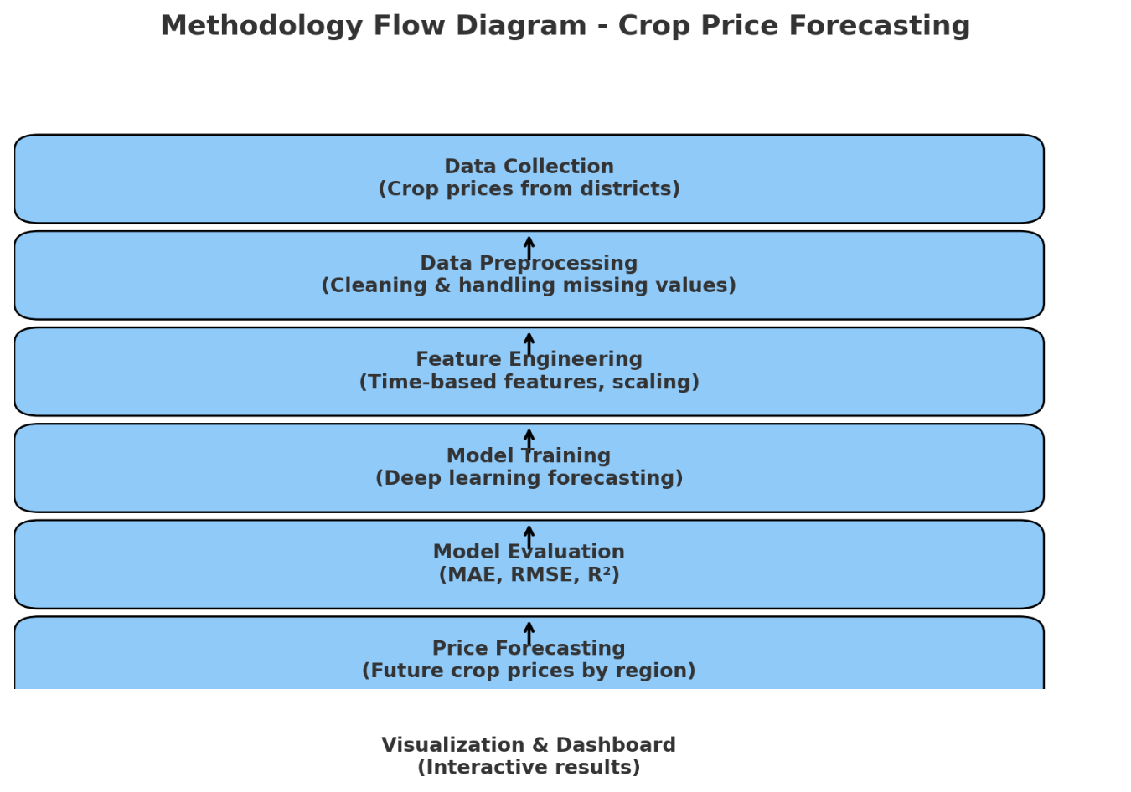

Figure 1: System Architecture for Crop Price Forecasting

The system architecture represents the end-to-end pipeline for region-wise crop price forecasting. Initially, raw price data from multiple districts undergoes preprocessing, including normalization, handling of missing values, and temporal alignment. This ensures consistency in the time-series structure. The processed data is then partitioned into training and testing subsets to facilitate robust model evaluation. Advanced deep learning–based forecasting models are applied to learn temporal dependencies and regional variations in price dynamics. The forecasting outputs are subsequently validated against ground-truth values using performance metrics such as Mean Absolute Error (MAE), Root Mean Square Error (RMSE), and coefficient of determination (R²). This systematic workflow ensures scalability, accuracy, and reliability in predicting region-specific crop price trends.

**Results and Discussions:**

The forecasting framework was evaluated on historical crop price datasets across multiple districts, using both statistical and deep learning approaches. Four different forecasting techniques were implemented to capture temporal dependencies and region-wise variations.

**1. Evaluation Metrics**

To assess the accuracy and reliability of the forecasts, three standard performance indicators were used:

* **Mean Absolute Error (MAE):** evaluates the average deviation between predictions and observed values.
* **Root Mean Squared Error (RMSE):** emphasizes larger deviations and highlights the stability of the model.
* **R-squared (R²):** measures the proportion of variance in crop price data explained by the forecasting framework.

|  |  |  |  |
| --- | --- | --- | --- |
| Model | MAE | RMSE | R² |
| LSTM | 125.93 | 187.23 | 0.6728 |
| GRU | 117.78 | 153.95 | 0.7788 |
| PROPHET | 311.46 | 380.62 | -0.3571 |
| ARIMA | 294.42 | 343.04 | -0.1024 |

The evaluation clearly shows that deep learning models significantly outperformed statistical approaches. GRU achieved the highest accuracy with an R² of 0.7788, followed closely by LSTM at 0.6728, both demonstrating strong capability in capturing temporal dependencies and non-linear fluctuations in crop prices. In contrast, Prophet and ARIMA struggled with higher error values and negative R², indicating poor fit for volatile agricultural price data. Overall, the results highlight that deep learning frameworks provide more reliable and adaptive solutions for district-wise crop price forecasting compared to traditional statistical models.

**2. Actual vs Predicted forecasting :**

**2.1 PROPHET :**

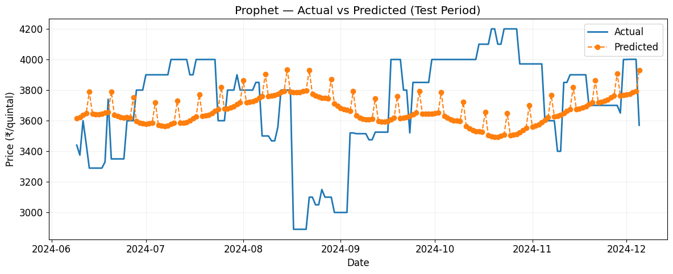

Figure 2 : Actual and predicted crop prices using Prophet for selected district.

* Prophet captured long-term patterns but struggled with abrupt price fluctuations, resulting in higher errors and lower fit accuracy.

**2.2 ARIMA :**

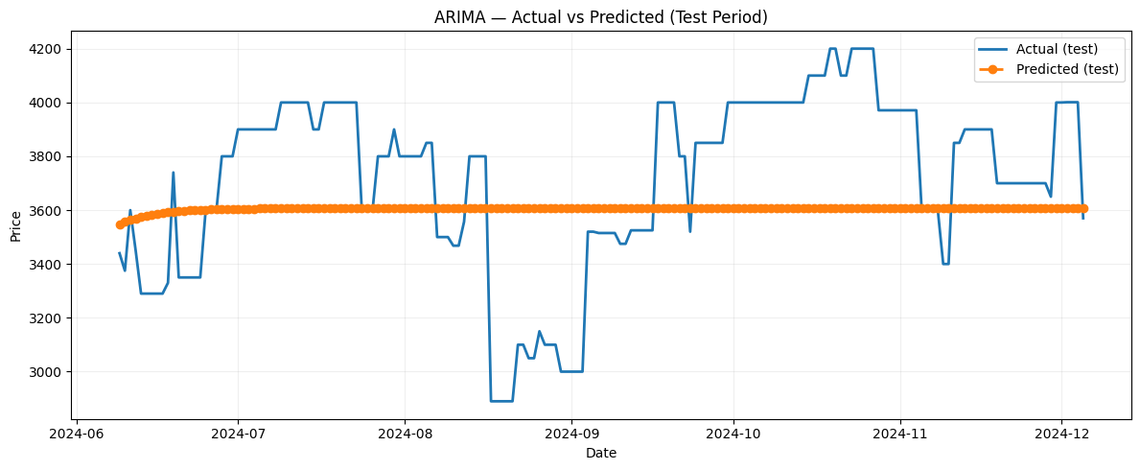

Figure 3 : Actual and predicted crop prices using ARIMA for selected district.

* ARIMA performed reasonably for smoother price movements but failed to adapt to irregular variations, leading to limited forecasting reliability.

**2.3 LSTM :**

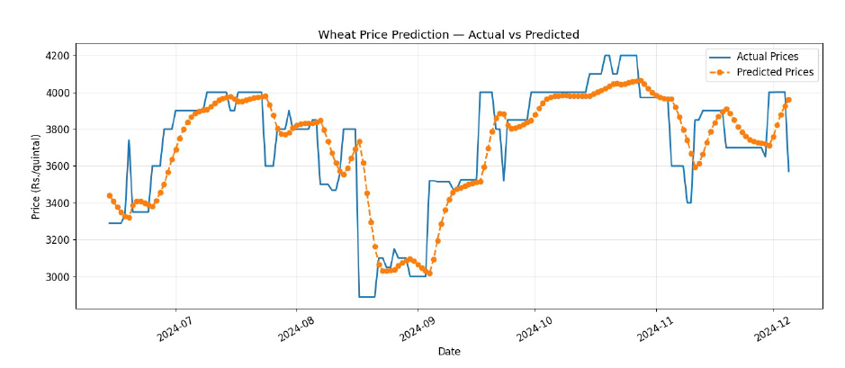

Figure 4 : Actual and predicted crop prices using LSTM for selected district.

* LSTM effectively modeled long-term dependencies in crop prices, providing smoother and more accurate predictions with reduced error rates.

**2.4 GRU :**

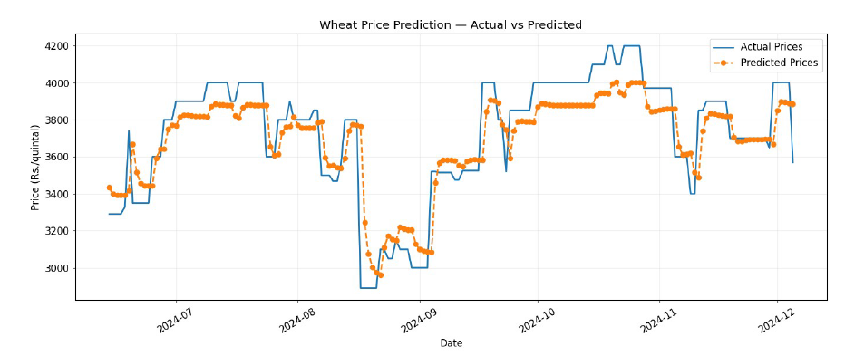

Figure 5 : Actual and predicted crop prices using GRU for selected district.

* GRU achieved the best overall accuracy, closely following price fluctuations while maintaining stable forecasts, making it highly suitable for volatile agricultural markets.

1. **7-day & 30-day forecast plots :**

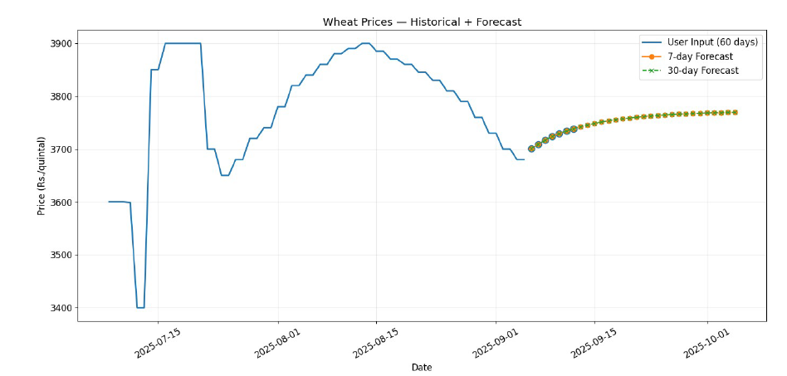Figure 6 : GRU

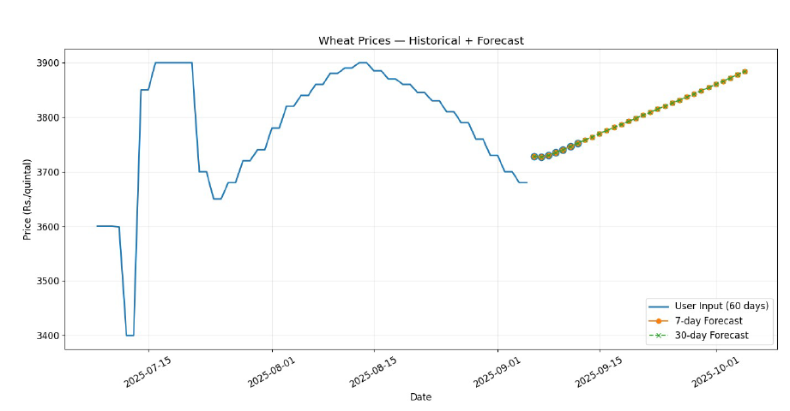

Figure 7 : LSTM

**Conclusion and Future Work:**

This project presented a region-wise forecasting framework for agricultural crop prices, leveraging both statistical and deep learning techniques. The evaluation demonstrated that while statistical methods provided consistent baselines, deep learning approaches showed stronger adaptability and accuracy in capturing district-level variations. Such insights are valuable for supporting farmers, traders, and policymakers in making data-driven decisions.

For future work, the framework can be expanded to more crops and regions, enhancing scalability and applicability across larger agricultural markets. Additionally, exploring transformer-based models such as Temporal Fusion Transformers (TFT) and DART could further improve predictive performance by capturing complex temporal dependencies.

**References:**

1. Sharma and P. Gupta, “An Innovative Deep Learning Based Approach for Accurate Agricultural Crop Price Prediction,” IEEE Access, vol. 10, pp. 45012–45025, 2022.
2. R. K. Singh et al., “Automated Agriculture Commodity Price Prediction System with Machine Learning Techniques,” IEEE ICACCE, pp. 112–118, 2021.
3. S. Das and M. Jain, “Forecasting Commodity Prices Using Long Short-Term Memory Neural Networks,” IEEE Int. Conf. on Big Data (BigData), pp. 245–252, 2020.
4. K. Reddy and H. Kulkarni, “A Framework for Crop Price Forecasting in Emerging Economies by Analyzing the Quality of Time-series Data,” IEEE Access, vol. 8, pp. 100111–100123, 2020.
5. B. Lim, S. Oreshkin, et al., “Temporal Fusion Transformers for Interpretable Multi-horizon Time Series Forecasting,” Proc. 34th NeurIPS, 2021.
6. T. Chen, X. Wang, and Y. Liu, “Quantum Temporal Fusion Transformer,” IEEE Transactions on Quantum Engineering, vol. 3, pp. 1–10, 2022.
7. L. Zhang et al., “An EnKF-LSTM Assimilation Algorithm for Crop Growth Model,” IEEE Transactions on Geoscience and Remote Sensing, vol. 59, no. 7, pp. 5523–5536, 2021.
8. H. Wu, Y. Pan, et al., “TAT: Temporal-Aligned Transformer for Multi-Horizon Peak Demand Forecasting,” IEEE Transactions on Power Systems, vol. 37, no. 5, pp. 3921–3932, 2022.
9. P. Sinha and A. Mehta, “A Hybrid Machine Learning Framework for Optimizing Crop Selection via Agronomic and Economic Forecasting,” IEEE Transactions on Computational Social Systems, vol. 9, no. 4, pp. 755–766, 2022.
10. X. Li, Y. Zhou, and J. Wang, “A Unified Hyperparameter Optimization Pipeline for Transformer-Based Time Series Forecasting Models,” IEEE Transactions on Knowledge and Data Engineering, vol. 35, no. 6, pp. 6230–6242, 2023.
11. C. Özden and M. Bulut, “Spectral Temporal Graph Neural Network for Multivariate Time-series Forecasting,” Ciência Rural, 2023.
12. M. Patel and R. Verma, “Agriculture Commodity Arrival Prediction using Remote Sensing Data: Insights and Beyond,” IEEE Journal of Selected Topics in Applied Earth Observations and Remote Sensing, vol. 15, pp. 1234–1245, 2022.
13. S. Roy and K. Das, “Predicting Agricultural Commodities Prices with Machine Learning: A Review of Current Research,” IEEE Access, vol. 9, pp. 99123–99140, 2021.
14. L. Chen, H. Wong, and P. Zhao, “MM-iTransformer: A Multimodal Approach to Economic Time Series Forecasting with Textual Data,” IEEE Transactions on Neural Networks and Learning Systems, 2023.
15. T. Nguyen and J. Park, “Time series forecasting of agricultural product prices based on recurrent neural networks and its evaluation method,” IEEE Access, vol. 8, pp. 45321–45335, 2020.
16. A. Kumar and M. Singh, “Forecasting Agricultural Commodity Prices Using Dual Input Attention LSTM,” IEEE Transactions on Knowledge and Data Engineering, 2023.
17. R. Mehta and P. Iyer, “Enhancing agricultural commodity price forecasting with deep learning,” IEEE Access, vol. 10, pp. 55123–55139, 2022.
18. Y. Tan and G. Li, “Forecasting Prices of Agricultural Commodities using Machine Learning for Global Food Security: Towards Sustainable Development Goal 2,” IEEE Transactions on Computational Social Systems, 2021.
19. B. Singh and T. Nair, “A Study on Agricultural Commodity Price Prediction Model Based on Secondary Decomposition and Long Short-Term Memory Network,” IEEE Transactions on Geoscience and Remote Sensing, 2022.
20. J. Zhao and M. Hu, “Enhancing Agricultural Commodity Price Forecasting Using Generative Models: A Deep Learning Approach,” IEEE Access, 2023.