|  |
| --- |
| Photo photo of cloud technology computing connected to digital storage in the data center via the internet |
| CLOUD COMPUTING  Create the static website using Azure Storage Service |
| |  |  |  | | --- | --- | --- | | KAVAN TEJA V | tejakavan@gmail.com | Academor | |

1. Open the azure cloud service and search for the storage accounts and open it.

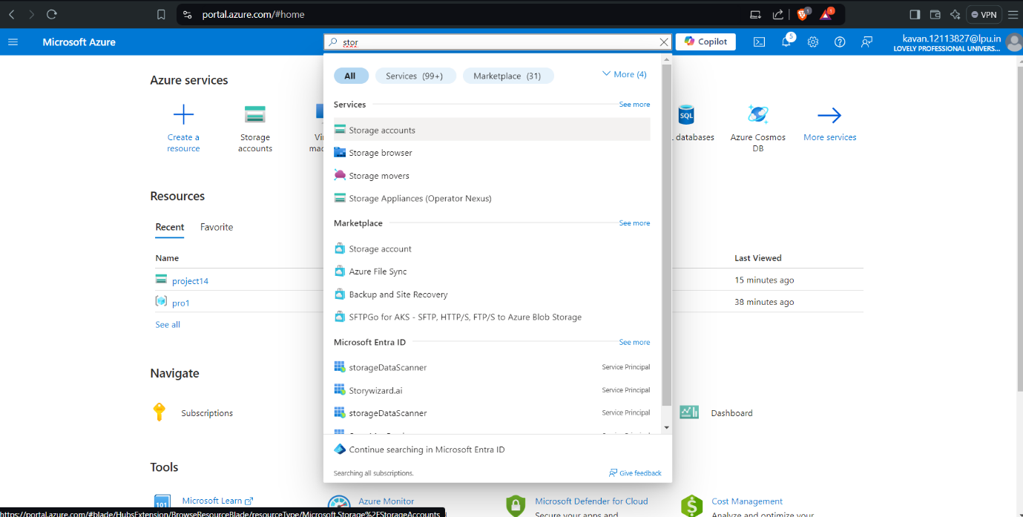

1. Select the Subscription, create the resource group, give the name of storage account name, select the region, and after that click upon the review + create.

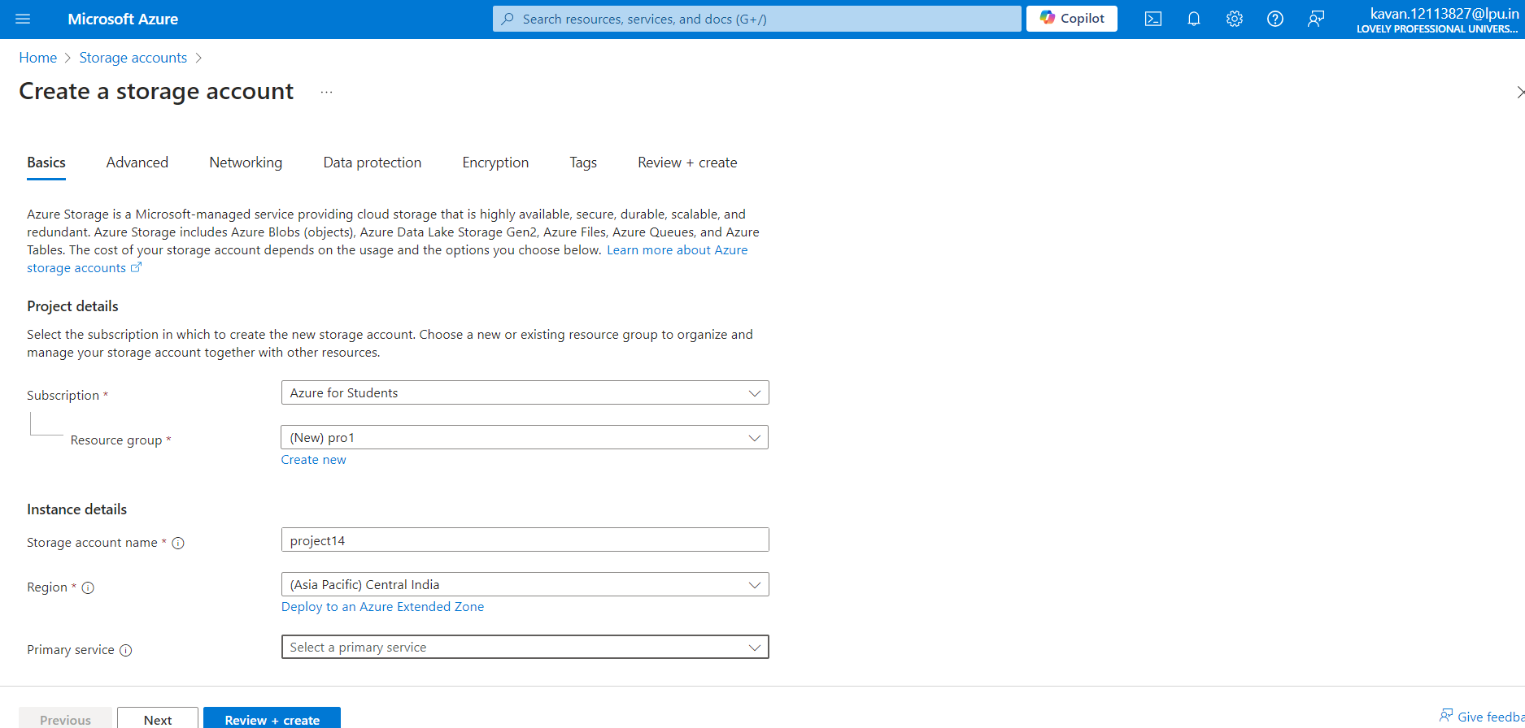

1. After clicking the review + create ,can see that deployment is in progress and wait for few seconds.

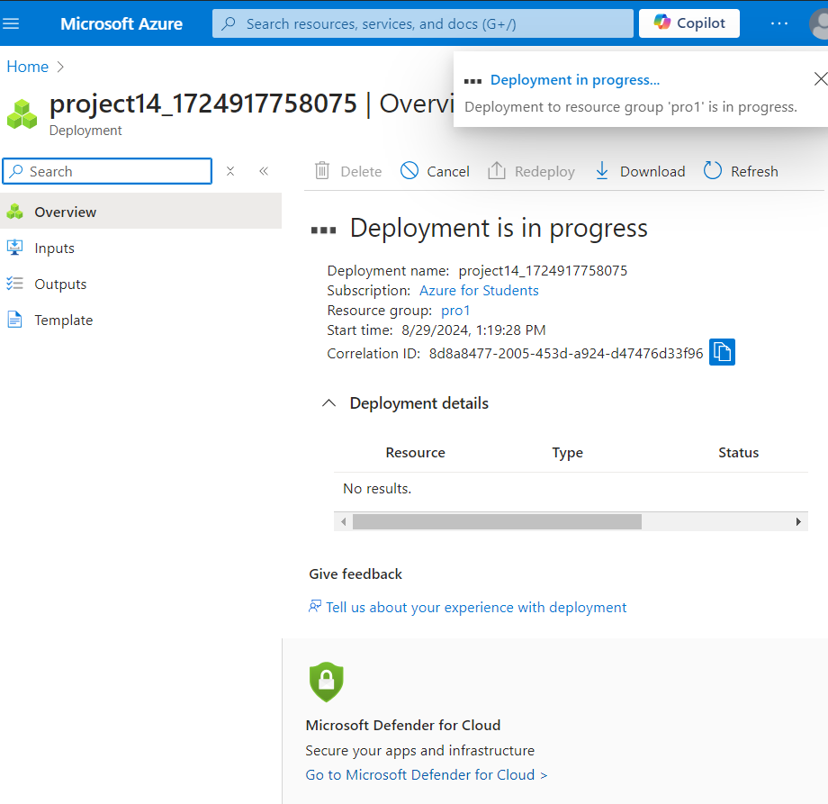

1. After waiting for few seconds, can see the Your deployment is complete

and click upon go to resource.

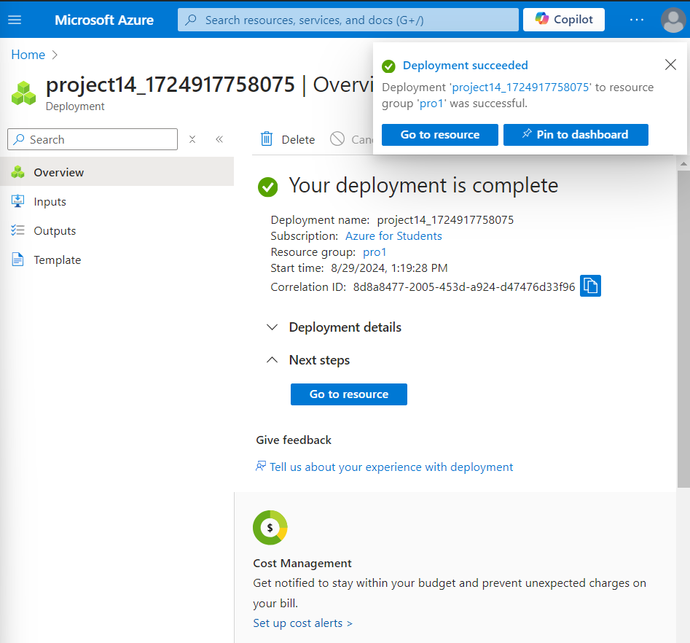

1. After going to the resource, can see the details of storage account

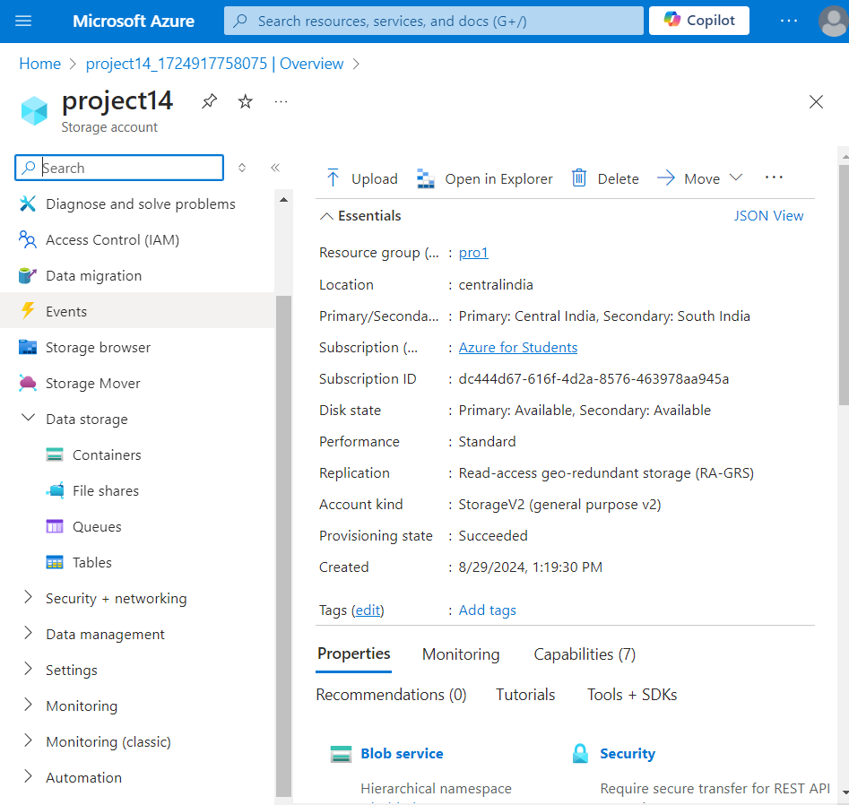

1. Now lets enable the static website to access it, click upon the data management in that can see the static website, and click upon it and enable it

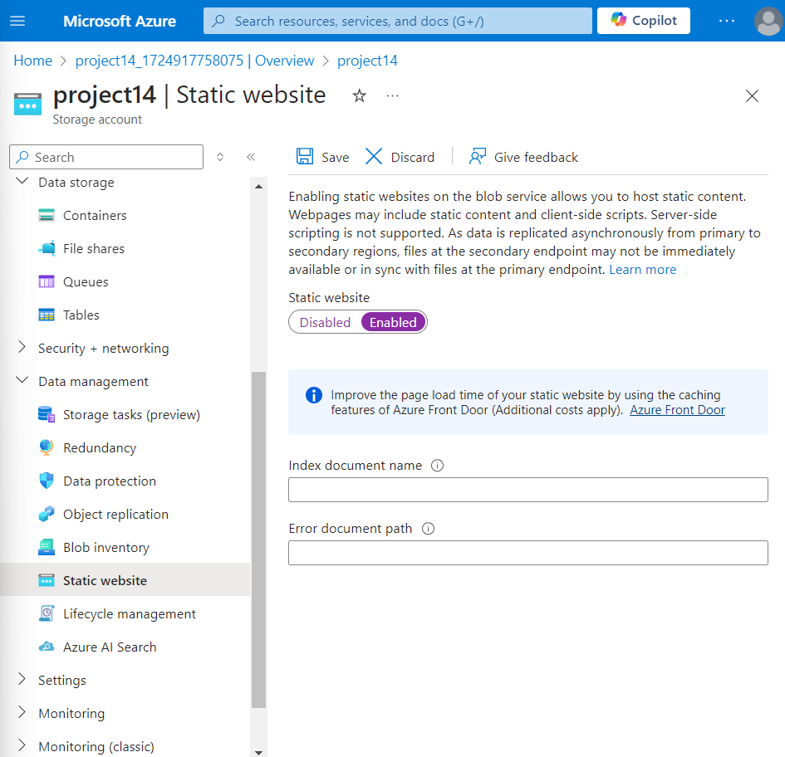

1. After enabling it, can see two rows that are index document name and error document name, give the name of the file with .html extension and fill the error document path.

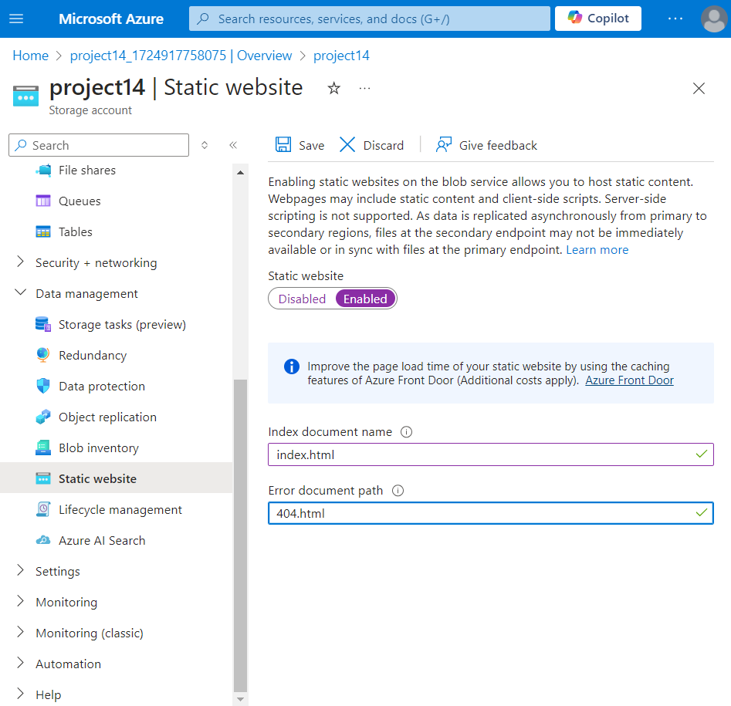

1. After filling the rows, click upon the save and can see the url endpoint, copy that endpoint.

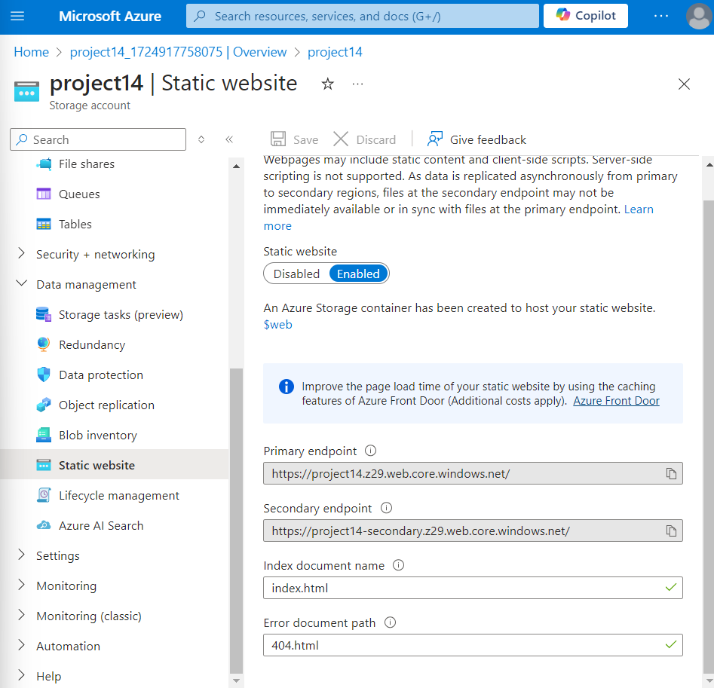

1. After copy the url endpoint, now lets create the container to store the code(index.html) of the website, click upon the data storage can see the container option and click upon it

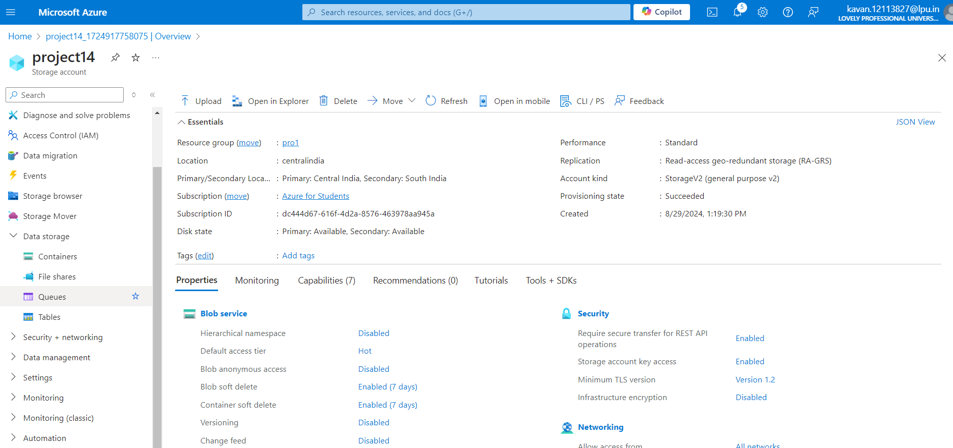

1. After clicking upon the container option, inside can see the two options $logs and $web click the $web to upload the file index.html, and select the option upload and select the file index.html and click the option upload.

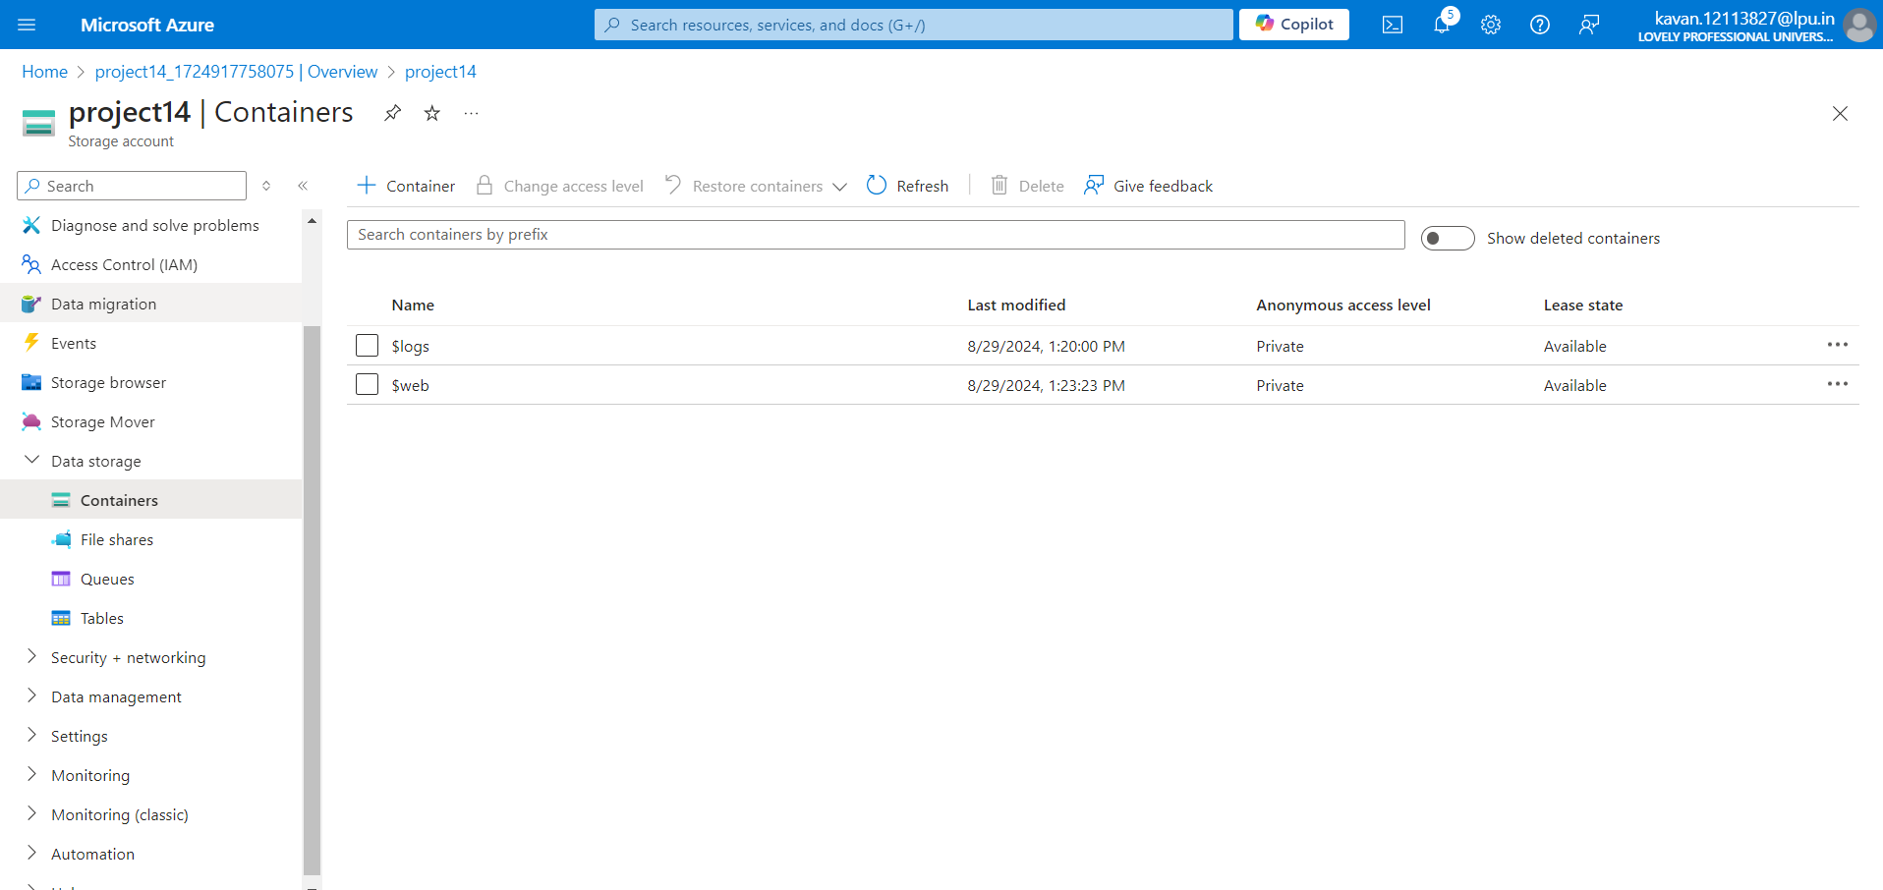

1. After uploading the file, can see toggle the successfully uploaded blob.

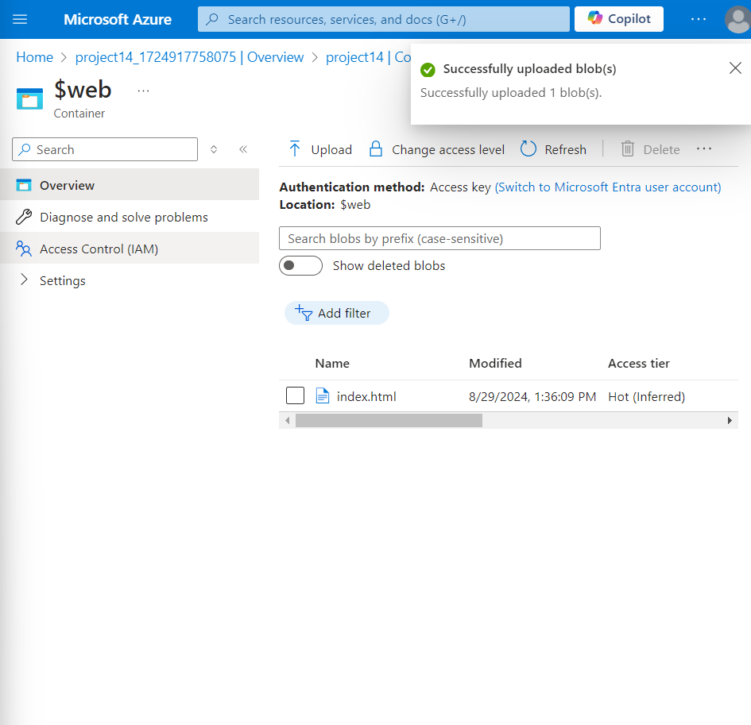

1. Now open the new tab in the browser and the paste the copied url endpoint ( <https://project14.z29.web.core.windows.net/> ) the tab and now can see the created the website in the browser.

