Name | KAVANVANSHIKUMAR CHAUDHARI
Roll no | 24204B0059
Batch | 03
Subject name | Python Programming & Data Structure
Teacher Name | Ms. Rasika Patil

Experiments | 3
Title | *a) Develop python program to demonstrate use of control loops:  i) while  ii) do while  *b) Develop program to demonstrate use of for loop in python (e.g.: various pattern building, printing multiplication table, checking palindrome number etc.)
Theory
Looping constructs allow repeated execution of a block of code.
• While Loop runs as long as a condition is true.
• Do-While Simulation is implemented in Python using while True with a break.
• For Loop is used to iterate over sequences or ranges.
These constructs help build logic for patterns, number processing, and iterative operations.
Syntax
• while condition:
• for i in range():
• break
• continue

Here's an explanation of how they work and their significance in solving iterative problems:
1. for Loops:
- for loops are used when you know the number of iterations or when iterating over a sequence (e.g., lists, tuples, strings).
- They iterate over each item in a sequence, executing a block of code for each Iteration.

Syntax | Example
for item in sequence:  # Code block to execute for each item | numbers = [1, 2, 3, 4, 5]  for num in numbers:  print(num)
2. while Loops:
A while loop is used to repeatedly execute a block of code as long as a specified condition is true. It continues iterating until the condition becomes false.
Syntax | Example
while condition:  # Code block to execute while condition is true | num = 1  while num <= 5:  print(num)  num += 1

3. Nested Loops:
You can nest loops within each other to perform more complex iterations, such as iterating over nested lists or performing matrix operations.
Syntax | Example
for outer_variable in outer_sequence:  table # Code block for the outer loop for rows  inner_variable in inner_sequence:  # Code block for the inner loop space | # Nested loops to create a multiplication  for i in range(1, 6): # Outer loop for the  for j in range(1, 6): # Inner loop for the columns  print(i * j, end='\t') # Print the product with a tab  print() # Print a new line after each row

Loop Control Statements:
Python provides loop control statements to modify the behavior of loops:
- break: Terminates the loop prematurely, exiting the loop entirely.
for i in range(5):
if i == 3:b
break print(i)
- continue: Skips the rest of the current iteration and moves to the next iteration. for i in range(5):
if i == 3:
continue print(i)
- pass: Placeholder that does nothing. It is used when a statement is syntactically required but no action is needed.
for i in range(5):
pass # Placeholder for future code

Programming Questions with Answer
FOR LOOP
1 | Print multiplication table of a number
SCRIPT | print("Name:", name)  print("Roll No:", roll_no)  # Program to display the multiplication table of a number  num = int(input("Display multiplication table of? ")) # Takes user input  # Iterate 10 times from i = 1 to 10  for i in range(1, 13):  print(num, 'x', i, '=', num*i) # Prints the formatted output
OP | 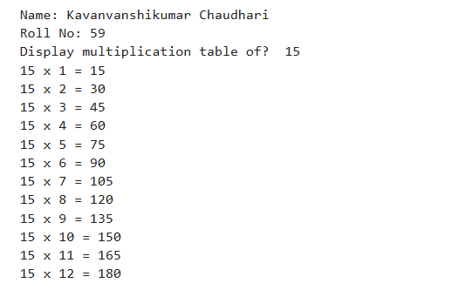
2 | Print a star pattern  * ** *** **** ***** * *** ***** *** * 1010101 10101 101 1
SCRIPT | print("Name:", name)  print("Roll No:", roll_no)  rows = 5  for i in range(1, rows + 1):  # Inner loop to print '*'  print("*" * i)  rows = 5  # Upper half of the diamond  for i in range(1, rows + 1, 2):  print((" " * ((rows - i) // 2)) + ("*" * i))  # Lower half of the diamond  for i in range(rows - 2, 0, -2):  print((" " * ((rows - i) // 2)) + ("*" * i))  rows = 3 # The initial count for the loop controls how many rows we get  current_length = 5  for i in range(rows, 0, -1):  output_str = ""  for j in range(current_length):  if j % 2 == 0:  output_str += "1"  else:  output_str += "0"  print(output_str)  current_length -= 2
OP | 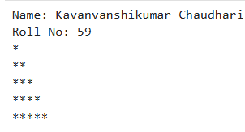  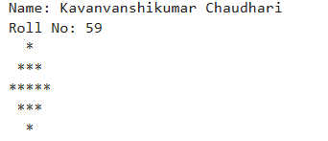  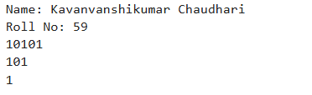
3 | Count digits in a number
SCRIPT | number = 987654 # Example input  count = 0  temp_num = number  while temp_num != 0:  temp_num //= 10 # Remove the last digit  count += 1 # Increment the count  print(f"The number of digits in {number} is: {count}")
OP | 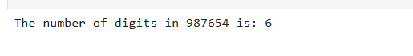
WHILE LOOP
1 | Print numbers from 1 to 20
SCRIPT | count = 1  # Loop while count is less than or equal to 20  while count <= 20:  print(count)  count += 1
OP | 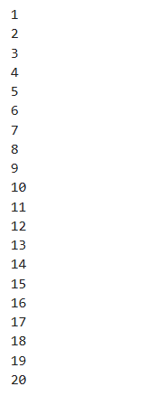
2 | Sum of digits of a number
SCRIPT | number = 12345  total_sum = 0  temp_num = number  while temp_num > 0:  digit = temp_num % 10  total_sum += digit  temp_num //= 10  print(f"The sum of digits of {number} is: {total_sum}")
OP
3 | Reverse a number
SCRIPT | number = 12345 # Example input  reversed_num = 0  temp_num = number  while temp_num > 0:  digit = temp_num % 10 # Get the last digit  reversed_num = (reversed_num * 10) + digit # Append digit to reversed number  temp_num //= 10 # Remove the last digit  print(f"The reverse of {number} is: {reversed_num}")
OP | 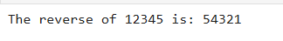
4 | Program to check if a number is a palindrome using for loop
SCRIPT | number = 121 # Example input  temp_num = number  reversed_num = 0  # Reverse the number using a while loop (as in the previous problem)  while temp_num > 0:  digit = temp_num % 10  reversed_num = (reversed_num * 10) + digit  temp_num //= 10  # Check if original is equal to reversed  if number == reversed_num:  print(f"{number} is a palindrome.")  else:  print(f"{number} is not a palindrome.")
OP | 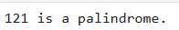
DO-WHILE SIMULATION
1 | Keep taking input until the user enters 0
SCRIPT | print("Enter numbers (enter 0 to stop):")  while True:  try:  user_input = int(input("Enter a number: "))  if user_input == 0:  print("0 entered. Stopping input.")  break # Exit the loop  else:  print(f"You entered: {user_input}")  except ValueError:  print("Invalid input. Please enter an integer.")
OP | 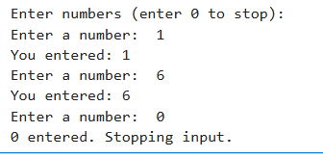
2 | Menu-driven calculator
SCRIPT | def add(n1, n2): return n1 + n2  def subtract(n1, n2): return n1 - n2  def multiply(n1, n2): return n1 * n2  def divide(n1, n2):  if n2 == 0:  return "Cannot divide by zero"  return n1 / n2  while True:  print("\n--- Calculator Menu ---")  print("1. Addition")  print("2. Subtraction")  print("3. Multiplication")  print("4. Division")  print("5. Exit")  choice = input("Enter choice (1-5): ")  if choice in ['1', '2', '3', '4']:  try:  num1 = float(input("Enter first number: "))  num2 = float(input("Enter second number: "))  result = 0  if choice == '1': result = add(num1, num2)  elif choice == '2': result = subtract(num1, num2)  elif choice == '3': result = multiply(num1, num2)  elif choice == '4': result = divide(num1, num2)  print(f"Result: {result}")  except ValueError:  print("Invalid number input.")  elif choice == '5':  print("Exiting calculator.")  break  else:  print("Invalid choice. Please enter a number between 1 and 5.")
OP | 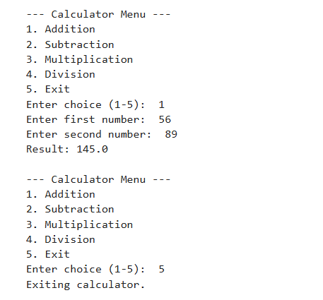
3 | Continue asking for password until correct
SCRIPT | correct_password = "mysecretpassword"  while True:  user_password = input("Enter the password: ")  if user_password == correct_password:  print("Correct password entered. Access granted.")  break # Exit the loop  else:  print("Incorrect password. Try again.")
OP | 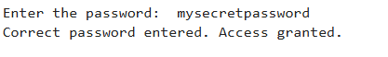
Debugging Questions with Corrected Answers
1 | Debug the following code  Wrong code:  i = 1  while i <= 5  print(i)  i = i + 1
OP | Error: The line while i <= 5 is missing the required colon (:) to start the indented block of code that belongs to the loop  Correct code:  i = 1  while i <= 5:  print(i)  i = i + 1
2 | Debug the following code  Wrong code:  for i in range(1, 10)  print(i)
OP | Error: The line for i in range(1, 10) is missing the required colon (:) to start the indented block of code that belongs to the loop  Correct code:  for i in range(1, 10):  print(i)
Conclusion | This experiment helped in understanding the use of while, do-while (using while), and for loops in Python. It demonstrated how loops are used to perform repetitive tasks efficiently, such as pattern printing, table generation, and palindrome checking.
Performance Indicators |  | Teachers Dated and Signature
Process Related  (15 M) | Product Related  (10 M) | Total (25 M)

