[1]

Neural Machine Interface

ENGR 845

Final Project Report

Muscle Fatigue Detection and Analysis using an EMG Sensor

Performed by Kavan Bhatt (SFSU ID: 922943759 and Email ID: [kbhatt@sfsu.edu](mailto:kbhatt@sfsu.edu)) and Ganavi Murthy (SFSU ID: 922958605 and Email ID: [gmurthy@sfsu.edu](mailto:gmurthy@sfsu.edu))

*Abstract*— Electromyography (EMG) is a muscle health diagnostic sensor that uses electrodes on the skin. It helps detect muscular disorders causing weakness, pain, fatigue, and paralysis. EMG is used in biomedical applications to collect data on normal muscle contractions. Two classifiers, Linear Discriminant Analysis (LDA) and Support Vector Machines (SVM), along with Mean Absolute Value (MAV) features extracted from EMG, are used. The study offers guidelines for predicting muscle fatigue using approved EMG sensors and classification methods.

# INTRODUCTION

With the rapid advancements in technology, there has been significant progress in the development of medical products aimed at improving the quality of life and extending human lifespan. Despite the availability of various treatments for muscle disorders, none have the capability to detect or prevent muscle fatigue proactively. This issue can be addressed by leveraging today's technology to create future developments focused on preventing muscle fatigue before it occurs. Prevention is often more effective than treatment, and while not all ailments can be prevented, certain measures can be reformed to reduce the risk and minimize pain. Furthermore, electromyography (EMG) sensors have the potential to transmit human muscle data to robotic arms, offering a potential solution for muscle deficiencies. While research and experiments involving raw data collection are underway, there is currently no specific utilization of EMG sensors for detecting muscle fatigue in medical systems. These sensors could be incorporated into medical systems to measure and prescribe appropriate exercise for patients or used in monitoring normal muscle activity to prevent fatigue in everyday activities. Additionally, this system could also find application beyond clinical settings, such as in gyms and among athletes, where it could be used to observe and control muscle exercise activity, preventing excessive strain and managing injuries. Moreover, the integration of artificial intelligence (AI) algorithms with electromyography (EMG) sensors holds great potential for enhancing the accuracy and efficiency of muscle fatigue detection. By analyzing the collected data in real-time, AI algorithms can identify patterns and indicators of muscle fatigue, providing valuable insights for proactive intervention and personalized treatment plans.

# Literature review

# Definition and Causes of Muscle Fatigue

Muscle fatigue is a complex physiological phenomenon characterized by a decline in muscle performance and the inability to sustain muscle contractions. It can be caused by various factors, including metabolic changes, depletion of energy stores, accumulation of metabolites such as lactate, impaired neuromuscular communication, and structural damage to muscle fibers. Understanding the definition and underlying causes of muscle fatigue is crucial for developing effective detection and analysis techniques.

1. *Significance of Muscle Fatigue Detection*

Accurate detection and analysis of muscle fatigue play a vital role in numerous fields, including sports medicine, rehabilitation, ergonomics, and clinical diagnostics. By monitoring muscle fatigue, researchers and practitioners can assess the impact of physical activities, optimize training protocols, prevent overexertion injuries, and design ergonomic interventions. Furthermore, early detection of muscle fatigue can aid in the diagnosis and management of neuromuscular disorders.

1. *Previous Studies on Muscle Fatigue Analysis Techniques*

Over the years, researchers have employed various techniques to analyze muscle fatigue. Electromyography (EMG) has emerged as a widely used non-invasive method for assessing muscle activity and fatigue. EMG measures the electrical activity produced by contracting muscles and provides valuable insights into muscle function. Previous studies have explored different signal processing algorithms, feature extraction methods, and classification techniques to identify and quantify muscle fatigue patterns.

1. *Existing Methods and Technologies for Muscle Fatigue Detection*

Several methods and technologies have been employed for muscle fatigue detection. These include time-domain analysis, frequency-domain analysis, time-frequency analysis, and machine learning-based approaches. Time-domain analysis involves analyzing EMG signals in the time domain to extract features such as amplitude, mean absolute value (MAV), root mean square (RMS), and median frequency. Frequency-domain analysis focuses on the spectral characteristics of EMG signals, examining features such as power spectral density and median frequency shifts. Time-frequency analysis techniques, such as wavelet transforms and spectrogram analysis, provide insights into the dynamic changes in muscle fatigue over time. Moreover, machine learning algorithms, including linear discriminant analysis (LDA), support vector machines (SVM), and artificial neural networks (ANN), have been employed to classify and predict muscle fatigue based on EMG data.

# Methodology

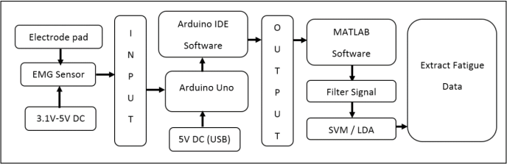

Figure 1. System Block Diagram

1. *Data Collection*

The methodology begins with the collection of data for muscle fatigue analysis. This involves recruiting participants who are representative of the target population and obtaining informed consent. Data collection may involve performing specific exercises or tasks that induce muscle fatigue while recording electromyography (EMG) signals. The EMG signals can be obtained using surface electrodes placed on specific muscles of interest. Additionally, other relevant data, such as participant demographics, muscle groups targeted, exercise protocols, and any subjective fatigue ratings, may also be collected.

1. *Electromyography (EMG) Sensors*

EMG sensors play a crucial role in capturing muscle activity and fatigue. These sensors are typically non-invasive and consist of surface electrodes that detect the electrical signals produced by contracting muscles. They are carefully placed on the skin over the targeted muscle groups. The type of electrodes and their placement locations may vary depending on the specific research or application. Proper calibration and positioning of the EMG sensors are essential to ensure accurate and reliable data acquisition.

1. *Signal Processing Techniques*

To analyze the collected EMG signals, signal processing techniques are employed. These techniques aim to extract meaningful features from the raw EMG data, which can then be used for further analysis and classification. Common signal processing techniques include filtering to remove noise and artifacts, rectification to obtain the absolute value of the EMG signal, and normalization to account for inter-individual variability. Additionally, time-domain analysis methods such as calculating mean absolute value (MAV), root mean square (RMS), or statistical moments may be applied to quantify muscle fatigue-related changes in the EMG signals.

1. *Feature Extraction Methods*

Feature extraction involves selecting relevant characteristics from the preprocessed EMG signals that can capture muscle fatigue patterns. Various features can be extracted, such as amplitude-based features (e.g., MAV, RMS), frequency-based features (e.g., median frequency, spectral moments), time-frequency features (e.g., wavelet coefficients, time-frequency entropy), or other domain-specific features. The choice of feature extraction methods depends on the specific research goals, signal characteristics, and classification algorithms to be utilized.

1. *Classification Algorithms*

Classification algorithms are employed to categorize the extracted features and determine the presence or absence of muscle fatigue. Commonly used algorithms include linear discriminant analysis (LDA), support vector machines (SVM), k-nearest neighbors (k-NN), or artificial neural networks (ANN). These algorithms are trained using labeled data, where the features extracted from EMG signals are associated with corresponding fatigue levels. The trained model can then be used to classify new, unseen data and predict the occurrence of muscle fatigue.

1. *Performance Evaluation Metrics*

The performance of the muscle fatigue detection system is assessed using appropriate evaluation metrics. These metrics include accuracy, sensitivity, specificity, precision, and area under the receiver operating characteristic (ROC) curve. Cross-validation techniques, such as k-fold cross-validation, may be employed to assess the generalizability and robustness of the classification model. Additionally, statistical tests and comparisons may be conducted to determine the significance of the results.

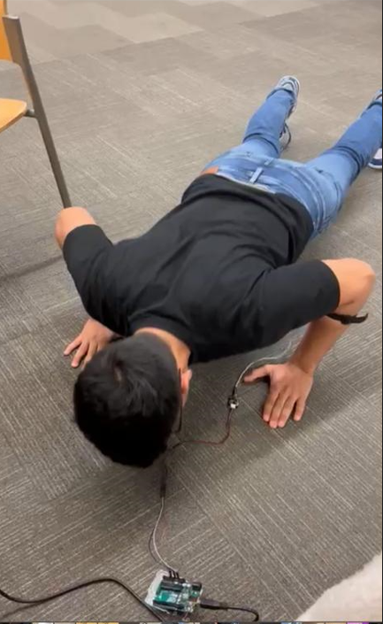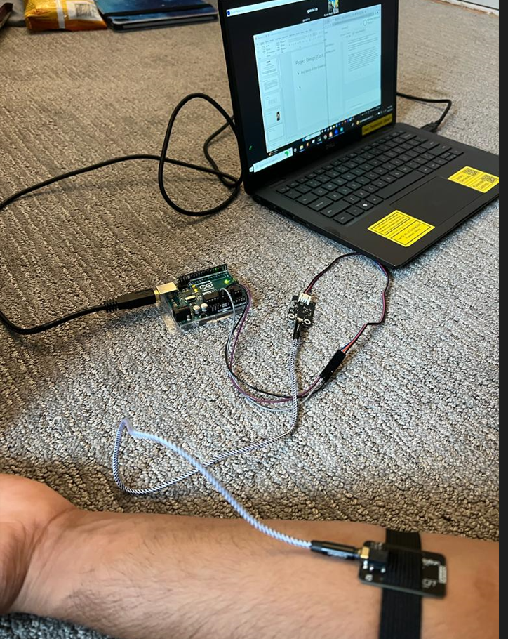

Figure 2. Performed Activity and Sensor Placement

# Results and Discussion

Fatigue occurs when a muscle is subjected to repetitive or sustained contractions, resulting in a decline in its ability to generate force. Specific activity (push-up) is performed by the subject to compare the data of fatigue and non-fatigue muscle at arm section of body. Below are the images obtained of data.

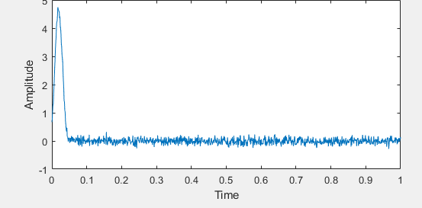

Figure 3a. Normal Muscle Signal (RAW)

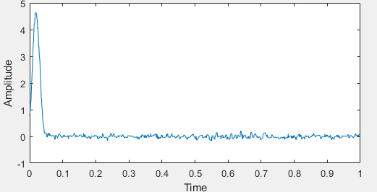

Figure 3b. Normal Muscle Signal (Filtered)

Fig

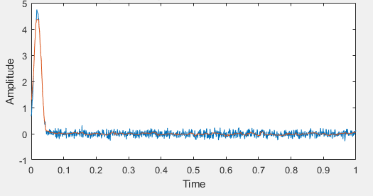

Figure 4a. Fatigued Muscle Signal (RAW)

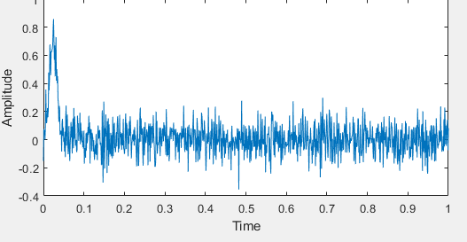

Figure 4b. Fatigued RAW subject

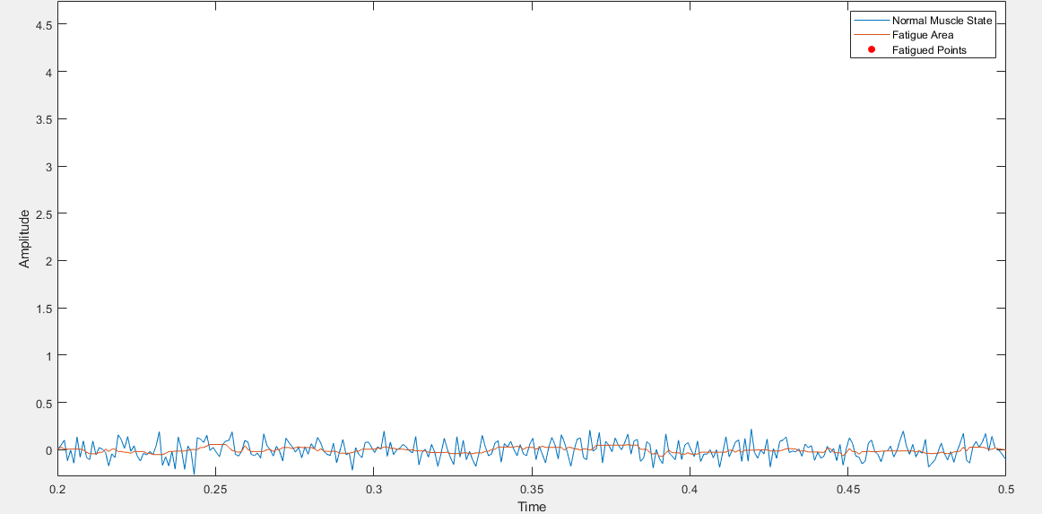

Figure 4c. Fatigued Filtered Area

The normal raw signal, represent the movement of the flexion and extension exercises of arm muscle. However, in the fatigued raw signal, there are no relaxation parts, indicating that the muscle is continuously under stress. Rectification and smoothing of signals took place in order to filter out and isolate specific activity from raw signals. Figure 4c shows us the muscle in fatigue state after all the filtration process.

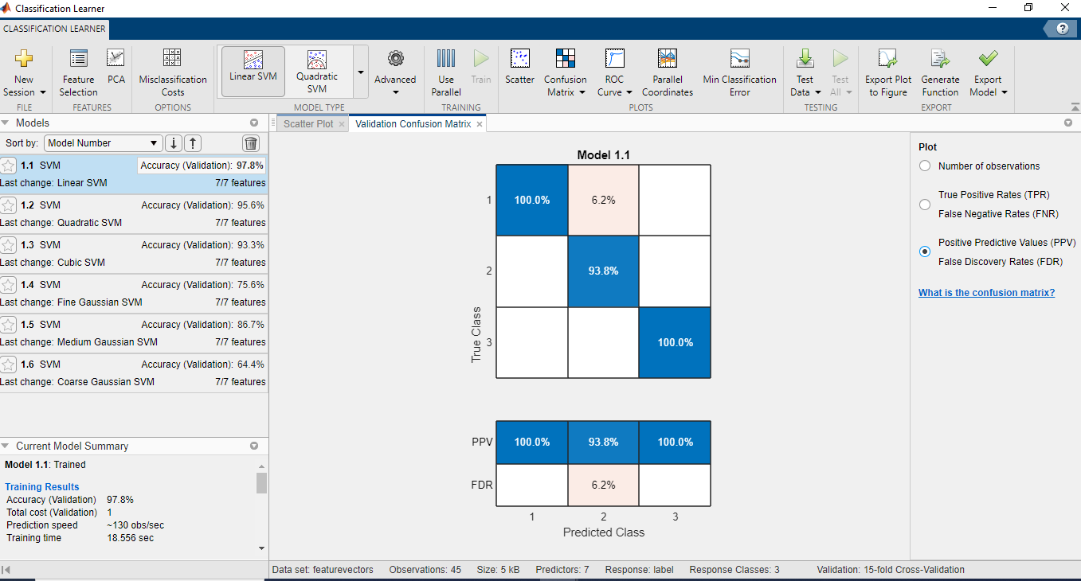

Figure 5a.

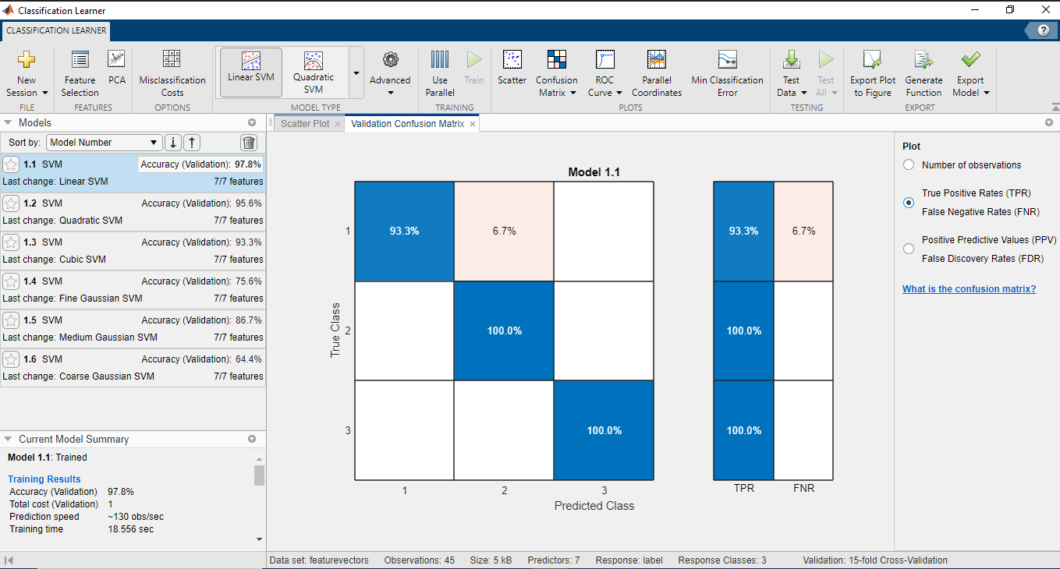

Figure 5b.

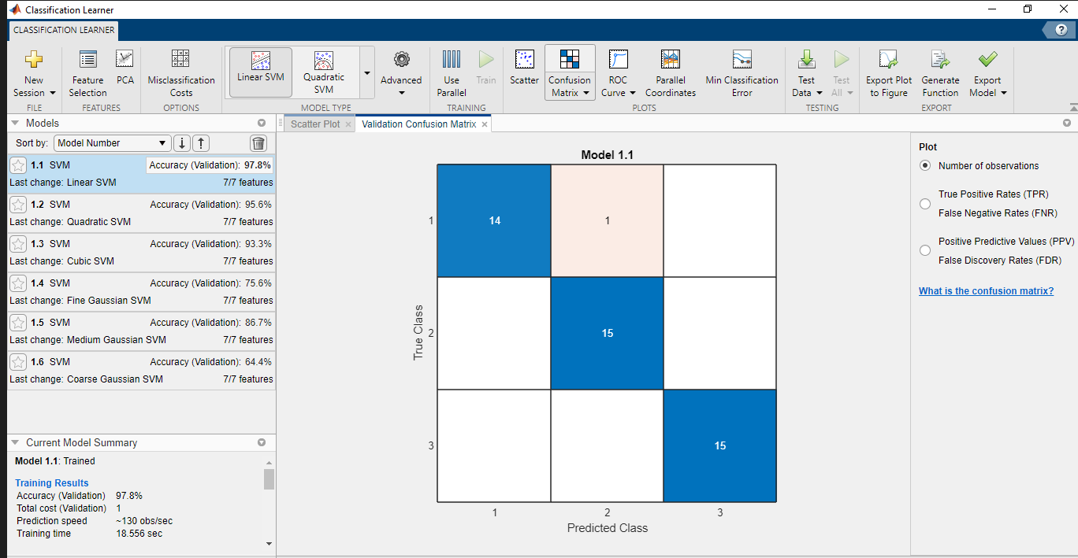

Figure 5c.

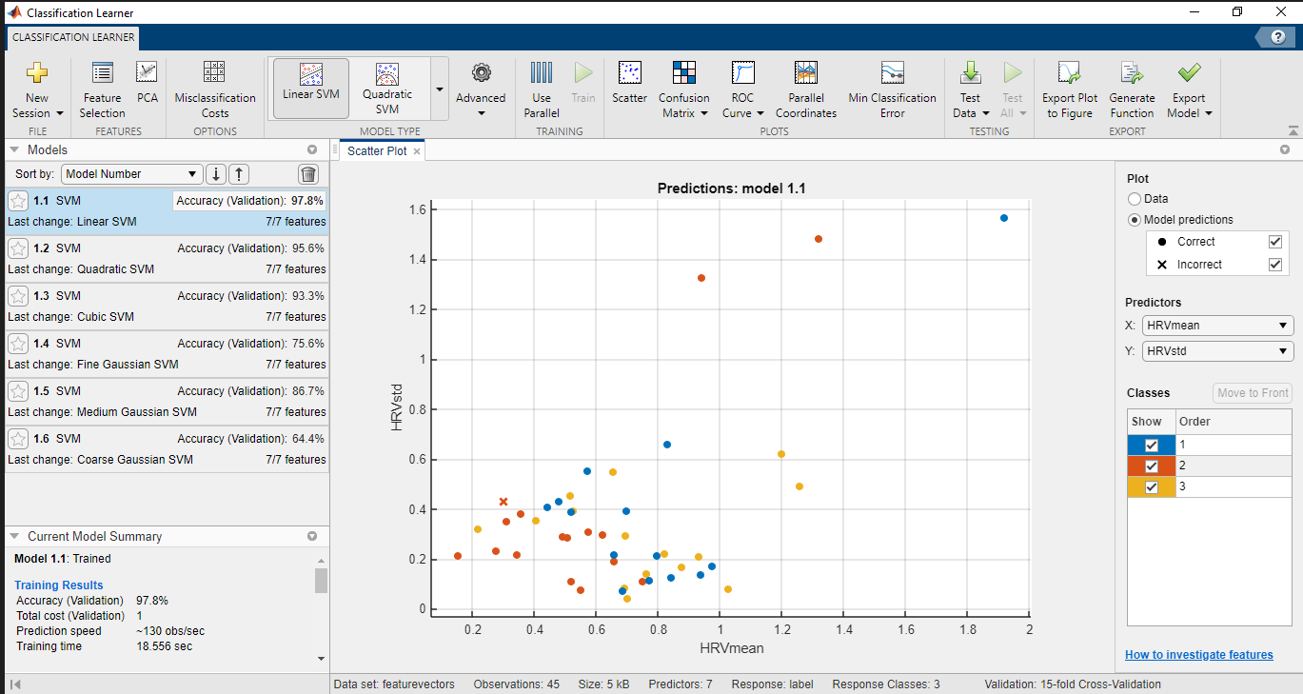

Figure 5d

# Applications and future directions

1. *Clinical Applications*

Muscle fatigue detection and analysis have significant implications in clinical settings. By accurately assessing muscle fatigue, healthcare professionals can diagnose and manage neuromuscular disorders, design personalized rehabilitation programs, and monitor patients' progress. Early detection of muscle fatigue can help prevent overexertion injuries, optimize treatment plans, and improve patient outcomes. Additionally, muscle fatigue analysis can aid in the evaluation of ergonomic interventions and assistive devices for individuals with muscle impairments.

1. *Sports and Rehabilitation Applications*

In the field of sports and rehabilitation, muscle fatigue detection plays a crucial role in optimizing training protocols and preventing injuries. Coaches and sports scientists can utilize real-time muscle fatigue feedback to adjust exercise intensity, develop customized training programs, and monitor athletes' performance. Muscle fatigue analysis also helps in the identification of asymmetries or imbalances in muscle activation, facilitating targeted rehabilitation and injury prevention strategies.

1. *Wearable Devices for Real-time Muscle Fatigue Monitoring*

The future of muscle fatigue detection lies in wearable devices that enable real-time monitoring of muscle activity. Advancements in sensor technology, miniaturization, and wireless connectivity have paved the way for unobtrusive and continuous monitoring of muscle fatigue during daily activities. Wearable EMG sensors can provide individuals with personalized feedback, helping them optimize their exercise routines, prevent overexertion, and maintain a healthy level of muscle activation. These devices can also be integrated with smartphone applications or cloud-based platforms, allowing users to track their muscle fatigue patterns over time and receive actionable insights.

1. *Potential Integration with Artificial Intelligence*

The integration of muscle fatigue detection with artificial intelligence (AI) holds great promise for enhancing accuracy and efficiency. AI algorithms can learn from large datasets and improve the classification and prediction of muscle fatigue patterns. Machine learning models can adapt and personalize their predictions based on individual characteristics, exercise history, and contextual factors. Furthermore, AI algorithms can uncover complex patterns and relationships in EMG data, enabling more comprehensive and nuanced analysis of muscle fatigue.

Acknowledgment

There are many people who have helped us directly or indirectly in the successful completion of our project. We would like to take this opportunity to thank one and all.

First of all, we would like to express our deep sense of gratitude towards our project guide and instructor Prof Xiaorong Zhang for always being available whenever we require their guidance as well as for motivating us throughout the project work.

We would thank all our friends for their help and constructive criticism during our project period. Finally, we are very much indebted to our parents for their moral support and encouragement to achieve higher goals. We have no words to express our gratitude and still we are very thankful to our parents who have shown us this world and for every support they gave us.

References

1. Analysis of lower limb muscle fatigue during standing balance tasks using electromyography-time frequency parameters. Journal of Physical Therapy Science, 27(8), 2591-2595. By Hwang, I. S., Park, D. S., Yoo, J. H., & Kim, Y.H. (2015)
2. Muscle Fatigue Detection in EMG Using Time Frequency Methods, ICA and Neural Networks by Abdul Hamit Subasi & M. Kemal Kiymik
3. <https://www.journals.elsevier.com/journal-of-electromyography-and-kinesiology> - The Journal of Electromyography and Kinesiology
4. <https://www.isek.org/> - The International Society of Electrophysiology and Kinesiology (ISEK).

1.