Global Events, Commodities and Currency Markets
The Hormuz Crisis and the New Financial Order: A Data-Driven Market Analysis
Applied Data Analytics and Market Research — Final Business Report
Date: July 2026
Prepared by: Group 14 [120A]
Department: Business
Course: Data Science in Business — Prof. Dr. Talha Ali Khan / Mr. Ebby Georges

Table of Contents
Table of Contents 2
Executive Summary 3
Introduction 3
Data and Methodology 4
Data Analytics Findings 4
Brent Crude Oil 4
Gold 5
Silver 6
Gold vs. Silver Comparison 6
Ten-Year Oil Trend and Latest Values 7
Currency Tracker Analysis 8
Comparisons to Long-Run Averages 9
Market Research Findings 9
Event Identification and Timeline 9
Linking Events to Commodity Data 9
Oil Supply Shock and Shipping Disruption 10
Gold, Geopolitical Uncertainty and the Silver Question 10
Crisis Period Comparison: 2008 vs. 2025-2026 10
Currency Markets, USD and RMB Roles 11
Which Market Is Most Sensitive to Global Events? 11
Risk Note: A Company Exposed to Oil Prices 12
Risk Note: Holders of USD, Gold or RMB/CNY Assets 12
Final Recommendation 12
Recommendation 1: Hedge Energy Cost Exposure Actively 12
Recommendation 2: Maintain Measured, Not Reactive, Exposure to Gold and Safe-Haven Assets 12
Recommendation 3: Plan for a Gradual, Not Sudden, Shift in Currency Settlement 13
Conclusion 13
Appendices 13
References (Sources) 14

Executive Summary
This report analyses one hundred years of Brent crude oil, gold and silver price data alongside the SWIFT RMB Tracker global currency dataset, covering the period from 1915 (precious metals) and 1946 (oil) through April 2026. The purpose is to describe how these markets have moved over time and to connect the observed patterns to the major global event now dominating financial headlines: the Iran-Hormuz Strait crisis, which escalated from a partial closure in February 2026 to a full U.S. naval blockade by mid-April 2026.
The data show that all three commodities are trading at, or close to, record levels in the first months of 2026. Gold reached an all-time closing high of roughly $5,278 per ounce in February 2026 before easing slightly, silver touched approximately $114 per ounce, and Brent crude jumped by more than 50% in a single month (February to March 2026) as the Strait of Hormuz closure removed a fifth of global seaborne oil supply from the market. The U.S. Dollar Index and Treasury cash position both stabilised over the same period even as the dollar's long-run share of global foreign-exchange reserves and international payments continued a two-decade decline, a trend the Hormuz crisis appears to be accelerating rather than causing.
Correlation analysis of annual average prices shows gold and silver moving almost in lock-step (correlation coefficient of 0.95), while oil is only moderately correlated with the two precious metals (0.46 and 0.51 respectively). This supports the view that gold and silver are behaving primarily as safe-haven and monetary assets during the current crisis, while oil is reacting to a direct physical supply shock.
The report's final recommendation is that businesses and investors with exposure to energy costs should assume continued volatility and hedge accordingly, that holders of dollar-denominated reserves should monitor the gradual diversification toward gold and alternative currencies without over-reacting to short-term noise, and that companies trading with China, Russia or Gulf partners should prepare for a growing share of transactions to settle outside the traditional dollar-clearing system.

Introduction
Background: Global commodity and currency markets have entered a period of unusual stress. Since late February 2026, Iran's intermittent and then complete closure of the Strait of Hormuz — the shipping channel that normally carries roughly one-fifth of the world's seaborne oil and a large share of global liquefied natural gas — has triggered the largest energy supply disruption since the 1973 oil crisis. At the same time, central banks have been accumulating gold at a record pace, the U.S. dollar's share of global reserves and payments has continued to slide, and BRICS nations have accelerated work on settlement systems that bypass the dollar entirely.
Objective: This report uses four datasets — Brent crude oil prices (1946-2026), gold prices (1915-2026), silver prices (1915-2026) and the SWIFT RMB Tracker currency dataset (January-April 2026) — to (1) describe what actually happened to these markets over time, and (2) connect the observed data patterns to the Hormuz crisis and the broader shift some commentators are calling a 'new financial order'. The report is written for a non-technical manager who needs to understand risk, opportunity and market direction rather than the statistical detail behind each chart.
Scope: The quantitative analysis (Part I, reproduced in full in the accompanying questionnaire document) covers data preparation, descriptive statistics, trend charts, currency tracker analysis and simple comparisons across the three commodities. The market research component (Part II) links these findings to the Hormuz crisis and related events described in the supporting briefing materials provided for this assignment, principally the 'A New Financial Order' special report and the April 2026 geopolitical briefing on the Iran war and GCC crisis. The report does not attempt to forecast the outcome of the conflict itself; any trendline shown in the appendix is explicitly labelled as an estimate, not a prediction.

Data and Methodology
Data sources: Four files were provided for this assignment. 'Brent Oil.csv' contains 963 monthly observations from January 1946 to March 2026. 'Gold 100years.csv' and 'silver 100 years.csv' each contain 1,336 monthly observations from January 1915 to April 2026. 'swift_currency_tracker_all_reports.csv' contains 330 rows drawn from four monthly SWIFT RMB Tracker-style reports (January, February, March and April 2026), covering global payment share, trade finance share, offshore RMB activity and FX spot rankings.
Data preprocessing: The three commodity files store one row per month, with the date field written as month-day-year and the day component fixed at '01' for every record (for example, 06-01-2008 represents June 2008, not the 6th of January). Parsing these dates using a day-first format initially produced impossible results — for instance, twelve consecutive 'days' in January rather than one row per calendar month — so the columns were re-parsed using a month-first format and Year and Month fields were derived from the corrected date. No missing values and no duplicate dates were found in any of the three files after cleaning. This date-format issue was the main data-quality finding for this assignment and is a useful reminder that a data set should always be sense-checked (for example, by counting rows per year) before being trusted for analysis.
Methodology: Descriptive statistics (minimum, maximum, mean, standard deviation) and annual averages were calculated for each commodity using Python (pandas). Trend and comparison charts were produced with matplotlib. A Pearson correlation matrix was calculated on annual average prices for the years common to all three commodity series. A twelve-month moving average was applied to the Brent oil series to smooth short-term noise, and a simple linear trendline was fitted to the last ten years of annual gold prices purely as an illustrative estimate. The currency tracker dataset was filtered by report month and metric to identify the top currencies by global payment share, the USD and CNY/RMB positions, and the leading offshore RMB financial centres.
Assumptions and limitations: The commodity series are treated as representative monthly benchmark prices rather than exact daily spot quotations; some 2026 observations may reflect provisional or rounded figures. The currency tracker only covers a four-month window (January-April 2026), so year-over-year currency comparisons were not possible and the analysis instead focuses on the most recent available month and the direction of change across the four reports. Correlation was calculated on annual averages rather than daily data because the commodity series are monthly.

Data Analytics Findings
This section summarises the main quantitative results from Part I of the questionnaire. Full question-by-question answers, tables and charts are provided in the accompanying questionnaire document; the discussion here focuses on the findings most relevant to a business reader.

Brent Crude Oil
Brent oil has ranged from a monthly average low of $21.11 in March 1946 to an all-time monthly high of $211.21 in June 2008, with an overall average across the full 80-year series of $62.71 per barrel. The most recent data point in the file, March 2026, stands at $102.86, comfortably above the long-run average. The five highest-priced years on record are 2008, 1980, 2011, 2013 and 2012 — all periods associated with either an oil price shock (1979-80 energy crisis) or a Gulf-region supply disruption (Arab Spring and its aftermath, 2011-2013).
The most striking recent movement is a 52% month-on-month jump in March 2026 alone, following a 12% rise in January and a further 3% rise in February. This three-month acceleration lines up precisely with the escalation of the Hormuz crisis: Iran's closure of the Strait from late February 2026, the collapse of the Islamabad peace talks on April 12, and the U.S. naval blockade announced the same day. Averaged over the last ten years in the dataset (2017-2026), Brent oil has ranged from a 2020 pandemic-driven low of about $49 to a 2022 high of roughly $106, with the current 2026 partial-year average of about $79 already trending toward the upper end of that range.
Of the three assets studied, Brent oil shows the lowest relative volatility by coefficient of variation (0.57) despite the recent spike, because its long history includes extended calmer periods that dilute the crisis months. In absolute terms, however, the March 2026 monthly move is one of the largest single-month changes in the entire 80-year series.
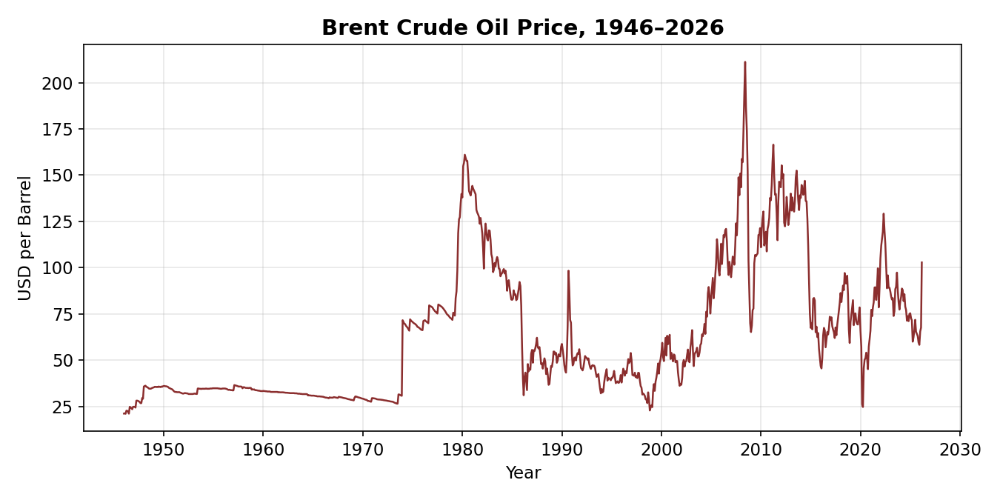

Gold
Gold has risen from $19.25 per ounce in January 1915 (the fixed price under the pre-war gold standard) to an all-time monthly high of $5,277.89 in February 2026, before easing slightly to $4,712.89 by April 2026. The long-run average across the full series is $397.55, meaning the current price is more than eleven times the 111-year historical average — a clear signal that gold is trading in genuinely exceptional territory rather than simply drifting upward with inflation.
The five strongest years for gold are, in order, 2026, 2025, 2024, 2023 and 2022 — an unbroken run of new records each year since 2022, well before the Hormuz crisis began. This tells a two-part story: gold was already on a multi-year bull run driven by central-bank buying, inflation concerns and general geopolitical uncertainty, and the Hormuz crisis has acted as an accelerant on top of that existing trend rather than as its sole cause. Annual average gold rose 40.6% in 2026 alone (partial year), on top of a 44.4% rise in 2025 and a 24.9% rise in 2008 during the global financial crisis, showing that the current rally is larger, in percentage terms, than even the 2008 crisis-driven surge.
Gold's coefficient of variation (1.64) is the highest of the three assets studied, reflecting the long span of the dataset (from a fixed pre-1971 gold-standard price to a fully free-floating modern market) rather than short-term instability; on a like-for-like recent-decade basis gold has actually been comparatively orderly, trending steadily rather than swinging sharply month to month, aside from the 2026 spike.
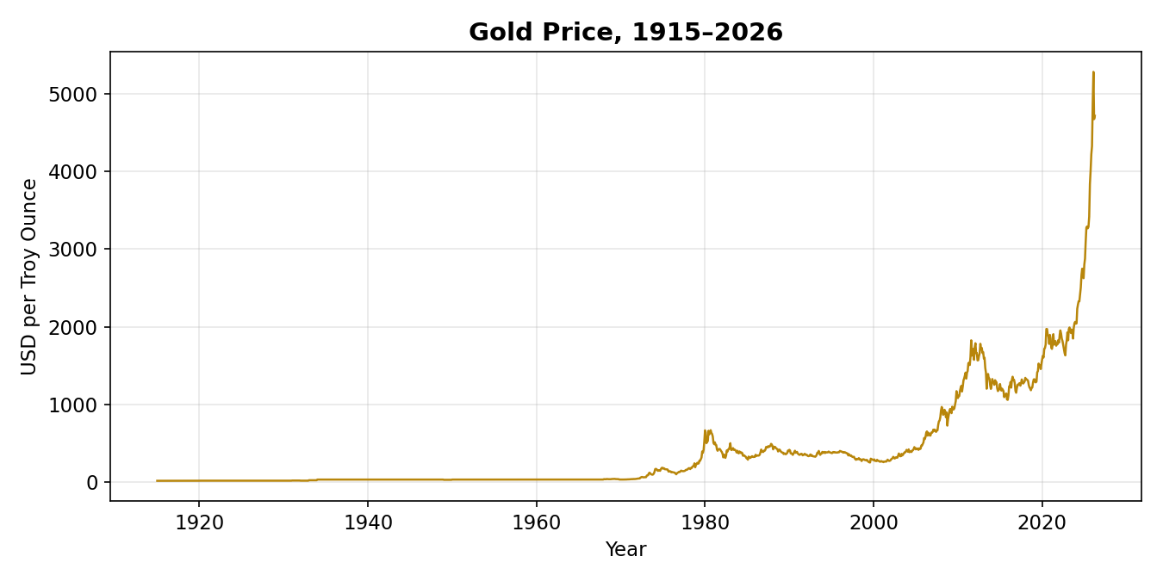

Silver
Silver has moved from $0.51 per ounce in January 1915 to an all-time high of roughly $113.95 in January 2026, before easing modestly to $88.36 by April 2026. The 111-year average sits at just $6.42, so, like gold, the current price is dramatically above its historical norm — in silver's case, by a factor of nearly fourteen. The strongest years on record are 2026, 2025, 2011, 2012 and 2024. The presence of 2011-2012 in that list reflects the earlier silver spike tied to the European debt crisis and heavy investment demand, while 2024-2026 reflects the current rally.
Silver's 2026 annual average is up 131.5% year over year — more than three times the percentage gain recorded by gold over the same period. This is consistent with silver's historical tendency to amplify the moves seen in gold, both on the way up and on the way down, because silver has a smaller market and a meaningful industrial-demand component (electronics, solar panels) alongside its role as a monetary metal.
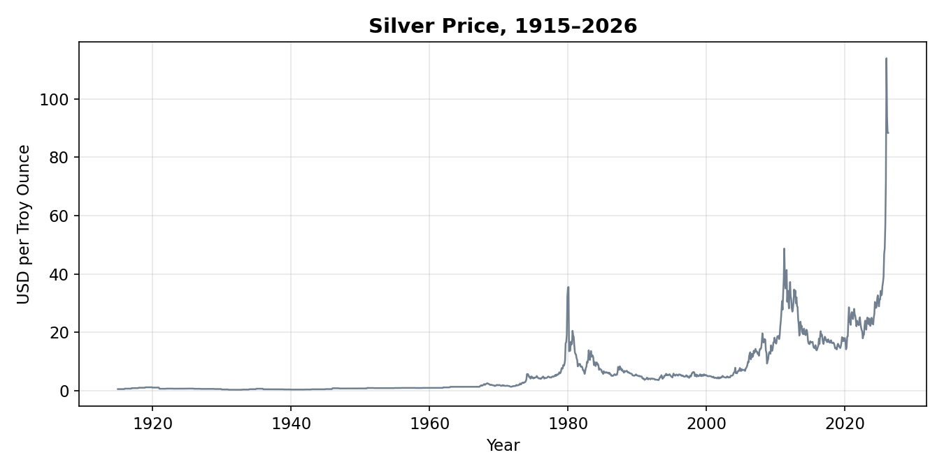

Gold vs. Silver Comparison
Plotted together, gold and silver track each other closely across the full history, with the correlation between their annual average prices at 0.95 — one of the strongest relationships in the entire dataset. Both metals set new all-time highs within weeks of each other in January-February 2026, both are running far above their long-run averages, and both accelerated sharply in the same crisis window. The main visible difference is amplitude: silver's percentage swings are consistently larger than gold's in both directions, which is the expected pattern for a smaller, more industrially-linked precious metal. In the current period, silver's behaviour looks closer to a leveraged version of gold than to a purely industrial commodity — its 2026 surge has tracked the safe-haven narrative driving gold rather than any story about industrial demand.
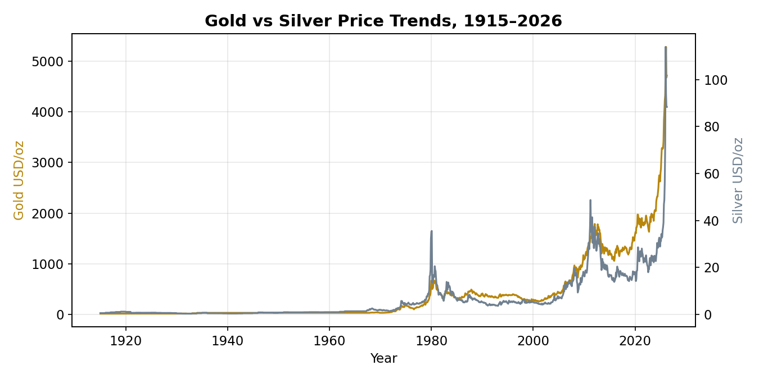

Ten-Year Oil Trend and Latest Values
The bar chart below shows average annual Brent prices for 2017-2026. Oil bottomed during the 2020 pandemic collapse in demand, recovered sharply through 2021-2022 as economies reopened and Russia's invasion of Ukraine disrupted energy markets, eased back through 2023-2025 as supply normalised, and has now turned sharply higher again in the 2026 partial year as the Hormuz crisis unfolds. The latest available values are Brent crude at $102.86 per barrel, gold at $4,712.89 per ounce and silver at $88.36 per ounce.
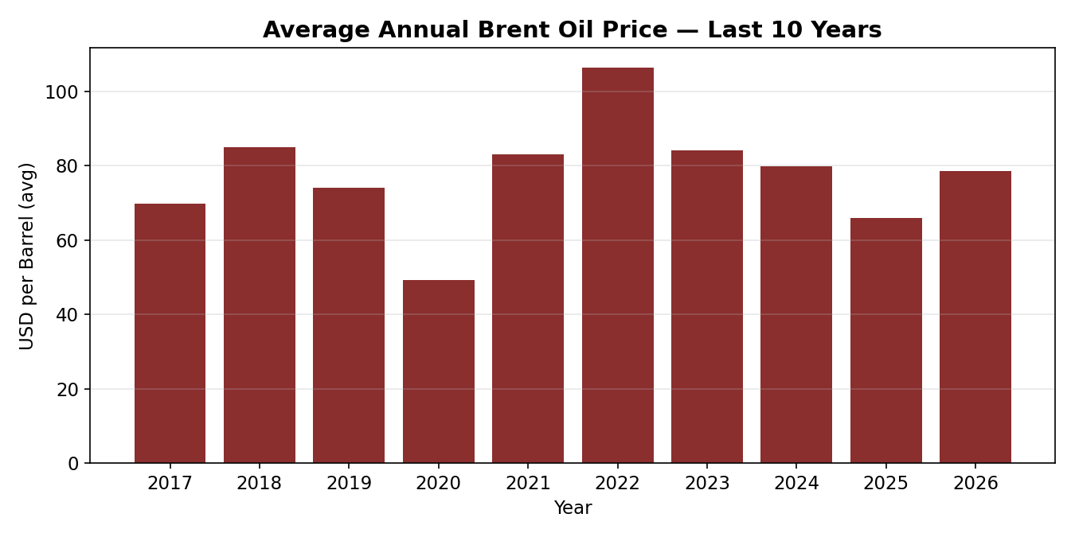

Currency Tracker Analysis
The SWIFT RMB Tracker data for April 2026 shows the U.S. dollar still firmly in first place for global payments with a 51.1% share, followed by the euro at 21.3%, sterling at 6.5% and the Japanese yen at 3.5%. The Chinese yuan (CNY/RMB) ranks fifth globally with a 3.1% payment share. Across the four available monthly reports (January-April 2026), the dollar, euro, sterling and yen have appeared in the global top five in every single report, while the yuan and Canadian dollar have alternated for the fifth and sixth positions — the yuan appearing in the top five twice in the four-month window, a modest but real sign of its growing role.
Within offshore RMB activity, Hong Kong dominates by a wide margin with a 75.2% share of offshore RMB business, more than ten times its nearest rival, the United Kingdom, at 6.9%. Singapore (4.4%), the United States (2.8%) and France (1.8%) round out the top five. This concentration shows that, despite talk of a broader de-dollarisation and multi-polar currency system, the practical infrastructure for using the yuan outside China still runs overwhelmingly through a single hub, Hong Kong, rather than being genuinely distributed across many financial centres.
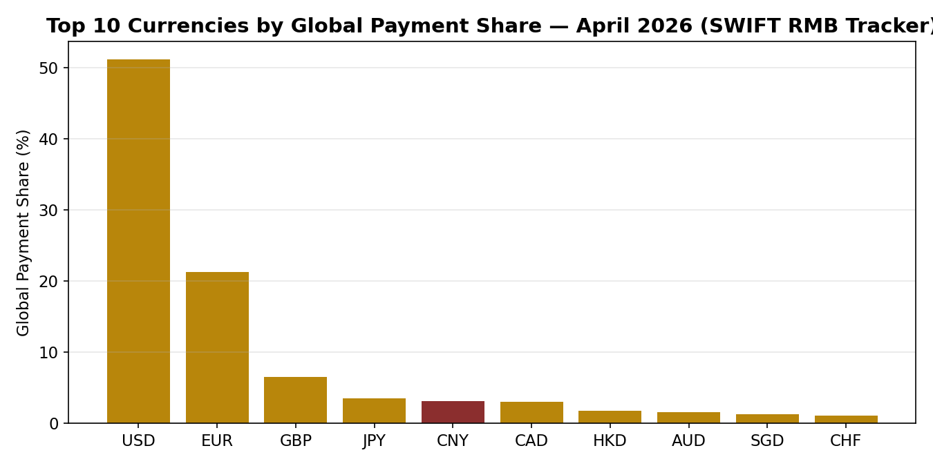

Comparisons to Long-Run Averages
Both gold and Brent oil are trading well above their full-history averages: gold's April 2026 value of $4,712.89 is roughly 11.9 times its 111-year average of $397.55, and Brent's latest value of $102.86 is about 1.6 times its 80-year average of $62.71. Measured by standard deviation relative to the mean (coefficient of variation), gold shows the largest relative price swings across its full history (1.64), followed closely by silver (1.54), with Brent oil noticeably lower (0.57) — though, as noted above, oil's single largest recent monthly move (the 52% March 2026 jump) is nonetheless one of the sharpest short-term shocks in the whole dataset.
Looking at a specific crisis comparison, in 2008 (the global financial crisis and an earlier oil price spike) Brent rose 26.7% for the year while gold rose 24.9% and silver rose only 10.8% — a year in which oil actually led the precious metals higher. In the current 2025-2026 window the pattern has reversed: Brent fell 17.4% in 2025 before rebounding 19.3% in the 2026 partial year, while gold rose 44.4% in 2025 and a further 40.6% in 2026, and silver rose 47.5% in 2025 and 131.5% in 2026. In other words, the current crisis has been led far more strongly by the precious metals than by oil, which is consistent with the idea that markets are pricing in monetary and geopolitical risk (favouring gold and silver as safe havens) at least as much as, if not more than, the physical oil supply shock itself.

Market Research Findings
This section connects the data patterns above to the global events described in the supporting briefing materials, principally the 'A New Financial Order' special report (updated April 13, 2026) and the geopolitical brief on the Iran-Hormuz crisis.

Event Identification and Timeline
Three connected global events stand out as the main drivers of the market moves observed in Part I. First, the Iran-Hormuz Strait crisis: large-scale strikes against Iranian targets began in late February 2026, Iran responded by closing the Strait of Hormuz — a route that normally carries roughly 20% of the world's oil shipments — and, after a brief ceasefire in early April, the conflict escalated again when peace talks in Islamabad collapsed on April 12 and the United States announced a naval blockade the following day. Second, sustained central-bank gold accumulation: central banks bought a record 710 tonnes of gold in the third quarter of 2025 alone, with full-year 2026 purchases projected near 900 tonnes, creating persistent demand that predates and now compounds the crisis-driven safe-haven buying. Third, an accelerating shift away from dollar settlement: Saudi Aramco has begun invoicing some crude cargoes to China outside the dollar, Russia and China now settle roughly 95% of their bilateral trade in yuan and roubles, and the dollar's share of global foreign-exchange reserves has fallen from 72% in 2005 to under 57% today under the IMF's revised reporting methodology.
A short timeline: October 2025 — BRICS holds its Kazan summit, with Turkey becoming the first NATO member to apply for BRICS membership; October 2025 — the U.S. Treasury General Account falls to a critical low near $7.9 billion; late February 2026 — large-scale strikes begin and Iran closes the Strait of Hormuz to commercial shipping; January-February 2026 — gold and silver both set new all-time highs; April 7-8, 2026 — a temporary ceasefire is agreed, with Iran charging over $1 million in tolls per ship for passage; April 12, 2026 — the ceasefire collapses and the U.S. announces a naval blockade of the Strait; April 13, 2026 — U.S. warships cross the Strait for the first time since the conflict began, and Iran threatens a 'severe response'.

Linking Events to Commodity Data
The event most directly connected to Brent oil prices is the Hormuz Strait closure itself. The March 2026 chart shows a 52% single-month price jump that lines up exactly with the period in which the closure went from partial to near-total, oil exports west of Hormuz fell by an estimated 76%, and roughly 128 million barrels became trapped in transit or floating storage as Gulf producers curtailed output. This is about as clean a case of a physical supply shock driving a commodity price as exists in the dataset, and it explains why oil's month-on-month move dwarfs anything seen in the rest of the 2017-2026 bar chart.
The event most directly connected to gold and silver is less a single incident than the compounding effect of geopolitical uncertainty layered on top of an already-strong multi-year trend of central-bank buying and de-dollarisation. Gold and silver both reached their all-time highs in January-February 2026, slightly ahead of the sharpest oil moves, which suggests investors were already pricing in crisis risk (and continuing to buy gold as a reserve asset) before the most extreme supply disruption actually hit oil markets. The gold vs. silver correlation of 0.95 shown in the combined chart confirms that both metals are responding to the same underlying driver — flight to safety and monetary hedging — rather than to industrial-demand factors that would normally push their prices apart.

Oil Supply Shock and Shipping Disruption
A shipping-route closure like the Hormuz blockade affects oil prices through a straightforward supply-and-demand mechanism: a substantial share of global supply (about one-fifth of seaborne oil shipments) is removed or delayed, while global demand does not fall by anywhere near the same amount in the short run, so the market clears at a much higher price. The Brent oil chart shows this precisely — a slow build from January to February 2026 as the crisis developed, then a sharp acceleration in March once the blockade tightened and roughly 128 million barrels were left stranded in transit or floating storage, with Saudi Arabia and the UAE curtailing production as onshore and offshore storage filled up. The 12-month moving-average chart in the appendix smooths out this spike and confirms that the underlying trend was already gently rising through 2025 before the crisis produced the sharp March 2026 jump on top of it.

Gold, Geopolitical Uncertainty and the Silver Question
Gold tends to rise during periods of geopolitical uncertainty for three connected reasons visible in this data: it is a physical asset with no counterparty or default risk, it is the reserve asset central banks are actively adding to their balance sheets regardless of the news cycle (710 tonnes bought in a single quarter in 2025), and it benefits directly from safe-haven demand whenever confidence in currencies or financial systems is shaken — exactly the environment created by a naval blockade of a critical energy chokepoint and an accelerating dollar reserve-share decline. The gold price chart shows this playing out as a steady multi-year climb that steepens sharply into the 2026 crisis window.
In the current period, silver is behaving far more like a leveraged precious metal than like a purely industrial commodity. If silver were being driven mainly by industrial demand (solar panels, electronics), its price moves would be expected to diverge from gold's, tracking manufacturing and green-energy investment cycles instead. Instead, the 0.95 correlation with gold, the fact that both metals set records within weeks of each other, and silver's 131.5% year-over-year jump in 2026 (more than three times gold's percentage gain, but in the same direction and same timeframe) all point to silver amplifying the same safe-haven and monetary story as gold, rather than following a separate industrial-demand narrative, during this crisis period.

Crisis Period Comparison: 2008 vs. 2025-2026
Comparing the global financial crisis year of 2008 with the current 2025-2026 period highlights an important shift in market leadership. In 2008, Brent oil rose 26.7% for the year and actually led gold (up 24.9%) and silver (up only 10.8%) higher — the crisis was fundamentally a financial and economic shock in which oil, still riding the tail end of the pre-crisis commodity boom, moved first and hardest. In 2025-2026, the roles have reversed: oil fell 17.4% in 2025 before rebounding 19.3% in the 2026 partial year, a much choppier path, while gold and silver rose steadily and sharply throughout both years (44.4% and 47.5% in 2025; 40.6% and 131.5% in the 2026 partial year). This tells a manager something useful: the current crisis is being priced first and foremost as a monetary and reserve-currency story by the gold and silver markets, with the oil market reacting more specifically and more sharply to the physical Hormuz supply shock only once the blockade was fully in place.

Currency Markets, USD and RMB Roles
The Global Currency Tracker shows the U.S. dollar retaining a commanding lead in international payments, with a 51.1% global payment share in April 2026 versus 21.3% for the euro — more than double its nearest rival, and consistent across every one of the four months in the dataset. This confirms that, despite the de-dollarisation headlines, the dollar's role as the dominant payment currency has not been displaced in the short window covered by this data; what has changed is the pace of gradual erosion in its reserve-currency share over a much longer horizon (from 72% of global reserves in 2005 to under 57% today).
The tracker shows CNY/RMB holding a stable but modest fifth-place global payment ranking (3.1% in April 2026), appearing in the global top five in two of the four monthly reports. This is a meaningful but incremental role, not evidence of the yuan displacing the dollar or euro in the near term. Sanctions, alternative settlement systems and BRICS Pay discussions matter for currency analysis because they represent the mechanism by which any future shift away from the dollar would actually happen — bilateral trade corridors like the roughly $200 billion in annual Russia-China trade now settled almost entirely (95%) in yuan and roubles show that meaningful volumes can move outside the dollar system when the political will and settlement infrastructure exist, even while the dollar keeps its lead in the broader multilateral SWIFT statistics captured by this tracker.
The offshore RMB data shows Hong Kong handling 75.2% of all offshore RMB activity, dwarfing every other financial centre. This tells a manager that, for now, 'internationalising the yuan' in practice still means 'transacting through Hong Kong' — the offshore RMB ecosystem remains highly centralised rather than genuinely globally distributed, which is an important nuance when assessing how quickly companies outside Asia could realistically shift meaningful volumes of trade into RMB settlement.

Which Market Is Most Sensitive to Global Events?
Taking all four datasets together, silver looks like the single most event-sensitive market in this analysis. It combines the highest year-over-year percentage moves of any series studied (131.5% in the 2026 partial year), the strongest correlation with the other headline safe-haven asset (0.95 with gold), and a smaller, thinner market that has historically amplified whatever gold is doing. Gold is a close second — it is the market institutions (central banks) are actively and visibly repositioning into, which gives its moves real staying power rather than just short-term speculation. Oil shows the sharpest single-month shock (52% in March 2026) but a lower overall coefficient of variation across its long history, because it also has long calm stretches; its sensitivity is real but more episodic, tied to specific physical disruptions rather than a sustained multi-year re-rating. Currency payment shares, by contrast, have moved the least in this dataset's short window — a reminder that headline SWIFT payment shares change slowly even during a live geopolitical crisis, while gold, silver and oil prices can move by double-digit percentages in a matter of weeks.

Risk Note: A Company Exposed to Oil Prices
A company with material exposure to oil prices — whether as a direct input cost (transport, manufacturing, chemicals) or through freight and logistics — should treat the current environment as high-risk and fast-moving rather than a temporary spike to wait out. Brent has already moved over 50% in a single month once during this crisis, and roughly 128 million barrels remain trapped in transit or floating storage while the Strait of Hormuz remains only partially open under Iran's selective, permission-based transit regime. Scenario planning provided in the supporting materials points to a wide range of outcomes: oil could fall back toward $68 per barrel if the Strait reopens within a quarter, or rise toward $132 per barrel if the closure persists for three quarters. Given that spread, companies should lock in forward energy costs where possible, build contractual pass-through clauses for fuel surcharges, and stress-test budgets against both the optimistic and pessimistic scenarios rather than a single base case.

Risk Note: Holders of USD, Gold or RMB/CNY Assets
A company or investor holding assets denominated in U.S. dollars should recognise a genuine but slow-moving trend: the dollar's global reserve share has fallen from 72% in 2005 to under 57% today, and its payment-share dominance, while still overwhelming (51.1% in April 2026), is not immune to further gradual erosion as bilateral trade corridors like Russia-China (95% settled in yuan/roubles) and selective Saudi-China oil invoicing grow. This is a multi-year diversification story, not a signal to abandon dollar holdings, but it does argue for maintaining some non-dollar and hard-asset diversification. Gold holders are benefiting from a rally that is both crisis-driven and structurally supported by record central-bank buying (710 tonnes in a single quarter, with 900 tonnes projected for the full 2026 year), which provides a demand floor even if geopolitical tensions ease. RMB/CNY holders should note that, while the currency's role is genuinely growing, offshore RMB activity remains heavily concentrated in Hong Kong (75.2% of the total), so RMB liquidity and settlement infrastructure outside that hub is still comparatively immature — a practical constraint on how quickly companies elsewhere can shift meaningful volumes into RMB.

Final Recommendation
Based on the combined data analytics and market research findings above, three practical recommendations follow for investors, companies and policymakers.

Recommendation 1: Hedge Energy Cost Exposure Actively
Given the 52% single-month oil price move already observed and a scenario range of roughly $68 to $132 per barrel depending on how long the Hormuz closure persists, businesses with meaningful fuel or energy exposure should use forward contracts, hedging instruments or contractual pass-through clauses now rather than waiting for further clarity, since the data shows this market can move sharply with very little warning once a physical supply shock hits.

Recommendation 2: Maintain Measured, Not Reactive, Exposure to Gold and Safe-Haven Assets
Gold and silver are both trading far above their long-run historical averages and are supported by a structural, multi-year trend of record central-bank buying that predates the current crisis. This suggests the rally has real underlying support rather than being purely speculative, but the extreme year-over-year percentage gains (up to 131.5% for silver) also mean these markets are already pricing in a great deal of bad news. A measured allocation to gold as a diversifier — rather than a large, reactive purchase at current elevated prices — is the more defensible approach for most companies and investors.

Recommendation 3: Plan for a Gradual, Not Sudden, Shift in Currency Settlement
The dollar remains dominant in global payments today (51.1% share, consistent across every month analysed), so there is no need for an abrupt change in how international invoices or reserves are denominated. At the same time, the multi-decade decline in the dollar's reserve share, the growth of yuan-rouble settlement in specific bilateral corridors, and BRICS discussions around alternative payment and settlement mechanisms mean that companies trading extensively with China, Russia or Gulf partners should begin building the operational capability (banking relationships, RMB-denominated contract terms, familiarity with offshore RMB centres such as Hong Kong) to settle a growing minority of transactions outside the dollar over the coming years, rather than treating dollar settlement as a permanent default.

Conclusion
The data confirm that 2026 is an unusual year for commodity and currency markets: gold, silver and oil have all posted extreme moves within a few months of each other, and all three moves connect logically to the same underlying event — the escalation of the Iran-Hormuz Strait crisis layered on top of pre-existing, slower-moving trends in central-bank gold buying and gradual de-dollarisation. Gold and silver, moving almost in lock-step, appear to be pricing a monetary and safe-haven story; oil is reacting more specifically to a physical supply shock once the Strait closure became severe enough to trap over 100 million barrels in transit. Currency payment-share data, by contrast, has barely moved in the short window studied, which is a useful reminder that headline currency dominance changes far more slowly than commodity prices, even during an active crisis. For a non-technical manager, the practical takeaway is straightforward: hedge tangible energy exposure now, treat precious metals as a supported but already-expensive diversifier, and prepare gradually — not urgently — for a world in which a growing minority of international trade settles outside the U.S. dollar.

Appendices
Appendix A: Full Part I and Part II questionnaire answers, including all required tables, are provided in the separate document 'Group_14-Section_Questionnaire_Answers.docx' submitted alongside this report, as required by the assignment instructions.
Appendix B: A four-to-six panel summary dashboard bringing together the recent oil, gold, silver, latest-value, currency-share and correlation results is shown below.
Appendix C (Bonus Analytics): Monthly percentage-change calculations, the correlation heat map, a gold-silver scatter plot, a 12-month Brent moving average and an illustrative gold trendline are included in the questionnaire document's bonus section, together with a clear note that the trendline is an estimate only and not a guaranteed forecast.
Appendix D: Underlying calculations, cleaned data and chart-generation code are provided in the accompanying spreadsheet workbook 'Group_14-Section_Data_Workbook.xlsx'.
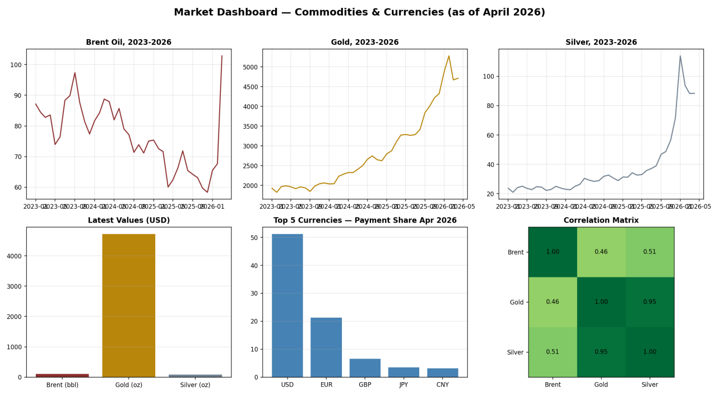

References (Sources)
Brent Oil.csv, Gold 100years.csv, silver 100 years.csv — commodity price datasets provided for this assignment.
swift_currency_tracker_all_reports.csv — SWIFT RMB Tracker-style global currency dataset provided for this assignment.
The Wall Street Ledger, 'A New Financial Order: Is It the End of an Era?' Special Report, Hormuz Crisis Impact Analysis, updated April 13, 2026 — course-provided briefing material.
'Critical New Context: The 2026 Iran War & GCC Crisis' geopolitical brief, April 2026 — course-provided briefing material.
Course materials: Data Science in Business — Expectations, Ethics & Deliverables; Data-Science Team-Management Playbook; Lectures 1-3 (Prof. Dr. Talha Ali Khan and Mr. Ebby Georges).

