Task_3_
Data _Analysis_Project_(Pandas)_Report.docx

Code:-
import os
import pandas as pd
def generate_sample_csv():
"""Generates a sample sales dataset CSV with intentional missing values for cleaning."""
csv_filename = "store_sales_data.csv"
raw_data = {
"Transaction_ID": [101, 102, 103, 104, 105, 106, 107, 108, 108, 109, 110],
"Product_Category": ["Electronics", "Clothing", "Home", "Electronics", "Clothing", "Home", "Electronics", "Home", "Home", "Clothing", "Electronics"],
"Units_Sold": [2, 1, 5, None, 3, 2, 1, 4, 4, None, 3],
"Unit_Price": [150.0, 45.0, 20.0, 300.0, 50.0, 15.0, 1200.0, 35.0, 35.0, 60.0, 80.0],
"Region": ["North", "East", "West", "South", "North", "East", "West", "South", "South", "North", "East"]
}

df = pd.DataFrame(raw_data)
df.to_csv(csv_filename, index=False)
print(f"[Setup] Local sample file '{csv_filename}' created successfully for analysis.\n")
return csv_filename

def main():
print("=========================================")
print(" DATA ANALYSIS DASHBOARD ")
print("=========================================")

target_csv = generate_sample_csv()

try:
print("--- Step 1: Loading Dataset ---")
df = pd.read_csv(target_csv)
print("Original Dataset Preview:")
print(df)
print("-" * 50)
print("\n--- Step 2: Data Cleaning ---")

duplicates_count = df.duplicated().sum()
if duplicates_count > 0:
df = df.drop_duplicates()
print(f"-> Removed {duplicates_count} duplicate transaction row(s).")

print("Checking for missing values:")
print(df.isnull().sum())

median_units = df["Units_Sold"].median()
df["Units_Sold"] = df["Units_Sold"].fillna(median_units)
print(f"-> Filled missing 'Units_Sold' values using calculated median: {median_units}")
print("-" * 50)

print("\n--- Step 3: Feature Transformation & Filtering ---")

df["Total_Revenue"] = df["Units_Sold"] * df["Unit_Price"]
print("Added 'Total_Revenue' calculated metric column successfully.")

high_value_sales = df[df["Total_Revenue"] > 100]
print("\nFiltered High-Value Transactions (Revenue > $100):")
print(high_value_sales[["Transaction_ID", "Product_Category", "Total_Revenue"]])
print("-" * 50)

print("\n--- Step 4: Grouping & Aggregations ---")

category_summary = df.groupby("Product_Category").agg(
Total_Units_Sold=('Units_Sold', 'sum'),
Gross_Revenue=('Total_Revenue', 'sum'),
Average_Unit_Cost=('Unit_Price', 'mean')
).reset_index()

print("Summary Metrics Grouped By Product Category:")
print(category_summary.to_string(index=False))
print("-" * 50)

print("\n--- Step 5: Final Generated Data Insights ---")
total_store_revenue = df["Total_Revenue"].sum()
top_category_row = category_summary.loc[category_summary["Gross_Revenue"].idxmax()]

print(f"1. Overall Gross Store Revenue generated: ${total_store_revenue:,.2f}")
print(f"2. Highest earning category: '{top_category_row['Product_Category']}' pulling in ${top_category_row['Gross_Revenue']:,.2f}")
print(f"3. Most volume units distributed: {category_summary.loc[category_summary['Total_Units_Sold'].idxmax()]['Product_Category']}")
print("=========================================")

output_filename = "cleaned_sales_summary.csv"
category_summary.to_csv(output_filename, index=False)
print(f"\n[Success] Summary dataset generated and stored cleanly inside '{output_filename}'.")

except FileNotFoundError:
print("[Error] Target dataset CSV file was not found. Please verify placement paths.")
except Exception as e:
print(f"[Runtime Exception] Something went wrong while running analytical tasks: {e}")
if __name__ == "__main__":
main()

Output:-
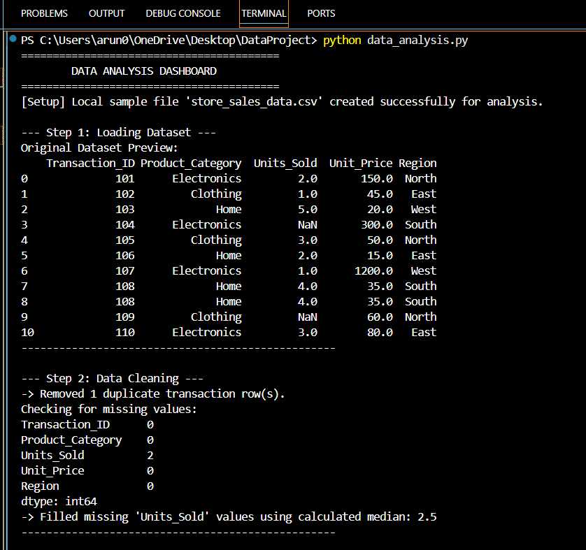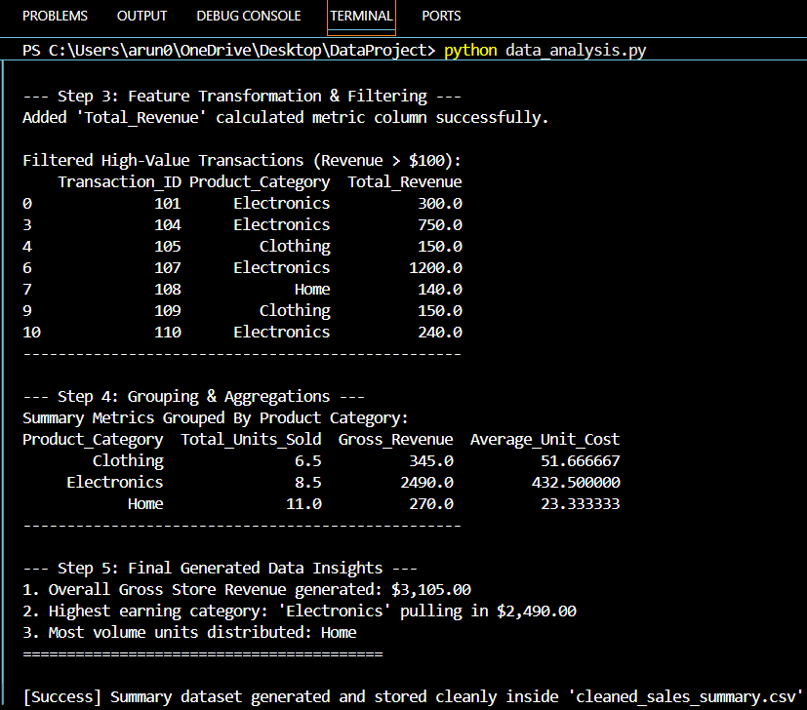

Github link:-
https://github.com/kavanapanchal/Data_Analysis_Project_-Pandas-

