
DHI_tvam
Detailed Report


Kavana S

DHI_TVAM

Table of Contents

- Understanding Depression: An Overview
Exploring the core aspects of depression and its impact on mental health.

- The Many Faces of Depression: Types & Underlying Causes
A deep dive into the different forms of depression and the factors that contribute to its onset.

- Global Insights: World Health Organization (WHO) Reports on Depression
Summarizing key findings and statistics from WHO's comprehensive reports on global mental health.

- Project Overview: Addressing the Depression Crisis
An in-depth look into the scope, objectives, and outcomes of the project dedicated to mitigating depression.

- Closing Thoughts: Conclusion and Future Directions
Wrapping up with a summary of findings and recommendations for moving forward.

Section 1: Understanding Depression – An Executive Overview

Introduction to Depression :
Depression is a widespread mental health disorder affecting millions globally, crossing cultural and social boundaries. Characterized by prolonged sadness, fatigue, and loss of interest, it impacts both personal and professional life, leading to reduced productivity and well-being. As a leading cause of disability, the WHO highlights depression's significant contribution to the global disease burden, emphasizing the need for urgent action.
The Global Impact of Depression :
In 2023, an estimated 280 million people worldwide are affected by depression, with projections indicating it will become the leading cause of disease burden by 2030. Beyond personal health, depression significantly contributes to economic losses through decreased workplace productivity and increased absenteeism.
Signs and Symptoms of Depression :
Depression presents in various forms, with common symptoms such as persistent sadness, hopelessness, irritability, changes in appetite or sleep, difficulty concentrating, and fatigue. In severe cases, it may lead to suicidal thoughts or behaviours.
The Importance of Awareness in the Workplace :
In today's workplace, mental health issues, particularly depression, can significantly diminish productivity, employee engagement, and overall morale. Organizations that prioritize mental health awareness and offer resources for employees facing depression are better positioned to cultivate a supportive and efficient work environment.

Conclusion :
Recognizing and addressing depression is vital for fostering a healthy and productive workforce. By understanding its global impact and symptoms, organizations can implement proactive measures to support employees and mitigate the condition's extensive effects.
Section 2: Exploring the Types and Causes of Depression

Introduction to Depression Types:
Depression manifests in various forms, each with distinct characteristics and symptoms. These include Major Depressive Disorder, Persistent Depressive Disorder (Dysthymia), and bipolar disorder, among others. Recognizing the specific type is crucial for accurate diagnosis and effective treatment.

Major Depressive Disorder (MDD):
Major Depressive Disorder is defined by extended periods of deep sadness or diminished interest in everyday activities. This condition can persist for weeks, months, or even years, and typically requires a comprehensive treatment plan involving both medication and therapy

Dysthymia (Persistent Depressive Disorder):
Persistent Depressive Disorder, also known as Dysthymia, is a chronic form of depression characterized by milder but long-lasting symptoms. While less severe than major depression, it can still significantly impair daily functioning over time.

Bipolar Disorder (Manic Depression):
Bipolar Disorder, commonly known as Manic Depression, is characterized by extreme mood fluctuations, including depressive episodes followed by periods of mania or elevated mood. These significant shifts can disrupt daily life and require comprehensive management for effective treatment

Social Stigma Around Mental Health:
The social stigma associated with mental health, particularly in India, complicates the issue of depression. Many individuals are reluctant to seek help due to fear of judgment or ostracism, which hinders early diagnosis and treatment. This reluctance ultimately contributes to the worsening of their condition.
Causes of Depression:
Depression arises from a complex interplay of biological, psychological, and environmental factors. These factors, acting either independently or in combination, contribute to the onset and persistence of depressive disorders. A clear understanding of these dimensions is essential for accurate diagnosis and effective treatment interventions, as everyone may be affected by varying degrees of influence from these causes.

- Biological factors :
- Genetics
- Neurochemical Imbalance
- Hormonal Changes

- Psychological Factors :
- Stress and Trauma
- Negative Thoughts Patterns
- Personality Traits

- Environmental Factors :
- Life Events
- Social Isolation
- Economic Stress

CONCLUSION:
In conclusion, depression arises from a combination of biological, psychological, and environmental factors, with stigmatic stress in India significantly contributing to its rise. The fear of social judgment prevents many from seeking help, exacerbating the condition, and delaying proper diagnosis and treatment.

Section 3: Global Insights – World Health Organization (WHO) Reports


WHO’s Global Depression Statistics :
Globally, around 280 million people experience depression, impacting about 5% of adults and 5.7% of those over 60. Women are more affected, and depression is linked to 700,000 suicides each year, making it the fourth leading cause of death among individuals aged 15-29. Despite effective treatments, 75% of individuals in low- and middle-income countries lack access to necessary care, often due to stigma and resource shortages​(World Health Organization (WHO))​

Depression in India: A Country-Specific View :
In India, recent WHO data indicates that approximately 56 million people suffer from depression, placing the country among the most affected globally. Social stigma surrounding mental health significantly hampers individuals' ability to seek help, with only a small percentage receiving adequate treatment. The National Institute of Mental Health and Neurosciences (NIMHANS) reports further highlight that access to mental health services, especially in rural areas, remains limited, exacerbating the challenge. Both organizations emphasize the urgent need for expanded mental health infrastructure and awareness campaigns to combat the growing mental health crisis.

Stigma and Mental Health in India :
According to the National Mental Health Survey of India (NMHS) conducted by NIMHANS and supported by the Ministry of Health and Family Welfare, over 80% of individuals suffering from depression in India do not seek professional help, largely due to stigma and a lack of awareness. The World Health Organization (WHO) also highlights that in low- and middle-income countries, including India, societal stigma significantly delays diagnosis and treatment of mental health disorders.
Both the WHO Mental Health Atlas and the NHIMANS survey stress that societal views in India are often influenced by myths and misconceptions about mental health, which label those with depression as weak or incapable. This stigma, combined with the limited availability of mental health services

Depression Projections: 2030 and Beyond:
The WHO estimates that by 2030, depression will become the leading cause of disability worldwide, surpassing other physical and mental health conditions. This alarming prediction highlights the urgent need for comprehensive mental health interventions and stigma reduction campaigns on a global scale.
In India, depression rates are also expected to rise significantly, with estimates suggesting that the country could see a substantial increase in the number of individuals affected by depression by 2030. While specific percentage projections for India are not always published, some estimates suggest that the depression rate in the country could exceed 6-7% of the population by 2030, given the current trajectory of mental health trends and the challenges of stigma and access to mental health care

Section 4: Project Overview: Addressing the Depression Crisis
Depression is not only a significant public health challenge but also a critical issue affecting human resources and, consequently, the Indian economy. With depression rates steadily increasing, the social and economic consequences may surpass current estimates. The World Health Organization (WHO) has projected that by 2030, depression will become the leading cause of disability worldwide. In India, where mental health resources are already limited, this could severely impact productivity and economic growth.
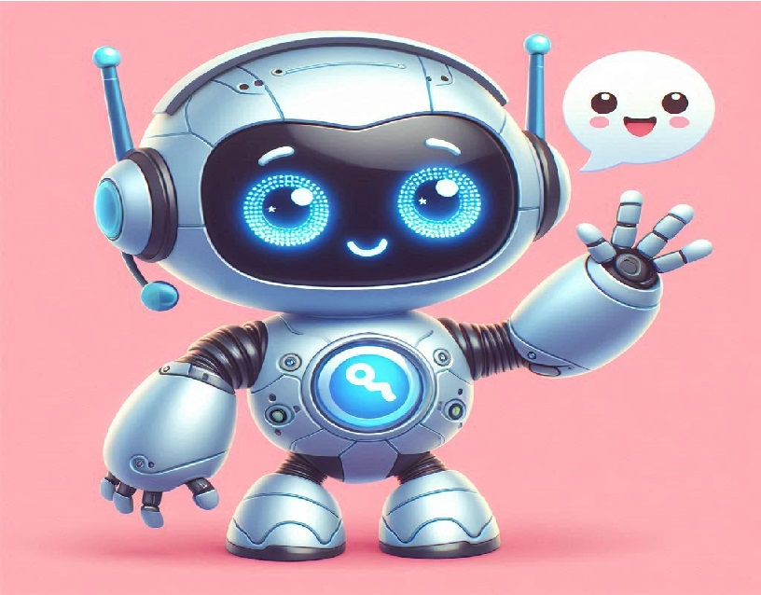
Recognizing the urgent need for innovative solutions, I developed DhiTvam, a deep-learning-based chatbot designed to offer emotional support and help individuals manage their mental well-being. DhiTvam is a proactive step toward addressing the growing mental health crisis in India. By providing a safe, non-judgmental platform for individuals to share their thoughts and emotions, the chatbot aims to break down the stigma surrounding mental health, which remains a significant barrier to seeking care.
Presenting Dhi_Tvam
Depression in India is often exacerbated by a lack of meaningful interaction and the reluctance of individuals to share their problems, stress, or emotional struggles with others. This has led to increasing mental health issues, particularly as many people are hesitant to seek help due to social stigma and personal barriers.
To address this critical issue, Dhi_Tvam enables users to interact freely, helping them clarify their thoughts and emotions. By providing a virtual companion, it also raises awareness about mental health and encourages users to acknowledge their emotional well-being without fear of judgment.
One of the key features of Dhi_Tvam is its ability to track users' thought patterns through backend data. In emergency situations, this information can be made accessible to healthcare professionals, offering valuable insights into the user’s mental state. This feature ensures that Dhi_Tvam not only serves as a conversational tool but also as a potential life-saving platform by facilitating timely intervention from medical professionals.
Future Enhancements
Looking ahead, the future vision for Dhi_Tvam involves enriching the user experience through animations and inspiring stories presented in both video and audio formats. By incorporating multimedia content, the chatbot will be able to capture and maintain users' attention more effectively, while motivating and inspiring them to overcome mental health challenges.
Additionally, Dhi_Tvam plans to collaborate with hospitals across India and work in tandem with NIMHANS (National Institute of Mental Health and Neurosciences). This partnership will enable regular updates to the chatbot's features, ensuring it stays relevant with the latest mental health practices. Moreover, psychiatrists will have access to backend data from the chatbot, offering valuable insights into patients who may hesitate to open up in face-to-face consultations. This will allow for more personalized care, ultimately improving mental health outcomes.

Benefits of Dhi_Tvam Chatbot:
- Accessible Mental Health Support: Dhi_Tvam provides a platform for users to express their emotions and thoughts without the fear of judgment, breaking down barriers to seeking help.
- Stigma Reduction: By offering a non-human interface, Dhi_Tvam helps users feel more comfortable discussing mental health issues, reducing the stigma surrounding mental health care.
- 24/7 Availability: Unlike traditional therapy, the chatbot is available around the clock, offering immediate support whenever users need it.
- Early Detection of Mental Health Issues: Through interaction, Dhi_Tvam can help identify signs of mental distress, enabling users to seek help before issues escalate.
- Valuable Data for Healthcare Providers: With the integration of backend data, doctors and psychiatrists can access valuable insights on users' mental states, helping tailor treatments for those who hesitate to open up in traditional settings.
- User Engagement through Multimedia: Future updates, such as videos and inspiring stories, will engage users more effectively, helping them stay motivated in their mental health journey.
- Scalability Across India: Dhi_Tvam has the potential to reach millions across India, including those in rural areas with limited access to mental health professionals.
Conclusion
In the face of India’s growing mental health crisis, Dhi_Tvam offers a transformative approach to tackling depression and emotional distress. By providing a safe, accessible, and non-judgmental space for users to express themselves, this chatbot helps break the stigma around mental health and encourages early intervention. Its ability to capture users' thoughts and provide critical insights to healthcare professionals bridges the gap between those in need and those who can help. With future enhancements like multimedia engagement and integration with healthcare providers across the country, Dhi_Tvam will continue to evolve into a powerful tool in the fight against mental health issues. It stands as a significant step forward in empowering individuals to take control of their mental well-being, making professional care more approachable and effective.
Section 5: Closing Thoughts: Conclusion and Future Directions
Dhi_Tvam is an innovative deep-learning-based chatbot designed to address the growing mental health crisis in India. Recognizing the urgent need for effective solutions, Dhi_Tvam offers a safe and non-judgmental platform for users to share their thoughts and emotions.
By breaking down the stigma surrounding mental health, Dhi_Tvam encourages individuals to seek help without fear of judgment. The chatbot provides essential emotional support, helping users manage their mental well-being in a confidential and supportive environment. Through its proactive approach, Dhi_Tvam aims to empower individuals to engage in open conversations about mental health, fostering a culture of understanding and acceptance.

Key Achievements & Impact:
Since its inception, Dhi_Tvam has made significant strides in offering support to individuals grappling with mental health issues. The chatbot facilitates conversations around mental health and assists in collecting valuable backend data, which can help mental health professionals better understand user needs. Early feedback indicates that users find comfort in having a reliable platform to express their feelings, thereby reducing the isolation often experienced by those suffering from depression.
Challenges Overcome:
Throughout the development process, we have encountered various challenges, including technological limitations and societal stigma. However, these challenges have been effectively addressed through continuous improvement and user feedback, allowing us to enhance the chatbot's capabilities and ensure it remains user-friendly and accessible.
Future Enhancements:
Looking ahead, we envision a more enriched user experience for Dhi_Tvam by incorporating animations and inspiring stories in both video and audio formats. These multimedia enhancements will not only capture users' attention but also motivate them to engage actively with their mental health journey. Additionally, we plan to establish partnerships with healthcare institutions, including NIMHANS, to facilitate real-time tracking of user data, allowing mental health professionals to offer informed support.
Partnerships & Collaborations:
Collaboration with hospitals and mental health organizations is crucial for the future of Dhi_Tvam. By working alongside professionals in the field, we can ensure that the chatbot remains aligned with best practices in mental health care, ultimately improving outcomes for users who may hesitate to seek help in traditional settings.
Vision for Dhi_Tvam's Future:
Our long-term vision for Dhi_Tvam is to expand its reach across India and potentially globally, making it a cornerstone of mental health support. We aspire for Dhi_Tvam to evolve into a comprehensive tool for individual users and healthcare providers, enabling them to understand patient needs more effectively.
We invite mental health professionals, healthcare institutions, and government bodies to join us in our mission to promote mental health awareness and improve access to care. Together, we can create an ecosystem where individuals feel empowered to seek help and receive the support they need.

