Report

Introduction:

Purpose : ‘ This analysis aims to study the relationship between wavelength and radiation for black body radiation data, and to investigate how temperature affects this relationship’

Data Source: ‘Data is retrieved from MySQL database named ‘blackbody data’ with a table ‘Planck’s’

Methodology:

Importing data with ‘mysql.connector’ module, which allows to connect to a MySQL database from Python

Connect to the MySQL Server with Credentials

Executing a Query and fetching the data. Loading the data into a pandas Data Frame

The dataset includes features such as ‘Wavelength’, ‘temperature’, ‘radiation’

Data was split into training and testing sets. Linear and polynomial regression models were applied to study the relationships.

Visualization included linear and polynomial regression plots and temperature effects on radiation.

* The dataset was successfully loaded and visualized.
* Linear regression, polynomial regression and exponential models were evaluated. The exponential regression model better captured the relationship between wavelength and radiation.
* Temperature effects were analyzed, showing varied radiation patterns across different temperatures.

Linear Regression :

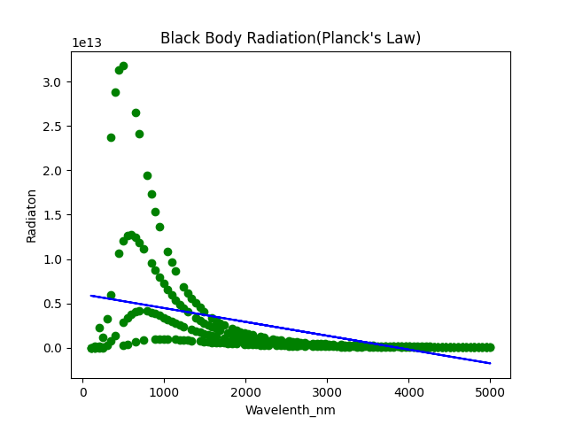 Polynomial Regression : Exponential Model :

Evaluation for Simple Linear Regression :

r2_Score == -4.241584535632963

mean_absolute_error == 2830685173589.217

mean_squared_error == 2.6874184471589214e+25

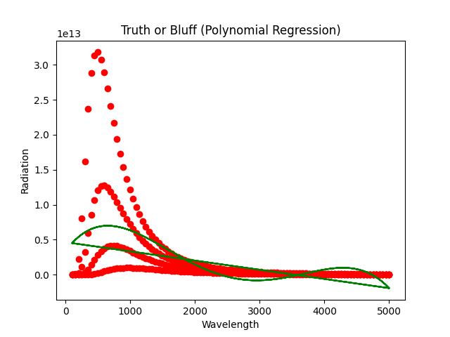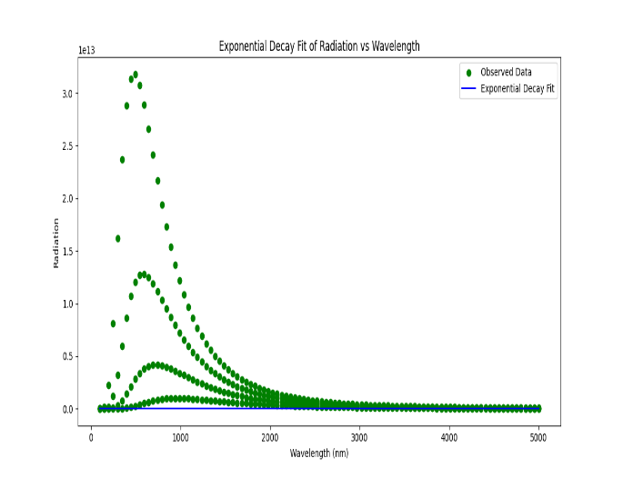

Effect of temperature on Radiation and Wavelength

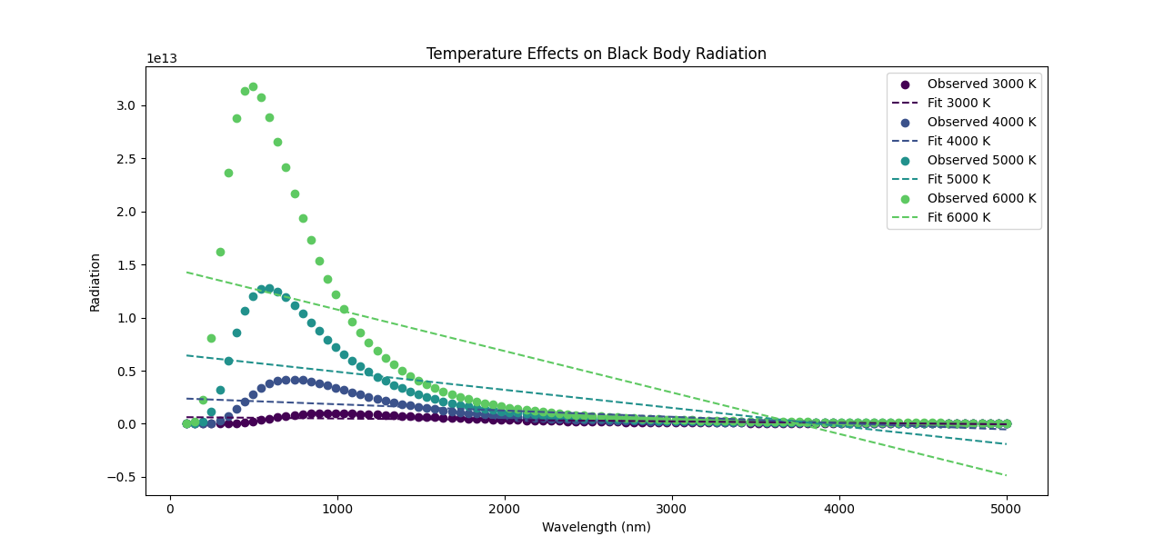

Conclusions:

The exponential model shows a rapid decay but doesn't capture the pattern of the observed data well. The fit is too simplistic and fails to follow the peaks and troughs seen in the data points.

The polynomial regression model attempts to follow the trend of the observed data more closely. Although it may introduce some oscillations that are not present in the actual data, it generally aligns better with the overall pattern, capturing the peaks and troughs more effectively than the exponential model.

The analysis demonstrated that polynomial regression provides a better fit for the data compared to linear regression. Temperature significantly affects radiation, which was evident in the plots. Future work could involve further exploration with different polynomial degrees or additional features.