DIGI-LYCEUM :-Indoor Navigation Using Augmented Reality

1Kenil Mavani, BE-Computer, SCET Surat

2 Kavan Patel, BE-Computer, SCET Surat

3Vaman Baldha, BE-Computer, SCET Surat

4Yash Panwala, BE-Computer, SCET Surat

5Prof. (Dr.) Dipali Kasat, Computer Engineering, SCET Surat

***Abstract-*** Navigation entails the continuous tracking of the user’s position and his surroundings for the purpose of dynamically planning and following a route to the user’s intended destination. The Global Positioning System (GPS) made the task of navigating outdoors relatively straightforward, but due to lack of signal reception inside the buildings, navigating indoors has become a very challenging task. With regard to this, a variety of new techniques exists that can be harnessed to solve this problem.

Apart from that, the augmented reality technology (AR) enables applications to generate and align a supplemented view of the real world. Thereby, we incorporated augmented reality into indoor positioning and designed a novel user interface with a compelling application that delivers an interactive indoor navigation experience through augmented graphical views aligned with indoor objects.

***Key words-*** Augmented Reality, Navigation, Indoor location, Global Positioning System (GPS).

1. INTRODUCTION

Navigation has been prime subject of research for many years. People have always been fascinated in developing devices, technologies and applications that help them find their location, and aid in navigating to destinations. According to a recent study carried out on mobile phone users [1], around 95% of users who own a Smartphone device used a mapping application at least once, while 80% of users used it more than 10 times during the period of study, which shows that maps are in everyday use for most of Smartphone users. Navigation requires knowledge of current position. The availability of cheap, globally available technology supporting current positioning through GPS has been a paramount driving force in the popularity of navigation applications for mobile devices. Ever since GPS became famous on a global scale, it has always been expected that a similar global solution for indoor navigations will be available sooner rather than later. Experiments have disclosed that Global Positioning System (GPS) is not suitable for enclosed areas due to the satellite signals being attenuated higher than 1dB per meter of structure [2]. Currently the solutions to achieve indoor positioning are through wireless technologies such as WLAN, GSM, Bluetooth, Infrared, and RFID. However, comparison among the positioning technologies [3] does not show the most feasible solution as is shown in Table 1. Indoor positioning based on wireless technology is highly depending on the availability of the connection in the building.

TABLE 1: Comparison among heterogeneous positioning technologies [3]

|  |  |  |  |  |  |  |
| --- | --- | --- | --- | --- | --- | --- |
|  | GPS | GSM | WLAN | BLUETOOTH | INFRARED | RFID |
| Range | Wide area | Wide area | Micro area | Micro area | Pico area | Pico area |
| Accur-acy | No signal | Low | Low | Low | High | High |
| Signal  Error Rate | No signal | Low | Mid | Low | Lowest | Lowest |

Augmented Reality (AR) is used to superimpose computer-generated graphics on the real view of the user to create the effect of mixture of virtual and reality. AR technology has been invented since 1950s’ and in recent years it has been explored rapidly in more domestic fields such as gaming fields and personal research projects from previous industrial application e.g. industrial manufacturing, medical visualization, military aircraft navigation and others [4].

1. INDOOR POSITIONING AND NAVIGATION WITH AUGMENTED REALITY
2. *Indoor positioning*

Markers offer an attractive alternative to discrete indoor positioning, as these can often be installed with very minimal cost. These specially constructed markers are optically recognizable by a camera-equipped device and as such can help with positioning. Several augmented reality projects have used marker-based localization also little progress has been done towards research on continuous localization using Augmented Reality. By trying to achieve continuous localization, used a large quantity of markers located at every location within the whole building.

1. *Presenting Navigation Instructions*

Using a visual arrow motif to indicate direction is a widely known and commonly used methodology for giving directions. We use a system of arrows to demonstrate the path to be taken by user and take an approach of directing users only towards the next “info point”, instead of showing full path to the destination, to limit the number of directions given to user at once. Presenting users with small amount of directions at every occasion was shown to have the potential to lower down the number of errors made while navigating.

1. Methodology

We used Android 6.0 as our development platform. We used Qualcomm’s Vuforia SDK for Android in Unity to make markers which are trained beforehand so that they can be recognized later in the camera stream.  After a marker is recognized, its position are derived. Below we demonstrated our demo of markers.

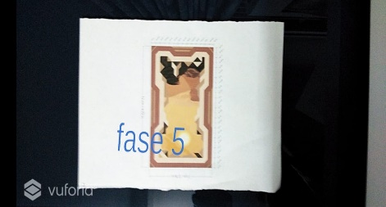

Figure 1: Markers

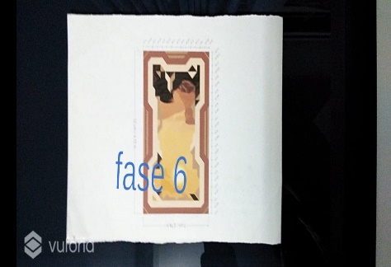

Figure 1.1: Markers

We divided this project into 3 phases:

Phase 1: Importing the indoor map data to mapbox

For building vector features and adding indoor map data firstly, we had to add a geo-referenced image to Mapbox Studio. **Georeferencing** is the process of assigning geographic coordinates to a raster image in order to determine its location in the world based on a map coordinate system. We will be georeferencing a JPEG image of our college map using QGIS a free open-source Geospatial Information System (GIS). We exported this image to GeoTIFF format in QGIS then we'll upload it to our Mapbox account as a tileset. Basically **tileset** is a collection of raster or vector data broken up into a uniform grid of square tiles at 22 preset zoom levels. Tilesets are core piece of making maps visible on mobile devices or in the browser. Later on, we added hallways, walls, and conference room features to our dataset along with custom properties designed for consumption in Unity. Where rooms were digitized using points. Each point feature was assigned properties to help with identifying and navigating to corresponding room. Here’s a snapshot of the properties added:

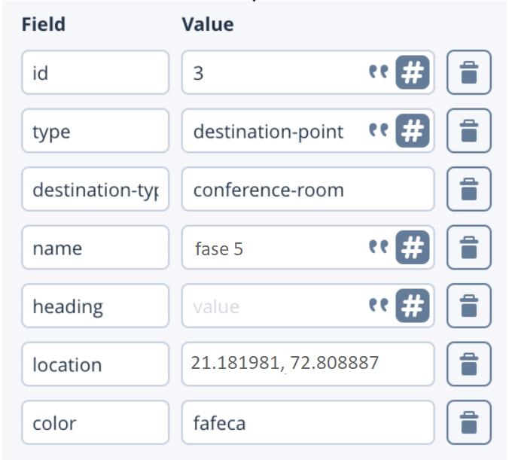

After adding the necessary properties, we exported that data to a tileset.

Phase 2: Render in unity

For rendering the features from our tileset, we used a ***MapAtWorldScale*** with ***RangeAroundTransformTileProvider.***.We chose ***MapAtWorldScale*** because we wanted the map to render at the real-world scale to support the augmented reality experience. ***Range-AroundTransformTileProvider*** uses the AR camera’s root transform to load tiles around it. The rendered tiles contain the vector data information that we added to our dataset.

Here’s an overview of how to set up our modifier stack to render the features listed below:

1. **Synchronization Points**

A modifier called ***FixedLocationMonoBehavior-Modifier*,** which registers the location data assoc-iated with synchronization point with the help of ***Sync-hronizationPointsLocationProvider****.* The registration process sets up the required UI elements corresponding to the sync points.

1. **Destination Points**

To set up the destination points, ***SpawnPrefab-Modifier*** is used, a variation of ***FixedLocationMo-noBehaviorModifier,*** which in addition to regis-tering the destination points, also (3D text) to represent the conference rooms.

1. **Nav Mesh**

Unity’s NavMesh is used to compute the naviga-tion path. NavMesh requires a mesh as input that’s used as a navigable path. To create this navigable path, line features are added in our dataset connecting corridors with synchronization and destination point locations.

Phase 3: Localize in world-scale AR.

The real challenge is orienting, positioning, and tracking a user’s device in the AR world. In this phase user has to scan markers that have sync ids. The table below shows the set of properties added for those sync points:

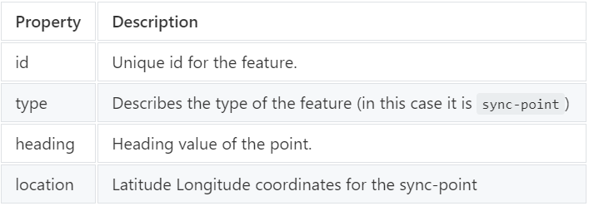

 After that, the list of destinations listed that the user can navigate to. Then, based on the destination, the app places a continuous chain of arrow sprites on the NavMesh to show the directions to the selected destination.

1. CONCLUSION

The indoor positioning system based on augmented reality aims to increase a user’s perception in percei-ving the information conveyed from the map and to ease the user in identifying the route that leads to the destination.

For future enhancement, more research may be focused on improving the intelligence of the route planner such as shortest-distance-route computation and alternative routes based on the criteria input from the user. For example, a user may prefer to choose route that is concentrated with canteen in the college. However, it is very dependent on the application. Therefore, the flexibility of the system is very important.

The concept of this work indicates its potential for future development as it incorporates visual technology in designing the indoor positioning technology, which is also a rapidly growing technology.

REFERENCES

[1] T.M.T. Do, J. Blom and D. Gatica-Perez “Smart-phone usage in the wild: a large-scale analysis of applications and context” In Proceedings of ICMI. 2011, 353-360, 2011

[2] B. B. Peterson, D. Bruckner, and S. Heye, “Measuring GPS Signals Indoors”, Proceedings of the Institute of Navigation’s ION GPS-2001, September, 2001.

[3] L. D. Chou, C.Y. Chang, “A Hierarchical Architecture for Indoor Positioning Services,” Department of Computer Science and Information Engineering National Central University, Taiwan.

[4] Ronald T. Azum, August 1997, A Survey of Augm-ented Reality, Hughes Research Laboratories, CA 90265.