



**Name : KAVASKAR S**

**Stream : IV MCA-B**

**Reg No : 2347230**

**Cloud computing**

**Lab-2**

1. **Describe IaaS**

IaaS (Infrastructure as a Service) in AWS is like renting a virtual data center. Instead of buying and managing your own servers, storage, and networking equipment, you provision these resources in the cloud on a pay-as-you-go basis. This frees you from upfront costs and allows you to scale your resources up or down quickly to meet your application's needs. AWS offers a wide range of IaaS services, including:

* **Amazon EC2 (Elastic Compute Cloud):** Provides virtual servers with various configurations (CPU, memory, storage) to run your applications.
* **Amazon S3 (Simple Storage Service):** Highly scalable object storage for any type of data, from backups to website content.
* **Amazon EBS (Elastic Block Store):** Block-level storage for attaching high-performance disk volumes to your EC2 instances.
* **Amazon VPC (Virtual Private Cloud):** Lets you create a logically isolated network segment within the AWS cloud for secure deployment of your resources.

1. **List the Compute and Storage services available in AWS and GCP.**
   1. **Compute**
      1. **AWS:**
         1. **Amazon EC2 (Elastic Compute Cloud):** The core compute service, offering a vast selection of virtual machine configurations for diverse workloads. You have full control over the operating system and instance settings.
         2. **AWS Lambda:** Serverless compute service ideal for short-lived tasks triggered by events. You only pay for the resources your code consumes, making it cost-effective for spiky workloads.
      2. **GCP:**
         1. **Google Compute Engine:** Similar to EC2, offering virtual machines with various configurations. GCP integrates well with other Google Cloud services.
         2. **Google Kubernetes Engine (GKE):** Managed Kubernetes service for deploying and managing containerized applications. GKE simplifies container orchestration, a complex task in traditional deployments.
   2. **Storage Services:**
      1. **AWS:**
         1. **Amazon S3 (Simple Storage Service):** Object storage designed for scalability and durability. Ideal for storing large datasets, backups, and static website content.
         2. **Amazon EBS (Elastic Block Store):** Block storage for attaching high-performance disks to EC2 instances. EBS provides persistent storage for applications that require frequent disk access.
      2. **GCP:**
         1. **Google Cloud Storage:** Similar to S3, offering object storage for various data needs. Integrates seamlessly with other GCP services.
         2. **Google Persistent Disk:** Block storage for persistent data attached to virtual machines in Google Compute Engine. Offers similar functionality to Amazon EBS.
2. **Create 2 Identical AWS EC2 Instances (Instance Name: Regno_EC2_VM1,** **Regno_EC2_VM2) and install the necessary packages to execute a program of your choice in ‘Regno_EC2_VM1’.**

STEPS:

* 1. Login to Learner Lab

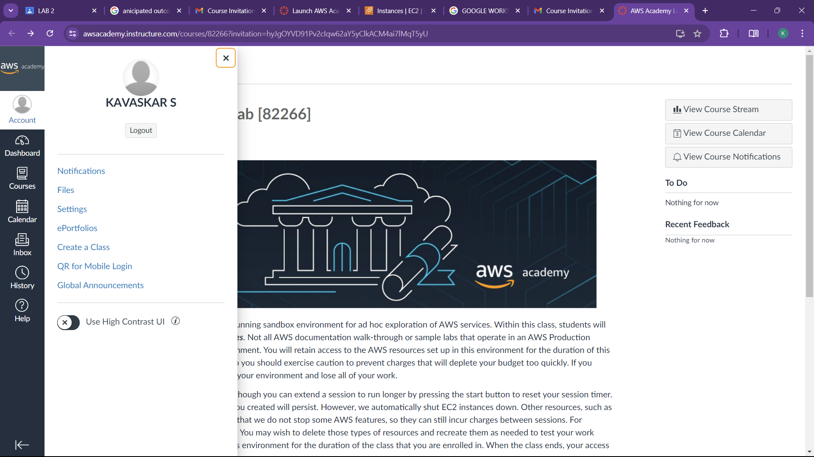

* 1. Launch Learner Lab

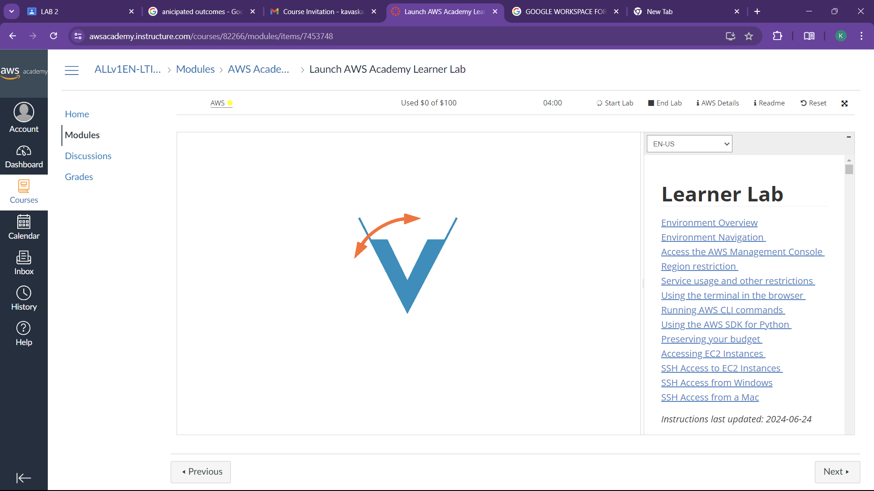

* 1. Go to services and Select EC2

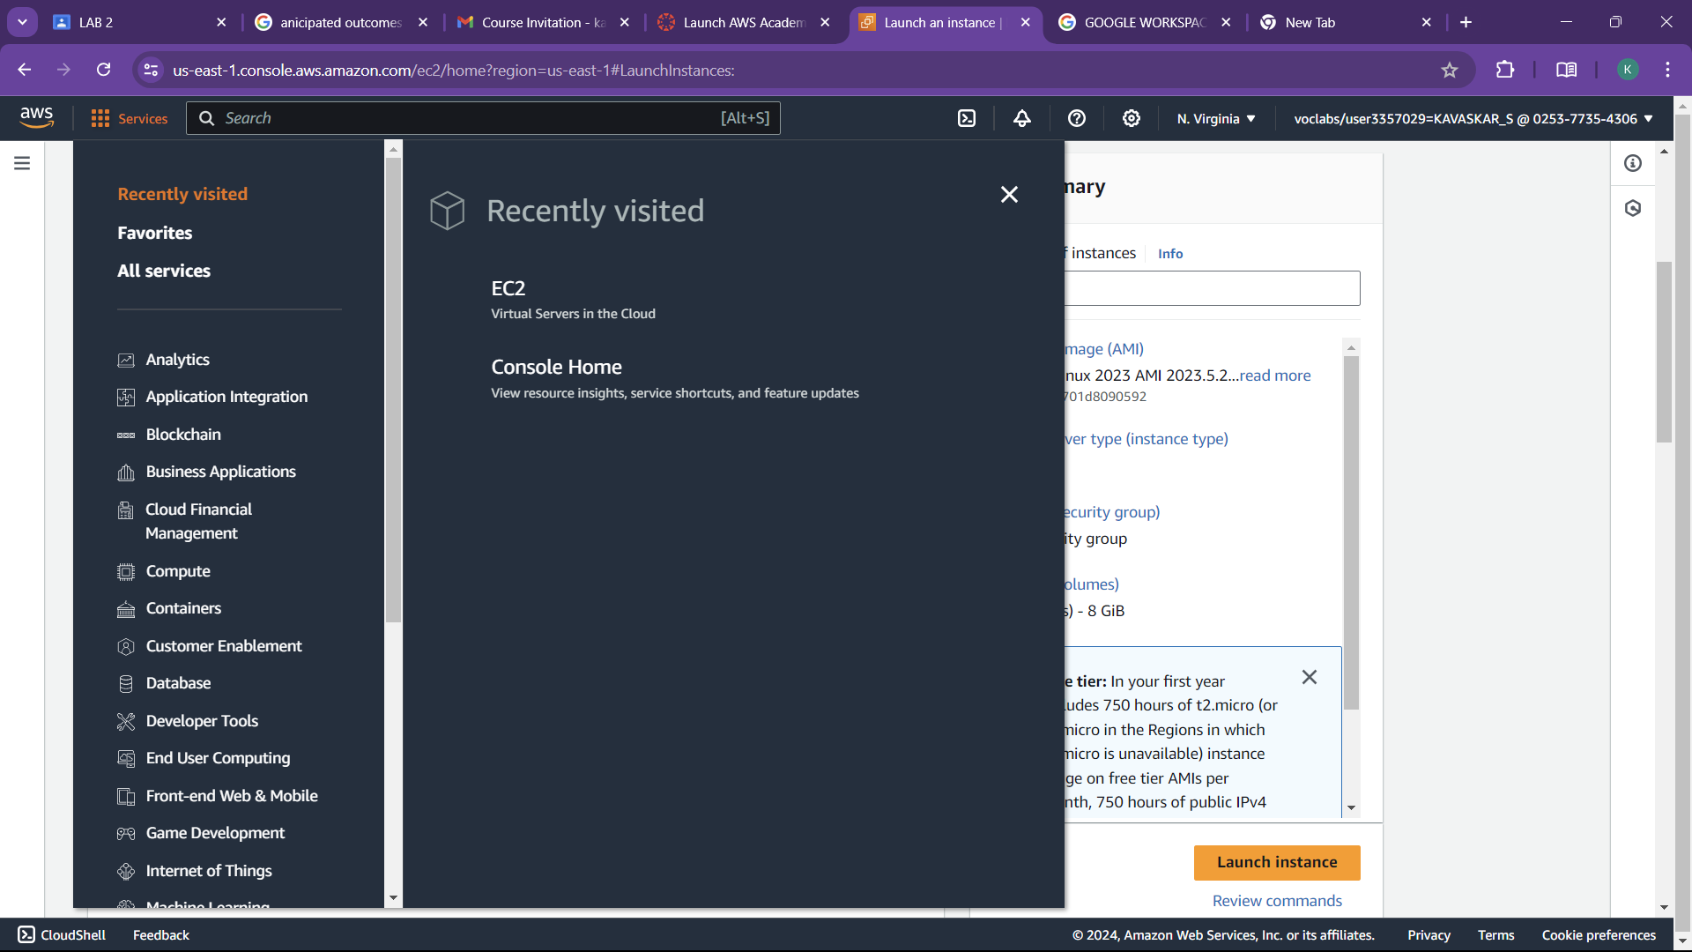

* 1. Give a name to the instance and select further options

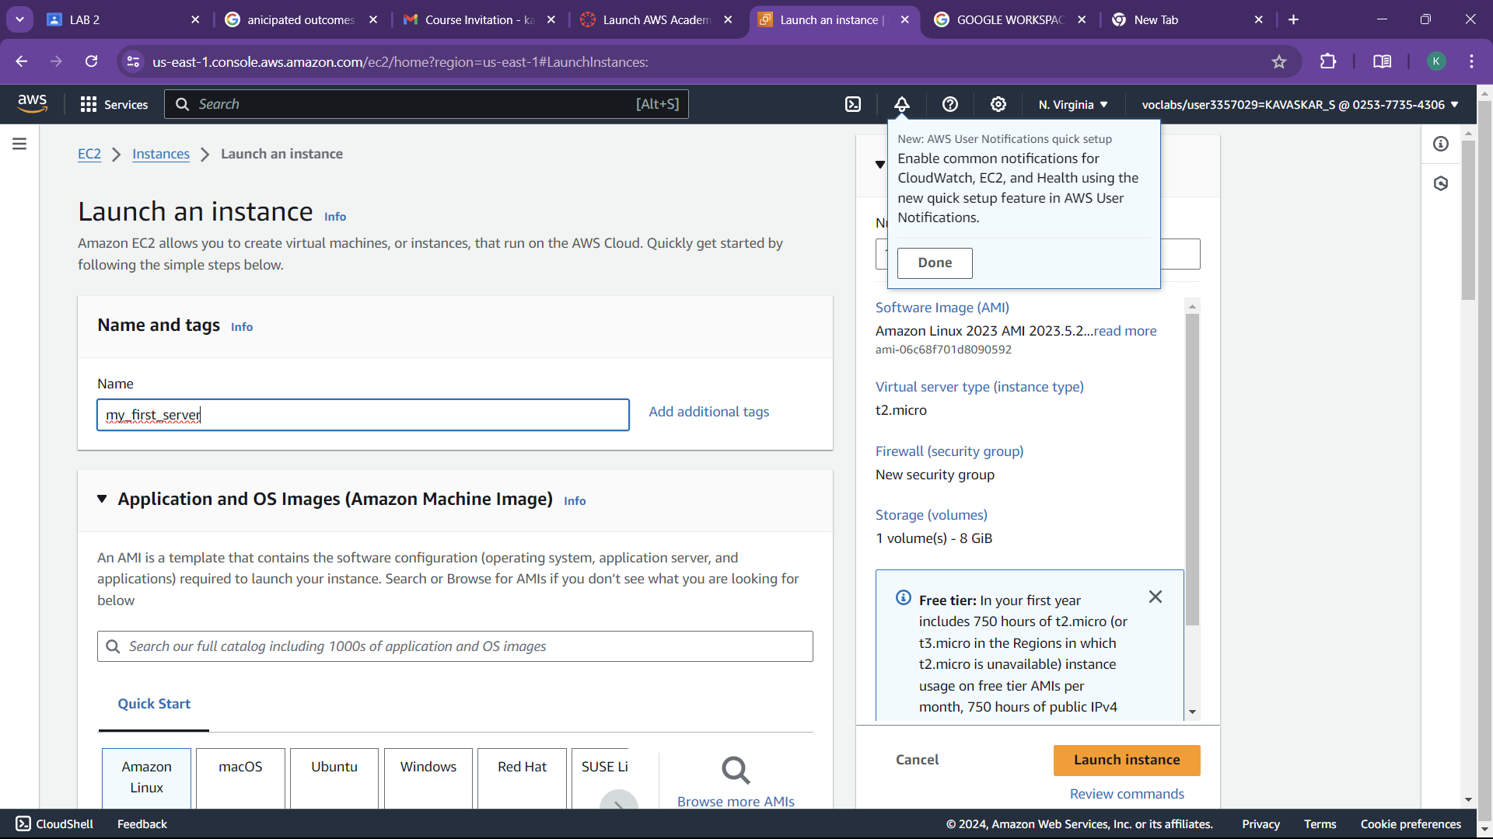

* 1. Click Launch instance to create to create a instance

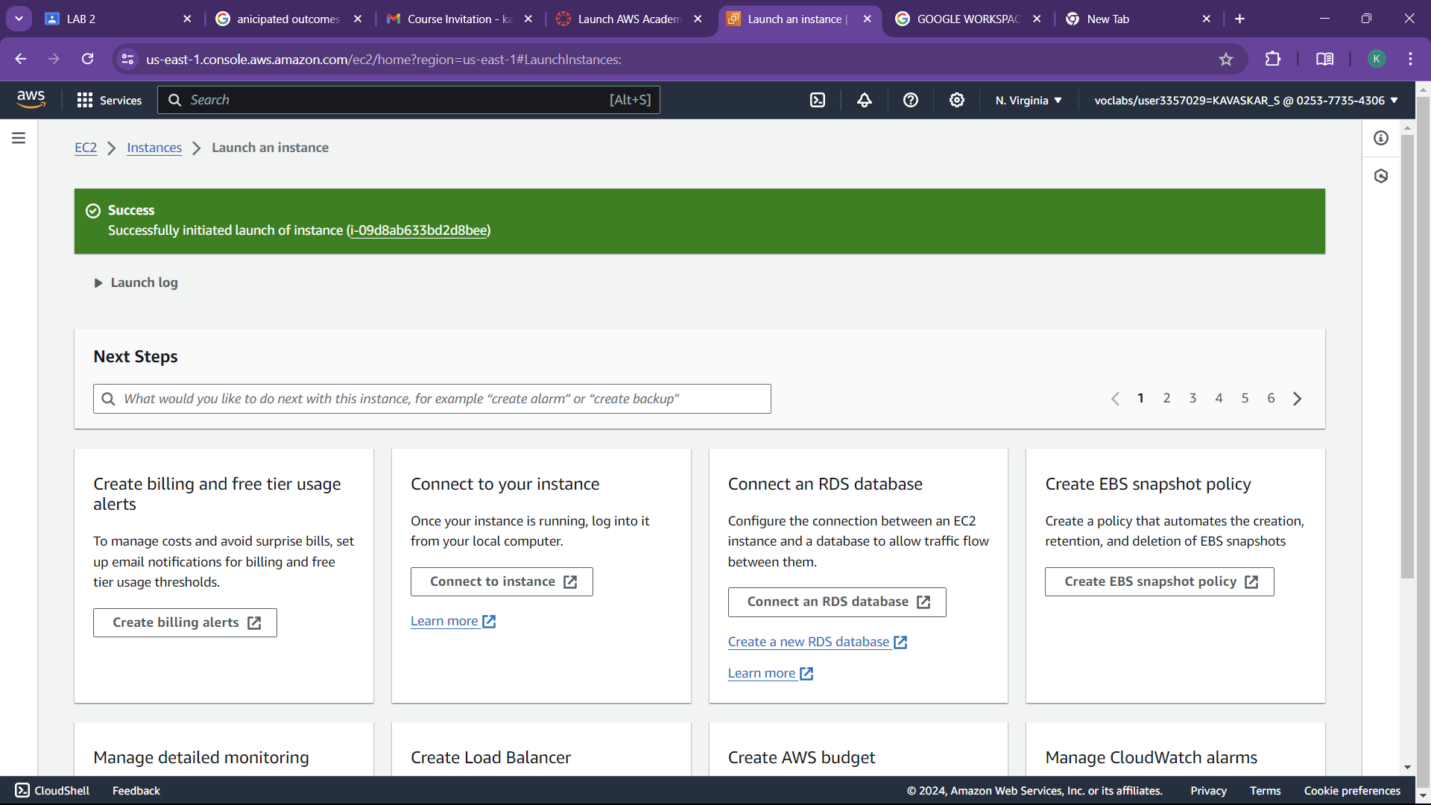

* 1. Finally go the instance dashboard to see the list of instance created

