🎓 Documentation: AI Content Creator Agent (MCP Server)
Contents
🎓 Documentation: AI Content Creator Agent (MCP Server) 1
1. Introduction 2
2. Problem Statement 2
3. Objective 3
4. System Design & Architecture 3
4.1 High-Level Architecture 3
4.2 Core Technologies 5
5. Agent Roles 5
5.1 Outliner Agent 5
5.2 Writer Agent 5
5.3 Proofreader Agent 5
5.4 Citation Inserter Agent 5
5.5 SEO Agent 6
5.6 Social Agent 6
5.7 Editor Agent 6
6. System Components and Feature Walkthrough 6
7. Dashboard & Insights 11
8. Output Structure 13
9. Execution Flow 13
10. Future Enhancements 14
11. Conclusion 16
12. Appendix 16

1. Introduction

In today’s digital landscape, content creation is both essential and labor-intensive, demanding a blend of creativity, research, and technical skill. With the advent of large language models (LLMs), there is a transformative opportunity to streamline and automate parts of this process. This project introduces the AI Content Creator Agent — an intelligent, end-to-end content automation system designed to generate, enhance, and publish blog content with minimal human input.
Inspired by the emerging concept of Model Context Protocol (MCP) servers, this system adopts a multi-agent architecture where specialized AI agents (e.g., Writer, Proofreader, SEO Optimizer, Social Media Strategist) collaborate to produce high-quality, SEO-optimized blog articles. Although it does not implement the official MCP SDK, the design reflects key MCP principles such as modularity, prompt orchestration, task-specific agents, and autonomous workflow execution.
The solution is delivered through a user-friendly Streamlit interface, allowing users to input blog topics, choose tone and audience, and optionally preview AI-generated outlines. Once generated, the blogs are saved in multiple formats, published to GitHub Pages (with RSS support), and auto-syndicated to Dev.to. It also supports manual Medium imports.
This project demonstrates how AI-powered multi-agent systems can significantly accelerate digital publishing workflows, offering a scalable blueprint for intelligent content automation.

2. Problem Statement

Manual content creation involves:
- Research and topic ideation
- Structuring and outlining
- Writing and proofreading
- Optimizing for SEO
- Generating social media content
- Publishing and maintaining consistency
These steps require significant time, coordination, and tools. The problem lies in the lack of a unified, automated pipeline that bridges content strategy, creation, and distribution.

3. Objective

To build an AI-powered server that:
- Accepts a topic and outputs a complete blog ecosystem
- Integrates agents for each stage of content generation
- Publishes output in multiple formats and platforms
- Provides analytics and planning tools

4. System Design & Architecture

4.1 High-Level Architecture

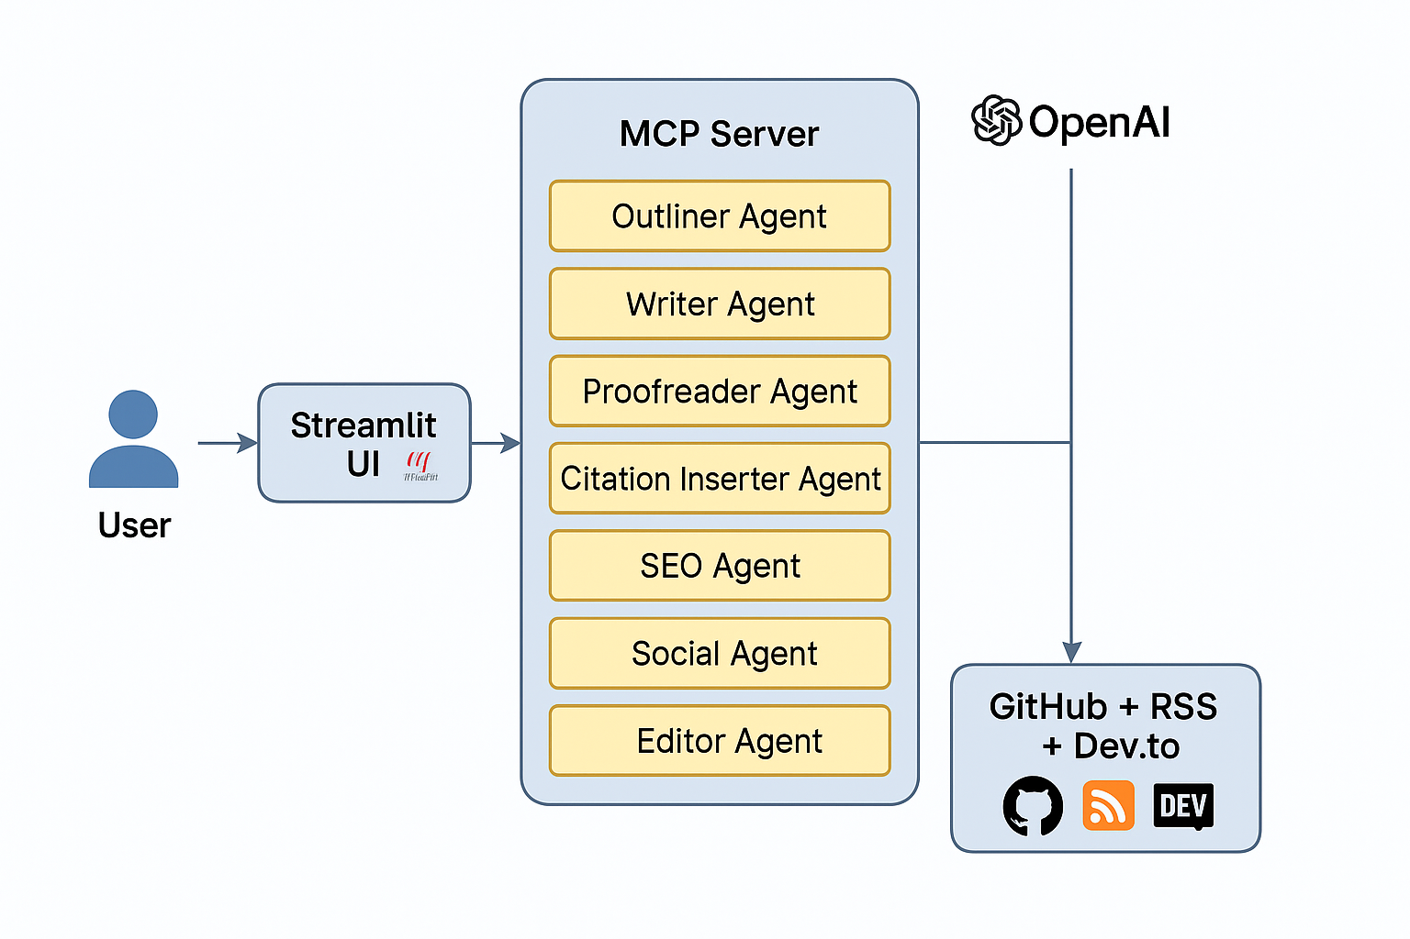
Figure 4. 1 High Level Architecture Diagram of the System

The high-level architecture of the AI Content Creator Agent follows a modular pipeline that connects user input to intelligent content generation and automated publishing. At its core, the system is structured as a web-accessible application powered by Streamlit, serving as the user interface layer.
Users initiate the workflow by submitting a blog topic and configuration parameters (tone, audience) through the UI. This input is passed into a coordinated backend orchestration layer, implemented in Python using the LangChain framework and powered by OpenAI GPT-4o.
A sequence of intelligent agents is triggered to process the input in stages—from outlining and writing to proofreading and optimizing. Each agent performs a dedicated role, and intermediate outputs are passed downstream to ensure contextual continuity.
Finalized content and metadata are stored in structured directories and rendered into static HTML pages. These pages are deployed to GitHub Pages, while an automatically maintained RSS feed (rss.xml) facilitates external syndication—particularly for platforms like Dev.to. The system also supports optional manual publishing to Medium.
This architecture ensures clean separation of concerns, scalability, and end-to-end automation, while maintaining user oversight through the UI and queue-based content generation management.

4.2 Core Technologies

Component | Role
Python | Backend logic & AI orchestration
LangChain | Agent routing, prompt management
OpenAI GPT-4o | LLM for all agent outputs
Streamlit | Web interface
GitHub Pages | Hosting for generated HTML + RSS
Dev.to | Auto-publishing via RSS
Matplotlib/Calplot | Visual analytics for dashboard

5. Agent Roles

5.1 Outliner Agent
Creates a structured outline based on topic and target audience.

5.2 Writer Agent
Writes a full draft following the outline, tone, and audience preferences.

5.3 Proofreader Agent
Polishes grammar, clarity, and flow.

5.4 Citation Inserter Agent
Adds reputable references and links.

5.5 SEO Agent
Generates:
- Meta description
- SEO tags
- Estimated reading time

5.6 Social Agent
Creates:
- Twitter thread
- LinkedIn post
- Instagram caption

5.7 Editor Agent
Summarizes the blog into key bullet points for previews.

6. System Components and Feature Walkthrough

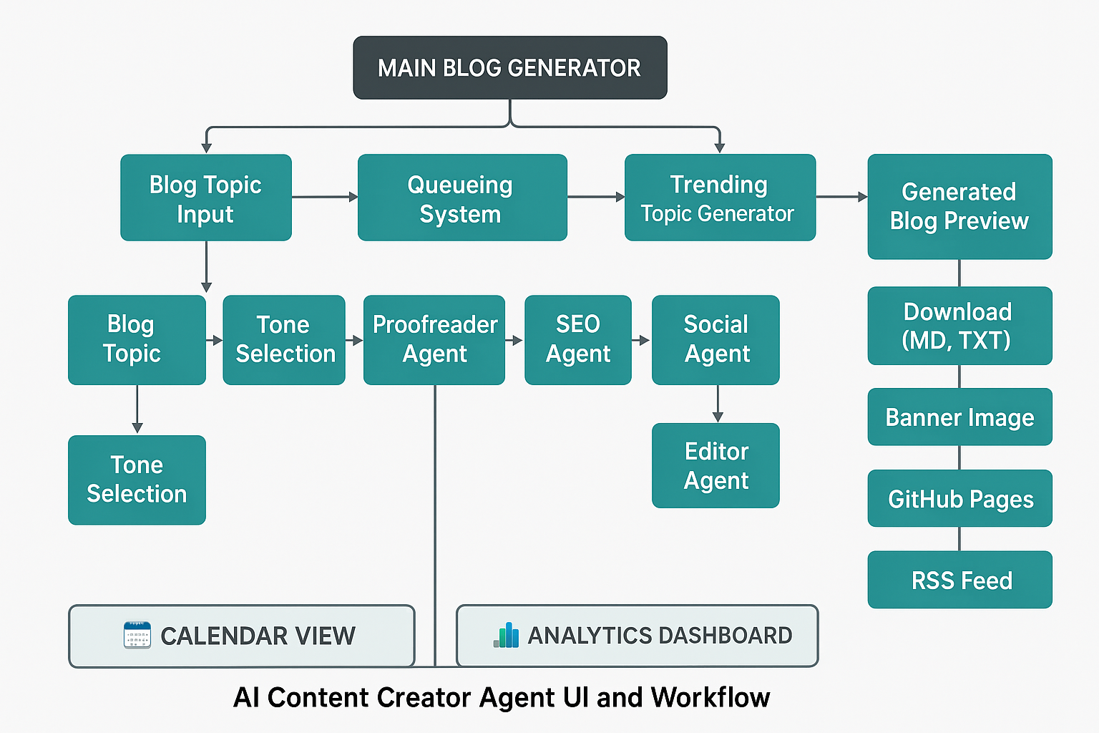
Figure 6. 1 Component Flow Diagram

The AI Content Creator Agent includes a user-friendly, modular interface powered by Streamlit, offering a seamless content generation workflow. Each component is designed to be intuitive, interactive, and optimized for productivity.
🧭 Navigation & Tabs
- Main Blog Generator Tab: Central hub for entering topics, selecting tone/audience, previewing outlines, and generating full content.
- 📆 Calendar View: Visual heatmap showing daily publishing activity.
- 📊 Analytics Dashboard: Summary of metrics, tag frequency, trends, and archive filters.
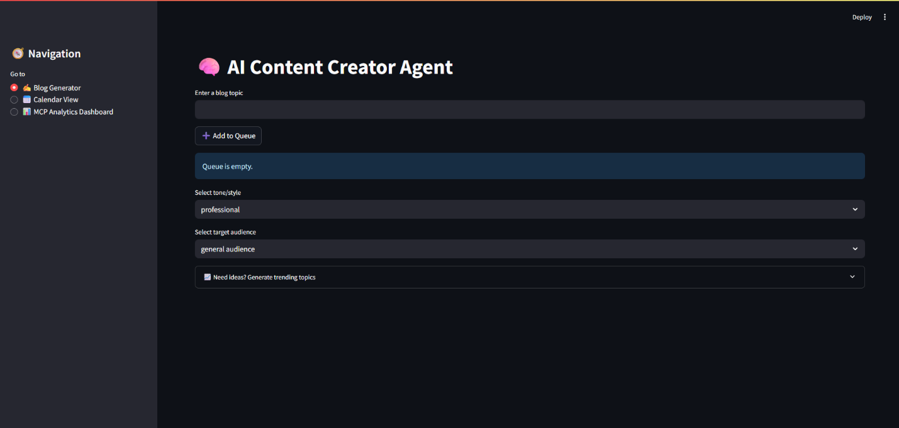
Figure 6. 2 Main Blog Generator Tab
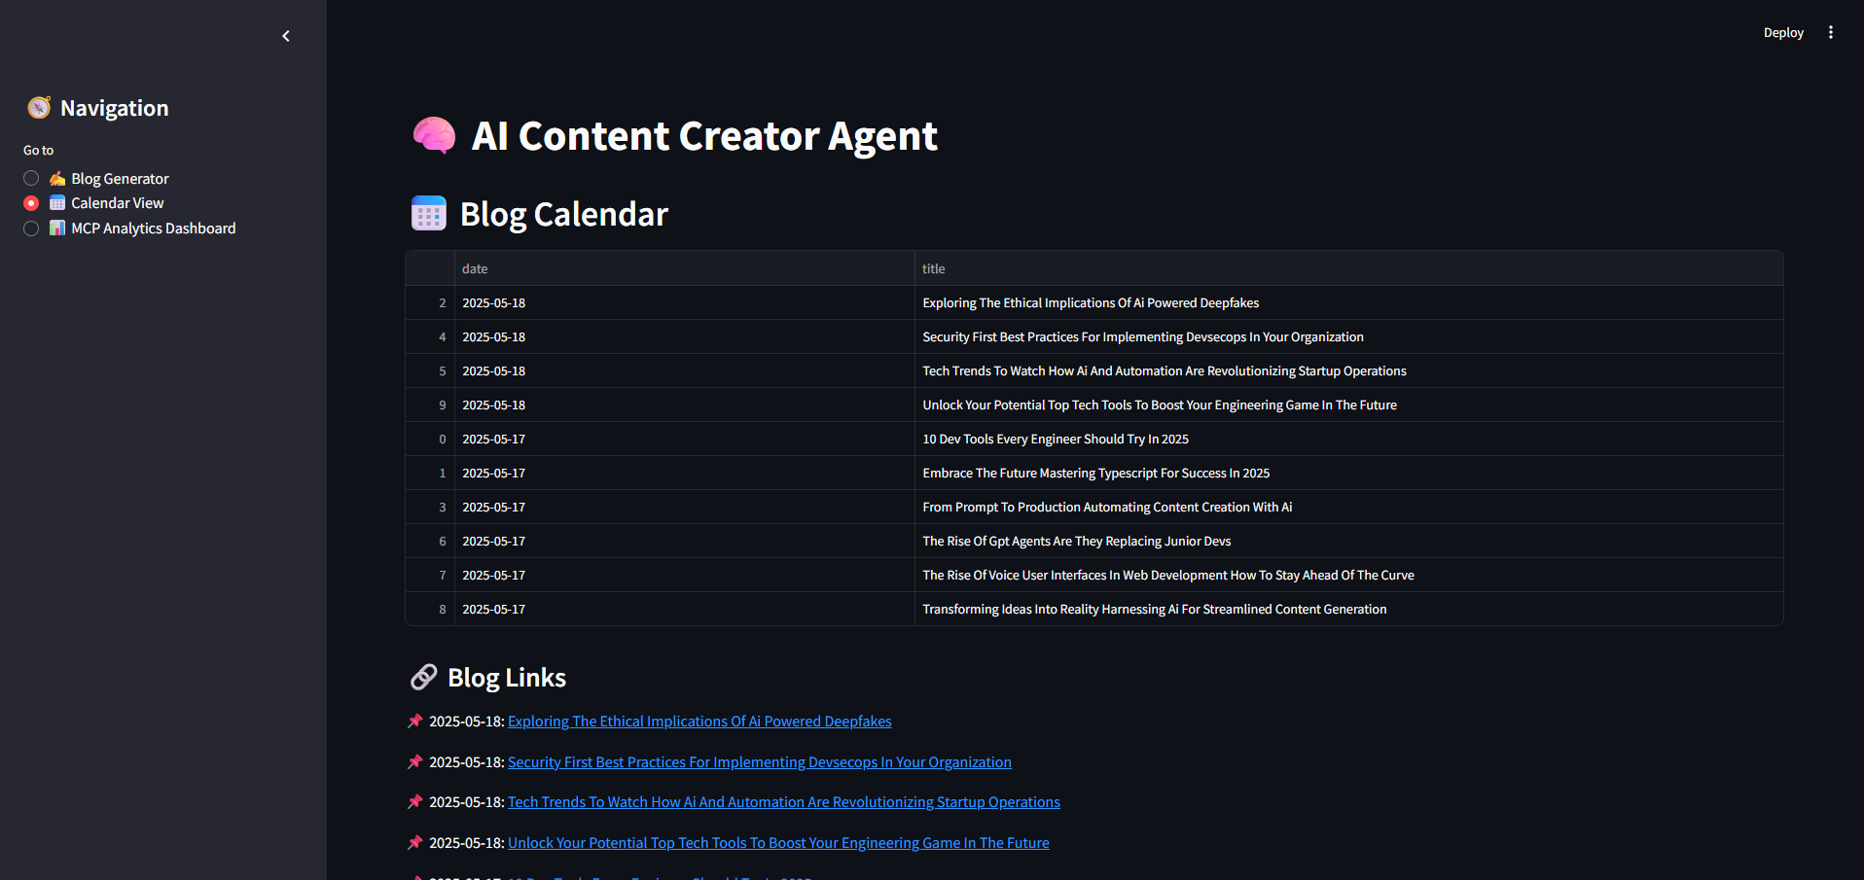
Figure 6. 3 Calender View
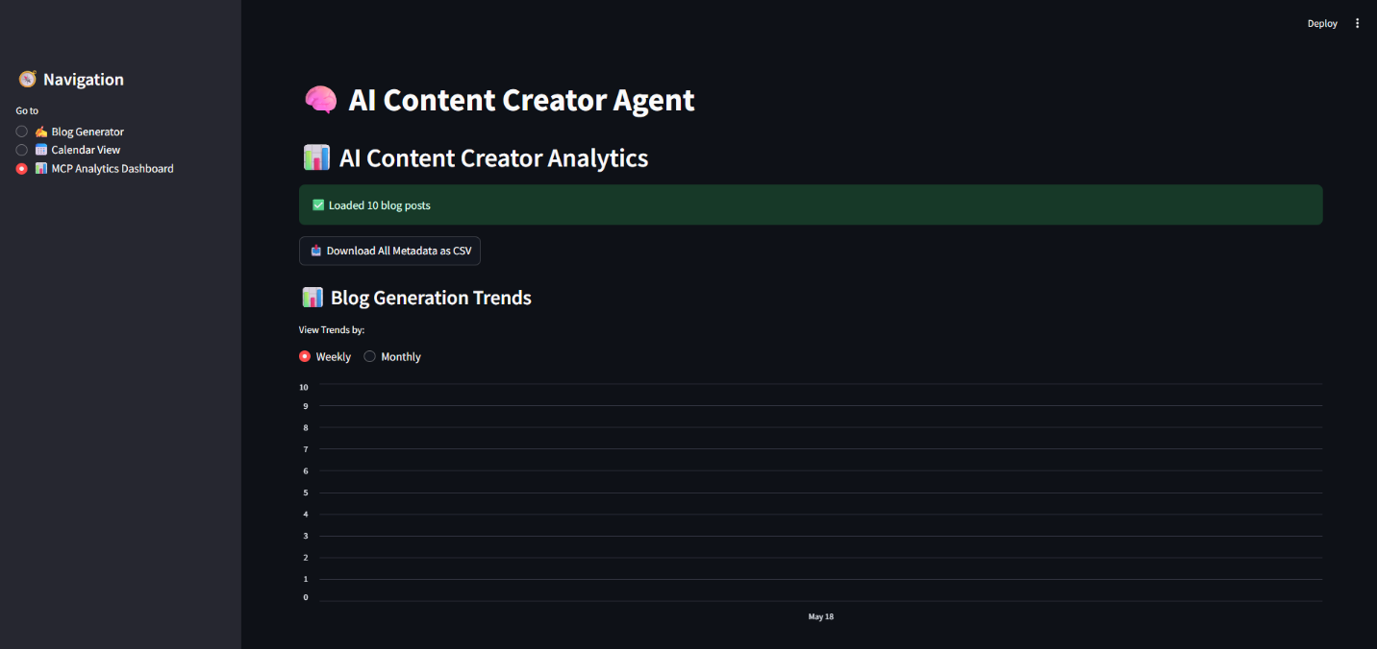
Figure 6. 4 Analytics Dashboard

✍️ Blog Generation Section
- Blog Topic Input: Users can enter any custom blog idea or topic.
- Tone Selection Dropdown: Choose writing tone (e.g., professional, witty, inspirational).
- Target Audience Dropdown: Select the intended reader group (e.g., beginners, developers, CTOs).

📚 AI-Generated Outline
- Outliner Agent Integration: Suggests a structured blog outline before writing begins.
- Editable Outline Box: Users can refine the suggested structure before content generation.

📈 Trending Topic Generator
- Category Selector: Choose from tech, AI, DevOps, startups, etc.
- Generate Suggestions: Invokes AI to propose hot topics in the selected domain.
- One-Click Selection: Insert suggestions directly into the blog topic field.

🚂 Queueing System
- Add to Queue: Accumulate multiple blog topics for batch generation.
- Generate Next: Runs one queued topic through the content pipeline.
- Run Full Queue: Automatically processes all queued topics end-to-end.

🔁 Automation Workflow:
- Scheduled Execution:
  - A Python-based scheduler (e.g., using schedule or cron) runs daily_generate.py once a day.
  - A new topic is either auto-suggested or fetched from a queue.
- Content Generation:
  - The full agent pipeline is triggered:
    - Writer → Proofreader → SEO → Captions → Editor → Citations
- GitHub Commit & Push:
  - The new .html, .md, and rss.xml files are automatically committed and pushed to the GitHub repo.
  - This updates the GitHub Pages site in real time.
- Dev.to Auto-Publish:
  - Since Dev.to monitors the RSS feed, it detects the new blog within minutes.
  - The blog appears as a draft on the Dev.to dashboard, ready for review/publishing.
- Email Notification:
  - Once picked up by Dev.to, an email is sent confirming draft creation.

🧠 AI Agent Pipeline
Upon content generation trigger, the following sequence occurs:
- Writer Agent – Drafts full content
- Proofreader Agent – Refines language and tone
- Citation Inserter Agent – Suggests references and links
- SEO Agent – Adds meta description and keyword tags
- Social Agent – Produces captions for Twitter, LinkedIn, Instagram
- Editor Agent – Summarizes content into bullet points

📤 Output & Publishing
- Generated Blog Preview: Display of the final, polished post
- Social Media Captions View: Inline display of captions for each platform
- Reading Time & Summary: Auto-generated metrics shown next to blog
- Share Banner Image: Visual asset for social sharing
- GitHub Pages Auto-Publishing: Blog is saved as .html and hosted
- RSS Feed Update: rss.xml automatically refreshed for Dev.to pickup

💾 Download Options
- Markdown (.md) – Original blog text
- Text (.txt) – Social captions
- JSON (.json) – Metadata (SEO, citations, tags, summary)
- PNG (.png) – Blog-specific social banner
- CSV (.csv) – Full export of all blog metadata from the dashboard

7. Dashboard & Insights

- Heatmap of blog publishing days
- Weekly/monthly generation trends
- Top SEO tags chart
- Tag-based filtering and keyword search
- Metadata export as CSV


Figure 7. 1 Weekly Monthly Blog Generation Trends Section
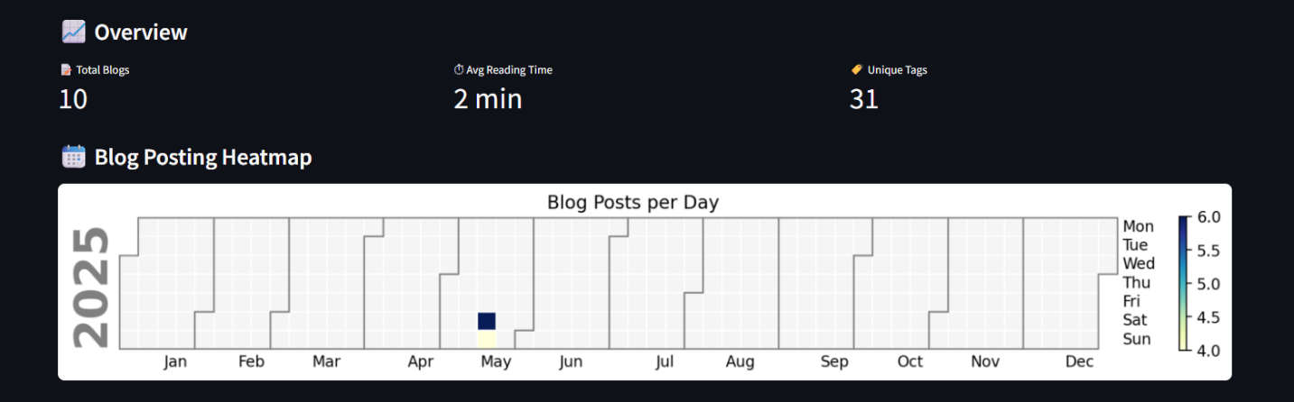
Figure 7. 2 Meta Data and Blog Posting Heatmap

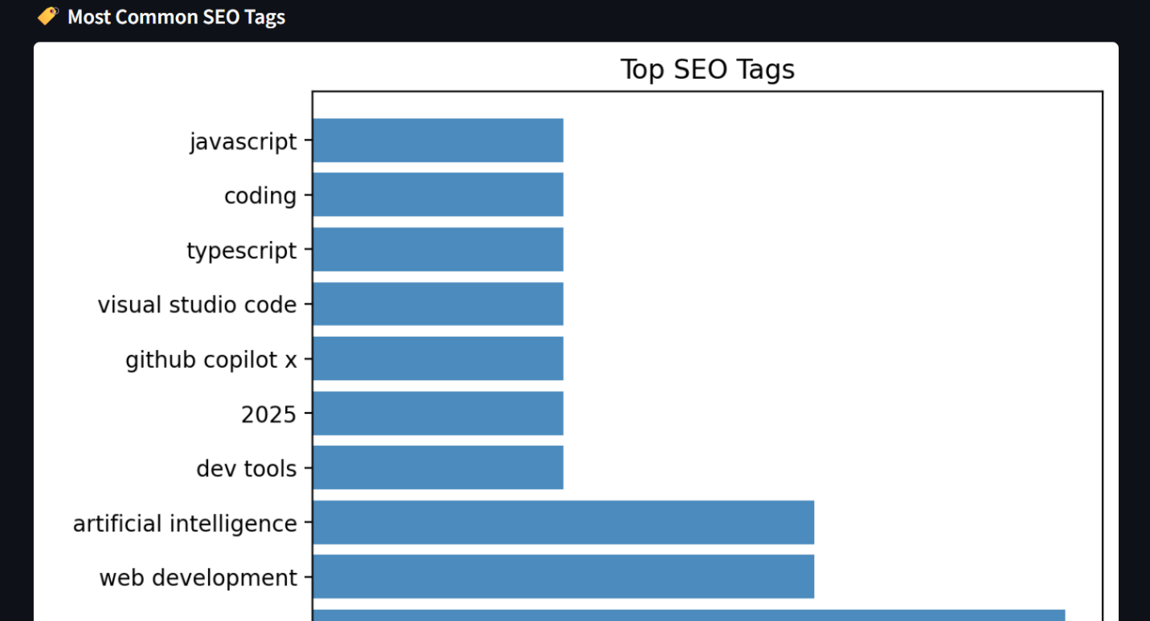
Figure 7. 3 Top SEO Tags Chart

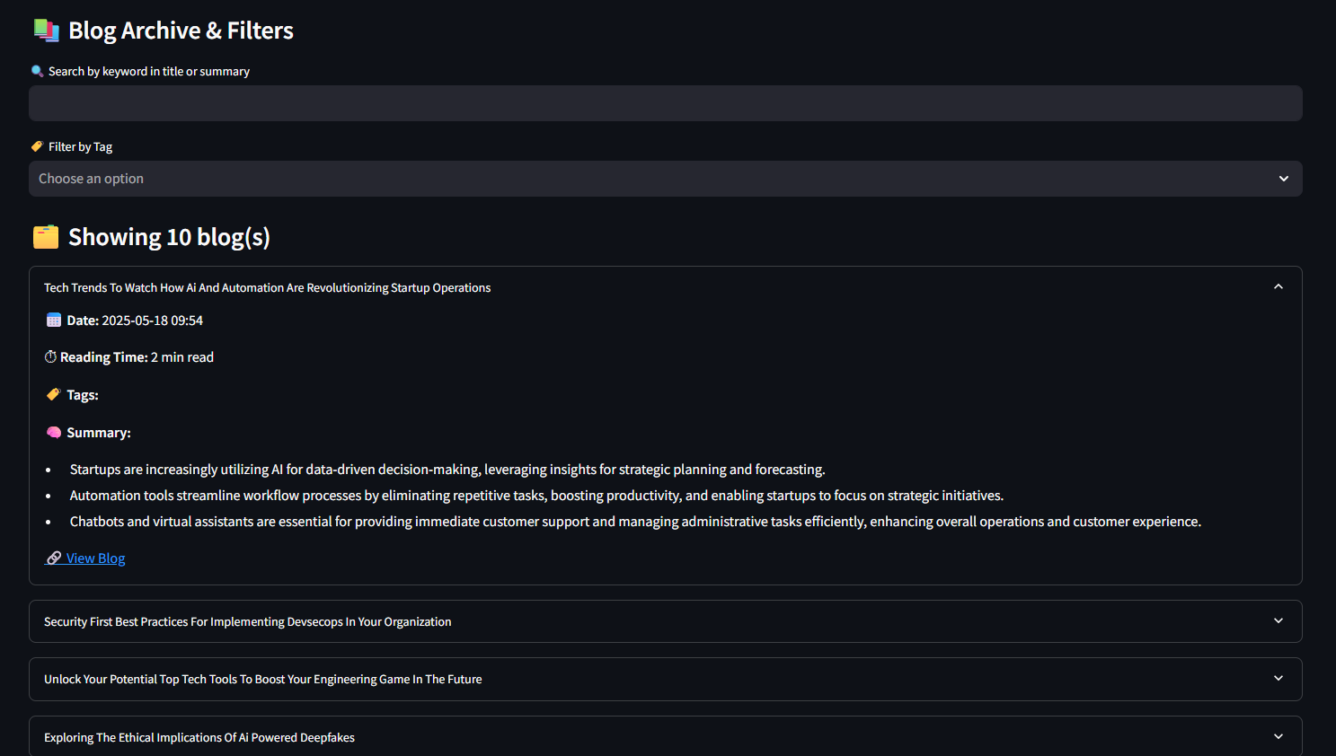
Figure 7. 4 Tag Based Filtering Keyword Search and Blog Archives

8. Output Structure

├── blogs/ ➝ Markdown blog posts
├── captions/ ➝ Social media text files
├── metadata/ ➝ SEO, summary, citation data
├── docs/ ➝ GitHub Pages (HTML + rss.xml)
├── banners/ ➝ Auto-generated social share banners

9. Execution Flow

- Enter topic via UI
- System checks for duplicates and suggests rewrites
- Agents generate:
  - Outline
  - Blog
  - Captions
  - Metadata
  - Citations
  - Banner
- Blog is saved and HTML is generated
- RSS is updated, Dev.to detects new post
- User can view/export content, analytics, or queue more
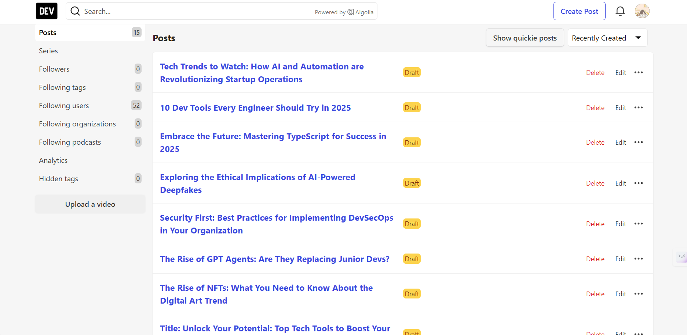
Figure 9. 1 New Posts Updated to Dev.to through RSS

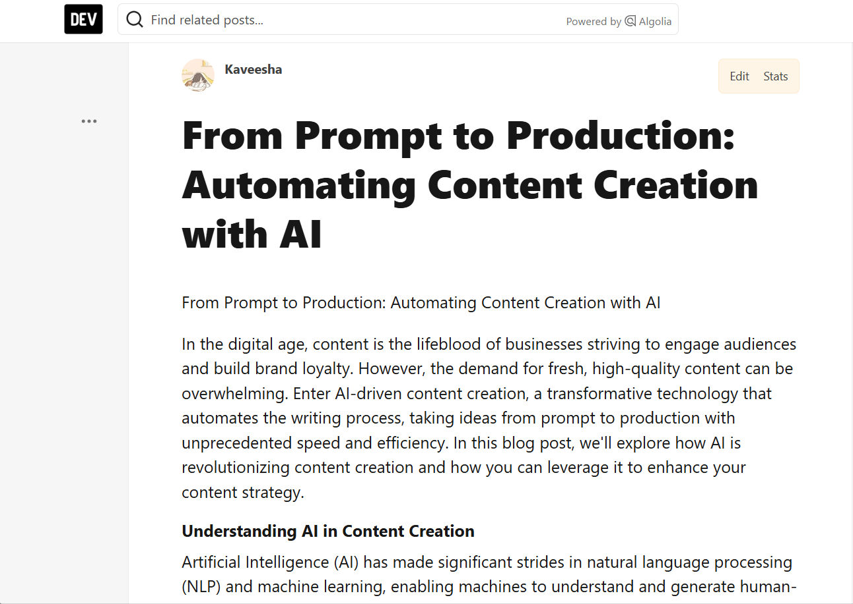
Figure 9. 2 AI Content Creator Generated Blog Posted on Dev.to

10. Future Enhancements

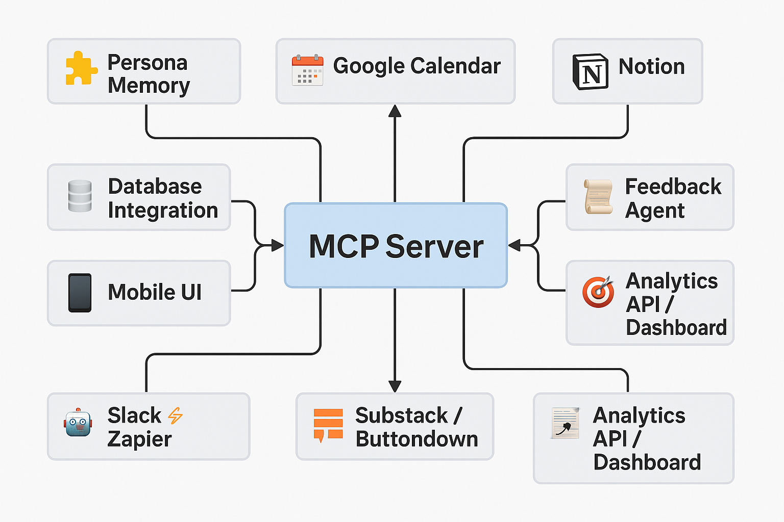
Figure 10. 1 Future Enhancements Overview Diagram

Feature | Description
🧩 Persona Memory | Enable memory for writing tone, author style, and preferred structure based on user profile.
📱 Mobile UI | Responsive Streamlit layout or mobile companion app for on-the-go blog generation.
🤖 Slack/Zapier Integration | Schedule or trigger blog generation via Slack commands or Zapier automations (e.g., generate a blog every Monday at 9AM).
📰 Newsletter Export (Substack/Buttondown)  🖼️ AI-Generated Thumbnails | One-click export to email marketing platforms to send blog content as newsletters.  Use tools like DALL·E or Stable Diffusion to automatically generate unique blog thumbnails based on the blog title, keywords, or summary.
🧠 Agent Chaining & Parallel Planning | Allow asynchronous/parallel execution of agents and planning of next content ideas based on trending searches.
🗄️ Database Integration | Store all generated content, metadata, user profiles, and feedback in a database (PostgreSQL or Supabase). Enables querying, analytics, and persistent memory.
📅 Google Calendar Integration | Auto-schedule blog publishing, reminders, and collaboration events tied to each blog topic.
📬 Gmail Integration | Email generated blogs to editors, teams, or oneself. Could also accept blog ideas from starred emails.
📓 Notion Integration | Sync blog content, drafts, and to-dos to a Notion workspace (content planning, scheduling, collaboration).
🎯 Analytics API / Webhook Dashboard | Push performance data or publishing status to a dashboard or analytics tracker (e.g., Grafana, Superset).
🧾 Feedback Collection Agent | Let users give feedback on generated content and tune models or prompt behavior over time.

11. Conclusion

The AI Content Creator Agent is a powerful example of how modern LLMs and agent-based orchestration can fully automate a creative pipeline. This MCP server design ensures modularity, extensibility, and end-to-end automation for content creators, marketers, and technical bloggers.
It transforms an idea into a digital asset—optimized, shareable, and ready to publish—without manual intervention.

12. Appendix

- GitHub Repo: https://github.com/kaveeshagim/ai-content-creator-agent
- Live Blog Page: https://kaveeshagim.github.io/ai-content-creator-agent
- Dev.to Feed: Kaveesha - DEV Community

