

BSc (Hons) in Information Technology specializing in Information

Technology

Department of Information Technology

Sri Lanka Institute of Information Technology

Sri Lanka

January 2022

### SE4050 – Deep Learning

**Assignment 01**

### Student ID : - IT19106502

### Student Name: - Madhubhashana I.K.

# Table of Contents

1. Introduction 3

2. Methodology 3

2.1 Detail Analysis for Dataset 3

2.2 Sample Images 4

4. Background Information about the algorithms used 4

3. Data Pre-processing 5

Model – 01 5

Model - 02 5

3.1 Sample Screenshots of Data Preprocessing 5

4. Model Architecture & Algorithm 6

4.1 Justification for the algorithm 7

4.2 Layer chosen 7

4.3 Activation Functions 7

5. Results and comparison 8

6. Discussion 9

6.1 Limitations 9

6.2 How Accuracy improve 9

# Introduction

**How to detect animals fast and accurately for crop repelling**

Now a day’s human and animal conflict rapidly increasing across Sri Lanka. As an example Elephants, wild boars, goats etc. they moving into the crop fields to search of food and make a damage to the crops not only by eating but also by trampling the crops by their foot and mouth. In some areas in country crop damage to the extent of 50-60% and sometimes is going 100% crop is damaged by wild animals. This research Report propose the solution for crop protection system to identify their using image processing. Have an ability to use this animal detection to identify the animals who come towards the crop. This is a solution for the problem raised how to detect them fast and accurately.

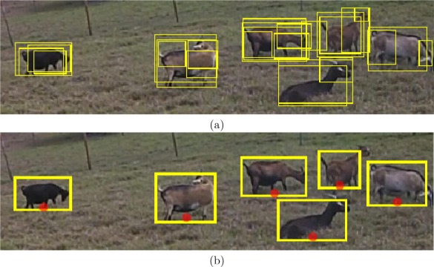

# Methodology

I obtained the datasets for crop harming animals for this research from the Kaggle website. The photographs were then rescaled and resized using appropriate augmentation tools because to the disparate scales and sizes of the images inside the zip file, and then those images were saved in a disk folder. A different code is used in this place specifically for this augmentation section.

## 2.1 Detail Analysis for Dataset

|  |  |
| --- | --- |
| Name | Mammals Dataset |
| Description | This contain zip file of image datasets of Mammals |
| Link | <https://www.kaggle.com/datasets/anirudhg15/mammals-classification> |
| File Size | 533MB |
| Classes | Elephant ,goat |
| Dataset stored in | <https://www.kaggle.com/> |

## 2.2 Sample Images

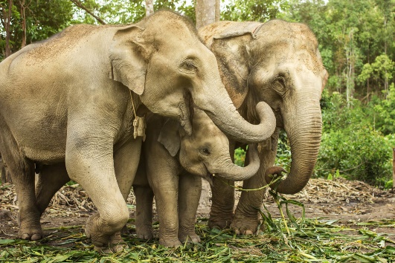 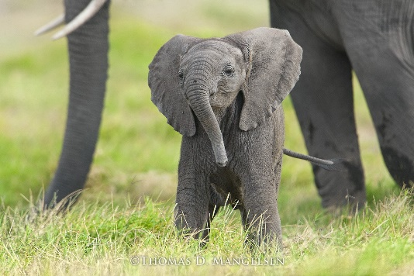

# 4. Background Information about the algorithms used

**CNN Algorithm**

CNN is an example of supervised deep learning.CNN is a well-liked and efficient recognition method in pattern recognition and image processing. It has a variety of advantages, including as versatility, a simple structure, and a low learning curve. The problem is now a major one in speech and picture recognition. Explaining the five layers of a convolutional neural network using basic CNN architecture

**Custom Prepared CNN architectures**

Convolutional layers, MaxPooling layers, Flatten layers, and a thick layer are employed to build this specially trained CNN design. This unique CNN architecture is used to compare it to 2 architectures, determine which one has the best model, and obtain results from the most accurate model.

# 3. Data Pre-processing

|  |  |
| --- | --- |
| Model – 01 | Model - 02 |
| Resizing images to desired size to get more accuracy and improve model performance. | Resizing images to desired size to get more accuracy and improve model performance |
| Normalize the image pixel value. (256*256).  Added feature to automatically resize images according to the mentioned image size. | Added Data cleaning feature to identify compatible issue in the file formats and remove them before training. |
| Data Augmentation added to the notebook before training the model it’s used when we have less number of data to train the model. | Entering the folder and check there are image without mentioned size, resize them into (300*300). |
| Have done data separating as train and tests. | Images put into the array and divided by 255 |
|  | Added label encoding to identify string type classes name and added one Hot encoding. |

## 3.1 Sample Screenshots of Data Preprocessing

Model 01

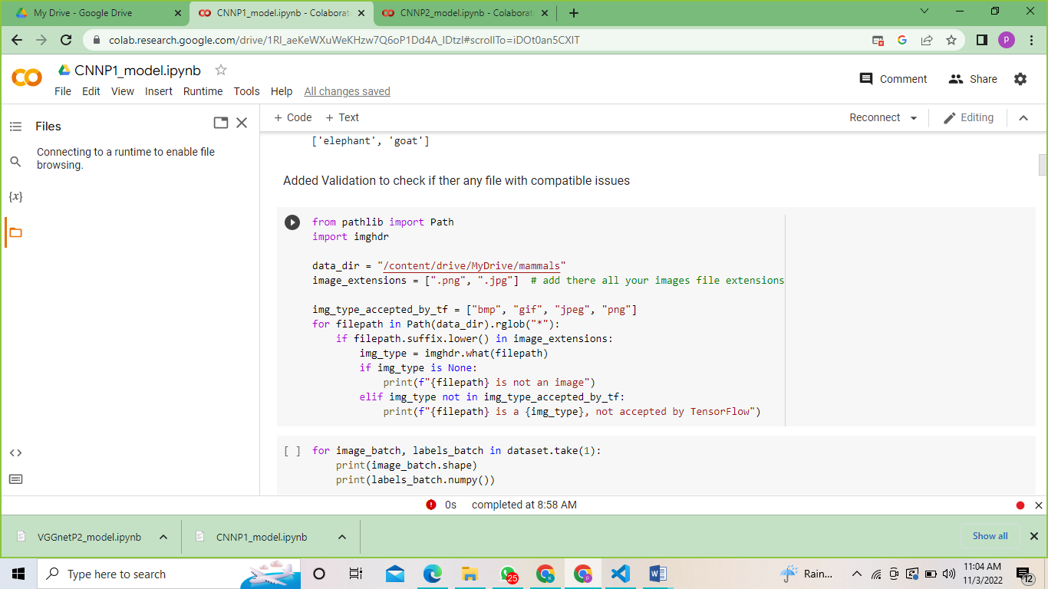

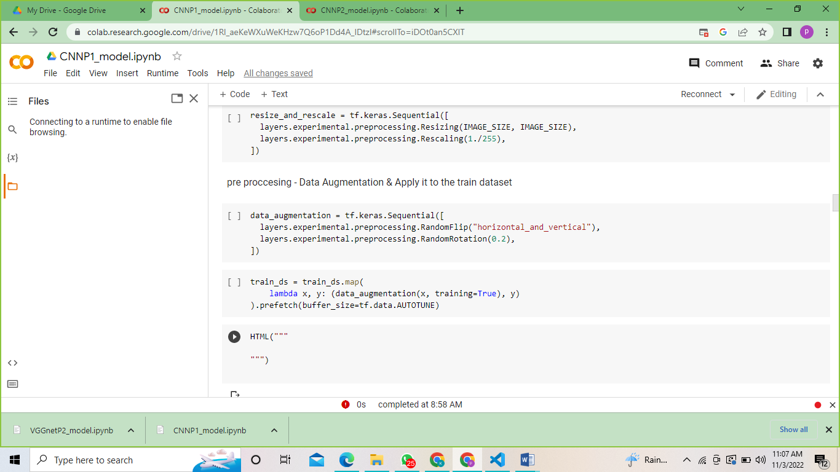

Model 02

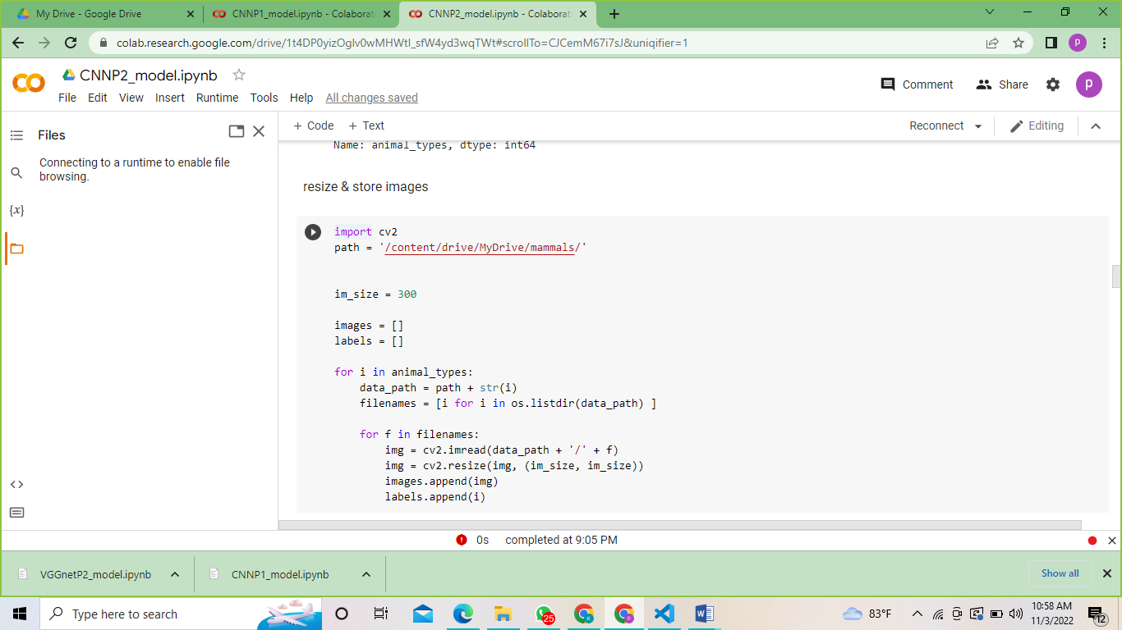

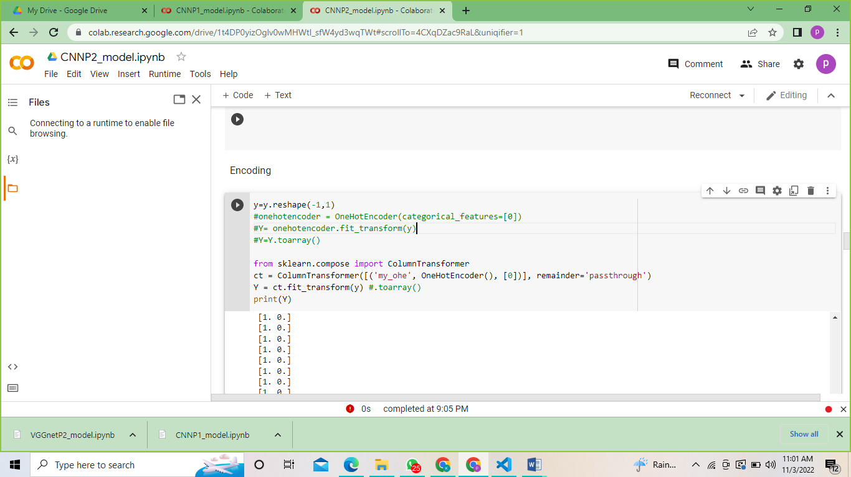

# 4. Model Architecture & Algorithm

## 4.1 Justification for the algorithm

Input, output, and hidden layers are just a few of the attributes that CNNs possess to aid in the processing and classification of pictures. Convolutional, pooling, and fully linked layers are a few of the hidden layers that have important roles to play.

Convolutional neural networks, often known as CNNs, and the neural networks that are commonly use for image recognition. The enormous dimensionality of the images is decreased without any information being lost because to its incorporated convolutional layer. CNNs are hence the best choice for this use case.

## 4.2 Layer chosen

**Model 01**

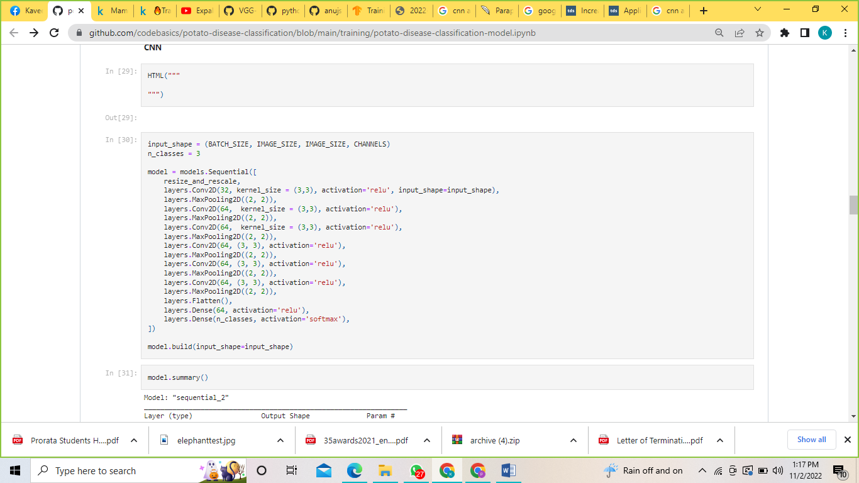

**Model 02**

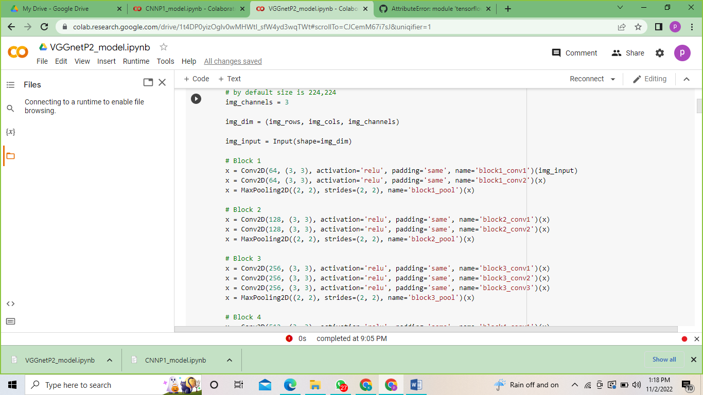

## 4.3 Activation Functions

Inside the N.network Softmax function doing the activation function task inside the output layer, and this function can use to when user need to classification with multiple class (More than one classes)

The relu activation function can be applied to either the output layer or the hidden layer. It accepts a number as input and returns a value between 0 and 1.

# 5. Results and comparison

|  |  |
| --- | --- |
| Model 1 | Mode 2 |
| Model Accuracy level :- 90+ | Model Accuracy level:-50+ |

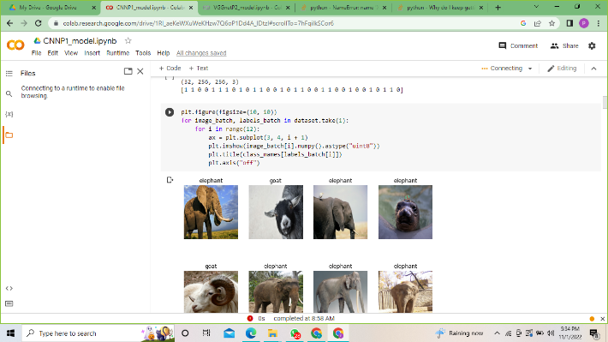 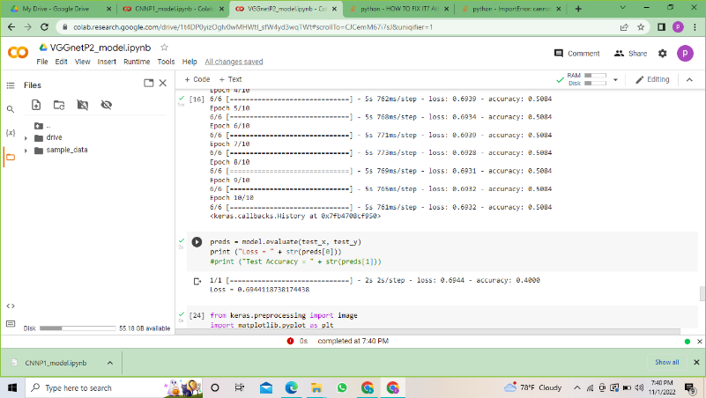

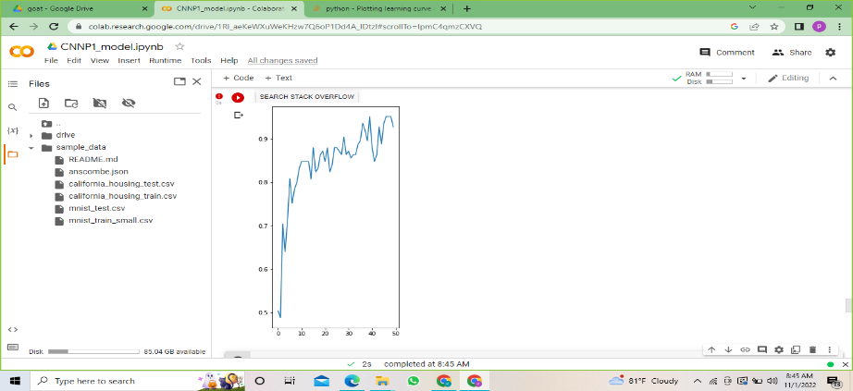

**When comparing with CNN model 1 and model 2 according to the results we can see custom model 1 reach high accuracy level.**

# 6. Discussion

## 6.1 Limitations

* Due to operations like maxpooling, CNN model training takes longer. Additionally, as the dataset grows, there is a chance that the colab's GPU would crash.
* When more layers are added, executing the training process on the CPU is insufficient; instead, GPU must be used.
* When not enough photos are provided, there is a chance of overfitting and under fitting.

## 6.2 How Accuracy improve

* To increase accuracy we can use larger number of data when we doing training.
* To increase the accuracy increase the number of epoch size.
* Use ensemble learning - The best strategies for minimizing model variance and boosting prediction accuracy are ensemble methods. When multiple models are integrated to create a single forecast that is selected among all other potential predictions from the combined models, the variance is eliminated.
* Increase number of layers – it will be a help to read your model deeply when start the model training.
* Reduce channel- Your image arrays' dimensions are reflected in the color channels. Grayscale images only have one channel, but the majority of color (RGB) images have three. The dataset becomes more complicated and takes longer to train the model as the complexity of the color channels increases. You can go ahead and convert your color photographs to grayscale if color isn't that important to your model.