TH_Java_SDK 3.5 Configuration File

- This demo base SSM framework,and the device use websocket as it’s
communication protocal,this sdk use java.org_websocket jar,implement websocket interface

- The main class is WSSServe.

- Development environment:
JDK 1.8, ecplise_J2EE, Maven 3.5 and above,Tomcat 9 and above,mysql 5.7.
Setting maven and tomcat in ecplise.

- Import fingerprint.sql into mysql database;

- Import project into ecplise

- open windows firewall port 7788.

- setting the server ip your computer local ip,and setting network and server port 7788.

- Config image setting.tomcat/conf/server.xml
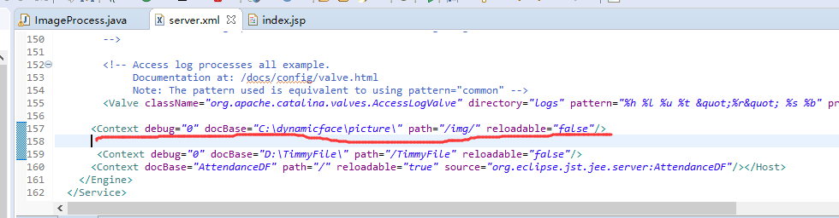

9.run the project, and operate

[backupnum 0-9 is fingerprint，backupnum 20-27 is face（20-23 is first face，24-27 is another face），backupnum 30-37 is palm，50 is photo

