Results and Discussion
Benchmarking Graph-Based Fraud Detection: Architecture Comparison Across Training Ratios, Datasets, Runtime and Complexity

1. Experimental setup
We evaluate graph neural fraud detectors under a shared protocol: fixed validation (20%) and test (40%) pools, with the labeled training pool restricted to 10%, 20%, 30% or 40% of nodes (stratified seeds 123–1234567). Reported scores are means ± standard deviation over five seeds. Primary metrics are G-Mean, AUROC, AUPRC and Macro-F1. The five benchmark graphs are Amazon, YelpChi, T-Finance, Elliptic and FDCompCN (T-Social excluded pending heterophily recomputation). Models with complete five-dataset coverage include BWGNN, GLHN, GraphConsis, PMP, SEC-GFD, BSL and DGA-GNN; SplitGNN is partial at 10%/40%; GAGA and GHRN cover a subset of datasets.

2. Dataset characteristics and comparison
The collection spans four application domains and deliberately orthogonal difficulty axes: class imbalance, local camouflage (heterophily), multi-relation structure, sparsity and scale (Dataset_Report_Full).
YelpChi (45,954 reviews, 14.53% spam, 32 features) is a multi-relation review graph (R-U-R, R-T-R, R-S-R). Local heterophily is severe on the product/time relations (~0.80) but low on R-U-R (~0.075), so methods that treat relations equally dilute the informative reviewer link. Amazon (11,944 users, 6.87% fraud over all nodes / ~9.5% over labeled, 25 features) shows extreme local camouflage (~0.90) with dense multi-relation user links and a large unlabeled set retained for message passing. T-Finance (39,357 accounts, 4.58% fraud, 10 features) is a dense homogeneous transaction graph (~21.2M edges, ~539 edges/node) with comparatively milder local heterophily (0.456), so anomalies partly cluster. Elliptic (203,769 Bitcoin transactions, 2.23% illicit among all nodes, 166 features) is large but sparse (~1.15 edges/node) with many unknown labels kept in-graph; features already encode one-hop aggregates, so GNNs partly re-aggregate precomputed structure. FDCompCN (5,317 listed companies, 10.51% fraud, 57 features) is extremely sparse (~1.37 mean degree after removing self-loops) with severe camouflage (~0.86) and thousands of isolated firms for which a GNN reduces to a feature-only classifier.
Comparing datasets: Amazon and YelpChi stress relation-aware and camouflage-resistant designs; T-Finance stresses scalability under density; Elliptic stresses scale under sparsity plus already-rich features; FDCompCN stresses structural sparsity and isolation. Fraud rate, camouflage and scale are largely independent axes—no single property predicts the others—so architecture winners shift by dataset.

3. Performance tables by training ratio
The following tables report mean ± std over seeds. Colour-coded static visualizations of the same tables appear as Figures 1–4.

3.1 Training ratio 10%
Model | Amazon |  |  |  | YelpChi |  |  |  | T-Finance |  |  |  | Elliptic |  |  |  | FDCompCN
 | G-Mean | AUROC | AUPRC | F1-Macro | G-Mean | AUROC | AUPRC | F1-Macro | G-Mean | AUROC | AUPRC | F1-Macro | G-Mean | AUROC | AUPRC | F1-Macro | G-Mean | AUROC | AUPRC | F1-Macro
BSL | 0.706±0.070 | 0.862±0.009 | 0.429±0.023 | 0.713±0.026 | 0.069±0.104 | 0.601±0.009 | 0.225±0.012 | 0.473±0.022 | 0.820±0.010 | 0.901±0.006 | 0.684±0.025 | 0.742±0.086 | 0.862±0.021 | 0.945±0.006 | 0.770±0.024 | 0.840±0.031 | 0.263±0.154 | 0.595±0.054 | 0.160±0.036 | 0.526±0.035
BWGNN | 0.891±0.016 | 0.953±0.017 | 0.834±0.016 | 0.865±0.025 | 0.778±0.005 | 0.858±0.005 | 0.528±0.011 | 0.650±0.012 | 0.908±0.010 | 0.953±0.006 | 0.833±0.015 | 0.808±0.020 | 0.903±0.007 | 0.962±0.004 | 0.839±0.014 | 0.847±0.029 | 0.324±0.202 | 0.548±0.011 | 0.123±0.003 | 0.435±0.118
DGA-GNN | 0.612±0.154 | 0.919±0.010 | 0.626±0.065 | 0.719±0.081 | 0.848±0.034 | 0.952±0.007 | 0.820±0.031 | 0.854±0.015 | 0.845±0.040 | 0.949±0.009 | 0.771±0.069 | 0.859±0.035 | 0.916±0.012 | 0.967±0.010 | 0.899±0.043 | 0.938±0.007 | 0.232±0.168 | 0.712±0.030 | 0.263±0.069 | 0.533±0.057
GAGA | 0.886±0.010 | 0.952±0.014 | 0.829±0.019 | — | — | — | — | — | — | — | — | — | — | — | — | — | 0.506±0.021 | 0.507±0.029 | 0.117±0.008 | —
GHRN | 0.890±0.007 | 0.955±0.008 | 0.832±0.024 | — | 0.696±0.030 | 0.793±0.008 | 0.430±0.005 | — | — | — | — | — | — | — | — | — | 0.358±0.191 | 0.559±0.030 | 0.134±0.016 | —
GLHN | 0.848±0.015 | 0.936±0.007 | 0.752±0.019 | 0.742±0.050 | 0.783±0.005 | 0.858±0.007 | 0.572±0.018 | 0.701±0.010 | 0.894±0.002 | 0.948±0.003 | 0.814±0.012 | 0.790±0.044 | 0.869±0.012 | 0.941±0.009 | 0.755±0.038 | 0.810±0.021 | 0.469±0.039 | 0.604±0.041 | 0.164±0.038 | 0.509±0.102
GraphConsis | 0.870±0.010 | 0.965±0.009 | 0.845±0.021 | 0.894±0.008 | 0.720±0.030 | 0.883±0.002 | 0.630±0.009 | 0.756±0.009 | 0.863±0.015 | 0.948±0.007 | 0.827±0.013 | 0.890±0.008 | 0.877±0.015 | 0.961±0.004 | 0.853±0.010 | 0.891±0.005 | 0.269±0.161 | 0.611±0.056 | 0.177±0.048 | 0.529±0.039
PMP | 0.868±0.009 | 0.956±0.009 | 0.864±0.019 | 0.901±0.008 | 0.680±0.079 | 0.896±0.004 | 0.629±0.011 | 0.737±0.023 | 0.863±0.016 | 0.957±0.010 | 0.869±0.012 | 0.910±0.006 | 0.819±0.078 | 0.924±0.004 | 0.710±0.029 | 0.851±0.039 | 0.305±0.252 | 0.550±0.027 | 0.132±0.021 | 0.410±0.093
SEC-GFD | 0.876±0.016 | 0.945±0.015 | 0.845±0.024 | 0.880±0.017 | 0.705±0.006 | 0.787±0.005 | 0.423±0.011 | 0.613±0.035 | 0.886±0.050 | 0.936±0.039 | 0.711±0.250 | 0.726±0.081 | 0.896±0.010 | 0.957±0.004 | 0.825±0.031 | 0.873±0.020 | 0.363±0.209 | 0.564±0.020 | 0.127±0.007 | 0.423±0.099
Table 1. Mean ± std test metrics at 10% training ratio across five datasets (G-Mean, AUROC, AUPRC, F1-Macro). Em dash = not run.

3.2 Training ratio 20%
Model | Amazon |  |  |  | YelpChi |  |  |  | T-Finance |  |  |  | Elliptic |  |  |  | FDCompCN
 | G-Mean | AUROC | AUPRC | F1-Macro | G-Mean | AUROC | AUPRC | F1-Macro | G-Mean | AUROC | AUPRC | F1-Macro | G-Mean | AUROC | AUPRC | F1-Macro | G-Mean | AUROC | AUPRC | F1-Macro
BSL | 0.758±0.010 | 0.868±0.012 | 0.437±0.018 | 0.708±0.017 | 0.056±0.054 | 0.600±0.005 | 0.226±0.008 | 0.466±0.007 | 0.825±0.018 | 0.901±0.005 | 0.690±0.018 | 0.761±0.054 | 0.871±0.008 | 0.943±0.007 | 0.755±0.040 | 0.813±0.044 | 0.378±0.065 | 0.620±0.025 | 0.179±0.025 | 0.551±0.025
BWGNN | 0.903±0.016 | 0.967±0.004 | 0.842±0.006 | 0.858±0.028 | 0.796±0.006 | 0.872±0.005 | 0.564±0.013 | 0.686±0.018 | 0.906±0.012 | 0.955±0.004 | 0.830±0.011 | 0.757±0.063 | 0.919±0.002 | 0.971±0.002 | 0.884±0.006 | 0.873±0.006 | 0.447±0.097 | 0.559±0.011 | 0.136±0.010 | 0.452±0.075
DGA-GNN | 0.744±0.091 | 0.936±0.021 | 0.692±0.147 | 0.808±0.078 | 0.884±0.028 | 0.969±0.003 | 0.888±0.014 | 0.885±0.008 | 0.851±0.034 | 0.954±0.006 | 0.824±0.040 | 0.887±0.018 | 0.925±0.007 | 0.978±0.011 | 0.940±0.017 | 0.947±0.009 | 0.346±0.046 | 0.747±0.012 | 0.336±0.014 | 0.572±0.020
GAGA | 0.893±0.009 | 0.952±0.008 | 0.842±0.016 | — | — | — | — | — | — | — | — | — | — | — | — | — | 0.515±0.022 | 0.529±0.024 | 0.134±0.018 | —
GHRN | 0.896±0.010 | 0.960±0.006 | 0.840±0.015 | — | 0.724±0.025 | 0.811±0.015 | 0.466±0.029 | — | — | — | — | — | — | — | — | — | 0.363±0.176 | 0.565±0.014 | 0.140±0.019 | —
GLHN | 0.878±0.034 | 0.946±0.014 | 0.811±0.041 | 0.788±0.081 | 0.798±0.007 | 0.871±0.005 | 0.595±0.010 | 0.708±0.020 | 0.900±0.007 | 0.952±0.004 | 0.820±0.016 | 0.786±0.017 | 0.895±0.009 | 0.956±0.007 | 0.812±0.026 | 0.826±0.017 | 0.546±0.018 | 0.648±0.023 | 0.207±0.013 | 0.580±0.016
GraphConsis | 0.883±0.024 | 0.968±0.003 | 0.848±0.027 | 0.895±0.012 | 0.724±0.047 | 0.890±0.024 | 0.662±0.045 | 0.768±0.026 | 0.872±0.025 | 0.953±0.005 | 0.841±0.007 | 0.894±0.004 | 0.892±0.004 | 0.968±0.002 | 0.885±0.013 | 0.909±0.006 | 0.385±0.152 | 0.667±0.014 | 0.223±0.013 | 0.570±0.048
PMP | 0.874±0.018 | 0.968±0.008 | 0.879±0.014 | 0.911±0.006 | 0.729±0.038 | 0.917±0.004 | 0.706±0.013 | 0.779±0.007 | 0.880±0.014 | 0.967±0.006 | 0.884±0.015 | 0.917±0.007 | 0.888±0.017 | 0.942±0.006 | 0.784±0.009 | 0.891±0.010 | 0.097±0.090 | 0.562±0.029 | 0.141±0.006 | 0.486±0.014
SEC-GFD | 0.899±0.017 | 0.964±0.005 | 0.871±0.009 | 0.877±0.015 | 0.731±0.016 | 0.814±0.013 | 0.485±0.022 | 0.629±0.045 | 0.896±0.061 | 0.947±0.029 | 0.764±0.180 | 0.783±0.068 | 0.915±0.004 | 0.968±0.001 | 0.863±0.008 | 0.846±0.023 | 0.384±0.161 | 0.556±0.024 | 0.123±0.011 | 0.387±0.172
SplitGNN | 0.818±0.028 | 0.891±0.019 | 0.555±0.026 | 0.687±0.051 | 0.815±0.005 | 0.890±0.005 | 0.641±0.024 | 0.716±0.010 | 0.919±0.012 | 0.953±0.009 | 0.859±0.019 | 0.819±0.013 | 0.878±0.011 | 0.944±0.007 | 0.736±0.041 | 0.760±0.021 | 0.398±0.228 | 0.563±0.041 | 0.137±0.029 | 0.349±0.168
Table 2. Mean ± std test metrics at 20% training ratio across five datasets (G-Mean, AUROC, AUPRC, F1-Macro). Em dash = not run.

3.3 Training ratio 30%
Model | Amazon |  |  |  | YelpChi |  |  |  | T-Finance |  |  |  | Elliptic |  |  |  | FDCompCN
 | G-Mean | AUROC | AUPRC | F1-Macro | G-Mean | AUROC | AUPRC | F1-Macro | G-Mean | AUROC | AUPRC | F1-Macro | G-Mean | AUROC | AUPRC | F1-Macro | G-Mean | AUROC | AUPRC | F1-Macro
BSL | 0.617±0.251 | 0.865±0.014 | 0.428±0.023 | 0.643±0.081 | 0.034±0.048 | 0.603±0.008 | 0.225±0.012 | 0.464±0.004 | 0.826±0.015 | 0.902±0.005 | 0.691±0.006 | 0.732±0.073 | 0.797±0.110 | 0.942±0.006 | 0.759±0.025 | 0.816±0.042 | 0.273±0.121 | 0.632±0.028 | 0.193±0.024 | 0.525±0.030
BWGNN | 0.910±0.008 | 0.973±0.002 | 0.845±0.014 | 0.842±0.020 | 0.803±0.006 | 0.883±0.006 | 0.595±0.013 | 0.687±0.016 | 0.916±0.007 | 0.958±0.004 | 0.843±0.020 | 0.789±0.058 | 0.927±0.002 | 0.976±0.002 | 0.899±0.004 | 0.870±0.019 | 0.471±0.129 | 0.594±0.058 | 0.159±0.042 | 0.436±0.092
DGA-GNN | 0.817±0.015 | 0.959±0.007 | 0.817±0.054 | 0.869±0.022 | 0.887±0.055 | 0.974±0.008 | 0.906±0.022 | 0.895±0.021 | 0.828±0.040 | 0.957±0.007 | 0.814±0.068 | 0.883±0.031 | 0.926±0.014 | 0.986±0.005 | 0.958±0.011 | 0.954±0.006 | 0.354±0.145 | 0.769±0.013 | 0.352±0.044 | 0.582±0.061
GAGA | 0.898±0.010 | 0.963±0.006 | 0.856±0.025 | — | — | — | — | — | — | — | — | — | — | — | — | — | 0.527±0.033 | 0.546±0.047 | 0.135±0.032 | —
GHRN | 0.903±0.014 | 0.968±0.003 | 0.857±0.017 | — | 0.737±0.024 | 0.825±0.013 | 0.500±0.041 | — | — | — | — | — | — | — | — | — | 0.358±0.230 | 0.588±0.022 | 0.157±0.022 | —
GLHN | 0.899±0.017 | 0.956±0.015 | 0.849±0.022 | 0.843±0.007 | 0.808±0.003 | 0.880±0.003 | 0.618±0.010 | 0.716±0.010 | 0.902±0.005 | 0.956±0.004 | 0.825±0.017 | 0.810±0.019 | 0.902±0.010 | 0.961±0.008 | 0.835±0.032 | 0.853±0.016 | 0.585±0.024 | 0.658±0.014 | 0.208±0.014 | 0.561±0.014
GraphConsis | 0.895±0.009 | 0.973±0.006 | 0.876±0.009 | 0.907±0.009 | 0.734±0.021 | 0.903±0.017 | 0.698±0.036 | 0.781±0.015 | 0.880±0.018 | 0.960±0.003 | 0.853±0.006 | 0.895±0.008 | 0.901±0.009 | 0.975±0.004 | 0.905±0.014 | 0.915±0.005 | 0.407±0.066 | 0.697±0.008 | 0.273±0.016 | 0.590±0.028
PMP | 0.886±0.024 | 0.974±0.002 | 0.897±0.009 | 0.913±0.003 | 0.745±0.051 | 0.929±0.003 | 0.746±0.013 | 0.793±0.016 | 0.867±0.037 | 0.968±0.007 | 0.887±0.020 | 0.912±0.015 | 0.822±0.145 | 0.939±0.014 | 0.755±0.078 | 0.850±0.083 | 0.140±0.206 | 0.540±0.030 | 0.126±0.015 | 0.443±0.080
SEC-GFD | 0.896±0.015 | 0.963±0.005 | 0.865±0.016 | 0.881±0.025 | 0.754±0.011 | 0.837±0.011 | 0.537±0.023 | 0.643±0.018 | 0.917±0.009 | 0.954±0.009 | 0.839±0.025 | 0.809±0.024 | 0.920±0.005 | 0.973±0.002 | 0.876±0.010 | 0.863±0.024 | 0.366±0.180 | 0.558±0.021 | 0.128±0.016 | 0.289±0.162
SplitGNN | 0.829±0.023 | 0.907±0.014 | 0.574±0.039 | 0.713±0.016 | 0.821±0.006 | 0.902±0.004 | 0.666±0.014 | 0.720±0.010 | 0.921±0.007 | 0.958±0.005 | 0.864±0.015 | 0.817±0.021 | 0.889±0.013 | 0.954±0.006 | 0.787±0.039 | 0.777±0.027 | 0.402±0.229 | 0.558±0.047 | 0.136±0.034 | 0.358±0.171
Table 3. Mean ± std test metrics at 30% training ratio across five datasets (G-Mean, AUROC, AUPRC, F1-Macro). Em dash = not run.

3.4 Training ratio 40%
Model | Amazon |  |  |  | YelpChi |  |  |  | T-Finance |  |  |  | Elliptic |  |  |  | FDCompCN
 | G-Mean | AUROC | AUPRC | F1-Macro | G-Mean | AUROC | AUPRC | F1-Macro | G-Mean | AUROC | AUPRC | F1-Macro | G-Mean | AUROC | AUPRC | F1-Macro | G-Mean | AUROC | AUPRC | F1-Macro
BSL | 0.576±0.334 | 0.861±0.017 | 0.432±0.026 | 0.653±0.102 | 0.040±0.042 | 0.605±0.009 | 0.230±0.013 | 0.464±0.004 | 0.824±0.018 | 0.902±0.007 | 0.692±0.022 | 0.756±0.090 | 0.842±0.043 | 0.941±0.006 | 0.746±0.050 | 0.829±0.025 | 0.297±0.103 | 0.622±0.029 | 0.179±0.026 | 0.529±0.028
BWGNN | 0.916±0.004 | 0.977±0.003 | 0.862±0.011 | 0.852±0.012 | 0.812±0.008 | 0.891±0.009 | 0.608±0.017 | 0.702±0.010 | 0.922±0.006 | 0.960±0.005 | 0.857±0.019 | 0.827±0.015 | 0.931±0.003 | 0.979±0.001 | 0.909±0.006 | 0.881±0.011 | 0.448±0.151 | 0.573±0.028 | 0.143±0.025 | 0.362±0.150
DGA-GNN | 0.769±0.089 | 0.957±0.014 | 0.784±0.091 | 0.834±0.068 | 0.916±0.027 | 0.980±0.005 | 0.928±0.017 | 0.914±0.014 | 0.826±0.033 | 0.956±0.007 | 0.814±0.053 | 0.882±0.019 | 0.933±0.012 | 0.988±0.004 | 0.963±0.007 | 0.957±0.005 | 0.377±0.030 | 0.784±0.019 | 0.381±0.022 | 0.589±0.014
GAGA | 0.908±0.005 | 0.968±0.003 | 0.863±0.010 | — | — | — | — | — | — | — | — | — | — | — | — | — | 0.544±0.063 | 0.563±0.069 | 0.148±0.044 | —
GHRN | 0.915±0.006 | 0.974±0.002 | 0.871±0.019 | — | 0.755±0.016 | 0.843±0.010 | 0.531±0.023 | — | — | — | — | — | — | — | — | — | 0.458±0.098 | 0.563±0.018 | 0.136±0.014 | —
GLHN | 0.908±0.012 | 0.962±0.006 | 0.862±0.013 | 0.852±0.006 | 0.817±0.003 | 0.889±0.003 | 0.643±0.007 | 0.729±0.009 | 0.904±0.005 | 0.958±0.005 | 0.831±0.020 | 0.815±0.031 | 0.914±0.008 | 0.968±0.005 | 0.870±0.016 | 0.856±0.016 | 0.598±0.030 | 0.681±0.020 | 0.225±0.025 | 0.573±0.008
GraphConsis | 0.886±0.012 | 0.976±0.004 | 0.868±0.018 | 0.907±0.006 | 0.757±0.024 | 0.914±0.020 | 0.716±0.040 | 0.791±0.018 | 0.864±0.024 | 0.961±0.003 | 0.853±0.006 | 0.899±0.010 | 0.912±0.012 | 0.978±0.002 | 0.915±0.007 | 0.922±0.003 | 0.371±0.051 | 0.699±0.018 | 0.281±0.015 | 0.575±0.019
PMP | 0.867±0.016 | 0.979±0.003 | 0.912±0.012 | 0.912±0.005 | 0.776±0.045 | 0.938±0.004 | 0.773±0.014 | 0.812±0.018 | 0.865±0.035 | 0.969±0.005 | 0.890±0.015 | 0.911±0.015 | 0.884±0.015 | 0.940±0.007 | 0.790±0.035 | 0.899±0.015 | 0.253±0.235 | 0.544±0.038 | 0.125±0.014 | 0.408±0.103
SEC-GFD | 0.903±0.013 | 0.970±0.007 | 0.877±0.020 | 0.878±0.016 | 0.767±0.012 | 0.849±0.013 | 0.564±0.031 | 0.668±0.020 | 0.919±0.007 | 0.959±0.005 | 0.836±0.041 | 0.809±0.035 | 0.926±0.004 | 0.977±0.002 | 0.892±0.004 | 0.871±0.017 | 0.486±0.098 | 0.605±0.037 | 0.153±0.018 | 0.411±0.136
SplitGNN | — | — | — | — | 0.792±0.047 | 0.873±0.046 | 0.588±0.132 | 0.679±0.059 | — | — | — | — | 0.640±0.000 | 0.758±0.000 | 0.301±0.000 | 0.478±0.000 | 0.475±0.004 | 0.569±0.004 | 0.130±0.008 | 0.362±0.088
Table 4. Mean ± std test metrics at 40% training ratio across five datasets (G-Mean, AUROC, AUPRC, F1-Macro). Em dash = not run.
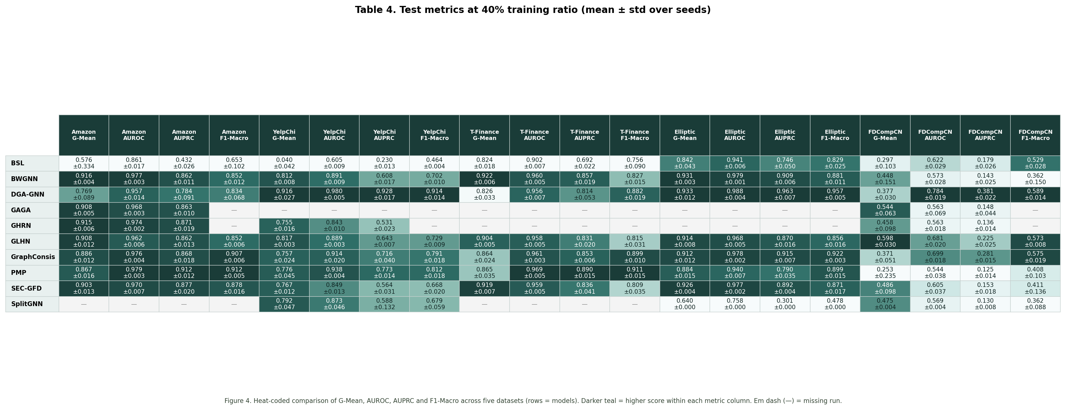
Figure 4. Heat-coded metric table at 40% training ratio (darker teal = higher score within each metric column).
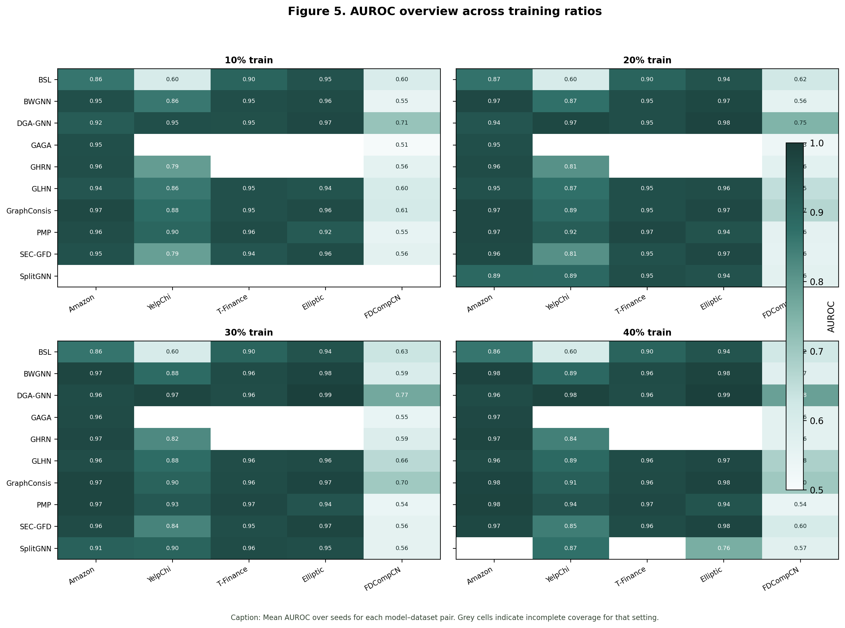
Figure 5. AUROC overview heatmaps across all training ratios.
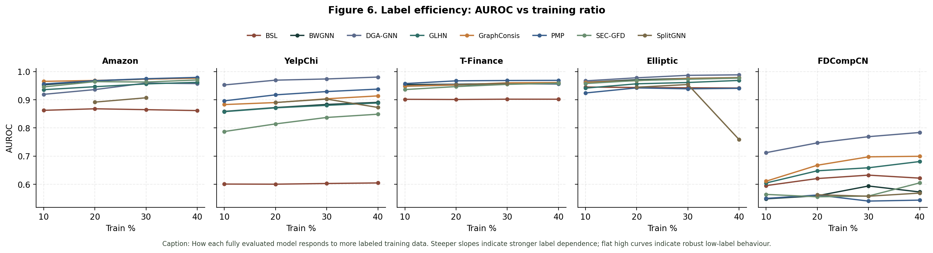
Figure 6. Label efficiency curves (AUROC vs training ratio) for fully covered models.

4. Architecture comparison and interpretation
Spectral / high-frequency models. BWGNN’s beta-wavelet filters target band-pass anomaly signals and remain strong on Amazon, T-Finance and Elliptic even at 10% labels (AUROC typically >0.95). Gains plateau as labels increase, consistent with a spectral prior that needs fewer labels when anomalies are frequency-separable. SplitGNN extends this idea with signed multi-relation splits and is competitive on dense YelpChi/T-Finance at 20–30%, but coverage gaps and weaker Elliptic/FDCompCN scores show sensitivity to sparsity and incomplete runs.
Relation-aware aggregators. GraphConsis was built for inconsistency across relations and delivers top-tier Amazon AUROC/AUPRC and strong T-Finance / Elliptic Macro-F1, aligning with multi-relation review and transaction semantics. PMP similarly ranks at or near the top on Amazon and T-Finance AUPRC / F1, indicating that prototype / message-passing refinements help under camouflage when neighbourhood structure is informative—but both are among the slowest per epoch on dense graphs.
Homophily-aware and grouping models. GLHN mixes low- and high-pass filters using predicted local homophily and is consistently solid across datasets without extreme failures, with a notable relative advantage on FDCompCN G-Mean where isolation makes pure neighbourhood aggregation unreliable. DGA-GNN’s dynamic grouping aggregation dominates YelpChi and Elliptic (AUROC ≈0.98 / 0.99 at 40%) and leads FDCompCN AUROC/AUPRC, suggesting grouped aggregation helps when neighbourhoods are noisy or heterophilic; its higher parameter count reflects grouping heads and binning capacity.
Efficiency-oriented detectors. SEC-GFD achieves competitive Amazon / T-Finance / Elliptic scores with very low per-epoch time and modest parameters—attractive when wall-clock budget matters. BSL’s barely-supervised disentanglement helps on Elliptic/T-Finance under scarce labels but collapses on YelpChi (AUROC ≈0.60), indicating that weak/strong unlabeled augmentations do not substitute for relation-selective modelling when camouflage is relation-specific. GAGA/GHRN (partial coverage) track BWGNN-like Amazon quality; GHRN is slower per epoch.
Why winners differ by dataset. (1) Multi-relation camouflage (YelpChi, Amazon): relation-aware or grouping models (DGA-GNN, GraphConsis, PMP) outrun vanilla spectral filters on YelpChi AUPRC. (2) Dense mild-heterophily transactions (T-Finance): spectral and consistency models all saturate high AUROC; ranking shifts to AUPRC/F1 and runtime. (3) Sparse large graphs (Elliptic): DGA-GNN and BWGNN exploit structure without drowning in density cost. (4) Isolated sparse corporate graph (FDCompCN): absolute scores drop sharply (AUPRC often <0.4); methods that degrade gracefully to features (DGA-GNN, GraphConsis, GLHN) retain relative advantages, while structure-heavy filters cannot invent missing edges.

5. Runtime and parameter complexity
Model | Amazon | YelpChi | T-Finance | Elliptic | FDCompCN
BSL | 0.098 | 0.098 | 0.455 | 0.024 | 0.016
BWGNN | 0.354 | 0.028 | 1.759 | 0.032 | 0.015
DGA-GNN | 0.768 | 0.435 | 1.923 | 0.085 | 0.023
GAGA | 0.155 | — | — | — | 0.327
GHRN | 1.729 | 1.361 | — | — | 0.041
GLHN | 0.391 | 0.413 | 0.907 | 0.056 | 0.090
GraphConsis | 1.047 | 3.028 | 7.065 | 0.290 | 0.079
PMP | 5.917 | 2.129 | 3.519 | 0.329 | 0.130
SEC-GFD | 0.078 | 0.080 | 0.330 | 0.017 | 0.021
SplitGNN | 0.807 | 0.750 | 6.269 | 0.023 | 0.050
Table 5. Average per-epoch training time in seconds (mean over seeds and training ratios).
Model | Amazon | YelpChi | T-Finance | Elliptic | FDCompCN
BSL | 15,107 | 15,779 | 13,667 | 28,643 | 18,179
BWGNN | 30,594 | 31,042 | 29,634 | 39,618 | 32,642
DGA-GNN | 371,358 | 147,684 | 43,236 | 304,497 | 106,916
GAGA | 7,218 | — | — | — | 7,730
GHRN | 18,306 | 18,754 | — | — | 20,354
GLHN | 7,254 | 8,514 | 5,214 | 70,422 | 14,614
GraphConsis | 119,170 | 124,546 | 36,226 | 76,162 | 143,746
PMP | 67,529 | 241,795 | 8,051 | 335,843 | 943,177
SEC-GFD | 29,787 | 31,138 | 26,892 | 9,768 | 35,963
SplitGNN | 2,315 | 2,379 | 875 | 2,123 | 2,963
Table 6. Trainable parameter counts by model and dataset.
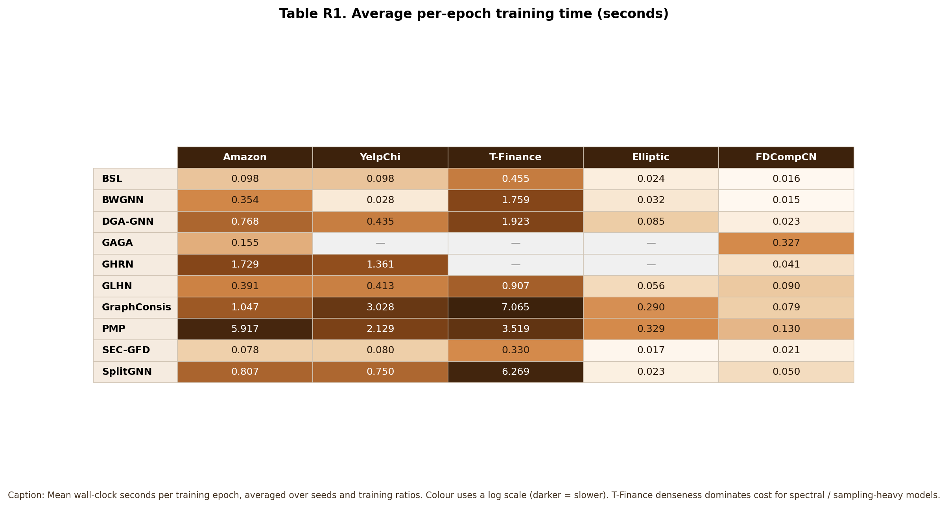
Figure 7. Visual table of average per-epoch training time (seconds).
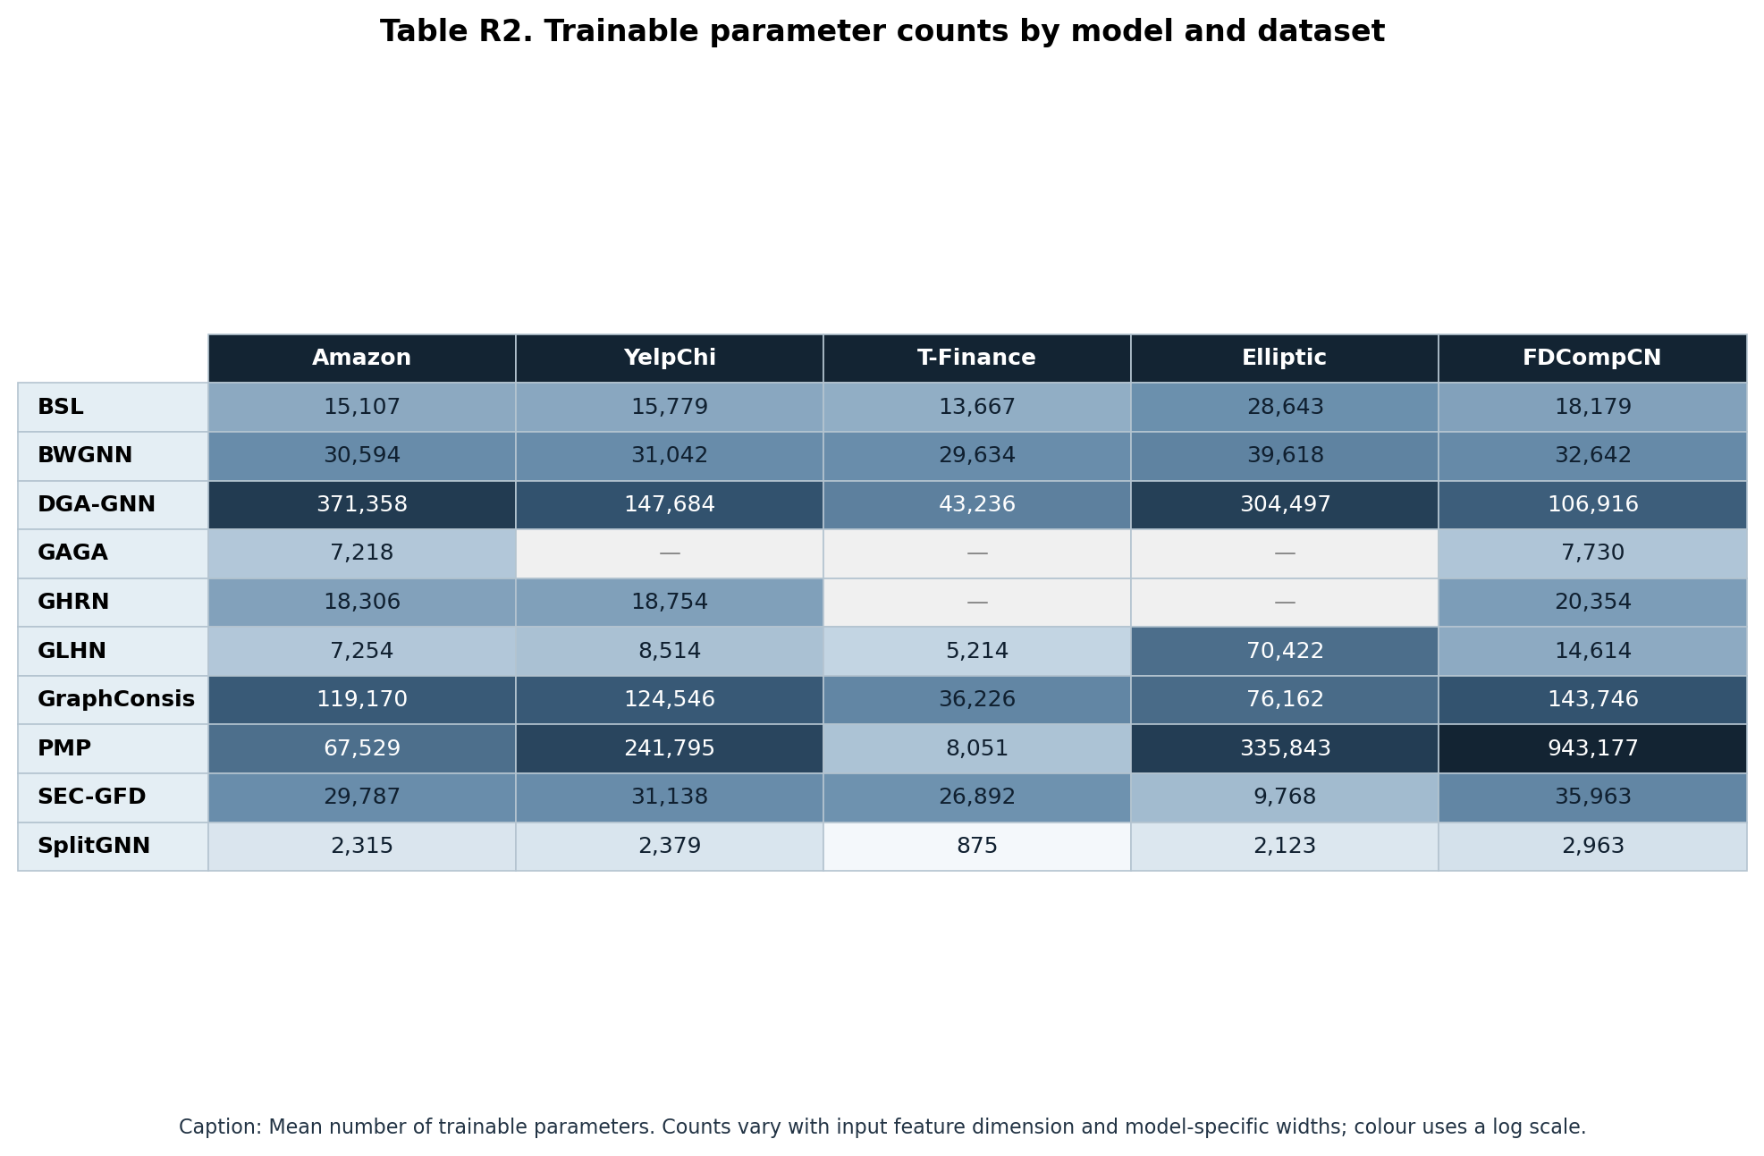
Figure 8. Visual table of trainable parameter counts.
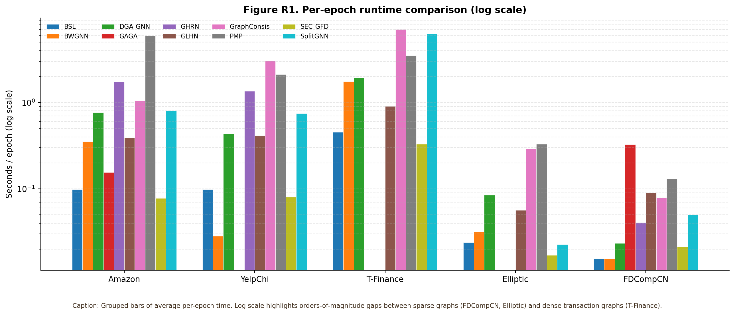
Figure 9. Grouped per-epoch runtime bars (log scale).
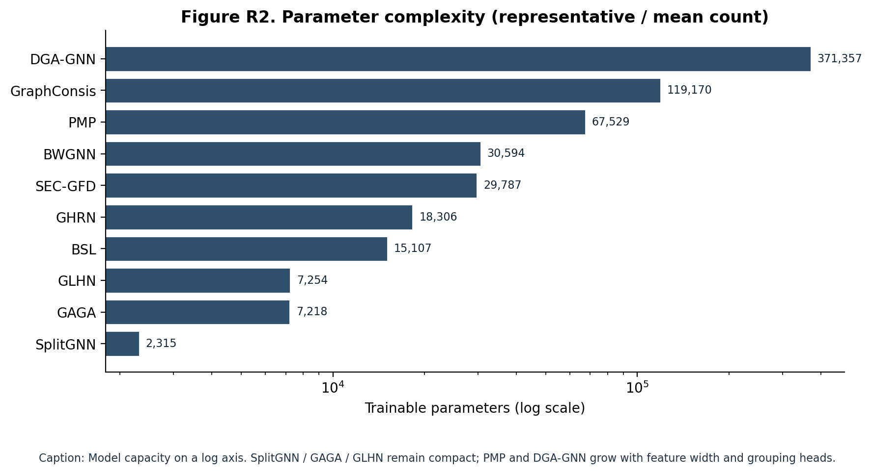
Figure 10. Parameter complexity comparison (log scale).
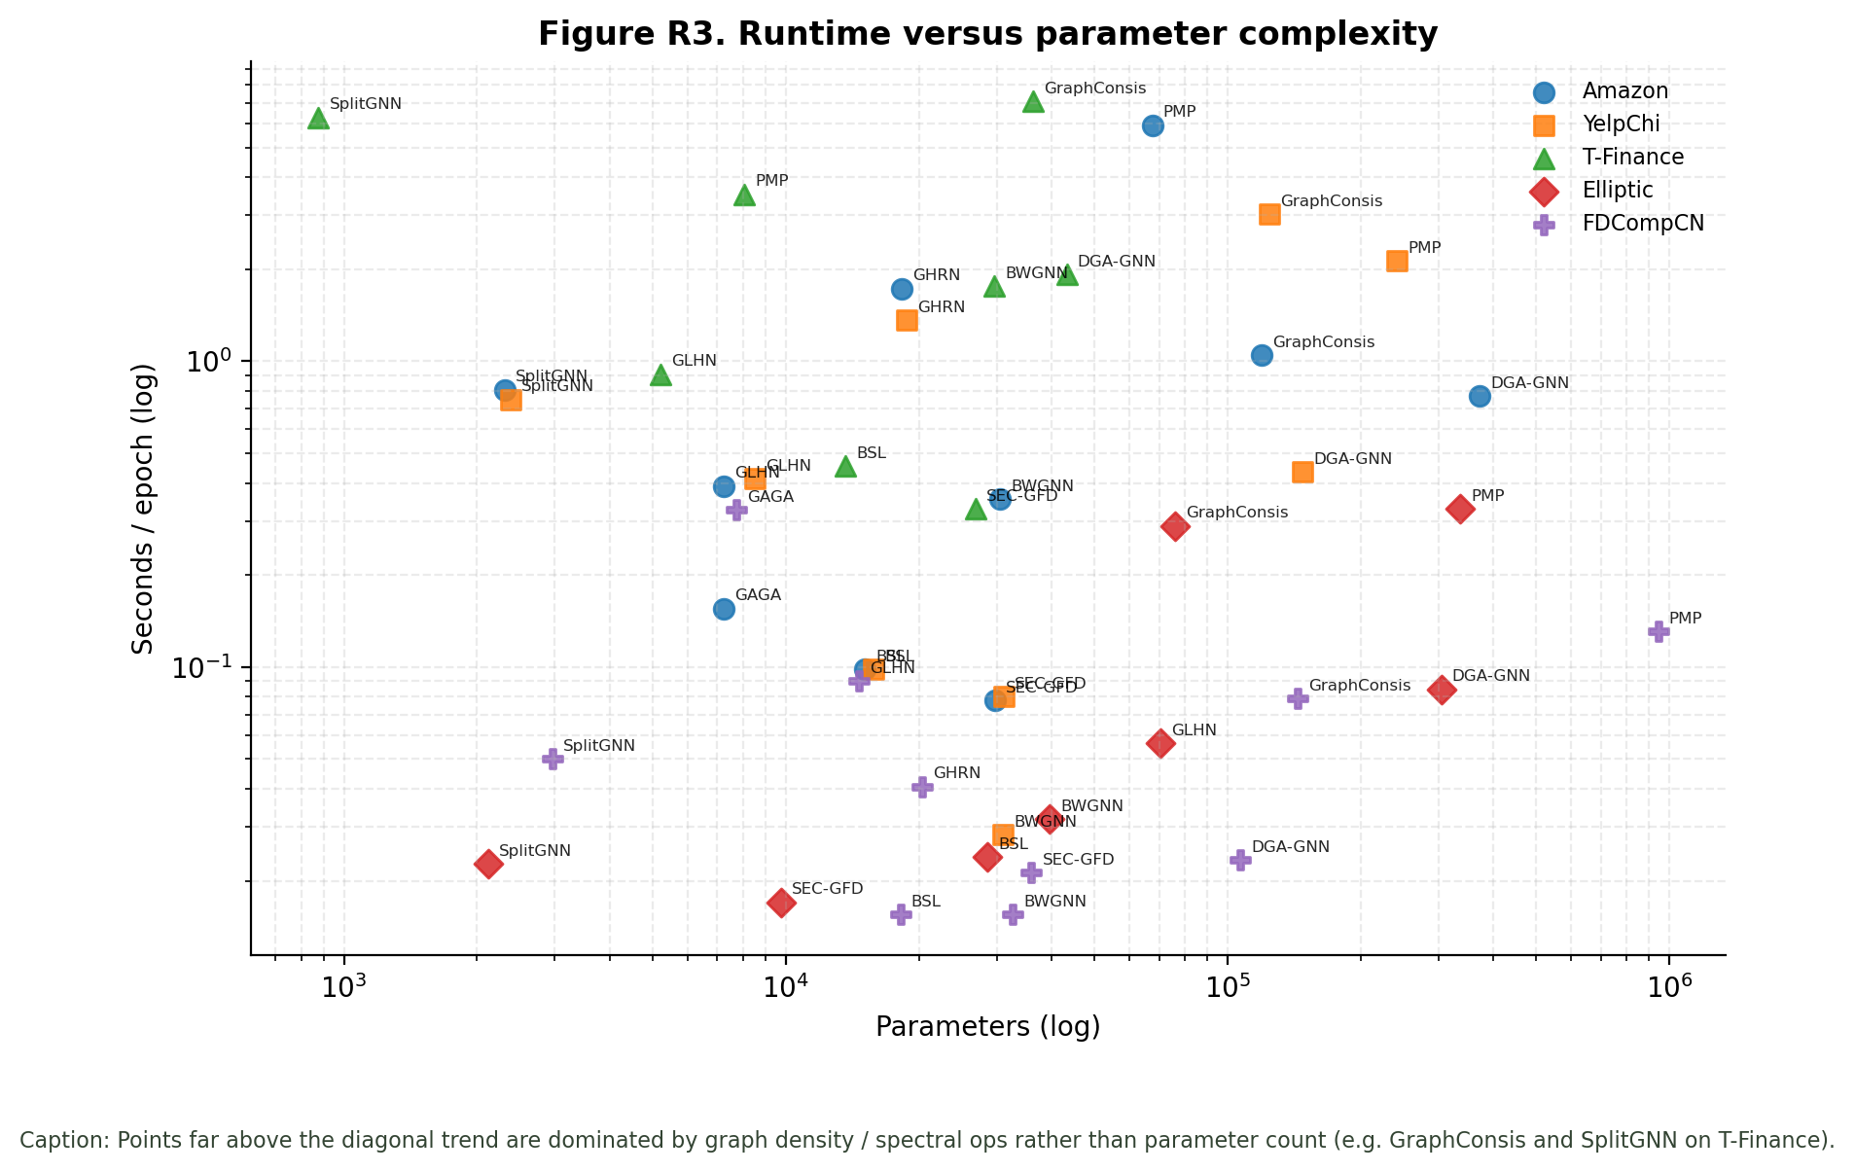
Figure 11. Runtime versus parameter complexity by dataset.
Runtime is driven more by graph density and spectral/sampling cost than by parameter count. GraphConsis and SplitGNN are expensive on T-Finance despite moderate or small parameter budgets; SEC-GFD and BSL remain fast across datasets. PMP and DGA-GNN combine larger capacity with higher epoch cost on Amazon/YelpChi. SplitGNN is the most compact parameterisation; PMP’s FDCompCN parameter blow-up reflects feature-dependent widths in that implementation.

6. Conclusions
No single architecture wins universally. Spectral anomaly filters (BWGNN) provide strong, label-efficient baselines on frequency-separable fraud; relation-aware and grouping models (GraphConsis, PMP, DGA-GNN) unlock YelpChi and further lift precision-oriented metrics; homophily-mixing (GLHN) and efficient spectral variants (SEC-GFD) offer balanced accuracy–cost trade-offs; barely-supervised designs need dataset conditions that match their assumptions. FDCompCN remains the hardest stress test because isolation removes the inductive bias GNNs rely on. Practitioners should match model family to the dominant dataset pathology—camouflage, density, sparsity or isolation—rather than expecting a global ranking.

