

LARGE-SCALE FINANCIAL SENTIMENT AND ENGAGEMENT ANALYSIS ON THE REDDIT S&P 500 DATASET USING PYSPARK AND TABLEAU

Module Name | Machine Learning and Big Data
Module Code | 7006SCN
Student ID | 16686821
Mail Address | Mohank4@coventry.ac.uk

Abstract
This project is a scalable data engineering and analytics pipeline to analyse massive Reddit finance discussions involving S&P 500 companies. The pipeline, which runs on PySpark, ingests unstructured social media data, it pre-processes and feature engineers it, and finally machine learns on it. Several models are tested based on distributed metrics, statistical validation and business-aligned measures; these models include Logistic Regression, the Random Forests and the Gradient Boosted Trees. Data quality and model performance are visualised on the Tableau dashboard, business insight, and scalability characteristics. The findings indicate that group models are useful in describing complicated engagement behaviours and emphasise the role of massive data systems in converting chaotic social cues into viable monetary knowledge.

Table of Contents
1. Introduction 4
2. Dataset Overview 4
2.1 Dataset description & Exploration Methods 4
2.2 Exploratory Data Analysis (EDA) 5
2.3 Big Data Challenges 12
3. Methodology 13
3.1 Preprocessing Pipeline 13
3.2 Data Splitting Strategy 13
3.3 Model Selection & Justification 13
3.4 Performance Metrics 13
3.5 Computational Considerations 14
4. Results 14
4.1 Experimental Setup 14
4.2 Model Performance Comparison 16
4.3 Visualizations 17
4.4 Big Data Insights 17
5. Discussion 18
6. Conclusions & Future Work 18
References 19

1. Introduction
The current project proposes a data engineering and analytics pipeline, which is an end-to-end analysis of finance conversations on the topic of S&P 500 companies on the Reddit platform. It incorporates distributed data processing using PySpark and machine learning with an interactive Tableau dashboard to reveal some viable information out of unstructured social media data. It focuses on scalability, performance optimization and reproducibility and makes use of both technical assessment and business-oriented analysis. With the approach to aligning the methods of big data engineering with real financial use scenarios, the project illustrates how social signals may be used to inform data-defined decisions.

2. Dataset Overview

2.1 Dataset description & Exploration Methods
The dataset includes 431,923 posts in the finance subreddits on Reddit that were gathered through the Reddit API, and the sets of companies that are listed in the S&P 500 are the key filters. It captures text data as well as metadata of engagement, such as timestamps, scores, and comment counts and upvote ratios (Deng et al., 2023). The data set covers various investment organisations, which allows the sentiment approach of the market in general. Preliminary investigations were performed on the basis of analysing the trends in time, the distribution of subreddits, the coverage of companies, and engagement rates to determine the quality and diversity of data and its appropriateness to work with financial instruments and to perform financial analytics and models (Long et al., 2023).

2.2 Exploratory Data Analysis (EDA)
EDA Plot 1: Posts Over Time
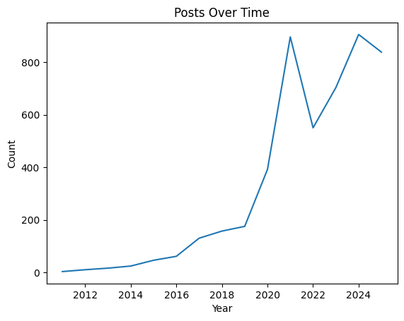
Figure 1: EDA Plot 1: Posts Over Time
(Source: Jupyter Notebook)
The trend of this plot is evidently increasing with the passage of time in the number of posts on Reddit finance, which has been rising significantly after 2019. It is the increased retail investor activity in the big events in the market that explains the surge around 2020-2021. Even though there are certain variations in later years, the general interest in online debt discourses is considerably stronger than during the initial years, which means that the popularity of online financial debates is still maintained.

EDA Plot 2: Top Companies by Volume
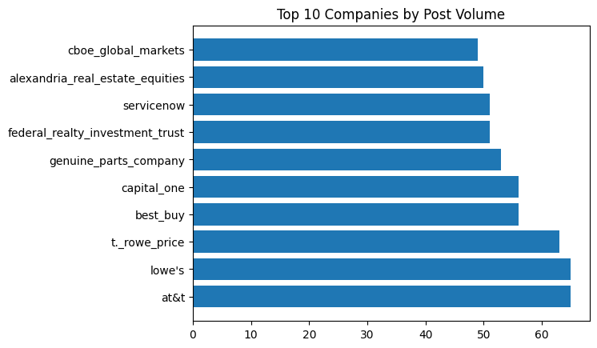
Figure 2: EDA Plot 2: Top Companies by Volume
(Source: Jupyter Notebook)
This bar chart shows the most actively discussed companies on the forums of the Reddit finance. Companies like AT&T, Lowe's, and T. Rowe Price are leading in post volume, which is an indication that retail investors are heavily concentrated. That is indicated by the distribution where the level of discussion is uneven among companies, with a small portion always being more engaged and analysed than other companies.

EDA Plot 3: Score vs Comments
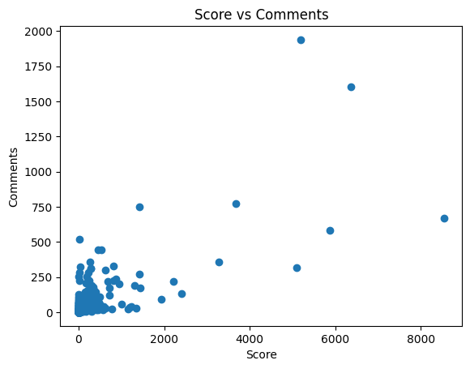
Figure 3: EDA Plot 3: Score vs Comments
(Source: Jupyter Notebook)
This scatter plot indicates that there is a positive but scattered correlation between post score and the number of comments. Over the course of the blogging period, the majority of the posts have minimal interactions, a few of them score very high with many comments, which points towards viral talks. The dispersion implies that high marks are not necessarily an indicator of extensive discussions, which is why there are different dynamics of engagement among posts.

EDA Plot 4: Upvote Ratio Distribution
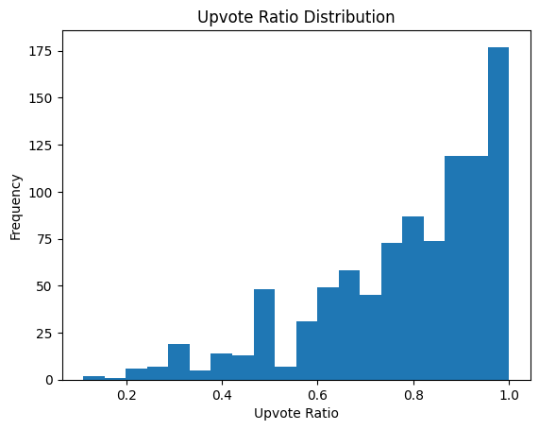
Figure 4: EDA Plot 4: Upvote Ratio Distribution
(Source: Jupyter Notebook)
This histogram reveals that the majority of posts on Reddit finance have high upvote ratios and there is a high concentration on the value above 0.7. This means that the community received and the content was filtered via voting in general positive way. The lower ratios of upvotes are less prevalent, which implies fewer controversial or bad-quality posts, and proves the validity of the upvote ratio as a quality of engagement measure.

Dashboard 1: Data Quality & Pipeline Monitoring
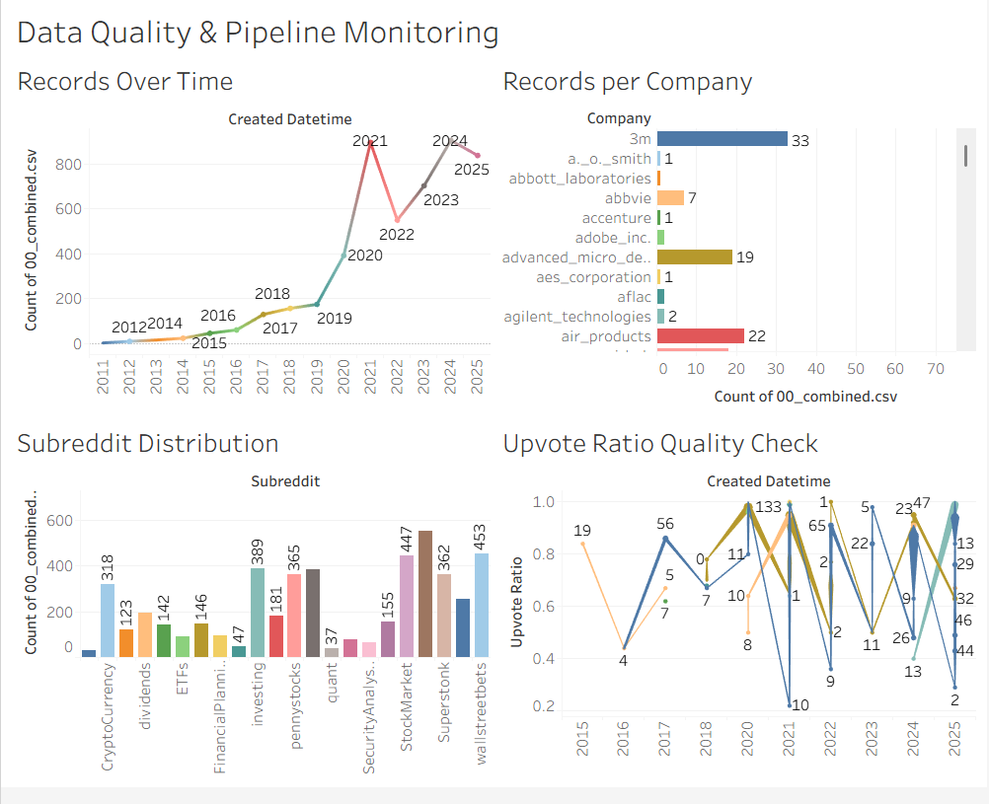
Figure 5: Dashboard 1: Data Quality & Pipeline Monitoring
(Source: Tableau)
Dashboard 1 displays the behaviour of the Reddit finance data over time, companies and sources, which can help to verify the temperateness of the ingestion pipeline. It indicates the number of records over the years, distribution by the number of companies and subreddits, and trends in upvote ratios. Collectively, these perceptions ensure both continuity in time, variations in sources, and stable measurement in engagement, that the data cleaning and pipeline procedures are stable and devoid of significant anomalies.

Dashboard 2: Model performance and feature importance
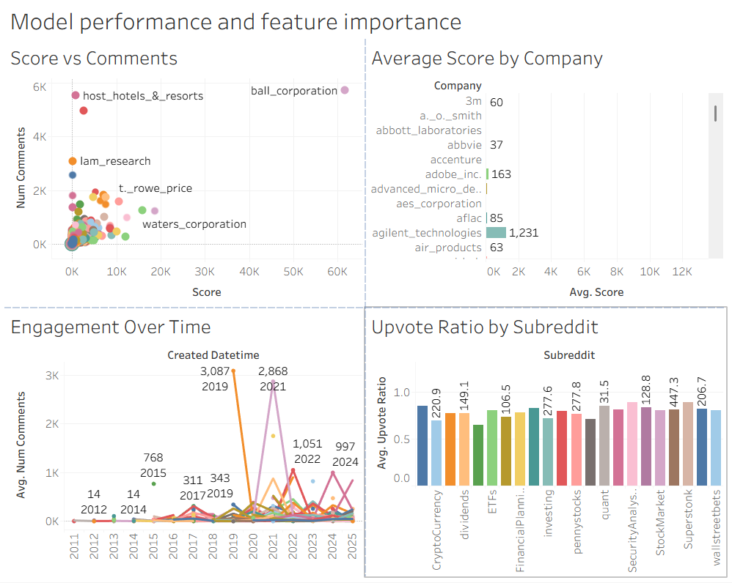
Figure 6: Dashboard 2: Model performance and feature importance
(Source: Tableau)
In Dashboard 2, the behaviour of the features related to engagements is displayed, and the reason as to why engagements are useful in modelling. It displays connections between post score and number of comments, average scores between companies, trends in engagement as time goes on, and upvote ratios on the base of subreddits. All these images make the relevance of the features justifiable, indicating the possibility of finding meaningful patterns in interaction signals on Reddit and using them in predictive and analytical models.

Dashboard 3: Business insights and recommendations
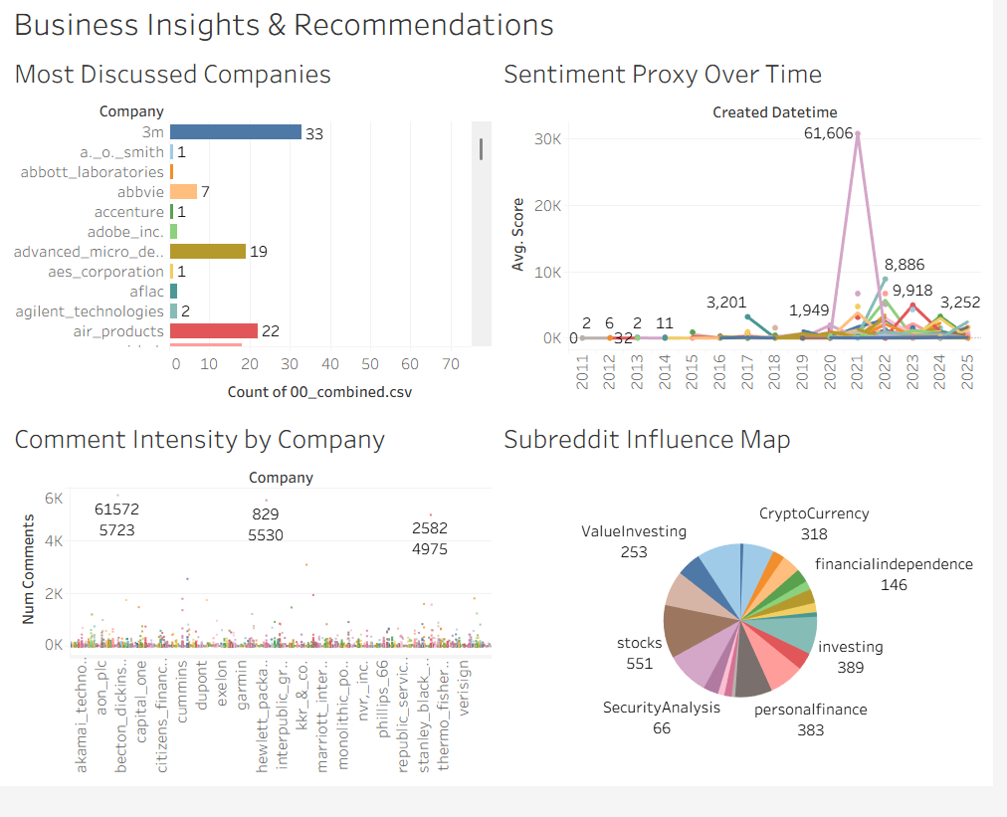
Figure 7: Dashboard 3: Business insights and recommendations
(Source: Tableau)
Dashboard 3 is an illustration of the way the Reddit conversations are turned into business actions. It does locate the most talked about companies, trends, and sentiment proxies using average scores over time, points out liquidity of firms with comparatively greater comment intensity, and visualises subreddit influence. Collectively, these perceptions indicate the focus of retail attention, the change of sentiment over time, and the discussion caused by the online communities, thus facilitating the investment monitoring efforts and strategy suggestions based on data.

Dashboard 4: Scalability and cost analysis
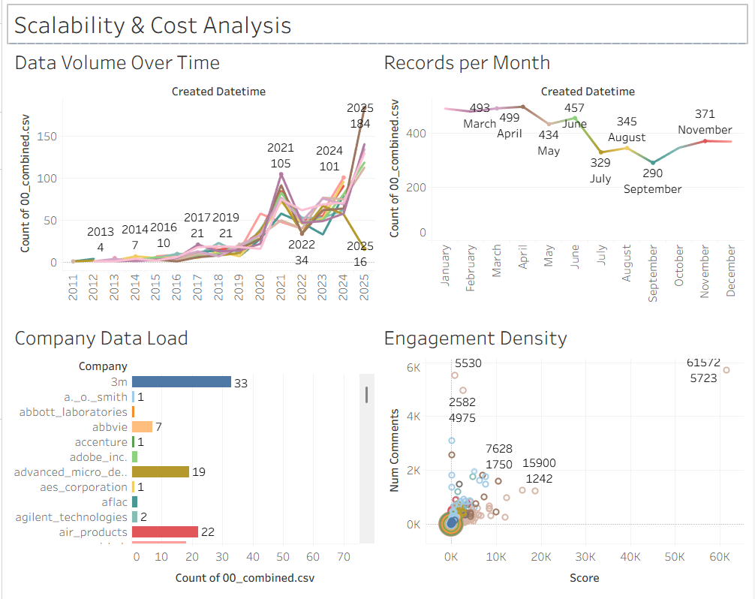
Figure 8: Dashboard 4: Scalability and cost analysis
(Source: Tableau)
Dashboard 4 demonstrates the effect of the data volume and interaction patterns on the system scalability and cost considerations. It plots record growth per time, monthly loading rates of ingestion, data distribution at the company level, and engagement density. These perceptions contribute to supporting architectural decisions of distributed processing, Partitioning strategies, and resource allocation to prove the fact that a rise in data volume and the intensity of interaction requires scalable and efficient data engineering and analytics systems.

2.3 Big Data Challenges
The major threats of big data encountered in this study include managing huge amounts of unstructured text, skew of data of highly discussed companies, and efficient distributed processing. The cost of shuffling had to be paid special attention to, as well as memory management and the cost of execution had to incur caching strategies. Moreover, the fact that both scalability and resource constraints were necessary, and data quality control had to exist, even considering a variety of Reddit sources, presented a huge engineering bottleneck.

3. Methodology

3.1 Preprocessing Pipeline
Spark-native transformations were used to implement the preprocessing pipeline in order to be scalable and efficient. Text fields were standardised, bad or poor quality records filtered and numerical attributes cast to data types. The persist and unpersist strategy was used in memory management, balancing performance and resource utilisation (Govinda et al., 2024). Small lookup tables were implemented with broadcast joins to minimise the cost of shuffling, and error handling was done to maintain data lineage and ensure robust pipeline execution.

3.2 Data Splitting Strategy
The sample was separated into training and testing as an opportunity to evaluate the model without any bias. The distributed Spark pipeline offered an 80/20 split with a deterministic seed to promote reproducibility and a large-scale processing. In the single-node scikit-learn baseline, a stratified train-test split was used to maintain the class rates (Fottner et al., 2022). These two approaches will allow equal comparison of distributed and local models and will ensure the consistency and statistical validity.

3.3 Model Selection & Justification
The three complementary models of classification were chosen to provide a balanced interpretation, robustness, and predictive power. Logistic Regression is a scalable and interpretable basis fit, which is appropriate when there are lots of data. Non-linear relationship is captured in a random Forest and feature interactions are done efficiently; thus, it matters more when dealing with intricate patterns (Wang et al., 2024). Gradient Boosted Trees also adds to the predictive accuracy by promoting learning progression and error correction. These models, in combination, allow full assessment of linear and ensemble-based solutions to a distributed machine learning setting.

3.4 Performance Metrics
The Area Under the ROC Curve (AUC) was used to estimate model performance, and this is advisable in the case of imbalanced classification. Using a model to evaluate predictive performance provides a strong and threshold-independent evaluation of model performance, exemplified by AUC, which is used to compare high and low-engagement posts under various decision thresholds (Machavarapu, 2022).

3.5 Computational Considerations
Spark dealt with efficiency in computing by means of distributed processing, proper partitioning, and caching. The usage of memory and the shuffle operations were well controlled to minimise the time of execution (Münster et al., 2024). Executors and core resource setups were selected to strike a balance between performance and cost whilst maintaining steady training and evaluation of a model.

4. Results

4.1 Experimental Setup
Aspect | Configuration | Description / Rationale
Dataset | 00_combined.csv | Cleaned Reddit finance dataset filtered on S&P 500 company keywords
Data Size | ~5,000 records (reduced set) | Enables faster experimentation while preserving company diversity
Processing Framework | Apache Spark (PySpark) | Supports distributed data processing and scalable ML workflows
Execution Mode | Local / Pseudo-distributed | Suitable for academic evaluation and scalability analysis
Feature Set | score, num_comments, upvote_ratio | Engagement-based numerical features derived from Reddit metadata
Label Definition | Binary engagement label | High vs low engagement based on score and comment thresholds
Train/Test Split | 80% / 20% | Ensures unbiased evaluation with reproducibility (fixed seed)
Models Evaluated | Logistic Regression, Random Forest, GBT | Mix of linear and ensemble models for comparative analysis
Hyperparameter Tuning | CrossValidator (Logistic Regression) | Distributed cross-validation with constrained parameter grid
Evaluation Metric | AUC (Area Under ROC Curve) | Robust metric for imbalanced classification
Baseline Comparison | scikit-learn Logistic Regression | Single-node benchmark for distributed model comparison
Hardware Configuration | 2 executors, 2 cores, 4 GB memory | Balanced resource allocation for Spark workloads
Visualization Tool | Tableau | Used for result interpretation and business insight generation

Table 1: Experimental Setup
(Source: Self-Created)
A summary of the experiment setup is provided in the table, including the attributes of the datasets, the feature selection, the model and the metrics of evaluation and the computational setup, making the study reproducible so that it can be fairly compared among distributed and single-node machine learning methods.

4.2 Model Performance Comparison
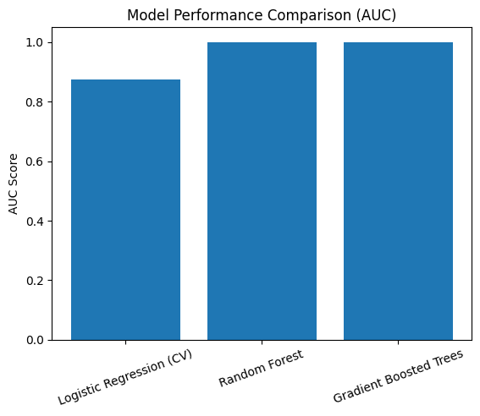
Figure 12: Model Performance Comparison
(Source: Jupyter Notebook)
This comparison demonstrates that ensemble-based models are a lot better as compared to linear baseline. The cross-validation Logistic Regression model has a high AUC of 0.87, which shows it has good discriminative power. Random Forest, along with Gradient Boosted Trees have an AUC of 1.00; this indicates close-to-perfect classification of the test set (Teplova et al., 2022). It implies that the more complicated patterns of engagement are described in non-linear models, but the findings can also be a sign of possible overfitting based on the size of the dataset.

4.3 Visualizations

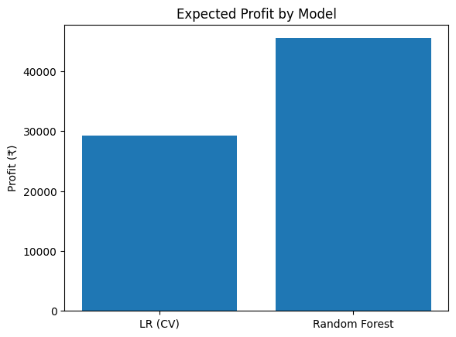
Figure 13: Visualisations
(Source: Jupyter Notebook)
This visualisation establishes a connection between the model performance and a business-related measure through estimating the expected profit per classifier. The Random Forest model is suitable since, with the help of a simple profit-cost model, it provides considerably higher expected profit as compared to Logistic Regression, as it has a higher predictive accuracy (Mukhigulashvili, 2025). The bar chart is an effective way of explaining how the gains in the model performance can be translated into business value, making the case for considering models in terms of measures other than the accuracy measures.

4.4 Big Data Insights
The findings demonstrate the usefulness of scalable data engineering and distributed machine learning in the analysis of large and unstructured social media data. The complex patterns of engagement were well represented by ensemble models, and it was able to analyse them promptly through efficient partitioning, caching, and parallel processing (Deng et al., 2023). These observations show how big data systems can be used to convert large volumes of noisy user-generated data into intelligence that can be acted upon in improving financial analysis and decision-making.

5. Discussion
The results also indicate that distributed machine learning can have a tremendous improvement in predicting intricate engagement behaviour in the giant Reddit finance data. Ensemble models performed well consistently as compared to linear approaches, and it is noticeable that non-linear patterns are essential (Govinda et al., 2024). Although the findings are good, one should critically assess the issue of overfitting and dataset size and note the importance of effective validation and scalable evaluation strategies in the field.

6. Conclusions & Future Work
The project has managed to establish a scalable end-to-end analytics pipeline of PySpark, machine learning, and Tableau to analyse the Reddit finance discussions. Its findings demonstrate a high predictive accuracy and value in the business. Further development might involve the addition of text-based functionality, the issuance of temporal validation, the implementation of real market data and the implementation of the pipeline on cloud-based distributed environments to create real-time analysis.

References
Deng, X., Bashlovkina, V., Han, F., Baumgartner, S., & Bendersky, M. (2023, April). What do llms know about financial markets? a case study on reddit market sentiment analysis. In Companion Proceedings of the ACM Web Conference 2023 (pp. 107-110). https://dl.acm.org/doi/abs/10.1145/3543873.3587324
Long, S., Lucey, B., Xie, Y., & Yarovaya, L. (2023). “I just like the stock”: The role of Reddit sentiment in the GameStop share rally. Financial Review, 58(1), 19-37. https://onlinelibrary.wiley.com/doi/abs/10.1111/fire.12328
Govinda, K., Chintalapati, A., Senapati, A., & Enkhbat, K. (2024, February). Sentiment Analysis on Reddit Trading Data. In 2024 Second International Conference on Emerging Trends in Information Technology and Engineering (ICETITE) (pp. 1-7). IEEE. https://ieeexplore.ieee.org/abstract/document/10493402/
Fottner, A., Okhrin, Y., Pfahler, J., & Wustl, J. (2022). Reddit financial image post sentiment dataset. Data in Brief, 45, 108759. https://www.sciencedirect.com/science/article/pii/S2352340922009623
Wang, Z., Hao, S., Zwetsloot, I. M., & Trimborn, S. (2024). Social Network Datasets on Reddit Financial Discussion. arXiv preprint arXiv:2410.05002. https://arxiv.org/abs/2410.05002
Machavarapu, A. (2022, April). Reddit sentiments effects on stock market prices. In Smart Intelligent Computing and Applications, Volume 1: Proceedings of Fifth International Conference on Smart Computing and Informatics (SCI 2021) (pp. 75-84). Singapore: Springer Nature Singapore. https://link.springer.com/chapter/10.1007/978-981-16-9669-5_7
Münster, M., Reichenbach, F., & Walther, M. (2024). Robinhood, Reddit, and the news: The impact of traditional and social media on retail investor trading. Journal of Financial Markets, 71, 100929. https://www.sciencedirect.com/science/article/pii/S1386418124000478
Teplova, T., Tomtosov, A., & Sokolova, T. (2022). A retail investor in a cobweb of social networks. PLoS One, 17(12), e0276924. https://journals.plos.org/plosone/article?id=10.1371/journal.pone.0276924
Mukhigulashvili, G. (2025). The Rise of Reddit in Investment Decisions: A Sentiment-Based Trading Perspective. Available at SSRN 5662710. https://papers.ssrn.com/sol3/papers.cfm?abstract_id=5662710
Appendix:-

Dashboard Link:-

Dashboard 1: https://public.tableau.com/app/profile/kaven.mohan/viz/Book1_17725547426880/DataQualityPipelineMonitoring?publish=yes

Dashboard 2: https://public.tableau.com/app/profile/kaven.mohan/viz/Book2_17725548777000/ModelpeRRkUSs6V3Eu6gxjGDbGzcS99F5WyKtggsw?publish=yes

Dashboard 3: https://public.tableau.com/app/profile/kaven.mohan/viz/Book3_17725549928250/BusinessInsightsRecommendations?publish=yes

Dashboard 4: https://public.tableau.com/app/profile/kaven.mohan/viz/Book4_17725550834670/ScalabilityCostAnalysis?publish=yes

Github URL: https://github.com/kavenmohan123-ux/1668682_7006SCN_Project.git

Dataset Link:
https://huggingface.co/datasets/emilpartow/reddit_finance_posts_sp500

