Sanjivani University, Kopargaon
Department of Cyber Security
Cryptography and System Security — Lab 3: Hill Cipher (Completed)
Name: Kaveri Rajguru
PRN: 2124UCSF1091

1. Manual Calculation — Encrypt "LP"
L = 11, P = 15 → Plaintext vector P = [11, 15]ᵀ
K × P = [3(11)+3(15), 2(11)+5(15)]ᵀ = [78, 97]ᵀ
Mod 26: 78 mod 26 = 0 → A 97 mod 26 = 19 → T
Result: "LP" encrypts to "AT"

2. Given 2×2 Program — Execution Result
The provided Colab code (key matrix K = [[3,3],[2,5]], message "HELP") was executed. Output obtained:
=== Hill Cipher Tool ===
Key Matrix:
[[3 3]
[2 5]]
Plaintext: HELP
[+] Encrypted Text: HIAT
[+] Decrypted Text: HELP
This matches the expected sample output in the manual, confirming the encryption/decryption round-trip is correct.

Colab Execution Screenshot
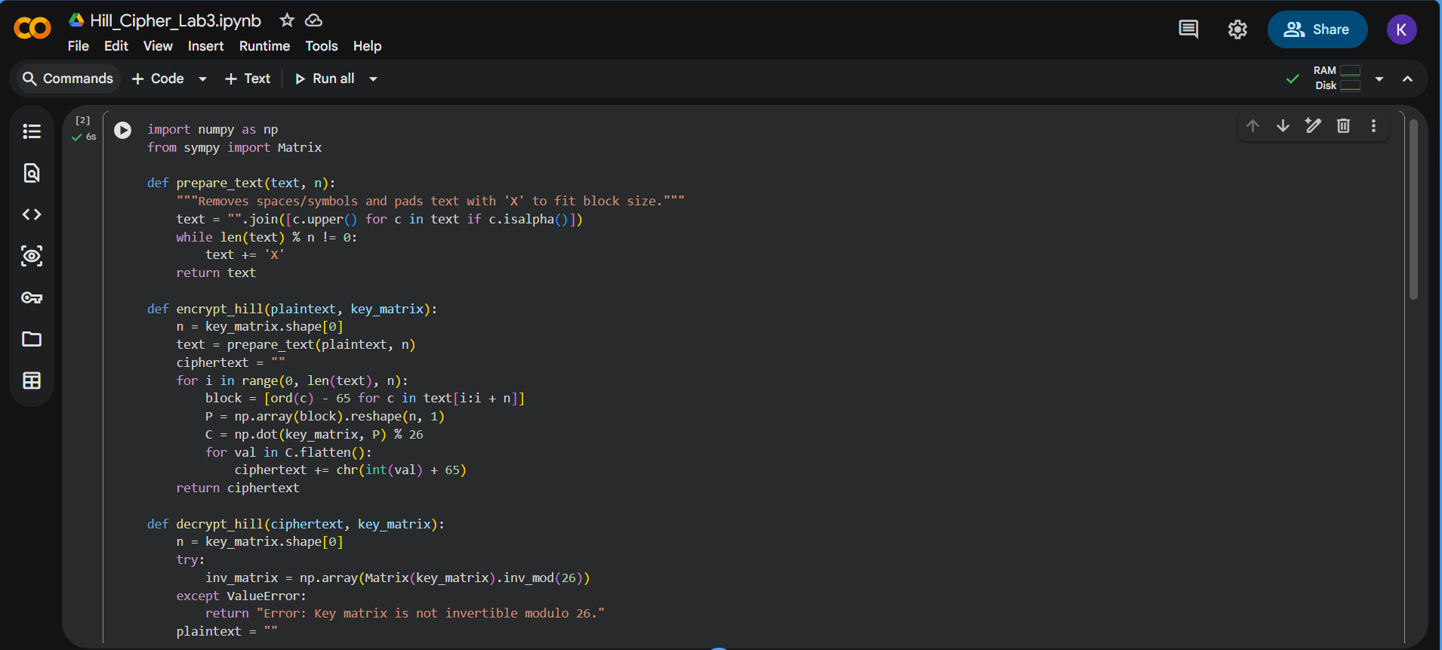
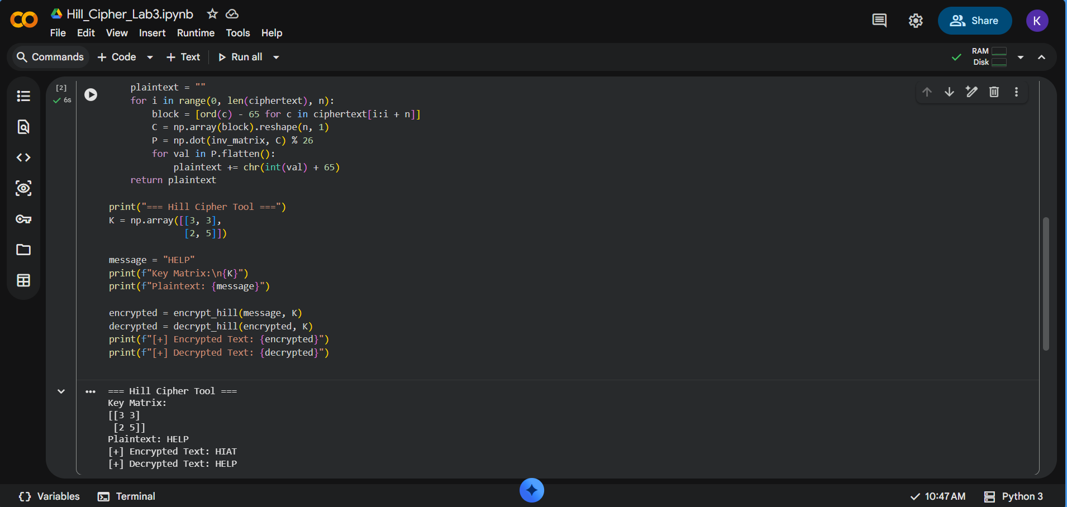

7. Colab Execution Code (Custom 3×3 Key Matrix)
import numpy as np
from sympy import Matrix

def prepare_text(text, n):
"""Removes spaces/symbols and pads text with 'X' to fit block size."""
text = "".join([c.upper() for c in text if c.isalpha()])
while len(text) % n != 0:
text += 'X'
return text

def encrypt_hill(plaintext, key_matrix):
n = key_matrix.shape[0]
text = prepare_text(plaintext, n)
ciphertext = ""
for i in range(0, len(text), n):
block = [ord(c) - 65 for c in text[i:i + n]]
P = np.array(block).reshape(n, 1)
C = np.dot(key_matrix, P) % 26
for val in C.flatten():
ciphertext += chr(int(val) + 65)
return ciphertext

def decrypt_hill(ciphertext, key_matrix):
n = key_matrix.shape[0]
try:
inv_matrix = np.array(Matrix(key_matrix).inv_mod(26))
except ValueError:
return "Error: Key matrix is not invertible modulo 26."
plaintext = ""
for i in range(0, len(ciphertext), n):
block = [ord(c) - 65 for c in ciphertext[i:i + n]]
C = np.array(block).reshape(n, 1)
P = np.dot(inv_matrix, C) % 26
for val in P.flatten():
plaintext += chr(int(val) + 65)
return plaintext

# --- Colab Interactive Execution: Custom 3x3 Key ---
print("=== Hill Cipher Tool (3x3 Key) ===")

# Custom 3x3 Key Matrix (det must be coprime to 26)
K = np.array([[6, 24, 1],
[13, 16, 10],
[20, 17, 15]])

message = "CRYPTO"
print(f"Key Matrix:\n{K}")
print(f"Plaintext: {message}")

encrypted = encrypt_hill(message, K)
decrypted = decrypt_hill(encrypted, K)

print(f"[+] Encrypted Text: {encrypted}")
print(f"[+] Decrypted Text: {decrypted}")

8. Student's Observation (Custom Input & Output)
Custom 3×3 Key Matrix Used | [[6, 24, 1], [13, 16, 10], [20, 17, 15]]

Custom Input Text (Plaintext) | CRYPTO

Observed Encrypted Output (Ciphertext) | CSNOPB

Observed Decrypted Output (Plaintext) | CRYPTO

Verified terminal output:
=== Hill Cipher Tool (3x3 Key) ===
Key Matrix:
[[ 6 24 1]
[13 16 10]
[20 17 15]]
Plaintext: CRYPTO
[+] Encrypted Text: CSNOPB
[+] Decrypted Text: CRYPTO
Determinant of K modulo 26 = 25, and gcd(25, 26) = 1, confirming the key matrix is invertible mod 26 — decryption recovers the exact original plaintext.

9.

Q1. Why must det(K) be coprime to 26? What if it isn't?
Decryption requires computing K⁻¹ (mod 26), and a matrix has a modular inverse mod 26 only when gcd(det(K), 26) = 1. 26 = 2 × 13, so det(K) must not be divisible by 2 or 13. If det(K) shares a factor with 26, K⁻¹ (mod 26) does not exist (K is 'singular' modulo 26), so the ciphertext cannot be uniquely decrypted back to the plaintext — the decryption step fails outright (as the code's try/except around inv_mod(26) is written to catch).

Q2. Known-Plaintext Attack — how is the key matrix deduced?
If an attacker has n linearly independent plaintext blocks and their corresponding ciphertext blocks, they can arrange the plaintext vectors as columns of a matrix P and the matching ciphertext vectors as columns of a matrix C, so that C = K·P (mod 26). If P is invertible mod 26, the attacker computes P⁻¹ (mod 26) and recovers the key as K = C · P⁻¹ (mod 26). Since the Hill cipher's encryption is a fixed linear transformation, only n such known pairs (for an n×n key) are enough to fully recover the key — this is why the cipher, despite hiding letter frequencies, offers no security against known-plaintext attacks.

Q3. Why is padding with 'X' mandatory?
The Hill cipher operates on fixed-size blocks (n×1 vectors) because encryption is defined as a matrix–vector multiplication K × P, which requires P to have exactly n components. If the plaintext length isn't an exact multiple of n, the final block would have fewer than n characters and could not form a valid vector for the matrix multiplication (a dimension mismatch). Padding with 'X' (a placeholder with no cryptographic significance) fills the last block to size n so every block can be processed identically by the algorithm.
Instructor Signature: .......................................................
Dr. Chetan D. Bawankar, Head, Department of Cyber Security

