https://github.com/aditya-grover/node2vec
https://github.com/palash1992/GEM
https://github.com/C-opt/GCN-tutorial/blob/master/train.py
https://www.kdd.org/kdd2016/papers/files/rfp0191-wangAemb.pdf
https://github.com/suanrong/SDNE/blob/master/main.py
https://arxiv.org/pdf/1705.02801.pdf

Hope :
Learn Embedding :
https://www.kdd.org/kdd2016/papers/files/rfp0184-ouA.pdf

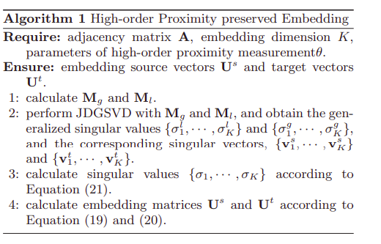
Note : Add equations from paper
-

Error:
S – U.diag(s).vt

Node2vec:
https://towardsdatascience.com/node2vec-graph-embedding-method-f306ac87004e
https://towardsdatascience.com/node2vec-embeddings-for-graph-data-32a866340fef
https://github.com/aditya-grover/node2vec

GCN :
https://github.com/dbusbridge/gcn_tutorial
https://arxiv.org/pdf/1609.02907.pdf

sdne :
https://github.com/suanrong/SDNE/blob/master/main.py
https://www.kdd.org/kdd2016/papers/files/rfp0191-wangAemb.pdf

struct2vec :
https://github.com/leoribeiro/struc2vec

Results:
kaveri@kaveri-ThinkPad-T420:~/PhD/Courses/Autumn/LearningWithGraphs/Project/GraphEmbedding/GEL/src/graph_embedding$ clear

kaveri@kaveri-ThinkPad-T420:~/PhD/Courses/Autumn/LearningWithGraphs/Project/GraphEmbedding/GEL/src/graph_embedding$ python3 main.py
######################################################################
Embedding Method: Laplacian, Evaluation Task: link-prediction
######################################################################
Original Graph: nodes: 34 edges: 78
Training Graph: nodes: 34 edges: 64
Loading training graph for learning embedding...
graph_train.edgelist
Graph Loaded...
begin norm_lap_mat
finish norm_lap_mat
finish getLap...
finish eigh(lap_mat)...
Saving embeddings...
Embedding Learning Time: 0.01 s
Nodes with embedding: 34
Begin evaluation...
######### Link Prediction Evaluation #########
MAP : 0.867, MRR : 0.867, AUC-ROC: 0.916, AUC-PR: 0.925, Accuracy: 0.800, F1: 0.786
##################################################
Prediction Task Time: 0.01 s
shape (34, 10)
Embedding dimension greater than 2, use tSNE to reduce it to 2
######################################################################
Embedding Method: GF, Evaluation Task: link-prediction
######################################################################
Original Graph: nodes: 34 edges: 78
Training Graph: nodes: 34 edges: 64
Loading training graph for learning embedding...
graph_train.edgelist
Graph Loaded...

total iter: 5
step 0: cost: 126.879
Saving embeddings...
Embedding Learning Time: 0.74 s
Nodes with embedding: 34
Begin evaluation...
######### Link Prediction Evaluation #########
MAP : 0.719, MRR : 0.719, AUC-ROC: 0.591, AUC-PR: 0.677, Accuracy: 0.600, F1: 0.538
##################################################
Prediction Task Time: 0.02 s
shape (34, 10)
Embedding dimension greater than 2, use tSNE to reduce it to 2
######################################################################
Embedding Method: SVD, Evaluation Task: link-prediction
######################################################################
Original Graph: nodes: 34 edges: 78
Training Graph: nodes: 34 edges: 64
Embedding Learning Time: 0.01 s
Nodes with embedding: 34
Begin evaluation...
######### Link Prediction Evaluation #########
MAP : 0.609, MRR : 0.609, AUC-ROC: 0.622, AUC-PR: 0.667, Accuracy: 0.533, F1: 0.533
##################################################
Prediction Task Time: 0.02 s
shape (34, 10)
Embedding dimension greater than 2, use tSNE to reduce it to 2
######################################################################
Embedding Method: HOPE, Evaluation Task: link-prediction
######################################################################
Original Graph: nodes: 34 edges: 78
Training Graph: nodes: 34 edges: 64
Loading training graph for learning embedding...
graph_train.edgelist
Graph Loaded...
Saving embeddings...
Embedding Learning Time: 0.03 s
Nodes with embedding: 34
Begin evaluation...
######### Link Prediction Evaluation #########
MAP : 0.000, MRR : 0.000, AUC-ROC: 0.500, AUC-PR: 0.500, Accuracy: 0.500, F1: 0.000
##################################################
Prediction Task Time: 0.05 s
shape (34, 2)
######################################################################
Embedding Method: GraRep, Evaluation Task: link-prediction
######################################################################
Original Graph: nodes: 34 edges: 78
Training Graph: nodes: 34 edges: 64
Loading training graph for learning embedding...
graph_train.edgelist
Graph Loaded...
Kstep = 0
/usr/local/lib/python3.6/dist-packages/GEL-0.1.0.dev0-py3.6.egg/graph_embedding/MatrixFactorization/grarep.py:31: RuntimeWarning: divide by zero encountered in log
probTranMat = np.log(Ak / tileMat) - np.log(1.0 / self.node_size)
Kstep = 1
/usr/local/lib/python3.6/dist-packages/GEL-0.1.0.dev0-py3.6.egg/graph_embedding/MatrixFactorization/grarep.py:31: RuntimeWarning: divide by zero encountered in log
probTranMat = np.log(Ak / tileMat) - np.log(1.0 / self.node_size)
Kstep = 2
/usr/local/lib/python3.6/dist-packages/GEL-0.1.0.dev0-py3.6.egg/graph_embedding/MatrixFactorization/grarep.py:31: RuntimeWarning: divide by zero encountered in log
probTranMat = np.log(Ak / tileMat) - np.log(1.0 / self.node_size)
Kstep = 3
/usr/local/lib/python3.6/dist-packages/GEL-0.1.0.dev0-py3.6.egg/graph_embedding/MatrixFactorization/grarep.py:31: RuntimeWarning: divide by zero encountered in log
probTranMat = np.log(Ak / tileMat) - np.log(1.0 / self.node_size)
Saving embeddings...
Embedding Learning Time: 0.01 s
Nodes with embedding: 34
Begin evaluation...
######### Link Prediction Evaluation #########
MAP : 0.778, MRR : 0.778, AUC-ROC: 0.884, AUC-PR: 0.907, Accuracy: 0.800, F1: 0.800
##################################################
Prediction Task Time: 0.04 s
shape (34, 16)
Embedding dimension greater than 2, use tSNE to reduce it to 2
######################################################################
Embedding Method: node2vec, Evaluation Task: link-prediction
######################################################################
Original Graph: nodes: 34 edges: 78
Training Graph: nodes: 34 edges: 64
Loading training graph for learning embedding...
graph_train.edgelist
Graph Loaded...
Preprocess transition probs...
Begin random walk...
Walk finished...
Learning representation...
Saving embeddings...
Embedding Learning Time: 1.21 s
Nodes with embedding: 34
Begin evaluation...
######### Link Prediction Evaluation #########
MAP : 0.630, MRR : 0.630, AUC-ROC: 0.689, AUC-PR: 0.701, Accuracy: 0.633, F1: 0.645
##################################################
Prediction Task Time: 0.02 s
shape (34, 10)
Embedding dimension greater than 2, use tSNE to reduce it to 2
######################################################################
Embedding Method: DeepWalk, Evaluation Task: link-prediction
######################################################################
Original Graph: nodes: 34 edges: 78
Training Graph: nodes: 34 edges: 64
Loading training graph for learning embedding...
graph_train.edgelist
Graph Loaded...
Begin random walks...
Walk finished...
Learning representation...
Saving embeddings...
Embedding Learning Time: 0.48 s
Nodes with embedding: 34
Begin evaluation...
######### Link Prediction Evaluation #########
MAP : 0.652, MRR : 0.652, AUC-ROC: 0.689, AUC-PR: 0.695, Accuracy: 0.667, F1: 0.706
##################################################
Prediction Task Time: 0.02 s
shape (34, 10)
Embedding dimension greater than 2, use tSNE to reduce it to 2
######################################################################
Embedding Method: LINE, Evaluation Task: link-prediction
######################################################################
Original Graph: nodes: 34 edges: 78
Training Graph: nodes: 34 edges: 64
Loading training graph for learning embedding...
graph_train.edgelist
Graph Loaded...
Pre-procesing for non-uniform negative sampling!

epoch:0 sum of loss:4.235081911087036
epoch:1 sum of loss:4.230283677577972
epoch:2 sum of loss:4.227959394454956
epoch:3 sum of loss:4.2156078815460205
epoch:4 sum of loss:4.218565762042999
Saving embeddings...
Embedding Learning Time: 37.32 s
Nodes with embedding: 34
Begin evaluation...
######### Link Prediction Evaluation #########
MAP : 0.611, MRR : 0.611, AUC-ROC: 0.689, AUC-PR: 0.697, Accuracy: 0.667, F1: 0.688
##################################################
Prediction Task Time: 0.01 s
shape (34, 10)
Embedding dimension greater than 2, use tSNE to reduce it to 2
######################################################################
Embedding Method: SDNE, Evaluation Task: link-prediction
######################################################################
Original Graph: nodes: 34 edges: 78
Training Graph: nodes: 34 edges: 64
Loading training graph for learning embedding...
graph_train.edgelist
Graph Loaded...
total iter: 0
Saving embeddings...
Embedding Learning Time: 0.67 s
Nodes with embedding: 34
Begin evaluation...
######### Link Prediction Evaluation #########
MAP : 0.867, MRR : 0.867, AUC-ROC: 0.920, AUC-PR: 0.930, Accuracy: 0.800, F1: 0.786
##################################################
Prediction Task Time: 0.02 s
shape (34, 128)
Embedding dimension greater than 2, use tSNE to reduce it to 2
######################################################################
Embedding Method: GAE, Evaluation Task: link-prediction
######################################################################
Original Graph: nodes: 34 edges: 78
Training Graph: nodes: 34 edges: 64
Loading training graph for learning embedding...
Graph Loaded...

targets is deprecated, use labels instead
Epoch: 0001 train_loss= 0.76905 train_acc= 0.32872 time= 0.08769
Epoch: 0002 train_loss= 0.76564 train_acc= 0.23702 time= 0.00150
Epoch: 0003 train_loss= 0.76093 train_acc= 0.19204 time= 0.00124
Epoch: 0004 train_loss= 0.75471 train_acc= 0.16955 time= 0.00188
Epoch: 0005 train_loss= 0.74680 train_acc= 0.15917 time= 0.00184
(34, 10)
Embedding Learning Time: 0.67 s
Nodes with embedding: 34
Begin evaluation...
######### Link Prediction Evaluation #########
MAP : 0.639, MRR : 0.639, AUC-ROC: 0.631, AUC-PR: 0.561, Accuracy: 0.667, F1: 0.643
##################################################
Prediction Task Time: 0.02 s
shape (34, 10)
Embedding dimension greater than 2, use tSNE to reduce it to 2
######################################################################
Embedding Method: GAE, Evaluation Task: link-prediction
######################################################################
Original Graph: nodes: 34 edges: 78
Training Graph: nodes: 34 edges: 64
Loading training graph for learning embedding...
Graph Loaded...
Epoch: 0001 train_loss= 1.30803 train_acc= 0.50346 time= 0.14301
Epoch: 0002 train_loss= 1.26415 train_acc= 0.51384 time= 0.00169
Epoch: 0003 train_loss= 1.34951 train_acc= 0.50346 time= 0.00136
Epoch: 0004 train_loss= 1.43565 train_acc= 0.48097 time= 0.00204
Epoch: 0005 train_loss= 1.21402 train_acc= 0.49827 time= 0.00135
(34, 10)
Embedding Learning Time: 0.98 s
Nodes with embedding: 34
Begin evaluation...
######### Link Prediction Evaluation #########
MAP : 0.620, MRR : 0.620, AUC-ROC: 0.644, AUC-PR: 0.562, Accuracy: 0.700, F1: 0.727
##################################################
Prediction Task Time: 0.02 s
shape (34, 10)
Embedding dimension greater than 2, use tSNE to reduce it to 2

Result for facebook network with hope:
######################################################################
Embedding Method: HOPE, Evaluation Task: link-prediction
######################################################################
Original Graph: nodes: 4039 edges: 88234
Training Graph: nodes: 4039 edges: 70608
Loading training graph for learning embedding...
graph_train.edgelist
Graph Loaded...
Saving embeddings...
Embedding Learning Time: 15.35 s
Nodes with embedding: 4039
Begin evaluation...
######### Link Prediction Evaluation #########
MAP : 0.325, MRR : 0.248, AUC-ROC: 0.604, AUC-PR: 0.618, Accuracy: 0.579, F1: 0.298
##################################################
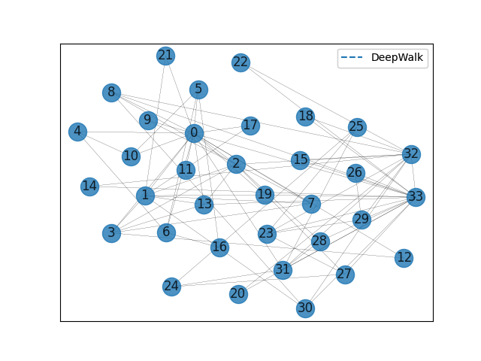
Prediction Task Time: 36.88 s

