My Name is Junseob Noh

My Name is Sathish Parthasarathi

My Name is Sukanya Chulliparambil Mohanan

My Name is MaryPravalika Jaddu

My Name is Mostafizur Rahman

My Name is Ankita Singh

My Name is Prakash Gurung

My Name is Mostafizur Rahman

My Name is Priyanka Garg

My Name is Manpreet Kaur

My Name is Pranav Sharma

My Name is Kavya Arora

My Name is BalaPrathima Gade

My Name is Preet Shah

My Name is Bruno Simoes

My Name is Tugrul Goktas

My Name is Prajwal Katuwal

My Name is Pavel Sazonov

My Name is swarnim sharma

My Name is Tugrul Goktas

My Name is Jay Kalal

My Name is HemaAbhinandu Kotha

My Name is AkhilDas PradeepKumar

My Name is Swathi Palavalli

My Name is KavirajSingh Jon

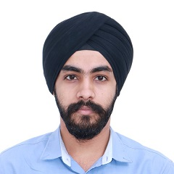

My Name is Althaf Edathara

My Name is Nipin Dasani

My Name is Kashish Jhaveri

My Name is Robert Routledge

My Name is Sahiba Sachdeva

My Name is Sofiya Raju

My Name is Sony Varghese

My Name is Krishnapriya Sarojam

My Name is SargunSingh Walia

My Name is Nikhil Patel

My Name is Gurminder Singh

My Name is Vrushabh Patel